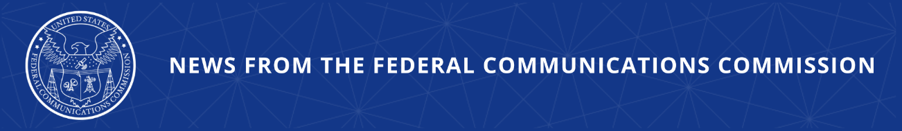

FCC to Re-Evaluate its Slamming and Truth-in-Billing Rules
Updates Would Ensure Consumer Protections While Removing Unnecessary Regulatory Burdens
--
WASHINGTON, July 24, 2025—The Federal Communications Commission today proposed changes to modernize and simplify its slamming and Truth-in-Billing rules. This proceeding will explore ways to reduce regulatory burdens, while retaining the core consumer protections where needed.

Adopted decades ago, the current rules protect consumers from having their local or long-distance service switched without their permission and require third party charges and other information on phone bills to be clear and easy to dispute. Although these goals are simple and commonsense, the current rules are out of sync with how modern communication services are sold and may stifle innovation without giving consumers additional protections.

Slamming is the illegal practice of changing a customer’s wireline telephone service provider for local, local toll, or long-distance service, or submitting a request to do the same without their permission. Today’s consumer typically subscribes to a single service that includes both local and long distance, often for a set monthly price. In large part because of this change in technology, and consumer preference, the FCC has not received any recent consumer complaints that describe a slam, and the last enforcement action taken against slamming occurred over seven years ago.

FCC Truth-in-Billing rules reflect an era where it was common to see a variety of add-ons including call waiting, call forwarding, and 3-way calling, with each “service” shown as a line item charges on the consumer’s bill. Most phone services offered today include these calling features at no additional cost to the consumer. Beyond this, as smartphone use has grown, third party charges have moved away from phone bills to app stores and in-app purchases.

Time and technology have passed these rules by. In keeping with the “Delete, Delete, Delete” initiative, today’s proposal would maintain important commonsense consumer protections while providing companies the flexibility to modernize their billing formats and customer service systems to better meet consumers where they are.

Action by the Commission July 24, 2025 by Notice of Proposed Rulemaking (FCC 25-41). Chairman Carr, Commissioners Gomez and Trusty approving. Chairman Carr, Commissioners Gomez and Trusty issuing separate statements.

CG Docket No. 17-169; CC Docket No. 98-170

###
Media Contact: MediaRelations@fcc.gov / (202) 418-0500
@FCC / www.fcc.gov

