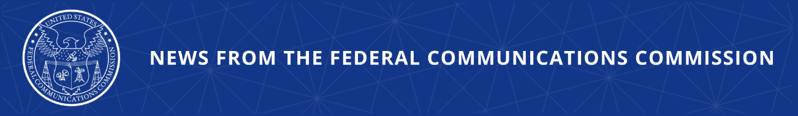

FCC Bars Over 1,200 Providers from Network Access for Their Continued Non-Compliance with Robocall Protections

WASHINGTON, August 25, 2025—Today, in the latest FCC action to protect Americans from illegal robocalls, the agency’s Enforcement Bureau removed over 1,200 non-compliant voice service providers from the Robocall Mitigation Database, effectively disconnecting them from U.S. phone network. These providers violated FCC rules by failing to maintain accurate Robocall Mitigation Database certifications, thereby shirking their obligations to protect consumers from illegal robocalls. Earlier this month, these companies received a final warning from the FCC when the Enforcement Bureau removed an initial tranche of 185 providers from the Database.

Chairman Brendan Carr issued the following statement:

“Robocalls are an all-too-common frustration—and threat—to Americans households. The FCC is doing everything in its power to fight back against these malicious and illegal calls. Providers that fail to do their duty when it comes to stopping these calls have no place in our networks. We’re taking action and we will continue to do so.”

Additional Background Information:

The FCC’s Robocall Mitigation Database is a critical tool through which the agency ensures providers are actively combatting robocalls and implementing STIR/SHAKEN caller ID authentication. Providers are required to certify that they have implemented STIR/SHAKEN on all IP-based portions of their networks. All providers must also submit robocall mitigation plans. Failure to meet these obligations may result in removal from the database and blocking of the provider’s traffic. Removed providers will only be permitted to refile in the database with express approval from the FCC’s Enforcement and Wireline Competition Bureaus.

In December 2024, the Commission ordered 2,411 providers to cure their deficient filings or provide a reason why they should not be removed from the Robocall Mitigation Database. Today’s action removes over 1,200 of these providers from the Robocall Mitigation Database. On August 6, the Enforcement Bureau removed a preliminary group of 185 providers from the database, all of which had appeared in at least one traceback as an originating, gateway, or non-responsive provider.

Following the prior removal of 185 companies by the FCC, a bipartisan group of 51 state attorneys general launched Operation Robocall Roundup which sent warning letters to 37 voice providers demanding that they act to stop illegal robocalls from being routed through their networks. The letters were sent to providers that the attorneys general noted had not complied with FCC rules requiring traceback support, Robocall Mitigation Database certification, and robocall mitigation plans—including seven providers the FCC had removed from the Database.

###
Media Contact: MediaRelations@fcc.gov / (202) 418-0500
@FCC / www.fcc.gov

