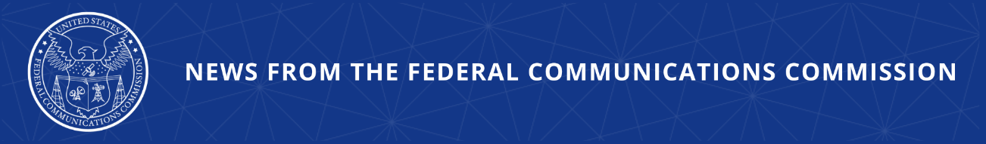

FCC Takes Action on “Bad Labs” Apparently Controlled By China
FCC Takes First Step to Enforce Recent “Bad Labs” Rules, Beginning Proceeding to Withdraw Recognition From Foreign Adversary-Owned Labs
--
WASHINGTON, September 8, 2025—Today, the FCC took an initial set of actions to address the threats posed by “bad labs.” These are labs that review and approve electronics for use in the U.S. but are ultimately owned or controlled by a foreign adversary nation. Specifically, the FCC’s Office of Engineering and Technology issued notices today that begin proceedings to withdraw recognition from an initial tranche of these “bad labs.” The FCC adopted this process at its May Commission Meeting, and it now takes these actions immediately upon those rules becoming effective. The agency has now begun proceedings to withdraw recognition from seven test labs owned or controlled by the Chinese government. The recognition of four other such labs have expired since the adoption of our rules and will not be renewed.

“President Trump is leading the charge to reshore America’s industrial capacity and safeguard critical supply chains from foreign adversary nations. Today’s FCC action on ‘Bad Labs’ will continue to do just that,” said FCC Chairman Brendan Carr. “Foreign adversary governments should not own and control the labs that test the devices the FCC certifies as safe for the U.S. market. This is an important step in restoring trust in the Commission’s equipment authorization process, and combatting foreign adversary threats. I commend OET, the Enforcement Bureau, and the agency’s Council on National Security for their work on this action.”

In May, the Commission adopted rules to prohibit the recognition of test labs and Telecommunications Certification Bodies that are owned by or subject to the control and direction of a range of entities that the U.S. government has identified as untrustworthy, including foreign adversary governments. The FCC’s rules, which took effect this weekend, also direct OET to withdraw the recognition from any such entity after providing Notice. Following adoption of our rules in May, the Commission’s initial investigation discovered that the following FCC-recognized labs were owned or controlled by a foreign adversary government under our rules: Chongqing Academy of Information and Communications; CQC Internet of Vehicles Technical Service Co. Ltd.; CVC Testing; CVC Testing Shanghai; TTL CAICT; TUV Rheinland-CCIC Ningbo Co. Ltd.; UL-CCIC; CESI (Guangzhou) Standards; China Academy of Information and Communications Technology (CAICT); Shanghai Institute of Measurement and Testing Technology (SIMT); and CCIC Southern Testing Co., Ltd. Today, the FCC sent Notices of Intent to Begin Proceedings to Withdraw Recognition from the first seven of these labs, while the latter four labs’ recognition have expired since the adoption of our rules. CESI (Guangzhou) and CAICT never sought renewal, while SIMT’s and CCIC Southern Testing’s renewal requests were denied today alongside the seven Notices.
###
Media Contact: MediaRelations@fcc.gov / (202) 418-0500
@FCC / www.fcc.gov
This is an unofficial announcement of Commission action. Release of the full text of a Commission order constitutes official action. See MCI v. FCC, 515 F.2d 385 (D.C. Cir. 1974).

