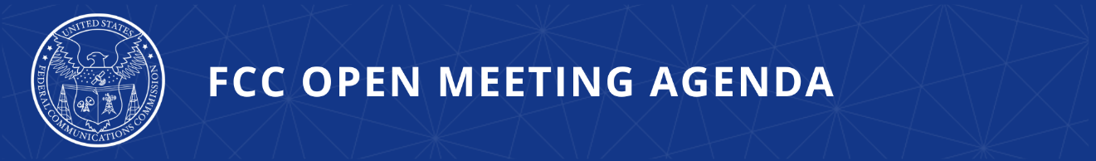

FCC Announces Tentative Agenda for December Open Meeting

WASHINGTON, November 25, 2025—Federal Communications Commission Chairman Brendan Carr announced that the items below are tentatively on the agenda for the December Open Commission Meeting scheduled for Thursday, December 18, 2025:

Updating Rules to Curb Robocallers' Access to Phone Numbers – The Commission will consider a Third Report and Order and Third Further Notice of Proposed Rulemaking to strengthen and modernize the Commission's requirements that all providers of Voice over Internet Protocol service must meet to maintain direct access to telephone numbers and protect consumers from illegal robocalling. The Commission would seek comment on ways to further bolster numbering resource protections as bad actors continue to seek new and creative methods for exploiting consumers and causing harm. (WC Docket Nos. 13-97, 07-243, 20-67)

Advancement of the Low Power Television, TV Translator and Class A Television Service – The Commission will consider a Report and Order amending its rules to provide regulatory certainty and clarity to LPTV broadcasters and reflect changes in the broadcast industry since the establishment of the LPTV service. (MB Docket No. 24-148)

Delete, Delete, Delete – The Commission will consider a Direct Final Rule that would continue the Commission’s efforts to modernize its regulatory framework by eliminating approximately 35 obsolete, outdated, and unnecessary rules from Parts 2, 15, and 18, totaling 11,970 words or approximately 25 pages of the Code of Federal Regulations. (GN Docket No. 25-133)

Public Drafts of Meeting Items – The FCC publicly releases the draft text of each item expected to be considered at the next Open Commission Meeting. One-page cover sheets are included in the public drafts to help summarize each item. All these materials will be available on the FCC’s Open Meeting page: www.fcc.gov/openmeeting.

Public Attendance – The Open Meeting is scheduled to commence at 10:30 a.m. ET in the Commission Meeting Room of the Federal Communications Commission, 45 L Street, N.E., Washington, D.C. While the Open Meeting is open to the public, the FCC headquarters building is not open access, and all guests must check in with and be screened by FCC security at the main entrance on L Street. Attendees at the Open Meeting will not be required to have an appointment but must otherwise comply with protocols outlined at: https://www.fcc.gov/visit. Open Meetings are streamed live at www.fcc.gov/live.

Press Access – Members of the news media are welcome to attend the meeting and will be provided reserved seating on a first-come, first-served basis. Following the meeting, the Chairman may hold a news conference in which he will take questions from credentialed members of the press in attendance. Afterwards, senior policy and legal staff will be made available to the press in attendance for questions related to the items on the meeting agenda. Commissioners may also choose to hold press conferences. Press may also direct questions to the Office of Media Relations (OMR): MediaRelations@fcc.gov. Questions about credentialing should be directed to OMR.

###
Media Contact: MediaRelations@fcc.gov / (202) 418-0500
@FCC / www.fcc.gov

