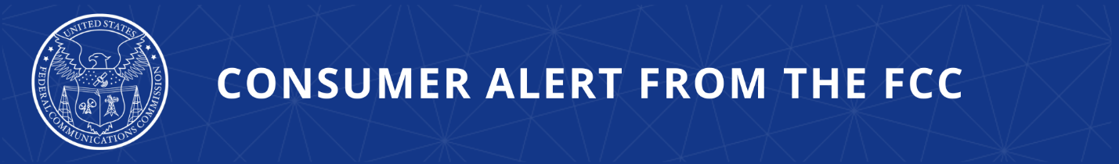

Consumer Complaints:
Online: https://consumercomplaints.fcc.gov
Phone: (888) 225-5322
Videophone: 1-844-432-2275

Consumer Warning: Don’t Let Fraud Ruin Your Holiday Festivities
FCC Encourages Consumers to Be Aware of Delivery and Charity Scams

The FCC’s Consumer and Governmental Affairs Bureau is encouraging consumers across the United States to be vigilant for phone and text message scams that use the holiday season as an opportunity to carry out fraudulent schemes.

The Commission recommends consumers remind their loved ones – especially those who might be targeted by scammers:
- Don’t Engage – Do not answer calls or texts from unknown parties.
- Hang Up on Pressure – Fear and pressure tactics are sure signs of a scam.
- Spot Imposters – Scammers use caller ID spoofing and personal info to seem legitimate.
- No Clicks – Never click on links or open attachments in unexpected messages.
- Don’t Share – Never share financial, password, or personal info with unknown callers.
- Gift Cards – Fraudsters love payments with gift cards, gold, and crypto currency.
- Call Back – Think it’s real? Call back using publicly available contact information.

Delivery Scams

Consumers should be aware of package delivery text scams. The newest twist takes advantage of tariff confusion, claiming that consumers owe a tariff – a type of import tax – that must be paid before their order can be delivered.

- ‘Stuck in Customs’ – Watch out for text notices saying your purchase is “stuck in customs” or your order will not be delivered until a tariff is paid.
- Check before you buy – Look for specific information about tariffs and duties on merchant websites before making a purchase. Pay special attention to resale apps and platforms like Etsy and E-Bay.
- No Surprises – Legitimate companies will tell you up front if there are additional fees, or will include them in the purchase price.
- Unique Package Identifiers – Look closely at tracking numbers and other order details included in emails or texts to ensure they match the information the merchant provided.
- Talk to the Source – Check directly with the retailer where you made the purchase or the shipping company if you think there may be a problem.

The U.S. Postal Inspection Service says to forward any suspicious emails to spam@uspis.gov and to forward texts messages to 7726.

FedEx and UPS websites have information about scam texts and other types of seasonal fraud.

Learn more about how to avoid package delivery scams.

Holiday Charity Scams

The holiday season is a time for giving. As Americans make donations this year, they should watch out for calls and texts soliciting support. It may be a scammer impersonating a real charity or collecting money for a fake charity from unsuspecting donors.

A few ways to avoid holiday charity scams include:

- Research – Do your research to make sure you are donating to trusted charities.
- Verify – If you need to contact a charity by phone or using text-to-donate, check the charity’s official website to see if the number you have is legitimate.
- Double-Check – Before making a charitable donation, be aware that crowd-funding websites, like those promoted on social media, often host individual requests for help that are not always vetted.

Learn more about charity scams and how to protect yourself.

###

Released: December 15, 2025
Media Contact: MediaRelations@fcc.gov / (202) 418-0500
@FCC / www.fcc.gov

