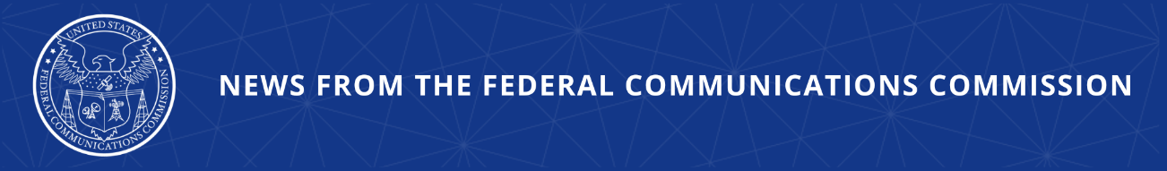

FCC Combats Robocallers’ Abuse of Phone Numbering Resources
Direct Access to Numbering Tools Will Now Require Robocall, Public Safety, and National Security Certification and Disclosure Compliance from VoIP Providers with Direct Access

WASHINGTON, December 18, 2025—The Federal Communications Commission today adopted changes to its rules to prevent phone numbering resources from being abused by robocallers. While the agency has built up its STIR/SHAKEN caller ID authentication rules and call traceback efforts, bad actors have leveraged the proliferation of VoIP providers with access to numbering services to bypass these protections and continue to bombard consumers with robocalls. The FCC today applied its robocall, public safety, and national security compliance certification and disclosure requirements to all interconnected VoIP providers that directly access U.S. numbering resources.

Voice service providers have access to resources which allow for the use of different phone numbers by different callers. These numbering resources are critical for the operation of an organized phone network ecosystem. However, those same critical resources have been misused by robocallers to bypass consumer protections and transmit scam calls. Bad actors are known to obtain large quantities of numbers to avoid robocall mitigation measures to continue exploiting American consumers.

The Order adopted by the Commission establishes rules requiring all interconnected VoIP providers with direct access to phone numbers to certify and disclose information about robocall compliance, public safety, and national security. These are requirements that the Commission had established previously but only applied them prospectively to new applicants leaving a gap in the FCC’s robocall protections because the then-existing authorization holders were not required to make these certifications. Today’s common-sense decision ensures that every VoIP provider with a direct access authorization is subject to the same rules to protect consumers. Affected direct access authorization holders will be required to file the updated requirements within 30 days of the effective date of these rules in order to maintain their authorizations.

In addition to adopting these rules, the Commission will seek further comment on how else it can bolster numbering resource protections. The Commission is specifically refreshing the record on how to best reclaim numbering resources from interconnected VoIP providers that have had their VoIP numbering authorization revoked or terminated. It will also build a record on how to restrict VoIP number authorizations for entities that pose national security risks, and thus appear on the FCC’s Covered List, or use equipment that poses such risks.

Action by the Commission December 18, 2025 by Third Report and Order and Third Further Notice of Proposed Rulemaking (FCC 25-86). Chairman Carr, Commissioners Gomez and Trusty approving. Chairman Carr and Commissioner Trusty issuing separate statements.

WC Docket Nos. 13-97, 07-243, 20-67

###
Media Contact: MediaRelations@fcc.gov / (202) 418-0500
@FCC / www.fcc.gov

