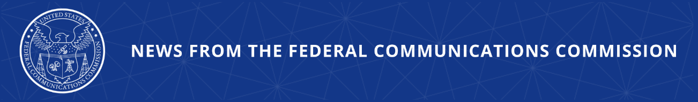

FCC Deletes Outdated Rules on Long-Forgotten Technologies
The Agency’s Latest Direct Final Rule Will Trash Rules on Analog Cable Receivers, Antiquated Cordless Phones, and Other Antiquated Devices

WASHINGTON, December 18, 2025—In its latest installment of the Delete, Delete, Delete proceeding, the Federal Communications Commission today voted to eliminate 36 rules that regulate obsolete equipment like analog cable receivers and long-gone cordless phones

Today’s item specifically focuses on rules managed by the Office of Engineering and Technology in Parts 2, 15, and 18 of the Code of Federal Regulations. The identified 36 rules targeted for removal cover a total of 12,008 words and more than 25 pages in the Code.

To eliminate unnecessary burdens faced by the public, the FCC’s Delete, Delete, Delete proceeding has sought comment on every rule, regulation, or guidance document for possible rescission. The proceeding has produced overwhelming public comment and constructive feedback that will be considered both in Delete and other proceedings.

So far, the Commission has deleted: Rules for prehistoric technologies—like telegraph, rabbit-ear receivers, and phone booths; requirements adopted in bygone era—like cable-rate regulation; illegal government overreaches—like Title II controls on the broadband industry; regulations on defunct services; and mandates that expired or sunset years ago—like auction procedures from the 3G era.

Action by the Commission December 18, 2025 by Direct Final Rule (FCC 25-85). Chairman Carr and Commissioner Trusty approving. Commissioner Gomez concurring in part and dissenting in part. Chairman Carr and Commissioner Gomez issuing separate statements.

GN Docket No. 25-13

###
Media Contact: MediaRelations@fcc.gov / (202) 418-0500
@FCC / www.fcc.gov

