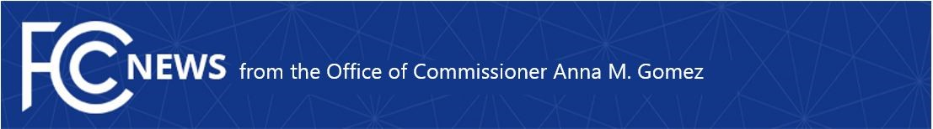

Media Contact:
Gomez.Press@fcc.gov

For Immediate Release
December 22, 2025

FCC COMMISSIONER GOMEZ ON ALARMING REPORTS OF EDITORIAL INTERFERENCE AT 60 MINUTES

WASHINGTON — FCC Commissioner Anna M. Gomez issued the following statement in response to reports that CBS News delayed a 60 Minutes segment following the federal government’s refusal to respond to thoroughly vetted, independent reporting:

“Against the backdrop of increased government pressure, reports that CBS News interfered with the editorial judgment of 60 Minutes are deeply alarming and strike at the heart of press freedom. When the FCC withheld approval of Paramount’s transaction to extract sweeping concessions, I warned that allowing the government to wield regulatory leverage in newsroom decision-making would inevitably threaten independent journalism. We are now seeing the real-world consequences of blurring the line between regulatory authority and editorial independence.

“A free press cannot function if the government is able to exercise veto power over critical reporting simply by refusing to engage. That is fundamentally incompatible with the First Amendment and the role of journalists in holding those in power to account. These concerns are only heightened when a media company seeking favorable action on future regulatory approvals tempers or delays coverage critical of this Administration, raising serious questions about whether editorial decisions are being influenced by external pressure rather than journalistic judgment.

“The public has the right to question how CBS will ensure the independence and integrity of its journalism going forward, concerns which are only compounded by the existence of a government-imposed media monitor at CBS, a deeply flawed and unprecedented form of government involvement in editorial affairs. In the days ahead, I hope CBS provides its viewers with a clear accounting of how this decision was made and demonstrates how it will safeguard the independence of its newsroom.”
###

Office of Commissioner Anna M. Gomez: (202) 418-2100
ASL Videophone: (844) 432-2275
www.fcc.gov/leadership/anna-gomez

This is an unofficial announcement of Commission action. Release of the full text of a Commission order constitutes official action. See MCI v. FCC, 515 F.2d 385 (D.C. Cir. 1974).

