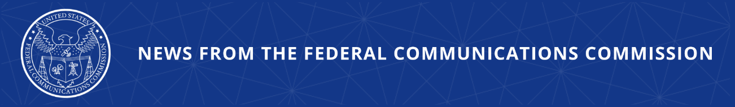

FCC Establishes New Foreign Adversary Control Reporting Requirements for FCC Licenses and Authorizations
Latest Transparency Measure Builds on Important National Security Wins Delivered by the FCC in 2025 to Strengthen the Security of U.S. Communications Networks

WASHINGTON, January 29, 2026—Today, the Federal Communications Commission established new foreign adversary control transparency rules for holders of, and applicants for, a broad range of Commission-granted licenses, leases, authorizations, grants, permits, and other approvals that will promote public transparency and enhance the agency’s ability to assess and protect the U.S. against emerging national security threats. Today’s action will ensure the public has access to a list of FCC licensees that are owned by, controlled by, or subject to the jurisdiction or direction of a foreign adversary.

As the FCC proposed last year, today’s Report & Order requires holders of certain FCC Licenses, Permits, and Authorizations to certify if they are owned by, controlled by, or subject to the jurisdiction or direction of a foreign adversary. Specifically, the order applies reporting requirements on a tailored basis by placing each license, permit, or authorization into three Schedules of licenses, based on a variety of factors including national security risk of foreign adversary control and reporting burdens.

In addition, today’s action will require that all regulatees that certify as to foreign adversary control disclose additional information, including all equity and voting interests of 5% or greater, as well as controlling interests held in the regulatee, the identity of the foreign adversary country or countries; and the nature of the control to which they are subject. To maximize the accessibility of the collected information to the public, the Report and Order will establish a single, consolidated reporting system and set a filing deadline of 60 days—120 days for small entities—after the adoption of a public notice announcing the launch of the consolidated reporting system. The Report and Order also establishes an enforcement framework for entities that violate the new foreign adversary control transparency rules.

The U.S. Government has long recognized that foreign adversaries have been engaged in a widespread and coordinated effort to exploit, attack, and otherwise compromise the integrity of U.S. communications networks. Today’s action, as well as those spearheaded by the Commission over the past year, including establishing the Council on National Security, will strengthen the security of U.S. communications networks by tracking many of the ideas laid out in the pending bipartisan Foreign Adversary Communications Transparency (FACT) Act led by Senator Deb Fischer and moving swiftly to protect national security.

Action by the Commission January 29, 2026 by Report and Order (FCC 26-2). Chairman Carr, Commissioners Gomez and Trusty approving. Chairman Carr and Commissioner Trusty issuing separate statements.

GN Docket No. 25-166

###
Media Contact: MediaRelations@fcc.gov / (202) 418-0500
FCC / www.fcc.gov

