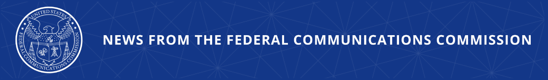

FCC Proposes Additional Modernizations to Agency’s TRS Rules
Proposal Will Enhance the Effectiveness of Internet-based Telecommunications Relay Services

WASHINGTON, January 29, 2026—Today, the Federal Communications Commission approved a proposal to enhance the effectiveness and functional equivalency of Internet-based telecommunications relay services (TRS). This proposal complements the analog TRS proceeding the Commission began last Fall and is part of the agency’s holistic first principles approach to ensuring that communications remain accessible.

When Congress enacted the Americans with Disabilities Act in 1990, it required providers to offer TRS so that people with hearing or speech disabilities can place and receive phone calls. TRS is available in all 50 states, the District of Columbia, Puerto Rico and the U.S. territories. Currently, the Commission recognizes six forms of TRS, three “analog” services and three Internet-based services.

As changes in communications technology continue to reshape the TRS landscape, the FCC is re-examining existing regulations with the objective of improving service quality, increasing efficiency, and removing unnecessary regulations. Through this Notice of Proposed Rulemaking, the FCC proposes targeted reforms that align Internet-based TRS with twenty-first century technological advancements that can better serve the needs of people with disabilities.

Today’s proposal includes enhancements for Internet Protocol (IP) Relay and Video Relay Services (VRS), along with administrative reforms to streamline the TRS program. For IP Relay, the Notice explores the use of automatic speech recognition for speech-to-text conversion and advanced text-to-speech technologies, the need for metrics for IP Relay quality, and compatibility of IP Relay with Real-Time Text technology. The Notice also proposes to enhance VRS functionality by adding captioning to VRS platforms, amend VRS calling rules for calls to U.S. embassies and consulates by U.S. residents while traveling abroad, and adjust call center requirements. Lastly, in line with the FCC’s ‘Delete, Delete, Delete’ initiative, this proposal aims to streamline TRS provider certification and user registration processes, update or eliminate obsolete rules, and close outdated dockets.

Action by the Commission January 29, 2026 by Notice of Proposed Rulemaking (FCC 26-4). Chairman Carr, Commissioners Gomez and Trusty approving and issuing separate statements.

CG Docket Nos. 03-123, 10-51, 12-38

###
Media Contact: MediaRelations@fcc.gov / (202) 418-0500
@FCC / www.fcc.gov

