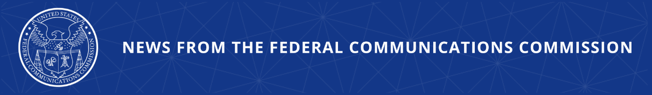

FCC Advances Transition to All-IP by Exploring Updates to Intercarrier Compensation Regime

WASHINGTON, February 18, 2026—Today, the Federal Communications Commission voted on proposals that would explore how to successfully phase-out the intercarrier compensation regime for voice telecommunications providers. This is the latest FCC effort to move America’s networks to Internet Protocol (IP) technology and address the outdated rules that keep Americans on legacy Time-Division Multiplexing (TDM) technology.

While IP-based network technology has been widely deployed, some providers continue to maintain older TDM-based networks, in part due to outdated regulatory regimes which, decades ago, successfully sought to incentivize the buildout of telephone networks but, today, too often disincentivize network modernization. Completing the transition to IP-based networks will promote technological modernization, public safety, and consumer protection benefits while enhancing long-term competition and service quality for consumers and lowering operating expenses for providers.

The FCC is working to thoughtfully create the right incentives for providers to upgrade to modern, high-speed networks. As part of that effort, the agency seeks to eliminate intercarrier compensation regulations that may encourage providers to continue using TDM networks. The Notice of Proposed Rulemaking adopted today will begin a thorough review of the intercarrier compensation rules, proposing to sunset any outdated regulations while being mindful of the complex issues, transition timelines, and paramount connectivity goals. It builds upon the Commission’s longstanding efforts to reform the legacy intercarrier compensation framework as part of its broader goal to transition networks to more efficient all-IP technology. Specifically, the Notice proposes to complete the transition of all remaining access charges to bill-and-keep, seeks comment on any cost recovery needed to accomplish this goal, further proposes detariffing those charges, and deregulating and detariffing end-user charges and interexchange services, among other reforms. Recognizing the importance of industry collaboration and input, the Notice also encourages industry collaboration to develop the most effective and efficient strategies for transitioning carriers to bill-and-keep and all-IP networks.

Action by the Commission February 18, 2026 by Notice of Proposed Rulemaking (FCC 26-11). Chairman Carr, Commissioners Gomez and Trusty approving. Chairman Carr and Commissioner issuing separate statements.

WC Docket Nos. 25-311, 25-208

###
Media Contact: MediaRelations@fcc.gov / (202) 418-0500
@FCC / www.fcc.gov

