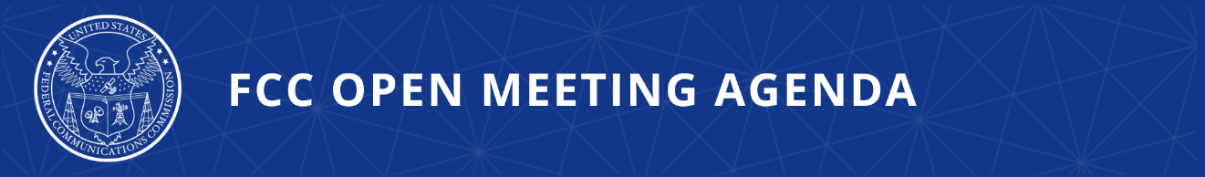

FCC Announces Tentative Agenda for March Open Meeting

WASHINGTON, March 5, 2026—Federal Communications Commission Chairman Brendan Carr announced that the items below are tentatively on the agenda for the March Open Commission Meeting scheduled for Thursday, March 26, 2026:

Improving Customer Service and Consumer Protection – The Commission will consider a Notice of Proposed Rulemaking that proposes a range of actions to address problems with offshore call centers, including actions to encourage and facilitate onshoring of call centers, improve customer service and security of communications, and steps to address illegal robocall scams that originate inside foreign call centers. (CG Docket Nos. 26-52, 17-59, 02-278)

Combatting Illegal Robocalls Through FCC Numbering Policies – The Commission will consider a Notice of Proposed Rulemaking that would seek comment on and evaluate whether to adopt changes to its numbering policies with respect to how assigned numbering resources are utilized, reported, and resold by service providers as part of its continuing effort to combat illegal robocalls. (WC Docket Nos. 26-49, 20-67, 13-97, 07-243)

Reducing Barriers to Network Improvements and Service Changes Accelerating Network Modernization – The Commission will consider a Report and Order that adopts measures to reduce regulatory barriers and costs that hinder the transition from outdated legacy networks and services to next-generation, IP-based infrastructure. (WC Docket Nos. 25-208, 25-209)

Spectrum Abundance for Weird Space Stuff – The Commission will consider a Notice of Proposed Rulemaking that proposes and seeks comment on ways in which to make additional spectrum available for command and control of spacecraft supporting emergent space operations, but which do not use spectrum as part of any radiocommunications services provided to the public. (SB Docket No. 26-54)

Modernizing Suspension and Debarment Rules – The Commission will consider a Report and Order, Direct Final Rule, and Further Notice of Proposed Rulemaking that would revise the FCC’s current nonprocurement suspension and debarment rules by adopting the Office of Management and Budget’s (OMB) Guidance for Governmentwide Debarment and Suspension and supplemental FCC-specific rules to expand the Commission’s tools for combatting fraud, waste, and abuse, and remove bad actors from Commission programs. (GN Docket No. 19-309)

Amending Part 1, 73, 74 and 76 Rules Applicable to Broadcast Stations – The Commission will consider a Report and Order to update rules for broadcast radio and television stations to reflect current application processing requirements, clarify and harmonize provisions, and remove references to outdated procedures and legacy filing systems. (MB Docket No. 24-626; GN Docket No. 25-133)

Rescinding Obsolete Provisions – The Commission will consider as part of the In re: Delete, Delete, Delete proceeding a Direct Final Rule that would remove 18 rules, including 17 rule provisions impacting the Office of Economics and Analytics’ (OEA) Auction Division that are no longer in use by the Commission or govern expired events and one rule impacting the Office of International Affairs (OIA). The OEA rules mainly impact Auctions and cover rules that required upfront payments for Universal Service Fund auctions that the Commission has never required for any Universal Service Fund Auction and a host of rules surrounding installment payments, which the Commission has not used since 1997. This Direct Final Rule also deletes one rule provision relating to the OIA that required carriers to submit a filing to a long-deleted requirement. This item would amend three rules that reference one of the Auctions’ rules that would be removed by this Direct Final Rule. (GN Docket 25-133)

Public Drafts of Meeting Items – The FCC publicly releases the draft text of each item expected to be considered at the next Open Commission Meeting. One-page cover sheets are included in the public drafts to help summarize each item. All these materials will be available on the FCC’s Open Meeting page: www.fcc.gov/openmeeting.

Public Attendance – The Open Meeting is scheduled to commence at 10:30 a.m. ET in the Commission Meeting Room of the Federal Communications Commission, 45 L Street, N.E., Washington, D.C. While the Open Meeting is open to the public, the FCC headquarters building is not open access, and all guests must check in with and be screened by FCC security at the main entrance on L Street. Attendees at the Open Meeting will not be required to have an appointment but must otherwise comply with protocols outlined at: https://www.fcc.gov/visit. Open Meetings are streamed live at www.fcc.gov/live.

Press Access – Members of the news media are welcome to attend the meeting and will be provided reserved seating on a first-come, first-served basis. Following the meeting, the Chairman may hold a news conference in which he will take questions from credentialed members of the press in attendance. Afterwards, senior policy and legal staff will be made available to the press in attendance for questions related to the items on the meeting agenda. Commissioners may also choose to hold press conferences. Press may also direct questions to the Office of Media Relations (OMR): MediaRelations@fcc.gov. Questions about credentialing should be directed to OMR.

###
Media Contact: MediaRelations@fcc.gov / (202) 418-0500
@FCC / www.fcc.gov

