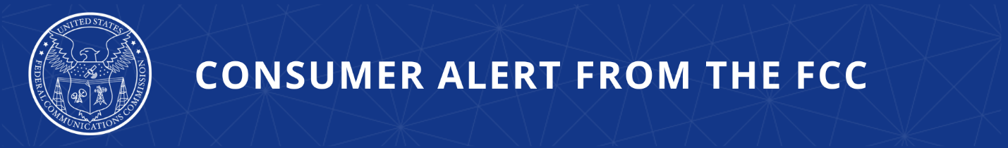

Consumer Complaints:
Online: https://consumercomplaints.fcc.gov
Phone: (888) 225-5322
Videophone: 1-844-432-2275

FCC Recognizes National Consumer Protection Week with Series of Consumer Protection Posts
New Resources Aimed to Equip the Public with Tools Needed to Stay Safe, Informed, and Connected

Stopping illegal robocalls and scam texts from defrauding Americans is the FCC’s top consumer protection priority. In recognition of National Consumer Protection Week, the FCC’s Consumer and Governmental Affairs Bureau highlighted two “long con” scams where fraudsters invest the time to build trust in hopes of a bigger payday – romance scams and crypto investment scams. The FCC also updated its consumer guide on unwanted robocalls and texts, and promoted resources focused on cell phone safety/cybersecurity for kids, and nationally established 3-digit numbers including 988 and 311.

The FCC received more than 125,000 unwanted call complaints in 2025. To restore trust in our phone networks, the FCC is fighting illegal robocalls at every point of a call’s journey, from its source to your phone. The top five robocalls scams by category in 2025 were: debt relief/loan assistance (27%), insurance/healthcare (11%), government imposter (7%), credit/credit cards (4%) and Google listing (2%).

Long Con Investment Scams
Some scammers may not be satisfied with just a single shot at your money. Instead, they play a long game over weeks or months, texting or calling and building a relationship to earn your trust. Once you seem comfortable, they create pressure to act fast on an “incredible” investment opportunity involving cryptocurrency or other assets. Then communication stops and you’ve lost money or shared personal information that can be used to commit account fraud. Learn more about how a cryptocurrency or asset investment scam typically unfolds, red flags to look for and tips to protect yourself online.

Find Romance without the Scam
Romance scams use similar tactics. Preying on our desire to find a partner, romance scammers often create fake profiles on dating apps and social media apps. After finding a "“match,” they begin their journey to establish trust. When the scammer senses the victim is emotionally invested, they ask for money to help with a catastrophic “illness” or dire “financial emergency.” Once the victim falls for the con and sends money, the scammer disappears without a trace. If you have met someone new online, be aware of red flags and follow these tips.

Kids’ First Phones
If you’re responsible for a young person, you know the pull of a first phone is hard to resist. The FCC has tips to help new smartphone users protect themselves and use a phone wisely. You can learn more by visiting our consumer guide.

Special Numbers for Important Occasions
Calling or texting 911 for emergencies has saved countless lives. And there are several other short, memorable, and helpful numbers like it. The FCC makes it easier for people throughout the country to reach emergency services and non-emergency aid. Find a list of these numbers and the services they can connect you with.

Call Center Customer Service Improvements
Earlier this week, Chairman Carr announced proposed improvements to customer service at communications service provider call centers to encourage onshoring and other reforms for certain U.S. businesses. Call center operations located outside of the U.S. have resulted in statistically shown frustration for consumers and the onslaught of robocalls facing American households and businesses. The FCC will consider new rules to encourage greater accountability for communications companies at the FCC’s March Open Meeting.

The FCC’s Consumer Help Center is available at: https://www.fcc.gov/consumers.

###

Released: March 6, 2026
Media Contact: MediaRelations@fcc.gov / (202) 418-0500
@FCC / www.fcc.gov

