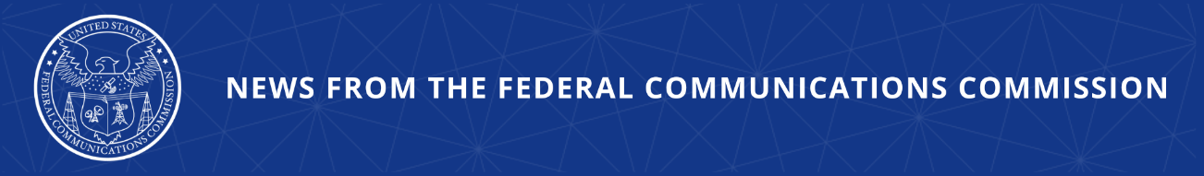
FCC Cuts Off Provider for Violating Robocall Rules
Action Immediately Prevents Company from Connecting with U.S. Networks

WASHINGTON, March 12, 2026—Today, the FCC effectively prohibited a voice service provider from continuing to connect to U.S. networks for failure to comply with the FCC’s robocall rules. Specifically, the FCC mandated that U.S. voice service providers and intermediate providers block calls from Belthrough LLC for violating the Commission’s robocall rules. The Commission also removed the company from the Robocall Mitigation Database. All providers immediately downstream of Belthrough must block and cease accepting all traffic, other than certain emergency traffic, within 48 hours. Providers must also comply with the Commission’s call blocking rules with respect to Belthrough within 30 days.

Chairman Brendan Carr issued the following statement:

“Cracking down on illegal robocalls is a top priority at the FCC. And the agency has been expanding our efforts on this front, including by effectively blocking bad actors from continuing to use our country’s communications network. Today, we’re taking action to cut off another shady provider, and will continue to use all tools at our disposal to block bad actors.”

Additional Background Information:

The FCC’s Robocall Mitigation Database was established to promote transparency and effective robocall mitigation. This database is a critical tool through which the agency ensures providers are actively combatting robocalls and implementing STIR/SHAKEN caller ID authentication. Providers are required to certify that they have implemented STIR/SHAKEN on all IP-based portions of their networks. All providers must also submit robocall mitigation plans. Failure to meet these obligations may result in removal from the database and blocking of the provider’s traffic.

In 2024 and 2025, the Industry Traceback Group (ITG) investigated various prerecorded voice message calls made without the consent of the called party that impersonated Internet Service Providers. The ITG conducted tracebacks and determined that Belthrough acted as the originator for some of the calls and the gateway provider for other calls, notified Belthrough of these calls and provided it access to supporting data identifying each call.

Today’s action follows the Enforcement Bureau’s September 10, 2025 Notification of Suspected Illegal Traffic, and the February 19, 2026 Initial Determination Order and Order to Show Cause. Other than acknowledging receipt of the Notice, Belthrough took no action in response to either the Notice or the Initial Determination Order. As a result, the company will be removed from the RMD and will not be permitted to re-file a certification without the prior approval of the FCC’s Enforcement and Wireline Competition Bureaus.
###
Media Contact: MediaRelations@fcc.gov / (202) 418-0500
@FCC / www.fcc.gov

