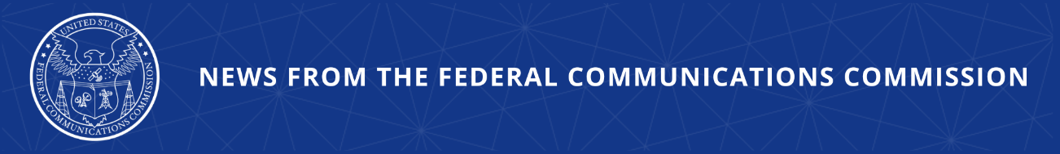

FCC Bans Seven Convicted E-Rate Fraudsters from USF Programs
Enforcement Action Demonstrates the Need for Proposed Reforms

WASHINGTON, March 20, 2026—Today, the FCC’s Enforcement Bureau barred seven individuals who had been convicted of defrauding the E-Rate program from participating in activities associated with any Universal Service Fund-supported program. Corporations controlled by these individuals received over $14 million in E-Rate funds from 2010 to 2016 but failed to provide much of the equipment for which they had billed the federal government.

The Commission is working to streamline the suspension and debarment processes so that it can more quickly and effectively prevent bad actors from misusing public funds. Specifically, at this month’s Open Meeting, the Commission will vote to align its rules with government‑wide best practices for suspension and debarment, enabling quicker action against misconduct so as to better protect these programs from abuse, and ensure limited resources are used responsibly.

Chairman Brendan Carr issued the following statement:

“Barring fraudsters from our connectivity programs is a fundamental responsibility of this agency. This is a just conclusion to this troubling case. But it also demonstrates the need for new tools to strengthen oversight of programs like the Universal Service Fund. We have more work to do on that front, and we intend to do it. Next week’s vote is a strong step forward for these overdue reforms.”

Additional Background Information:

In 2023, the Department of Justice announced the sentencing of Peretz Klein, Ben Klein, Moshe Schwartz, Simon Goldbrener, Sholem Steinberg, Aron Melber, and Susan Klein, who pleaded guilty to defrauding the federal E-Rate program in connection with E-Rate funds provided to private religious schools in Rockland County, New York. In April 2025, the FCC suspended each individual from further participation in the E-Rate program and began proceedings to ban them from participation in the future. Today’s Notices of Debarment conclude that process by formally prohibiting these individuals from participating in activities associated with the E-Rate program and any other program funded by federal universal service support mechanisms for three years.

The E-Rate program was authorized by Congress in 1996 to enhance access to advanced
telecommunications and information services for all public and nonprofit elementary and secondary
school classrooms and libraries. Under the E-Rate program, eligible schools and libraries may
request universal service discounts for internet connectivity.

###
Media Contact: MediaRelations@fcc.gov / (202) 418-0500
@FCC / www.fcc.gov

