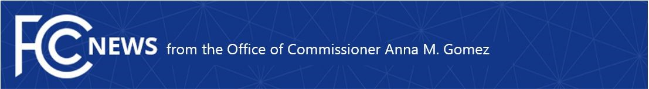

Media Contact:
Gomez.Press@fcc.gov

For Immediate Release
March 19, 2026

GOMEZ CONDEMNS CLOSED-DOOR APPROVAL OF UNLAWFUL NEXSTAR/TEGNA MERGER
FCC Ignores Federal Law and Bypasses Full Commission Vote to Approve Creation of New Broadcast Behemoth
WASHINGTON—FCC Commissioner Anna M. Gomez issued the following statement after the FCC's Media Bureau approved the Nexstar/TEGNA merger, which violates the existing 39% national ownership cap in federal law, without an open and transparent process and a vote before the full Commission:
“The FCC has once again chosen bureaucratic cover over public accountability. This merger was approved behind closed doors with no open process, no full Commission vote, and no transparency for the consumers and communities who will bear the consequences. A transaction of this magnitude, which includes new and novel issues before the FCC, demands open deliberation before the full Commission, not a quiet sign-off meant to avoid public scrutiny. Given the increasingly alarming pace of reckless media consolidation, the American public deserves to know how and why this decision was made.
“Local journalism is under extraordinary strain. Across the country, newsrooms are being consolidated, reporters laid off, and editorial decisions made far from the communities broadcast stations are licensed to serve. The Nexstar/TEGNA merger will accelerate exactly that trend, concentrating broadcast power in fewer corporate hands, shrinking independent editorial voices, and prioritizing national business interests over local needs. Nexstar has already begun cutting newsrooms throughout the country, and as these billion-dollar companies grow even larger, their increased negotiating leverage will drive up fees that translate into higher monthly bills for those families who can least afford them. The consequences of this rubber stamp approval will be felt in living rooms and newsrooms across the country, resulting in fewer voices, less competition, and higher costs for consumers.”
###

Office of Commissioner Anna M. Gomez: (202) 418-2100
ASL Videophone: (844) 432-2275
www.fcc.gov/leadership/anna-gomez

This is an unofficial announcement of Commission action. Release of the full text of a Commission order constitutes official action. See MCI v. FCC, 515 F.2d 385 (D.C. Cir. 1974).

