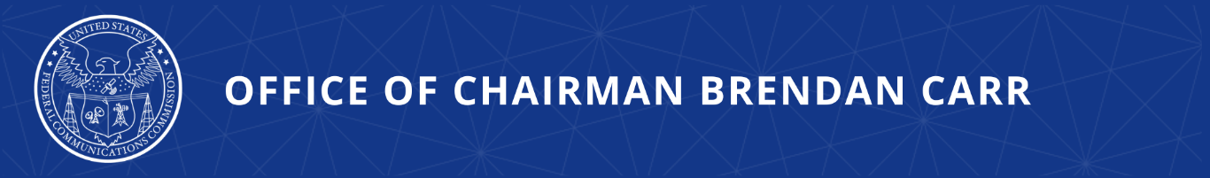

Chairman Carr Welcomes President Trump’s Executive Order on Preserving America’s Game

WASHINGTON, March 20, 2026—Today, FCC Chairman Brendan Carr joined President Donald J. Trump at the White House for the presentation of the Commander in Chief’s Trophy to the United States Naval Academy football team. At the presentation, President Trump signed a new Executive Order to preserve the Army-Navy Game, known as “America’s Game.” Specifically, the Executive Order calls on the Chairman of the FCC and the Secretary of Commerce to coordinate with relevant stakeholders to ensure that no college football games are broadcast in a manner that conflict with the airing of America’s Game.

Chairman Carr issued the following statement:

“I was honored to join President Trump at the White House today as he awarded the coveted Commander in Chief’s Trophy to the Navy Football team. The annual showdown between Army and Navy is always a classic and showcases the strength and bravery of this national service event. America’s Game stands as a symbol of excellences and our great national sprit. It is important that we continue to reserve a window of time on the second Saturday in December exclusively for this important event. I look forward to working with Secretary Lutnick on the successful implementation of this Executive Order.”

Additional Background:

For over a century, the Army-Navy Game has stood as a symbol of excellence and the American spirit. Now, the recent and potentially ongoing expansion of the College Football Playoffs (CFP) and other postseason college football games threatens to encroach upon the second Saturday in December—a date traditionally reserved exclusively for “America’s Game.” Such scheduling conflicts weaken the national focus on our Military Service Academies and detract from a morale-building event of vital interest to the Department of War.

President Trump’s “Preserving America’s Game” Executive Order states that the Secretary of Commerce and the Chairman of the FCC shall coordinate with the CFP Committee, the National Collegiate Athletic Association, related organizations, other appropriate government agencies, and the playoffs’ broadcast and media rights partners with the goal of establishing an exclusive window for the Army-Navy Game, during which no other college football game is broadcast.

The EO also specifies that the Chairman of the FCC shall consider reviewing the public interest obligations of broadcast licensees to determine whether those obligations would require that the Army-Navy Game remain a national service event.

###
Media Contact: MediaRelations@fcc.gov / (202) 418-0500
@FCC / www.fcc.gov

