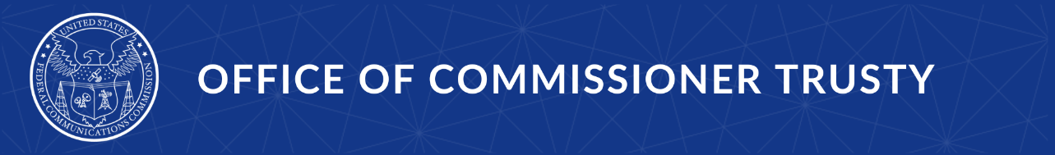

Media Contact:
TrustyPress@fcc.gov

For Immediate Release

COMMISSIONER TRUSTY HIGHLIGHTS CONNECTIVITY, INNOVATION, AND LOCAL IMPACT DURING KANSAS AND UTAH VISIT
Trip highlights “golden age of communications” in action and underscores importance of smart FCC policy to support broadband expansion, broadcasting, and emerging technologies
--
WASHINGTON, March 25, 2026 – FCC Commissioner Olivia Trusty today released the following statement after returning from a multi-day trip to Kansas and Utah, where she met with communications providers, innovators, and local stakeholders advancing connectivity and technology leadership across the United States.
“During my recent trip to Kansas and Utah, I had the opportunity to see firsthand how U.S. communications companies are advancing connectivity, innovation, and local connection, and to hear directly about the challenges they face,” said Commissioner Trusty.
In Kansas, Commissioner Trusty participated in a visit hosted by Senator Jerry Moran, where she began by touring Garmin’s facilities and observed how the company is strengthening U.S. leadership in aviation and consumer technology. Garmin highlighted its growing investment in domestic engineering, manufacturing, and testing, as well as the importance of continued coordination between the wireless and aviation industries on spectrum usage.
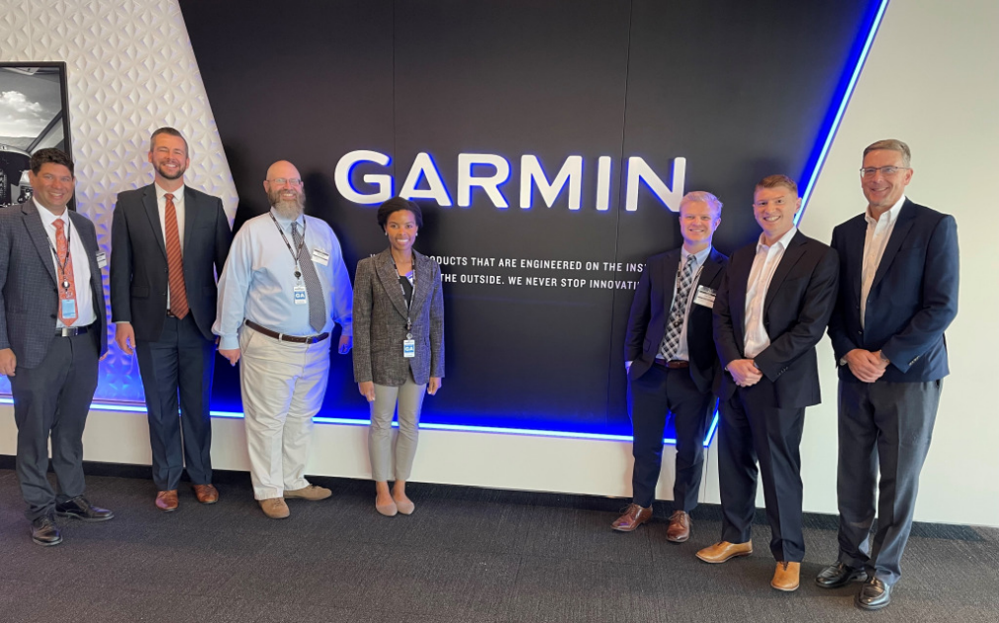
Commissioner Trusty also joined a roundtable with broadband providers, including members of the Communications Coalition of Kansas, who discussed the critical role they play in expanding connectivity to rural communities. Participants emphasized the importance of universal service programs and other federal and state funding mechanisms, noting that effective policy design is essential to sustaining broadband service.
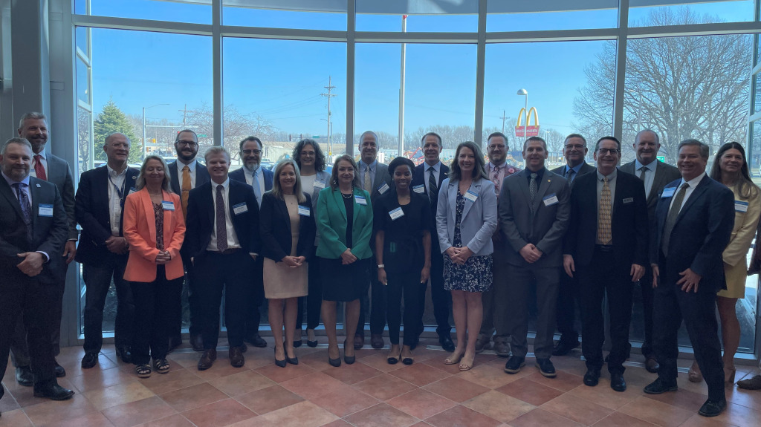
At a site visit with WTC Fiber, Commissioner Trusty saw firsthand how fiber expansion is connecting small towns and local businesses, strengthening economic opportunities in mutually reinforcing ways.
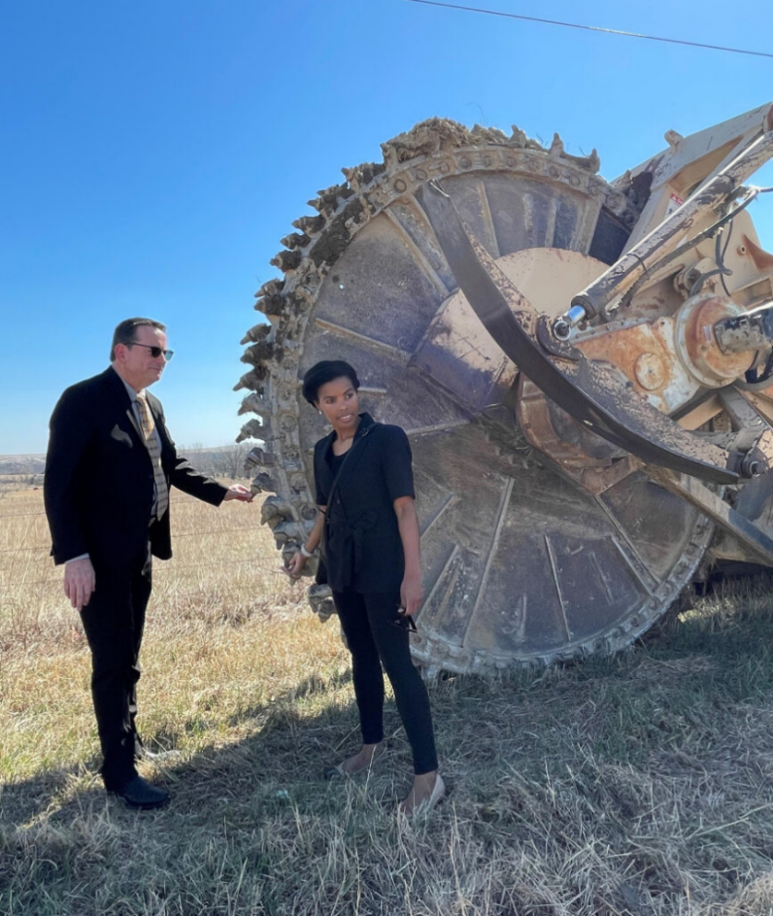

The Commissioner also met with local broadcasters, including WIBW in Topeka, who demonstrated how smaller stations are leveraging shared resources and new technologies to enhance service to their communities. Representatives from the Kansas Association of Broadcasters and other radio and television stations highlighted the competitive pressures they face and underscored the need for FCC policies that ensure a level playing field.
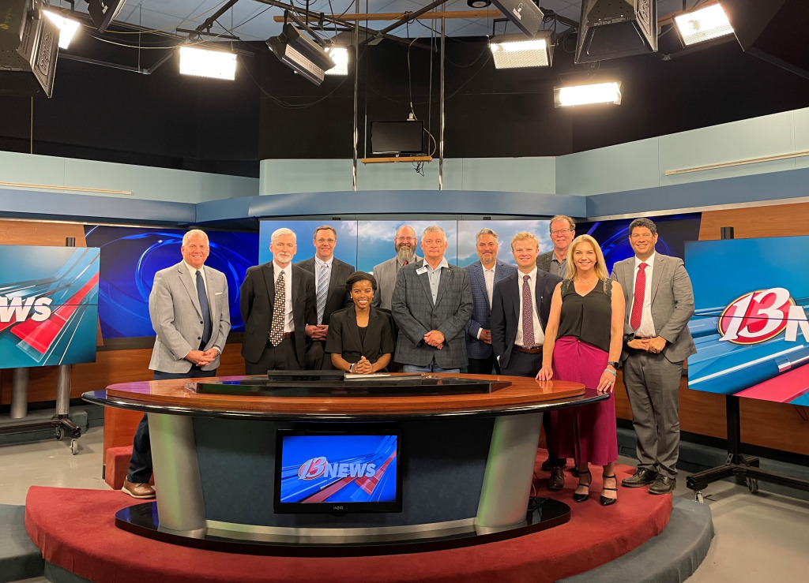
In Utah, Commissioner Trusty visited Bonneville in Salt Lake City, where she observed how broadcasters are adapting to evolving consumer habits by delivering content across multiple platforms, including traditional broadcasting, streaming, and podcasts. These efforts, she noted, are grounded in longstanding relationships of trust with local audiences and depend on a regulatory framework that supports continued innovation.
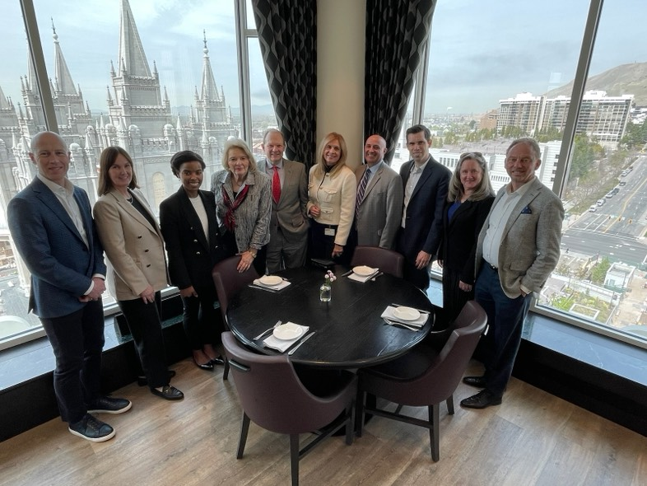

At BYU Broadcasting, Commissioner Trusty learned how the organization is preparing the next generation of journalists while also serving as a significant content creator in its own right. Through original programming and partnerships, BYU Broadcasting is advancing storytelling across genres including drama, comedy, and sports.

The Commissioner also visited Sorenson Communications, where she saw how innovation, particularly in artificial intelligence, is enhancing communication tools for individuals who are deaf or hard of hearing. Sorenson demonstrated how AI technologies can complement human interpreters by enabling everyday interactions, such as checking into hotels or filling prescriptions, where interpreters are not typically available. The company emphasized the importance of a consistent and predictable policy framework for AI development.
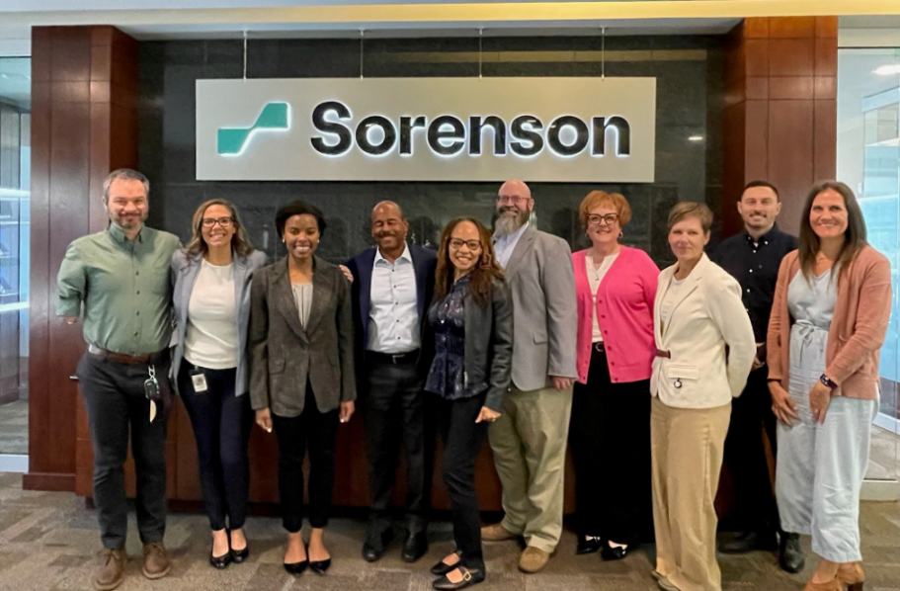
“Across Kansas and Utah, I saw how connectivity, innovation, and U.S. technology leadership are being advanced every day by providers on the ground, this is the golden age of communications in action,” Commissioner Trusty said. “These experiences reinforce the importance of the FCC’s ongoing work to ensure that our regulatory environment supports investment, competition, and the ability of providers to meet the evolving needs of the communities they serve.”

###
Office of Commissioner Trusty: (202) 418- 2300 / Twitter: @OliviaTrustyFCC / www.fcc.gov/about/leadership/olivia-trusty

This is an unofficial announcement of Commission action. Release of the full text of a Commission order constitutes official action. See MCI v. FCC, 515 F.2d 385 (D.C. Cir. 1974).

