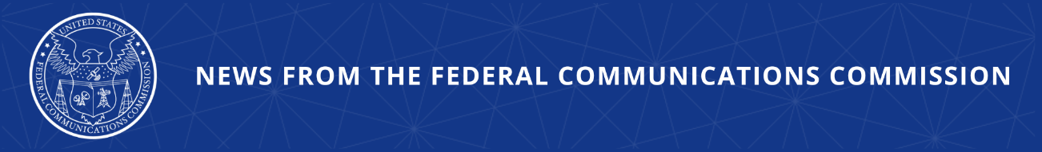

FCC Proposes Call Center Onshoring, English Proficiency Requirements
Rulemaking Also Seeks to Disincentivize Call Centers from Facilitating Robocall Scams

WASHINGTON, March 26, 2026—Today, the Federal Communications Commission voted to launch a new proceeding looking into the use of offshore call centers. The Commission will seek comment on proposals that would encourage businesses to bring call center jobs back to the U.S. and improve customer service at existing call centers, including a proposal to require call takers to be proficient in American Standard English. The proceeding also explores ways to financially deter illegal robocalls that originate abroad by seeking comment on the targeted use of fees or bonds.

Over the past few decades, many corporations shifted their customer service and call center operations from America to a range of foreign countries – with nearly 70 percent of U.S. companies outsourcing at least one department. These moves not only took jobs away from communities across the country, they created a range of other problems as well. Today, consumers in the U.S. regularly experience frustration and poor customer service when they connect with a call center located abroad. There can be communication and other barriers that make it difficult, if not impossible, for consumers to get a satisfactory resolution to their problems.

Foreign call centers have also contributed to the onslaught of robocalls facing American households and businesses. Bad actors often leverage the training and infrastructure of legitimate call centers to defraud Americans. In addition, overseas call centers often work with customers’ sensitive payment and account information, posing a risk to privacy, data protection, and national security.

The Notice of Proposed Rulemaking (NPRM) adopted today focuses on customer service centers run by communications providers regulated by the FCC, an industry that consistently ranks amongst the lowest in customer satisfaction surveys. The NPRM launches a proceeding that will seek comment on: ways to encourage and facilitate the onshoring of call centers; steps that can be taken to improve customer service and data security; ways to combat illegal robocall scams that originate inside foreign call centers; and the scope of the FCC’s legal authority on these fronts. Today’s action specifically asks about ideas such as: empowering consumers to transfer calls to a U.S.-based location and requiring that calls involving certain types of sensitive information be handled domestically; requiring covered providers to disclose the location of the call center during the customer interaction; requiring disclosure to consumers of the extent of a provider’s use of U.S. call centers; and requiring workers at call centers to be proficient in American Standard English and otherwise be trained appropriately for resolving issues with U.S. customers. The NPRM also seeks comment on the idea of requiring the use of bonds or fees to prevent robocalls.

Action by the Commission March 26, 2026 by Notice of Proposed Rulemaking (FCC 26-16). Chairman Carr, Commissioners Gomez and Trusty approving and issuing separate statements.

CG Docket Nos. 26-52, 17-59, 02-278

###
Media Contact: MediaRelations@fcc.gov / (202) 418-0500
@FCC / www.fcc.gov

