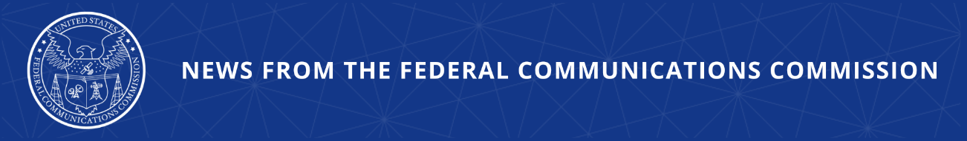

FCC Strengthens Protections for Public Funds
New Suspension and Debarment Tools Bolster Protections for Programs Including Universal Service Fund and Telecommunications Relay Services

WASHINGTON, March 26, 2026—Today, the Federal Communications Commission adopted an item bolstering its suspension and debarment program to align it with other agencies, and seeking comment on expanding the program to allow for the broader removal of participants that commit waste, fraud, and abuse.

Today’s action updates FCC processes to align them with government-wide best practices and enables the agency to take quicker and more comprehensive action against wrongdoers so as to better protect these programs from abuse and ensure limited resources are used responsibly to connect all Americans. The Report and Order adopts rules allowing the Commission to promptly and efficiently exclude or otherwise limit bad actors’ participation in Congressionally-mandated funding programs, such as the Universal Service Fund, Telecommunications Relay Services program, and the National Deaf-Blind Equipment Distribution Program.

Specifically, the new rules align FCC program management with the Office of Management and Budget’s Guidelines for Nonprocurement Debarment and Suspension, the government-wide standards governing debarment proceedings. The rules are also tailored to accommodate the unique nature and design of the Commission’s programs. The FCC will now be able to consider a wider range of misconduct by program participants that warrants removal, act more quickly in appropriate cases to cut off funds to bad actors, and promote increased and earlier transparency by program participants. Additionally, the new rules create an additional FCC-specific remedy called a Limited Denial of Participation that empowers the agency to address less egregious misconduct that still warrants restricting participation in Commission programs outside of the suspension and debarment process.

As part of today’s vote, the Commission also adopted a Direct Final Rule to adopt the most up-to-date version of the OMB Guidelines, and a Further Notice of Proposed Rulemaking that proposes extending the suspension and debarment rules to additional agency programs and proposes adoption of a mandatory reporting requirement to assist the agency in better protecting federal funds.

Action by the Commission March 26, 2026 by Report and Order, Direct Final Rule, and Further Notice of Proposed Rulemaking (FCC 26-18). Chairman Carr, Commissioners Gomez and Trusty approving. Chairman Carr and Commissioner Trusty issuing separate statements.

GN Docket No. 19-309

###
Media Contact: MediaRelations@fcc.gov / (202) 418-0500
@FCC / www.fcc.gov

