Federal
Communications Commission

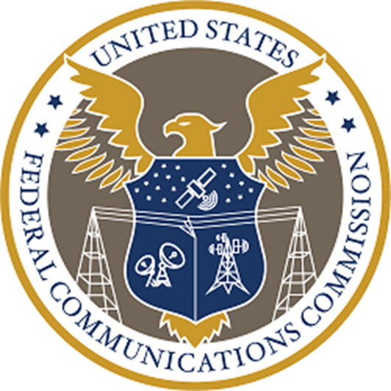

2027
Budget Estimates to Congress
April 2026

Table of Contents

INTRODUCTION AND SUMMARY OF REQUEST 5
Organizational Chart 11
Fiscal Year 2027 Proposed Appropriation Language 12
Summary of Distribution of Resources - Offsetting Collections – Regulatory Fees 13
Summary of FYs 2025 – 2027 FTEs and Funding by Bureaus and Offices 14
FTEs by Resource Category 15
Number of Contractors 15
FTEs - Historical and Estimated 16
Summary of Changes – Offsetting Collections (Regulatory Fees) 17
Narrative Explanation of Changes - Salaries and Expenses - Regulatory Fees 18
Office of Inspector General Narrative Explanation of Changes 19
FCC Office of Inspector General Narrative 19
Universal Service Fund Activities 21
Overall Status of Audit Recommendations 22
SPECTRUM AUCTIONS 23
Spectrum Auctions Program - Explanation of Requested Change 25
Spectrum Auctions Program 26
Summary of Distribution of Resources - Spectrum Auctions Program 31
Spectrum Auctions Expenditures Report 32
Spectrum Auctions Program – Cash Collected/Generated vs. Expenditures 32
Spectrum Auctions and Cash Collected/Generated by Fiscal Year 33
OTHER FUNDING PROVIDED BY CONGRESS 35
ECONOMY ACT REIMBURSABLE AGREEMENTS 37
Summary of Distribution of Resources – Economy Act Reimbursement Agreements 37
FEE COLLECTIONS 39
Regulatory Fees 41
Availability of Regulatory Fees 41
Historical Distribution of Appropriated Budget Authority – Regulatory Fees 42
Historical Appropriated Budget Authority – Spectrum Auctions Program 42
Application Processing Fees 43
PERFORMANCE PLAN 45
APPENDICES & EXHIBITS 47
Summary - Requested Resources and Outlays 49
Allocation of Obligations by Budget Object Class Code – FCC & OIG 51
Universal Service Fund Exhibit 52
Telecommunications Relay Service Fund Exhibit 54
GAO - IG Act Audit List 55
Response to Congressional Inquiries Concerning GAO Recommendations 55

INTRODUCTION AND SUMMARY OF REQUEST

This page is intentionally left blank

INTRODUCTION AND SUMMARY OF REQUEST
The Federal Communications Commission (FCC or Commission) and FCC Office of Inspector General (OIG) are pleased to present the fiscal year (FY) 2027 budget request.

The FCC is a regulatory agency of the United States Government. The FCC is charged with regulating interstate and international communications by radio, television, wire, satellite, and cable. The Commission also regulates telecommunications, advanced communication services and video programming for people with disabilities, as set forth in various sections of the Communications Act of 1934, 47 U.S.C. § 151 et seq, as amended.

As specified in section 1 of the Communications Act of 1934, as amended, the FCC’s mission is to “make available, so far as possible, to all the people of the United States, without discrimination on the basis of race, color, religion, national origin, or sex, rapid, efficient, Nation-wide, and world-wide wire and radio communication service with adequate facilities at reasonable charges.” In addition, section 1 provides that the Commission was created “for the purpose of the national defense” and “for the purpose of promoting safety of life and property through the use of wire and radio communications.”

The FCC is directed by five Commissioners appointed by the President and confirmed by the Senate for five-year terms, except when filling the unexpired term of a previous Commissioner. Only three Commissioners can be from the same political party at any given time. The President designates one of the Commissioners to serve as the Chairman.

The FCC’s vision is to pursue policies to accelerate high-speed internet builds to unleash the U.S. economy and give all Americans an equal opportunity for next-generation connectivity and promote national security and public safety by taking concrete actions to address threats posed by foreign adversaries. The FCC will continue to work to protect consumers, promote free speech through effective enforcement, and develop new approaches to protect American consumers from unlawful communications. Furthermore, the FCC will continue to enhance efficiency in its operations and will manage and direct its resources consistent with Administration policies and the authorities provided by Congress.

For FY 2027, the Commission requests the budget and personnel amounts that are summarized in the bullets and table below.

- The Commission requests $398,342,000 in budget authority from regulatory fee offsetting collections. This is $17,770,000 or 4.3 percent less than FY 2026 enacted level of $416,112,000.

- The Commission also requests $132,681,000 in budget authority for the Spectrum Auctions Program (Auctions Program). This is at the same level as the FY 2026 enacted level. Currently, the Commission’s Spectrum Auctions Program has generated over $233.5 billion for government use; at the same time, the total cost of the Spectrum Auctions Program has been less than $2.8 billion or 1.2 percent of the total auctions’ revenue. The Commission is grateful to the President and Congress for reinstating the FCC’s spectrum auction authority.

In creating a lean, accountable, and efficient commission that works for the American people, the Commission requests 1,294 Full Time Equivalents (FTEs) funded by budget authority from the Salaries and Expenses (S&E) and the Spectrum Auctions Program. With this FTE level, the Commission will meet its mission demands in FY 2027.

In furtherance of these objectives and the FCC’s mission, the FY 2027 budget request will support the following Strategic Goals:

Strategic Goal 1: Accelerate High-Speed Internet Builds

The FCC must promote a pro-growth agenda to unleash the U.S. economy and give all Americans a fair shot at next-generation connectivity. Maintaining and extending U.S. leadership in wireless communications is fundamental to that effort. Getting spectrum policies right translates directly into bringing Americans across the digital divide, creating jobs, and growing the U.S. economy. Through our spectrum auction authority, the FCC will enable greater and more intensive use of spectrum—particularly prime, mid-band spectrum—to harness the promise of new wireless technologies. The FCC must also cut red tape to help ensure that providers roll out upgraded, high-speed networks to more Americans on a faster timeline. The FCC must utilize the full complement of its capabilities, including restoring spectrum auction authority, to free up unused and underutilized spectrum to serve as a catalyst for innovation and growth.

Strategic Goal 2: Promote National Security and Public Safety

The U.S. continues to face persistent threats from foreign adversaries that explore ways to breach our networks, devices, and technology ecosystem. The FCC plays a vital role in safeguarding national security by protecting U.S. communications networks from equipment and services that pose national security risks, and by ensuring the resiliency of our critical communications networks. To safeguard and strengthen U.S. communications networks, the FCC must take concrete actions to address the human, technological, and natural threats and hazards jeopardizing the safety and prosperity of Americans and American companies. The Commission must bring to bear the full range of its regulatory, investigatory, and enforcement authorities and capabilities to maintain awareness of and respond to threats and hazards, align America’s technological and national security priorities, and do its part to promote the security and stability of the Nation. Also, America’s leadership in wireless deployment and standard setting is critical to our geopolitical leadership and national security. It ensures next-generation wireless services develop in ways that will benefit our innovators and interests—rather than regimes that seek to diminish America’s standing in the world.

The Commission also has a responsibility to promote the public’s access to 911, public safety, ensuring the American people have the means to communicate during major events and disasters, and that first responders and emergency managers have access to reliable communications to facilitate emergency response. The FCC develops and implements policies to ensure that our Nation’s first responders and the American public have access to effective and reliable communications and by collaborating with Federal government partners responsible for protecting the Nation’s communications infrastructure. The FCC supports public safety entities to protect the welfare of life and property and to safeguard the Nation’s security. To that end, the FCC develops rules and policies to ensure that the public safety community in the U.S. uses the limited spectrum resource to serve the public with freedom from harmful interference, access to the latest technologies, and minimal regulatory constraints. The FCC also engages Canada and Mexico to develop cross-border spectrum and frequency use agreements to promote efficient use of spectrum by U.S. public safety agencies and commercial operators offering services to public safety agencies in the border areas. The FCC also works closely with other U.S. government agencies and its international counterparts to help build international coalitions regionally and globally to lead secure network initiatives, secure communications supply chain, and minimize security vulnerabilities of interconnected global communications infrastructures.

Strategic Goal 3: Protect Consumers and Promote Free Speech

Advancements in communications services and technologies have created new challenges for American consumers. The FCC will continue to prioritize consumer protection and empower consumer choice in a rapidly changing communications landscape. The FCC will pursue effective enforcement and new approaches to protect consumers from illegal calls, phone-based scams, and other marketplace trends that affect consumers. The FCC will work to pursue policies that protect free speech and access to information, including efforts to foster media competition and ensuring access to local news sources. The FCC must also continue to ensure the availability of quality, functionally equivalent communications services to persons with disabilities.

Strategic Goal 4: Enhance Efficiency, Accountability, and Reduce Waste

The FCC will unleash prosperity through deregulation and ensure that they are efficiently delivering great results for the American people. The FCC will manage and direct the organization’s resources consistent with Administration policies and the authorities provided by Congress.

Additional Useful Information to Better Understand the Budget Request

Below is additional useful information for readers to better understand the information presented in the Commission’s budget request:

- FY 2025 numbers presented are actual numbers.
- FY 2026 numbers presented are enacted numbers.
- FY 2027 numbers represents the Commission’s FY 2027 request to Congress.

Organizational Chart

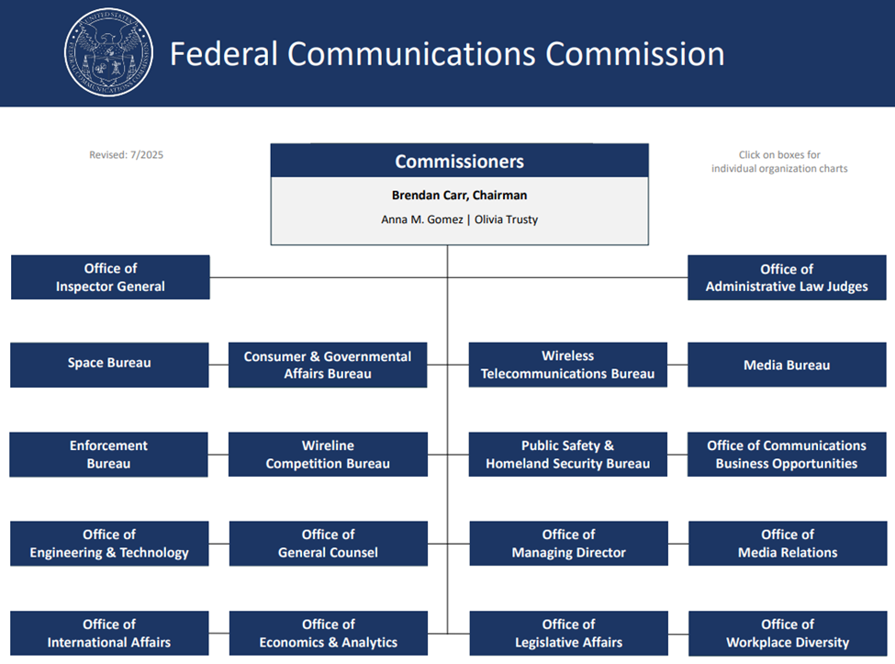

Fiscal Year 2027 Proposed Appropriation Language

For necessary expenses of the Federal Communications Commission, as authorized by law, including uniforms and allowances therefor, as authorized by 5 U.S.C. 5901–5902; not to exceed $4,000 for official reception and representation expenses; purchase and hire of motor vehicles; special counsel fees; and services as authorized by 5 U.S.C. 3109, $398,342,000, to remain available until expended: Provided, That $398,342,000 of offsetting collections shall be assessed and collected pursuant to section 9 of title I of the Communications Act of 1934, shall be retained and used for necessary expenses and shall remain available until expended: Provided further, That the sum above appropriated shall be reduced as such offsetting collections are received during fiscal year 2027 so as to result in a final fiscal year 2027 salaries and expenses appropriation estimated at $0: Provided further, That, notwithstanding 47 U.S.C. 309(j)(8)(B), proceeds from the use of a competitive bidding system that may be retained and made available for obligation shall not exceed $132,681,000 for fiscal year 2027: Provided further, That, of the amount appropriated under this heading, not less than $10,918,000 shall be for the salaries and expenses of the Office of Inspector General.
Summary of Distribution of Resources - Offsetting Collections – Regulatory Fees

Summary of FYs 2025 – 2027 FTEs and Funding by Bureaus and Offices

The Commission is responsible for the overall management, oversight, and administration of the Universal Service Fund (USF), including all USF policy decisions. All USF related activities are currently funded by regulatory fees. Please see the Universal Service Fund Activities section on page 21 for more information.

FTEs by Resource Category

Number of Contractors

FTEs - Historical and Estimated
Fiscal Years 2000 – 2027

Summary of Changes – Offsetting Collections (Regulatory Fees)

Narrative Explanation of Changes - Salaries and Expenses - Regulatory Fees

FTE Reduction to Base and Non-Salaries Inflationary Increase to Base: ($-13,819,000)
- Estimated FTE Reduction ($-16,389,000)

The FCC anticipates a continued reduction in its workforce through planned and early retirements and other attrition. The FCC is well positioned to continue carrying out its statutory mission with current and remaining staffing levels.

- Non-Salary Inflationary Increase ($2,570,000)

This request provides expected inflationary increases for phones, utilities, printing and reproduction services, contractual services, supplies, travel, training, and other expenses. This increase is developed using an estimated total inflationary rate of approximately two (2) percent.

FY 2027 One-Time Request for New Investments ($15,000,000)

- Information Technology Initiative

This request will allow FCC to accelerate the responsible use of artificial intelligence (AI) to modernize operations, improve decision-making, and enhance engagement with the public. In FY 2027, the FCC will publish its AI compliance plan, report determinations and waivers to OMB, and maintain an updated inventory of AI use cases in alignment with M-25-21. FCC will expand AI-enabled automation across service delivery and data analysis, reducing manual workload and improving efficiency. FCC will fully integrate AI governance into enterprise oversight boards to ensure transparency, accountability, and public trust. The FCC will also strengthen defenses against sophisticated cyber adversaries by expanding Zero Trust implementation, phishing-resistant multifactor authentication, and least-privilege access enforcement. Threat intelligence platforms and automated monitoring reduce detection and response times, while formal code deployment processes ensure security testing before release. All remaining end-of-support network devices will be decommissioned and replaced with secure, supported platforms, closing compliance gaps and removing unpatched vulnerabilities. At the same time, the FCC will modernize its enterprise architecture to reduce overall IT spend in the long term. Legacy systems and siloed infrastructure will be consolidated, high-maintenance platforms will be retired, and cloud-based technologies will be adopted. Full stack observability will provide visibility across the enterprise, enabling proactive risk management and optimized resource utilization. This modernization will also lower technical debt, reduce duplicative contracts, cut maintenance costs, and ensure IT investments will scale with mission.. In addition, these actions will eliminate legacy risks, reduce costs, and improve service delivery. They will also demonstrate compliance with OMB, NIST, and FedRAMP mandates while advancing FCC strategic goals for modernization, security, and public trust.

Office of Inspector General Narrative Explanation of Changes
Salaries and Expenses - Regulatory Fees
President’s FY 2027 Budget Request for FCC OIG — $10,918,000 reflecting a reduction of $2,582,000 from FY 26 Budget Request of $13.5 million.

The President’s budget request of $10,918,000 for FCC OIG reflects a reduction of $2,582,000 from the FY 2026 enacted level of $13,500,000. FCC OIG will adjust to this reduction through delayed hiring, process improvements, operational efficiencies, technology enhancements, and non-salary level reductions.

FCC Office of Inspector General Narrative

An FY 2027 budget of $10,918,000 would allow FCC OIG to perform basic oversight duties of the office and meet statutory oversight obligations.

FCC OIG’s oversight incorporates proactive and reactive efforts to protect Congressionally authorized programs administered by FCC. These include FCC’s Universal Service Fund (USF) and Telecommunications Relay Service (TRS) legacy programs funded at approximately $9 billion each year (E-rate, Lifeline, High Cost, Rural Health Care); as well as FCC’s $22+ billion in pandemic relief and supplemental broadband subsidy programs (Emergency Connectivity Fund, COVID Telehealth, Emergency Broadband Benefits Program, and the Affordable Connectivity Program).

While the supplemental pandemic-era broadband subsidy programs are no longer active, FCC OIG continues to vigorously identify and investigate suspected fraud, theft, and misconduct that diverted those funds from their intended uses. As demonstrated by the work of the Pandemic Response Accountability Committee, the supplemental emergency funding issued by FCC was at a higher risk of fraud due to the expedited implementation of those programs and reduced internal controls. Our statutes of limitation for pursuing civil and criminal investigations range from five to ten years, and we continue to work with law enforcement partners to pursue criminal, civil, and administrative sanctions against bad actors. We also refer matters to the FCC when action on a specific award may be appropriate to protect FCC funding at the front end. FCC OIG also oversees FCC’s $5 billion Supply Chain Reimbursement (“Rip and Replace”) Program, a Congressionally authorized national security priority, currently being administered to fund the removal and disposal of untrusted covered equipment and services in our nation’s telecommunications networks, and their replacement with trusted equipment and services.

FCC OIG continues to conduct mandated annual audits and evaluations to, among other things, help prevent and reduce improper payments and strengthen the information technology and cybersecurity posture of the agency. In addition, our Office of Audits conducts program-related audits tied to the Commission’s top challenges to help address gaps in internal controls, maximize efficiencies, and share opportunities for enhanced stewardship.

We carry out statutory hotline and whistleblower responsibilities, and have recently revamped our Hotline to better protect FCC programs and the public from fraud, waste, and abuse. Our improvements include both operational and analytic enhancements through updated technology, and the adoption of a new webform to bring in more actionable information.

We share recommendations, fraud indicators, and leading practices with FCC and the Universal Service Administrative Company to protect funding at the outset, before it is released, to prevent fraud and reduce improper payments. In addition to promoting strong financial stewardship of FCC’s program funds, FCC OIG is responsible for helping to ensure that program benefits are being delivered to eligible beneficiaries for intended purposes, and protecting the communities across our nation who rely on these programs to support education, work-life, telehealth, public safety, and national security. To deliver on our critical oversight mission, FCC OIG developed and implemented a strategic plan to ensure we concentrate our resources on the most impactful issues facing the Commission, with a focus on FCC’s top challenges. Finally, FCC OIG has increased transparency with all stakeholders and developed a renewed focus on accountability for excellence in operations and in demonstrating our return on investment.

With respect to staffing, the FY 2027 budget request supports 54 FTEs, and within this total, we anticipate hiring a Special Agent/1811 Law Enforcement Officer for the Office of Investigations and a Senior Attorney for the Office of Counsel.

Currently, our Office of Investigations is staffed exclusively by investigative attorneys, and we rely on other law enforcement agencies, such as the FBI, the U.S. Postal Inspection Service, the Internal Revenue Service Criminal Investigations Division, and other Offices of Inspector General, to support our criminal investigations. To enhance our law enforcement capacity, we will continue to fund the two law enforcement officer positions authorized in FY 2026, our Assistant Inspector General for Investigations and a Senior Special Agent, and hire one additional special agent/law enforcement officer in FY 2027. These law enforcement positions will allow us to timely pursue our full portfolio of criminal cases, using tools available to criminal investigators, without requiring external support.

Beyond our Office of Investigations, we seek to hire one new senior attorney to assist our Office of Counsel, which is staffed by one counsel and one attorney. This additional attorney will help our office pursue previously unleveraged administrative remedies, to include governmentwide suspension and debarment actions to protect FCC funds, and to conduct other duties traditionally performed by OIG counsel.

We intend to expand core training to all personnel to enhance our expertise, and maximize our capacity through enhanced use of advanced technology. Our recent expanded use of data analytics, increased focus on governmentwide partnerships, process improvements, and advanced technology have allowed us to do work in a more efficient manner.

Further, in compliance with the IG Reform Act of 2008, this budget includes $97,129 for staff training, a fair share contribution to the Council of the Inspectors General on Integrity and Efficiency, which is .40% assessment fee or $43,672 of the FY 2027 budget request as required by the Inspector General Act (5 U.S.C. § 406(g)(1)).

We are committed to continuing to demonstrate excellence in our oversight and operations to maximize our impact for FCC, Congress, and the American public, and to strengthen and protect the integrity of FCC programs and all who rely on them.

Universal Service Fund Activities

The Commission is responsible for the overall management, oversight, and administration of the Universal Service Fund (USF). The Commission develops policies and rules for the USF, and the Universal Service Administrative Company (USAC) collects and delivers funding through four programs – Schools and Libraries (E-Rate), Rural Health Care, Lifeline, and High Cost – focused on places where broadband and connectivity needs are critical. These programs serve people in rural, underserved, and difficult-to-reach areas.

The Commission works with USAC, as the Commission-designated administrator of the USF, to review USAC’s administrative expenses and also to oversee the effectiveness of USAC’s internal controls around USAC’s program management, procurements, information technology projects, and personnel processes.

USF Activities

The Commission’s continued budgetary and programmatic focus for the universal service programs includes: (1) promoting policies to help bring affordable, reliable, high-speed broadband to 100 percent of the country in a technology-neutral fashion promoting policies that accelerate broadband access and affordability for Americans and reflect market demands and advancement in network technologies, (2) protecting program integrity for each of the universal service programs, and (3) promoting efficiency, accountability, and fiscal responsibility. With these priorities in mind, the Commission targets support to deliver, expand, and maintain voice and broadband service to high cost and rural areas, low-income consumers, schools and libraries, and rural health care providers.

The below table shows the USF Outlays for FY 2025.

Overall Status of Audit Recommendations

The chart below shows the number of outstanding audit recommendations from various audits conducted by the OIG and the Government Accountability Office (GAO) at the end of each fiscal year. The numbers shown below exclude those recommendations for which the Commission has already submitted information to GAO and OIG requesting closure of the recommendation. The figures also exclude the recommendations that the Commission has determined to close as not implemented.

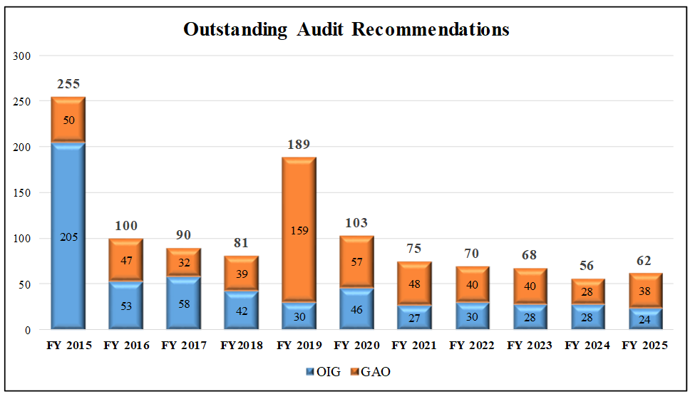

SPECTRUM AUCTIONS

This page is intentionally left blank

Spectrum Auctions Program - Explanation of Requested Change

The FCC requests $132,681,000 for the Spectrum Auctions Program for FY 2027, which is the same as the FY 2026 enacted level. Funding at this level will enable the Commission to continue its efforts to make more spectrum available for commercial use; to implement the Spectrum and Secure Technology and Innovation Act by conducting an auction of licenses for spectrum in the AWS-3 bands that are in the Commission’s inventory and to contribute at least 800 megahertz of spectrum to the pipeline; to continue the close-out of post-broadcast incentive auction (BIA) work related to displacement, repacking, and reimbursing from the TV Broadcaster Relocation Fund (TVBRF) to broadcasters, multichannel video programming distributors (MVPDs), Low Power TV (LPTV), TV translator stations, and FM broadcast stations for reasonable relocation costs incurred because of the Commission’s broadcast incentive auction; and to upgrade and improve the Commission’s auction infrastructure in preparation for future auctions.

Spectrum Auctions Program

The Commission’s Spectrum Auctions Program began with the authority to grant licenses through competitive bidding provided by the Omnibus Budget Reconciliation Act of 1993, P.L. 103-66 (OBRA) in 47 USC 309(j). The Commission adopted implementing regulations and conducted its first spectrum license auctions in July 1994. Subsequent legislation revised and expanded the Commission’s authority to use competitive bidding. From FY 1994 through the end of FY 2025, the total amount generated for government use and deficit reduction exceeded $233.5 billion. With limited exceptions, the Commission’s authority to grant a license or permit under section 309(j) lapsed on March 9, 2023 and was restored through September 30, 2034 when P.L. 119-21, the Working Families Tax Cut Act (Act) was enacted on July 4, 2025. The Act establishes a spectrum pipeline totaling at least 800 megahertz, with identification and auction deadlines.

The Commission is authorized to retain funds from auction revenues to develop, implement, and maintain the Spectrum Auctions Program. These funds cover the personnel and administrative costs required to plan and execute spectrum license auctions; operational costs to manage payments and collections activities; development, implementation, and maintenance of all information technology systems necessary for auctions operations, including development of a combinatorial bidding system; and a proportional share of the general administrative costs of the Commission. This budget submission assumes that the auctions program will continue to recover the costs of conducting auction activities from spectrum license auction receipts as the Commission continues to use auctions as a licensing mechanism for spectrum-based communications services.

The Act sets out the following timetable for the 800 megahertz spectrum pipeline target:

- By July 4, 2027, the Act requires the Commission to complete a system of competitive bidding for at least 100 megahertz of the 3.98-4.2 GHz band;
- By July 4, 2027, the Act requires NTIA to identify at least 200 megahertz of federal spectrum within the 1.3-10.5 GHz range, excluding the 3.1-3.45 GHz and 7.4-8.4 GHz bands, for full-power commercial use;
- By July 4, 2029, the Act requires the Commission to complete one or more systems of competitive bidding of not less than 200 megahertz that NTIA is to have identified;
- By July 4, 2029, the Act requires NTIA to identify for full-power commercial use federal spectrum within the 1.3-10.5 GHz range, excluding the 3.1-3.45 GHz and 7.4-8.4 GHz bands, to total 500 megahertz with spectrum previously identified by NTIA under the Act;
- By July 4, 2033, the Act requires the Commission to complete one or systems of competitive bidding of all the spectrum that NTIA will have identified under the Act; and
- By September 30, 2034, the Act requires the Commission to grant licenses for at least 300 megahertz of spectrum, including megahertz in the 3.98-4.2 GHz band licensed pursuant to the Act, excluding the 3.1-3.45 and 7.4-8.4 GHz bands and spectrum identified by NTIA pursuant to the Act.

For FY 2027, the Commission requests a level cap for the Spectrum Auctions Program obligations set at $132,681,000. Funding at this level will enable the Commission to undertake extensive work on the following mandates during FY 2027:
- implement the Spectrum and Secure Technology and Innovation Act by conducting an auction of licenses for spectrum in the AWS-3 bands that is in the Commission’s inventory;
- implement the Act by taking steps to contribute to the pipeline of at least 800 megahertz of spectrum, excluding the 3.1-3.45 GHz and 7.4-8.4 GHz bands, such as:
  - steps toward granting licenses through systems of competitive bidding for a total of not less than 300 megahertz of available spectrum, in addition to spectrum identified under the Act by the National Telecommunications and Information Administration (NTIA), before September 30, 2034;
  - steps towards completing a system of competitive bidding for at least 100 megahertz of available spectrum between 3.98 and 4.2 GHz before July 4, 2027, as part of the preceding 300 megahertz of licenses to be granted,;
  - consulting with NTIA as NTIA identifies at least 200 megahertz, in addition to the preceding 300 megahertz of available spectrum, of federal spectrum for full-power commercial use cases within the 1.3-10.5 GHz range, excluding 3.1-3.45 GHz and 7.4-8.4 GHz, before July 4, 2027, and completing systems of competitive bidding for not less than 200 megahertz of the identified spectrum before July 4, 2029;
  - consulting with NTIA as NTIA identifies additional megahertz, in addition to the preceding 300 megahertz of available spectrum, of federal spectrum for full-power commercial use cases within the 1.3-10.5 GHz range, excluding 3.1-3.45 GHz and 7.4-8.4 GHz, to total 500 megahertz in combination with spectrum previously identified by NTIA under the Act, before July 4, 2029, and completing systems of competitive bidding for all spectrum identified by NTIA under the Act before July 4, 2033;
- steps to implement general auction authority by conducting other auctions; enhancing the auctions program, such as upgrading infrastructure and security; and post-auction activities, such as processing applications that have remained pending since the 2023 lapse in general auction authority; and
- continue the close-out process for the post Broadcast Incentive Auction (BIA) work related to displacement, repacking, and reimbursing from the TV Broadcaster Relocation Fund (TVBRF) to broadcasters for their costs to implement the results of the BIA.

Moreover, as the demand for spectrum for new technologies extends to spectrum bands previously assigned for legacy applications, creative approaches must be found to accommodate existing licensees and operations while expanding opportunities for access by new users.

Auction Program Enhancements and Post-Auction Activities

In addition to the work related to the 800 megahertz pipeline described above, auctions funding also will be used for extensive work on the following during FY 2027:

- Auction for AWS-3 Licenses – The Spectrum and Secure Technology and Innovation Act directs the Commission to initiate a system of competitive bidding for unassigned AWS-3 licenses by June 2026. Bidding in Auction 113 for AWS-3 licenses is scheduled to commence in June 2026. Conducting the auction and processing applications for AWS-3 licenses will require Commission staff resources in FY 2027.

- 3.5 GHz Band Post-Auction Implementation – Licenses in the 3550-3650 MHz portion of the 3.5 GHz band were awarded through an auction. Due to the characteristics of and use cases for licenses in this band, the Commission has an ongoing need to interface with the Spectrum Access System Administrators (SASs), which manage the dynamic spectrum sharing environment in the 3.5 GHz band, as well as the Environmental Sensing Capability (ESC) operators, which facilitate federal incumbent protection in the band. The Commission monitors the operations of the FCC-approved SASs and ESCs to ensure compliance with the Commission’s rules and reviews applications for entities that apply to be SAS administrators and ESC operators. On August 5, 2024, the Commission adopted an NPRM seeking comment on a wide range of potential rule changes to improve the Citizens Broadband Radio Service for all current and future users of the 3.5 GHz band. Oversight of the SASs and ESCs and consideration of the issues in the open 3.5 GHz rulemaking will continue into FY 2027.

- 2.5 GHz Band – On July 10, 2019, the Commission released a Report and Order modernizing the 2.5 GHz band (2496-2690 MHz) and making additional spectrum available for 5G and other advanced wireless services. Among other steps, the Commission established a priority filing window providing Tribal Nations with a one-time licensing opportunity for unassigned 2.5 GHz spectrum over their rural Tribal lands. The Commission has so far issued 363 licenses to eligible Tribal entities enabling them to address the communications needs of their communities. Finally, in 2022 the Commission conducted Auction 108 for over 7,850 overlay licenses for remaining unassigned spectrum in the 2.5 GHz band. While all licenses in Auction 108 have been granted, certain post-auction activities requiring Commission staff resources may continue into FY 2027, in addition to activities related to the Rural Tribal Window.

- FM broadcast service construction permits – Pending the further development of the Commission’s upcoming auction schedule, the Commission may consider an auction of FM broadcast service construction permits in FY 2027. The initial public notice announcing this FM auction would list the specific vacant FM allotments for which the Commission would offer construction permits in the auction. The Commission also may consider an auction of commercial FM translator stations in FY 2027. Considering the possible auction will require Commission staff resources in FY 2027, as would any related pre-auction and post-auction activities.

- LPTV, TV Translator, and Class A broadcast service construction permits – Pending the further development of the Commission’s upcoming auction schedule and authority, the Commission may auction mutually exclusive broadcast television station construction permits in FY 2027. The Media Bureau may provide an opportunity for existing Class A, LPTV, and TV Translator stations to file major modification applications. The Media Bureau may also accept applications for new LPTV and TV Translator stations. If such applications are mutually exclusive, after an opportunity for applicants to settle, an auction will be required to resolve the mutual exclusivity and will require Commission staff resources in FY 2027.

- Optimization for New Spectrum Opportunities – The optimization team will help the Commission analyze and study options for using complex mathematical optimization techniques for making new spectrum licenses available through new auction formats, including overlay licenses, transitioning incumbents out of repurposed spectrum bands while assuring continued service to their customers, and other ways to implement spectrum sharing scenarios, to ensure the FCC is maximizing the amount of useful commercial spectrum. The team will develop optimal band plans accommodating incumbent uses and demonstrate the value of additional clearing or sharing as necessary. This research will also provide statistical and technical computation, analysis, simulation, and modeling, including geographic data and mapping, related to auctions.

- Spectrum Visualization Tools – Public Facing and Internal – The Commission continues to develop spectrum visualization tools to provide the public and government agencies with insights into how spectrum utilization could be modified to meet growing demand for wireless broadband services, including through licenses assigned by auction. These tools will help satisfy the public’s significant interest in understanding who has licensed rights to different spectrum bands at different locations and provide the ability to manipulate and analyze this data. Federal agencies also would benefit from this information as they consider sharing/relocation options. Additionally, it is critical for internal Commission teams to have robust data, including mapping, to understand coverage and operations across the country. For example, in anticipation of the auction of overlay licenses in the 2.5 GHz band (Auction 108), on March 21, 2022, the Commission announced the launch of a mapping tool for use by potential bidders to help assess whether and to what extent there is unassigned 2.5 GHz spectrum available in any U.S. county. Similar work will continue in FY 2027.

- Auction Application System Enhancement/Modernization – The Commission completed the replacement of the legacy auction application system for spectrum auctions in FY 2026 with a modernized system that improves security and provides the ability to customize the form and application review to support future auctions based on novel license eligibility requirements and auction formats, and must continue to be enhanced to maintain evolving federal system security requirements and data needs, as well as in response to any unique requirements for an auction for which functionality does not exist in the system. This ongoing work to maintain and enhance the new system will continue through FY 2027.

- Auction Bidding System Enhancement/Modernization – The Commission has largely completed modernizing the most commonly used bidding formats as part of the platform used for conducting auction bidding. The modernization work will continue through FY 2027 to further improve security, data management and access, and processing ability to accommodate increased or more complex bidding approaches and higher volumes of bids or auctionable items.

- Universal Licensing System Modernization – The Commission must modernize its licensing database and infrastructure to implement complex new service rules, as well as replace outdated technology to improve reliability, security, and access to data. The modernized system would enable the FCC to better support new auctions, inventory existing auction licenses, and re-license spectrum. In FY 2027, the work will continue.

Continued Close-Out of Post-Broadcast Incentive Auction Transition Work

The Incentive Auction Closing and Channel Reassignment Public Notice, released on April 13, 2017, announced the completion of the first-ever spectrum incentive auction. The Broadcast Incentive Auction (BIA) made available 84 megahertz of low-band spectrum for commercial and unlicensed wireless use by repurposing a portion of the broadcast TV band. The total net winning bids of the auction were $19.3 billion. Pursuant to the Middle Class Tax Relief and Job Creation Act of 2012, the auction proceeds, among other things, were directed to fund the first $1.75 billion, with the Reimbursement Expansion Act of 2018 (REA) funding the remainder, of the $2.7 billion Television Broadcaster Relocation Fund (TVBRF). The TVBRF reimburses entities for their reasonable expenses incurred as a result of stations being involuntarily relocated to new channels. The TVBRF permitted the Commission to obligate funds until July 3, 2023, and the Commission may reimburse entities from obligated funds for a period of 5 years thereafter, during which time the Commission staff will continue to administer reimbursement of previously obligated funds for reimbursement of eligible expenses. Several full power stations have not yet completed construction of final facilities and therefore remain on interim facilities. In addition, some repacked stations that have already vacated their pre-auction channel have ongoing construction to remove old antennas and equipment and take other follow-up efforts, and certain LPTV/translator stations are still working to complete the close-out procedures of the TVBRF. Activities that will continue to take place in FY 2027 include: licensing for broadcasters being relocated; reimbursement of ongoing construction expenses; close-out procedures for entities participating in the TVBRF; post-implementation site visits; data validations, audits, and disbursement validations; and processing of banking information submissions.
FCC Obligations in Support of the Auctions Program

Pursuant to the Communications Act, 47 U.S.C. §309(a), the Commission must provide its authorizing and appropriations committees in Congress with a detailed report of the FCC’s obligations in support of the auctions program for each fiscal year of operation. The following table shows available auction cash for recent fiscal years.

Spectrum Auctions Activities

Summary of Distribution of Resources - Spectrum Auctions Program

SPECTRUM AUCTIONS COST RECOVERY REIMBURSABLE AUTHORITY

Spectrum Auctions Expenditures Report

Section 309(j) of the Communications Act permits the Commission to use funds raised from auctions to fund its Auctions Program, including contracts for services and costs related to personnel performing work in support of the authorized Commission auctions under that section. The FCC’s Office of General Counsel and Office of Managing Director provide direction to the FCC’s employees attributing hours for this purpose. The House of Representatives and the Senate Appropriations Committees review and set a yearly cap for the Spectrum Auctions Program.

The actual, enacted and requested FTE levels for the Spectrum Auctions Program for FYs 2025 through 2027 are shown on page 15. The following two schedules provide details on the Spectrum Auctions Program since its inception in 1994 and perspective on how much money was collected/generated for the U.S. Treasury and for broader government use, as well as the total cost for running the Commission’s Spectrum Auctions Program.

Spectrum Auctions Program – Cash Collected/Generated vs. Expenditures
Fiscal Years 1994 through 2025

Spectrum Auctions and Cash Collected/Generated by Fiscal Year
Fiscal Years 1994 through September 2025

This page is intentionally left blank

OTHER FUNDING PROVIDED BY CONGRESS

Secure & Trusted Communications Network Reimbursement Program

The Secure and Trusted Communications Networks Act of 2019 (Secure Networks Act), among other measures, directed the Commission to establish the Secure and Trusted Communications Networks Reimbursement Program (Rip-and-Replace Program or Program) to fund the removal, replacement, and disposal of covered communications equipment or services that pose an unacceptable risk to the national security of the United States or the security and safety of U.S. persons from the networks of providers of advanced communications service. Specifically, the Program assists providers of advanced communications service with the costs of permanently removing, replacing, and disposing of communications equipment and services produced or provided by Huawei Technologies Company (Huawei) and ZTE Corporation (ZTE) and obtained by the providers on or before June 30, 2020.
The Rip-and-Replace Program provides funding allocations to eligible providers of advanced communications service based on their supported estimated costs. Reimbursement Program recipients obtain funding disbursements from their allocation upon a showing of actual expenses incurred. Recipients of Program funds shall use these funds solely to: (1) permanently remove covered communications equipment and services from their networks; (2) replace the covered communications equipment and services with non-covered equipment or services; and (3) dispose of the covered communications equipment and services, in accordance with the Secure Networks Act and the Commission’s rules.
On December 27, 2020, the Consolidated Appropriations Act, 2021 (Consolidated Appropriations Act), was signed into law. The legislation included a $1.9 billion appropriation that funds the Program. Because demand for program support significantly exceeded the $1.9 billion appropriation in the Consolidated Appropriations Act, the Bureau was required to implement the prioritization scheme mandated by the Secure Networks Act when it approved funding allocations. This led to the Bureau granting 126 applications by Priority 1 applicants (those with 2 million or fewer customers) and issuing those applicants prorated funding allocations equal to approximately 39.5% of their reasonable estimated costs on July 15, 2022.
Also on July 15, 2022, the Commission informed Congress that to fund all reasonable and supported cost estimates submitted to the Program and cover estimated administrative expenses, the Program would require approximately $4.98 billion, reflecting an approximate $3.08 billion shortfall from the $1.9 billion appropriation. On December 23, 2024, the Spectrum and Secure Technology and Innovation Act (Pub. L. 118-159) authorized the Commission to borrow from the Treasury of the United States up to an additional $3.08 billion to carry out the Program. The Commission borrowed the full amount and on April 15, 2025 allocated additional funding to active Priority 1 recipients so that their total allocation equaled 100% of their original reasonable and supported cost estimates. Priority 1 recipients must complete their permanent removal, replacement, and disposal of covered communications equipment and services by May 8, 2026. On April 24, 2025, the Bureau granted the application of the single Priority 3 recipient (with between two million and ten million customers; there were no Priority 2 recipients), which previously had been denied due to lack of funding. With the remaining available funding from the borrowed $3.08 billion, the Bureau issued that recipient a prorated allocation equal to approximately 29.79% of its reasonable estimated costs. That recipient will have one year from the receipt of its first disbursement to complete the permanent removal, replacement, and disposal of covered communications equipment and services.

ECONOMY ACT REIMBURSABLE AGREEMENTS

The Economy Act of 1932, P.L. 72-142, provides authority for federal agencies to order and be reimbursed for goods and services from other federal agencies, which are executed through interagency agreements, arrangements in which one agency (Servicing Agency) provides goods or services to another agency (Requesting Agency) and receives reimbursement of costs incurred. Agencies can use interagency agreements to conduct a wide variety of operations and can be routine in nature, involve the acquisition of goods or services necessary to maintain agency operations, or support a specific program.

As the Servicing Agency, the Commission requests $4 million in Economy Act Reimbursable Agreements with other Federal agencies for FY 2027 consistent with the FY 2026 enacted level of $4 million.

Summary of Distribution of Resources – Economy Act Reimbursement Agreements

This page is intentionally left blank

FEE COLLECTIONS

This page is intentionally left blank

Regulatory Fees

Pursuant to Section 9 of the Omnibus Reconciliation Act of 1989, which significantly revised Section 47 U.S.C. § 158 of the Communications Act of 1934, the Commission annually collects regulatory fees and retains them for Commission use to offset certain costs incurred by the Commission to carry out its functions.

These regulatory fees, also known as Section 9 fees, apply to the current FCC license holders and other entities (e.g., cable television systems) which benefit from the Commission’s regulatory activities that are not directly associated with its application processing functions.

The regulatory fees do not apply to governmental entities, nonprofit entities holding with tax-exempt status under the Internal Revenue Code, 26 U.S.C. § 501(c)(3), amateur radio operator licensees, and certain non-commercial entities.

Under the Section 9 provisions, the Commission has the authority to review its regulatory fees and to adjust the fees to reflect changes in its appropriation from year to year. The FCC may also add, delete, or reclassify services under certain circumstances. Additionally, the Commission may charge up to a 25 percent late payment penalty, dismiss applications or revoke licenses for non-payment of the fees, and may also waive, reduce, or defer payment of a fee for good cause.

The Commission originally implemented the Regulatory Fee Collection Program by rulemaking on July 18, 1994. The most recent regulatory fee order was released by the Commission on August 29, 2025.

Availability of Regulatory Fees

The RAY BAUM’S Act of 2018, P.L. 108-494, requires the Commission to transfer all excess collections to the U.S. Treasury General Fund for the sole purpose of deficit reduction. On September 30, 2025 the Commission transferred over $9.7 million in excess collections in FY 2025 to the U.S. Treasury General Fund to be used for deficit reduction.

The Commission receives an annual S&E appropriation. On March 1, 2013, the OMB issued a report to Congress on sequestration for FY 2013. For the FCC, this translated into a $17 million reduction in new budgetary authority. The sequestered amount is currently maintained in the Commission’s no-year account, which indicates that the unobligated balances brought forward each fiscal year excludes $17 million in unavailable balances of funds temporarily sequestered in FY 2013.

The FY 2027 request level for regulatory fees is $398,342,000, which is $17,770,000 or 4.3 percent less than the FY 2026 enacted level of $416,112,000. The distribution of budget authority from offsetting collections from regulatory fees is illustrated in the following graph.

Historical Distribution of Appropriated Budget Authority – Regulatory Fees

The following graph depicts the historical distribution of appropriated budget authority since FY 2018.

Historical Appropriated Budget Authority – Spectrum Auctions Program

The following graph depicts the historical appropriated budget authority for the Spectrum Auctions Program since FY 2018.
Application Processing Fees

The FCC’s authority to impose and collect application processing fees is granted by Congress in Section 8 of the Omnibus Reconciliation Act of 1989. Application processing fees, often referred to as Section 8 fees, are deposited in the U.S. Treasury General Fund and are not available to the Commission. The Auctions Program encompasses more than 300 different fees, with the vast majority collected at the time an original license application, renewal, or request for modification is filed with the Commission. Although there are certain exceptions, most fees are assessed as a one-time charge on a per-application basis.

Government, nonprofit, and non-commercial broadcast license applicants are exempt from the fees. A commercial bank is used to collect the fees, with all fees deposited in the U.S. Treasury General Fund. Once deposited, these fees are generally nonrefundable, regardless of the application process outcome. The Commission must review and revise the fees every two years, based upon changes to the Consumer Price Index (CPI). The Commission adopted an Order increasing application processing fees to reflect the CPI index changes on December 31, 2024, and released the Order on January 7, 2025. This adjustment complies with the statutory formula set forth in Section 8(b). Application processing and regulatory fee collections are summarized in the following schedule.

The RAY BAUM’S Act of 2018 substantially amended Section 8 of the Communications Act, 47 U.S.C. § 158 and provided an effective date of October 1, 2018 for those changes. Congress instructed that application fees in effect on the day before the effective date of the RAY BAUM’S Act shall remain in effect until such time as the Commission adjusts or amends such fees. Moving forward after October 1, 2018, the Commission's next amendment to the application fee schedule will be based on the updated requirements in Section 8 of the Communications Act as amended by the RAY BAUM'S Act. On January 7, 2025 the Commission released an order adjusting and amending application fees based RAY BAUM’s Act requirements.

This page is intentionally left blank

PERFORMANCE PLAN

Will be provided separately at a later date

This page is intentionally left blank

APPENDICES & EXHIBITS

This page is intentionally left blank

Fiscal Year 2027 Request to Congress

Summary - Requested Resources and Outlays

DISTRIBUTION OF BUDGET AUTHORITY – FCC & OIG

OUTLAYS

FULL-TIME EQUIVALENTs (FTEs) – FCC & OIG

Allocation of Obligations by Budget Object Class Code – FCC & OIG

Universal Service Fund Exhibit
Pursuant to the Communications Act of 1934, as amended by the Telecommunications Act of 1996 (1996 Act), all telecommunications service providers and other providers of telecommunications contribute to the Federal USF based on a percentage of their interstate and international end-user telecommunications revenues. These companies include wireline phone companies, wireless phone companies, paging service companies and certain Voice over Internet Protocol (VoIP) providers. The goals of USF are to increase access to both telecommunications and advanced services, such as high-speed Internet, for all consumers at just, reasonable, and affordable rates.

The 1996 Act established principles for universal service that specifically focused on increasing access to evolving services for consumers living in rural and insular areas and consumers with low incomes. Additional principles called for increased access to high-speed Internet in the nation's schools, libraries and rural health care facilities. The FCC established four programs within the USF to implement the statute. The four programs are: (1) High Cost - ensures consumers in rural, insular, and high cost areas have access to modern communications networks capable of providing voice and broadband service, both fixed and mobile, at rates that are reasonably comparable to those in urban areas; (2) Lifeline (for low-income consumers) - provides a monthly benefit on home or wireless phone and broadband service to eligible households and includes initiatives to expand phone service for residents of Tribal lands; (3) Schools and Libraries (E-rate) - provides funding to schools and libraries to obtain broadband, among other things; and (4) Rural Health Care - provides funding to eligible health care providers for telecommunications

Public Law 119-37 temporarily suspended the application of the Antideficiency Act to the Federal USF programs authorized under section 210 of the Communications Act of 1934, through January 30, 2026. The Antideficiency Act requires that funds be available before incurring an obligation on behalf of the Federal Government.

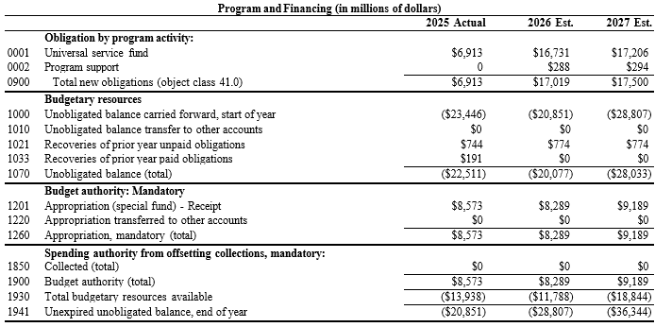

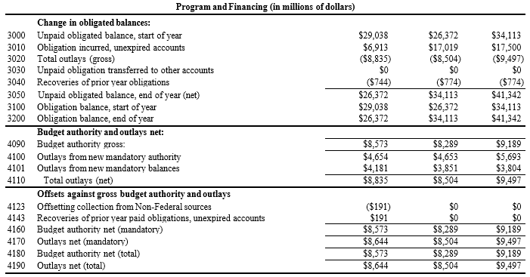

Telecommunications Relay Service Fund Exhibit
As part of the Americans with Disabilities Act of 1990, Congress amended the Communications Act of 1934 (Act) to direct the Commission "to ensure that interstate and intrastate telecommunications relay services (TRS) are available, to the extent possible and in the most efficient manner, to hearing and speech-impaired individuals in the United States." Section 225 of the Act also directs the Commission to prescribe regulations that "generally provide that costs caused by interstate telecommunications relay services shall be recovered from all subscribers for every interstate service and costs caused by intrastate telecommunications relay service shall be recovered from the intrastate jurisdiction." The shared-funding mechanism requires providers of interstate telecommunications services to contribute to a fund that reimburses TRS providers for the cost of providing interstate TRS. All telecommunications service providers and certain other providers of telecommunications contribute to the TRS Fund based on a percentage of their end-user telecommunications revenues. These companies include, but are not limited to, wireline phone companies, wireless phone companies, paging service companies and certain Voice over Internet Protocol (VoIP) providers.

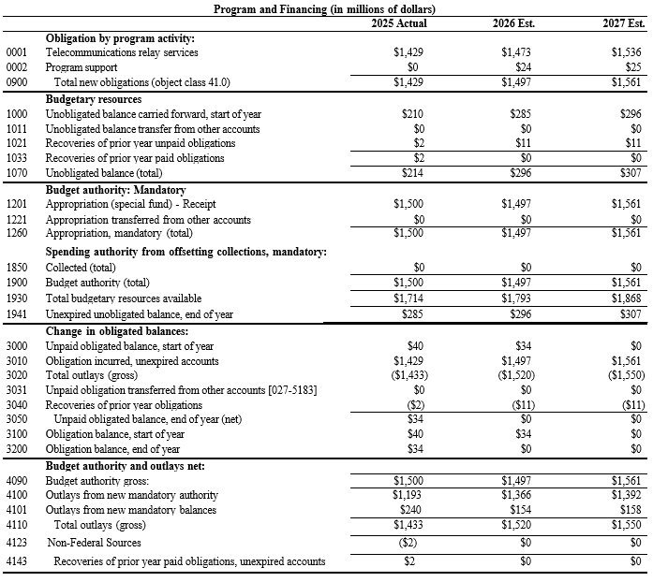

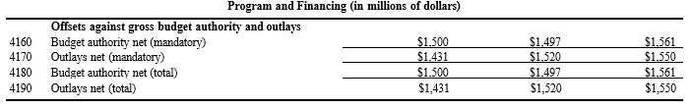

GAO - IG Act Audit List

Please see the Good Accounting Obligation in Government (GAO-IG) Act Report at the following link: https://www.fcc.gov/about/strategic-plans-budget

Response to Congressional Inquiries Concerning GAO Recommendations

Please see the Response to Congressional Inquiries Concerning GAO Recommendations at the following link: https://www.fcc.gov/chairman-letters-congress

47 U.S.C. § 151.
Id.

