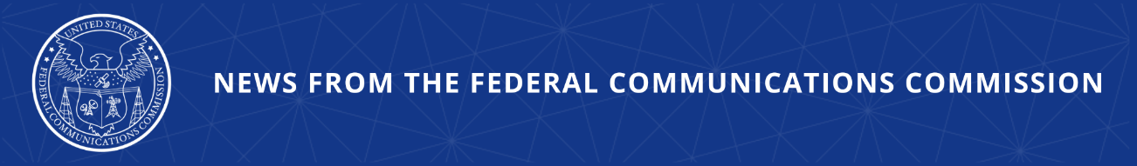

Unleashing American Drone Dominance
FCC Launches Proceeding in Support of President Trump’s Drone Strategy

TEXAS, April 1, 2026—Yesterday, FCC Chairman Brendan Carr joined Anduril Industries’ CEO Brian Schmipf and COO Matt Grimm at a test site in Texas to review demonstrations of cutting-edge drone and counter-drone technologies. This visit comes as the FCC is working closely with U.S. drone companies and taking aggressive action to implement President Trump’s national strategy of American drone dominance. As the next major step in the Commission’s work, today, the FCC’s Wireless Telecommunications Bureau (WTB) and the Office of Engineering and Technology (OET) issued a public notice, seeking input on an array of reforms the Commission might take to achieve U.S. supremacy in drone technology, manufacturing, and operations.

Chairman Carr issued the following statement:

“President Trump has been clear that the Administration will act to secure our airspace and unleash American drone dominance. As the President’s national strategy outlines, the production, deployment, and export of American drones are core elements of U.S. national security, technological sovereignty, and global competitiveness. I want to thank Anduril for welcoming me to their test site and providing me the opportunity to see the cutting edge of U.S. drone technology in action. Innovators, like Anduril, represent the tip of the spear in our fight to ensure a strong drone industrial base, accelerate domestic deployment and dominate global markets.”

“At the FCC, we are doing our part to promote U.S. drone leadership by cutting red tape, modernizing obsolete regulations, and securing a domestic drone supply chain. Today’s public notice is the next major step in that effort. We are seeking comment on a range of important actions, including modernizing experimental licensing, creating new drone innovation zones, and ensuring more spectrum for drone operators. I look forward to continue working alongside the all the relevant federal departments and agencies, in implementing President Trump’s strategy to secure American drone dominance.”

Additional Background Information:

In line with President Trump’s national strategy to unleash American drone dominance, the FCC has been laying the groundwork to give U.S. innovators the resources and regulatory clarity they need to develop a domestic drone ecosystem for commercial and military applications. The Commission has already taken several critical actions.

Late last year, following an Executive Branch national security determination, the FCC added foreign-produced unmanned aircraft systems (UAS) and UAS critical components to its Covered List. Although, following another national security determination the FCC removed some of these devices from the Covered List, most foreign-produced UAS and UAS critical components are still prohibited from receiving authorization for the U.S. market. Given this, the FCC is doubling down on accelerating the deployment of trusted drone technology.

The FCC has been shifting the application process for UAS and Counter-UAS experimental licenses to warp speed. Since January 2025, the Commission has granted 227 UAS experimental approvals, and, for the first time ever, 8 Counter-UAS experimental approvals. These include experimental licenses for use by the Department of War as part of the implementation of President Trump’s Unleashing American Drone Dominance executive order. Compared to the previous four years, from 2021-2024, approvals granted by the FCC for UAS conventional experimental licenses have increased by 68%.

But these actions are just the beginning. Today’s public notice seeks comment on additional means by which the FCC can continue to fulfill its public interest mandate and achieve American drone dominance.

In this public notice, the FCC’s WTB and OET seek input on an array of reforms the Commission might take to unleash American drone dominance, including:

- Alleviating unnecessary regulatory burdens that frustrate drone deployment, including Commission rules or policies—such as siting or device certification—that may create friction for the growth of a competitive, secure, and innovative domestic drone ecosystem.

- Ensuring that American drone manufacturers and users have access to sufficient spectrum for drone testing and operations, including services to the public.

- Facilitating and encouraging American firms’ investment in drone capabilities, developing infrastructure, and offering innovative and advanced capabilities.

- Ensuring that U.S.-based manufacturers and trusted suppliers have the regulatory clarity and technical access needed to scale production and secure investment.

- Coordinating more effectively with other federal agencies to align spectrum policies with national security imperatives and reduce the risk posed by untrusted foreign-origin UAS operating in U.S. airspace.

- Streamlining the FCC’s experimental licensing rules to facilitate more agile testing of UAS communications systems—including beyond visual line of sight (BVLOS) links, command and control (C2) systems, detect-and-avoid (DAA) technologies, and secure navigation tools—across a broader range of spectrum bands.

- Establishing additional dedicated drone innovation zones or testbeds, in partnership with federal, state, academic, or private entities, and whether streamlining authorizations to help spur early-stage experimentation and commercialization.

###
Media Contact: MediaRelations@fcc.gov / (202) 418-0500
@FCC / www.fcc.gov

