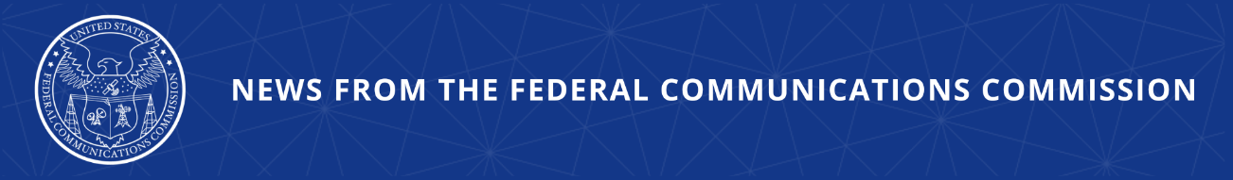

FCC Acts to Protect U.S. Consumers from Bank Impersonation Scams Linked to Suspicious Foreign Call Traffic
Investigation Found Provider Apparently Allowed Calls from Non-Compliant Accounts

WASHINGTON, April 2, 2026—Today, the Federal Communications Commission found Voxbeam Telecommunications apparently liable for accepting suspicious call traffic from a foreign provider that was not permitted to transmit traffic onto American networks. An FCC investigation found that, as a result of this traffic, financial impersonation robocalls were transmitted to U.S. consumers using non-compliant and long dormant accounts. Voxbeam apparently carried this traffic even though the foreign provider, Axfone, is not listed in the FCC’s Robocall Mitigation Database (RMD).

Voice service providers like Voxbeam are prohibited from accepting call traffic from providers that are not listed in the RMD because unlisted providers pose a higher risk of carrying illegal robocalls. Voxbeam has an obligation to block traffic from providers not listed in the RMD and an obligation to take all reasonable steps to protect consumers from likely scam robocalls—in this case tens of thousands of foreign calls coming from accounts that have not generated a call for years. Carrying traffic from unlisted providers is against the Commission’s rules, and it puts U.S. consumers at risk. The Commission proposed a $4.5 million fine and found Voxbeam apparently liable for accepting a provider that was not permitted to transmit onto U.S. networks.

Chairman Brendan Carr issued the following statement:

“Companies like Voxbeam must ensure they are not accepting traffic from sketchy operators. These gateway providers are the on-ramps to American phone networks and with that business model comes significant responsibility. As we saw in this case, failure to follow the FCC’s robocall mitigation rules can result in tens of thousands of scam calls reaching U.S. customers. The FCC is committed to protecting consumers from robocall scams like these.”

Additional Background Information:

The FCC’s Enforcement Bureau found that Orlando-based Voxbeam had transmitted foreign traffic into the U.S. from a foreign provider, Czechia-based Axfone, not listed in the Robocall Mitigation Database. Axfone was not and has never been in the RMD. To generate the calls, it used an account with Voxbeam that had not generated call traffic since 2018.

The FCC reminds U.S. providers to ensure their upstream providers are listed in the RMD before carrying their traffic and to be on the lookout for reanimated, long dormant accounts being used to enter U.S. networks.

Between March 31, 2025 and April 3, 2025, Voxbeam transmitted tens of thousands of calls from Axfone onto U.S. networks. Many of the calls transmitted from Axfone through Voxbeam appeared to spoof fraud prevention or customer service phone numbers belonging to U.S. financial institutions including Bank of America, Chase Bank, and others. The FCC investigation was prompted by a complaint filed by a financial institution whose customers had been receiving fraudulent calls that appeared to come from the institution’s fraud reporting number.

Official Disclaimer:

The proposed action, formally called a Notice of Apparent Liability for Forfeiture, or NAL, contains only allegations that advise a party on how it has apparently violated the law and may set forth a proposed monetary penalty. The Commission may not impose a greater monetary penalty in this case than the amount proposed in the NAL. Neither the allegations nor the proposed sanctions in the NAL are final Commission actions. The party will be given an opportunity to respond and the Commission will consider the party’s submission of evidence and legal arguments before acting further to resolve the matter.

The Notice of Apparent Liability for Forfeiture, adopted by a vote of the full Commission, is available here: https://docs.fcc.gov/public/attachments/FCC-26-22A1.pdf.

###
Media Contact: MediaRelations@fcc.gov / (202) 418-0500
@FCC / www.fcc.gov

