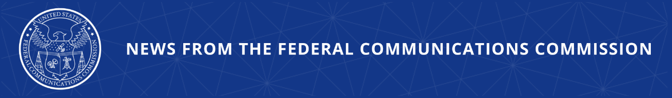
FCC Announces May Cybersecurity Workshops
Events Targeted to Broadcasters and Telecommunications Carriers to Address Cybersecurity Risks

WASHINGTON, April 7, 2026—The Federal Communications Commission today announced that it will host two cybersecurity workshops, led by its Public Safety and Homeland Security Bureau. The first workshop targeted to broadcasters will be held on May 14, 2026 and the second workshop for telecommunications carriers will be held on May 15, 2026. Both workshops will feature speakers from the FCC, federal partners, and industry experts.

The events will bring together public- and private-sector representatives to raise awareness of emerging cybersecurity risks, share and promote adoption of best practices, and highlight opportunities for public-private partnership on cybersecurity issues facing communications providers. Panelists and presenters will offer practical guidance for leaders, engineers, and executives—particularly at small- and medium-sized companies—to strengthen cybersecurity and improve incident response across the communications sector.

Additional Information:

The events are free and open to the public. Members of the media are welcome to attend. We request that both remote and in-person attendees register in advance to attend the workshops by using the following link: https://www.fcc.gov/form/public-safety-homeland-security.

WHEN: Thursday, May 14, 2026 and Friday, May 15, 2026
10:00 a.m. EDT

WHERE: Federal Communications Commission HQ
45 L Street NE
Washington, D.C.

LIVESTREAM: www.fcc.gov/live

###
Media Contact: MediaRelations@fcc.gov / (202) 418-0500
@FCC / www.fcc.gov

