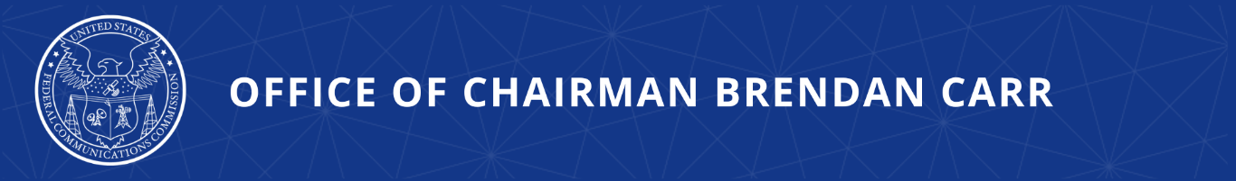

FCC Poised to Empower Super-Fast, Space-Based Broadband
Modernizing 90s-Era Rules Will Massively Boost Broadband Speeds and Capacity

WASHINGTON, April 8, 2026—Today, FCC Chairman Brendan Carr announced that the Commission would vote on an order to modernize its satellite spectrum-sharing rules—a change that could unlock more than $2 billion in economic benefits for the American people and up to seven-fold more capacity for space-based broadband services.

Drawing from the state-of-the-art in satellite technology, the FCC’s new technical rules would revise the decades-old framework for how Geostationary Orbit (GSO) and Non-Geostationary Orbit (NGSO) systems share spectrum. That 1990s-era framework predates the revolutionary changes in spectrum sharing technology that have been developed in the decades since.

The FCC’s new framework will enable faster speeds, lower costs, and greater reliability, representing another step to ensure that consumers benefit from competitive and affordable Internet options.

Chairman Carr issued the following statement:

“The FCC is moving fast to unleash affordable, high-speed Internet. By discarding last century’s satellite regulations, we could see billions of dollars in benefits for the American economy and broadband speeds many times faster than what is available today. This overdue rethinking of space spectrum sharing rules will bring greater competition to the broadband marketplace and reduce the number of satellites needed to serve a given area. Our Build America Agenda is unleashing America’s space industry to deliver for consumers.”

Additional Background Information:

The Report and Order, if adopted by a vote of the full Commission at its next monthly meeting, would replace the Equivalent Power Flux Density (EPFD) framework with modern, performance-based GSO protection criteria that take account of the improved spectrum sharing possibilities that modern satellite technology has brought, including through use of adaptive coding and modulation (ACM). The new sharing regime builds on the Commission’s time-tested framework for good-faith coordination to allow NGSO and GSO operators to bargain for appropriate interference protections through voluntary, private agreements.

The current, decades-old regulatory regime has significantly limited the ability of operators to deliver high-speed, low-latency broadband services to consumers. Until now, NGSO operators’ power levels have been restricted by EPFD limits developed in the late-1990s to protect GSO satellites. Such limits were based on theoretical designs for NGSO systems of that era, long before modern advancements were developed for the NGSO constellations currently in orbit. This government-imposed overprotection of GSO systems has meant that American households and businesses—most critically in rural and remote areas—do not receive the fastest space-based broadband American innovation has available.

The public draft of the Report and Order will be available on Thursday on the April Open Meeting webpage: https://www.fcc.gov/April2026.

###
Media Contact: MediaRelations@fcc.gov / (202) 418-0500
@FCC / www.fcc.gov

