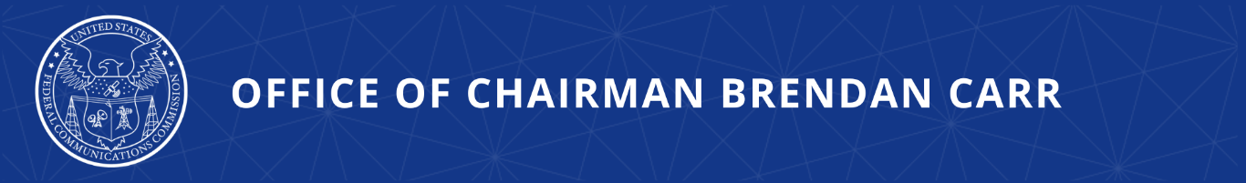

FCC to Ensure Integrity and Security in Electronic Device Testing
Proposed Rules Would Prohibit Using Labs in Countries Without Reciprocal Agreements

WASHINGTON, April 8, 2026—Today, FCC Chairman Brendan Carr announced that the Commission will vote on new rules to ensure integrity, security, and reciprocity in electronic device testing. The proposed rules, which will be voted on at the Commission’s next monthly meeting, follow on the FCC’s actions against “Bad Labs” and would prohibit the recognition of test labs and certification bodies in foreign countries that have not signed agreements to recognize American test labs and certification bodies. Before these proposed rules can be finalized, the FCC will also vote to adopt a streamlined approval process for devices tested in U.S. labs or labs in reciprocal countries.

Chairman Brendan Carr issued the following statement:

“President Trump has revolutionized America’s approach to the world by putting reciprocity at the heart of our international commercial relations. Today, more than 75% of testing occurs in countries that have refused to commit to reciprocal treatment of U.S.-based labs and certification bodies. This month, the FCC will begin the process to end this unfair system.”

Additional Background Information:

Last year, the FCC unanimously adopted rules to prohibit the recognition of test labs and certification bodies owned or controlled by foreign adversaries. Since those rules were adopted, the FCC has taken action to withdraw recognition from, or deny recognition to, twenty-three “Bad Labs” that threatened U.S, national security. This month’s Order and Notice of Proposed Rulemaking (NPRM) is an important next step.

For decades, the FCC only allowed device testing and certification in the U.S. or foreign countries with Mutual Recognition Agreements (MRAs) with the U.S. guaranteeing reciprocal treatment. The Obama Administration abandoned this commitment to reciprocity in 2015, allowing testing and certification to happen anywhere in the world, regardless of the country’s commitment to reciprocity. Testing in such foreign labs undermines FCC oversight and enforcement, threatening the reliability, integrity of the equipment authorization process, which is critical to national security.

The NPRM to be voted on this month proposes to prohibit recognition of all test labs and certification bodies in countries that lack either an MRA with the U.S. or other comparable reciprocal trade agreement. These labs would be phased out over two years. In the meantime, the Order the FCC will vote on this month would create a fast-track priority review process for devices tested in trusted test labs – namely those located in the United States or reciprocal international locations. The Order would also adopt a range of other measures to promote the integrity of the equipment authorization system: require the disclosure of the location and number of employees engaged in FCC-recognized testing, improve the FCC’s post-market surveillance procedures, strengthen enforcement mechanisms, and establish confidential reporting channels for industry participants to raise concerns about violations or national security threats.

The public draft of the proposed Report and Order and NPRM, which will be voted on at their April 30 Open Meeting, will be made available tomorrow at: https://www.fcc.gov/April2026.

###
Media Contact: MediaRelations@fcc.gov / (202) 418-0500
@FCC / www.fcc.gov

