Communications Status Report for
Areas Impacted by Super Typhoon Sinlaku

April 17, 2026

This report provides information on the status of communications services in geographic areas impacted by Super Typhoon Sinlaku, reported as of 6:00 a.m. EDT / 8:00 p.m. Chamorro Standard Time (ChST) on April 17, 2026. This report incorporates network outage data submitted by communications providers to the Federal Communications Commission’s (FCC) Disaster Information Reporting System (DIRS). We note that the operational status of communications services may evolve rapidly during a disaster. The FCC will provide daily updates to this report until DIRS data collection is deactivated for the region.

On April 13, 2026, the FCC activated DIRS for the Commonwealth of the Northern Mariana Islands (CNMI).

On April 15, 2026, the FCC extended the scope of the DIRS activation area to include Guam.

The following municipalities are in the current geographic area that is part of the DIRS activation area (the “disaster area”) for today’s report.

COMMONWEALTH OF THE NORTHERN MARIANA ISLANDS: Rota, Saipan, and Tinian

GUAM: Guam

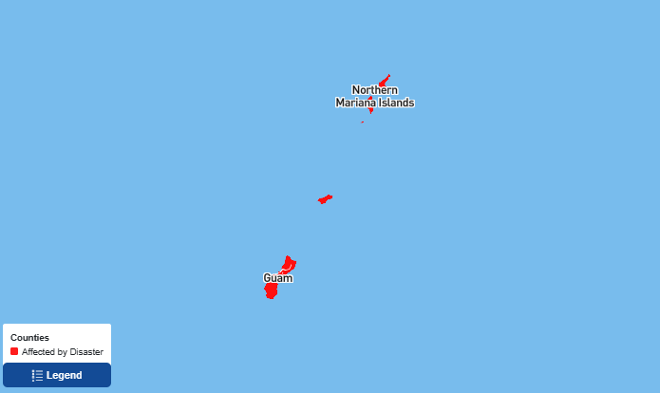

911 Services

The FCC’s Public Safety and Homeland Security Bureau learns about the status of communications services provided to each Public Safety Answering Point (PSAP) through the filings of 911 Service Providers in DIRS, reporting to the FCC’s Public Safety Support Center, in coordination with state and territory 911 Administrators, and, if necessary, direct contact with individual PSAPs.

- There are no PSAPs reported in DIRS as being affected.

Wireless Services

The following section describes the status of wireless communications services in the disaster area as reported in DIRS.

Percent of Cell Sites Out of Service

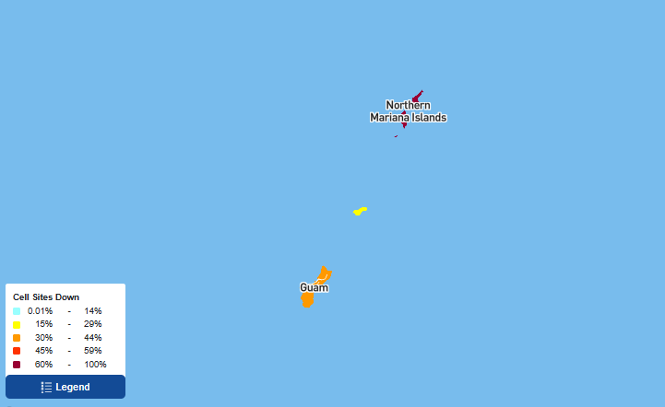

The following table provides cell sites out of service by island. 46.3% of the cell sites in the affected area are out of service. The information shown was provided by communications carriers providing services in Guam and in the CNMI.

Guam/Commonwealth of the Northern Mariana Islands
State | Affected Municipalities | Cell Sites Served | Cell Sites Out | Percent Out | Cell Sites Out Due to Damage | Cell Sites Out Due to Transport | Cell Sites Out Due to Power | Cell Sites Up but On Back-up Power
GU | GUAM | 359 | 152 | 42.3% | 0 | 0 | 152 | 206
MP | ROTA | 11 | 3 | 27.3% | 0 | 0 | 3 | 8
MP | SAIPAN | 75 | 48 | 64% | 1 | 0 | 47 | 27
MP | TINIAN | 9 | 7 | 77.8% | 1 | 0 | 6 | 2
TOTAL | - | 454 | 210 | 46.3% | 2 | 0 | 208 | 243

Please note: some cell site outages may be the result of multiple causes.

The number of cell site outages in a specific area does not necessarily correspond to the availability of wireless service to consumers in that area. Wireless networks are often designed with numerous, overlapping cell sites that provide maximum capacity and continuity of service even when an individual site is inoperable. In addition, wireless providers frequently use temporary facilities, such as cells-on-wheels (also known as COWs), will increase power at operational sites, will initiate roaming agreements, or take other actions to maintain service to affected consumers during emergencies or other events that result in cell site outages.

Cable Systems and Wireline (Combined)

- The FCC has not received any reports in DIRS relating to cable systems or wireline communications in the activation area.

Broadcast

Television station status:

- The FCC has not received any reports in DIRS relating to television stations in the activation area.

FM Radio station status:

- There are no FM radio stations reported as being out of service.

AM Radio station status:

- The FCC has not received any reports in DIRS relating to AM radio stations in the activation area.

Mandatory Disaster Response Initiative

The Mandatory Disaster Response Initiative was activated for Super Typhoon Sinlaku response activities on April 13, 2026. As a reminder, all facilities-based mobile wireless providers operating in the above-referenced areas are hereby notified and required to: (1) provide for reasonable roaming under disaster arrangements when technically feasible; (2) activate mutual aid arrangements with other facilities-based mobile wireless providers for providing aid upon request to those providers during emergencies; (3) take reasonable measures to enhance municipal preparedness and restoration; (4) take reasonable measures to increase consumer readiness and preparation; and (5) take reasonable measures to improve public awareness and stakeholder communications on service and restoration status.

Special Temporary Authority (STA)/Waivers/Extensions

The FCC may grant Special Temporary Authority (STA) to permit immediate or temporary operation of certain radio facilities during emergencies or other urgent conditions, as well as waivers to support emergency communications and service restoration.

- On April 15, 2026, the FCC Wireless Telecommunications Bureau conditionally granted Federated Wireless, Inc.’s request for a precautionary, limited, and conditional emergency waiver of sections 96.67(c)(2) and (3) of the Commission’s rules governing the Citizens Broadband Radio Service. The link(s) for the document are as follows: DA-26-365A1.docx , DA-26-365A1.pdf , DA-26-365A1.txt

The Federal Communications Commission Activates the Disaster Information Reporting System (DIRS) and the Mandatory Disaster Response Initiative (MDRI) in Response to Super Typhoon Sinlaku, Public Notice, DA 26-359 (PSHSB) (rel. April 13, 2026).
The Federal Communications Commission Announces the Expansion of the Disaster Information Reporting System and the Mandatory Disaster Response Initiative in Response to Super Typhoon Sinlaku, Public Notice, DA-26-371 (PSHSB) (rel. April 15, 2026).
See Improving the Resiliency of Mobile Wireless Communications Networks, Order, 31 FCC Rcd 13745, para. 10 (2016) (recognizing the difficulties in accurately depicting the ongoing status of a wireless provider’s service during emergencies).
See 47 CFR § 4.17(a)(3)(i) (detailing criteria for activating roaming under disaster arrangements).
See 47 CFR § 4.17(a)(3)(ii) (explaining what mutual aid arrangements must include).
47 CFR § 4.17(a)(3)(i)-(v); see also FCC, Wireless Network Resiliency During Disasters (June 4, 2024), https://www.fcc.gov/wireless-network-resiliency-during-disasters.

