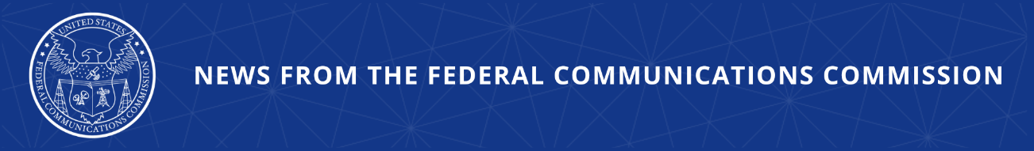

FCC Clears the Way for American Leadership in Next-Gen, Direct-to-Device Connectivity
FCC Establishing Regulatory Framework for Fast Connections Right from Your Smartphone or Device to High-Speed Satellites

WASHINGTON, April 23, 2026—The FCC took two major steps this week to ensure America leads the world in next-gen connectivity. Specifically, the FCC acted to create the regulatory environment that will allow the growing market for direct-to-device (D2D) services—meaning, connectivity provided directly to a smartphone or device from next-gen satellites—to develop and flourish throughout the U.S. These technologies, which promise an end to cellular dead zones and enhanced competition, are drawing widespread interest, innovation, and investment. In the last 18 months alone, there has been more than $28 billion in deal flow across at least 130 megahertz of spectrum that will be used for D2D.

Earlier this week, the FCC’s Space Bureau granted AST SpaceMobile a permanent license to operate the company’s foundational satellite system. With this license, AST is now authorized immediately to deploy its constellation of 248 satellites throughout the United States with D2D offerings, working in partnership with AT&T, Verizon, and FirstNet. AST is one of many satellite companies engaged in fierce competition over this potentially disruptive market.

The FCC is also taking broader action today to preserve regulatory certainty for a host of services and companies that use spectrum to connect satellites with portable devices. Specifically, the Space Bureau has released a decision that reaffirms existing licensees’ exclusive rights to use certain D2D spectrum bands by dismissing the requests of several operators to enter those same bands. The Space Bureau’s decision also dismisses two petitions for rulemaking to change the agency’s time-tested rules on spectrum rights.

By preserving the regulatory certainty necessary for long-term investment in D2D, the FCC is setting the stage for ubiquitous connectivity, the end of coverage gaps, and more robust IoT.

Chairman Brendan Carr issued the following statement:

“Thanks to President Trump, America is leading the world once again in next-generation technologies. That includes positioning the U.S. to lead the way in deploying direct-to-device (D2D) services—meaning, fast and ubiquitous connectivity provided directly form next-gen satellite constellations to your smartphone or device. As competition in this growing market intensifies, American consumers stand to come out ahead as the big winners. That’s why the FCC is laser-focused this year on making our rules as friendly as possible for investment and innovation in D2D services. We are taking important actions this week to give this exciting industry the clarity it needs to build satellite systems and invest in spectrum confidently. And we’re just getting started. Stay tuned for more exciting developments from the FCC’s world-class team to supercharge D2D for the American people.”

Additional Background Information:

Today’s order reaffirms the FCC’s longstanding approach to the “Big LEO” spectrum bands (1610-1626.5 MHz (Earth-to-space) and 2483.5-2500 MHz (space-to-Earth)). While the band plan has been modified periodically, the market access applications and rulemaking petitions dismissed by the FCC today would have upended this structure and undermined the public interest. Today’s order also clarifies the current mobile satellite service (MSS) licensing framework for the 2 GHz and 1.5 GHz bands.

And two days ago, the FCC released an order approving AST SpaceMobile’s request to operate a 248-satellite constellation to provide supplemental coverage from space (SCS). This authorization will allow SCS in low-band frequencies between 700 and 900 MHz held by AT&T, Verizon, and FirstNet. The FCC grant also allows AST to offer D2D outside the United States.

###
Media Contact: MediaRelations@fcc.gov / (202) 418-0500
@FCC / www.fcc.gov

