Communications Status Report for
Areas Impacted by Super Typhoon Sinlaku

April 24, 2026

This report provides information on the status of communications services in geographic areas impacted by Super Typhoon Sinlaku, reported as of 6:00 a.m. EDT / 8:00 p.m. Chamorro Standard Time (ChST) on April 22, 2026. This report incorporates network outage data submitted by communications providers to the Federal Communications Commission’s (FCC) Disaster Information Reporting System (DIRS). We note that the operational status of communications services may evolve rapidly during a disaster. The FCC will provide daily updates to this report until DIRS data collection is deactivated for the region.

On April 13, 2026, the FCC activated DIRS for the Commonwealth of the Northern Mariana Islands (CNMI).

On April 15, 2026, the FCC expanded the scope of the DIRS activation area to include Guam.

On April 23, 2026, the FCC deactivated DIRS for Guam.

The following municipalities are in the current geographic area that is part of the DIRS activation area (the “disaster area”) for today’s report.

COMMONWEALTH OF THE NORTHERN MARIANA ISLANDS: Rota, Saipan, and Tinian

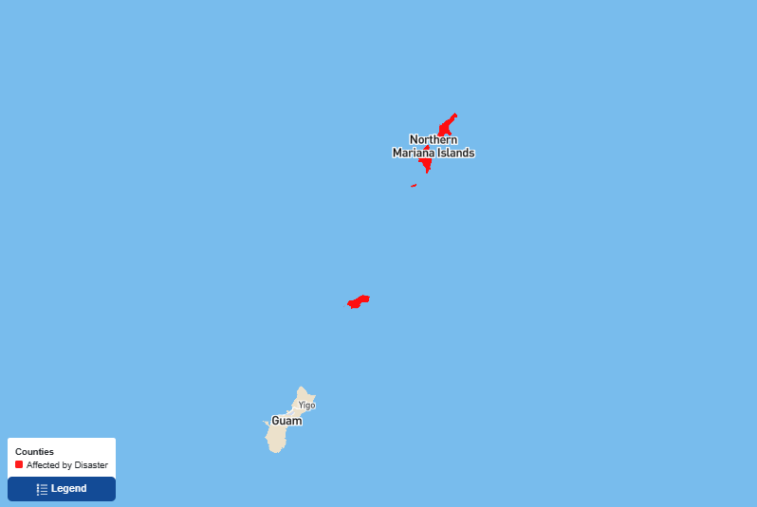

911 Services

The FCC’s Public Safety and Homeland Security Bureau learns about the status of communications services provided to each Public Safety Answering Point (PSAP) through the filings of 911 Service Providers in DIRS, reporting to the FCC’s Public Safety Support Center, in coordination with state and territory 911 Administrators, and, if necessary, direct contact with individual PSAPs.

- There are no PSAPs reported in DIRS as being affected.

Wireless Services

The following section describes the status of wireless communications services in the disaster area as reported in DIRS.

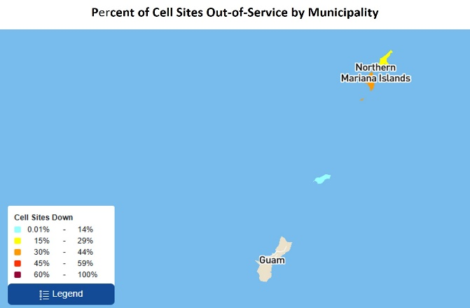
The following table provides cell sites out of service by island. 28.4% of the cell sites in the affected area are out of service. The information shown was provided by communications carriers providing services in the CNMI.

Commonwealth of the Northern Mariana Islands

State | Affected Municipalities | Cell Sites Served | Cell Sites Out | Percent Out | Cell Sites Out Due to Damage | Cell Sites Out Due to Transport | Cell Sites Out Due to Power | Cell Sites Up but On Back-up Power
MP | ROTA | 11 | 1 | 9.1% | 0 | 0 | 1 | 3
MP | SAIPAN | 75 | 22 | 29.3% | 2 | 0 | 20 | 53
MP | TINIAN | 9 | 4 | 44.4% | 1 | 0 | 3 | 5
TOTAL | - | 95 | 27 | 28.4% | 3 | 0 | 24 | 61

Please note: some cell site outages may be the result of multiple causes.

The number of cell site outages in a specific area does not necessarily correspond to the availability of wireless service to consumers in that area. Wireless networks are often designed with numerous, overlapping cell sites that provide maximum capacity and continuity of service even when an individual site is inoperable. In addition, wireless providers frequently use temporary facilities, such as cells-on-wheels (also known as COWs), will increase power at operational sites, will initiate roaming agreements, or take other actions to maintain service to affected consumers during emergencies or other events that result in cell site outages.

Cable Systems and Wireline (Combined)

Cable and wireline companies reported 4,325 subscribers out of service in the disaster area. This includes the loss of telephone, television, and/or Internet services.

Broadcast

Television Station Status:

- The FCC has not received any reports in DIRS on the status of television stations.

FM Radio station status:

- The FCC has not received any reports in DIRS on the status of FM stations.

AM Radio station status:

- The FCC has not received any reports in DIRS on the status of AM stations.

Mandatory Disaster Response Initiative

The Mandatory Disaster Response Initiative was activated for Super Typhoon Sinlaku response activities on April 13, 2026. As a reminder, all facilities-based mobile wireless providers operating in the above-referenced areas are hereby notified and required to: (1) provide for reasonable roaming under disaster arrangements when technically feasible; (2) activate mutual aid arrangements with other facilities-based mobile wireless providers for providing aid upon request to those providers during emergencies; (3) take reasonable measures to enhance municipal preparedness and restoration; (4) take reasonable measures to increase consumer readiness and preparation; and (5) take reasonable measures to improve public awareness and stakeholder communications on service and restoration status.

Special Temporary Authority (STA)/Waivers/Extensions

The FCC may grant Special Temporary Authority (STA) to permit immediate or temporary operation of certain radio facilities during emergencies or other urgent conditions, as well as waivers to support emergency communications and service restoration.

- On April 15, 2026, the FCC Wireless Telecommunications Bureau conditionally granted Federated Wireless, Inc.’s request for a precautionary, limited, and conditional emergency waiver of sections 96.67(c)(2) and (3) of the Commission’s rules governing the Citizens Broadband Radio Service. The link(s) for the document are as follows: DA-26-365A1.docx , DA-26-365A1.pdf , DA-26-365A1.txt

- On April 16, 2026, the FCC Space Bureau issued a STA to SpaceX enabling provision of Supplemental Coverage from Space in Guam and the CNMI.

- On April 23, 2026, FCC Wireline Competition Bureau (WCB) waives certain Lifeline, E-Rate, Rural Health Care, and Contributions rules and deadlines to assist participants and service providers, including Universal Service Fund contributors, located in the areas affected by Typhoon Sinlaku and its immediate aftermath. The link(s) to this waiver are as follows: DA-26-396A1.docx, DA-26-396A1.pdf, and DA-26-396A1.txt.

- On April 23, 2026, to assist telephone customers in Guam and the Commonwealth of the Northern Mariana Islands with the impacts of Super Typhoon Sinlaku, the WCB granted a temporary partial waiver of the Commission’s telephone number “aging” rule, specifically section 52.15(f)(1)(ii) with respect to the maximum aging period for residential customers’ telephone numbers, which states, in pertinent part, that service providers may only age telephone numbers that have been disconnected for up to 90 days before making them available for assignment to other customers. WCB is also encouraging service providers to port telephone numbers to locations that may be outside of a customer’s telephone rate center and to waive certain service charges in order to assist customers experiencing this disaster. The link(s) to this waiver are as follows: DA-26-397A1.docx , DA-26-397A1.pdf , DA-26-397A1.txt

The Federal Communications Commission Activates the Disaster Information Reporting System (DIRS) and the Mandatory Disaster Response Initiative (MDRI) in Response to Super Typhoon Sinlaku, Public Notice, DA 26-359 (PSHSB) (rel. April 13, 2026).
The Federal Communications Commission Announces the Expansion of the Disaster Information Reporting System and the Mandatory Disaster Response Initiative in Response to Super Typhoon Sinlaku, Public Notice, DA-26-371 (PSHSB) (rel. April 15, 2026).
See Improving the Resiliency of Mobile Wireless Communications Networks, Order, 31 FCC Rcd 13745, para. 10 (2016) (recognizing the difficulties in accurately depicting the ongoing status of a wireless provider’s service during emergencies).
See 47 CFR § 4.17(a)(3)(i) (detailing criteria for activating roaming under disaster arrangements).
See 47 CFR § 4.17(a)(3)(ii) (explaining what mutual aid arrangements must include).
47 CFR § 4.17(a)(3)(i)-(v); see also FCC, Wireless Network Resiliency During Disasters (June 4, 2024), https://www.fcc.gov/wireless-network-resiliency-during-disasters.

