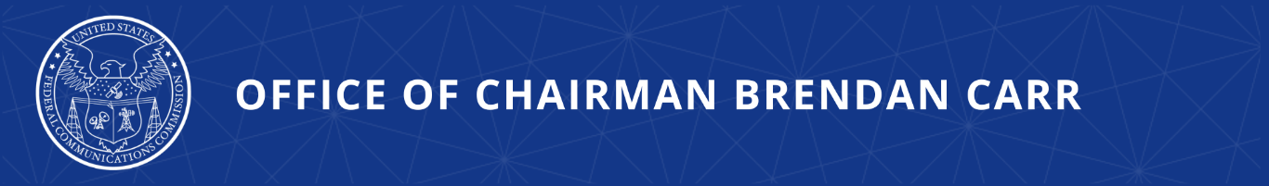

FCC to Vote on Requiring Carriers to Take Stronger Actions to Combat Illegal Robocalls
‘Know Your Upstream Provider’ Proposed Rulemaking on May Open Meeting Agenda

WASHINGTON, April 28, 2026—Today, FCC Chairman Brendan Carr proposed new tools to combat robocalls before they reach consumers and bolster caller ID authentication. The proposals, if adopted by a vote of the full Commission at its May Open Meeting, would remove voice service providers from U.S. networks when they enable illegal robocalls and enhance oversight and standards in the implementation of the STIR/SHAKEN framework. To do so, the Chairman proposes enhanced “know-your-upstream-provider” requirements to remove bad actors who enable robocalls.

Chairman Carr issued the following statement:

“We must bring meaningful robocall relief to consumers. The FCC is attacking the problem of illegal robocalls at every point in the call path in order to help consumers and restore trust in America’s voice networks. These proposals set the stage for significant advancement toward those goals by aiming to get providers to take accountability and step up their game in our shared battle against illegal robocalls.”

Additional Background Information:

The Notice of Proposed Rulemaking proposed by the Chairman offers enhanced solutions to combat illegal calls and protect consumers. The proposals seek to:
- Cut voice service providers that enable robocalls out of the voice ecosystem through improved “know-your-upstream-provider” requirements and STIR/SHAKEN oversight;
- Raise the standards for how voice service providers apply STIR/SHAKEN attestations to calls so attestations are more trustworthy; and
- Close STIR/SHAKEN implementation loopholes.

These proposals are aimed at improving the FCC-mandated STIR/SHAKEN framework, which deters impermissible number spoofing, supports call traceback efforts, and informs providers’ call analytics engines that are used to make call blocking and labeling decisions. Requirements to comply with this framework are enforced by the FCC’s Robocall Mitigation Database where all voice service providers must be registered to participate in domestic phone networks and can be removed by the FCC for insufficient efforts to stop scam calls. The FCC also has rules requiring providers to perform due diligence in reviewing the customers and providers from which they accept call traffic. Together, these tools empower responsible providers to protect consumers and pushes out providers that do not meet their obligations.

###
Media Contact: MediaRelations@fcc.gov / (202) 418-0500
@FCC / www.fcc.gov

