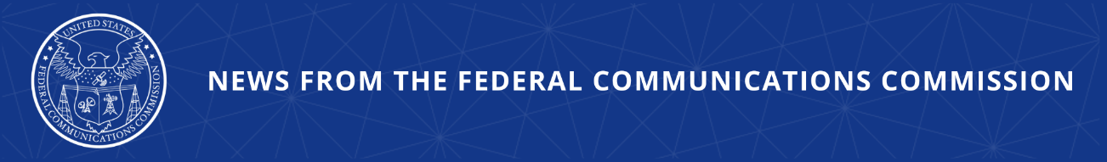

FCC Proposes Strengthening ‘Know-Your-Customer’ Rules
Commission Aims to Enhance Consumer Protection and Stop Illegal Calls Before They Reach American Households and Businesses

WASHINGTON, April 30, 2026—In an effort to stop illegal calls before they ever reach the American people, the Federal Communications Commission today adopted an item seeking to strengthen its “Know-Your-Customer” (KYC) rules for voice service providers. By screening new and renewing customers, originating voice service providers are in the best position to prevent scammers and other bad actors from flooding telecommunications networks with illegal calls.

Stopping illegal calls is the FCC’s top consumer protection priority, and the agency is taking a holistic approach by attacking them at every point in their lifecycle. This includes stopping illegal calls before they enter the phone network, requiring providers to block unwanted or illegal calls, and giving consumers more information about the calls they receive.

In today’s Further Notice of Proposed Rulemaking, the FCC is seeking comment on clearer, more rigorous customer verification standards. Potential measures include new requirements for providers to verify customer identities—including name, address, government ID, and alternative phone numbers—before enabling service.

Commission rules already require originating providers to take “affirmative, effective” measures to “know its customers,” and ensure that its services are not used to originate illegal call traffic. Yet some providers are not doing enough, resulting in more illegal calls that defraud Americans and making it difficult to hold the criminals making these call accountable.

The Commission also seeks comment on how to assess and enforce violations of the KYC rules based on the number of illegal calls placed to ensure that penalties are in line with the harm caused by callers. The Commission also asks how enhancing KYC requirements can prevent or deter other criminal uses of communications networks.

Action by the Commission April 30, 2026 by Further Notice of Proposed Rulemaking (FCC 26-27). Chairman Carr, Commissioners Gomez and Trusty approving. Chairman Carr and Commissioner Trusty issuing separate statements.

CG Docket Nos. 17-59, 02-278

###
Media Contact: MediaRelations@fcc.gov / (202) 418-0500
@FCC / www.fcc.gov

