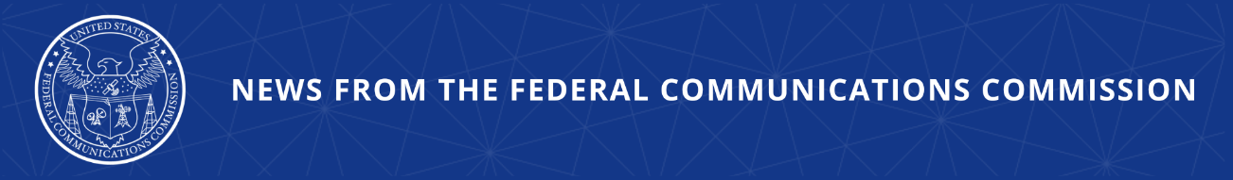

FCC Looks to Prohibit Electronic Device Testing Using Labs in Countries Without Reciprocal Agreements
New Rules Streamline Approval Process for Devices Tested in Trusted Labs

WASHINGTON, April 30, 2026—Today, the Federal Communications Commission voted to launch a rulemaking which proposes prohibiting the recognition of electronic device test labs and certification bodies in foreign countries that have not signed reciprocity agreements to recognize American test labs and certification bodies. The FCC also adopted new rules streamlining the approval process for devices that are tested in U.S. labs or labs in reciprocal countries. Test labs review electronic devices for sale and use in the United States as part of the FCC’s equipment authorization program.

Today’s actions help ensure integrity, security, and reciprocity in electronic device testing. Until 2015, the FCC only allowed device testing and certification in the U.S. or foreign countries with Mutual Recognition Agreements (MRA) with the U.S., guaranteeing reciprocal treatment. The new rules and the proposed rules adopted today look to restore – and improve upon – this successful policy in order to bolster FCC oversight and enforcement, strengthen the reliability and integrity of the FCC’s equipment authorization process, and prioritize national security.

The Notice of Proposed Rulemaking adopted today will seek comment on the proposed prohibition of recognizing any test labs and certification bodies in countries that lack either an MRA with the U.S. or other comparable reciprocal trade agreement. Under this proposal, these labs would be phased out over two years after any final rules were adopted and implemented.

In addition, the FCC adopted an Order to create a fast-track priority review process for devices tested in trusted test labs – namely those located in the United States or reciprocal international locations. The Order would also adopt a range of other measures to promote the integrity of the equipment authorization system: require the disclosure of the location and number of employees engaged in FCC-recognized testing, improve the FCC’s post-market surveillance procedures, strengthen enforcement mechanisms, and establish confidential reporting channels for industry participants to raise concerns about violations or national security threats.

Today’s action follows last year’s FCC adoption of rules to prohibit the recognition of test labs and certification bodies owned or controlled by foreign adversaries. Since those rules were adopted, the FCC has taken action to withdraw recognition from, or deny recognition to, twenty-three “Bad Labs” that threatened U.S. national security.

Action by the Commission April 30, 2026 by Second Report and Order, Order on Reconsideration, and Second Further Notice of Proposed Rulemaking (FCC 26-28). Chairman Carr, Commissioners Gomez and Trusty approving. Chairman Carr and Commissioner Trusty issuing separate statements.

ET Docket No. 24-136

###
Media Contact: MediaRelations@fcc.gov / (202) 418-0500
@FCC / www.fcc.gov

