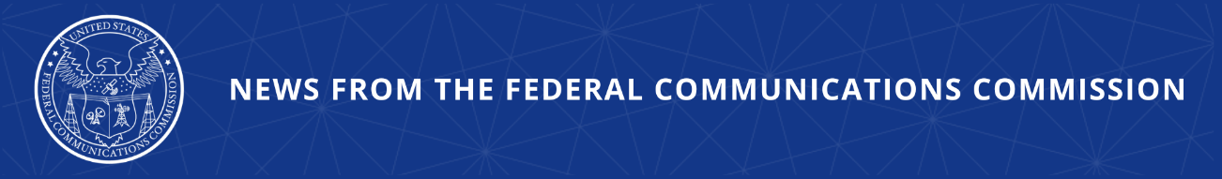

FCC Adopts Rules to Enhance the Integrity of the E-Rate Program
Today’s Action will Bring Greater Transparency and Consistency to the Bidding Process

WASHINGTON, April 30, 2026—Today, the Federal Communications Commission adopted rules to enhance the integrity of the E-Rate program by amending its rules and establishing a new competitive bidding portal and document repository. Today’s action will assist E-Rate applicants with program compliance and decrease the risk of waste, fraud, and abuse in the E-Rate program. The Commission is also taking actions to simplify and streamline the E-Rate processes and procedures, while giving greater flexibility for both applicants and service providers.

The E-Rate program provides support to ensure that schools and libraries can obtain affordable, high-speed broadband services and internal connections. The Commission is committed to the responsible stewardship of E-Rate funds and protecting against waste, fraud, and abuse, and an open competitive bidding process is a cornerstone of, and fundamental, to the integrity of the E-Rate program. This action brings greater transparency and consistency to the competitive bidding process, helping ensure schools and libraries receive the most cost-effective services.

Additional Background Information:

Today’s Report and Order and Order on Reconsideration will create and implement a competitive bidding portal and repository for the funding year 2028 competitive bidding cycle, beginning July 1, 2027. Specifically, it will require prospective service providers to submit bids responding to applicants’ requests for bids and require applicants to upload competitive bidding documentation, including bid evaluations, vendor selection documentation, and contracts to the portal. This action will consolidate where information is provided and stored, creating a centralized repository which will reduce the need for applicants to respond to documentation requests from the Commission and the E-Rate program administrator.

Today’s action also includes rule changes to simplify and streamline E-Rate processes for applicants and service providers, including refining procedures for applicants transitioning service providers, eliminating unnecessary paperwork, and providing greater flexibility to refile rejected requests for reimbursement.

Action by the Commission April 30, 2026 by Report and Order and Order on Reconsideration (FCC 26-30). Chairman Carr and Commissioner Trusty approving. Commissioner Gomez approving in part and dissenting in part. Chairman Carr, Commissioners Gomez and Trusty issuing separate statements.

WC Docket 21-455; CC Docket 02-6

###
Media Contact: MediaRelations@fcc.gov / (202) 418-0500
@FCC / www.fcc.gov

