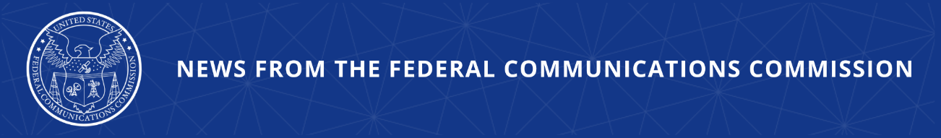

FCC Proposes Enhanced ‘Know-Your-Upstream-Provider’
Requirements to Combat Illegal Robocalls
Launches Agency’s Latest Efforts to Bring Meaningful Robocall Relief to Consumers by Attacking Illegal Robocalls at Every Point in the Call Path

WASHINGTON, May 20, 2026—The Federal Communications Commission today proposed new, more specific Know-Your-Upstream-Provider (“KYUP”) requirements to hold voice service providers accountable for ensuring bad actor providers are eliminated from the voice ecosystem. The proposal also looks to enhance the STIR/SHAKEN framework to ensure that caller ID authentication is broadly implemented and maximally effective at deterring illegal robocalls.

The proposed enhanced KYUP requirements are designed to expose providers that enable illegal calls and root them out of the voice ecosystem. Today, voice service providers have a general obligation to know the providers that send them voice traffic, but some providers evade or ignore this obligation, permitting bad actors to use their network or services to transmit illegal calls that defraud consumers. The proposal seeks to raise the bar to ensure that all voice service providers in a call path are vetted. Under the proposal, providers would be required to collect information about upstream providers, verify that information, monitor their upstream providers’ traffic and practices, and refuse or discontinue service when the evidence shows an upstream provider is a bad actor.

The proposed enhancements to the STIR/SHAKEN caller ID authentication framework are aimed at strengthening its value as an important element in the FCC’s effort to combat illegal calls. STIR/SHAKEN deters impermissible number spoofing, supports call traceback efforts, and informs providers’ call analytics engines that are used to make call blocking and labeling decisions. While effective when consistently and properly implemented, not all providers are fulfilling this obligation. The proposals in the Notice of Proposed Rulemaking are designed to enhance oversight of providers’ implementation of STIR/SHAKEN, raise the standards for how providers assign STIR/SHAKEN attestations to calls so they are more trustworthy, and close implementation loopholes.

These proposed enhancements build on the FCC’s comprehensive effort to protect consumers and restore trust in voice communications by combatting calls at every point in the call path. Other important actions include proposals to empower consumers with caller identity information that they can use in deciding which calls to answer, prevent illegal foreign-originated calls from reaching consumers, and enhance providers’ obligations to perform due diligence of their customers before they originate their calls. Each of these add to existing call blocking obligations, the FCC’s Robocall Mitigation Database, in which all voice service providers must be registered to access and participate in the voice ecosystem, and targeted enforcement actions.

Action by the Commission May 20, 2026 by Further Notice of Proposed Rulemaking (FCC 26-32). Chairman Carr, Commissioners Gomez and Trusty approving and issuing separate statements.

WC Docket No. 17-97; CG Docket No. 17-59

###
Media Contact: MediaRelations@fcc.gov / (202) 418-0500
@FCC / www.fcc.gov

