

Media Contact:
TrustyPress@fcc.gov

For Immediate Release

COMMISSIONER TRUSTY HIGHLIGHTS IMPORTANCE OF U.S. COMMUNICATIONS LEADERSHIP DURING NEBRASKA VISIT
Trip underscores the vital role of advanced communications in national defense, public safety, and Americans’ daily lives
--
WASHINGTON, May 27, 2026 – FCC Commissioner Olivia Trusty today released the following statement after returning from a visit to Nebraska hosted by Senator Deb Fischer, where she met with government, military, nonprofit, and private-sector stakeholders working to strengthen U.S. leadership in advanced communications technologies.
“During my recent trip to Nebraska, I saw firsthand the critical role advanced communications technologies play in keeping Americans safe and connected, including in some of the nation’s most rural communities,” said Commissioner Trusty. “I am grateful to Senator Fischer for hosting this informative visit and for her continued leadership on these important issues.”
Commissioner Trusty began her visit at U.S. Strategic Command (STRATCOM) at Offutt Air Force Base, where she received briefings on STRATCOM’s mission and the work of the Joint Electromagnetic Spectrum Operations Center. Discussions focused on ensuring the U.S. military can operate effectively in contested electromagnetic environments and maintain America’s technological edge against emerging threats.
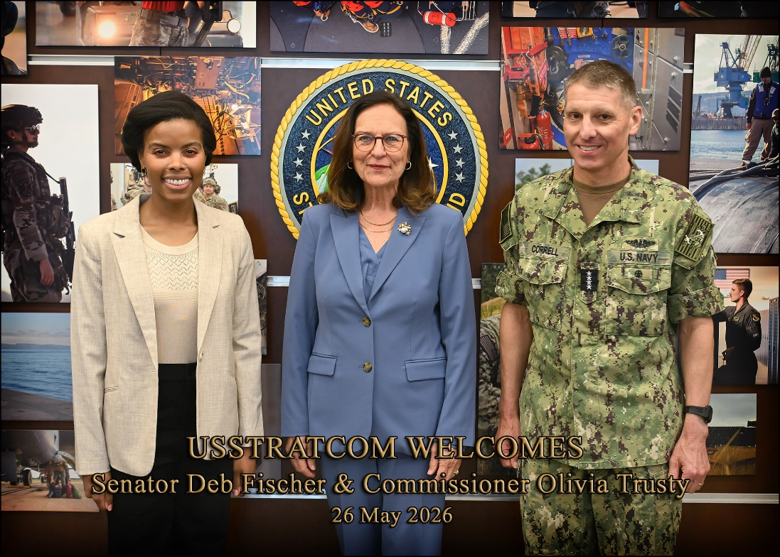
Commissioner Trusty also visited Boys Town, where staff from Boys Town and Cox Communications demonstrated how wired and wireless connectivity support education, health research, and essential crisis-response services, including the Boys Town Hotline that provides a critical youth resource and supports the 988 Suicide & Crisis Lifeline.
Commissioner Trusty later participated in a rural broadband roundtable hosted by the Nebraska Telecommunications Association alongside broadband providers, broadband customers, and Commissioners from the Nebraska Public Service Commission. Participants discussed the transformative impact of broadband connectivity in rural communities, the importance of accurate broadband mapping and data, and the need for coordinated federal and state funding programs to support deployment and ensure rural Americans can fully benefit from emerging technologies, including Artificial Intelligence.
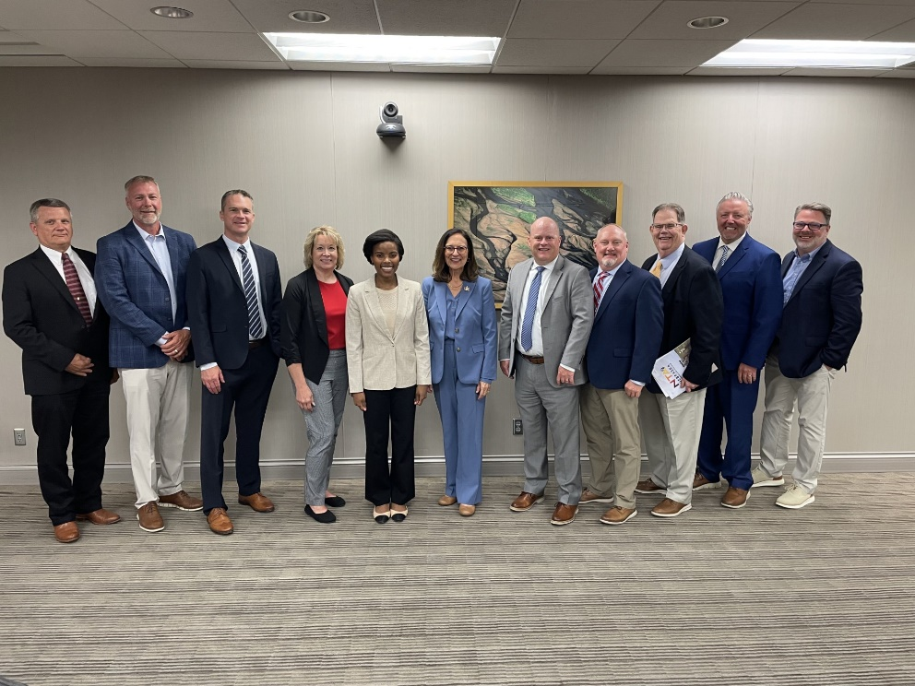
The Commissioner also met with public safety officials and emergency response stakeholders to discuss how fiber, wireless, and satellite technologies work together to support resilient communications during emergencies and natural disasters.
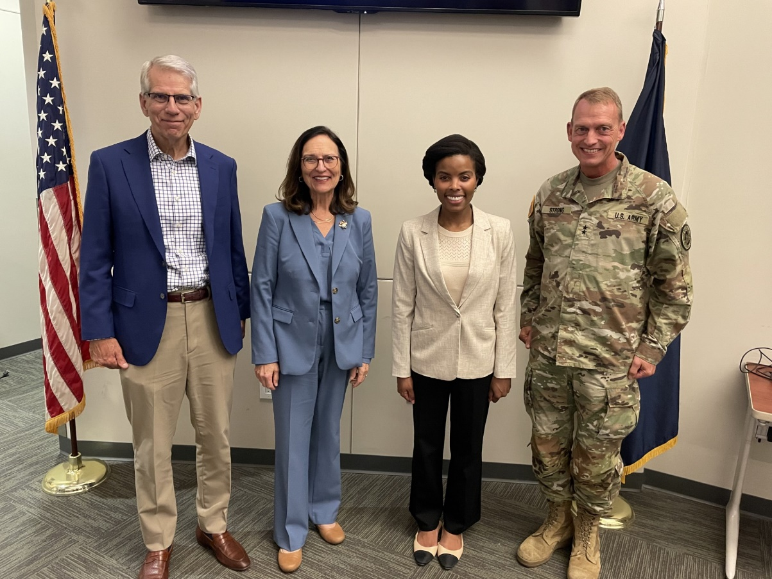
“In Nebraska, I saw how advanced communications technologies are essential not only to Americans’ ability to participate in modern life, but also to protecting communities from both malicious threats and natural disasters,” Commissioner Trusty said. “These experiences reinforced my commitment to the FCC’s mission of expanding connectivity for all Americans – including those in rural communities – and advancing U.S. leadership in communications services and technologies.”

###
Office of Commissioner Trusty: (202) 418- 2300 / Twitter: @OliviaTrustyFCC / www.fcc.gov/about/leadership/olivia-trusty

This is an unofficial announcement of Commission action. Release of the full text of a Commission order constitutes official action. See MCI v. FCC, 515 F.2d 385 (D.C. Cir. 1974).

