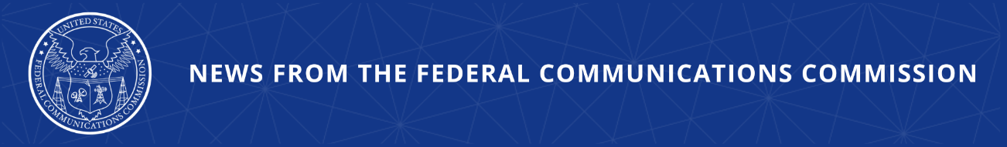

FCC Cuts Off Provider That Transmitted Walmart-Impersonation Robocalls
Action Prevents Company from Connecting with U.S. Networks

WASHINGTON, June 12, 2026—Today, the Federal Communications Commission prohibited a bad actor voice service provider from continuing to connect to U.S. networks. Specifically, the FCC mandated that U.S. voice service providers and intermediate providers block calls from SK Teleco LLC for repeated violations of the Commission’s robocall rules. The Commission also removed the company from the Robocall Mitigation Database. All providers immediately downstream of SK Teleco must begin blocking calls from SK Teleco within 30 days. Providers may choose to initiate blocking within 48 hours consistent with Commission rules.

Patrick Webre, Chief of the Enforcement Bureau issued the following statement:

“Eliminating fraudulent robocalls demands industry-wide cooperation, meaning every telecom provider must actively police and take responsibility for the traffic on their networks. The FCC is aggressively intensifying its crackdown on illegal robocalls by deploying new, advanced tactics across the telecom landscape. Today’s enforcement action shuts down another rogue provider that has consistently failed to police its network and protect consumers."

Additional Background Information:

The FCC’s Robocall Mitigation Database was established to promote transparency and effective robocall mitigation. This database is a critical tool through which the agency ensures providers are actively combatting robocalls and implementing STIR/SHAKEN caller ID authentication. Providers are required to certify that they have implemented STIR/SHAKEN on all IP-based portions of their networks. All providers must also submit robocall mitigation plans. Failure to meet these obligations may result in removal from the database and blocking of the provider’s traffic.

In 2025, the Industry Traceback Group (ITG) conducted tracebacks on several Walmart impersonation-calls in response to consumer complaints and determined that SK Teleco was the originating provider for the calls. The ITG notified SK Teleco of these calls and provided it access to supporting data identifying each call. SK Teleco did not contest that it had originated the calls and it did not provide the ITG with proof of the requisite consent for the calls. SK Teleco certified in its RMD filing that it would respond within 24 hours to all traceback requests and cooperate with the FCC and the ITG in investigating and stopping any illegal robocallers that use its service to originate calls. However, SK Teleco failed to respond to traceback requests from the ITG for each of the calls.

Today’s action follows the Enforcement Bureau’s December 2, 2025 Notification of Suspected Illegal Traffic, and the April 20, 2026 Initial Determination Order and Order to Show Cause. SK Teleco did not sufficiently respond to the Notice and did not file any response to the Initial Determination Order. As a result, the company is removed from the RMD and will not be permitted to re-file a certification without the prior approval of the FCC’s Enforcement and Wireline Competition Bureaus.

###
Media Contact: MediaRelations@fcc.gov / (202) 418-0500
@FCC / www.fcc.gov

