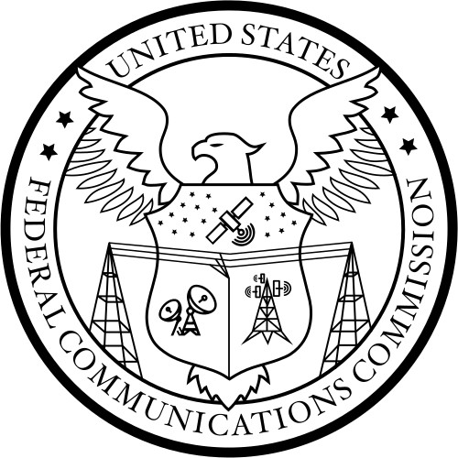 PUBLIC NOTICE
Federal Communications Commission News media Information 202-418-0500 45 L Street, NE Internet: https://www.fcc.gov
Washington, D.C. 20554 ftp.fcc.gov

Report No. 3234 Released: June 23, 2026

PETITIONS FOR RECONSIDERATION OF ACTION IN PROCEEDING

Petitions for Reconsideration have been filed in the Commission’s proceeding listed in this Public Notice and published pursuant to 47 CFR Section 1.429(e). The full text of these documents is available for viewing on the ECFS database, https://www.fcc.gov/ecfs. Oppositions to Petitions for Reconsideration must be filed within 15 days of the date of publication of this Public Notice in the Federal Register. See Section 1.4(b)(1) of the Commission’s rules (47 CFR § 1.4(b)(1)). Replies to an Opposition must be filed within 10 days after the time for filing Oppositions has expired.

Subject: Modernizing Spectrum Sharing for Satellite Broadband
(SB Docket No. 25-157)
Filed By: - Brenna Sparks on behalf of DIRECTV, LLC (Filed 6/12/2026)

- FCC -

