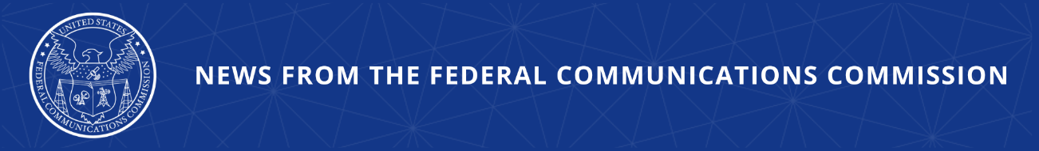

FCC Modernizes Next Generation 911 Reliability and Interoperability
Action Will Strengthen Communications Networks and Reduce Risk of 911 Outages

WASHINGTON, June 25, 2026—Today, the Federal Communications Commission implemented rules to ensure that emerging Next Generation 911 (NG911) networks are reliable and interoperable. NG911 is replacing legacy 911 technology across the country with Internet Protocol (IP)-based infrastructure that will support new 911 capabilities, including text, video, and data. In order for NG911 to be fully effective, NG911 networks must be designed to safeguard the reliability of critical components and support the interoperability needed to seamlessly transfer 911 calls and data from one network to another.

As the nation has embarked on the transition to NG911 over the last decade, the Commission has seen a corresponding increase in major, multi-state 911 service outages that have disrupted access to life-saving emergency services for millions of Americans. Too often, these outages have occurred in parts of transitional NG911 systems outside the scope of the 911 reliability framework adopted in 2013, which does not address the increasingly complex array of call scenarios in IP-based network architectures that exist today. In many of these instances, operators could have prevented or mitigated outages by implementing reliability measures appropriate for IP-based systems.

The new rules reduce the risk of 911 outages by ensuring that evolving all-IP systems support the reliability of NG911 and requiring entities whose operations are essential to NG911 call delivery to have necessary reliability and redundancy measures in place. The rules modernize and streamline the 911 reliability standards applicable to covered providers to reflect widely recognized reliability best practices appropriate to IP-based 911 networks.

The Commission also requires providers to report on their implementation of NG911 interoperability. In the accompanying Second Further Notice of Proposed Rulemaking, the Commission proposed to require interstate interoperability testing and is seeking comment on how 911 authorities can integrate advanced video calling into NG911 networks to improve accessibility.

Action by the Commission June 25, 2026 by Second Report and Order and Second Further Notice of Proposed Rulemaking (FCC 26-39). Chairman Carr, Commissioners Gomez and Trusty approving. Chairman Carr and Commissioner Gomez issuing separate statements.

PS Docket Nos. 21-479, 13-75

###
Media Contact: MediaRelations@fcc.gov / (202) 418-0500
@FCC / www.fcc.gov

