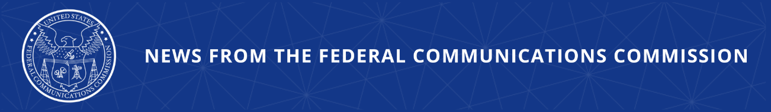

FACT SHEET: Supporting State, Local, and Tribal Efforts to Counter Drone Threats
FCC Takes Quick Action to Support Implementation of SAFER SKIES Act

The Federal Communications Commission today took a number of expedited steps to support implementation of the SAFER SKIES Act and promote public safety leading into the July 4th weekend and America 250 celebrations. Just yesterday, the Department of Homeland Security and Department of Justice issued an Interim Final Rule establishing the framework for state, local, Tribal, and territorial (SLTT) law enforcement and correctional agencies to conduct C-UAS operations under the SAFER SKIES Act. The series of actions taken today by the FCC advances the coordinated federal effort to implement the SAFER SKIES Act by clarifying the legal authority and providing guidance that enable SLTT law enforcement and correctional agencies operating under that Act to take effective counter-drone measures. These include waiving rules to allow the marketing and importation of counter-drone equipment; granting temporary spectrum authority to permit SLTT counter-drone actions in the near term; and clarifying that certain activities related to testing and use of counter-drone technology are permitted under the Communications Act.

What Took Place Today

The Commission issued a series of actions and guidance today, including:

- Sale and Importation Equipment Waiver: The Office of Engineering and Technology (OET) issued an Order waiving the FCC’s equipment authorization rules to allow manufacturers and vendors to market and import, and SLTT law enforcement and correctional agencies to operate, counter-unmanned aircraft systems (C-UAS) equipment that is included on the SAFER SKIES Act’s Authorized Systems List prior to such equipment receiving an FCC equipment authorization.

- Blanket Temporary Spectrum Authority: All FCC Bureaus and Offices that license spectrum released an order jointly providing broad temporary spectrum authorization for SLTTs to deploy C-UAS systems on the Authorized Systems List, recognizing that these authorized C-UAS systems rely on a range of spectrum bands that will continue to evolve in response to emerging UAS threats.

- Counter-Drone Operations by Local Authorities: The Wireless Telecommunications Bureau (WTB) issued a Declaratory Ruling addressing when C-UAS operations are exempt from the statutory prohibition against willful or malicious interference under section 333 of the Communications Act. WTB clarified that section 333 does not apply to federal government entities, and that non-federal parties, including SLTT authorities or federal contractors, testing or operating C-UAS signal jamming on behalf of or under the oversight of the federal government will similarly not be liable under section 333. WTB clarified that SLTT law enforcement and correctional agency personnel may engage in C-UAS signal jamming under the authority of the SAFER SKIES Act without section 333 liability.

- Facilitating Experimental Testing of C-UAS Equipment: WTB and OET issued a Declaratory Ruling making clear that parties testing C-UAS signal jammers under FCC experimental authorization do not violate section 333 to the extent they control and operate both the jamming equipment and the UAS to be jammed. This provides legal certainty for manufacturers to develop and test critical C-UAS technologies.

How It Keeps Americans Safe

Unmanned aircraft systems (UAS), otherwise known as drones, are a transformative technology with the potential to enhance public safety and promote innovation. At the same time, drones in the hands of criminals, hostile foreign actors, and terrorists can pose serious threats to the homeland. The steps the FCC took today support a coordinated federal effort that empowers trained state, local, Tribal, and territorial law enforcement and corrections officials to use counter-drone technologies in the face of credible threats to our communities.

National Security Agenda

The United States faces a persistent threat from foreign adversaries who seek to undermine America’s global technology leadership. With the creation last year of the FCC’s Council on National Security, the FCC has made great strides to counter these threats. This includes improving American cyber, AI, and network security, as well as cracking down on dangerous entities, equipment, and services that are identified on the FCC’s Covered List, including certain foreign-produced UAS and UAS critical components, which pose an unacceptable national security risk. Today’s actions further that agenda by helping put critical counter-drone technology in the hands of trained local law enforcement officials on the front lines of protecting the safety and security of American communities.

SAFER SKIES Act

In December 2025, Congress passed the SAFER SKIES Act as part of the FY2026 National Defense Authorization Act, expanding counter-drone authority to SLTT law enforcement and corrections officials. The law empowers trained local officials to detect, track, disable, or seize drones that pose a credible threat to people, facilities, and assets, major events, critical infrastructure, and correctional facilities. On July 1, 2026, the Department of Homeland Security and Department of Justice issued an Interim Final Rule codifying the framework that enables SLTT law enforcement and corrections agencies to conduct C-UAS operations under the SAFER SKIES Act. Among other things, the framework provides the training and certification, authorized technologies, and compliance requirements for SLTT agencies exercising C-UAS authority.

###

Released: July 2, 2026
Media Contact: MediaRelations@fcc.gov / (202) 418-0500
@FCC / www.fcc.gov

