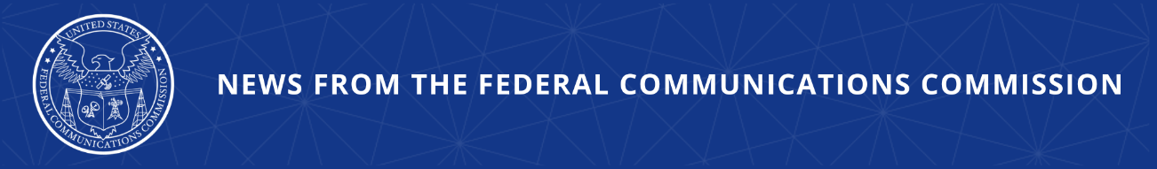

FCC Announces Agreement Strengthening Payola Protections for Artists
Rigorous Reporting and Disclosure Requirements Ensure Artists Get a Fair Deal

WASHINGTON, July 9, 2026—Today, the FCC announced that iHeartMedia, Inc. has agreed to enter into a consent decree with the agency. The agreement resolves an investigation the FCC’s Enforcement Bureau launched last year into iHeartMedia’s compliance with federal rules that prohibit a practice known as payola. One form of payola, sometimes called “showola,” involves a radio station pressuring artists to perform at station-hosted music shows or festivals for free or for reduced compensation in exchange for more favorable airtime for their songs. iHeartMedia is the largest owner of radio stations in the United States and hosts live events and festivals around the country, including ones that feature artists that get airtime on iHeart stations. This agreement implements rigorous reporting and disclosure procedures to provide the Commission with additional insight into the relationship between spins on air and performances at live events—ensuring no prohibited pressure or relationships.

This action is consistent with the FCC’s broader policy of ensuring that artists are treated fairly. It is against federal law to use the threat of manipulated airtime to unduly pressure artists to perform at live events for free or for reduced compensation. Today’s announcement also serves to remind artists of their existing rights under payola and showola laws. Artists may report suspected violations of the FCC’s payola rules to payola@fcc.gov.

Chairman Brendan Carr issued the following statement:

“The FCC is committed to ensuring that artists—especially up-and-coming ones—get a fair shake in their dealings with the broadcast industry. Artists’ talent and the listening public should determine their success. Today’s agreement adds significant new protections and offers the FCC greater transparency to ensure that artists retain their right to decide when and where they will perform. Artists have every right to ensure that the radio industry complies with the payola and showola regulations that protect them.”

Additional Background Information:

Payola is the unreported payment or acceptance of any money, service, or valuable consideration in exchange for airplay for any programming. Anyone who has paid, accepted, or agreed to pay or accept such payments must report that fact to the station licensee before the involved matter is broadcast. Further, licensees must announce that the matter contained in the program is paid for, and to disclose the identity of the person furnishing the money or other valuable consideration. As part of this agreement, iHeartMedia will designate an internal compliance officer, develop and implement procedures for training, produce regular reports to the FCC, and establish a whistleblower hotline for any employee who suspects wrongdoing.

On January 30, 2025, Senator Marsha Blackburn alerted the FCC of a potential new payola practice where radio stations and networks offer more airtime for an artist’s songs if the artist performs a free show, with an implicit suggestion that declining to perform could result in reduced airplay. On February 6, 2025, the FCC’s Enforcement Bureau then issued an Enforcement Advisory reminding broadcast licensees that payola is not only a violation of the United States Criminal Code, but may also subject broadcasters to sanctions under the Communications Act. The FCC takes claims of payola violations seriously and will continue to investigate evidence or allegations of payola violations.

###
Media Contact: MediaRelations@fcc.gov / (202) 418-0500
@FCC / www.fcc.gov

