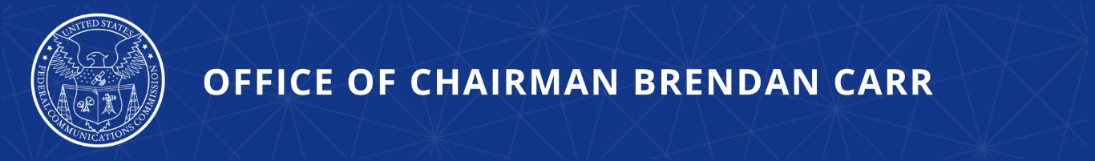

Chairman Carr Proposes to Expand Direct-to-Device Satellite Broadband Connectivity to Unlicensed Wireless Devices
Proceeding Also Proposes Allowing Unlicensed Wireless Devices to Operate on Spacecrafts

WASHINGTON, July 15, 2026—FCC Chairman Brendan Carr today proposed a new proceeding to explore new avenues to allow innovative unlicensed wireless devices to communicate directly with satellites. With the transformative wave of investment and innovation in recent years around direct-to-device (“D2D”) services, this proceeding will look at the more than 225 megahertz of unlicensed spectrum to potentially support the capacity requirements and complement other bands for D2D services. The proposal would also clarify that using equipment authorized under the FCC’s part 15 rules for unlicensed wireless devices is permitted within FCC-authorized spacecraft.

Since the Commission adopted its pioneering framework to enable Supplemental Coverage from Space, consumers have benefitted from the ubiquitous – and often lifesaving – connectivity that D2D provides in areas with inadequate cellular coverage. The proposed Notice of Proposed Rulemaking would, if adopted by the Commission at its next August Open Meeting, examine potential reforms to enable devices operating in some of the part 15 bands to communicate with FCC-authorized satellites, whether on an uplink or downlink basis.

Chairman Carr issued the following statement:

“President Trump has pushed to restore America’s leadership in next-gen tech. That is exactly what the FCC has been doing—ensuring that our nation’s consumers are the first in the world to benefit from this emerging technology. Direct-to-device means fast and ubiquitous connectivity provided directly from next-gen satellite constellations to your smartphone or device. Coupling that resource with the innovation hotbed that is our unlicensed wireless device ecosystem could be a game changer. This new effort brings together two of the most cutting-edge areas of wireless technology in ways that can help bring connectivity to ‘dead zones’ and open doors to tomorrow’s tech ideas.”

Additional Background Information:

Devices operating under the FCC’s part 15 rules for unlicensed wireless devices are widely used by businesses and consumers and include Wi-Fi and Bluetooth transmitters for wireless local area connectivity, medical imaging devices, wireless microphones, automobile and garage door opener remote controls, and IoT sensors. By eliminating the burden and cost to obtain a Commission spectrum license, the FCC’s part 15 rules have spurred innovation in new devices and applications without creating significant risk of harmful interference to licensed and unlicensed services. Unlocking unlicensed bands for D2D promises to open up new services that seamlessly integrate devices across terrestrial and satellite platforms and provide consumers with another option for connectivity.

More than $40 billion has coursed through the American space economy for D2D since the Commission adopted its Supplemental Coverage from Space framework. In 2025, SpaceX acquired 65 megahertz of D2D spectrum from EchoStar for $19.6 billion. AST announced a $550 million agreement to use L-band spectrum currently leased to Ligado. And most recently, Amazon and RocketLab struck separate deals collectively totaling nearly $20 billion to acquire Globalstar and Iridium respectively, including their D2D spectrum portfolios. To enable this healthy market discovery, the FCC’s Space Bureau recently issued long-awaited legal clarity to reaffirm American innovators’ exclusively held D2D spectrum rights

Permitting devices operating in the bands available for part 15 unlicensed devices to communicate with satellites could provide an opportunity for additional consumers to access direct-to-device services. It would foster innovation by allowing industry stakeholders to develop new services that seamlessly integrate unlicensed devices across terrestrial and satellite platforms and provide consumers with another option for direct-to-device satellite communication services.

If adopted by a vote of the full Commission, this NPRM not only supports unlicensed wireless devices connecting to space-based services, but would propose allowing such unlicensed wireless devices to be used in space on-board and between spacecraft. In keeping with the FCC’s efforts to support the space economy, it will explore other scenarios where part 15 devices might effectively and safely operate in space, building a record to further unlock opportunities for innovation.

The public draft of this proposal will be available on FCC.gov tomorrow on the Open Meeting webpage: https://www.fcc.gov/August2026.

###
Media Contact: MediaRelations@fcc.gov / (202) 418-0500
@FCC / www.fcc.gov

