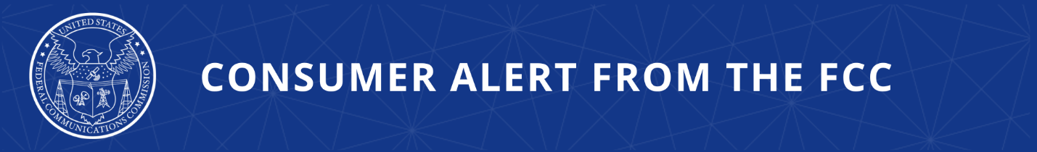

Consumer Complaints:
Online: https://consumercomplaints.fcc.gov
Phone: (888) 225-5322
Videophone: 1-844-432-2275

FCC Consumer Alert: Bank Impersonation Scams
Bank Imposters Pressure Consumers to Take Immediate Action to Protect Their Money

The Federal Communications Commission today warned consumers to be alert for bank impersonation scams. Imposter scams continue to bombard consumers and, according to the FTC, bank impersonation scams account for the highest losses of any impersonation scam category. Victims will often lose everything in their account.

Bank imposter scams typically press consumers to take immediate action in order to secure their account or protect their money. Scammers may call or text with phony “fraud alerts” that require you to authenticate your account by confirming your account details or sharing personal information.
More complicated scams may try to convince you that the bank is working with a government agency to investigate suspicious activity in your account and that you will need to move the funds to another account or convert them to gold or cryptocurrency to protect them.

Regardless of the pitch, it is always a scam. Banks will never call or text and ask you to move your money to protect it.

Tips to Avoid Bank Imposter Scams

If you get a call claiming to be from a bank or credit card company, hang up and call back using the customer service phone number on your account statement. Or call the customer service number on the back of your bank card or credit card. If you get a text message claiming to be from your bank, don’t click on any links in the message, and contact your bank directly if you have concerns about your account.

Additional ways to protect yourself from robocall scams:
- Don't answer calls from numbers you don't recognize.
- Hang up immediately if someone asks for money or personal information.
- Never share account numbers, Social Security numbers, passwords, PINs, or other sensitive information.
- Don’t respond to texts or click on links from unknown numbers.
- Ask your phone company about call-blocking tools and consider using call-blocking apps.

FCC Action to Protect Consumers

To fight imposter scam calls, the FCC is holding telephone service providers that fail to protect consumers accountable. The FCC has taken enforcement action against providers that turned a blind eye to scammers impersonating banks, government agencies, internet service providers, and major retailers.

In April 2026, the FCC proposed a $4.5 million fine, for a phone provider that allowed tens of thousands of fake calls pretending to be from various banks to target consumers.

The FCC has also rolled out a comprehensive strategy to attack scam calls at every stage of the call path, from before your number is dialed to when the call reaches your phone.

As part of this plan, the FCC is:
- Expanding know-your-customer and know-your-upstream provider requirements so bad actors can’t place scam calls.
- Exploring how phone numbers and area codes are used so we can restore trust in calls that are made.
- Ensuring that all voice service providers are doing their part to identify and block bad traffic so it never reaches your phone.
- Providing you with more information about the calls that do reach your phone, so you don’t have to guess if the call is one you want to answer.

FCC Resources

Example of bank impersonation scam call:

“Hello, this is Coin Base’s automated security system. We are reaching out to you as part of our standard security protocols. A password change request for your Coin Base account has been initiated due to a phone call customer support received. If this was not you, please press ‘1.’ If this was you, you may hang up.” (audio file)

To raise awareness about imposter scams, the FCC joined with the Elder Justice Coordinating Council and companies across the country as part of the “Never, Ever” campaign to shine a light on government and business imposter scams, which often target older Americans.

###

Released: July 21, 2026
Media Contact: MediaRelations@fcc.gov / (202) 418-0500
@FCC / www.fcc.gov

