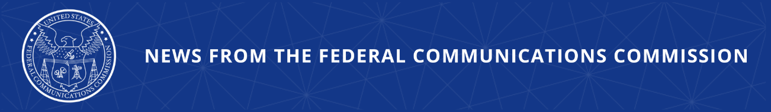

FCC Authorizes Agriculture and Rural Community-Focused Wireless Technology Innovation Zone at Iowa State
Agency Also Expands Innovation Zones in Boston, Raleigh, and Salt Lake City

WASHINGTON, August 28, 2026—Today, the Federal Communications Commission authorized a new Innovation Zone at Iowa State University to provide a platform to develop and refine wireless technologies intended to connect rural communities and to study new use cases for precision agriculture for both crop and livestock farms. Innovation Zones are locations designated for use by specific experimental licensees to foster robust wireless research and development through the testing of new advanced technologies, applications, and prototype networks outside of a traditional small campus or laboratory setting.

Today’s Public Notice from the FCC’s Office of Engineering and Technology also expands the identified spectrum bands in the Innovation Zone at Northeastern University in Boston, Mass., and expands the geographical boundaries of existing Innovation Zones at North Carolina State University in Raleigh, N.C. and at the Salt Lake City Innovation Zone.

Chairman Brendan Carr issued the following statement:

“We are making room for innovation through research and development in rural wireless technologies. Innovation Zones serve as real world laboratories for wireless services, including the targeting of specific challenges like those in rural communities. By building on the work already underway at Iowa State, we can supercharge experimentation in precision agriculture that leverages the technology of today and tomorrow, whether it’s 5G, 6G, or drones.”

Additional Background Information:

Today’s action approves a proposal from the Platforms for Advanced Wireless Research office – a public-private partnership that oversees the research platforms – for an Iowa State Innovation Zone to “serve as a wireless living lab for smart and connected rural communities, enabling the research and development of rural-focused wireless technologies that provide affordable, high-capacity connectivity to rural communities and industries such as agriculture.” The FCC’s approval also anticipates that the experimentation done at the Iowa State Innovation Zone could support research and innovation in open, standards-based wireless networks in real-world agriculture and rural settings.

The FCC today also modified the conditions of existing Innovation Zones to further facilitate and expand the ongoing research taking place in those geographic areas. The Northeastern University Innovation Zone was approved to increase the permitted maximum power on certain frequencies and expand the authorized frequency bands within that designated area. The NC State and Salt Lake City Innovation Zones were also permitted to increase the permitted maximum power on certain frequencies and expand the authorized frequency bands and geographic boundaries of their zones. In addition, the FCC is renewing the New York City Innovation Zone, the Salt Lake City Innovation Zone, the North Carolina State Innovation Zone, and the Northeastern Innovation Zone for another five-year term.

The Public Notice authorizing the Iowa State Innovation Zone, approving the expanding permissions for Northeastern University, North Carolina State University, and the Salt Lake City Innovation Zone, and renewing the New York City, Salt Lake City, North Carolina State, and Northeastern Innovation Zones is available at: www.fcc.gov/document/oet-announces-updates-innovation-zones.

###
Media Contact: MediaRelations@fcc.gov / (202) 418-0500
@FCC / www.fcc.gov

