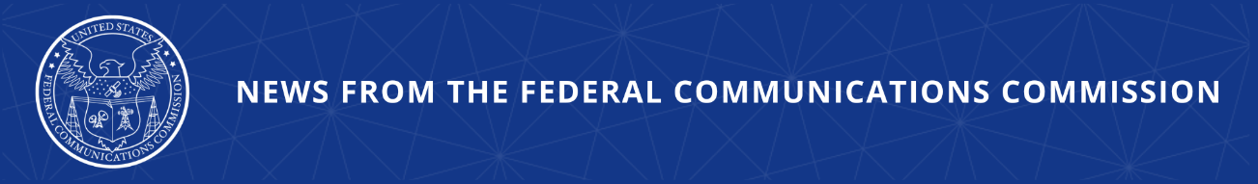

FCC Cuts Off Providers for Violating Robocall Rules
Fourteen Companies Will Be Blocked from Connecting to U.S. Phone Networks

WASHINGTON, September 2, 2026—Today, the Federal Communications Commission effectively prohibited 14 voice service providers from connecting to U.S. networks for failing to comply with FCC robocall rules. The FCC’s Enforcement Bureau removed the companies from its Robocall Mitigation Database and ordered U.S. voice service providers and intermediate providers to block calls from these companies. All providers operating on U.S. networks have two days to begin blocking all traffic from these companies, in compliance with the Commission’s Robocall Mitigation Database and call blocking rules.

Chairman Brendan Carr issued the following statement:

“Today’s action pushes more than a dozen providers off of U.S. networks for failing to abide by our robocall rules. The FCC continues to attack the problem of illegal robocalls at every point along the call path, and everyone in this ecosystem has an obligation to step up and do what they can to protect consumers against fraud and scammers.”

Additional Background Information:

The 14 companies removed from the FCC’s Robocall Mitigation Database today had been ordered to correct deficiencies in their database certifications and show cause why they should not be removed. But these companies failed to respond or take meaningful steps to update their database filings. The removed providers are: Apps Communications, CFX Business Solutions, Conference America, Convergence Technology Solutions, CSB Technologies, Digital Division, Dixie Net Communications, HIGHCOMM, Inatech Solutions, makrodepot, Opex Communications, Reachme.com, SECURE, and Skycom Healthcare.

The FCC’s Robocall Mitigation Database was established to promote transparency and effective robocall mitigation. This database is a critical tool through which the agency ensures providers are actively combatting robocalls and implementing STIR/SHAKEN caller ID authentication. Providers are required to certify that they have implemented STIR/SHAKEN on all IP-based portions of their networks. All providers must also submit robocall mitigation plans. Failure to meet these obligations can result in removal from the database and blocking of the provider’s traffic.

###
Media Contact: MediaRelations@fcc.gov / (202) 418-0500
@FCC / www.fcc.gov

