Before the
Federal Communications Commission
Washington, D.C. 20554

In the Matter of  Promoting Diversification of Ownership in the  Broadcasting Services  Review of Media Bureau Data Practices  Amendment of Part 1 of the Commission’s Rules, Concerning Practice and Procedure, Amendment of CORES Registration System | )  )  )  )  )  )  )  )  )  ) | MB Docket No. 07-294  MB Docket No. 10-103  MD Docket No. 10-234

REPORT AND ORDER, SECOND REPORT AND ORDER,
AND ORDER ON RECONSIDERATION

Adopted: January 8, 2016 Released: January 20, 2016

By the Commission: Commissioner Pai approving in part, dissenting in part and issuing a statement; Commissioner O’Rielly approving in part, concurring in part and issuing a statement.
Table of Contents
Heading Paragraph #
I. introduction 1
II. background 4
III. discussion 24
A. RUFRN Requirement 25
B. Improvements to Data Collection from NCE Stations 43
C. Limited Availability of SUFRNs 56
D. Filing Burden Reduction and Improved Data Integrity 59
E. Other Proposals 85
IV. procedural matters 89
A. Final Regulatory Flexibility Analysis 89
B. Final Paperwork Reduction Act Analysis 90
C. Congressional Review Act 91
V. ordering clauses 92
APPENDIX A – List of Comments and Reply Comments
APPENDIX B – Rule Changes
APPENDIX C – Final Regulatory Flexibility Analysis
APPENDIX D – Draft Form 2100, Schedule 323
APPENDIX E – Draft Form 2100, Schedule 323-E

introduction
- The Commission has a long-standing goal of promoting diversity in ownership of broadcast stations to ensure that diverse viewpoints and perspectives are available to the American people in the content they receive over the broadcast airwaves. In pursuit of this goal, the Commission has a long history of promulgating rules and regulations designed to foster diversity in terms of minority and female ownership in particular. In this Report and Order, Second Report and Order, and Order on Reconsideration (Report and Order), the Commission acts to improve the data available to analyze issues relevant to ownership and viewpoint diversity by refining the collection of data reported on FCC Form 323, Ownership Report for Commercial Broadcast Stations, and FCC Form 323-E, Ownership Report for Noncommercial Broadcast Stations.
- A necessary precursor to the Commission’s policy-making efforts in this area is the collection of comprehensive, reliable data reflecting the race, gender, and ethnicity of the owners and other interest holders in broadcast stations. Such data are essential to effectively study and analyze ownership trends, to assess the impact of Commission rules, and to provide a foundation for the adoption of new rules, among other things. To be useful for this purpose, to the greatest extent possible the data must be capable of being read, verified, searched, aggregated, and cross-referenced electronically. Moreover, for our broadcast ownership data to be complete, reliable, and usable for study and analysis, individuals reported on Forms 323 and 323-E must be uniquely identified. The enhancements described herein enable the Commission to obtain data reflecting a more useful, accurate, and thorough assessment of minority and female broadcast station ownership in the United States while reducing certain filing burdens. These improvements also address the directive from the U.S. Court of Appeals for the Third Circuit that the Commission obtain more and better data concerning broadcast ownership to support its rulemaking decisions. Ultimately, we believe that these actions will assist the Commission’s future initiatives to promote diverse ownership.
- Accordingly, pursuant to our statutory mandate contained in Section 257 of the Telecommunications Act of 1996 (the 1996 Act) and Section 309(j) of the Communications Act of 1934 (the Act) to promote opportunities for small businesses and women and minorities in the broadcasting industry, we implement a Restricted Use FRN (RUFRN) within the Commission’s Registration System (CORES) that individuals may use solely for the purpose of broadcast ownership report filings. The Commission believes that the RUFRN will allow for sufficient unique identification of individuals listed on broadcast ownership reports without necessitating the disclosure to the Commission of individuals’ full Social Security Numbers (SSNs). In light of our adoption of the RUFRN requirement, we eliminate the availability of the Special Use FRN (SUFRN) for broadcast station ownership reports, except in very limited circumstances as further described herein. We also prescribe revisions to Form 323-E that conform reporting for noncommercial educational (NCE) broadcast stations more closely to those for commercial stations, including information about race, gender, and ethnicity of existing, reportable attributable interest holders; the use of a unique identifier; and the biennial filing requirement. Finally, we make a number of significant changes to our reporting requirements that reduce the filing burdens on broadcasters, streamline the process, and improve data quality. These changes include extending the biennial filing deadline, reducing the number of filings required, improving the reporting of other broadcast and newspaper interests, and other modifications.

background
- The Commission has been engaged in a sustained effort to improve the quality, utility, and reliability of our broadcast ownership data. In 2009, the Commission substantially revised the biennial Form 323 to facilitate longitudinal comparative studies of broadcast station ownership. The changes also addressed flaws in the data collection process identified by the United States Government Accountability Office (GAO) and by researchers who had attempted to use the data submitted on previous versions of Form 323. GAO noted that “more accurate, complete, and reliable [broadcast ownership] data would allow FCC to better assess the impact of its rules and regulations and allow the Congress to make more informed legislative decisions,” and it “recommend[ed] that FCC take steps to improve the reliability and accessibility of its data on the gender, race, and ethnicity of broadcast outlet owners.”
- To improve the quality of its broadcast ownership data, the Commission adopted several significant changes to Form 323. First, it set a uniform “as of” date of October 1 for the ownership data being reported in the biennial filing and established a uniform filing deadline of November 1, requiring all filers to report their ownership interests as they exist on the “as of” date of the filing year and to submit their reports no later than one month thereafter. These uniform dates make it possible to discern statistically valid trends in minority and female broadcast ownership over time, which was not possible using the previous rolling filing deadlines, and to ensure the timely collection of the data. The Commission expanded the requirement to file Form 323 biennially to include sole proprietors and partnerships of natural persons, as well as low power television (LPTV) and Class A licensees.
- In the 323 Order, the Commission also concluded that an FRN should be reported for each interest holder reported on Form 323 and directed staff to revise Form 323 accordingly. The Commission delegated authority to staff to revisit the CORES FRN issue if additional changes to the form were necessary. In order “to further improve the ability of researchers and other users of the data to cross-reference information and construct ownership structures,” the Media Bureau revised Form 323 to require that an FRN be reported for every interest holder reported on the form. The Bureau also included built-in checks and pre-fill capabilities to assure greater accuracy of the data reported and ease of completion of the form.
- Accompanying the 323 Order was a Fourth Diversity Further Notice, in which the Commission sought comments on changes to Form 323-E. The Commission sought comment on whether to seek race, gender, and ethnicity data from persons reported on Form 323-E in order to obtain data that would further the Commission’s goal to advance diversity in the broadcast industry. Noting that many NCE broadcast station licensees are non-profit, non-stock entities or governmental organizations that are controlled by governing boards comprising members without a financial stake in the broadcast station, the Commission sought comment on how to define ownership in the noncommercial context. Among other things, the Fourth Diversity Further Notice sought comment on whether the Commission should adopt the same or similar modifications for Form 323-E as it did for Form 323 in the 323 Order and whether the data quality measures adopted in the 323 Order would be appropriate and sufficient to ensure that the data collected by Form 323-E are aggregable. The Fourth Diversity Further Notice was published in the Federal Register on May 27, 2009, with comments due on or before June 26, 2009, and reply comments due on or before July 13, 2009.
- On August 11, 2009, the Commission submitted a revised Form 323 to the Office of Management and Budget (OMB) for approval pursuant to the Paperwork Reduction Act (PRA) requirements and published the Federal Register notice initiating a 60-day comment period. Among the changes submitted was a requirement that each filer provide a CORES FRN for each reported attributable interest holder. Many comments submitted to OMB objected to the revision requiring filers to report CORES FRNs for individuals holding attributable interests, arguing that it required them to provide SSNs to the Commission, which they claimed triggered privacy, data security, and identity theft concerns. Commenters also suggested that obtaining CORES FRNs for reportable individuals would be burdensome, and that in some cases filers might not be able to obtain the CORES FRN for all individual attributable interest holders because individuals might be unwilling either to obtain CORES FRNs for themselves or to provide their SSNs to the filer for the purpose of obtaining CORES FRNs on their behalf. Two Petitions for Writs of Mandamus were filed with the U.S. Court of Appeals for the D.C. Circuit to stay the Commission’s implementation of the revisions to Form 323. Both were denied.
- On October 6, 2009, the Office of the Managing Director (OMD) at the Commission submitted a letter to OMB addressing the comments filed in response to the revised Form 323. OMD explained that requiring CORES FRNs on Form 323 is an integral part of the Commission’s effort to “improve the quality, reliability, and usability of the collected data by eliminating inconsistencies and inadequacies in the data submitted.” The Reply Letter rejected allegations that the Commission failed to comply with the notice requirements of the PRA or ran afoul of the Privacy Act. OMD also disputed commenters’ objections that the CORES FRN requirement raised security and identity theft concerns. The Commission utilizes a “robust security architecture . . . for CORES that exceeds Federal guidelines and recommendations” and has deployed operational controls that comply with National Institute of Standards and Technology guidance. OMD stated that the Commission’s servers are securely located, that its databases are behind several firewalls, and that all servers and communications are monitored. The Reply Letter also noted that administrative access to the CORES application is limited and that all transmission of non-public data is encrypted.
- On October 19, 2009, OMB approved the revised Form 323, which included the requirement that filers provide a CORES FRN for individuals holding an attributable interest in the licensee. After several delayed filing deadlines, the Commission set July 8, 2010 as the first biennial filing deadline using the revised Form 323. In response to industry concerns about filers’ ability to obtain CORES FRNs from all individual interest holders due to individuals’ concerns about privacy, security, and identity theft, the Media Bureau allowed filers, as an interim measure, to obtain an SUFRN for individuals (but not entities) reported on the form in lieu of obtaining a CORES FRN. When clicking a button on the electronic version of Form 323 to generate an SUFRN, filers were advised via a pop-up box that “[i]f, after using diligent and good-faith efforts,” a filer is unable to obtain an SSN from an individual that must be reported on Form 323 in order to generate a CORES FRN, the filer may elect to automatically generate in the electronic Form 323 an SUFRN for that individual. The respondents were also informed that those who use an SUFRN on Form 323 would be deemed to be fully compliant with the filing obligations and the lack of a CORES-based FRN would not subject a filer to enforcement action. SUFRNs were available to filers for the 2009, 2011, and 2013 biennial filing periods. Filers were directed that SUFRNs, like CORES-based FRNs, must be used consistently.
- In November 2009, two parties filed petitions seeking reconsideration of the requirement to obtain CORES FRNs for individuals holding attributable interests, arguing that the CORES FRN requirement is overly burdensome and raises privacy and data security issues and that the Commission provided inadequate notice of the CORES FRN requirement.
- In June 2010, the Media Bureau initiated the Review of Media Bureau Data Practices proceeding to “examin[e] . . . [the Bureau’s] data practices to improve the way the Commission collects, uses and disseminates data.” The Bureau solicited input concerning potential improvements to all of its existing data collections, including both the biennial and non-biennial sections of Forms 323 and 323-E. Among other things, the Bureau asked whether its various data collections should be continued or eliminated; whether the Bureau should collect additional data and for what purpose(s); how the Bureau’s data collections could be improved; what burdens exist for the Commission, industry, and the public; and what potential improvements could be made concerning public access to, and Commission dissemination of, submitted data. The Commission received numerous comments in this proceeding, including two submissions — from the National Association of Broadcasters (NAB) and the Minority Media and Telecommunications Council (MMTC) — that addressed issues related to the Commission’s broadcast ownership report forms and data.
- In December 2010, the Commission initiated another separate rulemaking proceeding in which it proposed to update CORES to enhance the Commission’s data collection efforts and to improve customer interface with CORES. In the CORES NPRM, the Commission stated that, “[s]ince the creation of CORES, entities have been able to obtain multiple FRNs in order to permit different members of their corporate family to obtain their own individual FRNs, regardless of whether those entities had different taxpayer identification numbers (‘TINs’).” For entities, the TIN is generally their employer identification number (EIN), and for individuals, the TIN is generally their SSN. The Commission stated that it has had difficulty using CORES to identify all the FRNs an entity holds when the entity has used inconsistent TINs or did not provide a TIN to obtain an FRN through CORES. The Commission also observed that some filers erroneously invoked exceptions to the requirement to provide a TIN, making those entities or individuals difficult to track. The Commission proposed several options to resolve these issues. In addition, the Commission asked whether it should expand the availability of SUFRNs for purposes other than the filing of Form 323.
- In July 2011, the U.S. Court of Appeals for the Third Circuit, as part of its review of the Commission’s media ownership rules, vacated and remanded certain aspects of the Diversity Order. The Third Circuit concluded that the Commission’s decision to adopt a revenue-based eligible entity definition to facilitate ownership diversity was arbitrary and capricious because the Commission did not show how such a definition specifically would assist minorities and women, who were among the intended beneficiaries of the action. The court also remanded each of the measures adopted in the Diversity Order that relied on the eligible entity definition. The court found that the eligible entity definition was not supported by “data attempting to show a connection between the definition chosen and the goal of the measures adopted — increasing ownership of minorities and women,” stressing that regulations seeking to increase ownership by women and minorities must be based on reliable data. The court stated that, “[a]t a minimum, in adopting or modifying its rules, the FCC must ‘examine the relevant data and articulate a satisfactory explanation for its action[,] including a rational connection between the facts found and the choice made.’” The court also made plain that, “[i]f the Commission requires more and better data . . . it must get the data.” The court stated that the actions taken in the 323 Order and Fourth Diversity Further Notice to reliably analyze minority and female ownership “will, however, lay necessary groundwork for the Commission’s actions on remand.”
- On November 14, 2012, the Media Bureau released the first electronic analysis of commercial broadcast ownership data submitted pursuant to the revised biennial reporting requirements for 2009 and 2011 (2012 323 Report). A subsequent report, released by the Bureau on June 27, 2014 (2014 323 Report), contained an analysis of the commercial broadcast ownership data submitted during the 2013 filing cycle. The data contained in the reports are “snapshots” of the status of minority and female ownership in the broadcast industry and are part of a planned series of biennial “snapshots” that can be used for trend analysis. These reports provide detailed information by race, ethnicity, and gender concerning ownership of commercial television, radio, Class A television, and LPTV stations. In preparing these reports, Commission staff observed difficulties with, and errors within, the broadcast ownership data submitted to the Commission. Upon review of the biennial ownership reports, Commission staff discovered that many commercial broadcast stations submitted reports with apparently inaccurate or insufficient data to permit electronic calculation of voting interests. As a result, such biennial ownership reports were not included in the Commission’s analysis. Commission staff worked with numerous broadcasters to correct errors contained in their 2011 and 2013 biennial Form 323 filings via amendments, which allowed stations covered by those reports to be properly categorized for the 2012 and 2014 323 Reports. In addition, Commission staff manually analyzed a large number of ownership reports, together with other available information, in order to assign certain stations to the appropriate categories manually for purposes of the report. The 2012 323 Report stated that the problems with the data stemmed, in part, from the “complexity of the information required to accurately file” the revised version of Form 323.
- The Commission also sought public comment on both reports. On December 3, 2012, the Commission issued a Public Notice in the 2010 Quadrennial Regulatory Review proceeding offering parties the opportunity to comment on the 2012 323 Report (2012 323 Report PN). The 2012 323 Report PN broadly sought “additional comment on data contained in [the 2012 323 Report],” specifically referencing the Commission’s efforts “to improve its collection and analysis of broadcast ownership information” and make “improvements to the reliability and utility of the data reported in FCC Form 323.” Some commenters responding to the 2012 323 Report PN expressed concern that the incomplete and inaccurate ownership data submitted to the Commission render it difficult to accurately track broadcast ownership trends from 2009 and 2011. One commenter suggested that the manner in which the Commission currently provides broadcast ownership data from Form 323 to the public does not meet the objective that such data be capable of being electronically searched, aggregated, or cross referenced. On June 27, 2014, the Bureau issued an Order as part of the 2014 Quadrennial Regulatory Review proceeding seeking comment on the 2014 323 Report. Certain commenters responding to the data contained in the 2014 323 Report acknowledged that the Commission has taken steps to improve the quality of its broadcast ownership data, but asserted that the Commission should do more to make its broadcast ownership data easier to use, search, aggregate, and cross reference electronically, for the benefit of studies and analysis.
- On January 3, 2013, the Commission released its Sixth Diversity Further Notice, in which it sought comment on the Commission’s requirement that licensees and other entities filing Form 323 provide a CORES FRN — which requires submission of an SSN or TIN to the Commission — for attributable individuals. Noting that the CORES FRN enables unique identification of individuals, the Commission sought comment on its proposal to eliminate the interim SUFRN. The Commission reasoned that SUFRNs do not provide a reliable means of linking a reported interest holder to a unique individual and the continued use of the SUFRN undermines the Commission’s efforts to “accurately ascertain the nature and extent of minority and female ownership of broadcast properties.” Pointing out that the Third Circuit in Prometheus II highlighted the importance of reliable data to support rulemaking initiatives, the Sixth Diversity Further Notice asked for comments on the importance of the CORES FRN as a unique identifier for increasing the quality, cross-referencing, aggregability, and searchability of broadcast station ownership data. The Commission also asked whether it should continue to permit filers to use the SUFRN in the event that reportable individuals are unwilling to provide their SSN to a third party or unwilling to obtain and provide a CORES FRN. The Commission also proposed to extend the CORES FRN requirement to all entities and individuals reported on Form 323-E and invited comment on potential costs and benefits associated with that requirement. The Sixth Diversity Further Notice proposed to extend the filing deadline for broadcast ownership reports to give filers an additional 30 days. As noted above, the Sixth Diversity Further Notice also sought additional comment on proposals regarding Form 323 submitted in the Review of Media Bureau Data Practices proceeding. The notice specifically sought comment on certain proposals NAB and MMTC submitted in that proceeding and sought input on the costs and benefits associated with those proposals. The Sixth Diversity Further Notice was published in the Federal Register on January 15, 2013. Comments on the Sixth Diversity Further Notice were due on or before February 14, 2013 and reply comments due on or before March 1, 2013.
- The Commission received significant opposition in response to the Sixth Diversity Further Notice’s proposal that all attributable interest holders submit an SSN to the Commission in order to receive a CORES FRN for use on broadcast ownership reports. As a result, on February 12, 2015, the Commission released the Seventh Diversity Further Notice, which proposed to implement a new RUFRN — an identifier that would not require the submission of an SSN to the Commission — for use on Form 323 and Form 323-E filings. This proposal reflected the Commission’s effort to balance its goal of collecting reliable ownership data with the privacy, data security, and identity theft concerns of those individuals with attributable interests in broadcast stations. As an alternative to the CORES FRN, the proposed RUFRN would be generated when an individual submits his or her full name, residential address, date of birth, and only the last four digits of the individual’s SSN.
- The Commission reiterated its position that it must be able to uniquely identify all parties, including individuals, reported on broadcast ownership reports and tentatively concluded that the RUFRN “will provide reasonable assurance of unique identification” of attributable individuals and is a superior method of uniquely identifying individuals than the existing SUFRN. The Commission sought comment on what additional information, if any, the Commission could require to ensure that the data collected on the ownership reports will be reliable.
- The Commission also acknowledged that commenters to the Sixth Diversity Further Notice argued that a CORES FRN cannot serve as a unique identifier, because multiple FRNs could be associated with a single TIN/SSN; an FRN may be associated with no TIN/SSN or an incorrect one; or outside groups do not have access to the underlying TIN/SSN information. The Seventh Diversity Further Notice stated that, to guard against a single individual obtaining multiple RUFRNs, “the CORES system will be programmed to verify that the submitted information is complete and does not duplicate any information that is already associated with an RUFRN in CORES.” In the Seventh Diversity Further Notice, the Commission acknowledged the privacy and security concerns raised in the Sixth Diversity Further Notice as it related to the requirement that interest holders submit an SSN, and reiterated that its systems, including CORES, have a security infrastructure in place that exceeds Federal guidelines. The Seventh Diversity Further Notice also emphasized that the benefits of improved data collection outweigh any de minimis costs or burdens associated with obtaining a CORES FRN or RUFRN. The Commission explained that an individual that already has a CORES FRN may continue to report it on the Form 323 or Form 323-E filings and that there is no need to obtain an RUFRN.
- The Commission sought comment on these subjects and its conclusions that the RUFRN proposal will improve the reliability and usability of the broadcast report data. The Seventh Diversity Further Notice also sought comment on its conclusion that the RUFRN as a unique identifier will permit the Commission to implement burden-reducing modifications that could reduce the types of errors identified in the 2009, 2011, and 2013 filing periods.
- The Commission also sought comment on extending the RUFRN to Form 323-E in the event that changes proposed in the pending Fourth and Sixth Diversity Further Notices are adopted. As discussed above, the Fourth Diversity Further Notice proposed to collect race, gender, and ethnicity information from attributable individuals reported on Form 323-E, and the Sixth Diversity Further Notice proposed to extend the CORES FRN reporting requirement to noncommercial stations. In the Seventh Diversity Further Notice, the Commission proposed that, in the event those proposed changes are adopted, individuals reported on Form 323-E also may be permitted to obtain and provide an RUFRN in lieu of a CORES FRN for use on the broadcast ownership report filings. The Commission further acknowledged the comments opposing the Sixth Diversity Further Notice proposal to extend the CORES FRN requirement to NCE stations. There, commenters argued that the CORES FRN requirement would be unduly burdensome and would discourage individuals from serving on the boards of NCE stations. Moreover, commenters argued that NCE station licensees would have difficulty obtaining SSNs from board members, which may include government officials. The Seventh Diversity Further Notice sought comment on how these concerns would be implicated if RUFRNs were available as an alternative to CORES FRNs for Form 323-E. The Commission noted that officers and directors of NCE stations are already considered to be attributable interest holders in NCE stations and are already required to be reported on Form 323-E and sought comment on whether NCE stations present unique concerns with respect to ownership reporting requirements that should be considered by the Commission. The Commission also sought alternatives to the RUFRN for the unique identification of individuals in the NCE context.
- Finally, the Seventh Diversity Further Notice sought additional comment on the elimination of the SUFRN, a proposal also contained in the Sixth Diversity Further Notice. The Commission noted that commenters previously supported the proposal to retain the availability of the SUFRN for the limited purpose of reporting an individual that is unwilling to provide his or her SSN to third parties or unwilling to obtain and provide a CORES FRN and opposed the Commission’s use of its enforcement authority against individuals who failed to provide a CORES FRN. The Seventh Diversity Further Notice sought comment on whether the SUFRN should continue to be available to Form 323 filers (and, in the event proposed modifications are adopted, to Form 323-E filers), provided that a filer has used reasonable and good-faith efforts to obtain a CORES FRN or RUFRN from or on behalf of an individual. The Commission also asked whether the availability of the SUFRN would protect filers in the case of recalcitrant individuals and whether filers should be required to instruct individuals of the obligation to obtain and provide a CORES FRN or an RUFRN. The Seventh Diversity Further Notice also sought comment on the type of instruction and notification of the risk of enforcement action the Commission should provide or require if a CORES FRN or RUFRN is not reported for that individual. The Seventh Diversity Further Notice was published in the Federal Register on February 26, 2015. Comments were due on or before March 30, 2015 and reply comments were due on or before April 13, 2015.

discussion
- By the actions we take here, we advance the Commission’s commitment to improving the comprehensiveness and reliability of the ownership data collected on Forms 323 and 323-E to enable more effective analysis of ownership trends in support of policy initiatives promoting diversity in ownership of broadcast stations. Accordingly, we will no longer allow filers to use SUFRNs on biennial ownership reports, except in limited cases, and instead will require that on such forms filers provide a CORES FRN or RUFRN for any reportable individual attributable interest holder. In addition, we update our reporting requirements for NCE stations to more closely parallel the requirements for commercial stations. We also make certain changes to the Commission’s Form 323 and Form 323-E aimed at reducing the filing burdens on broadcasters and improving data collection. Finally, we decline to adopt certain proposals detailed in comments in this proceeding as redundant, unnecessary, technically infeasible, or unsupported.

RUFRN Requirement
- We conclude that the RUFRN is important to the Commission’s ongoing mission to improve, streamline, and modernize the way it collects and uses data. We continue to believe that the Commission must be able to uniquely identify parties reported on broadcast ownership reports for purposes of creating reliable and usable data in support of our policy initiatives promoting diverse ownership. The Commission has recognized that the TIN/SSN backed CORES FRNs offer a unique identifier and therefore play an important role in promoting the integrity of the data collected on Form 323. The Commission, however, is also sensitive to concerns that have been expressed regarding a mandate that every individual attributable interest holder of a broadcast station submit his or her SSN to the Commission for purposes of broadcast ownership reporting. The creation of the new RUFRN mechanism within CORES, allowing individuals to obtain a unique identification number without submitting a full SSN, properly balances the concerns of individual attributable interest holders with the Commission’s mandate to ensure the reliability and utility of its broadcast ownership data.
- Broadcast Ownership Reporting Using the RUFRN Supports the Commission’s Data Gathering and Policy Making Initiatives. The Commission has previously recognized that Sections 257 of the 1996 Act and 309(j) of the Act support its efforts to gather the ownership data contained in Form 323. Section 257 directs the Commission to identify and eliminate “market entry barriers for entrepreneurs and other small businesses in the provision and ownership of telecommunications services and information services, or in the provision of parts or services to providers of telecommunications services and information services.” To implement this mandate, the Commission is directed to “promote the policies and purposes of [the 1996 Act] favoring diversity of media voices, vigorous economic competition, technological advancement, and promotion of the public interest, convenience and necessity.” As the Commission has previously recognized, improving the reporting of ownership data enables the Commission to carry out this mandate.
- Similarly, pursuant to Section 309(j), the Commission must award licenses in a manner that “promot[es] economic opportunity and competition and ensur[es] that new and innovative technologies are readily accessible to the American people by avoiding excessive concentration of licenses and by disseminating licenses among a wide variety of applicants, including small businesses, rural telephone companies, and businesses owned by members of minority groups and women.” Congress directed the Commission to regulate in a manner that ensures that “small businesses, rural telephone companies, and businesses owned by members of minority groups and women” are represented in licensed activities. The statute further requires that the Commission “ensure that small businesses, rural telephone companies, and businesses owned by members of minority groups and women are given the opportunity to participate in the provision of spectrum-based services.” As the Commission has previously determined, Section 309(j) is evidence of a congressional policy in support of the grant of broadcast licenses to a wide variety of groups, including minorities and women.
- In the 1998 Biennial Review Order, the Commission concluded that, in order to fulfill its statutory mandates, it must collect race, gender, and ethnicity information from all interest holders reported on Form 323. Collecting these data enables the Commission not only to assess the current state of minority and female ownership of broadcast stations but also to determine the success of programs that are designed to facilitate opportunities for women- and minority-owned businesses and to promote a diversity of media voices. Just as it is essential for the Commission to collect these ownership data to fulfill its mandates, it is important that these data be reliable, aggregable, and useful for studies and trend analysis by others.
- We find that flaws in the current practices related to the reporting of SUFRNs for individuals listed on Form 323 compromise the integrity of the data collected and thereby frustrate the Commission’s attempts to fulfill its statutory mandates under Section 257 and Section 309(j). The SUFRN was devised as merely a computer-generated number to be created by clicking a button within Form 323 itself and not backed by any identifying information. The Commission collects no information when the system generates a new SUFRN, and there is no database analogous to CORES that contains uniquely identifying information associated with SUFRNs. The SUFRN therefore offers the Commission no way to cross reference or trace back reported information to a single individual. It was intended only as an interim measure. Based on the Commission’s experience reviewing the ownership reports submitted during three separate biennial reporting cycles, it is clear that SUFRNs have been used in a manner that is inconsistent with the Commission’s direction and that undermines the integrity of the data. On the one hand some SUFRNs have been used in conjunction with multiple individuals, and on the other hand individuals have used multiple SUFRNs. Because the Commission currently cannot determine whether two SUFRNs identify one or more individuals, it cannot reliably examine the complete attributable holdings of an individual reported with an SUFRN (either at a specific time or over time), or search, aggregate, and cross reference the ownership data. Any attempt at such analysis would require manual analysis of every single entry where an SUFRN appears together with a subjective analysis of other textual information contained on the form or available from other public sources. Manual, subjective analysis of thousands of Form 323 entries using various sources of information compromises data integrity and data utility. Consequently, the Commission cannot rely on the SUFRNs reported to provide reliable ownership data.
- In the Sixth Diversity Further Notice, the Commission tentatively concluded that TINs/SSNs within CORES were necessary as underlying unique identifiers of individuals. Commenters to the Sixth Diversity Further Notice strongly objected to the proposed Commission mandate that all individual attributable interest holders submit an SSN to the Commission to obtain a traditional CORES FRN.
- In contrast, in the Seventh Diversity Further Notice, we tentatively found that a proposed alternative to the traditional CORES FRN would provide a reasonable basis for determining that an individual is uniquely identified within the CORES system. Specifically, we proposed making available a new identifier, the RUFRN. Filers wishing to use this identifier would be required to submit an individual’s full name, residential address, date of birth, and only the last four digits of the individual’s SSN. In response to the Seventh Diversity Further Notice, commercial broadcasters and public interest groups support the alternative RUFRN approach. Some commenters argue that the use of SUFRNs on Form 323 “ha[s] introduced inaccuracy and uncertainty into media ownership data,” because SUFRNs are not backed by identifying information that can reliably be linked to a unique individual. While the CORES FRN system is a superior solution, RUFRNs are a sufficient means for identifying individuals and allowing longitudinal analysis of media ownership trends, they state. No commenters propose additional or different pieces of information that would better enable the Commission to ensure that individuals are uniquely identified.
- Some commenters disagree that the RUFRN proposal is superior to the existing SUFRN system. Although these commenters focus primarily on issues related to NCE attributable interest holders, which are addressed in detail below, some of the arguments suggest that the use of RUFRNs will not substantially and meaningfully improve the quality of the Commission’s broadcast ownership data generally. These commenters assert that if SUFRNs are being misused, it is either due to mistakes or conscious decisions not to comply with Bureau guidance. According to these commenters, either remains possible with the proposed RUFRN system. In addition, commenters state, insofar as the Commission intends to allow use of ownership data by third-party researchers, much of the benefit that comes from the use of RUFRNs is negated by the Commission’s proposal to hold securely and confidentially within CORES all identifying information used to obtain RUFRNs, except for names and the RUFRNs themselves.
- We find that our policy initiatives are dependent on the quality of the data collected. We conclude that having reasonable assurance that attributable interest holders are uniquely identified on ownership reports in a manner that ensures that the data can be meaningfully searched, aggregated, and cross referenced electronically is crucial to the quality and usability of our ownership data. We conclude that the SUFRN cannot provide unique identification of individual attributable interest holders on broadcast ownership reports, and we conclude that requiring an FRN generated by CORES, either through existing mechanisms or via the RUFRN method, for all attributable interest holders on broadcast ownership reports is essential to improve the quality and usability of the data collected. We therefore adopt the RUFRN as an alternative mechanism within CORES that will allow an individual (not entities) to obtain an RUFRN by submitting an alternate set of identifying information that does not include a full SSN: full name, residential address, date of birth, and the last four digits of the individual’s SSN.
- The identifying information provided by the individual will be stored confidentially within CORES, as other sensitive information is stored in CORES to support CORES FRNs issued pursuant to existing functionalities. Only the individual’s name and RUFRN will be available publicly. Both the RUFRN and the associated ownership information will be entirely machine readable and will not require manual consideration of each biennial ownership form to analyze whether various Form 323 entries might identify the same individual or different individuals. The CORES system will be programmed to verify that the information submitted by the applicant is complete and does not duplicate any information that is already associated with an RUFRN in CORES. We conclude that, since RUFRNs will be backed by identifying information, and since CORES will not issue multiple RUFRNs for the same identifying information, RUFRNs can be relied on to identify individuals uniquely. When the applicant obtains an RUFRN, the applicant will be asked to list all CORES FRNs registered to the individual and all SUFRNs the individual previously used in any broadcast ownership report filings since the 2009 biennial reporting cycle. We conclude that such disclosures will allow the Commission to identify CORES FRNs, RUFRNs, and SUFRNs that identify the same individual, promoting the usefulness of the broadcast ownership data for purposes of electronic searching, aggregating, and cross-referencing and for trend analysis. RUFRNs may be used only on broadcast ownership reporting forms and only for individuals (not entities) reported as attributable interest holders. Once an RUFRN is issued, any ownership report filing that lists the individual associated with that RUFRN will be required to include that RUFRN. However, an individual may opt to use a traditional CORES FRN instead of obtaining and using an RUFRN.
- We do not believe that the existence of possible situations or limitations some commenters identified in objecting to the RUFRN compel us to abandon our conclusion that RUFRNs offer superior data quality to SUFRNs for the purpose of broadcast ownership reports. As we stated in the Seventh Diversity Further Notice, we expect that individuals and entities will comply with our rules and provide accurate information during the CORES registration process to the greatest extent possible. Moreover, we find that the specificity of the identifying information required to obtain an RUFRN and the fact that a number of pieces of information are required will be sufficient to provide the Commission with reasonable certainty that the information identifies a unique filer within the CORES system. While holding some of this information confidential does limit the ability of outside researchers to use it to ensure unique identification, that limitation does not decrease the ability of the Commission to do so, just as the confidentiality of an SSN underlying a CORES FRN does not. Further, the Commission’s obligation to hold confidential the identifying information underlying the RUFRN will not limit appreciably the utility of RUFRNs to outside researchers as a unique identifier, because the RUFRN application will include a mechanism to prevent issuance of multiple RUFRNs based on the same identifying information (i.e., issuance of multiple RUFRNs to the same individual). Based on the Commission’s experience in the 2009, 2011, and 2013 reporting cycles, we conclude that the RUFRN will improve the reliability and usability of the broadcast ownership report database, in furtherance of our statutory mandates.
- RUFRNs Are Not Burdensome, and the Benefits Outweigh the Costs. We conclude that our decision to allow individual attributable interest holders the option of obtaining and using an RUFRN in lieu of a traditional CORES FRN will impose minimal costs and burdens, if any, on individuals or filers. As noted above, individuals who already have a CORES FRN will be able to continue using their existing number without having to register for an RUFRN, and any other reportable individual that wishes to obtain a CORES FRN instead of an RUFRN will still be able to do so. Like registering for a CORES FRN, registering for an RUFRN will be a one-time process that takes a few moments to complete. An individual need only fill out a short online form requiring just a few pieces of information: a name, address, birth date, and the last four digits of the SSN. There are at most de minimis costs or burdens associated with obtaining the number. An individual does not need to provide personal information to anyone other than the Commission to obtain a CORES FRN or RUFRN. That information can be provided to the Commission alone, and then the CORES FRN or RUFRN can be provided to a licensee for reporting purposes. In addition, the RUFRN will serve as a unique identifier that can be cross referenced easily, which will enable the Commission to make certain modifications to broadcast ownership reporting that will reduce the burdens on all filers, as described below, and therefore further improve the quality of the ownership data submitted to the Commission. We conclude that these benefits outweigh the de minimis costs or burdens associated with obtaining an RUFRN. Although some commenters argue that implementing the RUFRN would impose specific burdens on NCE licensees, as discussed below, no commercial entity disputes our finding that RUFRNs will not be burdensome for commercial entities or individuals holding attributable interests in them.
- Security of Commission Systems. In the Sixth Diversity Further Notice, the Commission sought comment on any security concerns related to the requirement that a TIN/SSN for every attributable interest holder be provided to the Commission. The Commission noted that while TIN/SSN data is collected during the CORES FRN registration process, TINs/SSNs are not disclosed on any Commission application or form, including Forms 323 and 323-E. Commenters raised concerns that a CORES FRN requirement for individuals will open individuals to threats of identity theft. Some commenters pointed to a system breach described in a GAO report on information security (Information Security GAO Report) and suggested that the Commission’s systems are vulnerable to a security breach. In the Seventh Diversity Further Notice, the Commission described the safeguards in place on the Commission’s systems and improvements that have been implemented to assure the security of the Commission’s systems, including that of CORES. The Commission reiterated that security continues to be one of the Commission’s highest priorities, and sought comment on whether the elimination of the requirement of individual attributable interest holders to submit a full SSN to CORES eliminates the privacy and identity theft concerns that have been previously raised. The Commission also asked for guidance on how to address any remaining concerns that are not alleviated, and whether those concerns outweigh the importance of the data collection.
- In response, NAB states that RUFRNs, because they create a unique identifier without requiring individuals to submit full SSNs to the Commission, provide a “safety valve” for individuals who might be reluctant to obtain a CORES FRN due to data privacy and security concerns. NAB claims this is accomplished without compromising the quality of the Commission’s ownership data. Thus, states NAB, the RUFRN proposal for commercial broadcasters reflects a better balancing of affected interests than simply eliminating the SUFRN and mandating CORES FRNs in all cases.
- NCE commenters, on the other hand, continue to express concerns about identity theft, even though the RUFRN does not require the disclosure of full SSNs. NCE commenters state that the existence of an individual’s name, address, date of birth, and the last four digits of an SSN would permit hackers to predict a full SSN. Even if an individual’s full SSN is not reconstructed, assert the Alabama Educational Television Commission (AETC) et al., a successful hacker could still gain access to countless private accounts held by those interest holders because many financial institutions, utility accounts, and other businesses use the last four digits of the SSN to restore a lost password or access an account, frequently in combination with other information the Commission proposes to require for an RUFRN. NCE commenters also raise concerns regarding the potential disclosure of individuals’ residential addresses, stating that NCE board members are often public officials or other prominent individuals who wish to keep this information private for the safety of themselves and their families.
- Even if the Commission’s systems have not been breached to date, NCE commenters argue, there is no assurance that a successful breach will not occur in the future. They again point to the Information Security GAO Report and cite to reports of recent breaches at the White House and other Federal offices. Some commenters claim that the risk of breach would increase if the Commission begins storing in CORES information about NCE board members because some are public officials or other prominent individuals. Although it is sometimes necessary to collect personal information that can be used for identity theft, AETC et al. assert, to provide maximum protection, the collection of such information must be limited to situations where there is no alternative.
- As stated in the Seventh Diversity Further Notice, the Commission agrees with commenters that privacy and security with respect to personally identifiable information are paramount, and we remain committed to protecting such interests. We note that the Commission’s systems currently safely house a significant amount of information that is the same, similar, or — in the case of full SSNs — even more sensitive than the information underlying the RUFRN. Despite commenters’ repeated citation to the Information Security GAO Report, as the Commission has stated before, we are not aware of any breaches to CORES. As we have previously stated, the Commission was in the process of implementing certain improvements before the completion of the Information Security GAO Report, and the Commission continues to strengthen its security environment using the recommendations contained in the Report. The enhanced perimeter controls, malware protection, and monitoring devices continue to be in place, and the workstation operating systems are routinely upgraded with improved security. The Commission’s systems and security architecture continue to contain robust strict operational controls that comply with National Institute of Standards and Technology guidance. The Commission’s system servers remain behind several firewalls, and security controls continue to be upgraded to protect CORES data from intrusion by outsiders and the general Commission population. Furthermore, the Commission has recently moved to a Managed Trusted Internet Protocol Service (MTIPS) provider that will move the Commission from being Internet Protocol Version 4 to Internet Protocol Version 6 going forward. Again, administrative access to CORES remains limited and all servers continue to be monitored through the use of automated tools and operational procedures. The Commission will continue to make the necessary upgrades to ensure the security of CORES and all of its systems, and protecting the personally identifiable information contained in its system will remain one of the Commission’s highest priorities.
- No commercial entity has contested our proposal to implement the RUFRN system for individual attributable interest holders in commercial broadcast stations, and NCE commenters have offered no compelling reason why we must conclude that the system security needs or risks of NCE attributable interest holders are greater than those of commercial attributable interest holders. Indeed, the quality of the information is similar or exactly the same. The observation that NCE attributable interest holders may be public officials or other prominent individuals is also true in the commercial realm. The Commission takes its data security obligations to all entities and individuals that have confidential information housed within the Commission’s systems extremely seriously. Commenters also concede that it is sometimes necessary to collect personally identifiable information when no alternative method exists. Indeed, this is such a situation. As noted above, to fulfill its statutory mandate to promote diversity of media voices and avoid excessive concentration of licenses by disseminating them to, among others, businesses owned by members of minority groups, the Commission must have reliable, comprehensive data reflecting the attributable interest holders in broadcast stations. The Commission has repeatedly requested comment on alternatives that would balance the Commission’s need to uniquely identify individual attributable interest holders on the biennial ownership reports with privacy needs. No commenter in this proceeding has offered an alternative to the CORES FRN or RUFRN and we have concluded that the SUFRN is not a suitable alternative. We believe that that the RUFRN as an alternative to a traditional CORES FRN is a reasonable approach that balances the Commission’s need to uniquely identify reportable individuals with the security and privacy concerns raised by the commenters.

Improvements to Data Collection from NCE Stations
- To enhance the completeness of the Commission’s data collection, promote data integrity, and ensure that data are electronically readable and aggregable, we revise Form 323-E for NCE stations to collect race, gender, and ethnicity information for attributable interest holders, require that CORES FRNs or RUFRNs be used, and conform the biennial filing deadline for NCE broadcast ownership reports with the biennial filing deadline for commercial station ownership reports.
- Including NCE Stations Improves Data Completeness. As noted above, the Commission has previously determined that it has authority under Section 257 and Section 309(j) to collect ownership information from commercial broadcast stations. We find that the Commission’s analysis with regard to the collection of data from commercial stations is equally applicable in the NCE context. NCE stations hold Commission licenses, as do commercial licensees. Their programming impacts local communities. Nothing in the statute distinguishes the noncommercial nature of any segment of a service as exempting it from the overall statutory mandates. Accordingly, we find that the Commission has authority to collect race, gender, and ethnicity information from attributable interest holders in NCE stations, and we affirm the conclusion in the Fourth Diversity Further Notice that doing so will further our goal of designing policies to advance diversity. Further, the adoption of the CORES FRN requirement in the context of Form 323-E is supported by our statutory mandates under Section 257 of the 1996 Act and Section 309(j) of the Act.
- The Commission has previously found that, in order to adopt policies or regulations to promote minority and female ownership of broadcast stations, it is imperative to have information about female and minority ownership in broadcasting as a whole — specifically including “the entire universe of NCE stations.” The GAO and outside researchers have criticized the Commission specifically for its failure to collect data concerning ownership of NCE stations, and many have described prior data collections as incomplete.
- The Fourth Diversity Further Notice sought comment on the proper definition of “ownership” in the NCE context, asking whether looking at the composition of the board of directors or other governing body of an NCE station would be appropriate for determining “ownership” for Form 323-E purposes. Several commenters support this approach, noting, for example, that board members have legally cognizable duties to the station licensees, often are involved in station operations and hiring decisions, have final authority over NCE licensees, and are responsible to the local communities they serve. Other commenters argue that dissimilarities between the governance of commercial and NCE stations precludes any definition of “ownership” in the NCE context. These parties note that board members do not have equity stakes in the stations they serve; are often governmental officials, governmental appointees, individuals elected by station members, or volunteers; and often are not involved in day-to-day station operations.
- Officers and directors of NCE stations already are defined as attributable interest holders in NCE stations and they already are reported on Form 323-E. We find that the additional requirements we impose here — including requiring race, gender, and ethnicity information, and a CORES FRN or RUFRN — do not involve crafting or imposing a new legal definition of “ownership” with respect to NCE stations. For Form 323 and Form 323-E purposes, the concept of ownership relies on the attribution standards set forth in Section 73.3555 of our rules, which generally do not depend on equity interests but instead “seek to identify those interests . . . that confer . . . a degree of influence or control such that the holders have a realistic potential to affect the programming decisions of licensees or other core operating functions.” Arguments that the Commission should not impose these additional requirements for NCE stations because the individuals have no equity ownership therefore are not compelling.
- Individuals or entities that hold attributable ownership interests in commercial broadcast stations often do not hold equity interests in those stations. For example, an officer or director of a commercial broadcast licensee is an attributable owner of the licensee’s station(s), regardless of whether he or she has any equity interest in the licensee. Members of partnerships and limited liability companies likewise are attributable owners, regardless of whether or not they hold an equity stake. Voting stock interests held in trust are attributable to the parties who can vote the stock, which usually include the trustee but may or may not include the beneficiary (the party that holds the equity). Non-voting stock cannot give rise to an attributable ownership interest, even though it has equity value, unless the Commission’s EDP Rule is implicated. Simply put, the Commission’s standards for attributable ownership generally do not depend on equity positions, and many parties hold attributable interests in stations without any equity involvement in those stations. These attribution standards apply to both commercial and noncommercial stations, and the individuals and entities these standards capture have the potential to exert influence over the licensee, regardless of whether the station at issue is commercial or noncommercial. Officers and directors therefore are attributable owners of the NCE licensees they serve.
- The observation that NCE board members are often governmental officials, governmental appointees, individuals elected by station members, or volunteers does not lead us to a different conclusion. Our attribution standards depend not on the manner in which an individual came to be a member of a station’s board of directors or other governing body, but rather on the ability to influence station programming or operations that his or her membership confers. Similarly, because a party can exert influence over a station without being involved in the day-to-day operations of that station, our attribution rules do not depend on — or even reference — such involvement. Instead, officers and directors are attributable owners because holders of such positions have a realistic potential to affect station programming or core operations. While the extent to which NCE officers or directors are involved in day-to-day station operations may vary, this situation is not unique to NCE stations and does not provide a basis for different treatment.
- Our rules do, however, allow officers and directors to be exempted from attribution in limited circumstances. Specifically, an officer or director can be exempted from attribution in an entity that is involved in businesses other than broadcasting, provided that his or her duties are wholly unrelated to the operation of the broadcast station(s) at issue. One commenter questions whether such exemptions are available in the NCE context. We reiterate that our attribution standards, including the standards applicable to attribution exemptions for officers and directors, apply to both commercial and NCE stations. Our revised Form 323-E, like our current and revised versions of Form 323, reflects the attribution exemption for certain officers and directors. We remind filers, however, that an attribution exemption cannot be invoked for an officer or director unless he or she does not, and will not, have the ability to influence the broadcast operations of the licensee or station(s).
- The Fourth Diversity Further Notice also asked for input concerning the burden of providing race and gender information on Form 323-E. Several commenters argue that requiring the collection and reporting of such information would be unduly burdensome and might discourage board participation. Other commenters argue that the collection of such information would be minimally burdensome and agree with our tentative conclusion that such information is necessary to construct a complete picture of minority and female participation in broadcasting. As a result of our commitment to obtaining robust and complete ownership data concerning minority and female participation in broadcasting, we believe that the collection of this information about the NCE station category is necessary. The absence of such information with respect to NCE stations restricts the Commission’s ability to comprehensively consider broadcasting’s impact in local markets. The GAO Report specifically identified the Commission’s failure to collect this race, gender, and ethnicity information from NCE stations as a key reason that the agency lacks comprehensive data on ownership of broadcast outlets by minorities and women. Moreover, we are unconvinced that providing this information would be burdensome or discourage participation because many NCE stations already provide similar information in an annual report to the Corporation for Public Broadcasting (CPB). The record does not reflect that the CPB reporting is burdensome or discourages participation, and we do not believe that providing similar information to the Commission would have a significantly different impact. Additionally, the other actions adopted herein should reduce the burdens on all filers. Therefore, we believe that any additional burdens associated with providing race, gender, and ethnicity information are outweighed by the benefits of requiring the reporting of such information.
- RUFRNs are Necessary to Uniquely Identify NCE Attributable Interest Holders. The Sixth Diversity Further Notice tentatively concluded that obtaining and reporting a CORES FRN for individuals identified on Form 323-E is not burdensome and sought comment. Similarly, in the Seventh Diversity Further Notice, the Commission proposed to permit an individual listed on Form 323-E to obtain and provide an RUFRN, in lieu of a CORES FRN, for use on broadcast ownership filings if the Commission modifies the Form 323-E requirements as described in the Fourth Diversity Further Notice. The Commission has reviewed the record with respect to these issues and concludes that extending the RUFRN requirement to Form 323-E is necessary to help ensure the reliability of the broadcast ownership data we collect.
- While some commenters support our conclusion that RUFRNs are essential to allow analysis of the data, other commenters dispute that position. For instance, AETC et al. claim that the Commission has failed to demonstrate why the proposed RUFRN requirement is necessary to track broadcast ownership. Similarly, the University of Utah and the Utah State Board of Regents et al. argue that the benefits derived from the use of RUFRNs on Form 323-E filings “would be marginal, at best.” According to the Public Broadcast Licensees, the ability to cross reference based on a unique identifier “has little or no relevance to the NCE industry,” where the existence of multiple broadcast interests is “quite rare” in the case of NCE board members and directors.
- We disagree. We believe a unique identifier for each individual attributable interest holder is necessary to make the NCE data aggregable, machine readable, and searchable in the same manner as commercial broadcast station information. As the GAO recognized, to fully understand and analyze the ownership of broadcast stations, NCE stations must be included in the ownership data the Commission collects. As described above, the Commission’s experience with the commercial biennial ownership reports from 2009, 2011, and 2013 revealed that use of SUFRNs is not workable to create data reliability and the record of this proceeding offers no reason to believe that use of SUFRNs in broadcast ownership reports for NCE stations would likely be any more successful. The presence of the RUFRN on the reports for noncommercial stations will allow the tracking of ownership trends over time and allow us to determine with certainty the presence of multiple broadcast interests.
- Obtaining an RUFRN is Not Burdensome in the NCE Context. Several commenters argue that the CORES FRN and RUFRN requirements would be unduly burdensome and would discourage people from serving on the boards of NCE stations. Parties also state that licensees may have difficulty obtaining the necessary information from board members, some of whom are appointed governmental officials. We find that the process for obtaining a CORES FRN or RUFRN is quite simple and will only need to be done once. While we recognize that the first time they file the new Form 323-E, NCE filers may require additional time and effort to coordinate with attributable interest holders, we find that the lead time between now and the 2017 filing window should be sufficient. We are not persuaded that the requirement will significantly inhibit individuals from serving on the boards of NCEs. We note that the individuals at issue are already attributable interest holders in NCE stations and they are already identified as such on Form 323-E. With respect to obtaining an FRN, each attributable interest holder has the option of obtaining either a CORES FRN, requiring the submission of an SSN to the Commission, or an RUFRN, requiring the submission of other limited personal information, including only the last four digits of the SSN. The attributable individual need not share any of the personally identifying information with anyone other than the Commission; he or she may obtain the FRN number directly from the Commission and provide only the FRN to the licensee and the public. The Commission will house the personal information confidentially and securely. Under such circumstances we do not believe the FRN requirement would serve as a serious disincentive to participation in NCE stations. SUFRNs will be available for use on Form 323-E in the limited circumstances described below.

Limited Availability of SUFRNs
- In the Seventh Diversity Further Notice, we sought comment on whether the SUFRN should continue to be available to filers of broadcast ownership reports in the event that after a filer has used reasonable and good-faith efforts, reportable individuals are unwilling to provide their identifying information or unwilling to obtain and provide a CORES FRN or RUFRN themselves. We also asked whether filers should be required to take specific steps to substantiate that they have used reasonable and good-faith efforts, including informing reportable interest holders of their obligations and the risk of enforcement action if they fail to provide an RUFRN, CORES FRN, or identifying information sufficient to permit an RUFRN or CORES FRN to be obtained on their behalf. Some commenters urge the Commission to discontinue the use of interim SUFRNs entirely and to use its enforcement authority against anyone not willing to comply with the ownership reporting obligations. Other commenters generally support the proposal to retain the SUFRN but argue that the Commission should not use its enforcement authority or require filers to substantiate their reasonable good-faith efforts to comply with the ownership reporting requirements.
- We confirm that SUFRNs will remain available for the limited purpose of protecting the position of filers in the case of interest holders that refuse to obtain an FRN or provide the licensee with the information necessary to generate an FRN for the interest holder. We expect that, where an individual interest holder does not already have a CORES FRN, filers will acquire an RUFRN or CORES FRN for such individuals after obtaining the requisite identifying information, or will instruct the individual to obtain his or her own RUFRN or CORES FRN and to provide the FRN to the filer for reporting on the biennial ownership report form. As previously noted, the RUFRN method will avoid the need for individuals to disclose their full SSNs to the Commission. In order for our RUFRN system to be effective, we believe it is necessary to ensure that filers are using reasonable and good-faith efforts to obtain RUFRNs from individuals with reportable interests (or from CORES on behalf of such individuals). Therefore, we conclude that filers should be required to take specific steps to substantiate that they are making such efforts. We find that instructing an individual about his or her obligations and about potential enforcement action are specific steps that demonstrate “reasonable and good-faith efforts.” No commenters proposed alternative steps that would show that such efforts are being made. We expect that filers will inform reportable individuals of their obligations and the risk of enforcement action for failing to provide an RUFRN or CORES FRN or to permit an RUFRN or CORES FRN to be obtained on their behalf. An SUFRN may be obtained only if an individual still refuses to provide a means of reporting a valid RUFRN or CORES FRN after the filer has taken such steps. In the event that an SUFRN is used, the Commission may take enforcement action against the filer and/or the recalcitrant individual. However, the filer itself will be exempt from enforcement action if the filer substantiates that it has used reasonable and good-faith efforts as described herein.
- We direct the Media Bureau to include instructions for Forms 323 and 323-E and post language on its Form 323 and 323-E website, informing reportable interest holders of their obligation to obtain and provide an RUFRN or CORES FRN, or to permit an RUFRN or CORES FRN to be acquired on their behalf, and to alert interest holders of the risk of enforcement action for the failure to provide an RUFRN or CORES FRN or to permit an RUFRN or CORES FRN to be obtained. While the burden to obtain an RUFRN or CORES FRN or to permit the filer to acquire an RUFRN or CORES FRN falls to the interest holder, the Commission reminds filers of their obligation to review the biennial ownership report and affirm that, to the best of the filer’s “knowledge and belief, all statements in [the ownership report] are true, correct, and complete.” This includes verifying that the FRN reported for an individual is correct and that no SUFRN has been used in the absence of reasonable and good-faith efforts to obtain an RUFRN or CORES FRN, including informing a recalcitrant interest holder of the obligation and threat of enforcement action. We note that the biennial nature of the filing requirement and the existence of OMB procedural requirements prior to full implementation of these rules suggest that the 2017 filing period will be the first filing period implicated by the requirements described herein. This time frame mitigates any potential burden because filers have ample time to ensure that they have a current and correct RUFRN or CORES FRN for the individuals and entities reported on Forms 323 and 323-E.

Filing Burden Reduction and Improved Data Integrity
- To make sound legislative, regulatory, and policy determinations, the Commission must have complete and reliable broadcast ownership data. At the same time, we are mindful of the burden ownership reporting represents for the industry. The Commission’s experience with Form 323 submissions for 2009, 2011, and 2013 reveals that many filings contained errors. Such errors undermine the Commission’s ability to electronically process ownership data and make it difficult for the Commission and outside analysts to evaluate the data. Accordingly, we find that certain improvements to the forms will greatly reduce the burden on filers, significantly streamline the filing process, and increase the quality and usability of the data submitted to the Commission. These changes include extending the biennial filing deadline for Forms 323 and 323-E, reducing the number of filings required, modifying the reporting of other broadcast and daily newspaper interests, and additional improvements described below. We believe they will greatly reduce the burden on filers and increase the quality and usability of submitted ownership data.
- Background. The Commission already has taken multiple steps to address the quality of its broadcast ownership data, including setting uniform “as of” and filing dates for biennial Form 323 filings; expanding the biennial Form 323 filing requirement to include sole proprietors and partnerships of natural persons, as well as LPTV and Class A licensees; revising and clarifying the instructions to Form 323; modifying Form 323’s electronic interface so that ownership data incorporated into the database can be electronically read, searched, aggregated, and cross referenced; building checks into Form 323 to perform verification and review functions and to prevent the filing of incomplete or inaccurate data; and simplifying completion of the form by providing menu and checkbox options, as well as pre-fill capabilities, for data entry. In addition, the Commission modified Form 323 in March 2013 to allow for more precise reporting of data about the race(s) of attributable individuals.
- Despite these efforts, many ownership reports submitted to the Commission contained errors in 2009, 2011, and 2013. As discussed above, the Commission’s experience reviewing those submissions revealed numerous filing mistakes that prevented accurate electronic processing of submitted reports. In preparing the 2012 323 Report and the 2014 323 Report, Commission staff (1) required many parties to submit corrective amendments to their biennial Form 323 filings, and (2) after reviewing submitted filings and additional information, manually moved additional stations with reporting errors to the proper ownership categories. Nevertheless, the Commission was unable to account for all filing errors. Improving the accuracy and completeness of the data set remains a Commission priority.
- The Commission has solicited a wide variety of input concerning potential further modifications to Form 323 and Form 323-E, including changes designed to decrease filing burdens and reduce errors in ownership filings. For example, the Fourth Diversity Further Notice asked whether modifications made in the 323 Order with respect to Form 323 should also be applied to Form 323-E and sought input concerning additional measures to improve data quality, including improvements to the computer interface, additional data-verification measures, and steps to ensure that data can be electronically searched, aggregated, and cross referenced. In the Review of Media Data Practices proceeding, the Commission solicited public input to improve Form 323 and Form 323-E, including specifically seeking burden-reducing measures and methods to improve public access to ownership data. The Commission also asked for public comment concerning the data contained in the 2012 323 Report and potential actions to improve the quality of that data. The Sixth Diversity Further Notice solicited additional comment on specific proposed modifications to our ownership report forms as suggested in comments submitted in the Review of Media Data Practices proceeding.
- We have received extensive public input as a result of these requests. NAB in particular identifies burdens that complicate the ownership report filing process for both Form 323 and Form 323-E. As the Commission noted in the 2012 323 Report, the complexity of the ownership report form was a factor that led parties to submit incomplete and/or inaccurate ownership information. We therefore agree that burdens associated with preparing and submitting biennial ownership reports have a negative impact on the quality of our ownership data and believe that reducing the amount of time and resources required to address the mechanical aspects of the ownership report preparation and filing process will allow parties to spend more time focused on the accuracy and completeness of the ownership information they submit to the Commission. We believe that modifying the filing deadline, reducing the number of filings required, and modifying the reporting of other broadcast and daily newspaper interests will improve data quality while alleviating filing burdens.
- Modification of Filing Dates. Currently, Form 323 must be filed by November 1 of odd-numbered years and reflect ownership information that is accurate as of October 1 of that filing year. In the Sixth Diversity Further Notice, the Commission sought comment on its proposal to move the due date from November 1 to December 1, with the October 1 “as of” date to remain unchanged. NAB supports such an extension, and no commenters oppose providing filers with additional time for completing and submitting ownership reports. We continue to believe that providing filers an additional 30 days will lead to more accurate reporting of ownership information without any significant delay in the collection and analysis of the data. We make that change.
- The Commission declines to adopt proposals for different filing deadlines. While some commenters argue that a December 1 deadline is inconvenient for filers and Commission staff due to the date’s proximity to the Thanksgiving holiday and other Commission filing deadlines, those commenters fail to suggest an alternative date. Further, we find that the 60-day period between the “as of” date and the filing date should provide sufficient flexibility for filers such that other deadlines or holidays do not complicate compliance. Filers can file any time from October 1 through December 1. MMTC asks that we impose an annual, rather than biennial, ownership reporting obligation. At this time, we believe that any marginal benefit of having an annual rather than a biennial snapshot of ownership data is outweighed by the additional burden such a requirement would place on licensees to undertake the full reporting obligation twice as often.
- The Fourth Diversity Further Notice asked whether the Commission should adopt uniform filing and “as of” dates for Form 323-E. We will require NCE filers to submit Form 323-E in accordance with the same “as of” date and filing deadline applicable to commercial broadcasters (i.e., their filings will be due on December 1 of odd-numbered years and the ownership information provided should be current as of October 1 of the filing year). Currently, NCE stations submit biennial Form 323-E in accordance with a set of rolling deadlines. Each NCE station’s biennial deadline is keyed to the anniversary of the date on which its license renewal application is required to be filed. The information contained on each report must be current as of no more than 60 days prior to the filing of that report. At least one commenter argues that these current deadlines should remain in place. When adopting uniform filing and “as of” dates for Form 323, the Commission noted that, as a result of the prior, rolling deadlines, “new data are continually incorporated into the database as it is filed, mixing new data and old data . . . [which] has impeded the ability to perform time-related comparisons using our database.” Thus, in order to “[t]o make the data easier to work with, to address the problems created by the staggered ownership report filing deadlines currently in effect, and to facilitate studies of ownership,” the Commission required all biennial Form 323 filers to submit reports by November 1, with data current as of October 1. The same reasoning applies equally to Form 323-E and convinces us to require NCE stations to file according to the same schedule.
- Some commenters suggest that, to reduce the burden on NCE broadcasters and their counsel, any uniform filing date for Form 323-E should be in the first quarter, to correspond to a date that certain NCE stations submit similar data to CPB. This suggestion would not allow the Commission to obtain the synchronized data needed to evaluate minority and female participation in broadcasting over all the services over time. Moreover, since not all NCE stations submit data to CPB, efforts by the Commission to coordinate with CPB would not fully address the filing deadline issue.
- Reduction in the Number of Required Filings. The current version of Form 323 allows parent entity filers to list only one subsidiary licensee and its associated stations. As a result, parent entities with multiple licensee subsidiaries must file separate ownership reports for each of those licensees. In most cases, these reports are virtually identical to each other except for the details concerning the licensee and station(s) involved. In order to reduce the number of filings submitted to the Commission, NAB suggests that we modify Form 323 to allow parents with several wholly owned licensee subsidiaries to list all of those licensees and their associated stations on a single report. In the Sixth Diversity Further Notice, we solicited comment on this proposal and asked whether it should be expanded to allow parent entities to file consolidated reports for all of their licensee subsidiaries, regardless of whether or not those subsidiaries are wholly owned. No commenters oppose these proposals, and NAB indicates that it approved of our expanded version.
- We believe that modifying Form 323 to allow a parent entity with multiple licensee subsidiaries to file one report that covers all of those licensees will greatly reduce the burden on many filers with no negative impact on the quality of our ownership data. We therefore make the following three changes to Form 323: (1) we modify the form to allow parent filers to list multiple subsidiary licensees and the stations associated with those licensees, (2) we delete the portion of Section II-A, Question 3(a) (non-biennial), and Section II-B, Question 3(a) (biennial), asking filers to identify the relationship that each reportable individual or entity has to the licensee, and (3) we delete Section II-B, Question 4 (biennial), asking each parent filer to identify the entity or entities directly below it in the licensee’s ownership chain. Our revised version of Form 323-E is consistent with these modifications as well.
- Improvements to Reporting of Other Broadcast and Daily Newspaper Interests. In the Review of Media Data Practices proceeding, NAB requested that the Commission eliminate Section II-B, Question 3(c), of Form 323, which requires a filer to disclose the other attributable newspaper and broadcast interests of attributable parties listed in response to Section II-B, Question 3(a). NAB argues that submission of this data is particularly burdensome, requiring significant amounts of data entry and file uploading via a series of subforms or spreadsheet attachment(s). We sought comment on NAB’s proposal in the Sixth Diversity Further Notice. NAB reiterates its support, and no commenters oppose the proposal.
- As discussed in more detail below, we decline to eliminate Section II-B, Question 3(c), entirely. Nevertheless, we believe that modifications to the reporting requirements for other attributable broadcast and daily newspaper interests will reduce filing burdens and improve both the quality and the usability of our ownership data. Specifically, we take the following actions with respect to the reporting of other broadcast interests on Form 323: (1) we delete the broadcast interests portion Section II-B, Question 3(c); (2) we add simple yes/no buttons to the relevant subforms; and (3) we modify the public search capabilities of our electronic filing system to allow users to search ownership report filings by FRN and output the results as either a list of reports or a list of stations. Taken together, these three changes will simplify reporting and allow interested parties to determine the other broadcast interests held by reported individuals and entities, if any, in a straightforward manner.
- Two factors make these changes possible. First, our implementation of the RUFRN requirement will make the FRN information in our ownership database more useful as a means to cross reference information across multiple filings. Second, information concerning the other attributable broadcast interests of a party listed on one biennial ownership report is contained in one or more other biennial ownership reports (i.e., report(s) filed in connection with that party’s other attributable stations).
- Section II-B, Question 3(c), in the biennial section of Form 323 also requires the respondent to provide information concerning the attributable daily newspaper interests held by parties that hold attributable interests in the respondent. We will not delete this portion of the question. Unlike information about broadcast interests, information concerning daily newspaper interests does not appear anywhere on Form 323 except in responses to Question 3(c). In other words, an interest holder’s daily newspaper interests cannot be ascertained except in direct response to this question. We therefore cannot remove the newspaper interests portion of Section II-B, Question 3(c), without sacrificing the quality and completeness of our data. Moreover, we believe that a slight modification to this question will improve the quality of our Form 323 data collection and enhance the ability of parties to search, aggregate, and cross reference our broadcast ownership data. Specifically, we modify the relevant subforms and attachments to require filers to provide an FRN for each person and entity listed.
- Finally, the reasoning in support of the modifications to the reporting of broadcast interests discussed above applies equally well to both the biennial and the non-biennial sections of Form 323, as well as to Form 323-E. Accordingly, we apply these changes to both sections of Form 323, and include parallel modifications to both sections of the revised version of Form 323-E. Moreover, we apply our modifications to the reporting of newspaper interests to both the biennial and non-biennial sections of Form 323, because they share a common underlying rationale. We believe these changes will further reduce filing burdens and improve the quality of our ownership data.
- Addition of Tribal Nation/Entity Designation. In the Review of Media Bureau Data Practices proceeding, the Bureau asked, among other things, whether it should collect additional data and for what purpose(s) and how the Bureau’s data collections could be improved. In addition, the Fourth Diversity Further Notice sought comment concerning what data would meaningfully expand the Commission’s understanding of minority and female ownership, including information to determine if NCE stations are serving underserved audiences. In response to the Fourth Diversity Further Notice, two commenters suggest that the Commission include a designation within Form 323-E to allow parties to identify Tribal entities. No parties oppose this request.
- We agree that collecting information on a biennial basis concerning participation of Tribal Nations and Tribal entities in broadcasting will help us evaluate service to underserved and minority populations. Moreover, such data will help inform our ongoing efforts to expand broadcast opportunities for Tribal Nations and Tribal entities, as developed in our Rural Radio proceeding. Because these efforts involve both commercial and noncommercial broadcasting, and in light of our ongoing efforts to improve our broadcast ownership data collections, we believe that the rationale for adding a Tribal Nation/entity designation to Form 323-E applies equally to Form 323. In addition, collection of this information on a biennial basis will be minimally burdensome, and any increased burden is outweighed by the significant burden-reducing measures adopted elsewhere in this Report and Order. Accordingly, the revised versions of both Form 323 and Form 323-E allow (but do not require) filers to indicate whether or not licensees and/or attributable entities are Tribal Nations or Tribal entities.
- Improved Data Practices. As noted above, the Commission noticed its intent to improve the Form 323 and 323-E data collections and sought comment on improvements and burden-reducing measures in the Review of Media Data Practices proceeding. The Commission also asked for public comment concerning the data contained in the 2012 323 Report and potential actions to improve the quality of that data. In furtherance of these ongoing efforts to improve data quality, reduce filing burdens, and improve public access to ownership data, we make minor changes to our ownership report forms. These include: (1) clarifying reporting of 47 C.F.R. § 73.3613 documents on Form 323 and Form 323-E, (2) adding a category to Form 323 for Limited Liability Companies, (3) eliminating the capitalization question from Form 323, and (4) adding a designation to Form 323 for jointly held interests.
- First, we reduce burdens and improve both the quality and usability of our ownership data by clarifying the manner in which filers should report contracts and other instruments that must be filed pursuant to section 73.3613 of our rules. Form 323, Section II-A, Question 1 (non-biennial), and Section II-B, Question 1 (biennial), requires commercial full-power television stations, AM radio stations, and FM radio stations to list all 73.3613 documents. Form 323-E, Section II, Question 5, imposes the same obligation on NCE filers. The respondent on a given report may or may not be a party to these contracts and instruments. Some filers list all relevant documents on the licensee’s ownership report, while other filers opt to list different documents on different reports (perhaps based on whether or not the respondent is a party to the document). The latter approach requires filers to include different, often overlapping, lists of documents on multiple reports and forces researchers and other parties to examine all of a station’s ownership filings to construct a complete list of that station’s required contracts and instruments.
- To address these issues, we modify the relevant questions on Form 323 and Form 323-E to require all section 73.3613 documents for a station to be listed on the report for that station’s licensee. This clarification will reduce filing burdens, because filers will be able to enter all required information on the licensee report and simply check “N/A” for all parent filings. This clarification also will improve public access to and use of our ownership data, because parties reviewing ownership reports will need to examine only one of a station’s filings to construct a full list of that station’s section 73.3613 documents.
- Second, we improve data quality by adding a category to Form 323 for limited liability companies. Section I, Question 8, of Form 323 requires the filer to identify the nature of the respondent, and currently allows the filer to choose between categories for sole proprietorships, for-profit corporations, not-for-profit corporations, general partnerships, and limited partnerships. Respondents that do not fit into one of these categories must select the “other” category and provide an explanatory exhibit. Over the years, limited liability companies have become increasingly common in the ownership structures of commercial broadcast stations. We believe it is prudent to add a separate category allowing parties to identify filing entities that are limited liability companies. Adding this category will reduce burdens on limited liability company filers by eliminating the need to type an exhibit. It will also improve our data by placing more ownership information into machine-readable data fields and, thereby, improving the ability of parties to electronically search, aggregate, and cross reference our ownership data.
- Third, we reduce burdens by eliminating Form 323, Section II-A, Question 2 (non-biennial), and Section II-B, Question 2 (biennial), which requires filers to provide capitalization information for any respondent that is a licensee, permittee, or entity that has a majority interest in, or otherwise exercises de facto control over the licensee. We can eliminate the question without meaningfully compromising data quality because Section II-A, Question 3(a) (non-biennial), and Section II-B, Question 3(a) (biennial), better address the Commission’s need to ascertain equity ownership of, and voting rights in, the respondent than does Question 2. Moreover, eliminating the capitalization question will reduce filing burdens on corporate filers.
- Fourth, in addition to our general desire to improve the quality of our broadcast ownership data collections, our 2012 323 Report PN evidenced a desire to implement practical changes to Form 323 that would reduce data errors and make our ownership data more complete and usable. In furtherance of these objectives, we add a yes/no question to the subforms identifying attributable parties to allow parties to identify jointly held voting interests.
- In certain circumstances, two or more parties hold a voting interest in a licensee or other respondent jointly. Two parties may, for example, hold 100 percent of the voting interest in an entity together, as joint tenants (as opposed to each individual holding 50 percent of the voting interests). Similarly, agreements for partnerships or limited liability companies may provide that two or more individuals exercise voting power together, such that any of the relevant parties can fully exercise the voting interest. Because the current version of Form 323 provides no mechanism for parties to identify situations in which voting interests are jointly held, it is likely that filers report such interests in different ways, which leads to errors and inconsistencies in our data. When preparing the 2012 323 Report, we found that our inability to identify and interpret jointly held voting interests on ownership reports rendered it impossible for Commission staff to electronically or manually process those reports. Parties reviewing non-biennial Form 323 filings will face similar difficulties. Accordingly, we find that adding a question to both the biennial and non-biennial sections of Form 323 to address this issue is a minimally burdensome way to improve the quality of our ownership data.
- Finally, the subforms for Form 323 Section II-A, Question 3(a) (nonbiennial) and Section II-B, Question 3(a) (biennial) provide categories for filers to identify each attributable party’s positional interest in the respondent. To increase the usability of our ownership data, and in light of the Commission’s recent decision concerning attribution of television joint sales agreements (JSAs), we will add a new positional interest category that will allow filers to identify reported parties that are attributable by virtue of a JSA or Local Marketing Agreement.

Other Proposals
- Commenters in this proceeding provide several additional suggestions relating to Form 323, Form 323-E, procedures related to those forms, and the Commission’s Consolidated Database System (CDBS) that we decline to implement at this time. We discuss those proposals briefly below.
- MMTC asks the Commission to create a separate filing category for transfers to bankruptcy trustees, debtors-in-possession, or trusts, arguing that this would help identify business failures. We decline to do so, because the suggestion is outside the scope of this proceeding, would be burdensome and costly, and similar information is available already. Creating a new filing category would require changes to Form 323 and Form 323-E, the associated database elements in CDBS, and also changes to the Commission’s forms for assignments and transfers of broadcast authorizations, the database infrastructure associated with those forms, and the Public Access portion of CDBS. The record does not demonstrate sufficient utility of the information to justify these costly undertakings. In any event, parties can use the public access portion of CDBS to obtain information concerning individual transactions, including those that involve assignments or transfers to bankruptcy trustees, debtors-in-possession, or trusts.
- Several commenters ask the Commission to modify its electronic filing systems, the Public Access portion of CDBS, or the online instructions for CDBS. For example, parties ask the Commission to create new filing systems for parties with limited broadband access and/or update CDBS accounts to recognize the type of entity, list only reports applicable to that entity, indicate previous filings and dates, allow users to pre-populate entries in new reports based on prior reports (including forms of different types), and provide automated filing reminders. Several of these capabilities already exist in CDBS. For example, if a party uses the same CDBS account for all of its filings, that account already contains the station’s prior filings as well as information about those filings, including submission dates. CDBS in many cases allows users to pre-populate new ownership reports by copying or prefilling data from another filing of the same type. To utilize these and other burden-reducing capabilities in CDBS, filers sometimes use different CDBS accounts for different types of filings and different entities. We do not want filers to lose the ability to benefit from that practice. The remaining suggestions are either technically infeasible or impose significant costs on the Commission that appear to exceed any possible benefits at this time. Other commenters suggest various enhancements to search capabilities within the Public Access portion of CDBS, including searching ownership reports by gender, race, ethnicity, voting percentage, and equity percentage; displaying explanatory messages when searches produce no results; and alerting searchers about assignment and/or transfer applications. Researchers and other parties currently can download the data files from the Commission’s website at any time and study, search, and manipulate the data in a wide variety of ways. This suggests that developing an extensive catalog of complex query options within the public search functionality of our electronic filing system would impose unnecessary costs on the Commission.
- Finally, several commenters ask that the Commission not audit ownership data submitted by NCE stations and/or that NCE entities be subject to reduced compliance standards and/or forfeitures. We believe that in order to maintain and improve the quality of both our commercial and noncommercial ownership data, we must have the ability to audit broadcast ownership data and hold parties responsible for their submissions. Accordingly, we decline to make any changes to our approach to ownership report data audits and related forfeitures at this time.

procedural matters

Final Regulatory Flexibility Analysis
- As required by the Regulatory Flexibility Act of 1980, as amended (RFA), the Commission has prepared a Final Regulatory Flexibility Analysis (FRFA) relating to the Report and Order. The FRFA is set forth in Appendix C.

Final Paperwork Reduction Act Analysis
- This document contains information collection requirements subject to the Paperwork Reduction Act of 1995 (PRA), Public Law 104-13. The requirements will be submitted to the Office of Management and Budget (OMB) for review under Section 3507(d) of the PRA. OMB, the general public, and other Federal agencies will be invited to comment on the information collection requirements contained in this proceeding. The Commission will publish a separate document in the Federal Register at a later date seeking these comments. In addition, we note that pursuant to the Small Business Paperwork Relief Act of 2002, Public Law 107-198, see 44 U.S.C. 3506(c)(4), we seek specific comment on how the Commission might “further reduce the information collection burden for small business concerns with fewer than 25 employees.”

Congressional Review Act
- The Commission will send a copy of this Report and Order in a report to be sent to Congress and the Government Accountability Office pursuant to the Congressional Review Act, see 5 U.S.C. § 801(a)(1)(A).

ordering clauses
- Accordingly IT IS ORDERED that, pursuant to the authority contained in Sections 1, 2(a), 4(i), 257, 303(r), 307, 309, and 310 of the Communications Act of 1934, as amended, 47 U.S.C. §§ 151, 152(a), 154(i), 257, 303(r), 307, 309, and 310, this Report and Order IS ADOPTED.
- IT IS FURTHER ORDERED that the Koerner & Olender Petition for Reconsideration and the Fletcher Heald Petition for Reconsideration are GRANTED to the extent the relief requested is consistent with this Report and Order and are otherwise DENIED.
- IT IS FURTHER ORDERED that the rule amendments attached hereto as Appendix B and the revised filing procedures and changes to FCC Form 323 and FCC Form 323-E adopted in this Report and Order will become effective upon publication of a notice in the Federal Register announcing approval by the Office of Management and Budget.
- IT IS FURTHER ORDERED that the Media Bureau is hereby delegated authority to make all necessary changes to Form 323, Form 323-E, and the Commission’s electronic database system to implement the changes adopted in this Report and Order.
- IT IS FURTHER ORDERED that the Commission’s Consumer and Governmental Affairs Bureau, Reference Information Center, SHALL SEND a copy of this Report and Order, including the Final Regulatory Flexibility Analysis, to the Chief Counsel for Advocacy of the Small Business Administration.
- IT IS FURTHER ORDERED that the Commission SHALL SEND a copy of this Report and Order in a report to be sent to Congress and the Government Accountability Office pursuant to the Congressional Review Act, see 5 U.S.C. § 801(a)(1)(A).
FEDERAL COMMUNICATIONS COMMISSION

Marlene H. Dortch
Secretary
APPENDIX A

List of Comments and Reply Comments
Commenter Abbreviation
Seventh Diversity Further Notice – Comments
Alabama Educational Television Commission (AETC), Board of Trustees of the University of Alabama on behalf of the University of Alabama and the University of Alabama at Birmingham, State Board of Education, State of Idaho, Board of Trustees of Jacksonville State University, John Brown University, and Weber State University | AETC et al. Mar. 30, 2015 Comments
Association of Public Television Stations (APTS), Corporation for Public Broadcasting (CPB), National Public Radio, Inc. (NPR), and Public Broadcasting Service (PBS) | APTS et al. Mar. 30, 2015 Comments
John Q | John Q Feb. 18, 2015 Comments
Office of Communications, Inc., of the United Church of Christ (UCC), Media Alliance, Benton Foundation, Common Cause, Communications Workers of America, Media Council Hawai’i, and Prometheus Radio Project | UCC et al. Mar. 30, 2015 Comments
Noncommercial Radio Licensees | Noncommercial Radio Licensees Mar. 30, 2015 Comments
Public Broadcast Licensees | Public Broadcast Licensees Mar. 30, 2015 Comments
Public Radio Regional Organizations | Public Radio Regional Organizations Mar. 30, 2015 Comments
Public Television and Radio Licensees | Public Television and Radio Licensees Mar. 27, 2015 Comments
Taylor University Broadcasting, Inc. | TUBI Mar. 27, 2015 Comments
University Station Alliance | University Station Alliance Mar. 27, 2015 Comments

Seventh Diversity Further Notice – Reply Comments
APTS, CPB, NPR, and PBS | APTS et al. April 13, 2015 Reply
National Association of Broadcasters (NAB) | NAB April 13, 2015 Reply
The University of Utah and the Utah State Board of Regents, Valley Public Television, Inc., WGBH Educational Foundation, and Nashville Public Television, Inc. | University of Utah and the Utah State Board of Regents et al. April 13, 2015 Reply
UCC, Media Alliance, Benton Foundation, Common Cause, Communications Workers of America, Media Council Hawai’i, and Prometheus Radio Project | UCC et al. April 13, 2015 Reply

Sixth Diversity Further Notice – Comments
AETC, Board of Trustees of the University of Alabama on behalf of the University of Alabama and the University of Alabama at Birmingham, State Board of Education, State of Idaho, Board of Trustees of Jacksonville State University, John Brown University, Spring Arbor University, and Weber State University | AETC et al. Feb. 14, 2013 Comments
C-SPAN Radio | C-SPAN Radio Feb. 14, 2013 Comments
Capital of Texas Public Telecommunications Council, Amarillo Junior College District, Guam Educational Telecommunications Corp., and Bowling Green State University | Capital of Texas Public Telecommunications Council et al. Feb. 12, 2013 Comments
Educational Media Foundation (EMF) | EMF Feb. 14, 2013 Comments
Joint Public Broadcast Licensees | Public Broadcast Licensees Feb. 14, 2013 Comments
NAB | NAB Feb. 14, 2013 Comments
NPR, PBS, APTS, and CPB | NPR et al. Feb. 14, 2013 Comments
Public Broadcasting Licensees | Public Television and Radio Licensees Feb. 14, 2013 Comments
State University of New York (SUNY) | SUNY Feb. 14, 2013 Comments
Syracuse University and University of Kansas | Syracuse/Kansas Feb. 14, 2013 Comments
The Regents of the University of California, on behalf of its San Diego campus | Regents of the University of California Feb. 14, 2013 Comments
UCC, Media Alliance, National Organization for Women Foundation, Benton Foundation, Common Cause, Communications Workers of America, Media Council Hawaii’i, and Prometheus Radio Project | UCC et al. Feb. 14, 2013 Comments
University Station Alliance | University Station Alliance Feb. 14, 2013 Comments

Sixth Diversity Further Notice – Reply Comments
AETC, Board of Trustees of the University of Alabama on behalf of the University of Alabama and the University of Alabama at Birmingham, State Board of Education, State of Idaho, Board of Trustees of Jacksonville State University, John Brown University, Spring Arbor University, and Weber State University | AETC et al. Mar. 1, 2013 Reply
NAB | NAB Mar. 1, 2013 Reply
Public Radio Regional Organizations | Public Radio Regional Organizations Mar. 1, 2013 Reply

Fourth Diversity Further Notice – Comments
APTS, CBP, NPR, and PBS | APTS et al. June 26, 2009 Comments
Broadband Institute of California | Broadband Institute of California June 29, 2009 Comments
Carolyn M. Byerly and Reginald Miles | Byerly/Miles June 23, 2009 Comments
EMF | EMF June 25, 2009 Comments
Minnesota Public Radio | Minnesota Public Radio June 29, 2009 Comments
National Federation of Community Broadcasters and Prometheus Radio Project | NFCB/Prometheus June 26, 2009 Comments
Native Public Media | Native Public Media June 26, 2009 Comments
Public Television and Radio Licensees | Public Television and Radio Licensees June 26, 2009 Comments
UCC, the National Organization for Women Foundation, Media Alliance, Common Cause, and the Benton Foundation | UCC et al. June 26, 2009 Comments

Fourth Diversity Further Notice – Reply Comments
APTS, CBP, NPR, and PBS | APTS et al. July 13, 2009 Reply
Free Press | Free Press July 13, 2009 Reply
Native Public Media | Native Public Media July 13, 2009 Reply
UCC, the National Organization for Women Foundation, Media Alliance, Common Cause, and the Benton Foundation | UCC et al. July 13, 2009 Reply

APPENDIX B
Rule Changes

PART 73 – RADIO BROADCAST SERVICES

1. The authority citation for Part 73 continues to read as follows:

Authority: 47 U.S.C. 154, 303, 334, 336 and 339.

2. Section 73.3615, paragraphs (a) through (f), are deleted and replaced with the following:

§ 73.3615 Ownership reports.

(a) The Ownership Report for Commercial Broadcast Stations (FCC Form 2100, Schedule 323) must be filed electronically every two years by each licensee of a commercial AM, FM, or TV broadcast station and any entity that holds an interest in the licensee that is attributable pursuant to § 73.3555 (each a “Respondent”). The ownership report shall be filed by December 1 in all odd-numbered years. Each ownership report shall provide all information required by, and comply with all requirements set forth in, the version of FCC Form 2100, Schedule 323 (including all instructions for the form and schedule) that is current on October 1 of the year in which the ownership report is filed. The information provided on each ownership report shall be current as of October 1 of the year in which the ownership report is filed. A Respondent with a current and unamended biennial ownership report (i.e., an ownership report that was filed pursuant to this subsection) on file with the Commission that is still accurate and which was filed using the version of FCC Form 2100, Schedule 323 that is current on October 1 of the year in which its biennial ownership report is due may electronically validate and resubmit its previously filed biennial ownership report.
(b)(i) Each permittee of a commercial AM, FM or TV broadcast station and any entity that holds an interest in the permittee that is attributable pursuant to § 73.3555 (each a “Respondent”) shall file an ownership report on FCC Form 2100, Schedule 323 within 30 days of the date of grant by the FCC of an application by the permittee for original construction permit. Each ownership report shall provide all information required by, and comply with all requirements set forth in, the version of FCC Form 2100, Schedule 323 (including all instructions for the form and schedule) that is current on the date on which the ownership report is filed.
(ii) Except as specifically noted below, each permittee of a commercial AM, FM or TV broadcast station and any entity that holds an interest in the permittee that is attributable pursuant to § 73.3555 (each a “Respondent”) shall file an ownership report on FCC Form 2100, Schedule 323 on the date that the permittee applies for a station license. Each ownership report shall provide all information required by, and comply with all requirements set forth in, the version of FCC Form 2100, Schedule 323 (including all instructions for the form and schedule) that is current on the date on which the ownership report is filed. If a Respondent has a current and unamended ownership report on file with the Commission that (1) was filed pursuant to subsection (b)(i)) or (c) of this rule, (2) was submitted using the version of FCC Form 2100, Schedule 323 that is current on the date on which the ownership report due pursuant to this subsection is filed, and (3) is still accurate, the Respondent may certify that it has reviewed such ownership report and that it is accurate, in lieu of filing a new ownership report.
(c) Each permittee or licensee of a commercial AM, FM or TV broadcast station and any entity that holds an interest in the permittee or licensee that is attributable pursuant to § 73.3555 (each a “Respondent”), shall file an ownership report on FCC Form 2100, Schedule 323 within 30 days of consummating authorized assignments or transfers of permits and licenses. Each ownership report shall provide all information required by, and comply with all requirements set forth in, the version of FCC Form 2100, Schedule 323 (including all instructions for the form and schedule) that is current on the date on which the ownership report is filed.
(d) The Ownership Report for Noncommercial Broadcast Stations (FCC Form 2100, Schedule 323-E) must be filed electronically every two years by each licensee of a noncommercial educational AM, FM or TV broadcast station and any entity that holds an interest in the licensee that is attributable pursuant to §73.3555 (each a “Respondent”). The ownership report shall be filed by December 1 in all odd-numbered years. Each ownership report shall provide all information required by, and comply with all requirements set forth in, the version of FCC Form 2100, Schedule 323-E (including all instructions for the form and schedule) that is current on October 1 of the year in which the ownership report is filed. The information provided on each ownership report shall be current as of October 1 of the year in which the ownership report is filed. A Respondent with a current and unamended biennial ownership report (i.e., an ownership report that was filed pursuant to this subsection) on file with the Commission that is still accurate and which was filed using the version of FCC Form 2100, Schedule 323-E that is current on October 1 of the year in which its biennial ownership report is due may electronically validate and resubmit its previously filed biennial ownership report.
(e)(i) Each permittee of a noncommercial educational AM, FM or TV broadcast station and any entity that holds an interest in the permittee that is attributable pursuant to § 73.3555 (each a “Respondent”) shall file an ownership report on FCC Form 2100, Schedule 323-E within 30 days of the date of grant by the FCC of an application by the permittee for original construction permit. Each ownership report shall provide all information required by, and comply with all requirements set forth in, the version of FCC Form 2100, Schedule 323-E (including all instructions for the form and schedule) that is current on the date on which the ownership report is filed.
(ii) Except as specifically noted below, each permittee of a noncommercial educational AM, FM or TV broadcast station and any entity that holds an interest in the permittee that is attributable pursuant to § 73.3555 (each a “Respondent”) shall file an ownership report on FCC Form 2100, Schedule 323-E on the date that the permittee applies for a station license. Each ownership report shall provide all information required by, and comply with all requirements set forth in, the version of FCC Form 2100, Schedule 323-E (including all instructions for the form and schedule) that is current on the date on which the ownership report is filed. If a Respondent has a current and unamended ownership report on file with the Commission that (1) was filed pursuant to subsection (e)(i)) or (f) of this rule, (2) was submitted using the version of FCC Form 2100, Schedule 323-E that is current on the date on which the ownership report due pursuant to this subsection is filed, and (3) is still accurate, the Respondent may certify that it has reviewed such ownership report and that it is accurate, in lieu of filing a new ownership report.
(f) Each permittee or licensee of a noncommercial educational AM, FM or TV broadcast station, and any entity that holds an interest in the permittee or licensee that is attributable pursuant to § 73.3555 (each a “Respondent”), shall file an ownership report on FCC Form 2100, Schedule 323-E within 30 days of consummating authorized assignments or transfers of permits and licenses. Each ownership report shall provide all information required by, and comply with all requirements set forth in, the version of FCC Form 2100, Schedule 323-E (including all instructions for the form and schedule) that is current on the date on which the ownership report is filed.
* * * * *
PART 74 – EXPERIMENTAL RADIO, AUXILIARY, SPECIAL BROADCAST AND OTHER PROGRAM DISTRIBUTIONAL SERVICES
3. The authority citation for Part 74 continues to read as follows:

Authority: 47 U.S.C. 154, 302a, 303, 307, 309, 336 and 554.

4. Section 74.797 is amended by revising the Section to read as follows:
The Ownership Report for Commercial Broadcast Stations (FCC Form 2100, Schedule 323) must be electronically filed by December 1 in all odd-numbered years by each licensee of a low power television station or other Respondent (as defined in § 73.3615(a) of this chapter). A licensee or other Respondent with a current and unamended biennial ownership report (i.e., a report that was filed pursuant to this subsection) on file with the Commission that is still accurate and which was filed using the version of FCC Form 2100, Schedule 323 that is current on October 1 of the year in which its biennial ownership report is due may electronically validate and resubmit its previously filed biennial ownership report. The information provided on each ownership report shall be current as of October 1 of the year in which the ownership report is filed. For information on filing requirements, filers should refer to §73.3615(a) of this chapter.
APPENDIX C

Final Regulatory Flexibility Analysis

- As required by the Regulatory Flexibility Act of 1980, as amended (RFA), the Commission incorporated an Initial Regulatory Flexibility Analysis (IRFA) of the possible significant economic impact on a substantial number of small entities by the policies and rules proposed in the Fourth Diversity Further Notice of Proposed Rulemaking (Fourth Diversity Further Notice), the Sixth Diversity Further Notice of Proposed Rulemaking (Sixth Diversity Further Notice), and the Seventh Diversity Further Notice of Proposed Rulemaking (Seventh Diversity Further Notice). No comments were filed addressing the IRFA regarding the issues raised in these further notices of proposed rulemaking. Because the Commission amended the rules in the Report and Order, Second Report and Order, and Order on Reconsideration (Report and Order), the Commission has included this Final Regulatory Flexibility Analysis (FRFA). This present FRFA conforms to the RFA.

Need for, and Objectives of, the Report and Order
- The Report and Order enhances the collection of data reported on FCC Form 323, Ownership Report for Commercial Broadcast Stations, and FCC Form 323-E, Ownership Report for Noncommercial Broadcast Stations, to improve the data available to analyze issues relevant to ownership and viewpoint diversity. These improvements are designed to advance the Commission’s long-standing goal of promoting diversity in ownership of broadcast stations to ensure that diverse viewpoints and perspectives are available to the American people in the content they receive over the broadcast airwaves. In pursuit of this goal, the Commission has a long history of promulgating rules and regulations intended to foster diversity in terms of minority and female ownership. A necessary precursor to the Commission’s rulemaking efforts is the collection of comprehensive, reliable data reflecting the race, gender, and ethnicity of the owners and other interest holders in broadcast stations. Such data are essential to effectively study and analyze ownership trends, to assess the impact of Commission rules, and to provide the foundation for the consideration of new rules, among other things. To be useful for this purpose, to the greatest extent possible the data must be capable of being read, verified, searched, aggregated, and cross-referenced electronically.
- Accordingly, pursuant to our statutory mandate contained in Section 257 of the Telecommunications Act of 1996 (the 1996 Act) and Section 309(j) of the Communications Act of 1934 (the Act) to promote opportunities for small businesses and women and minorities in the broadcasting industry, the Commission implements a Restricted Use FRN (RUFRN) within the Commission’s Registration System (CORES) that individuals may use solely for the purpose of broadcast ownership report filings. The Commission believes that the RUFRN will allow for sufficient unique identification of individuals listed on broadcast ownership reports without necessitating the disclosure to the Commission of individuals’ full Social Security Numbers (SSNs). In light of the adoption of the RUFRN requirement, the Commission eliminates the availability of the Special Use FRN (SUFRN) for broadcast station ownership reports, except in very limited circumstances as further described herein. The Commission also prescribes revisions to Form 323-E that conform reporting for noncommercial broadcast stations more closely to those for commercial stations, including information about race, gender, and ethnicity of existing attributable interest holders; the use of a unique identifier; and the biennial filing requirement. Finally, the Commission makes a number of significant changes to the reporting requirements that reduce the filing burdens on broadcasters, streamline the process, and improve data quality. These changes include extending the biennial filing deadline, reducing the number of filings required, improving the reporting of other broadcast and newspaper interests, and other modifications.

Summary of Significant Issues Raised by Public Comments in Response to the IRFA
- The Commission received no comments in direct response to the IRFAs contained in the Fourth Diversity Further Notice, the Sixth Diversity Further Notice, and the Seventh Diversity Further Notice in this docket. However, as further discussed below, the Commission received comments that discuss the additional burdens on broadcast licensees, including small entities. For reasons discussed below, some commenters oppose the adoption of the RUFRN requirement, the elimination of the availability of the SUFRN, and the expansion of the race, gender, and ethnicity reporting for Form 323-E.
- The actions taken in the Report and Order advance the Commission’s commitment to improving the comprehensiveness and reliability of the ownership data collected on Forms 323 and 323-E to enable more effective analysis of ownership trends in support of policy initiatives promoting diversity in ownership of broadcast stations. As a result, the Commission will no longer allow filers to use SUFRNs on biennial ownership reports, except in limited cases, and instead will require that on such forms filers provide an RUFRN or CORES FRN for any reportable individual attributable interest holder. In addition, the Commission updates its reporting requirements for NCE stations to more closely parallel the requirements for commercial stations. The Report and Order also makes certain changes to the Commission’s Form 323 and 323-E aimed at reducing the filing burdens on broadcasters and improving data collections. Finally, the Commission declines to adopt certain proposals detailed in comments in this proceeding as redundant, unnecessary, technically infeasible, or unsupported.
- Availability of the RUFRN. Currently, filers of Form 323 (Ownership Report for Commercial Broadcasters) must provide an FCC Registration Number (FRN) generated via CORES for each reported attributable party. To obtain a CORES FRN, an individual must submit his or her SSN to the Commission through CORES. CORES FRNs therefore can be used to uniquely identify individuals reported on Form 323, which is crucial to the quality and utility of the Commission’s broadcast ownership data. Filers also have the option of reporting an SUFRN for individuals, if after good-faith efforts, the filer is unable to report a CORES FRN for that individual. As further discussed below, the Commission finds that the existence of SUFRNs undermines the usefulness and integrity of the Commission’s broadcast ownership data, because they are not backed by identifying information that allows the Commission to uniquely identify an individual reported on the biennial ownership reports.
- In the Report and Order, the Commission notes that it is sensitive to the concerns raised regarding a proposed requirement that every individual interest holder of a broadcast station submit his or her SSN to the Commission for the purpose of reporting a CORES FRN on the broadcast ownership reports. The Commission finds that the RUFRN (which does not require the submission of a full SSN but instead requires submission of full name, residential address, date of birth, and only the last four digits of the individual’s SSN) will support the Commission’s data gathering and policy-making initiatives by providing reasonable assurance that individuals reported on the broadcast ownership reports are uniquely identified in a manner that ensures that the data collected can be meaningfully searched, aggregated, and cross-referenced electronically. Moreover, the use of SUFRNs on Form 323 has compromised the integrity of the data collected and frustrated the Commission’s attempts to fulfill its statutory mandates under Section 257 and Section 309(j). Accordingly, the Report and Order adopts the RUFRN for use on Form 323 by attributable individuals. An individual requesting an RUFRN would be required to submit his or her name, date of birth, and residential address, along with the last four digits of his or her SSN, to CORES.
- The identifying information provided by the individual in order to obtain an RUFRN will be confidentially stored within CORES, and only the individual’s name and RUFRN will be available publicly. The underlying information will be entirely machine readable and will not require the manual consideration of each biennial ownership form to compare associated name and address information to analyze whether Form 323 entries might identify the same individual or different individuals. When the individual applicant obtains an RUFRN, the applicant will be asked to list all CORES FRNs registered to the individual and all SUFRNs that the individual previously used in any broadcast ownership report filings since the 2009 biennial reporting cycle. The Commission concludes that this disclosure will allow the Commission to identify all CORES FRNs, RUFRNs, and SUFRNs that identify the same individual, which will promote the usefulness of the broadcast ownership data for purposes of electronic searching, aggregating and cross-referencing, and for trend analysis. Once an RUFRN is issued, an ownership report filing that lists the individual associated with that RUFRN will be required to include that RUFRN. However, an individual may opt to use a traditional CORES FRN instead of obtaining and using an RUFRN.
- The Commission also concludes that permitting individual interest holders the ability to obtain and report an RUFRN in lieu of a traditional CORES FRN will impose minimal costs and burdens, if any, on individuals or filers. Those that already have a CORES FRN will be able to continue to use that existing number without the need to register for an RUFRN, and any individuals interested in obtaining a CORES FRN will still be able to do so. Registering for an RUFRN is a one-time process that takes a few moments to complete, and there are at most de minimis costs or burdens associated with obtaining the RUFRN. The use of the RUFRN as a unique identifier that can be easily cross-referenced will also enable the Commission to make certain modifications to broadcast ownership reporting that will reduce burdens on all filers, as described below, and will therefore further improve the quality of the ownership data submitted to the Commission. Although some commenters argue that implementing the RUFRN would impose specific burdens on NCE licensees, as discussed below, no commercial station disputes our finding that RUFRNs will not be burdensome for commercial entities.
- Commenters also raise concerns about the security and integrity of CORES and argue that registering for a CORES FRN or an RUFRN may leave individuals vulnerable to identity theft. The Commission agreed with commenters that privacy and security with respect to personally identifiable information are paramount, and the Commission stated that it is confident that the steps taken and the procedures in place assure the security of the Commission’s systems. In fact, the Commission stated that it is not aware of any breaches to CORES. In the Seventh Diversity Further Notice, the Commission explained that it was in the process of implementing certain improvements before the completion of the Information Security GAO Report, and the Commission continues today to strengthen its security environment using the recommendations included in the Report. The CORES architecture exceeds Federal guidelines, and the Commission’s databases are behind several firewalls. Administrative access to the CORES application is limited and all transmission of non-public data is encrypted. Moreover, the Commission has made numerous upgrades to its network, including implementing enhanced perimeter controls, malware protection, and monitoring devices, and upgrading workstations to operating systems with improved security. As a result, the Commission’s network is stronger, better, and more secure than ever before. Security will continue to be one of the Commission’s highest priorities, and the Commission will continue to make the necessary upgrades to ensure the security of CORES and all of its systems. In response to the Seventh Diversity Further Notice, the National Association of Broadcasters also commented that RUFRNs, because they create a unique identifier without requiring individuals to submit full SSNs to the Commission, provide a ‘safety valve’ for individuals who might be reluctant to obtain a CORES FRN due to data privacy concerns.
- Modifications to Form 323-E. To enhance the completeness of the Commission’s data collection, promote data integrity, and ensure that data are electronically readable and aggregable, the Commission also revises Form 323-E for NCE stations to collect race, gender, and ethnicity information for attributable interest holders, require that CORES FRNs or RUFRNs be used, and conform the biennial filing deadline of broadcast ownership reports for NCEs with commercial stations. The Commission finds that it has authority under Section 257 of the 1996 Act and Section 309(j) of the Act to collect race, gender, and ethnicity information from attributable interest holders in NCE stations, and the Commission affirms the conclusion in the Fourth Diversity Further Notice that doing so will further the goal of designing policies to advance diversity.
- The Fourth Diversity Further Notice sought comment on the proper definition of “ownership” in the NCE context, asking whether looking at the composition of the board of directors or other governing body of an NCE station would be appropriate for determining “ownership” for Form 323-E purposes. Several commenters support this approach, noting, for example, that board members have legally cognizable duties to the station licensees, often are involved in station operations and hiring decisions, have final authority over NCE licensees, and are responsible to the local communities they serve. Other commenters argue that dissimilarities between the governance of commercial and NCE stations precludes any definition of “ownership” in the NCE context. These parties note that board members do not have equity stakes in the stations they serve; are often governmental officials, governmental appointees, individuals elected by station members, or volunteers; and often are not involved in day-to-day station operations.
- The Commission finds that officers and directors of NCE stations already are defined as attributable interest holders in NCE stations and that such individuals are already identified on Form 323-E. The additional requirements imposed in the Report and Order do not involve crafting or imposing a new legal definition of ‘ownership’ with respect to NCE stations. For purposes of Form 323 and 323-E, the concept of ownership relies on the attribution standards set forth in Section 73.3555 of the Commission’s rules. The Report and Order notes the instances in which individuals or entities may hold attributable ownership interests in commercial broadcast stations without holding equity interests in those stations. For example, an officer or director of a commercial broadcast licensee is an attributable owner of the licensee’s station(s), regardless of whether he or she has any equity interest in the licensee. The Commission’s standards for attributable ownership generally do not depend on equity positions, and many parties hold attributable interests in stations without any equity involvement in those stations. These attribution standards apply to both commercial and noncommercial stations, and the individuals and entities these standards capture have the potential to exert influence over the licensee, regardless of whether the station at issue is commercial or noncommercial. The Commission adds that the observation that NCE board members are often governmental officials, governmental appointees, individuals elected by station members, or volunteers does not alter the Commission’s view, as the attribution standards rely not on the manner in which that individual became a member of the station’s governing body, but on the ability to influence station programming or operations of that station that the membership confers. Accordingly, arguments that the Commission should not impose these additional requirements for NCE stations because the individuals have no equity ownership therefore are not compelling. The Commission notes that its rules do allow officers and directors to be exempted from attribution in limited circumstances, even in the NCE context.
- The Commission is unconvinced that providing the race, gender, and ethnicity on Form 323-E is burdensome and would discourage board participation. Many NCE stations already provide similar information in an annual report to the Corporation for Public Broadcasting (CPB), and the record does not reflect that the CPB reporting is burdensome or discourages participation. The Commission does not believe that providing similar information to the Commission would have a significantly different impact, and other actions adopted herein should reduce the burden on all filers. Accordingly, the Commission believes that any additional burdens associated with providing race, gender, and ethnicity information are outweighed by the benefits of requiring the reporting of such information.
- The Report and Order also concludes that extending the RUFRN mechanism to Form 323-E is necessary to help ensure the reliability of the broadcast ownership data it collects. While some commenters support the conclusion that RUFRNs are essential to allow analysis of the data, others argue that the RUFRNs would offer limited utility on Form 323-E. The Commission disagrees. The Commission believes that a unique identifier for each individual attributable interest holder is necessary to make the NCE data aggregable, machine readable, and searchable in the same manner as commercial broadcast station information. As the GAO recognized, to fully understand and analyze the ownership of broadcast stations, NCE stations must be included. The Commission’s experience with the commercial biennial ownership reports from 2009, 2011, and 2013 revealed that use of SUFRNs is not workable to create data reliability and the record in this proceeding offers no reason to believe that use of SUFRNs in broadcast ownership reports for NCE stations would likely be any more successful. The presence of the RUFRN on the reports for noncommercial stations will allow the tracking of ownership trends over time and allow us to determine with certainty the presence of multiple broadcast interests.
- The Commission also disagrees with commenters that argue that the CORES FRN and RUFRN requirements are unduly burdensome and would discourage people from serving on the boards of NCE stations. The process for obtaining a CORES FRN or RUFRN is quite simple and only has to be completed once. And while the first time they file the revised Form 323-E, NCE filers may require additional time and effort to coordinate with attributable interest holders, the Commission finds that the sufficient lead time between now and the 2017 filing window will sufficiently mitigate any burden. The Commission is not persuaded that the requirement will significantly inhibit interest holders from serving on the boards of NCE stations as they are already identified as such on Form 323-E. Moreover, the attributable interest holder need not share any personally identifying information with anyone other than the Commission in order to obtain a CORES FRN or an RUFRN. The Commission does not believe that the RUFRN would serve as a serious disincentive to participation in NCE stations, and reminds filers that SUFRNs will be available for use on Form 323-E in the same limited circumstances that SUFRNs will be available to Form 323 filers.
- Limited Availability of SUFRNs. The Report and Order retains the availability of the SUFRN, but only for the limited purpose of protecting the position of filers in the case of interest holders that refuse to obtain an FRN or provide the licensee with the information necessary to generate an FRN for the interest holder. The Commission expects that where an individual interest holder does not already have a CORES FRN, filers will acquire an RUFRN or CORES FRN for such individuals after obtaining the requisite identifying information, or will instruct the individual to obtain his or her own RUFRN or CORES FRN and to provide the FRN to the filer for reporting on the biennial ownership report form. In order for the RUFRN system to be effective, the Commission believes that it is necessary to ensure that filers are using reasonable and good faith efforts to obtain RUFRNs from individuals with reportable interests (or from CORES on behalf of such individuals). Filers should take specific steps to substantiate that they are making such efforts, and the Commission finds that instructing an individual about his or her obligations and about potential enforcement action are specific steps that would demonstrate “reasonable and good faith efforts.” An SUFRN may be obtained only if an individual still refuses to provide a means of reporting a valid RUFRN or CORES FRN after the filer has taken such steps. If an SUFRN is used, the Commission may take enforcement action against the filer and/or the recalcitrant individual. The filer itself will be exempt from enforcement action if the filer substantiates that it has used reasonable and good faith efforts as described herein.
- The Media Bureau is directed to include instructions for Forms 323 and 323-E and post language on its Form 323 and 323-E website, informing reportable interest holders of their obligation to obtain and provide an RUFRN or CORES FRN, or to permit an RUFRN or CORES FRN to be acquired on their behalf, and to alert interest holders of the risk of enforcement action for failure to provide an RUFRN or CORES FRN or to permit an RUFRN or CORES FRN to be obtained. The Commission anticipates that the 2017 filing period will be the first filing period that the requirement will be implicated, and the time frame mitigates any potential burden because filers will have ample time to ensure that they have a current and correct RUFRN or CORES FRN for the individuals and entities reported on the Forms 323 and 323-E.
- Filing Burden Reductions and Improved Data Integrity. In the Report and Order, the Commission also implemented a number of changes to Forms 323 and 323-E and moved the filing deadlines in order to reduce filing burdens and improve data quality.
- To permit filers more time to file Form 323, the Commission moved the filing deadline from November 1 to December 1. The Commission found that the 60-day period between the October 1 “as of” date and the filing date should provide sufficient flexibility for filers such that other deadlines or holidays do not complicate compliance. The Commission also adopted a uniform filing date of December 1 for filing the Form 323-E biennial ownership report. In the Fourth Diversity Further Notice, the Commission sought comment on whether it should adopt uniform filing and “as of” dates for Form 323-E. Currently, NCE stations submit biennial Form 323-E in accordance with a set of staggered deadlines. Some commenters suggested that a uniform filing date for Form 323-E should be in the first quarter, to correspond to a date that certain NCE stations submit similar data to CPB. The Commission found that this suggestion would not allow it to obtain the synchronized data, i.e., commercial and noncommercial ownership data that is captured on the same date, needed to evaluate minority and female participation in broadcasting over all the services over the time. Moreover, because not all NCE stations submit data to CPB, efforts by the Commission to coordinate with CPB would not fully address the filing deadline issue. Accordingly, the Commission will require NCE filers to submit Form 323-E in accordance with the same “as of” date and filing deadline applicable to commercial broadcasters (i.e., their filings will be due on December 1 of odd-numbered years and the ownership information provided should be current as of October 1 of the filing year). The Commission required NCE stations to file Form 323-E on the same schedule as Form 323 in order to make the ownership data collected by the ownership reports easier to work with and to facilitate ownership studies using data captured on a uniform “as of” date.
- The current version of Form 323 allows parent-entity filers to list only one subsidiary licensee and its associated stations. As a result, parent entities with multiple licensee subsidiaries must file separate ownership reports for each of those licensees. In the Sixth Diversity Further Notice, the Commission sought comment on a proposal to modify the form to allow parents with several wholly owned licensee subsidiaries to list all of those licensees and their associated stations on one report and whether the proposal should be expanded to allow parent entities to file consolidated reports for all of their licensee subsidiaries, regardless of whether or not those subsidiaries are wholly owned. The Commission found that modifying Form 323 to allow a parent entity with multiple licensee subsidiaries to file one report that covers all of those licensees will greatly reduce the burden on many filers with no negative impact on the quality of the ownership data. Accordingly, the Commission adopted three changes to Form 323: (1) it modified Section I, Question 7, of the form to allow parent filers to list multiple subsidiary licensees and the stations associated with those licensees; (2) it deleted the portion of Section II-A, Question 3(a) (non-biennial), and Section II-B, Question 3(a) (biennial), asking filers to identify the relation that each reportable individual or entity has to the licensee; and (3) it deleted Section II-B, Question 4 (biennial), asking each parent filer to identify the entity or entities directly below it in the licensee’s ownership chain. The revised version of Form 323-E incorporates these modifications as well. No commenters opposed these proposals.
- In the Review of Media Data Practices proceeding, NAB requested that the Commission eliminate Section II-B, Question 3(c), of Form 323, which requires a filer to disclose the other attributable newspaper and broadcast interests of attributable parties listed in response to Section II-B, Question 3(a). NAB argued that submission of this data is burdensome, requiring significant amounts of data entry and file uploading via a series of subforms and spreadsheet attachment(s). The Commission sought comment on this proposal in the Sixth Diversity Further Notice and no commenters opposed the proposal. The Commission declined to eliminate the question in its entirety, but believes that modifications to the reporting requirements for other attributable broadcast and daily newspaper interests will reduce filing burdens and improve the quality of the Commission’s data. Because information concerning the other attributable broadcast interests of a party listed on one ownership report is contained on one or more other ownership reports, we believe we can greatly simplify the reporting of other broadcast interests of attributable parties on the biennial Form 323 without sacrificing the completeness or usability of our data. In other words, the public can ascertain a reported interest holder’s other broadcast interests by performing a search of other filed ownership reports. Accordingly, the Commission (1) deletes the broadcast interest portion Section II-B, Question 3(c); (2) adds simple yes/no buttons to relevant subforms; (3) modifies the public search capabilities of the electronic filing system to allow users to search ownership report filings by FRN and output the results as either a list of reports or a list of stations.
- Information concerning daily newspaper interests does not appear anywhere on Form 323 except in response to Question 3(c). In other words, an interest holder’s daily newspaper interests cannot be ascertained except in direct response to this question. The Commission determined that it therefore cannot remove the newspaper interests portion of Section II-B, Question 3(c), without sacrificing the quality and completeness of the data. However, to improve the quality of the data collected in response to this question and enhance the ability of parties to search, aggregate, and cross-reference that data, the Commission modified the subforms and the spreadsheet attachments for the newspaper interests portion of Section II, Question 3(c), to require filers to provide an FRN (either a CORES FRN or RUFRN, or an SUFRN, subject to the limitations addressed above) for each person and entity listed. In order to further reduce filing burdens and improve the quality of the ownership data, the Commission incorporated these changes into biennial and non-biennial versions of Form 323 and Form 323-E.
- In the Report and Order, the Commission adopted commenters’ proposal to allow parties to identify themselves as Tribal entities on Form 323-E in order to inform the Commission’s ongoing efforts to expand broadcast opportunities for Tribal entities. Because these efforts involve both commercial and noncommercial broadcasting, and in light of the Commission’s ongoing efforts to improve its broadcast ownership data collections, the Commission found that the rationale for adding a Tribal Entity designation to Form 323-E applied equally to Form 323. The Commission found that the collection of this information on a biennial basis will be minimally burdensome, and any increased burden is outweighed by the significant burden-reducing measures adopted in the Report and Order. Accordingly, the Commission modified Section II-B, Question 2(a), of Form 323 and the parallel question in the revised version of Form 323-E to allow (but not require) filers to indicate whether or not licensees and/or reported attributable entities are Tribal Nations or Tribal entities.
- The Commission also opted to include in Section I, Question 8, of Form 323 the designation for limited liability companies. Currently, the question requires a filer to identify the nature of the respondent, and currently allows the filer to choose between the designations of sole proprietorship, for-profit corporation, not-for-profit corporation, general partnership, and limited partnership. Respondents that do not fit into one of these categories must select “other” and provide an explanatory exhibit. The Commission found that adding the limited liability company designation to this question will reduce burdens on limited liability company filers by eliminating the need to provide an exhibit.
- The Commission also reduced burdens and improved the quality and usability of the ownership data by clarifying the manner in which filers should report contracts and other instruments that must be filed with the Commission, as described in 47 C.F.R. § 73.3613. Currently, Form 323 and Form 323-E require stations to list all contracts required to be filed with the Commission pursuant to section 73.3613. The respondent on any given report may or may not be a party to these contracts and instruments. Some filers list all relevant documents on the licensee’s ownership report, while other filers opt to list different documents on different reports. The latter approach requires filers to include different, often overlapping, lists of documents on multiple reports and forces researchers and other parties to examine all of a station’s ownership filings to construct a complete list of that station’s required contracts and instruments. To address these issues, the Commission modified the relevant questions on Form 323 and Form 323-E to require all section 73.3613 documents for a station to be listed on the report for that station’s licensee. The Commission determined that clarification will reduce filing burdens, because filers will be able to enter all required information on the licensee report and simply check “N/A” for all parent filings.
- The Commission also reduced burdens by eliminating Question 2 of Section II-A and Section II-B of Form 323, which requires filers to provide capitalization information for any respondent that is a licensee, permittee, or entity that has a majority interest in, or otherwise exercises de facto control over the licensee. Eliminating this question will reduce filing burdens without meaningfully compromising data quality because Question 3(a) better addresses the Commission’s need to ascertain equity ownership of, and voting rights in, the respondent than does Question 2(a).
- To improve the quality of the broadcast ownership data collections, the Commission added a “yes/no” question to each subform of Form 323, Section II-A, Question 3(a) (non-biennial), and Section II-B, Question 3(a) (biennial), to allow parties to identify jointly held voting interests. In certain circumstances, two or more parties hold a voting interest in a licensee or other respondent jointly. Two parties may, for example, hold 100 percent of the voting interest in an entity together, as joint tenants (as opposed to each individual holding 50 percent of the voting interests). Similarly, agreements for partnerships or limited liability companies may provide that two or more individuals exercise voting power together, such that any of the relevant parties can fully exercise the voting interest. Because the current version of Form 323 provides no mechanism for parties to identify situations in which voting interests are jointly held, it is likely that filers report such interests in different ways, which leads to errors and inconsistencies in our data. In reviewing submitted data, the Commission found that the inability to identify and interpret jointly held voting interests on ownership reports rendered it impossible for Commission staff to electronically or manually process those reports. Parties reviewing non-biennial Form 323 filings will face similar difficulties. Accordingly, the Commission finds that adding a question to Form 323 to address this issue is a minimally burdensome way to improve the quality of our ownership data. Because the Commission did not believe that there are many jointly held voting interests in the NCE context, the Commission did not make a similar modification to Form 323-E at this time.
- The Commission also modifies Form 323 Section II-A, Question 3(a) (non-biennial) and Section II-B, Question 3(a) (biennial) to add a new positional interest category that will allow filers to identify reported parties that are attributable by virtue of a joint sales agreement (JSA) or local marketing agreement (LMA). This change is designed to increase the usability of our ownership data and reflects the Commission’s recent decision concerning attribution of television JSAs.
- The Report and Order also addressed some proposals submitted by commenters that it has declined to implement at this time. The Commission declined to adopt a proposal to extend reporting requirements to parties that operate a station pursuant to a nonattributable LMA. The Commission declined to extend the reporting requirement to nonattributable operating agreements because it was not convinced that the current record reflects that a data collection focused on this category of nonattributable interest holders would meaningfully improve the data set. The Commission also declined to adopt a proposal to create a separate filing category for transfers to bankruptcy trustees, debtors-in-possession, or trusts, because the record did not demonstrate the utility of the information, particularly in light of the fact that the Commission’s online application database and/or website already provide information concerning individual transactions.
- Several commenters asked the Commission to modify its electronic filing system, the Public Access portion of CDBS, or the online instructions for CDBS. For example, parties asked the Commission to create new filing systems for parties with limited broadband access and/or to update CDBS accounts to recognize the type of entity, list only reports applicable to that entity, indicate previous filings and dates, allow users to pre-populate entries in new reports based on prior reports (including forms of different types), and provide automated filing reminders. Several of these capabilities already exist in CDBS. For example, if a party uses the same CDBS account for all of its filings, that account already contains the station’s prior filings as well as information about those filings, including submission dates. CDBS in many cases allows users to pre-populate new ownership reports by copying or prefilling data from another filing of the same type. To utilize these and other burden-reducing capabilities in CDBS, filers sometimes use different CDBS accounts for different types of filings and different entities. The Commission did not want filers to lose the ability to benefit from the ability to use the same CDBS account for all of its filings. The remaining suggestions were either technically infeasible or would impose significant costs on the Commission that appear to exceed any possible benefits at this time. Other commenters suggested various enhancements to search capabilities within the Public Access portion of CDBS, including searching ownership reports by gender, race, ethnicity, voting percentage, and equity percentage; displaying explanatory messages when searches produce no results; and alerting searchers about assignment and/or transfer applications. Researchers and other parties currently can download the data files from the Commission’s website at any time and study, search, and manipulate the data in a wide variety of ways. This limits the need for the Commission to develop an extensive catalog of complex query options within the Public Access portion of CDBS. The Commission found that the costs of implementing these suggested modifications to CDBS at this time exceed the benefits.
- Several commenters asked that the Commission not audit ownership data submitted by NCE stations and/or that NCE entities be subjected to reduced compliance standards and/or forfeitures. The Commission found that in order to maintain and improve the quality of both the commercial and noncommercial ownership data, the Commission must have the ability to audit broadcast ownership data and hold parties responsible for their submissions. Accordingly, the Commission declined to make any changes to its approach to ownership report data audits and related forfeitures.

Description and Estimate of the Number of Small Entities to Which the Proposed Rules Would Apply
- The RFA directs agencies to provide a description of, and, where feasible, an estimate of the number of small entities that may be affected by the proposed rules, if adopted. The RFA defines the term “small entity” as having the same meaning as the terms “small business,” “small organization,” and “small governmental jurisdiction” under Section 3 of the Small Business Act. In addition, the term “small business” has the same meaning as the term “small business concern” under the Small Business Act. A small business concern is one which: (1) is independently owned and operated; (2) is not dominant in its field of operation; and (3) satisfies any additional criteria established by the Small Business Administration (SBA). The actions taken herein affect small television and radio broadcast stations. A description of these small entities, as well as an estimate of the number of such small entities, is provided below.
- Television Broadcasting. The SBA defines a television broadcasting station that has no more than $38.5 million in annual receipts as a small business. The definition of business concerns included in this industry states that establishments are primarily engaged in broadcasting images together with sound. These firms operate television broadcasting studios and facilities for the programming and transmission of programs to the public. These firms also produce or transmit visual programming to affiliated broadcast television stations, which in turn broadcast the programs to the public on a predetermined schedule. Programming may originate in their own studio, from an affiliated network, or from external sources. Census data for 2007 indicate that 808 such firms were in operation for the duration of that entire year. Of these, 709 had annual receipts of less than $25.0 million per year and 99 had annual receipts of $25.0 million or more per year. Based on this data and the associated size standard, the Commission concludes that the majority of such firms are small.
- Additionally, the Commission has estimated the number of licensed commercial television stations to be 1,391. According to Commission staff review of BIA/Kelsey, LLC’s Media Access Pro Television Database on July 22, 2015, about 1,268 of an estimated 1,391 commercial television stations (or approximately 91 percent) had revenues of $38.5 million or less. The Commission has estimated the number of licensed noncommercial educational television stations to be 394. We do not have revenue data or revenue estimates for noncommercial stations. These stations rely primarily on grants and contributions for their operations, so we will assume that all of these entities qualify as small businesses. We note that in assessing whether a business entity qualifies as small under the above definition, business control affiliations must be included. Our estimate, therefore, likely overstates the number of small entities that might be affected by any changes to the filing requirements for FCC Form 323 or Form 323-E, because the revenue figures on which this estimate is based do not include or aggregate revenues from affiliated companies.
- An element of the definition of “small business” is that the entity not be dominant in its field of operation. The Commission is unable at this time and in this context to define or quantify the criteria that would establish whether a specific television station is dominant in its market of operation. Accordingly, the foregoing estimate of small businesses to which the rules may apply does not exclude any television stations from the definition of a small business on this basis and is therefore over-inclusive to that extent. An additional element of the definition of “small business” is that the entity must be independently owned and operated. It is difficult at times to assess these criteria in the context of media entities, and our estimates of small businesses to which they apply may be over-inclusive to this extent.
- Radio Broadcasting. The SBA defines a radio broadcasting entity that has $38.5 million or less in annual receipts as a small business. Business concerns included in this industry are those “primarily engaged in broadcasting aural programs by radio to the public.” Census data for 2007 indicate that 2,926 such firms were in operation for the duration of that entire year. Of these, 2,877 had annual receipts of less than $25.0 million per year and 49 had annual receipts of $25.0 million or more per year. Based on this data and the associated size standard, the Commission concludes that the majority of such firms are small.
- Further, according to Commission staff review of BIA/Kelsey, LLC’s Media Access Pro Radio Database on July 22, 2015, about 11,354 (or about 99.9 percent) of 11,364 commercial radio stations in the United States have revenues of $38.5 million or less. The Commission has estimated the number of licensed noncommercial radio stations to be 4,091. We do not have revenue data or revenue estimates for these stations. These stations rely primarily on grants and contributions for their operations, so we will assume that all of these entities qualify as small businesses. We note that in assessing whether a business entity qualifies as small under the above definition, business control affiliations must be included. Our estimate, therefore, likely overstates the number of small entities that might be affected by any changes to filing requirements for FCC Form 323 or Form 323-E, because the revenue figures on which this estimate is based do not include or aggregate revenues from affiliated companies.
- In this context, the application of the statutory definition to radio stations is of concern. An element of the definition of “small business” is that the entity not be dominant in its field of operation. We are unable at this time and in this context to define or quantify the criteria that would establish whether a specific radio station is dominant in its field of operation. Accordingly, the foregoing estimate of small businesses to which the rules may apply does not exclude any radio station from the definition of a small business on this basis and is therefore over-inclusive to that extent. An additional element of the definition of “small business” is that the entity must be independently owned and operated. We note that it is difficult at times to assess these criteria in the context of media entities, and our estimates of small businesses to which they apply may be over-inclusive to this extent.
- Class A TV and LPTV Stations. The rules and policies adopted herein apply to licensees of low power television (LPTV) stations, including Class A TV stations and, as well as to potential licensees in these television services. The same SBA definition that applies to television broadcast licensees would apply to these stations. The SBA defines a television broadcast station as a small business if such station has no more than $38.5 million in annual receipts. As of June 30, 2015, there are approximately 422 licensed Class A stations and 1,920 licensed LPTV stations. Given the nature of these services, we will presume that all of these licensees qualify as small entities under the SBA definition. We note, however, that under the SBA’s definition, revenue of affiliates that are not LPTV stations should be aggregated with the LPTV station revenues in determining whether a concern is small. Our estimate may thus overstate the number of small entities since the revenue figure on which it is based does not include or aggregate revenues from non-LPTV affiliated companies.

Description of Projected Reporting, Recordkeeping and Other Compliance Requirements
- The Report and Order requires all individuals reported on Form 323 and Form 323-E to obtain and provide a CORES FRN or an RUFRN. However, the SUFRN remains available in limited circumstances, but individuals for whom an SUFRN is reported may be subject to enforcement action. Currently, the Commission requires all attributable interest holders of commercial broadcast stations to be reported on Form 323. The Report and Order also now requires filers of Form 323-E to provide the race, gender, and ethnicity of individuals reported on Form 323-E. The Report and Order states that both Form 323 and Form 323-E are due no later than December 1, 2017, and every two years thereafter. The Ownership Reports must reflect information current as of October 1 of the filing year.

Steps Taken to Minimize Significant Impact on Small Entities, and Significant Alternatives Considered
- The RFA requires an agency to describe any significant alternatives that is has considered in reaching its proposed approach, which may include the following four alternatives (among others): (1) the establishment of differing compliance or reporting requirements or timetables that take into account the resources available to small entities; (2) the clarification, consolidation, or simplification of compliance and reporting requirements under the rule for small entities; (3) the use of performance, rather than design, standards; and (4) an exemption from coverage of the rule, or any part thereof, for small entities.
- The Report and Order explains that the RUFRN is designed to be an alternative to requiring submission of an individual’s full SSN to CORES in order to generate a CORES FRN for purposes of being reported on the biennial ownership reports. The Commission found that an FRN generated through CORES is far superior for purposes of tracking individual owners and that the decision to allow individual attributable interest holders the option of obtaining and using an RUFRN in lieu of a TIN/SSN backed CORES FRN will impose minimal costs and burdens, if any, on individuals or filers. However, the Commission decided to maintain the availability of the SUFRN in limited circumstances so that filers, including small entities, may timely submit a Form 323 or Form 323-E even if the filer was unable to obtain a CORES FRN or RUFRN for a reported individual. The individual for whom an SUFRN is reported may be subject to enforcement action for failure to obtain and provide a CORES FRN or RUFRN, pursuant to Commission policy and its rules.
- The Commission has extended the filing deadline for Form 323 to permit all filers, including small businesses, an additional 30 days to file the ownership report. The Commission also set the filing deadlines for Form 323-E to coincide with the deadlines for Form 323. The Commission considered a proposal to set the uniform filing deadline for Form 323-E to the first quarter to coincide with the date that certain NCE stations submit similar data to CPB. The Commission found that this suggestion would not allow it to obtain the synchronized data needed to evaluate minority and female participation in broadcasting over all the services over time. Moreover, because not all NCE stations submit data to CPB, efforts by the Commission to coordinate with CPB would not fully address the filing deadline issue.
- The Report and Order adopted changes to Forms 323 and 323-E to reduce the filing burden on all filers, including small entities. The Commission alleviated the filing burden by modifying Form 323 to allow a parent entity with multiple licensee subsidiaries to file one report that covers all of those licensees. This modification will also be reflected on the revised Form 323-E. The Commission also deleted the broadcast interests portion of Section II-B, Question 3(c), and instead will add simple yes/no radio buttons to the subforms of that question that require filers to indicate whether each reported entity or individual has other attributable broadcast interests. In order to further reduce filing burdens and improve the quality of our ownership data, the Commission incorporated this change into biennial and non-biennial versions of Form 323 and Form 323-E. The Commission also modified the relevant questions on Form 323 and Form 323-E to require all section 73.3613 documents for a station to be listed on the report for that station’s licensee. This clarification will reduce filing burdens, because filers will be able to enter all required information on the licensee report and simply check “N/A’ for all parent filings. The Commission also reduced burdens by eliminating on Form 323, Question 2 of Section II-A and Section II-B, which requires filers to provide capitalization information for any respondent that is a licensee, permittee or entity that has a majority interest in, or otherwise exercises de facto control over the licensee. Form 323 will now include a limited liability company designation in Section 1, Question 8, which will reduce the filing burden on limited liability company filers by eliminating the need to provide an explanatory exhibit.

Report to Congress
- Commission will send a copy of the Report and Order, including this FRFA, in a report to Congress and the Government Accountability Office, pursuant to the Congressional Review Act. In addition, the Commission will send a copy of the Report and Order, including this FRFA, to the Chief Counsel for Advocacy of the Small Business Administration. A copy of this Report and Order and FRFA (or summaries thereof) will also be published in the Federal Register.

APPENDIX D

DRAFT FORM 2100, SCHEDULE 323

Federal Communications Commission 3060-0010 NOT APPROVED BY OMB
Washington, D.C. 20554

DRAFT FORM 2100, SCHEDULE 323
INSTRUCTIONS FOR OWNERSHIP REPORT FOR COMMERCIAL BROADCAST STATIONS

GENERAL INSTRUCTIONS

1. Definitions. For the purposes of completing this form:

- A Licensee is a natural person or an entity that holds a Commission license for a commercial broadcast station.

- A Permittee is a natural person or an entity that holds a Commission construction permit for a commercial broadcast station.

- A Respondent is any person or entity that is required to file Form 2100, Schedule 323.

2. Filing Requirements: Non-Biennial Ownership Reports. Licensees and Permittees of commercial AM, FM, or full power television stations must file Form 2100, Schedule 323 to report all attributable interests in the Licensee or Permittee as follows.

- Transfers of Control/Assignment of License or Construction Permit. Licensees and Permittees must file Form 2100, Schedule 323 within 30 days after the consummation of a transfer of control or an assignment of a commercial AM, FM, or full power television station license or construction permit. See 47 C.F.R. Section 73.3615(c). Note: FCC consent is required prior to consummation of transfers of control/assignments of broadcast authorizations.

- Post-grant of Construction Permit. A Permittee of a new commercial AM, FM, or full power television broadcast station must file Form 2100, Schedule 323 within 30 days after the grant of an original construction permit. See 47 C.F.R. Section 73.3615(b)(i).

- Application for Station License. On the date that a Permittee applies for a license to cover an original construction permit for a new commercial AM, FM, or full power television broadcast station, the Permittee must file Form 2100, Schedule 323 to update its ownership information. A filer may choose to certify the continuing accuracy and completeness of a previously-filed ownership report. If the permit was not assigned or transferred since it was first granted, the filer may certify the continuing accuracy and completeness of a previously-filed report that was submitted pursuant to item (1), above (i.e., a report that was filed in connection with grant of the original construction permit). If the permit was assigned or transferred since it was first granted, the filer may certify the continuing accuracy and completeness of a previously-filed report that was submitted pursuant to item (2), above (i.e., a post-consummation ownership report). In either case, the information in the previously-filed report must remain accurate. See 47 C.F.R. Section 73.3615(b)(ii).

In the case of organizational structures that include holding companies or other forms of indirect ownership, a separate FCC Form 2100, Schedule 323 must be filed for each entity in the organizational structure that has an attributable interest in the Licensee or Permittee. If a Permittee or Licensee holds multiple construction permits and/or station licenses for which the filing of a non-biennial ownership report was triggered pursuant to (1), (2), or (3), above, and the information submitted on the Permittee’s or Licensee’s ownership report is equally applicable to each such permit and/or license, the Licensee or Permittee may file a single Form 2100, Schedule 323 listing all such licenses and/or permits. Similarly, if a non-Licensee/Permittee Respondent holds attributable interests in multiple Licensees or Permittees and the information submitted on the Respondent’s ownership report is equally applicable to each such Licensee/Permittee and all associated licenses/permits, the Respondent may file a single Form 2100, Schedule 323 listing all such Licensees/Permittees and licenses/permits. Notwithstanding the foregoing, any Respondent that both (1) is a Licensee and/or Permittee and (2) holds attributable interests in one or more Licensees and/or Permittees must file two ownership reports – one as a Licensee/Permittee and one as a non-Licensee/Permittee Respondent.

3. This form is not to be used to request a transfer of control or assignment of license or construction permit. The appropriate forms for use in connection with such transfers or assignments are FCC Forms 314, 315, and/or 316. See 47 C.F.R. Sections 73.3540 and 73.3541. It is the responsibility of the Licensee or Permittee to determine if a given transaction constitutes a transfer of control or an assignment. However, for purposes of example only, and for the convenience of interested persons, there are listed below some of the more common types of transfers. A transfer of control takes place when:

- An individual stockholder gains or loses affirmative or negative (50 percent) control. (Affirmative control consists of control of more than 50 percent of voting stock; negative control consists of control of exactly 50 percent of voting stock.)

- Any family group or any individual in a family group gains or loses affirmative or negative (50 percent) control.

- Any group in privity gains or loses affirmative or negative (50 percent) control.

The following are examples of transfers of control or assignments requiring prior Commission consent:

- A, who owns 51 percent of the Licensee’s or Permittee’s stock, sells 1 percent or more thereof. A transfer has been effected.

- X corporation, wholly owned by Y family, retires outstanding stock which results in family member A’s individual holdings being increased to 50 percent or more. A transfer has been effected.

- A and B, husband and wife, each owns 50 percent of the Licensee’s or Permittee’s stock. A sells some of his stock to B. A transfer has been effected.

- A is one of the partners in the Licensee. A sells any part of his interest to newcomer B or existing partner C. An assignment has been effected.

- X partnership incorporates. An assignment has been effected.

- Minority stockholders form a voting trust to vote their 50 percent or more combined stockholdings. A transfer has been effected.

- A, B, C, D, and E each own 20 percent of the stock of X corporation. A, B, and C sell their stock to F, G, and H at different times. A transfer is effected at such time as 50 percent or more of the stock passes out of the hands of the stockholders who held stock at the time the original authorization for the Licensee or Permittee corporation was issued.

4. Filing Requirements: Biennial Reports. Licensees of commercial AM, FM, and full power television broadcast stations, as well as Licensees of Class A Television and Low Power Television (LPTV) stations, must file FCC Form 2100, Schedule 323 every two years to report all attributable interests in the Licensee. Ownership reports must be filed by December 1 in all odd-numbered years. The information in each ownership report shall be current as of October 1 of the year in which the ownership report is filed. See 47 C.F.R. Section 73.3615(a).

In the case of organizational structures that include holding companies or other forms of indirect ownership, a separate FCC Form 2100, Schedule 323 must be filed for each entity in the organizational structure that has an attributable interest in the Licensee. If a Licensee holds multiple station licenses and the information submitted on the Licensee’s ownership report is equally applicable to each such license, the Licensee may file a single Form 2100, Schedule 323 listing all such licenses. Similarly, if a non-Licensee Respondent holds attributable interests in multiple Licensees and the information submitted on the Respondent’s ownership report is equally applicable to each such Licensee and all licenses, the Respondent may file a single Form 2100, Schedule 323 listing all such Licensees and licenses. Notwithstanding the foregoing, any Respondent that both (1) is a Licensee and (2) holds attributable interests in one or more Licensees must file two ownership reports – one as a Licensee and one as a non-Licensee Respondent.

If there has been no change in the information submitted since the filing of the last biennial report, and that last biennial report was filed on the current version of Form 2100, Schedule 323, a Licensee or other Respondent may electronically validate and resubmit its previously-filed biennial Form 2100, Schedule 323.

5. Electronic Filing of FCC Form 2100, Schedule 323. All Form 2100, Schedule 323 filings must be submitted electronically. Use the Media Bureau Electronic Filing system (http://www.fcc.gov/encyclopedia/media-bureau-filing-systems-and-databases).

Section I – General Information (All Respondents Must Complete)

Questions 1 and 2: Respondent and Contact Representative. In response to Question 1, enter the legal name, address, contact information and FCC Registration Number of the Respondent. If the report is filed on behalf of more than one license/permit, enter the call sign and Facility ID Number of one of the licenses/permits covered by the report. Provide the name, organization, and contact information for the Respondent’s representative in response to Question 2.

For non-U.S. addresses, include the country name with the city in the City field, and answer “NA” in the State field. Provide a U.S. zip code or non-U.S. postal code, as applicable, in the Zip/Postal Code field.

Licensees/Permittees. The name of the Licensee or Permittee should be stated exactly as it appears on the station’s existing license or construction permit. The current street address or post office box used by the Licensee or Permittee for receipt of Commission correspondence should be set forth. Any change in the name of the Licensee or Permittee, which does not involve a change in ownership requiring prior Commission approval, can be communicated to the Commission by letter. Changes in the mailing address previously used by the Licensee or Permittee should be promptly transmitted to the Commission. See 47 C.F.R. Section 1.5. To report any changes in the mailing address, use the Media Bureau Electronic Filing system (http://www.fcc.gov/encyclopedia/media-bureau-filing-systems-and-databases).

FCC Registration Number (FRN). The Respondent must provide its FRN – a ten-digit unique entity identifier. An FRN can be obtained through the Commission Registration System, CORES, which is listed among the FCC E-Filing systems (http://www.fcc.gov/e-file/).

If a Respondent submits and/or is listed as an attributable interest holder on multiple ownership reports, it must provide the same FRN on all such ownership reports. Filers should coordinate with each other to ensure such consistency.

Questions concerning the FCC Registration Number can be directed to the Commission’s Registration System help desk via email at CORES@fcc.gov or by calling 1-877-480-3201 (Mon.-Fri. 8 a.m.-6 p.m. ET).

Facility ID Number. Facility ID numbers can be located by using the “Station Search” at the Media Bureau Electronic Filing system (http://www.fcc.gov/mb/elecfile.html). In addition, the Facility ID Number is included on all broadcast authorizations and postcards.

Question 3: Application Filing Fee. By law, the Commission is required to collect charges for certain of the regulatory services it provides to the public. A fee is required to be paid and submitted with the filing of a Licensee’s biennial ownership report only. All other Form 2100, Schedule 323 reports are fee-exempt reports. Amendments to filed reports do not require payment of additional fees.

In cases where there has been no change in information since the last filing of a station’s biennial ownership report, and a Respondent electronically validates and resubmits its previously-filed Form 2100, Schedule 323, such resubmission constitutes the station’s biennial ownership report for that year and the required fee must also be submitted. The fee for the biennial ownership report (whether on a new Form 2100, Schedule 323 or as a resubmission) is payable by the Licensee and is calculated on an individual station basis. It is the number of stations for which a report is filed that determines the total fee due; not the number of Form 2100, Schedule 323 filings submitted to provide a complete set of ownership information.

Fee Exemption: Entities with Attributable Interests. Respondents that are not Licensees but that are required to file Form 2100, Schedule 323 because they have an attributable interest in one or more Licensees are not required to pay the biennial report fee. Such filers should select the option marked “Fee-exempt Report” in response to Question 3.

Fee Exemption: Governmental Entities. Governmental entities, which include any possession, state, city, county, town, village, municipal corporation or similar political organization or subpart thereof controlled by publicly elected and/or duly appointed public officials exercising sovereign direction and control over their respective communities or programs, are exempt from payment of a fee in connection with the filing of any Form 2100, Schedule 323. Such filers should select the option marked “Governmental Entity” in response to Question 3.

If “other” is selected, provide the reason for the fee exemption.

Question 4: Respondent and Report Information. In response to subsection (a), select the appropriate option to indicate whether the Respondent, is

- a Licensee;

- a Permittee (non-biennial reports only); or

- an entity required to file a Form 2100, Schedule 323 because it holds an attributable interest in one or more Licensees or, in the case of non-biennial reports, Permittees.

Also indicate the nature of the Respondent. If “other” is selected, provide an exhibit describing the nature of the Respondent.

In response to subsection (b), indicate the report is (1) filed to satisfy the biennial filing requirement; (2) a validation and resubmission of a previously-filed biennial report (certifying no change from the previously-filed biennial report), (3) filed in connection with a transfer of control or assignment of permit or license, (4) a report by a Permittee within 30 days after the grant of a construction permit; (5) a report in conjunction with a Permittee’s application for a station license; (6) an certification of accuracy of an previously report filed ownership report by a Permittee (report in conjunction with a Permittee’s application for a station license); or (7) for the purposes of amending a previously-filed report.

A Respondent with a current and unamended biennial ownership report on file with the Commission that is still accurate and that was filed using this version of Form 2100, Schedule 323 may select option (2) to validate and resubmit the Respondent’s previously-filed biennial ownership report. A Respondent that selects option (2) will not be permitted to make changes to the information contained in Section I, Question 5, or Section II-B of the new biennial report. If such changes are needed, the Respondent should NOT select option (2) but instead should make use of the report copying or prefilling capabilities within CDBS to create the new report.

If a report is filed pursuant to option (6), provide the file number of the previously-filed report that is being certified. A Respondent that selects option (6) will not be permitted to make changes to the information contained in Section I, Question 5, or Section II-A of the new report. If such changes are needed, the Respondent should NOT select option (6) and should instead select option (5) and make use of the report copying or prefilling capabilities within CDBS to create the new report.

A Respondent should select option (7) only if the purpose of the filing is to correct one or more errors in a previously-submitted report. Filing under option (7) will update the previously-filed report, and the report will have the same file number as the previously-filed report. If the report is being submitted pursuant to option (7), provide the File Number of the previously-filed report and an exhibit listing, by Section and Question Number, the portions of the previous report that are being revised. A Respondent that wishes to create a new report based on data contained in a previously-submitted report should NOT select option (7). Instead, the Respondent should make use of the report copying or prefilling capabilities within the Commission’s electronic filing system to create the new report.

Also enter the “as of” date in the field provided. When filing a biennial ownership report (option (1) or (2)), the date entered must be Oct. 1 of the filing year.

Question 5: Licensee/Permittee and License/Permit Information. All Licensee/Permittee Respondents must enter the name and FRN of the Licensee/Permittee and provide information for each license/permit held by the Licensee/Permittee and covered by the ownership report, including call sign, Facility ID Number, community of license, and class of service. All non-Licensee/Permittee Respondents must enter the name and FRN for each Licensee/Permittee covered by the ownership report. In addition, such Respondents must provide the required information for each license/permit that is held by one of those Licensee(s)/Permittee(s) and covered by the ownership report.

Section II-A – Non-Biennial Ownership INFORMATION

Question 1: Contract Information. Licensees and Permittees of full power commercial television stations, AM radio stations, and FM radio stations are required to file with the Commission any contracts or other instruments, or modifications thereof, relating to the ownership, control, or management of the Licensee or Permittee or to its stock. See 47 C.F.R. Section 73.3613. Licensees and Permittees must file all contracts or instruments of the types specified in Section 73.3613. The filing requirement is not limited to executed contracts, but includes documents such as options, pledges, and other executory agreements and contracts relating to ownership, control, or management.

Licensee/Permittee Respondents should list all documents required to be filed pursuant to Section 73.3613 for all of the stations covered by the report. For each contract or instrument, the Respondent should provide a description of the document, a listing of the parties, the month and year of execution, and the month and year of expiration (if the agreement is perpetual or does not have a fixed expiration date, select “No Expiration Date”). In addition, the Respondent should use the checkboxes provided to indicate whether each document is an attributable local marketing agreement (LMA), an attributable joint sales agreement (JSA), a network affiliation agreement or a document that does not fall into any of these categories. If an agreement falls into multiple categories, check each applicable box. If “other” is selected, indicate the agreement type. Each contract/instrument must be identified and listed directly in the fields provided. For the purposes of completing Question 1, only a listing of the relevant contract and instruments, including the specific information discussed above, is required. Do not attach copies of the contracts/instruments to the form.

Non-Licensee/Permittee Respondents should select “Not Applicable” in response to this question and should not provide any information concerning contracts or other instruments.

Question 2: Ownership Interests. As used in Question 2, an attributable interest is an ownership interest in or relationship to a Licensee that confers on its holder a certain degree of influence or control over the Licensee as defined in the Commission’s rules. For guidance concerning attributable interests, Respondents should consult the instructions below. In addition, Respondents should review the Commission’s attribution policies and standards, which are set forth in 47 C.F.R. Section 73.3555, as revised and explained in Review of the Commission’s Regulations Governing Attribution of Broadcast and Cable/MDS Interests, MM Docket No. 94-150, 14 FCC Rcd 12559 (1999), recon. granted in part, 16 FCC Rcd 1097 (2000) and Report and Order in MM Docket No. 83-46, 97 FCC 2d 997 (1984), recon. granted in part, 58 RR 2d 604 (1985), further modified on recon., 61 RR 2d 739 (1986). Finally, Respondents should consult Promoting Diversification of Ownership in the Broadcasting Services, MB Docket No. 07-294, Second Report and Order, and Order on Reconsideration, FCC 16-1, ¶¶ 47-50 (Jan. 20, 2016).

Part (a). This Question requires Respondents to enter detailed information about ownership interests by generating a series of subforms. Answer each question on each subform. The first subform listing should be for the Respondent itself. If the Respondent is not a natural person, also list each of the officers, directors, stockholders, non-insulated partners, non-insulated members and other persons or entities with a direct attributable interest in the Respondent. (A “direct” interest is one that is not held through any intervening companies or entities.) In the case of vertical or indirect ownership structures, report only those interests in the Respondent that also represent an attributable interest in the Licensee(s) and/or Permittee(s) for which the report is being submitted.

List each person or entity with a direct attributable interest in the Respondent separately. Entities that are part of an organizational structure that includes holding companies or other forms of indirect ownership must file separate ownership reports. In such a structure, do not report or file separate reports for persons or entities that do not have an attributable interest in the Licensee(s) and/or Permittee(s) for which the report is being submitted.

The following interests are attributable, and the holders of such interests must be reported in response to Question 2(a):

If a Corporation: Each officer, director, and owner of stock accounting for 5 percent or more of the issued and outstanding voting stock of the Respondent is considered the holder of an attributable interest, and must be reported. Where the 5 percent stock owner is itself a corporation, each of its directors and executive officers (president, vice-president, secretary, treasurer or their equivalents) is considered a holder of an attributable interest. In certain circumstances, however, one or more of a corporation’s officers and directors may be exempted from attribution and need not be reported in response to Question 2(a). Refer to Question 2(e) for additional explanation and instructions.

In addition, a party that holds voting stock in the corporate stockholder of a corporate Respondent is considered the holder of an attributable interest, and must be reported, if that voting interest, when multiplied by the corporate stockholder’s interest in the Respondent, would account for 5 percent or more of the issued and outstanding voting stock of the Respondent, except that, other than for purposes of subsection (i) of Note 2 to 47 C.F.R. § 73.3555, the multiplier does not apply to any link in the ownership chain representing an interest greater than 50 percent. For example, where Corporation X owns stock accounting for 25 percent of the Respondent’s votes, only Corporation X shareholders holding 20 percent or more of the issued and outstanding voting stock of Corporation X have a 5 percent or more indirect interest in the Respondent (0.25 x 0.20 = 0.05) and, therefore, are considered to have an attributable interest in the Respondent. For purposes other than subsection (i) of Note 2 to 47 C.F.R. § 73.3555, any shareholder holding more than 50 percent of the issued and outstanding voting stock of Corporation X will be deemed to have an interest in the Respondent equal to the interest held by Corporation X. For example, where Corporation X owns stock accounting for 25 percent of the Respondent’s votes, a Corporation X shareholder holding more than 50 percent of the issued and outstanding voting stock of Corporation X will be considered to have a 25 percent indirect interest in the Respondent. For such ownership structures, report on Form 2100, Schedule 323 only interests that amount to 5 percent or more of the issued and outstanding voting stock of the Licensee after the multiplier is applied. Where the 5 percent stock owner is a partnership, each general partner and any limited partner that is not insulated, regardless of the partnership interest, is considered to have an attributable interest that must be reported.

Stock subject to stockholder cooperative voting agreements accounting for 5 percent or more of the votes in a corporate respondent will be treated as if held by a single entity and any stockholder holding 5 percent or more of the stock in that block is considered a holder of an attributable interest.

Pursuant to the Commission’s single majority shareholder exemption, if a single party holds more than 50 percent of a Respondent’s voting stock, and a simple majority is all that is required to control the Respondent’s corporate affairs, the voting stock holdings of the Respondent’s other stockholders are not attributable interests. As a result, such minority stockholders need not be reported on ownership report filings based on their voting stock holdings. Notwithstanding the foregoing, if such a minority shareholder holds a positional interest in the Respondent (e.g., is an officer or director of the Respondent that is not exempted from attribution), or if the minority shareholder’s combined equity and debt interests in the Respondent are attributable under the Commission’s Equity Debt Plus attribution standard (described below), such minority shareholder has an attributable interest in the Respondent and must be reported.

An investment company, insurance company or trust department of a bank is not considered a holder of an attributable interest, and a Respondent may properly certify that such entity’s interest is non-attributable (see Question 2(b), below), IF its aggregated holding accounts for less than 20 percent of the outstanding votes in the Respondent AND IF such entity exercises no influence or control over the corporation, directly or indirectly; and such entity has no representatives among the officers and directors of the corporation, unless that entity’s combined equity and debt interests in the Respondent give rise to attribution under the Commission’s Equity Debt Plus attribution standard described below.

If a PARTNERSHIP: All partners, including all limited partners, are considered attributable interest holders. However, a limited partner in a limited partnership is not considered an attributable interest holder IF the limited partner is not materially involved, directly or indirectly, in the management or operation of the media-related activities of the partnership and the Respondent so certifies (see Question 2(b), below). Sufficient insulation of a limited partner for purposes of this certification would be assured if the limited partnership arrangement:

(1) specifies that any exempt limited partner (if not a natural person, its directors, officers, partners, etc.) cannot act as an employee of the limited partnership if his or her functions, directly or indirectly, relate to the media enterprises of the company;

(2) bars any exempt limited partner from serving, in any material capacity, as an independent contractor or agent with respect to the partnership’s media enterprises;

(3) restricts any exempted limited partner from communicating with the Licensee or the general partner on matters pertaining to the day-to-day operations of its business;

(4) empowers the general partner to veto any admissions of additional general partners admitted by vote of the exempt limited partners;

(5) prohibits any exempt limited partner from voting on the removal of a general partner or limits this right to situations where the general partner is subject to bankruptcy proceedings, as described in Sections 402 (4)-(5) of the Revised Uniform Limited Partnership Act, is adjudicated incompetent by a court of competent jurisdiction, or is removed for cause, as determined by an independent party;

(6) bars any exempt limited partner from performing any services to the limited partnership materially relating to its media activities, with the exception of making loans to, or acting as a surety for, the business; and

(7) states, in express terms, that any exempt limited partner is prohibited from becoming actively involved in the management or operation of the media businesses of the partnership.

Notwithstanding conformance of the partnership agreement to these criteria, the requisite certification cannot be made IF the limited partner’s interest is attributable under the Commission’s Equity Debt Plus attribution standard described below; or IF the Respondent has actual knowledge of a material involvement of a limited partner in the management or operation of the media-related businesses of the partnership. In the event that the Respondent cannot certify as to the noninvolvement of a limited partner, the limited partner will be considered as an attributable interest holder and the interest must be reported. Moreover, a limited partner cannot be insulated, and must be reported as an attributable interest holder, if that limited partner’s combined equity and debt interests in the limited partnership give rise to attribution under the Commission’s Equity Debt Plus attribution standard, described below, or if that limited partner holds an officer or director position and is not exempted from attribution (as discussed below).

If one or more insulated limited partners would, absent insulation, have voting rights in the Respondent, the voting interests reported for the non-insulated partners should be adjusted (i.e., increased) as necessary to reflect the effective voting interests of the non-insulated partners.

Partnerships sometimes have officers and directors. Each executive officer or director of a partnership is considered to be a holder of an attributable interest. In some cases, however, one or more of a partnership’s officers and directors may be exempted from attribution and need not be reported in response to Question 2(a). Refer to Question 2(e) for additional explanation and instructions.

If a LIMITED LIABILITY COMPANY: The Commission treats a limited liability company as a limited partnership, each of whose members is considered to be an attributable interest holder. However, where a limited liability company member is insulated in the manner specified above with respect to a limited partnership and where the relevant state statute authorizing the limited liability company permits a limited liability company member to insulate itself in accordance with the Commission’s criteria, that limited liability company member is not considered an attributable interest holder. A member cannot be insulated, however, and must be reported as an attributable interest holder, if that member’s combined equity and debt interests in the limited liability company give rise to attribution under the Commission’s Equity Debt Plus attribution standard, described below, or if that member holds an officer or director position and is not exempted from attribution (as discussed below).

If one or more insulated members would, absent insulation, have voting rights in the Respondent, the voting interests reported for the non-insulated members should be adjusted (i.e., increased) as necessary to reflect the effective voting interests of the non-insulated members.

Limited liability companies sometimes have officers and directors. Each executive officer or director of a limited liability company is considered to be a holder of an attributable interest. In some cases, however, one or more of a limited liability company’s officers and directors may be exempted from attribution and need not be reported in response to Question 2(a). Refer to Question 2(e) for additional explanation and instructions.

Attributable Agreements. Pursuant to Section 73.3555, Notes 2(j) and 2(k), certain agreements give rise to an attributable interest in a Licensee or Permittee. Any party to such agreement that creates an attributable interest in the Licensee/Permittee by virtue of the standards set forth in 73.3555, Notes 2(j) and 2(k) must be listed in response to Question 2(a) in the ownership report filed by the Licensee/Permittee – regardless of whether or not the Licensee/Permittee itself is a party to the agreement(s). In addition, each such party must file its own ownership report(s), pursuant to the standards set forth in these Instructions, in connection with the relevant Licensee/Permittee and license(s)/permit(s).

Equity Debt Plus Attribution Standard. Certain interests held by substantial investors in, or creditors of, the Respondent may also be attributable, and the investor/creditor must be reported, if the interest falls within the Commission’s Equity Debt Plus (EDP) attribution standard. Under the EDP standard, the interest held is attributable if, aggregating both equity and debt, it exceeds 33 percent of the total asset value (all equity plus all debt) of the Respondent – a broadcast station licensee, cable television system, daily newspaper or other media outlet subject to the Commission’s broadcast multiple ownership or cross-ownership rules – AND the interest holder also holds (1) an attributable interest in a media outlet in the same market, or (2) supplies over 15 percent of the total weekly broadcast programming hours of the station in which the interest is held. For example, the equity interest of an insulated limited partner in a limited partnership Respondent would normally not be considered attributable, but, under the EDP standard, that interest would be attributable if the limited partner’s interest exceeded 33 percent of the Respondent’s total asset value AND the limited partner also held a 5 percent voting interest in another radio or television station licensee in the same market. See Section 73.3555, Note 2(i), of the Commission’s rules.

Pursuant to a 2008 Commission order, an interest holder may exceed the 33 percent EDP threshold without triggering attribution where the investment would enable an Eligible Entity (as that term is defined by the Commission) to acquire a broadcast station provided that: (1) the combined equity and debt of the interest holder in the Eligible Entity is less than 50 percent, or (2) the total debt of the interest holder in the Eligible Entity does not exceed 80 percent of the asset value of the station being acquired by the Eligible Entity and the interest holder does not hold any equity interest, option, or promise to acquire an equity interest in the Eligible Entity or any related entity. See In re Promoting Diversification of Ownership in the Broadcasting Services, MB Docket No. 07-294, Report and Order and Third Further Notice of Proposed Rule Making, 23 FCC Rcd 5922 (2008). However, the Commission subsequently suspended this application of the Eligible Entity definition. See Media Bureau Provides Notice of Suspension of Eligible Entity Rule Changes and Guidance on the Assignment of Broadcast Station Construction Permits to Eligible Entities, Public Notice, 26 FCC Rcd 10370 (Med. Bur. 2011).

FCC Registration Numbers (FRNs). Respondents must provide an FRN – a ten-digit unique entity identifier – for each person or entity reported on Form 2100, Schedule 323. An FRN can be obtained through the Commission Registration System, CORES, which is listed among the FCC E-Filing systems (http://www.fcc.gov/e-file/).

Individuals (but not entities) may report either a CORES FRN or a Restricted Use FRN (RUFRN) on Form 2100, Schedule 323. If an RUFRN or CORES FRN has been previously reported for an individual on one or more ownership report filings (either commercial or noncommercial), the Respondent must use that previously-reported RUFRN or CORES FRN for that individual on all current and future ownership report filings.

In limited circumstances, a Respondent may report a Special Use FRN (SUFRN) for an individual. Before generating or submitting an SUFRN for an individual, Respondents should read the Commission’s Form 2100, Schedule 323 and Form 2100, Schedule 323-E Frequently Asked Questions concerning the SUFRN (http://www.fcc.gov/bureaus/mb/industry_analysis/form323faqs.html). By reporting an SUFRN for an individual, the Respondent affirms to the Commission that after using reasonable and good faith efforts, the Respondent is unable to obtain an FRN and/or obtain and/or receive permission to use the Social Security Number or other identifying information of that individual in order to generate a CORES FRN or RUFRN for that individual. If an individual interest holder does not already have a CORES FRN, we expect filers to acquire an RUFRN or CORES FRN for that individual or instruct the individual to obtain his or her own RUFRN or CORES FRN and to provide the FRN to the filer for reporting on the ownership report form. Filers must take specific steps to substantiate that they are making the required reasonable and good faith efforts, which include informing reportable individuals of their obligations and the risk of enforcement action for failing to provide an RUFRN or CORES FRN or to permit an RUFRN or CORES FRN to be obtained on their behalf. An SUFRN may be obtained only if an individual still refuses to provide a means of reporting a valid RUFRN or CORES FRN after the filer has taken such steps. See Promoting Diversification of Ownership in the Broadcasting Services, MB Docket No. 07-294, Report and Order, Second Report and Order, and Order on Reconsideration, FCC 16-1, ¶¶ 56-58 (Jan. 20, 2016) (Second Report and Order). Respondents are encouraged to refer individual interest holders who are resistant to providing the Respondent with the means of reporting a CORES FRN or RUFRN to the Second Report and Order and to the Commission’s Form 2100, Schedule 323 and Form 2100, Schedule 323-E website.
While the burden to obtain an RUFRN or CORES FRN or to permit the filer to acquire an RUFRN or CORES FRN falls to the interest holder, the Commission reminds filers of their obligation to review the ownership report and affirm that, to the best of the filer’s “knowledge and belief, all statements in [the ownership report] are true, correct, and complete.” This includes verifying that the CORES FRN or RUFRN reported for each reported party is correct and that no SUFRN has been used for an individual in the absence of reasonable and good-faith efforts to obtain an RUFRN or CORES FRN, including informing a recalcitrant interest holder of the obligation and potential for enforcement action. However, the filer itself will be exempt from enforcement action if the filer substantiates that it has used reasonable and good-faith efforts as described herein.
If an SUFRN has not been reported previously for an individual on any ownership report filings (either commercial or noncommercial), and, pursuant to the instructions and standards set forth above, the Respondent is unable to obtain a CORES FRN or RUFRN for that individual, the Respondent should click the button on the relevant subform for this question to generate an SUFRN for that individual. If an SUFRN has been previously reported for an individual on one or more ownership report filings (either commercial or noncommercial) and, pursuant to the discussion and standards set forth above, the Respondent remains unable to obtain a CORES FRN or RUFRN for that party, the Respondent must report the previously-used SUFRN for the individual.

RUFRNs and SUFRNs may only be used to file ownership reports, and may not be used for any other purpose at the FCC. RUFRNs and SUFRNs are only available for natural persons. In addition, RUFRNs and SUFRNs are not available for any natural person who is a Respondent on one or more ownership reports.

If a party submits and/or is listed as an attributable interest holder on multiple ownership reports, it must provide the same FRN on all such ownership reports, regardless of whether that FRN is a CORES FRN, RUFRN, or SUFRN. Filers should coordinate with each other to ensure such consistency.

The guidance concerning Special Use FRNs provided in Media Bureau Announces Online Availability of Revised Biennial Form 323, an Instructional Workshop on the Revised Form, and the Possibility of Obtaining a Special Use FRN for the Form, MB Docket No. 07-294, Public Notice, 24 FCC Rcd 14329 (Med. Bur. 2009) has been superseded as discussed herein and as provided in the Second Report and Order.

Questions concerning the FCC Registration Number can be directed to the Commission’s Registration System help desk via email at CORES@fcc.gov or by calling 1-877-480-3201 (Mon.-Fri. 8 a.m.-6 p.m. ET).

Address Information. Provide address information for the interest holder in the relevant fields. Provide a U.S. zip code or non-U.S. postal code, as applicable, in the Zip/Postal Code field. If the interest holder has a non-U.S. address, select “NA” in the State field and provide the name of the country in the Country field. Otherwise, select the proper state abbreviation for the State field and leave the Country field blank.

Listing Type. Indicate whether the interest holder is the Respondent on the report. Respondent interest holders should be identified on the first subform of this question.

Positional Interests. Check the boxes for each type of interest in the Respondent held by the interest holder. If “other” is selected, specify the interest type.

Percentages of Votes and Total Assets (Equity Debt Plus). Provide the interest holder’s voting percentage in the Respondent in the field provided. If the interest holder holds an attributable interest in the Respondent solely pursuant to the Commission’s Equity Debt Plus attribution standard, discussed above, provide the interest holder’s percentage of total assets (Equity Debt Plus) in the field provided. Otherwise, leave the total assets (Equity Debt Plus) field blank.

Jointly Held Voting Interests. In certain circumstances, two or more parties hold a voting interest in a Respondent jointly. Two parties may, for example, hold 100 percent of the voting interest in an entity together, as joint tenants (as opposed to each individual holding 50 percent of the voting interests). Similarly, agreements for partnerships or limited liability companies may provide that two or more individuals exercise voting power together. Use the radio buttons on the subform to indicate whether the voting interest reported on that subform is held jointly.

Other Broadcast Interests. Use the radio buttons on the subform to indicate whether the interest holder reported on that subform also has attributable interests in one or more broadcast stations other than those covered by the ownership report.

Part (b). Respondents must indicate that the information provided in part (a) of Question 2 is complete by certifying that all interests, including equity, financial, or voting interests, not reported in response to Question 2(a) are non-attributable.

Part (c). Use either the question subforms or one or more XML attachments to provide information concerning any daily newspapers in which any of the interest holders listed in response to Question 2(a) has an attributable interest and that are located within the pertinent in-market signal contours of any broadcast stations for which this report is filed. See 47 C.F.R. Section 73.3555. List each interest holder/newspaper combination on a separate line, and provide the name and FRN of the interest holder, the name and location of the newspaper publication, and the interest holders’ voting percentage interest and positional interest(s) in the newspaper entity. If the interest holder holds an attributable interest in the newspaper entity solely on the basis of the Commission’s Equity Debt Plus attribution standard (discussed above), also provide a figure for percentage of total assets (Equity Debt Plus). Otherwise, either leave the field blank (if using the subform) or enter “NA” into the field (if using XML attachments).

Both direct and indirect ownership interests must be reported, and percentage figures provided for each interest holder should represent the aggregate of all direct and indirect interests held by that interest holder.

The Respondent must provide an FRN for each interest holder reported in response to this question. Because any interest holder listed in response to this question must also be listed in response to Section II-A, Question 2(a), each FRN provided for an interest holder in response to this question must match an FRN provided for an interest holder in response to Section II-A, Question 2(a). Detailed information and guidance concerning the FRN requirement is provided in the section of these Instructions addressing Section II-A, Question 2(a), above.

Part (d). Indicate whether any individuals listed in Question 2(a) are married to each other or related to each other as parent-child or siblings. If the answer is “Yes,” enter the names and FRNs of the married and/or related individuals and select the applicable option indicating the familial relationship.

Part (e). If the Respondent seeks an attribution exemption for any officer or director with duties wholly unrelated to the Licensee(s)/Permittee(s), select “Yes” and enter the name and title of the each such individual in the applicable fields. For each such individual, provide an exhibit establishing that he or she will not exercise authority or influence in areas that will affect the Respondent or the Licensee(s)/Permittee(s) and station(s) covered by the report. This exhibit should describe that individual’s duties and responsibilities and explain the manner in which such individual is insulated from the Respondent and, therefore, should not be attributed an interest. Attach any such explanation as Exhibit 4.

When answering this question, Respondents should note that exemption from attribution cannot be invoked for an officer or director unless he or she does not, and will not, have the ability to influence the broadcast operations of the Permittee(s)/Licensee(s) or Station(s). See 47 C.F.R. § 73.3555, Note 2(g).

Section II-B – Biennial Ownership INFORMATION

Question 1: Contract Information. Licensees of full power commercial television stations, AM radio stations, and FM radio stations are required to file with the Commission any contracts or other instruments, or modifications thereof, relating to the ownership, control, or management of the Licensee or to its stock. See 47 C.F.R. Section 73.3613. Licensees must file all contracts or instruments of the types specified in Section 73.3613. The filing requirement is not limited to executed contracts, but includes documents such as options, pledges, and other executory agreements and contracts relating to ownership, control, or management.

Licensee Respondents that hold one or more licenses for full power commercial television stations, AM radio stations, and/or FM radio stations should list all documents required to be filed pursuant to Section 73.3613 for all of the stations covered by the report. For each contract or instrument, the Respondent should provide a description of the document, a listing of the parties, the month and year of execution, and the month and year of expiration (if the agreement is perpetual or does not have a fixed expiration date, select “No Expiration Date”). In addition, the Respondent should use the checkboxes provided to indicate whether each document is an attributable local marketing agreement (LMA), an attributable joint sales agreement (JSA), a network affiliation agreement or a document that does not fall into any of these categories. If an agreement falls into multiple categories, check each applicable box. If “other” is selected, indicate the agreement type. Each contract/instrument must be identified and listed directly in the fields provided. For the purposes of completing Question 1, only a listing of the relevant contract and instruments, including the specific information discussed above, is required. Do not attach copies of the contracts/instruments to the form.

Non-Licensee Respondents, as well as Licensee Respondents that hold only authorizations for Class A Television or LPTV stations, should select “Not Applicable” in response to this question and should not provide any information concerning contracts or other instruments.

Question 2: Ownership Interests. As used in Question 2, an attributable interest is an ownership interest in or relationship to a Licensee that confers on its holder a certain degree of influence or control over the Licensee as defined in the Commission’s rules. For guidance concerning attributable interests, Respondents should consult the instructions below. In addition, Respondents should review the Commission’s attribution policies and standards, which are set forth in 47 C.F.R. Section 73.3555, as revised and explained in Review of the Commission’s Regulations Governing Attribution of Broadcast and Cable/MDS Interests, MM Docket No. 94-150, 14 FCC Rcd 12559 (1999), recon. granted in part, 16 FCC Rcd 1097 (2000) and Report and Order in MM Docket No. 83-46, 97 FCC 2d 997 (1984), recon. granted in part, 58 RR 2d 604 (1985), further modified on recon., 61 RR 2d 739 (1986). Finally, Respondents should consult Promoting Diversification of Ownership in the Broadcasting Services, MB Docket No. 07-294, Second Report and Order, and Order on Reconsideration, FCC 16-1, ¶¶ 47-50 (Jan. 20, 2016).

Part (a). This Question requires Respondents to enter detailed information about ownership interests by generating a series of subforms. Answer each question on each subform. The first subform listing should be for the Respondent itself. If the Respondent is not a natural person, also list each of the officers, directors, stockholders, non-insulated partners, non-insulated members and other persons or entities with a direct attributable interest in the Respondent. (A “direct” interest is one that is not held through any intervening companies or entities.) In the case of vertical or indirect ownership structures, report only those interests in the Respondent that also represent an attributable interest in the Licensee(s) for which the report is being submitted.

List each person or entity with a direct attributable interest in the Respondent separately. Entities that are part of an organizational structure that includes holding companies or other forms of indirect ownership must file separate ownership reports. In such a structure, do not report or file separate reports for persons or entities that do not have an attributable interest in the Licensee(s) for which the report is being submitted.

The following interests are attributable, and the holders of such interests must be reported in response to Question 2(a):

If a Corporation: Each officer, director, and owner of stock accounting for 5 percent or more of the issued and outstanding voting stock of the Respondent is considered the holder of an attributable interest, and must be reported. Where the 5 percent stock owner is itself a corporation, each of its directors and executive officers (president, vice-president, secretary, treasurer or their equivalents) is considered a holder of an attributable interest. In certain circumstances, however, one or more of a corporation’s officers and directors may be exempted from attribution and need not be reported in response to Question 2(a). Refer to Question 2(e) for additional explanation and instructions.

In addition, a party that holds voting stock in the corporate stockholder of a corporate Respondent is considered the holder of an attributable interest, and must be reported, if that voting interest, when multiplied by the corporate stockholder’s interest in the Respondent, would account for 5 percent or more of the issued and outstanding voting stock of the Respondent, except that, other than for purposes of subsection (i) of Note 2 to 47 C.F.R. § 73.3555, the multiplier does not apply to any link in the ownership chain representing an interest greater than 50 percent. For example, where Corporation X owns stock accounting for 25 percent of the Respondent’s votes, only Corporation X shareholders holding 20 percent or more of the issued and outstanding voting stock of Corporation X have a 5 percent or more indirect interest in the Respondent (0.25 x 0.20 = 0.05) and, therefore, are considered to have an attributable interest in the Respondent. For purposes other than subsection (i) of Note 2 to 47 C.F.R. § 73.3555, any shareholder holding more than 50 percent of the issued and outstanding voting stock of Corporation X will be deemed to have an interest in the Respondent equal to the interest held by Corporation X. For example, where Corporation X owns stock accounting for 25 percent of the Respondent’s votes, a Corporation X shareholder holding more than 50 percent of the issued and outstanding voting stock of Corporation X will be considered to have a 25 percent indirect interest in the Respondent. For such ownership structures, report on Form 2100, Schedule 323 only interests that amount to 5 percent or more of the issued and outstanding voting stock of the Licensee after the multiplier is applied. Where the 5 percent stock owner is a partnership, each general partner and any limited partner that is not insulated, regardless of the partnership interest, is considered to have an attributable interest that must be reported.

Stock subject to stockholder cooperative voting agreements accounting for 5 percent or more of the votes in a corporate respondent will be treated as if held by a single entity and any stockholder holding 5 percent or more of the stock in that block is considered a holder of an attributable interest.

Pursuant to the Commission’s single majority shareholder exemption, if a single party holds more than 50 percent of a Respondent’s voting stock, and a simple majority is all that is required to control the Respondent’s corporate affairs, the voting stock holdings of the Respondent’s other stockholders are not attributable interests. As a result, such minority stockholders need not be reported on ownership report filings based on their voting stock holdings. Notwithstanding the foregoing, if such a minority shareholder holds a positional interest in the Respondent (e.g., is an officer or director of the Respondent that is not exempted from attribution), or if the minority shareholder’s combined equity and debt interests in the Respondent are attributable under the Commission’s Equity Debt Plus attribution standard (described below), such minority shareholder has an attributable interest in the Respondent and must be reported.

An investment company, insurance company or trust department of a bank is not considered a holder of an attributable interest, and a Respondent may properly certify that such entity’s interest is non-attributable (see Question 2(b), below), IF its aggregated holding accounts for less than 20 percent of the outstanding votes in the Respondent AND IF such entity exercises no influence or control over the corporation, directly or indirectly; and such entity has no representatives among the officers and directors of the corporation, unless that entity’s combined equity and debt interests in the Respondent give rise to attribution under the Commission’s Equity Debt Plus attribution standard described below.

If a PARTNERSHIP: All partners, including all limited partners, are considered attributable interest holders. However, a limited partner in a limited partnership is not considered an attributable interest holder IF the limited partner is not materially involved, directly or indirectly, in the management or operation of the media-related activities of the partnership and the Respondent so certifies (see Question 2(b), below). Sufficient insulation of a limited partner for purposes of this certification would be assured if the limited partnership arrangement:

(1) specifies that any exempt limited partner (if not a natural person, its directors, officers, partners, etc.) cannot act as an employee of the limited partnership if his or her functions, directly or indirectly, relate to the media enterprises of the company;

(2) bars any exempt limited partner from serving, in any material capacity, as an independent contractor or agent with respect to the partnership’s media enterprises;

(3) restricts any exempted limited partner from communicating with the Licensee or the general partner on matters pertaining to the day-to-day operations of its business;

(4) empowers the general partner to veto any admissions of additional general partners admitted by vote of the exempt limited partners;

(5) prohibits any exempt limited partner from voting on the removal of a general partner or limits this right to situations where the general partner is subject to bankruptcy proceedings, as described in Sections 402 (4)-(5) of the Revised Uniform Limited Partnership Act, is adjudicated incompetent by a court of competent jurisdiction, or is removed for cause, as determined by an independent party;

(6) bars any exempt limited partner from performing any services to the limited partnership materially relating to its media activities, with the exception of making loans to, or acting as a surety for, the business; and

(7) states, in express terms, that any exempt limited partner is prohibited from becoming actively involved in the management or operation of the media businesses of the partnership.

Notwithstanding conformance of the partnership agreement to these criteria, the requisite certification cannot be made IF the limited partner’s interest is attributable under the Commission’s Equity Debt Plus attribution standard described below; or IF the Respondent has actual knowledge of a material involvement of a limited partner in the management or operation of the media-related businesses of the partnership. In the event that the Respondent cannot certify as to the noninvolvement of a limited partner, the limited partner will be considered as an attributable interest holder and the interest must be reported. Moreover, a limited partner cannot be insulated, and must be reported as an attributable interest holder, if that limited partner’s combined equity and debt interests in the limited partnership give rise to attribution under the Commission’s Equity Debt Plus attribution standard, described below, or if that limited partner holds an officer or director position and is not exempted from attribution (as discussed below).

If one or more insulated limited partners would, absent insulation, have voting rights in the Respondent, the voting interests reported for the non-insulated partners should be adjusted (i.e., increased) as necessary to reflect the effective voting interests of the non-insulated partners.

Partnerships sometimes have officers and directors. Each executive officer or director of a partnership is considered to be a holder of an attributable interest. In some cases, however, one or more of a partnership’s officers and directors may be exempted from attribution and need not be reported in response to Question 2(a). Refer to Question 2(e) for additional explanation and instructions.

If a LIMITED LIABILITY COMPANY: The Commission treats a limited liability company as a limited partnership, each of whose members is considered to be an attributable interest holder. However, where a limited liability company member is insulated in the manner specified above with respect to a limited partnership and where the relevant state statute authorizing the limited liability company permits a limited liability company member to insulate itself in accordance with the Commission’s criteria, that limited liability company member is not considered an attributable interest holder. A member cannot be insulated, however, and must be reported as an attributable interest holder, if that member’s combined equity and debt interests in the limited liability company give rise to attribution under the Commission’s Equity Debt Plus attribution standard, described below, or if that member holds an officer or director position and is not exempted from attribution (as discussed below).

If one or more insulated members would, absent insulation, have voting rights in the Respondent, the voting interests reported for the non-insulated members should be adjusted (i.e., increased) as necessary to reflect the effective voting interests of the non-insulated members.

Limited liability companies sometimes have officers and directors. Each executive officer or director of a limited liability company is considered to be a holder of an attributable interest. In some cases, however, one or more of a limited liability company’s officers and directors may be exempted from attribution and need not be reported in response to Question 2(a). Refer to Question 2(e) for additional explanation and instructions.

Attributable Agreements. Pursuant to Section 73.3555, Notes 2(j) and 2(k), certain agreements give rise to an attributable interest in a Licensee. Any party to such agreement that creates an attributable interest in the Licensee by virtue of the standards set forth in 73.3555, Notes 2(j) and 2(k) must be listed in response to Question 2(a) in the ownership report filed by the Licensee – regardless of whether or not the Licensee itself is a party to the agreement(s). In addition, each such party must file its own ownership report(s), pursuant to the standards set forth in these Instructions, in connection with the relevant Licensee(s) and license(s).

Equity Debt Plus Attribution Standard. Certain interests held by substantial investors in, or creditors of, the Respondent may also be attributable, and the investor/creditor must be reported, if the interest falls within the Commission’s Equity Debt Plus (EDP) attribution standard. Under the EDP standard, the interest held is attributable if, aggregating both equity and debt, it exceeds 33 percent of the total asset value (all equity plus all debt) of the Respondent – a broadcast station licensee, cable television system, daily newspaper or other media outlet subject to the Commission’s broadcast multiple ownership or cross-ownership rules – AND the interest holder also holds (1) an attributable interest in a media outlet in the same market, or (2) supplies over 15 percent of the total weekly broadcast programming hours of the station in which the interest is held. For example, the equity interest of an insulated limited partner in a limited partnership Respondent would normally not be considered attributable, but, under the EDP standard, that interest would be attributable if the limited partner’s interest exceeded 33 percent of the Respondent’s total asset value AND the limited partner also held a 5 percent voting interest in another radio or television station licensee in the same market. See Section 73.3555, Note 2(i), of the Commission’s rules.

Pursuant to a 2008 Commission order, an interest holder may exceed the 33 percent EDP threshold without triggering attribution where the investment would enable an Eligible Entity (as that term is defined by the Commission) to acquire a broadcast station provided that: (1) the combined equity and debt of the interest holder in the Eligible Entity is less than 50 percent, or (2) the total debt of the interest holder in the Eligible Entity does not exceed 80 percent of the asset value of the station being acquired by the Eligible Entity and the interest holder does not hold any equity interest, option, or promise to acquire an equity interest in the Eligible Entity or any related entity. See In re Promoting Diversification of Ownership in the Broadcasting Services, MB Docket No. 07-294, Report and Order and Third Further Notice of Proposed Rule Making, 23 FCC Rcd 5922 (2008). However, the Commission subsequently suspended this application of the Eligible Entity definition. See Media Bureau Provides Notice of Suspension of Eligible Entity Rule Changes and Guidance on the Assignment of Broadcast Station Construction Permits to Eligible Entities, Public Notice, 26 FCC Rcd 10370 (Med. Bur. 2011).

FCC Registration Numbers (FRNs). Respondents must provide an FRN – a ten-digit unique entity identifier – for each person or entity reported on Form 2100, Schedule 323. An FRN can be obtained through the Commission Registration System, CORES, which is listed among the FCC E-Filing systems (http://www.fcc.gov/e-file/).

Individuals (but not entities) may report either a CORES FRN or a Restricted Use FRN (RUFRN) on Form 2100, Schedule 323. If an RUFRN or CORES FRN has been previously reported for an individual on one or more ownership report filings (either commercial or noncommercial), the Respondent must use that previously-reported RUFRN or CORES FRN for that individual on all current and future ownership report filings.

In limited circumstances, a Respondent may report a Special Use FRN (SUFRN) for an individual. Before generating or submitting an SUFRN for an individual, Respondents should read the Commission’s Form 2100, Schedule 323 and Form 2100, Schedule 323-E Frequently Asked Questions concerning the SUFRN (http://www.fcc.gov/bureaus/mb/industry_analysis/form323faqs.html). By reporting an SUFRN for an individual, the Respondent affirms to the Commission that after using reasonable and good faith efforts, the Respondent is unable to obtain an FRN and/or obtain and/or receive permission to use the Social Security Number or other identifying information of that individual in order to generate a CORES FRN or RUFRN for that individual. If an individual interest holder does not already have a CORES FRN, we expect filers to acquire an RUFRN or CORES FRN for that individual or instruct the individual to obtain his or her own RUFRN or CORES FRN and to provide the FRN to the filer for reporting on the ownership report form. Filers must take specific steps to substantiate that they are making the required reasonable and good faith efforts, which include informing reportable individuals of their obligations and the risk of enforcement action for failing to provide an RUFRN or CORES FRN or to permit an RUFRN or CORES FRN to be obtained on their behalf. An SUFRN may be obtained only if an individual still refuses to provide a means of reporting a valid RUFRN or CORES FRN after the filer has taken such steps. See Promoting Diversification of Ownership in the Broadcasting Services, MB Docket No. 07-294, Report and Order, Second Report and Order, and Order on Reconsideration, FCC 16-1, ¶¶ 56-58 (Jan. 20, 2016) (Second Report and Order). Respondents are encouraged to refer individual interest holders who are resistant to providing the Respondent with the means of reporting a CORES FRN or RUFRN to the Second Report and Order and to the Commission’s Form 2100, Schedule 323 and Form 2100, Schedule 323-E website.
While the burden to obtain an RUFRN or CORES FRN or to permit the filer to acquire an RUFRN or CORES FRN falls to the interest holder, the Commission reminds filers of their obligation to review the ownership report and affirm that, to the best of the filer’s “knowledge and belief, all statements in [the ownership report] are true, correct, and complete.” This includes verifying that the CORES FRN or RUFRN reported for each reported party is correct and that no SUFRN has been used for an individual in the absence of reasonable and good-faith efforts to obtain an RUFRN or CORES FRN, including informing a recalcitrant interest holder of the obligation and potential for enforcement action. However, the filer itself will be exempt from enforcement action if the filer substantiates that it has used reasonable and good-faith efforts as described herein.
If an SUFRN has not been reported previously for an individual on any ownership report filings (either commercial or noncommercial), and, pursuant to the instructions and standards set forth above, the Respondent is unable to obtain a CORES FRN or RUFRN for that individual, the Respondent should click the button on the relevant subform for this question to generate an SUFRN for that individual. If an SUFRN has been previously reported for an individual on one or more ownership report filings (either commercial or noncommercial) and, pursuant to the discussion and standards set forth above, the Respondent remains unable to obtain a CORES FRN or RUFRN for that party, the Respondent must report the previously-used SUFRN for the individual.

RUFRNs and SUFRNs may only be used to file ownership reports, and may not be used for any other purpose at the FCC. RUFRNs and SUFRNs are only available for natural persons. In addition, RUFRNs and SUFRNs are not available for any natural person who is a Respondent on one or more ownership reports.

If a party submits and/or is listed as an attributable interest holder on multiple ownership reports, it must provide the same FRN on all such ownership reports, regardless of whether that FRN is a CORES FRN, RUFRN, or SUFRN. Filers should coordinate with each other to ensure such consistency.

The guidance concerning Special Use FRNs provided in Media Bureau Announces Online Availability of Revised Biennial Form 323, an Instructional Workshop on the Revised Form, and the Possibility of Obtaining a Special Use FRN for the Form, MB Docket No. 07-294, Public Notice, 24 FCC Rcd 14329 (Med. Bur. 2009) has been superseded as discussed herein and as provided in the Second Report and Order.

Questions concerning the FCC Registration Number can be directed to the Commission’s Registration System help desk via email at CORES@fcc.gov or by calling 1-877-480-3201 (Mon.-Fri. 8 a.m.-6 p.m. ET).

Address Information. Provide address information for the interest holder in the relevant fields. Provide a U.S. zip code or non-U.S. postal code, as applicable, in the Zip/Postal Code field. If the interest holder has a non-U.S. address, select “NA” in the State field and provide the name of the country in the Country field. Otherwise, select the proper state abbreviation for the State field and leave the Country field blank.

Listing Type. Indicate whether the interest holder is the Respondent on the report. Respondent interest holders should be identified on the first subform of this question.

Positional Interests. Check the boxes for each type of interest in the Respondent held by the interest holder. If “other” is selected, specify the interest type.

Citizenship, Gender, Ethnicity and Race Information. Among other things, Question 2(a) seeks information as to those persons to which the Commission’s minority and female ownership policies have historically applied. In addition to citizenship and gender information, Question 2(a) seeks information concerning the ethnicity and race of reported individuals. Interest holders that are not natural persons should answer “N/A” in response to this question.

Ethnicity. Indicate whether or not the individual being reported is Hispanic or Latino (i.e., a person of Cuban, Mexican, Puerto Rican, South or Central American, or other Spanish Culture or origin, regardless of race).

Race. The five racial categories are as follows:

- American Indian or Alaska Native. A person having origins in any of the original peoples of North and South America (including Central America), and who maintains tribal affiliation or community attachment.

- Asian. A person having origins in any of the original peoples of the Far East, Southeast Asia, or the Indian Subcontinent including, for example, Cambodia, China, India, Japan, Korea, Malaysia, Pakistan, the Philippine Islands, Thailand, and Vietnam.

- Black or African American. A person having origins in any of the black racial groups of Africa.

- Native Hawaiian or Other Pacific Islander. A person having origins in any of the original peoples of Hawaii, Guam, Samoa, or other Pacific Islands.

- White. A person having origins in any of the original peoples of Europe, the Middle East, or North Africa.

Check all racial categories that apply to the individual being reported.

Tribal Nation or Tribal Entity. The Respondent may use the checkbox provided to identify any entity reported in response to Question 2(a) that is a Tribal Nation or Tribal entity. For purposes of this question, a Tribal Nation or Tribal entity means any Indian or Alaska Native Tribe, band, nation, pueblo, village or community which is acknowledged by the federal government to constitute a government-to-government relationship with the United States and eligible for the programs and services established by the United States for Indians. See The Federally Recognized Indian Tribe List Act of 1994 (Indian Tribe Act), Pub. L. 103-454, 108 Stat. 4791 (1994) (the Secretary of the Interior is required to publish in the Federal Register an annual list of all Indian Tribes which the Secretary recognizes to be eligible for the special programs and services provided by the United States to Indians because of their status as Indians); Statement of Policy on Establishing a Government-to-Government Relationship with Indian Tribes, Policy Statement, 16 FCC Rcd 4078, 4080 (2000); see also 47 C.F.R. §§ 73.3573(f)(6) & Note 5, 73.7000.

Percentages of Votes, Equity, and Total Assets (Equity Debt Plus). Provide the interest holder’s voting and equity percentages in the Respondent in the fields provided. If the interest holder holds an attributable interest in the Respondent solely pursuant to the Commission’s Equity Debt Plus attribution standard, discussed above, provide the interest holder’s percentage of total assets (Equity Debt Plus) in the field provided. Otherwise, leave the total assets (Equity Debt Plus) field blank.

Jointly Held Voting Interests. In certain circumstances, two or more parties hold a voting interest in a Respondent jointly. Two parties may, for example, hold 100 percent of the voting interest in an entity together, as joint tenants (as opposed to each individual holding 50 percent of the voting interests). Similarly, agreements for partnerships or limited liability companies may provide that two or more individuals exercise voting power together. Use the radio buttons on the subform to indicate whether the voting interest reported on that subform is held jointly.

Other Broadcast Interests. Use the radio buttons on the subform to indicate whether the interest holder reported on that subform also has attributable interests in one or more broadcast stations other than those covered by the ownership report.

Part (b). Respondents must indicate that the information provided in part (a) of Question 2 is complete by certifying that all interests, including equity, financial, or voting interests, not reported in response to Question 2(a) are non-attributable.

Part (c). Use either the question subforms or one or more XML attachments to provide information concerning any daily newspapers in which any of the interest holders listed in response to Question 2(a) has an attributable interest and that are located within the pertinent in-market signal contours of any broadcast stations for which this report is filed. See 47 C.F.R. Section 73.3555. List each interest holder/newspaper combination on a separate line, and provide the name and FRN of the interest holder, the name and location of the newspaper publication, and the interest holders’ voting percentage interest, equity percentage interest, and positional interest(s) in the newspaper entity. If the interest holder holds an attributable interest in the newspaper entity solely on the basis of the Commission’s Equity Debt Plus attribution standard (discussed above), also provide a figure for percentage of total assets (Equity Debt Plus). Otherwise, either leave the field blank (if using the subform) or enter “NA” into the field (if using XML attachments).

Both direct and indirect ownership interests must be reported, and percentage figures provided for each interest holder should represent the aggregate of all direct and indirect interests held by that interest holder.

The Respondent must provide an FRN for each interest holder reported in response to this question. Because any interest holder listed in response to this question must also be listed in response to Section II-B, Question 2(a), each FRN provided for an interest holder in response to this question must match an FRN provided for an interest holder in response to Section II-B, Question 2(a). Detailed information and guidance concerning the FRN requirement is provided in the section of these Instructions addressing Section II-B, Question 2(a), above.

Part (d). Indicate whether any individuals listed in Question 2(a) are married to each other or related to each other as parent-child or siblings. If the answer is “Yes,” enter the names and FRNs of the married and/or related individuals and select the applicable option indicating the familial relationship.

Part (e). If the Respondent seeks an attribution exemption for any officer or director with duties wholly unrelated to the Licensee(s), select “Yes” and enter the name and title of the each such individual in the applicable fields. For each such individual, provide an exhibit establishing that he or she will not exercise authority or influence in areas that will affect the Respondent or the Licensee(s)/Permittee(s) and station(s) covered by the report. This exhibit should describe that individual’s duties and responsibilities and explain the manner in which such individual is insulated from the Respondent and, therefore, should not be attributed an interest. Attach any such explanation as Exhibit 4.

When answering this question, Respondents should note that exemption from attribution cannot be invoked for an officer or director unless he or she does not, and will not, have the ability to influence the broadcast operations of the Licensee(s) or Station(s). See 47 C.F.R. § 73.3555, Note 2(g).

Question 3: Licensee Ownership Structure Chart. Licensees must include as an attachment a chart or similar document showing the Licensee’s vertical or other ownership structure including the Licensee and all entities that have attributable interests in the Licensee. Any chart format is acceptable provided that it (a) meets the technical requirements for the submission of attachments via the Commission’s online filing system; and (b) accurately depicts the Licensee’s complete ownership structure, as described above. Licensee Respondents with a single parent entity may provide a brief explanatory textual exhibit in lieu of a flowchart or similar document. Licensee Respondents with no parent entities should so indicate in a textual exhibit. Non-Licensee Respondents should select “N/A” in response to this question.

SECTION III – CertificatioN (All Respondents Must Complete)

The person certifying the accuracy of the information in this report must be the individual Licensee or Permittee, an appropriate officer or director of the Licensee or Permittee, a general partner in the Licensee or Permittee partnership, or a member of the Licensee or Permittee limited liability company. If this report is filed for a Respondent that is not a Licensee or Permittee, the person certifying the accuracy of the information must be an appropriate officer or director of the Respondent, a general partner in the Respondent partnership, or a member of the limited liability company Respondent. The date of the signature must be no earlier than Oct. 1 of the filing year when filing a biennial ownership report.

FCC NOTICE REQUIRED BY THE PAPERWORK REDUCTION ACT AND THE PRIVACY ACT

We have estimated that each response to this collection of information will take 2.5 to 4.5 hours. Our estimate includes the time to read the instructions, look through existing records, gather and maintain the required data, and actually complete and review the form or response. If you have any comments on this burden estimate, or on how we can improve the collection and reduce the burden it causes you, please write to the Federal Communications Commission, AMD-PERM, Paperwork Reduction Project (3060-0010), Washington, DC 20554. We will also accept your comments via the Internet if you send them to pra@fcc.gov. Please DO NOT SEND COMPLETED APPLICATIONS TO THIS ADDRESS. Remember - you are not required to respond to a collection of information sponsored by the Federal government, and the government may not conduct or sponsor this collection, unless it displays a currently valid OMB control number or if we fail to provide you with this notice. This collection has been assigned an OMB control number of 3060-0010.

The Federal Communications Commission (FCC or Commission) is soliciting this information under authority of Sections 2(a), 4(i), 257, 303(r), 307, 309, and 310 of the Communications Act of 1934, as amended, as part of its responsibilities that relate to the ownership of commercial broadcast stations, including AM and FM radio and television, as well as to interests in daily newspapers that are subject to the Commission’s media ownership rules. The Commission needs this information to process FCC Form 2100, Schedule 323, “Ownership Report for Commercial Broadcast Stations.”

The authority under which the FCC requires filers to comply with the requirements of FCC Form 2100, Schedule 323, “Ownership Report for Commercial Broadcast Stations,” including the submission of their personally identifiable information, is derived from 47 C.F.R. Sections 73.3555, 73.3615, 73.6026, and 74.797.

The Commission uses these records in this system:

- To assess the data contained in responses to FCC Form 2100, Schedule 323, “Ownership Report for Commercial Broadcast Stations,” which the Commission uses to evaluate licensees’ or permittees’ compliance with the Commission’s media ownership rules, etc. This form is filed:

- To satisfy the biennial filing requirement (Biennial Ownership Report);
- As a validation and resubmission of a previously filed Biennial Ownership Report;
- In connection with the transfer of control or assignment of a broadcast station;
- By a permittee within 30 days after the grant of a construction permit and on the date that the permittee files its license application;
- As a certification of accuracy of the initial or post-consummation Ownership Report filed by the permittee in conjunction with its application for a station license; or
- As an amendment of a previously filed Ownership Report.

- To undertake studies of minority and female ownership that support its diversity policy goals and other ownership studies to support its statutory requirement to review the media ownership rules quadrennially to determine whether they are necessary in the public interest as the result of competition.

- Any other uses of FCC Form 2100, Schedule 323 within the Commission’s authority.

The PII that is contained in FCC Form 2100, Schedule 323 and the PII that may be stored in the Commission’s information system(s) are covered by the FCC system of records notice, FCC/MB-1, “Ownership Report for Commercial Broadcast Stations.” Information about individuals covered by this system of records notice may routinely be disclosed under the following conditions for:

- Public Access – under the rules of the Commission, documents filed under CDBS are publicly available;

- Adjudication and Litigation – where by careful review, the agency determines that the records are both relevant and necessary to litigation and the use of such records is deemed by the agency to be for a purpose that is compatible with the purpose for which the agency collected the records, these records may be used by a court or adjudicative body in a proceeding when: (a) the agency or any component thereof; or (b) any employee of the agency in his or her official capacity; or (c) any employee of the agency in his or her individual capacity where the agency has agreed to represent the employee; or (d) the United States Government is a party to litigation or has an interest in such litigation;

- Financial obligations under the Debt Collection Acts – a record from this system may be disclosed to other Federal agencies for the purpose of collecting and reporting on delinquent debts as authorized by the Debt Collection Act of 1982 or the Debt Collection Improvement Act of 1996. A record from this system may be disclosed to any Federal, state, or local agency to conduct an authorized computer matching program in compliance with the Privacy Act of 1974, as amended, to identify and locate individuals who are delinquent in their repayment of certain debts owed to the U.S. Government. A record from this system may be used to prepare information on items considered income for taxation purposes to be disclosed to Federal, state, and local governments;

- Law enforcement and Investigation – where there is an indication of a violation or potential violation of a statute, regulation, rule, or order, records from this system may be shared with appropriate Federal, state, or local authorities either for purposes of obtaining additional information relevant to a FCC decision or for referring the record for investigation, enforcement, or prosecution by another agency;

- Congressional Inquiries – when requested by a Congressional office in response to an inquiry by an individual made to the Congressional office for their own records;

- Government-wide Program Management and Oversight – when requested by the National Archives and Records Administration for the purpose of records management inspections conducted under authority of 44 U.S.C. 2904 and 2906; when the U.S. Department of Justice is contacted in order to obtain that department’s advice regarding disclosure obligations under the Freedom of Information Act; or when the Office of Management and Budget is contacted in order to obtain that office’s advice regarding obligations under the Privacy Act; and

- Breach Notification – a record from this system may be disclosed to appropriate agencies, entities, and persons when (1) the Commission suspects or has confirmed that the security or confidentiality of information in the system of records has been compromised; (2) the Commission has determined that as a result of the suspected or confirmed compromise there is a risk of harm to economic or property interests, identity theft or fraud, or harm to the security or integrity of this system or other systems or programs (whether maintained by the Commission or another agency or entity) that rely upon the compromised information; and (3) the disclosure made to such agencies, entities, and persons is reasonably necessary to assist in connection with the Commission’s efforts to respond to the suspected or confirmed compromise and prevent, minimize, or remedy such harm.

In each of these cases, the FCC will determine whether disclosure of the records is compatible with the purpose for which the records were collected.

THE FOREGOING NOTICE IS REQUIRED BY THE PAPERWORK REDUCTION ACT OF 1995, P.L. 104-13, OCTOBER 1, 1995, 44 U.S.C. 3507 AND THE PRIVACY ACT OF 1974, PUBLIC LAW 93-579, DECEMBER 31, 1974, 5 U.S.C. SECTION 552A(E)(3).

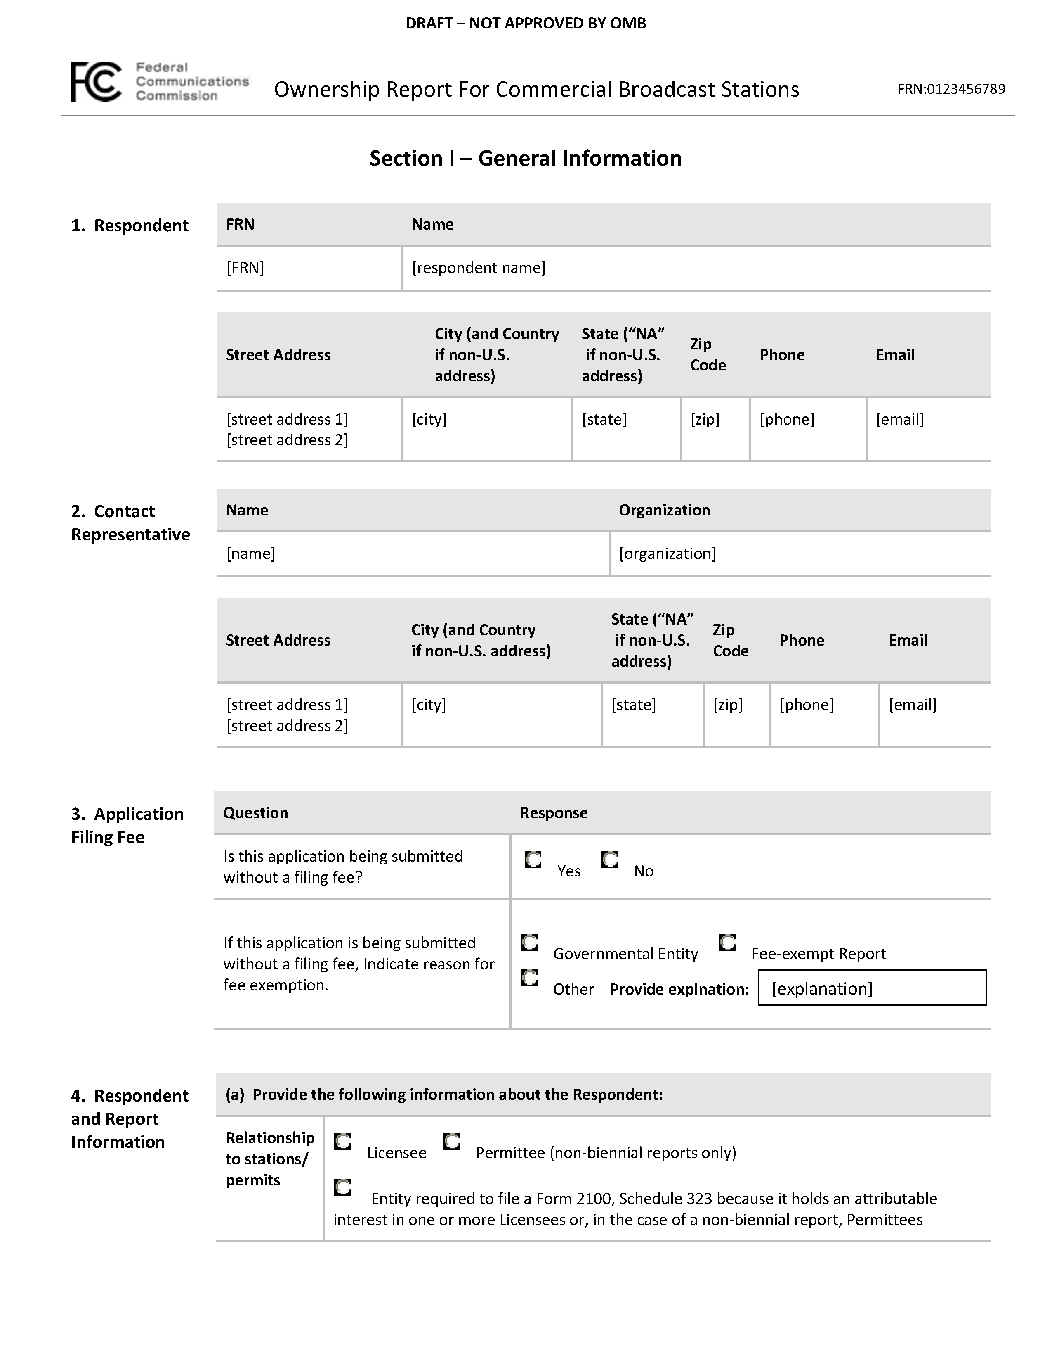
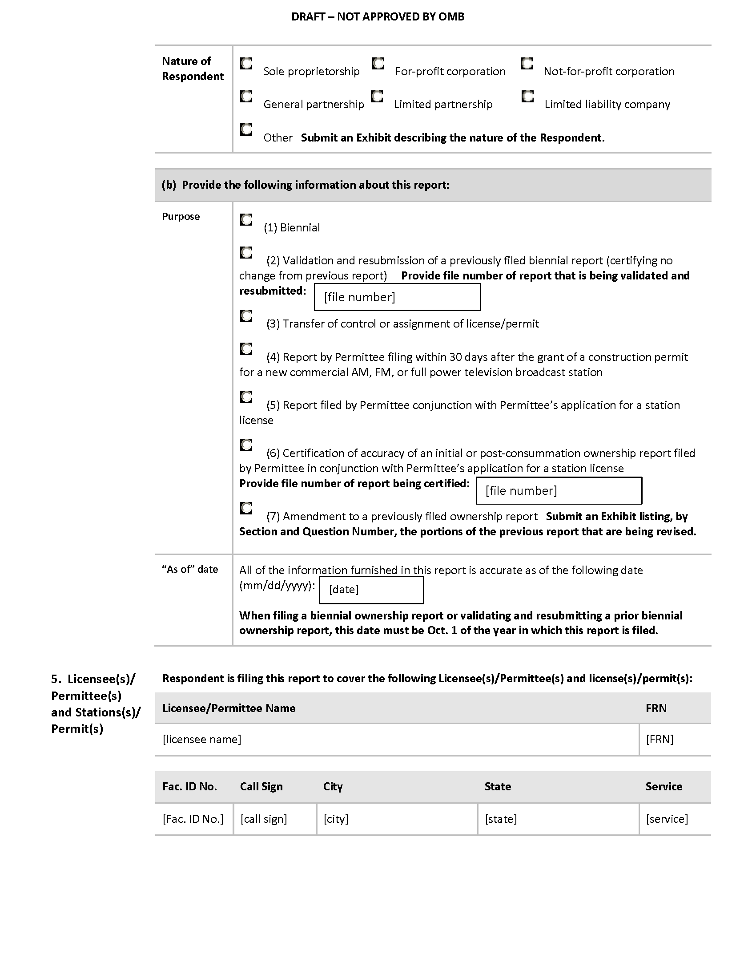
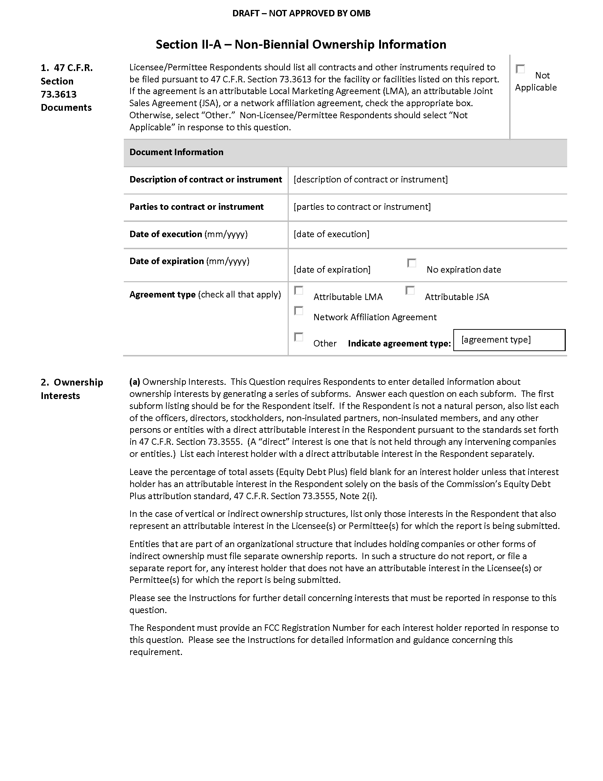
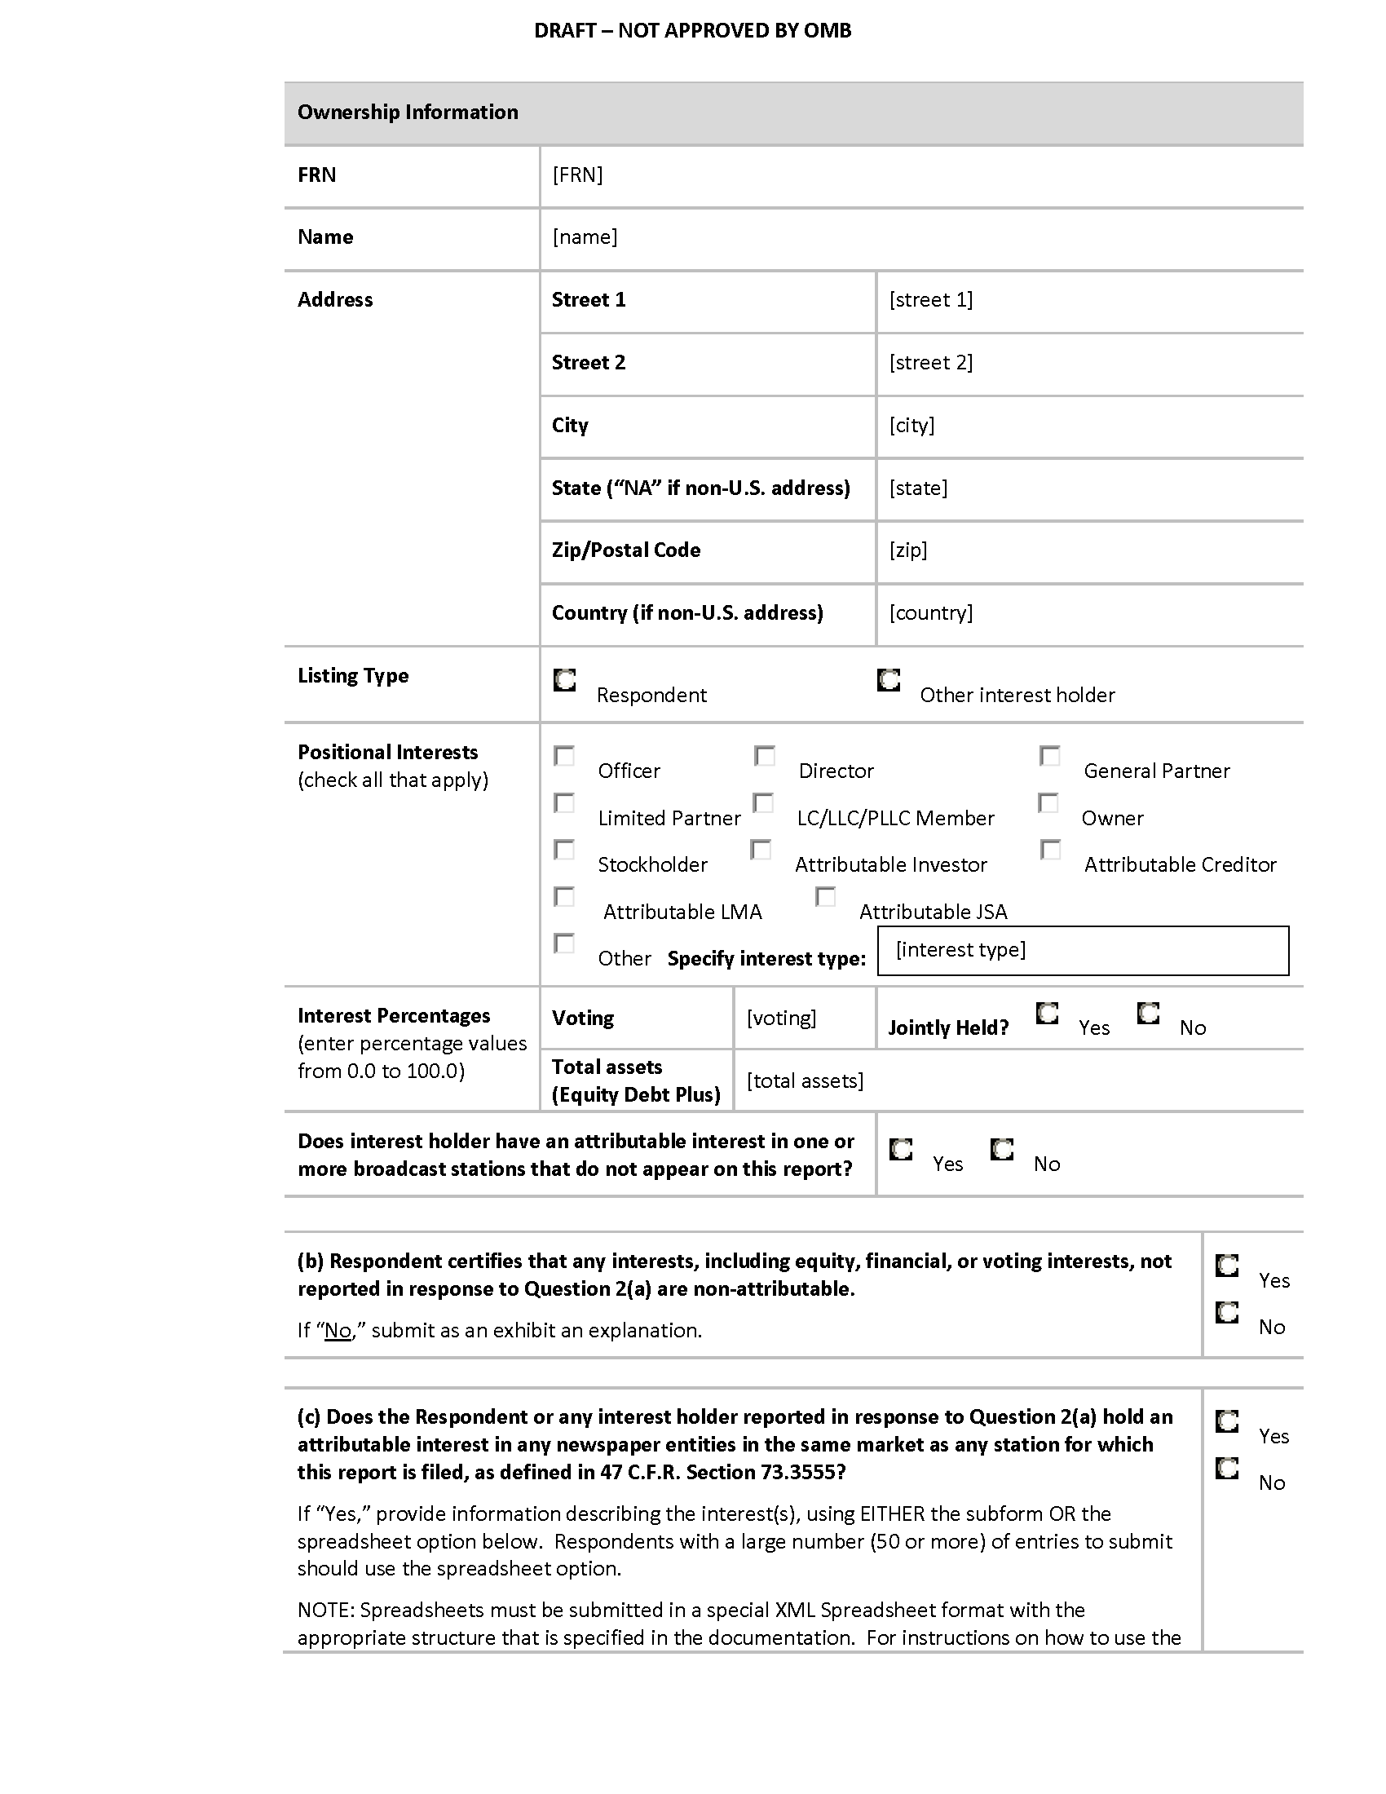
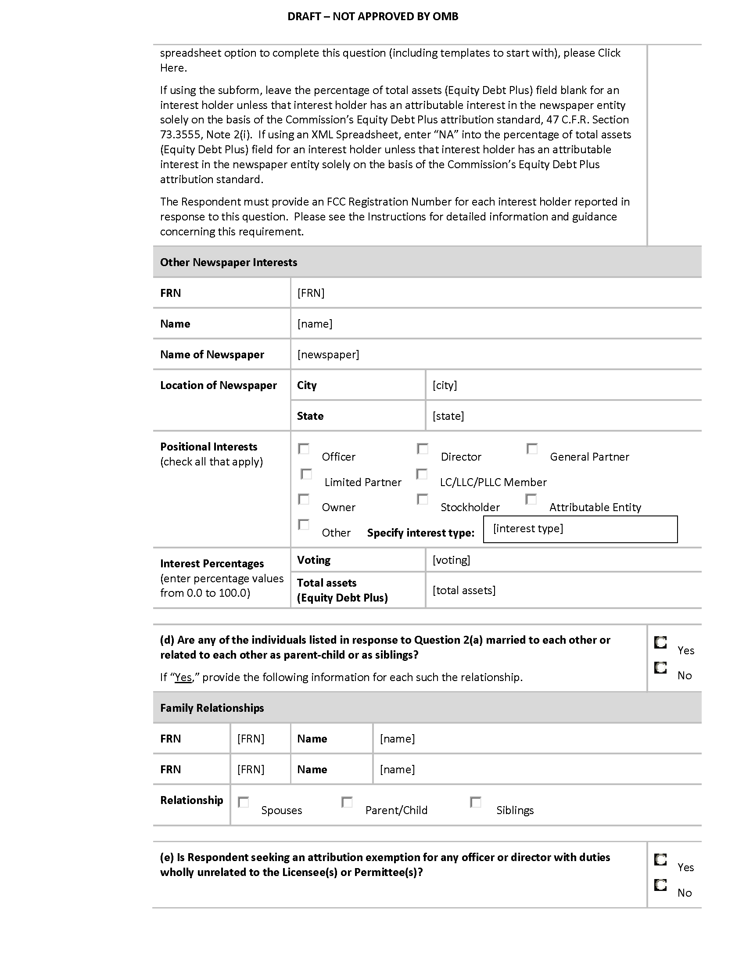
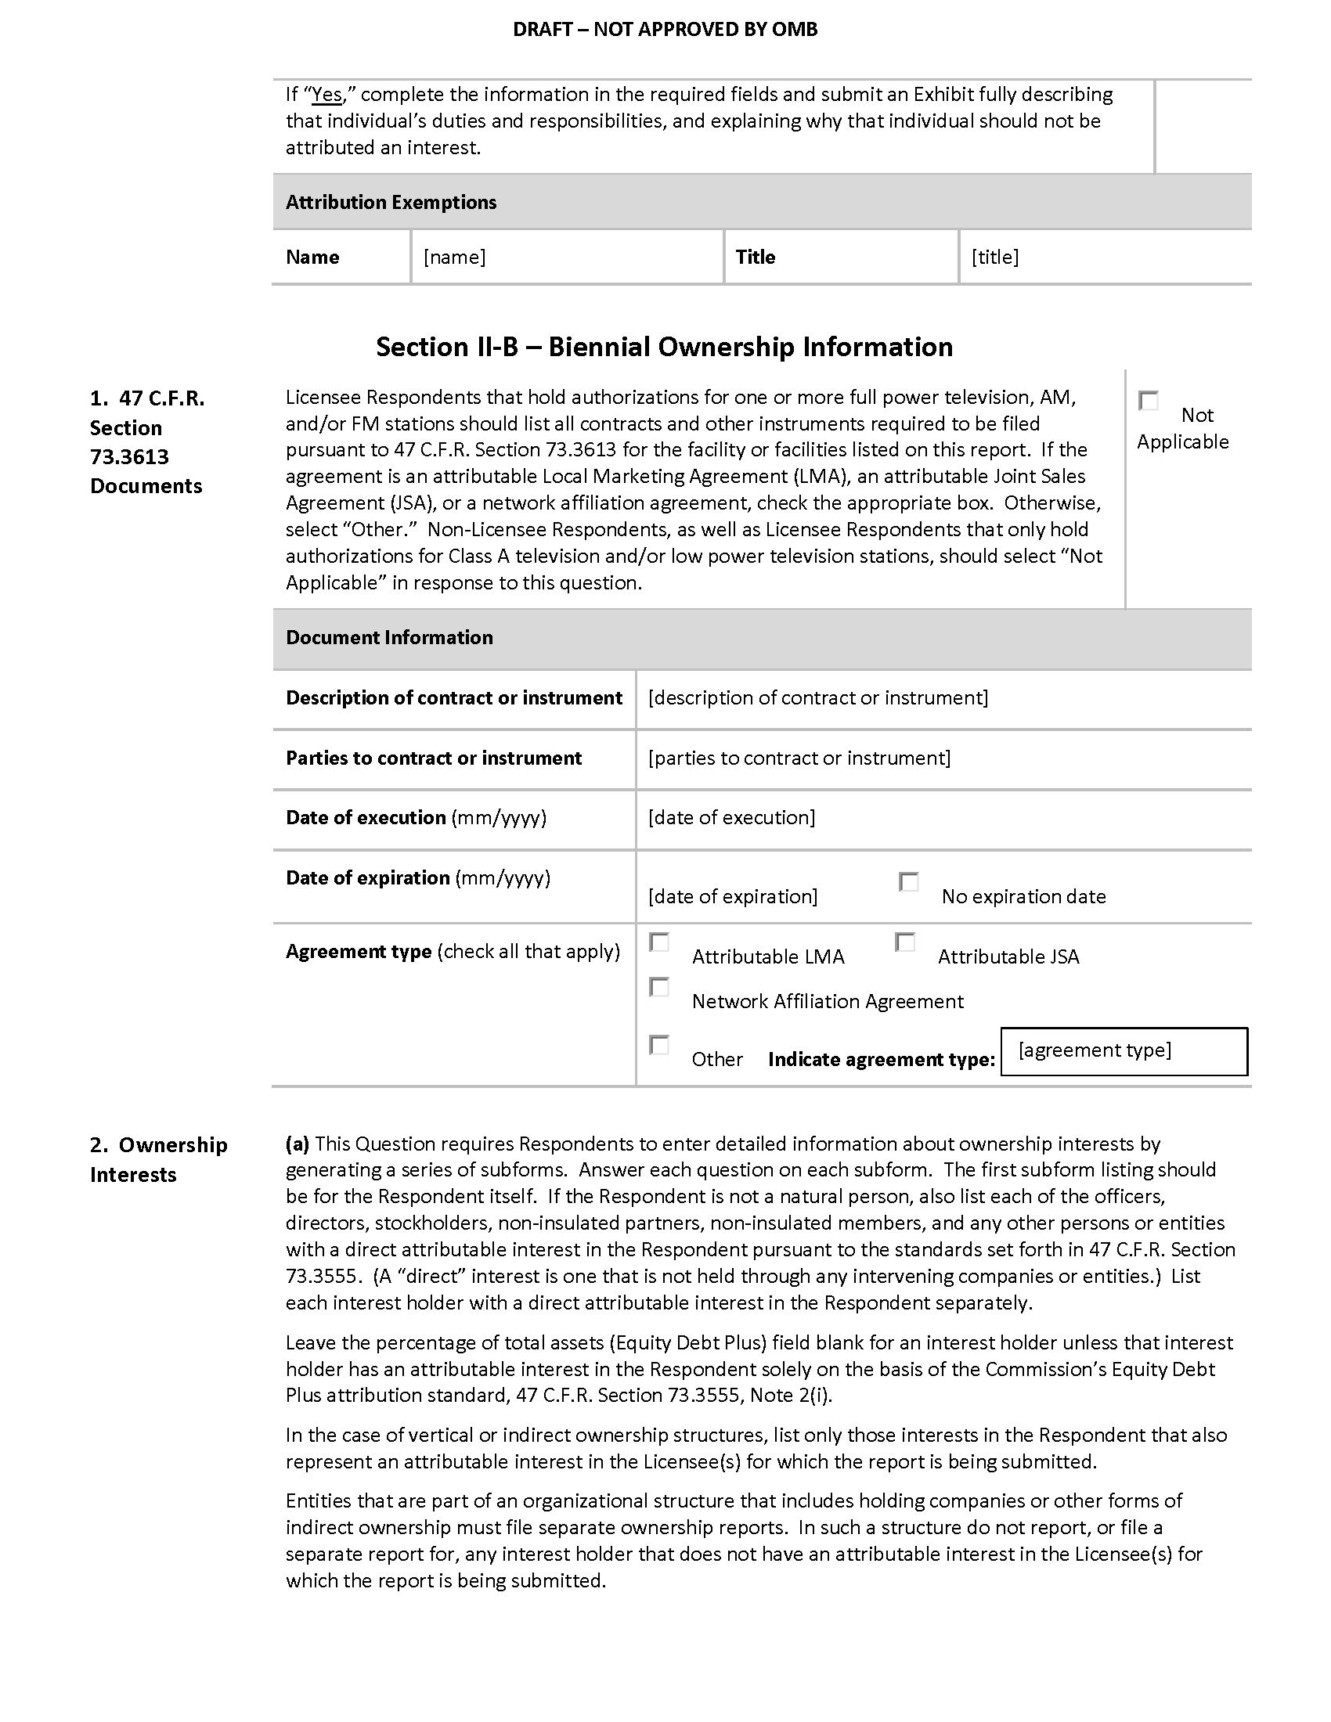
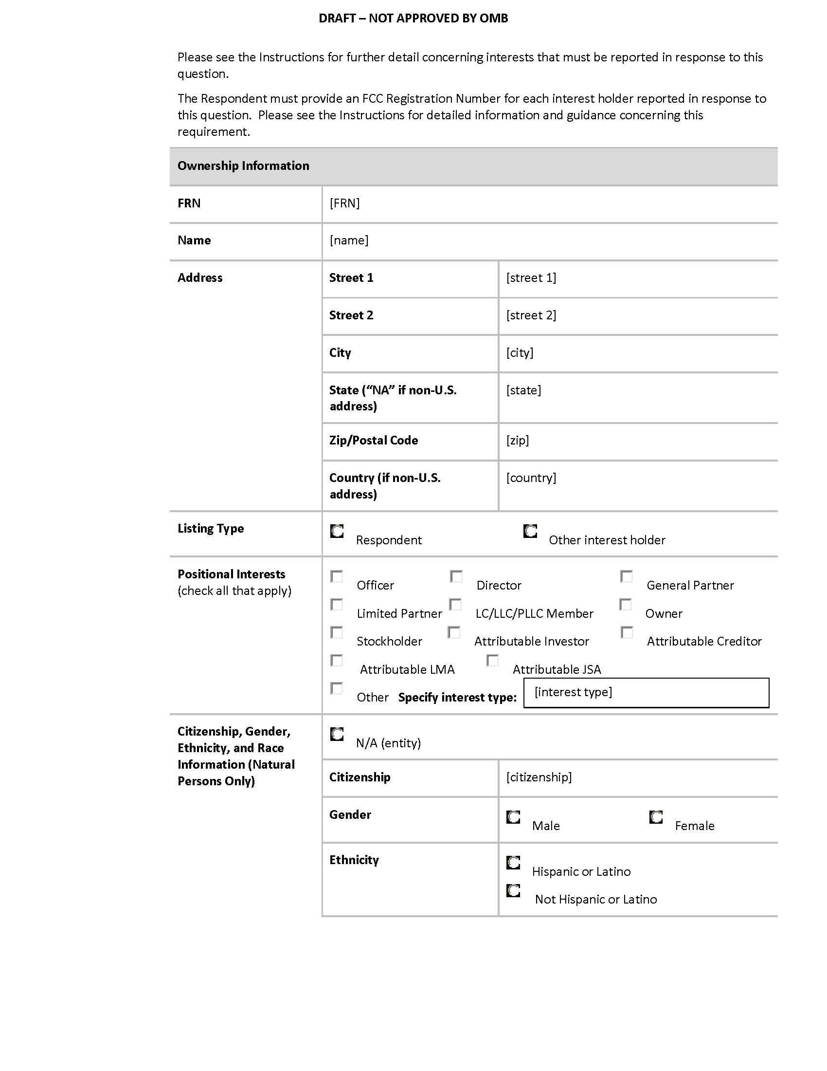
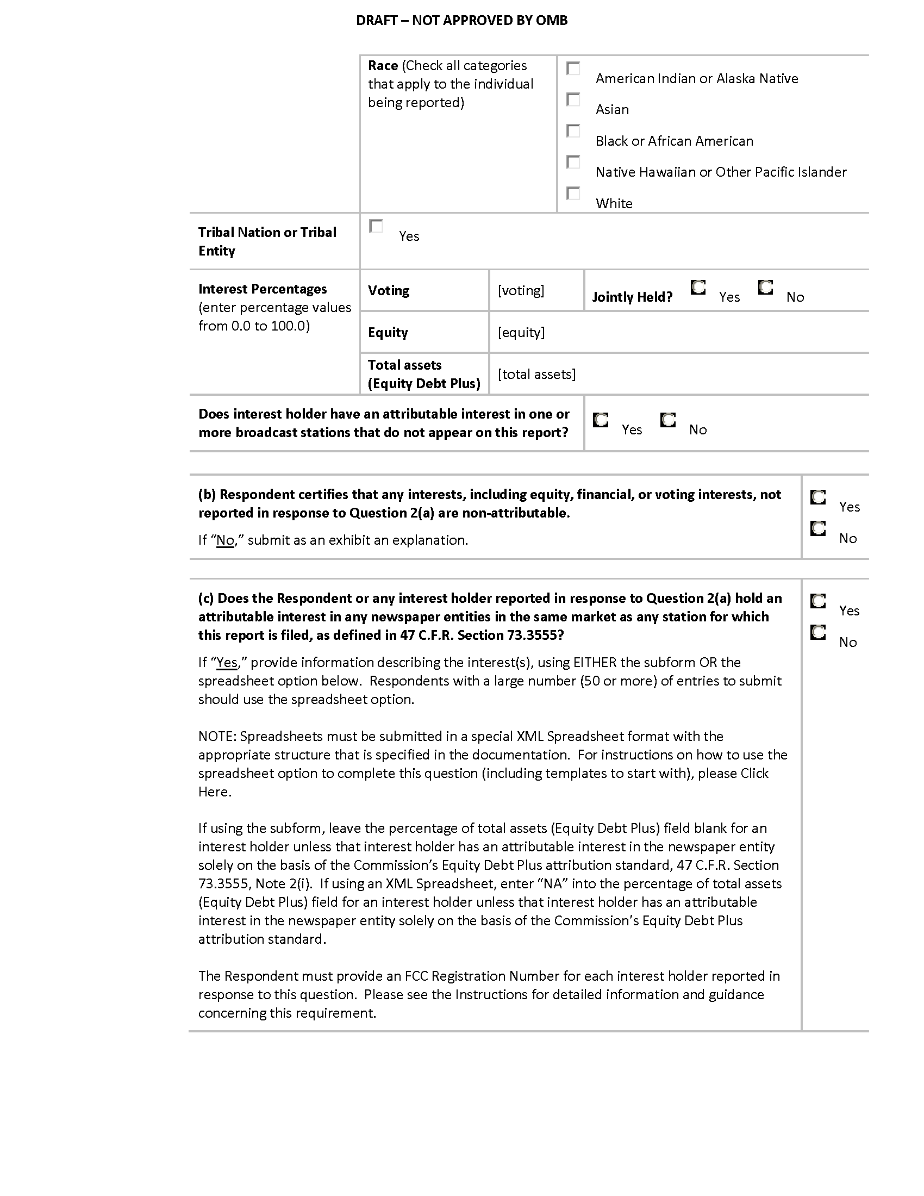
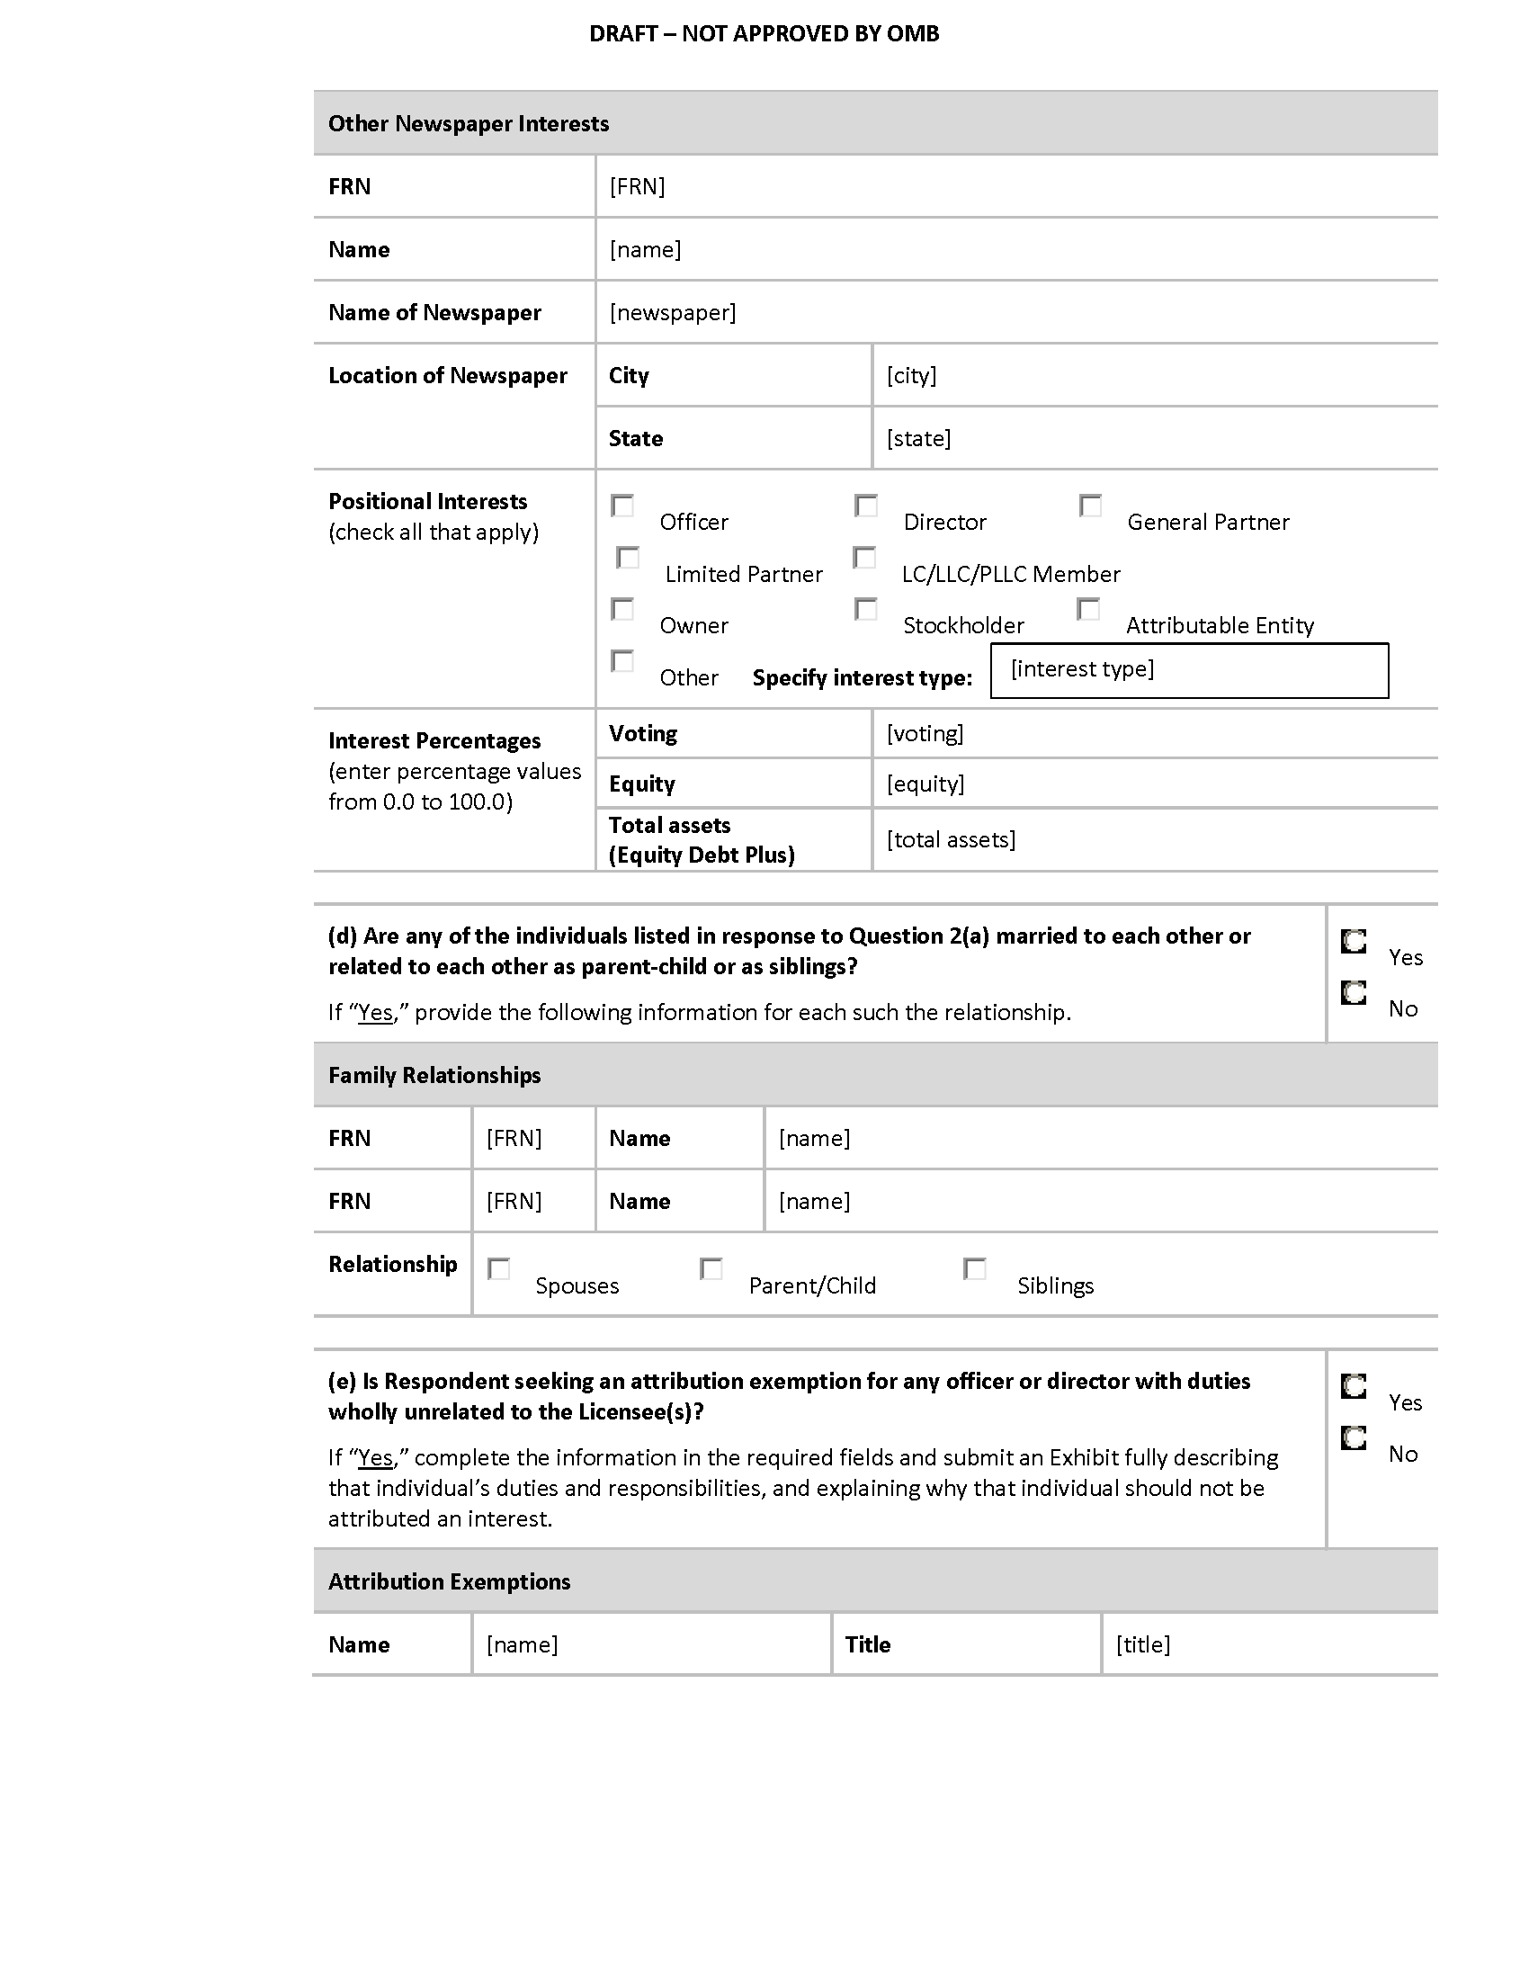
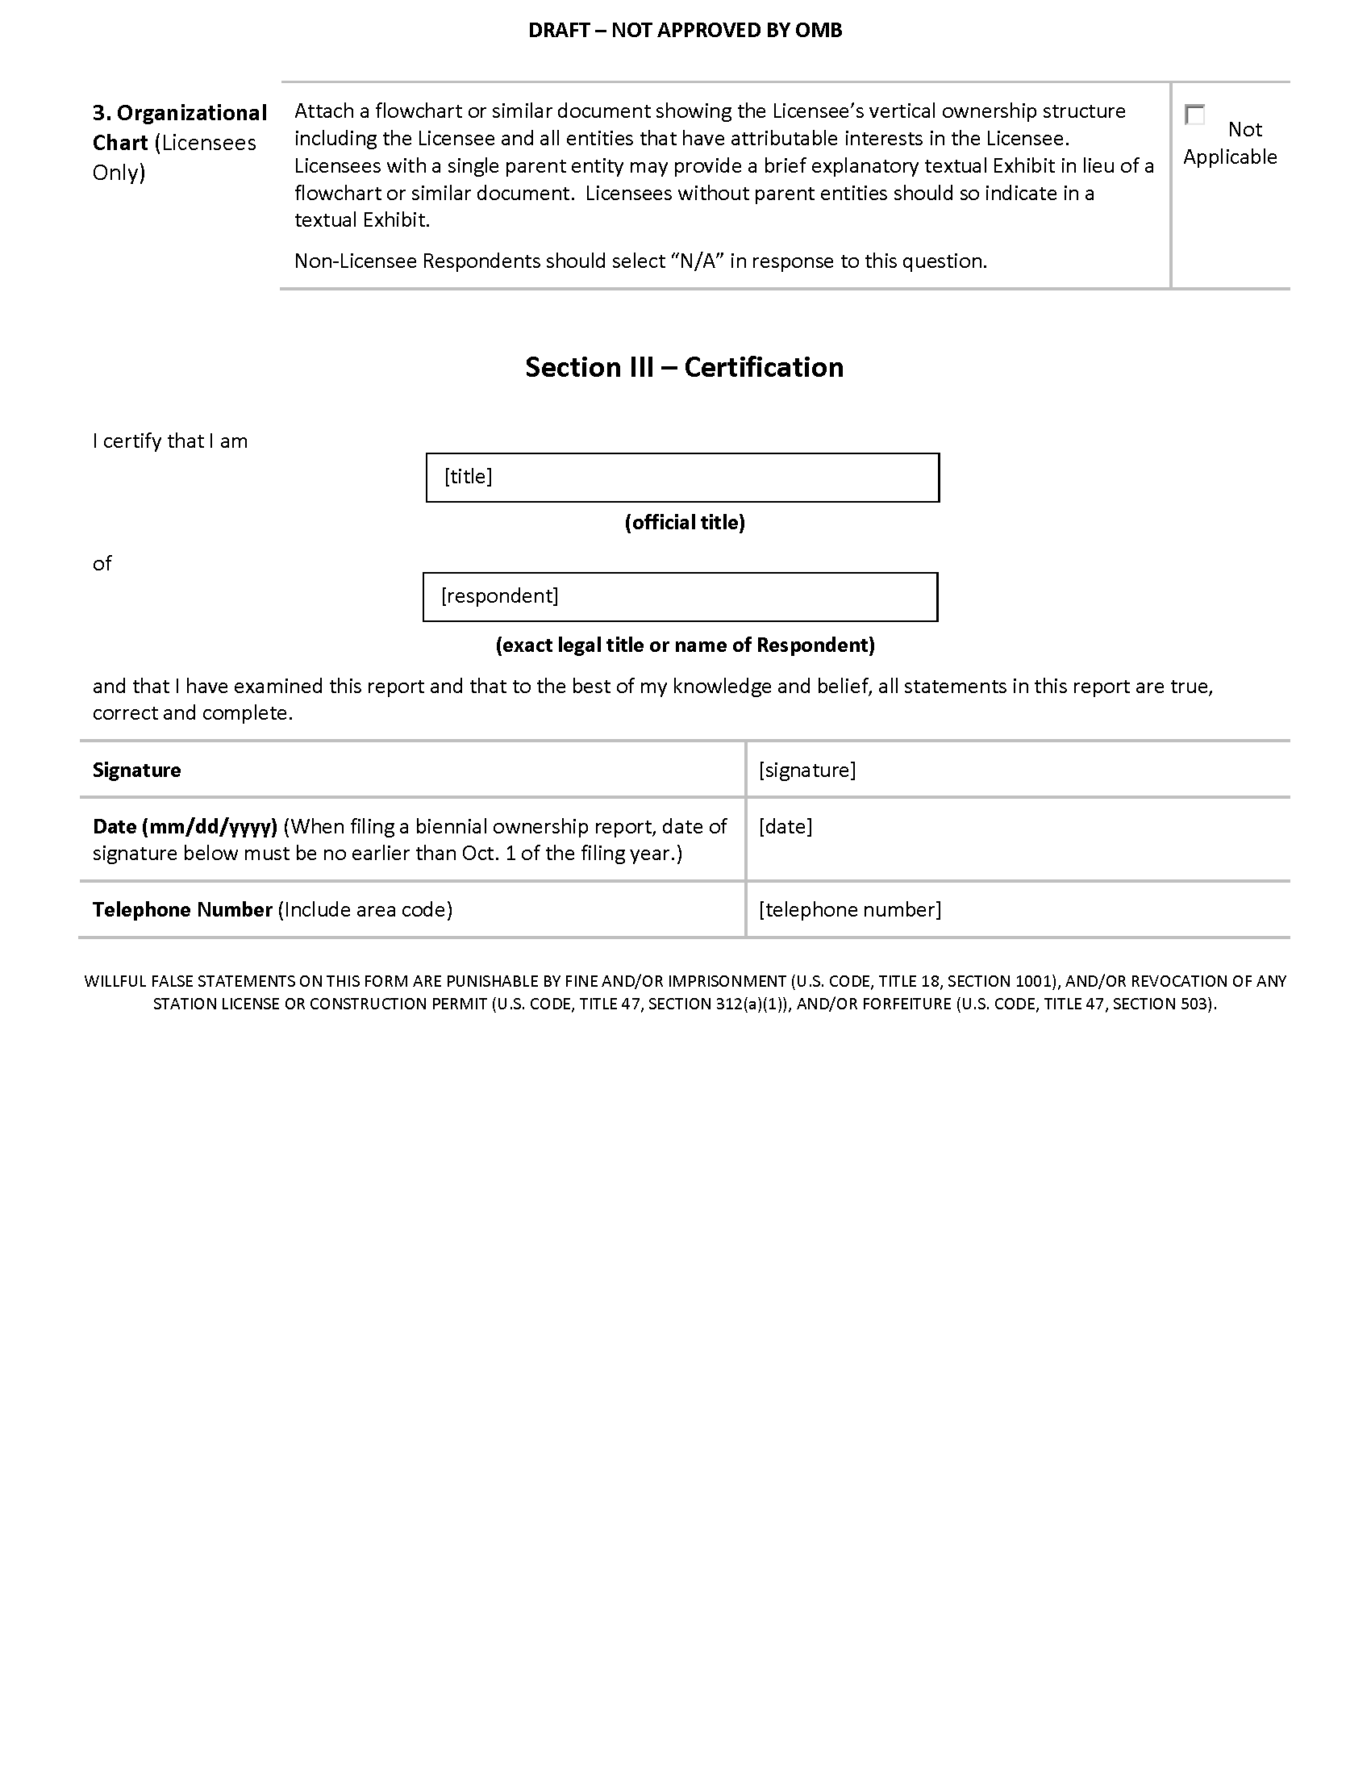

APPENDIX E

DRAFT FORM 2100, SCHEDULE 323-E

Federal Communications Commission 3060-0084 NOT APPROVED BY OMB
Washington, D.C. 20554

DRAFT FORM 2100, SCHEDULE 323-E
INSTRUCTIONS FOR OWNERSHIP REPORT FOR NONCOMMERCIAL BROADCAST STATIONS

GENERAL INSTRUCTIONS

1. Definitions. For the purposes of completing this form:

- A Licensee is a natural person or an entity that holds a Commission license for a noncommercial educational broadcast station.

- A Permittee is a natural person or an entity that holds a Commission construction permit for a noncommercial educational broadcast station.

- A Respondent is any person or entity that is required to file Form 2100, Schedule 323-E.

2. Filing Requirements: Non-Biennial Ownership Reports. Licensees and Permittees of noncommercial educational AM, FM, or full power television stations must file Form 2100, Schedule 323-E to report all attributable interests in the Licensee or Permittee as follows.

- Transfers of Control/Assignment of License or Construction Permit. Licensees and Permittees must file Form 2100, Schedule 323-E within 30 days after the consummation of a transfer of control or an assignment of a noncommercial educational AM, FM, or full power television station license or construction permit. See 47 C.F.R. Section 73.3615(f). Note: FCC consent is required prior to consummation of transfers of control/assignments of broadcast authorizations.

- Post-grant of Construction Permit. A Permittee of a new noncommercial educational AM, FM, or full power television broadcast station must file Form 2100, Schedule 323-E within 30 days after the grant of an original construction permit. See 47 C.F.R. Section 73.3615(e)(i).

- Application for Station License. On the date that a Permittee applies for a license to cover an original construction permit for a new noncommercial educational AM, FM, or full power television broadcast station, the Permittee must file Form 2100, Schedule 323-E to update its ownership information. A filer may choose to certify the continuing accuracy and completeness of a previously-filed ownership report. If the permit was not assigned or transferred since it was first granted, the filer may certify the continuing accuracy and completeness of a previously-filed report that was submitted pursuant to item (1), above (i.e., a report that was filed in connection with grant of the original construction permit). If the permit was assigned or transferred since it was first granted, the filer may certify the continuing accuracy and completeness of a previously-filed report that was submitted pursuant to item (2), above (i.e., a post-consummation ownership report). In either case, the information in the previously-filed report must remain accurate. See 47 C.F.R. Section 73.3615(e)(ii).

In the case of organizational structures that include holding companies or other forms of indirect ownership, a separate FCC Form 2100, Schedule 323-E must be filed for each entity in the organizational structure that has an attributable interest in the Licensee or Permittee. If a Permittee or Licensee holds multiple construction permits and/or station licenses for which the filing of a non-biennial ownership report was triggered pursuant to (1), (2), or (3), above, and the information submitted on the Permittee’s or Licensee’s ownership report is equally applicable to each such permit and/or license, the Licensee or Permittee may file a single Form 2100, Schedule 323-E listing all such licenses and/or permits. Similarly, if a non-Licensee/Permittee Respondent holds attributable interests in multiple Licensees or Permittees and the information submitted on the Respondent’s ownership report is equally applicable to each such Licensee/Permittee and all associated licenses/permits, the Respondent may file a single Form 2100, Schedule 323-E listing all such Licensees/Permittees and licenses/permits. Notwithstanding the foregoing, any Respondent that both (1) is a Licensee and/or Permittee and (2) holds attributable interests in one or more Licensees and/or Permittees must file two ownership reports – one as a Licensee/Permittee and one as a non-Licensee/Permittee Respondent.

3. This form is not to be used to request a transfer of control or assignment of license or construction permit. The appropriate forms for use in connection with such transfers or assignments are FCC Forms 314, 315, and/or 316. See 47 C.F.R. Sections 73.3540 and 73.3541. It is the responsibility of the Licensee or Permittee to determine if a given transaction constitutes a transfer of control or an assignment.

4. Filing Requirements: Biennial Reports. Licensees of noncommercial educational AM, FM, and full power television broadcast stations, as well as Licensees of Class A Television and Low Power Television (LPTV) stations, must file FCC Form 2100, Schedule 323-E every two years to report all attributable interests in the Licensee. Ownership reports must be filed by December 1 in all odd-numbered years. The information in each ownership report shall be current as of October 1 of the year in which the ownership report is filed. See 47 C.F.R. Section 73.3615(d).

In the case of organizational structures that include holding companies or other forms of indirect ownership, a separate FCC Form 2100, Schedule 323-E must be filed for each entity in the organizational structure that has an attributable interest in the Licensee. If a Licensee holds multiple station licenses and the information submitted on the Licensee’s ownership report is equally applicable to each such license, the Licensee may file a single Form 2100, Schedule 323-E listing all such licenses. Similarly, if a non-Licensee Respondent holds attributable interests in multiple Licensees and the information submitted on the Respondent’s ownership report is equally applicable to each such Licensee and all licenses, the Respondent may file a single Form 2100, Schedule 323-E listing all such Licensees and licenses. Notwithstanding the foregoing, any Respondent that both (1) is a Licensee and (2) holds attributable interests in one or more Licensees must file two ownership reports – one as a Licensee and one as a non-Licensee Respondent.

If there has been no change in the information submitted since the filing of the last biennial report, and that last biennial report was filed on the current version of Form 2100, Schedule 323-E, a Licensee or other Respondent may electronically validate and resubmit its previously-filed biennial Form 2100, Schedule 323-E.

5. Electronic Filing of FCC Form 2100, Schedule 323-E. All Form 2100, Schedule 323-E filings must be submitted electronically. Use the Media Bureau Electronic Filing system (http://www.fcc.gov/encyclopedia/media-bureau-filing-systems-and-databases).

Section I – General Information (All Respondents Must Complete)

Questions 1 and 2: Respondent and Contact Representative. In response to Question 1, enter the legal name, address, contact information and FCC Registration Number of the Respondent. If the report is filed on behalf of more than one license/permit, enter the call sign and Facility ID Number of one of the licenses/permits covered by the report. Provide the name, organization, and contact information for the Respondent’s representative in response to Question 2.

For non-U.S. addresses, include the country name with the city in the City field, and answer “NA” in the State field. Provide a U.S. zip code or non-U.S. postal code, as applicable, in the Zip/Postal Code field.

Licensees/Permittees. The name of the Licensee or Permittee should be stated exactly as it appears on the station’s existing license or construction permit. The current street address or post office box used by the Licensee or Permittee for receipt of Commission correspondence should be set forth. Any change in the name of the Licensee or Permittee, which does not involve a change in ownership requiring prior Commission approval, can be communicated to the Commission by letter. Changes in the mailing address previously used by the Licensee or Permittee should be promptly transmitted to the Commission. See 47 C.F.R. Section 1.5. To report any changes in the mailing address, use the Media Bureau Electronic Filing system (http://www.fcc.gov/encyclopedia/media-bureau-filing-systems-and-databases).

FCC Registration Number (FRN). The Respondent must provide its FRN – a ten-digit unique entity identifier. An FRN can be obtained through the Commission Registration System, CORES, which is listed among the FCC E-Filing systems (http://www.fcc.gov/e-file/).

If a Respondent submits and/or is listed as an attributable interest holder on multiple ownership reports, it must provide the same FRN on all such ownership reports. Filers should coordinate with each other to ensure such consistency.

Questions concerning the FCC Registration Number can be directed to the Commission’s Registration System help desk via email at CORES@fcc.gov or by calling 1-877-480-3201 (Mon.-Fri. 8 a.m.-6 p.m. ET).

Facility ID Number. Facility ID numbers can be located by using the “Station Search” at the Media Bureau Electronic Filing system (http://www.fcc.gov/mb/elecfile.html). In addition, the Facility ID Number is included on all broadcast authorizations and postcards.

Question 3: Respondent and Report Information. In response to subsection (a), select the appropriate option to indicate whether the Respondent, is

- a Licensee;

- a Permittee (non-biennial reports only); or

- an entity required to file a Form 2100, Schedule 323-E because it holds an attributable interest in one or more Licensees or, in the case of non-biennial reports, Permittees.

Also indicate whether the Respondent’s governing board (or other governing entity) is directly or indirectly under the control of another entity. If “yes” is selected, a separate Form 2100, Schedule 323-E must be submitted for each such controlling entity.

In response to subsection (b), indicate the report is (1) filed to satisfy the biennial filing requirement; (2) a validation and resubmission of a previously-filed biennial report (certifying no change from the previously-filed biennial report), (3) filed in connection with a transfer of control or assignment of permit or license, (4) a report by a Permittee within 30 days after the grant of a construction permit; (5) a report in conjunction with a Permittee’s application for a station license; (6) a certification of accuracy of a previously filed ownership report by a Permittee (report in conjunction with a Permittee’s application for a station license); or (7) for the purposes of amending a previously-filed report.

A Respondent with a current and unamended biennial ownership report on file with the Commission that is still accurate and that was filed using this version of Form 2100, Schedule 323-E may select option (2) to validate and resubmit the Respondent’s previously-filed biennial ownership report. A Respondent that selects option (2) will not be permitted to make changes to the information contained in Section I, Question 4, or Section II-B of the new biennial report. If such changes are needed, the Respondent should NOT select option (2) but instead should make use of the report copying or prefilling capabilities within CDBS to create the new report.

If a report is filed pursuant to option (6), provide the file number of the previously-filed report that is being certified. A Respondent that selects option (6) will not be permitted to make changes to the information contained in Section I, Question 4, or Section II-A of the new report. If such changes are needed, the Respondent should NOT select option (6) and should instead select option (5) and make use of the report copying or prefilling capabilities within CDBS to create the new report.

A Respondent should select option (7) only if the purpose of the filing is to correct one or more errors in a previously-submitted report. Filing under option (7) will update the previously-filed report, and the report will have the same file number as the previously-filed report. If the report is being submitted pursuant to option (7), provide the File Number of the previously-filed report and an exhibit listing, by Section and Question Number, the portions of the previous report that are being revised. A Respondent that wishes to create a new report based on data contained in a previously-submitted report should NOT select option (7). Instead, the Respondent should make use of the report copying or prefilling capabilities within the Commission’s electronic filing system to create the new report.

Also enter the “as of” date in the field provided. When filing a biennial ownership report (option (1) or (2)), the date entered must be Oct. 1 of the filing year.

Question 4: Licensee/Permittee and License/Permit Information. All Licensee/Permittee Respondents must enter the name and FRN of the Licensee/Permittee and provide information for each license/permit held by the Licensee/Permittee and covered by the ownership report, including call sign, Facility ID Number, community of license, and class of service. All non-Licensee/Permittee Respondents must enter the name and FRN for each Licensee/Permittee covered by the ownership report. In addition, such Respondents must provide the required information for each license/permit that is held by one of those Licensee(s)/Permittee(s) and covered by the ownership report.

Section II-A – Non-Biennial Ownership INFORMATION

Question 1: Contract Information. Licensees and Permittees of full power noncommercial educational television stations, AM radio stations, and FM radio stations are required to file with the Commission any contracts or other instruments, or modifications thereof, relating to the ownership, control, or management of the Licensee or Permittee or to its stock. See 47 C.F.R. Section 73.3613. Licensees and Permittees must file all contracts or instruments of the types specified in Section 73.3613. The filing requirement is not limited to executed contracts, but includes documents such as options, pledges, and other executory agreements and contracts relating to ownership, control, or management.

Licensee/Permittee Respondents should list all documents required to be filed pursuant to Section 73.3613 for all of the stations covered by the report. For each contract or instrument, the Respondent should provide a description of the document, a listing of the parties, the month and year of execution, and the month and year of expiration (if the agreement is perpetual or does not have a fixed expiration date, select “No Expiration Date”). In addition, the Respondent should use the checkboxes provided to indicate whether each document is a network affiliation agreement or another type of document. If an agreement falls into both categories, check both boxes. If “other” is selected, indicate the agreement type. Each contract/instrument must be identified and listed directly in the fields provided. For the purposes of completing Question 1, only a listing of the relevant contract and instruments, including the specific information discussed above, is required. Do not attach copies of the contracts/instruments to the form.

Non-Licensee/Permittee Respondents should select “Not Applicable” in response to this question and should not provide any information concerning contracts or other instruments.

Question 2: Ownership Interests. As used in Question 2, an attributable interest is an ownership interest in or relationship to a Licensee that confers on its holder a certain degree of influence or control over the Licensee as defined in the Commission’s rules. For guidance concerning attributable interests, Respondents should consult the instructions below. In addition, Respondents should review the Commission’s attribution policies and standards, which are set forth in 47 C.F.R. Section 73.3555, as revised and explained in Review of the Commission’s Regulations Governing Attribution of Broadcast and Cable/MDS Interests, MM Docket No. 94-150, 14 FCC Rcd 12559 (1999), recon. granted in part, 16 FCC Rcd 1097 (2000) and Report and Order in MM Docket No. 83-46, 97 FCC 2d 997 (1984), recon. granted in part, 58 RR 2d 604 (1985), further modified on recon., 61 RR 2d 739 (1986). Finally, Respondents should consult Promoting Diversification of Ownership in the Broadcasting Services, MB Docket No. 07-294, Second Report and Order, and Order on Reconsideration, FCC 16-1, ¶¶ 47-50 (Jan. 20, 2016).

Part (a). This Question requires Respondents to enter detailed information about ownership interests by generating a series of subforms. Answer each question on each subform. The first subform listing should be for the Respondent itself. If the Respondent is not a natural person, also list each of the officers, directors, stockholders, non-insulated partners, non-insulated members and other persons or entities with a direct attributable interest in the Respondent. (A “direct” interest is one that is not held through any intervening companies or entities.) In the case of vertical or indirect ownership structures, report only those interests in the Respondent that also represent an attributable interest in the Licensee(s) and/or Permittee(s) for which the report is being submitted.

List each person or entity with a direct attributable interest in the Respondent separately. Entities that are part of an organizational structure that includes holding companies or other forms of indirect ownership must file separate ownership reports. In such a structure, do not report or file separate reports for persons or entities that do not have an attributable interest in the Licensee(s) and/or Permittee(s) for which the report is being submitted.

Attributable Agreements. Pursuant to Section 73.3555, Notes 2(j) and 2(k), certain agreements give rise to an attributable interest in a Licensee or Permittee. Any party to such agreement that creates an attributable interest in the Licensee/Permittee by virtue of the standards set forth in 73.3555, Notes 2(j) and 2(k) must be listed in response to Question 2(a) in the ownership report filed by the Licensee/Permittee – regardless of whether or not the Licensee/Permittee itself is a party to the agreement(s). In addition, each such party must file its own ownership report(s), pursuant to the standards set forth in these Instructions, in connection with the relevant Licensee/Permittee and license(s)/permit(s).

FCC Registration Numbers (FRNs). Respondents must provide an FRN – a ten-digit unique entity identifier – for each person or entity reported on Form 2100, Schedule 323-E. An FRN can be obtained through the Commission Registration System, CORES, which is listed among the FCC E-Filing systems (http://www.fcc.gov/e-file/).

Individuals (but not entities) may report either a CORES FRN or a Restricted Use FRN (RUFRN) on Form 2100, Schedule 323-E. If an RUFRN or CORES FRN has been previously reported for an individual on one or more ownership report filings (either commercial or noncommercial), the Respondent must use that previously-reported RUFRN or CORES FRN for that individual on all current and future ownership report filings.

In limited circumstances, a Respondent may report a Special Use FRN (SUFRN) for an individual. Before generating or submitting an SUFRN for an individual, Respondents should read the Commission’s Form 2100, Schedule 323 and Form 2100, Schedule 323-E Frequently Asked Questions concerning the SUFRN (http://www.fcc.gov/bureaus/mb/industry_analysis/form323faqs.html). By reporting an SUFRN for an individual, the Respondent affirms to the Commission that after using reasonable and good faith efforts, the Respondent is unable to obtain an FRN and/or obtain and/or receive permission to use the Social Security Number or other identifying information of that individual in order to generate a CORES FRN or RUFRN for that individual. If an individual interest holder does not already have a CORES FRN, we expect filers to acquire an RUFRN or CORES FRN for that individual or instruct the individual to obtain his or her own RUFRN or CORES FRN and to provide the FRN to the filer for reporting on the ownership report form. Filers must take specific steps to substantiate that they are making the required reasonable and good faith efforts, which include informing reportable individuals of their obligations and the risk of enforcement action for failing to provide an RUFRN or CORES FRN or to permit an RUFRN or CORES FRN to be obtained on their behalf. An SUFRN may be obtained only if an individual still refuses to provide a means of reporting a valid RUFRN or CORES FRN after the filer has taken such steps. See Promoting Diversification of Ownership in the Broadcasting Services, MB Docket No. 07-294, Report and Order, Second Report and Order, and Order on Reconsideration, FCC 16-1, ¶¶ 56-58 (Jan. 20, 2016) (Second Report and Order). Respondents are encouraged to refer individual interest holders who are resistant to providing the Respondent with the means of reporting a CORES FRN or RUFRN to the Second Report and Order and to the Commission’s Form 2100, Schedule 323 and Form 2100, Schedule 323-E website.
While the burden to obtain an RUFRN or CORES FRN or to permit the filer to acquire an RUFRN or CORES FRN falls to the interest holder, the Commission reminds filers of their obligation to review the ownership report and affirm that, to the best of the filer’s “knowledge and belief, all statements in [the ownership report] are true, correct, and complete.” This includes verifying that the CORES FRN or RUFRN reported for each reported party is correct and that no SUFRN has been used for an individual in the absence of reasonable and good-faith efforts to obtain an RUFRN or CORES FRN, including informing a recalcitrant interest holder of the obligation and potential for enforcement action. However, the filer itself will be exempt from enforcement action if the filer substantiates that it has used reasonable and good-faith efforts as described herein.
If an SUFRN has not been reported previously for an individual on any ownership report filings (either commercial or noncommercial), and, pursuant to the instructions and standards set forth above, the Respondent is unable to obtain a CORES FRN or RUFRN for that individual, the Respondent should click the button on the relevant subform for this question to generate an SUFRN for that individual. If an SUFRN has been previously reported for an individual on one or more ownership report filings (either commercial or noncommercial) and, pursuant to the discussion and standards set forth above, the Respondent remains unable to obtain a CORES FRN or RUFRN for that party, the Respondent must report the previously-used SUFRN for the individual.

RUFRNs and SUFRNs may only be used to file ownership reports, and may not be used for any other purpose at the FCC. RUFRNs and SUFRNs are only available for natural persons. In addition, RUFRNs and SUFRNs are not available for any natural person who is a Respondent on one or more ownership reports.

If a party submits and/or is listed as an attributable interest holder on multiple ownership reports, it must provide the same FRN on all such ownership reports, regardless of whether that FRN is a CORES FRN, RUFRN, or SUFRN. Filers should coordinate with each other to ensure such consistency.

The guidance concerning Special Use FRNs provided in Media Bureau Announces Online Availability of Revised Biennial Form 323, an Instructional Workshop on the Revised Form, and the Possibility of Obtaining a Special Use FRN for the Form, MB Docket No. 07-294, Public Notice, 24 FCC Rcd 14329 (Med. Bur. 2009) has been superseded as discussed herein and as provided in the Second Report and Order.

Questions concerning the FCC Registration Number can be directed to the Commission’s Registration System help desk via email at CORES@fcc.gov or by calling 1-877-480-3201 (Mon.-Fri. 8 a.m.-6 p.m. ET).

Address Information. Provide address information for the interest holder in the relevant fields. Provide a U.S. zip code or non-U.S. postal code, as applicable, in the Zip/Postal Code field. If the interest holder has a non-U.S. address, select “NA” in the State field and provide the name of the country in the Country field. Otherwise, select the proper state abbreviation for the State field and leave the Country field blank.

Listing Type. Indicate whether the interest holder is the Respondent on the report. Respondent interest holders should be identified on the first subform of this question.

Positional Interests: Check the boxes for each type of interest in the Respondent held by the interest holder. If “other” is selected, specify the interest type.

Principal Profession or Occupation: Indicate the principal profession or occupation of the reported individual. Interest holders that are not natural persons should answer “Not Applicable” in response to this question.

By Whom Appointed or Elected: Indicate the person(s) responsible for appointing or electing the reported individual. Interest holders that are not natural persons should answer “Not Applicable” in response to this question.

Percentages of Votes and Total Assets (Equity Debt Plus). Provide the interest holder’s voting percentage in the Respondent in the field provided. If the interest holder holds an attributable interest in the Respondent solely pursuant to the Commission’s Equity Debt Plus attribution standard, discussed above, provide the interest holder’s percentage of total assets (Equity Debt Plus) in the field provided. Otherwise, leave the total assets (Equity Debt Plus) field blank.

Other Broadcast Interests. Use the radio buttons on the subform to indicate whether the interest holder reported on that subform also has attributable interests in one or more broadcast stations other than those covered by the ownership report.

Part (b). Respondents must indicate that the information provided in part (a) of Question 2 is complete by certifying that all interests, including equity, financial, or voting interests, not reported in response to Question 2(a) are non-attributable.

Part (c). If the Respondent seeks an attribution exemption for any officer or member of the governing board (or other governing entity) with duties wholly unrelated to the Licensee(s)/Permittee(s), select “Yes” and enter the name and title of the each such individual in the applicable fields. For each such individual, provide an exhibit establishing that he or she will not exercise authority or influence in areas that will affect the Respondent or the Licensee(s)/Permittee(s) and station(s) covered by the report. This exhibit should describe that individual’s duties and responsibilities and explain the manner in which such individual is insulated from the Respondent and, therefore, should not be attributed an interest. Attach any such explanation as Exhibit 4.

When answering this question, Respondents should note that exemption from attribution cannot be invoked for an officer or member of the governing board (or other governing entity) unless he or she does not, and will not, have the ability to influence the broadcast operations of the Permittee(s)/Licensee(s) or Station(s). See 47 C.F.R. § 73.3555, Note 2(g).

Section II-B – Biennial Ownership INFORMATION

Question 1: Contract Information. Licensees of full power noncommercial educational television stations, AM radio stations, and FM radio stations are required to file with the Commission any contracts or other instruments, or modifications thereof, relating to the ownership, control, or management of the Licensee or to its stock. See 47 C.F.R. Section 73.3613. Licensees must file all contracts or instruments of the types specified in Section 73.3613. The filing requirement is not limited to executed contracts, but includes documents such as options, pledges, and other executory agreements and contracts relating to ownership, control, or management.

Licensee Respondents that hold one or more licenses for full power noncommercial educational television stations, AM radio stations, and/or FM radio stations should list all documents required to be filed pursuant to Section 73.3613 for all of the stations covered by the report. For each contract or instrument, the Respondent should provide a description of the document, a listing of the parties, the month and year of execution, and the month and year of expiration (if the agreement is perpetual or does not have a fixed expiration date, select “No Expiration Date”). In addition, the Respondent should use the checkboxes provided to indicate whether each document is a network affiliation agreement or another type of document. If an agreement falls into both categories, check both boxes. If “other” is selected, indicate the agreement type. Each contract/instrument must be identified and listed directly in the fields provided. For the purposes of completing Question 1, only a listing of the relevant contract and instruments, including the specific information discussed above, is required. Do not attach copies of the contracts/instruments to the form.

Non-Licensee Respondents, as well as Licensee Respondents that hold only authorizations for Class A Television or LPTV stations, should select “Not Applicable” in response to this question and should not provide any information concerning contracts or other instruments.

Question 2: Ownership Interests. As used in Question 2, an attributable interest is an ownership interest in or relationship to a Licensee that confers on its holder a certain degree of influence or control over the Licensee as defined in the Commission’s rules. For guidance concerning attributable interests, Respondents should consult the instructions below. In addition, Respondents should review the Commission’s attribution policies and standards, which are set forth in 47 C.F.R. Section 73.3555, as revised and explained in Review of the Commission’s Regulations Governing Attribution of Broadcast and Cable/MDS Interests, MM Docket No. 94-150, 14 FCC Rcd 12559 (1999), recon. granted in part, 16 FCC Rcd 1097 (2000) and Report and Order in MM Docket No. 83-46, 97 FCC 2d 997 (1984), recon. granted in part, 58 RR 2d 604 (1985), further modified on recon., 61 RR 2d 739 (1986). Finally, Respondents should consult Promoting Diversification of Ownership in the Broadcasting Services, MB Docket No. 07-294, Second Report and Order, and Order on Reconsideration, FCC 16-1, ¶¶ 47-50 (Jan. 20, 2016).

Part (a). This Question requires Respondents to enter detailed information about ownership interests by generating a series of subforms. Answer each question on each subform. The first subform listing should be for the Respondent itself. If the Respondent is not a natural person, also list each of the officers, directors, stockholders, non-insulated partners, non-insulated members and other persons or entities with a direct attributable interest in the Respondent. (A “direct” interest is one that is not held through any intervening companies or entities.) In the case of vertical or indirect ownership structures, report only those interests in the Respondent that also represent an attributable interest in the Licensee(s) for which the report is being submitted.

List each person or entity with a direct attributable interest in the Respondent separately. Entities that are part of an organizational structure that includes holding companies or other forms of indirect ownership must file separate ownership reports. In such a structure, do not report or file separate reports for persons or entities that do not have an attributable interest in the Licensee(s) for which the report is being submitted.

Attributable Agreements. Pursuant to Section 73.3555, Notes 2(j) and 2(k), certain agreements give rise to an attributable interest in a Licensee. Any party to such agreement that is attributable in the Licensee by virtue of the standards set forth in 73.3555, Notes 2(j) and 2(k) must be listed in response to Question 2(a) in the ownership report filed by the Licensee – regardless of whether or not the Licensee itself is a party to the agreement(s). In addition, each such party must file its own ownership report(s), pursuant to the standards set forth in these Instructions, in connection with the relevant Licensee(s) and license(s).

FCC Registration Numbers (FRNs). Respondents must provide an FRN – a ten-digit unique entity identifier – for each person or entity reported on Form 2100, Schedule 323-E. An FRN can be obtained through the Commission Registration System, CORES, which is listed among the FCC E-Filing systems (http://www.fcc.gov/e-file/).

Individuals (but not entities) may report either a CORES FRN or a Restricted Use FRN (RUFRN) on Form 2100, Schedule 323-E. If an RUFRN or CORES FRN has been previously reported for an individual on one or more ownership report filings (either commercial or noncommercial), the Respondent must use that previously-reported RUFRN or CORES FRN for that individual on all current and future ownership report filings.

In limited circumstances, a Respondent may report a Special Use FRN (SUFRN) for an individual. Before generating or submitting an SUFRN for an individual, Respondents should read the Commission’s Form 2100, Schedule 323 and Form 2100, Schedule 323-E Frequently Asked Questions concerning the SUFRN (http://www.fcc.gov/bureaus/mb/industry_analysis/form323faqs.html). By reporting an SUFRN for an individual, the Respondent affirms to the Commission that after using reasonable and good faith efforts, the Respondent is unable to obtain an FRN and/or obtain and/or receive permission to use the Social Security Number or other identifying information of that individual in order to generate a CORES FRN or RUFRN for that individual. If an individual interest holder does not already have a CORES FRN, we expect filers to acquire an RUFRN or CORES FRN for that individual or instruct the individual to obtain his or her own RUFRN or CORES FRN and to provide the FRN to the filer for reporting on the ownership report form. Filers must take specific steps to substantiate that they are making the required reasonable and good faith efforts, which include informing reportable individuals of their obligations and the risk of enforcement action for failing to provide an RUFRN or CORES FRN or to permit an RUFRN or CORES FRN to be obtained on their behalf. An SUFRN may be obtained only if an individual still refuses to provide a means of reporting a valid RUFRN or CORES FRN after the filer has taken such steps. See Promoting Diversification of Ownership in the Broadcasting Services, MB Docket No. 07-294, Report and Order, Second Report and Order, and Order on Reconsideration, FCC 16-1, ¶¶ 56-58 (Jan. 20, 2016) (Second Report and Order). Respondents are encouraged to refer individual interest holders who are resistant to providing the Respondent with the means of reporting a CORES FRN or RUFRN to the Second Report and Order and to the Commission’s Form 2100, Schedule 323 and Form 2100, Schedule 323-E website.
While the burden to obtain an RUFRN or CORES FRN or to permit the filer to acquire an RUFRN or CORES FRN falls to the interest holder, the Commission reminds filers of their obligation to review the ownership report and affirm that, to the best of the filer’s “knowledge and belief, all statements in [the ownership report] are true, correct, and complete.” This includes verifying that the CORES FRN or RUFRN reported for each reported party is correct and that no SUFRN has been used for an individual in the absence of reasonable and good-faith efforts to obtain an RUFRN or CORES FRN, including informing a recalcitrant interest holder of the obligation and potential for enforcement action. However, the filer itself will be exempt from enforcement action if the filer substantiates that it has used reasonable and good-faith efforts as described herein.
If an SUFRN has not been reported previously for an individual on any ownership report filings (either commercial or noncommercial), and, pursuant to the instructions and standards set forth above, the Respondent is unable to obtain a CORES FRN or RUFRN for that individual, the Respondent should click the button on the relevant subform for this question to generate an SUFRN for that individual. If an SUFRN has been previously reported for an individual on one or more ownership report filings (either commercial or noncommercial) and, pursuant to the discussion and standards set forth above, the Respondent remains unable to obtain a CORES FRN or RUFRN for that party, the Respondent must report the previously-used SUFRN for the individual.

RUFRNs and SUFRNs may only be used to file ownership reports, and may not be used for any other purpose at the FCC. RUFRNs and SUFRNs are only available for natural persons. In addition, RUFRNs and SUFRNs are not available for any natural person who is a Respondent on one or more ownership reports.

If a party submits and/or is listed as an attributable interest holder on multiple ownership reports, it must provide the same FRN on all such ownership reports, regardless of whether that FRN is a CORES FRN, RUFRN, or SUFRN. Filers should coordinate with each other to ensure such consistency.

The guidance concerning Special Use FRNs provided in Media Bureau Announces Online Availability of Revised Biennial Form 323, an Instructional Workshop on the Revised Form, and the Possibility of Obtaining a Special Use FRN for the Form, MB Docket No. 07-294, Public Notice, 24 FCC Rcd 14329 (Med. Bur. 2009) has been superseded as discussed herein and as provided in the Second Report and Order.

Address Information. Provide address information for the interest holder in the relevant fields. Provide a U.S. zip code or non-U.S. postal code, as applicable, in the Zip/Postal Code field. If the interest holder has a non-U.S. address, select “NA” in the State field and provide the name of the country in the Country field. Otherwise, select the proper state abbreviation for the State field and leave the Country field blank.

Listing Type. Indicate whether the interest holder is the Respondent on the report. Respondent interest holders should be identified on the first subform of this question.

Positional Interests. Check the boxes for each type of interest in the Respondent held by the interest holder. If “other” is selected, specify the interest type.

Principal Profession or Occupation. Indicate the principal profession or occupation of the reported individual. Interest holders that are not natural persons should answer “Not Applicable” in response to this question.

By Whom Appointed or Elected. Indicate the person(s) responsible for appointing or electing the reported individual. Interest holders that are not natural persons should answer “Not Applicable” in response to this question.

Citizenship, Gender, Ethnicity, and Race Information. Among other things, Question 2(a) seeks information as to those persons to which the Commission’s minority and female ownership policies have historically applied. In addition to citizenship and gender information, Question 2(a) seeks information concerning the ethnicity and race of reported individuals. Interest holders that are not natural persons should answer “N/A” in response to this question.

Ethnicity. Indicate whether or not the individual being reported is Hispanic or Latino (i.e., a person of Cuban, Mexican, Puerto Rican, South or Central American, or other Spanish Culture or origin, regardless of race).

Race. The five racial categories are as follows:

- American Indian or Alaska Native. A person having origins in any of the original peoples of North and South America (including Central America), and who maintains tribal affiliation or community attachment.

- Asian. A person having origins in any of the original peoples of the Far East, Southeast Asia, or the Indian Subcontinent including, for example, Cambodia, China, India, Japan, Korea, Malaysia, Pakistan, the Philippine Islands, Thailand, and Vietnam.

- Black or African American. A person having origins in any of the black racial groups of Africa.

- Native Hawaiian or Other Pacific Islander. A person having origins in any of the original peoples of Hawaii, Guam, Samoa, or other Pacific Islands.

- White. A person having origins in any of the original peoples of Europe, the Middle East, or North Africa.

Check all racial categories that apply to the individual being reported.

Tribal Nation or Tribal Entity. The Respondent may use the checkbox provided to identify any entity reported in response to Question 2(a) that is a Tribal Nation or Tribal entity. For purposes of this question, a Tribal Nation or Tribal entity means any Indian or Alaska Native Tribe, band, nation, pueblo, village or community which is acknowledged by the federal government to constitute a government-to-government relationship with the United States and eligible for the programs and services established by the United States for Indians. See The Federally Recognized Indian Tribe List Act of 1994 (Indian Tribe Act), Pub. L. 103-454, 108 Stat. 4791 (1994) (the Secretary of the Interior is required to publish in the Federal Register an annual list of all Indian Tribes which the Secretary recognizes to be eligible for the special programs and services provided by the United States to Indians because of their status as Indians); Statement of Policy on Establishing a Government-to-Government Relationship with Indian Tribes, Policy Statement, 16 FCC Rcd 4078, 4080 (2000); see also 47 C.F.R. §§ 73.3573(f)(6) & Note 5, 73.7000.

Percentages of Votes, Equity, and Total Assets (Equity Debt Plus). Provide the interest holder’s voting and equity percentages in the Respondent in the fields provided. If the interest holder holds an attributable interest in the Respondent solely pursuant to the Commission’s Equity Debt Plus attribution standard, discussed above, provide the interest holder’s percentage of total assets (Equity Debt Plus) in the field provided. Otherwise, leave the total assets (Equity Debt Plus) field blank.

Other Broadcast Interests. Use the radio buttons on the subform to indicate whether the interest holder reported on that subform also has attributable interests in one or more broadcast stations other than those covered by the ownership report.

Part (b). Respondents must indicate that the information provided in part (a) of Question 2 is complete by certifying that all interests, including equity, financial, or voting interests, not reported in response to Question 2(a) are non-attributable.

Part (c). If the Respondent seeks an attribution exemption for any officer or member of the governing board (or other governing entity) with duties wholly unrelated to the Licensee(s)/Permittee(s), select “Yes” and enter the name and title of the each such individual in the applicable fields. For each such individual, provide an exhibit establishing that he or she will not exercise authority or influence in areas that will affect the Respondent or the Licensee(s)/Permittee(s) and station(s) covered by the report. This exhibit should describe that individual’s duties and responsibilities and explain the manner in which such individual is insulated from the Respondent and, therefore, should not be attributed an interest. Attach any such explanation as Exhibit 4.

When answering this question, Respondents should note that exemption from attribution cannot be invoked for an officer or member of the governing board (or other governing entity) unless he or she does not, and will not, have the ability to influence the broadcast operations of the Permittee(s)/Licensee(s) or Station(s). See 47 C.F.R. § 73.3555, Note 2(g).

Question 3: Licensee Ownership Structure Chart. Licensees must include as an attachment a chart or similar document showing the Licensee’s vertical or other ownership structure including the Licensee and all entities that have attributable interests in the Licensee. Any chart format is acceptable provided that it (a) meets the technical requirements for the submission of attachments via the Commission’s online filing system; and (b) accurately depicts the Licensee’s complete ownership structure, as described above. Licensee Respondents with a single parent entity may provide a brief explanatory textual exhibit in lieu of a flowchart or similar document. Licensee Respondents with no parent entities should so indicate in a textual exhibit. Non-Licensee Respondents should select “N/A” in response to this question.

SECTION III – CertificatioN (All Respondents Must Complete)

The person certifying the accuracy of the information in this report must be the individual Licensee or Permittee, an appropriate officer or member of the governing board (or other governing entity) of the Licensee or Permittee. If this report is filed for a Respondent that is not a Licensee or Permittee, the person certifying the accuracy of the information must be an appropriate officer or member of the governing board (or other governing entity) of the Respondent. The date of the signature must be no earlier than Oct. 1 of the filing year when filing a biennial ownership report.

FCC NOTICE REQUIRED BY THE PAPERWORK REDUCTION ACT AND THE PRIVACY ACT

We have estimated that each response to this collection of information will take 2.5 to 4.5 hours. Our estimate includes the time to read the instructions, look through existing records, gather and maintain the required data, and actually complete and review the form or response. If you have any comments on this burden estimate, or on how we can improve the collection and reduce the burden it causes you, please write to the Federal Communications Commission, AMD-PERM, Paperwork Reduction Project (3060-0084), Washington, DC 20554. We will also accept your comments via the Internet if you send them to pra@fcc.gov. Please DO NOT SEND COMPLETED APPLICATIONS TO THIS ADDRESS. Remember - you are not required to respond to a collection of information sponsored by the Federal government, and the government may not conduct or sponsor this collection, unless it displays a currently valid OMB control number or if we fail to provide you with this notice. This collection has been assigned an OMB control number of 3060-0084.

The Federal Communications Commission (FCC or Commission) is soliciting this information under authority of Sections 2(a), 4(i), 257, 303(r), 307, 309, and 310 of the Communications Act of 1934, as amended, as part of its responsibilities that relate to the ownership of non-commercial broadcast stations, including radio and television stations. The Commission needs this information to process FCC Form 2100, Schedule 323-E, “Ownership Report for Noncommercial Broadcast Stations.”

The authority under which the FCC requires filers to comply with the requirements of FCC Form 2100, Schedule 323-E, “Ownership Report for Noncommercial Broadcast Stations,” including the submission of their personally identifiable information, is derived from 47 C.F.R. Sections 73.3555 and 73.3615.

The Commission uses these records in this system:

- To assess the data contained in responses to FCC Form 2100, Schedule 323-E, “Ownership Report for Noncommercial Broadcast Stations,” which the Commission uses to undertake studies of minority and female ownership that support its diversity policy goals and other ownership studies to support its statutory requirement to review the media ownership rules quadrennially to determine whether they are necessary in the public interest as the result of competition. This form is filed:

- To satisfy the biennial filing requirement (Biennial Ownership Report);
- As a validation and resubmission of a previously filed Biennial Ownership Report;
- In connection with the transfer of control or assignment of a broadcast station;
- By a permittee within 30 days after the grant of a construction permit and on the date that the permittee files its license application;
- As a certification of accuracy of the initial or post-consummation Ownership Report filed by the permittee in conjunction with its application for a station license; or
- As an amendment of a previously filed Ownership Report.

- Any other uses of FCC Form 2100, Schedule 323-E within the Commission’s authority.

The PII that is contained in FCC Form 2100, Schedule 323-E and the PII that may be stored in the Commission’s information system(s) are covered by the FCC system of records notice, FCC/MB-1, “Ownership Report for Commercial Broadcast Stations.” Information about individuals covered by this system of records notice may routinely be disclosed under the following conditions for:

- Public Access – under the rules of the Commission, documents filed under CDBS are publicly available.

- Adjudication and Litigation – where by careful review, the agency determines that the records are both relevant and necessary to litigation and the use of such records is deemed by the agency to be for a purpose that is compatible with the purpose for which the agency collected the records, these records may be used by a court or adjudicative body in a proceeding when: (a) the agency or any component thereof; or (b) any employee of the agency in his or her official capacity; or (c) any employee of the agency in his or her individual capacity where the agency has agreed to represent the employee; or (d) the United States Government is a party to litigation or has an interest in such litigation;

- Financial obligations under the Debt Collection Acts – a record from this system may be disclosed to other Federal agencies for the purpose of collecting and reporting on delinquent debts as authorized by the Debt Collection Act of 1982 or the Debt Collection Improvement Act of 1996. A record from this system may be disclosed to any Federal, state, or local agency to conduct an authorized computer matching program in compliance with the Privacy Act of 1974, as amended, to identify and locate individuals who are delinquent in their repayment of certain debts owed to the U.S. Government. A record from this system may be used to prepare information on items considered income for taxation purposes to be disclosed to Federal, state, and local governments;

- Law enforcement and Investigation – where there is an indication of a violation or potential violation of a statute, regulation, rule, or order, records from this system may be shared with appropriate Federal, State, or local authorities either for purposes of obtaining additional information relevant to a FCC decision or for referring the record for investigation, enforcement, or prosecution by another agency;

- Congressional Inquiries – when requested by a Congressional office in response to an inquiry by an individual made to the Congressional office for their own records;

- Government-wide Program Management and Oversight – when requested by the National Archives and Records Administration for the purpose of records management inspections conducted under authority of 44 U.S.C. 2904 and 2906; when the U.S. Department of Justice is contacted in order to obtain that department’s advice regarding disclosure obligations under the Freedom of Information Act; or when the Office of Management and Budget is contacted in order to obtain that office’s advice regarding obligations under the Privacy Act; and

- Breach Notification – a record from this system may be disclosed to appropriate agencies, entities, and persons when (1) the Commission suspects or has confirmed that the security or confidentiality of information in the system of records has been compromised; (2) the Commission has determined that as a result of the suspected or confirmed compromise there is a risk of harm to economic or property interests, identity theft or fraud, or harm to the security or integrity of this system or other systems or programs (whether maintained by the Commission or another agency or entity) that rely upon the compromised information; and (3) the disclosure made to such agencies, entities, and persons is reasonably necessary to assist in connection with the Commission’s efforts to respond to the suspected or confirmed compromise and prevent, minimize, or remedy such harm.

In each of these cases, the FCC will determine whether disclosure of the records is compatible with the purpose for which the records were collected.

THE FOREGOING NOTICE IS REQUIRED BY THE PAPERWORK REDUCTION ACT OF 1995, P.L. 104-13, OCTOBER 1, 1995, 44 U.S.C. 3507 AND THE PRIVACY ACT OF 1974, PUBLIC LAW 93-579, DECEMBER 31, 1974, 5 U.S.C. SECTION 552A(E)(3).

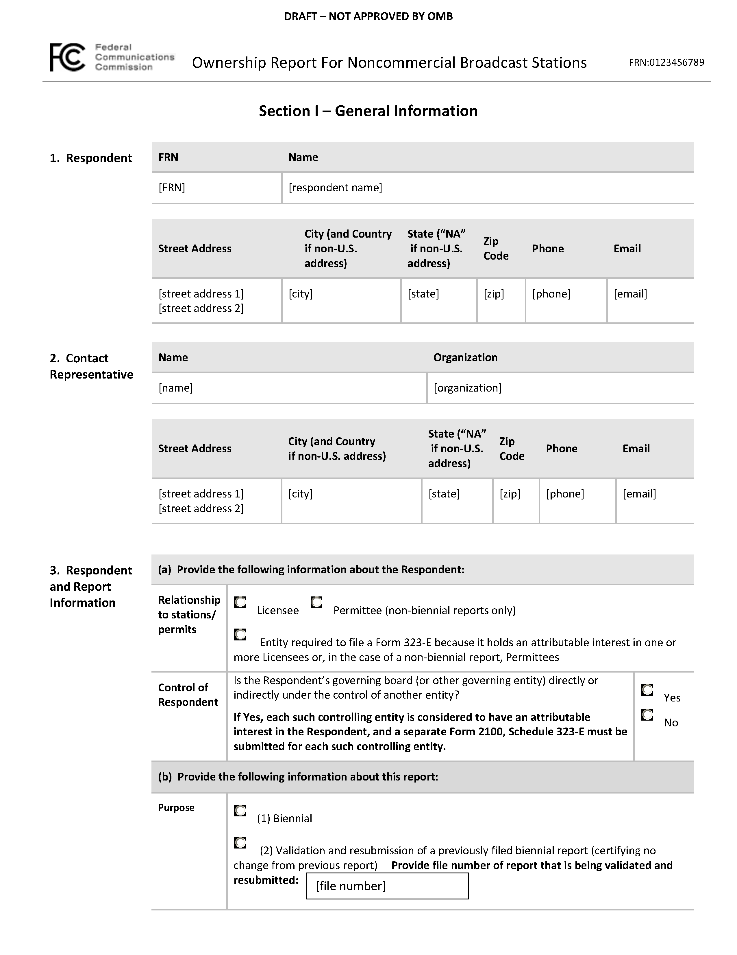
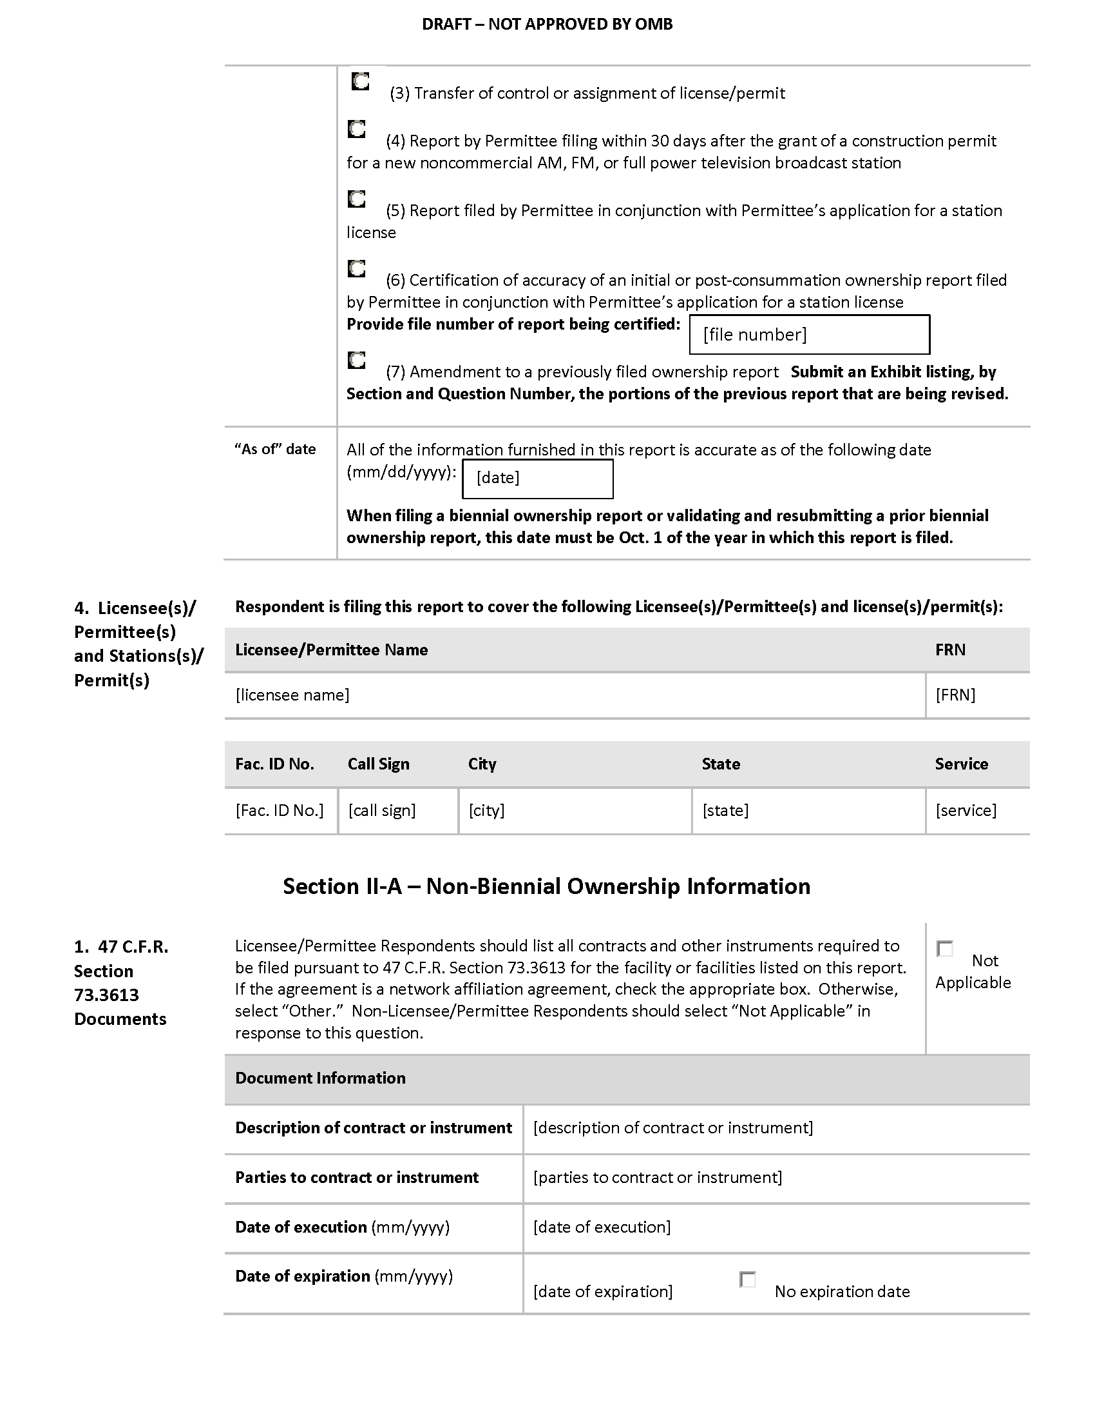
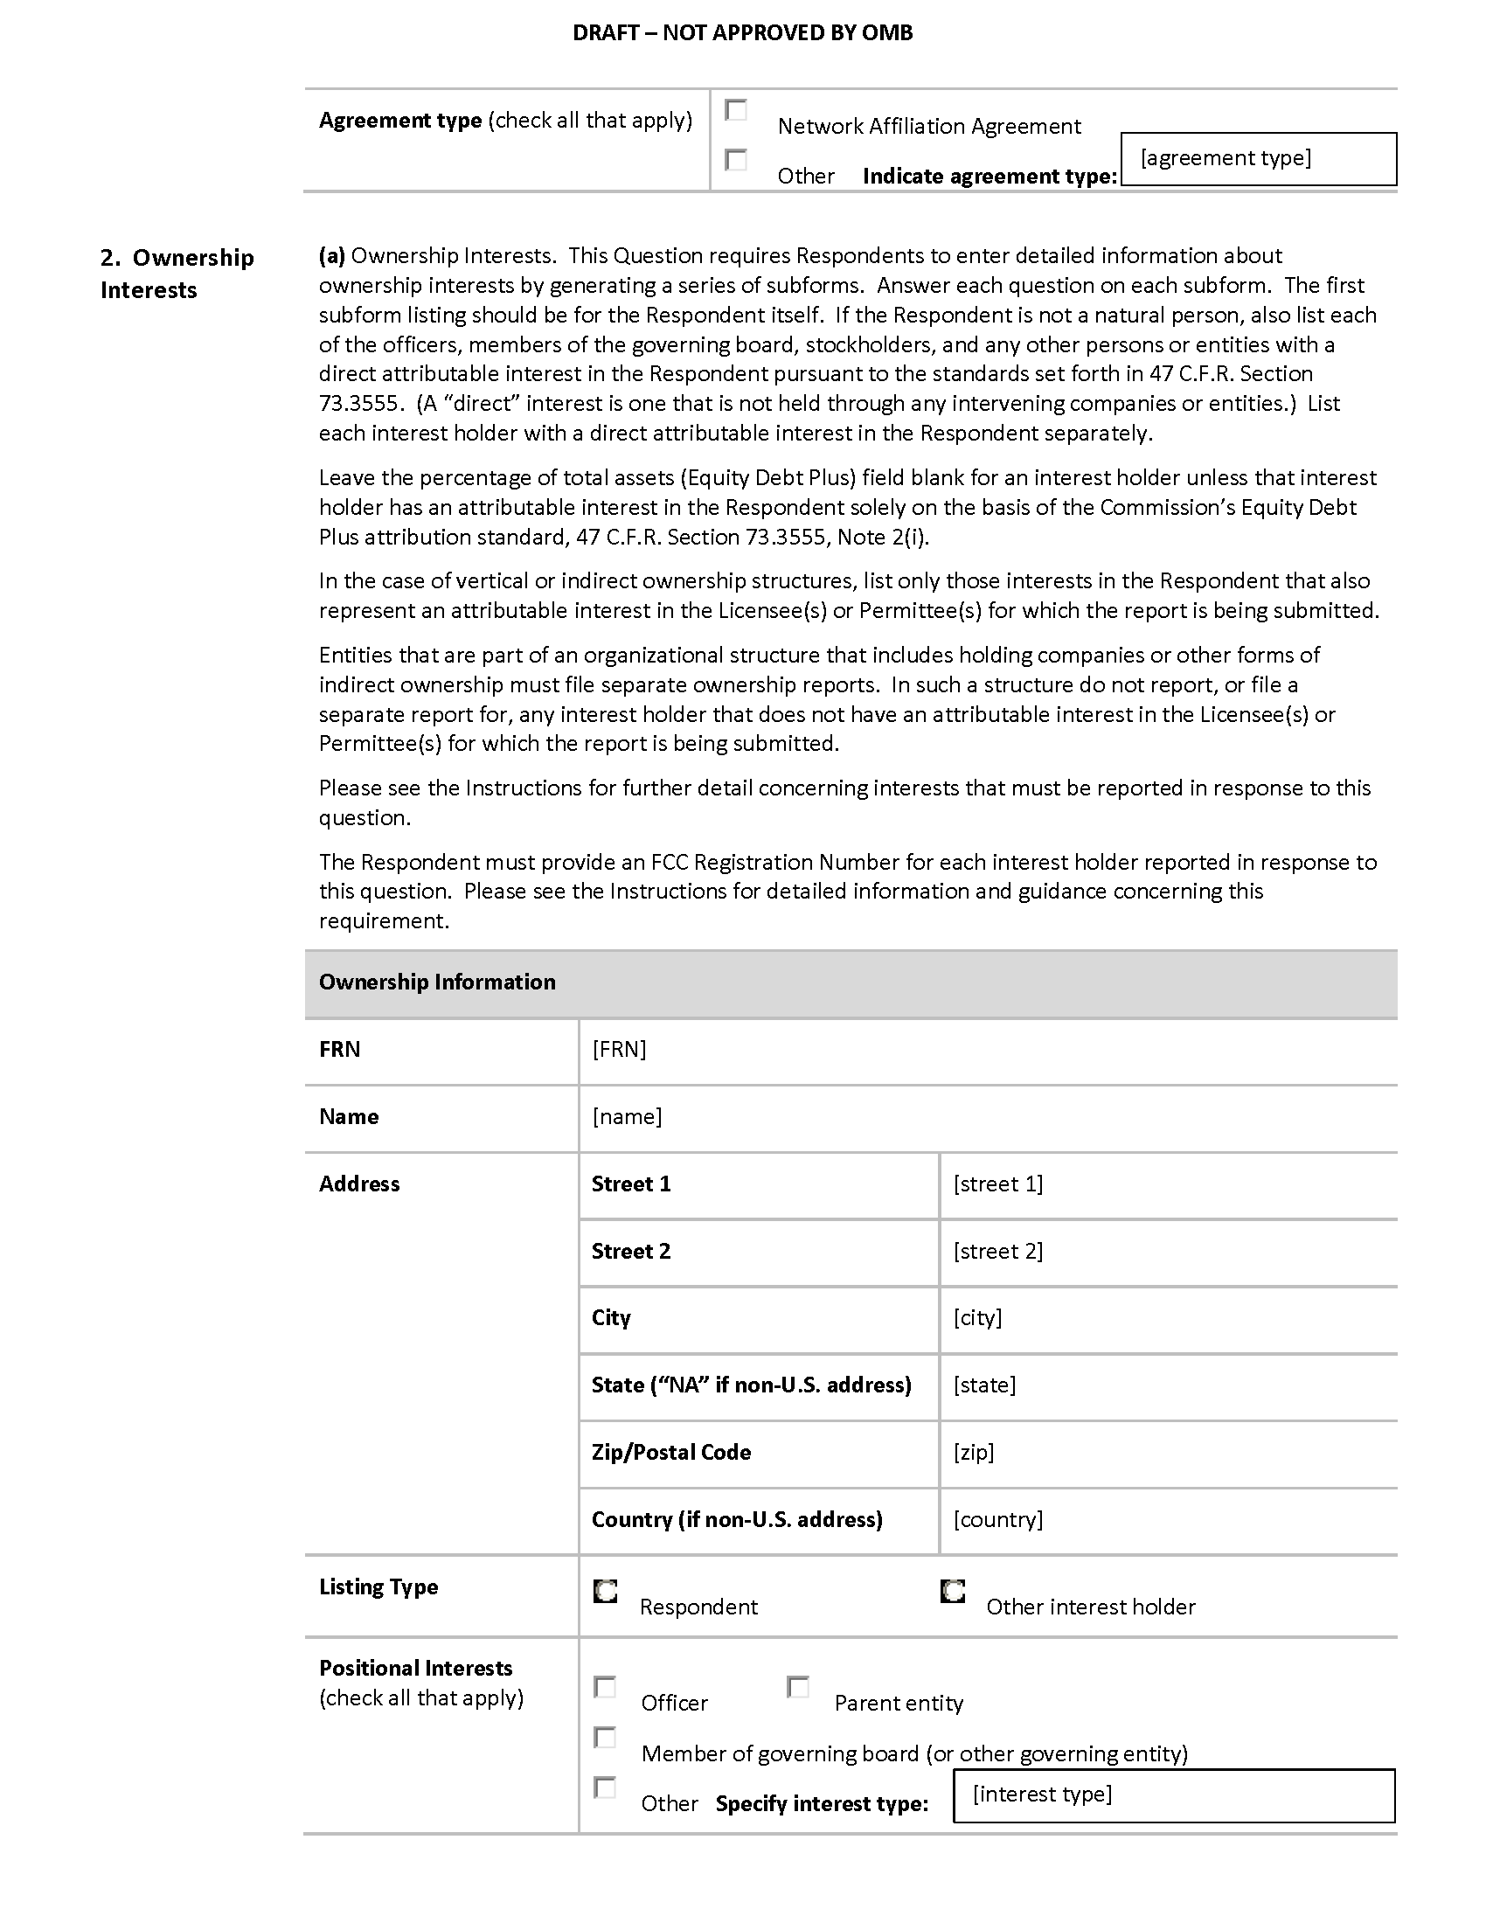
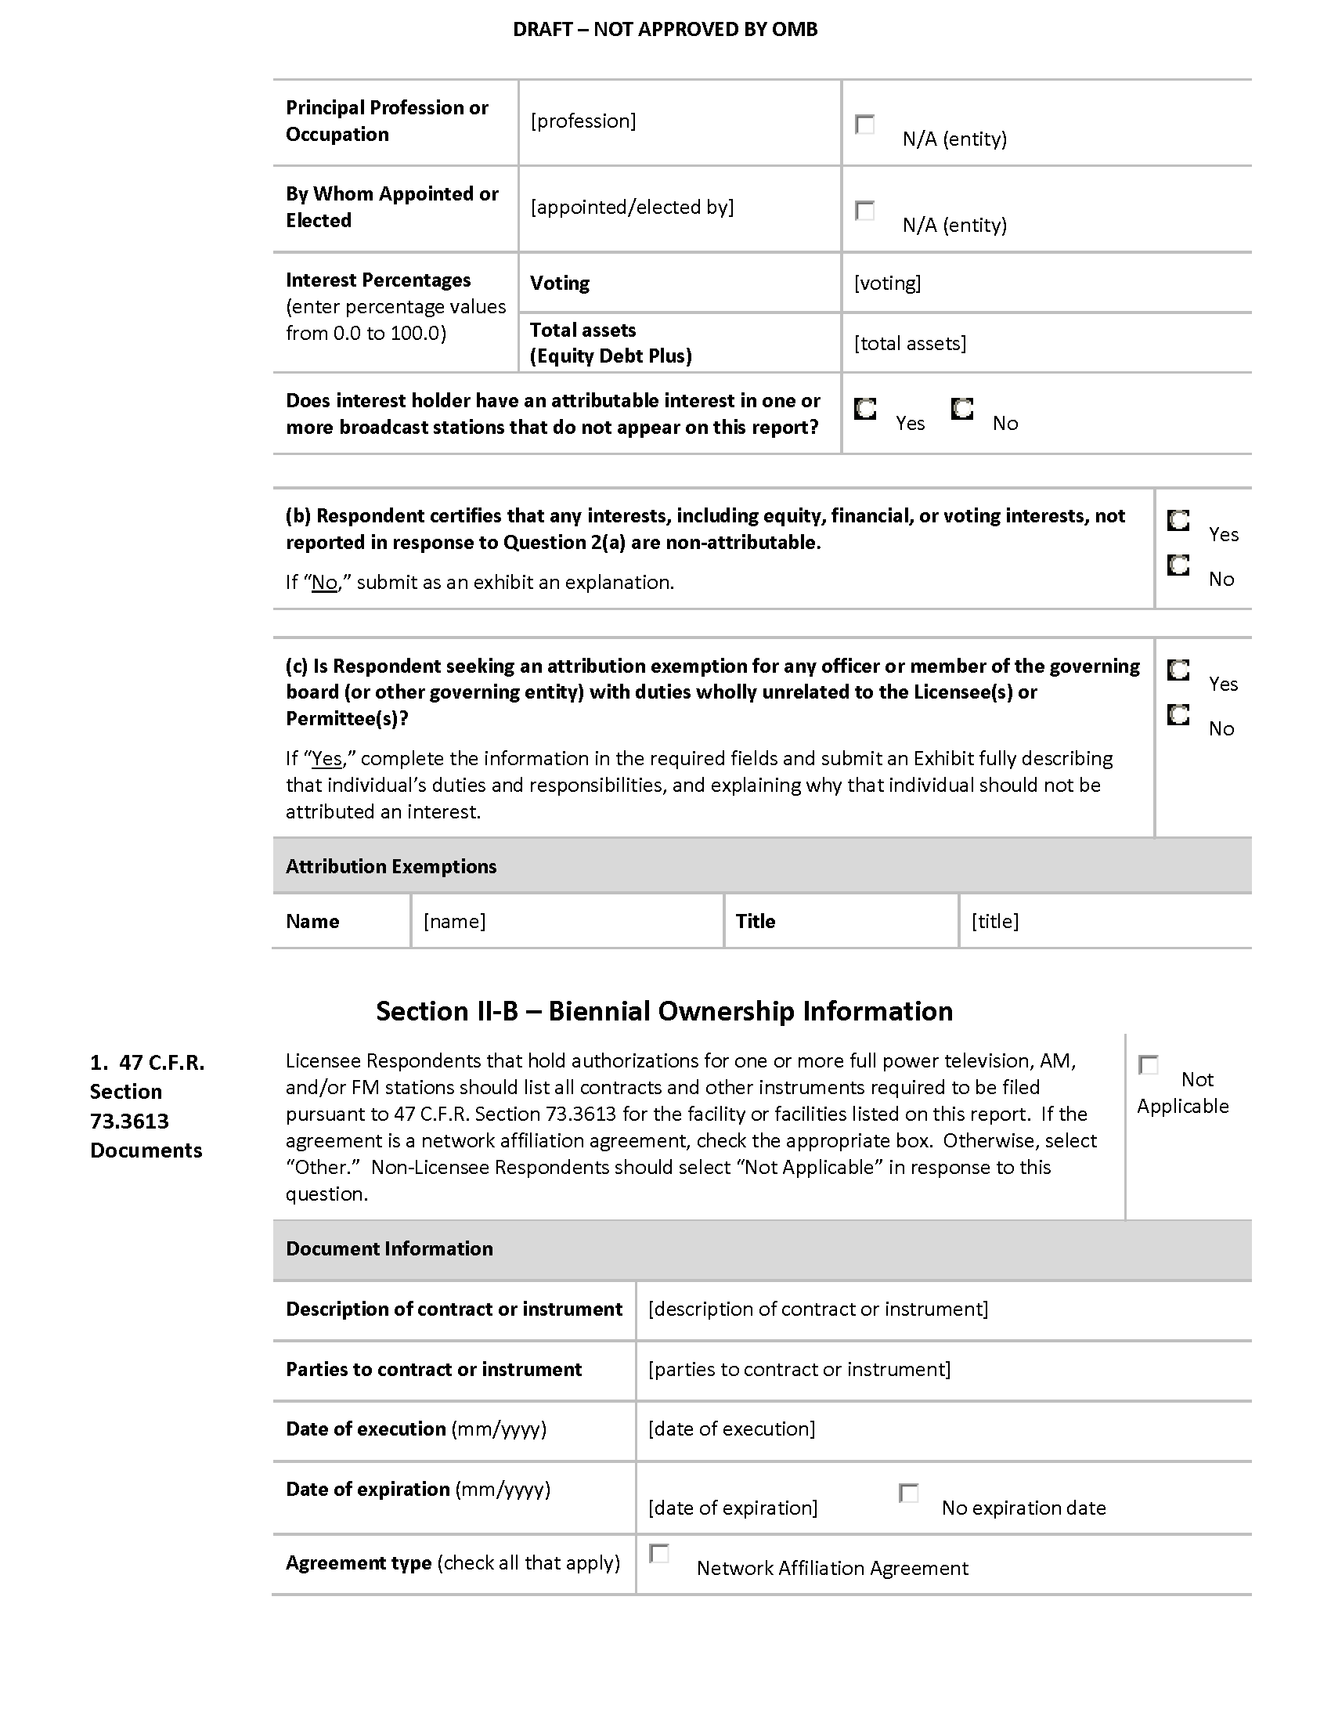
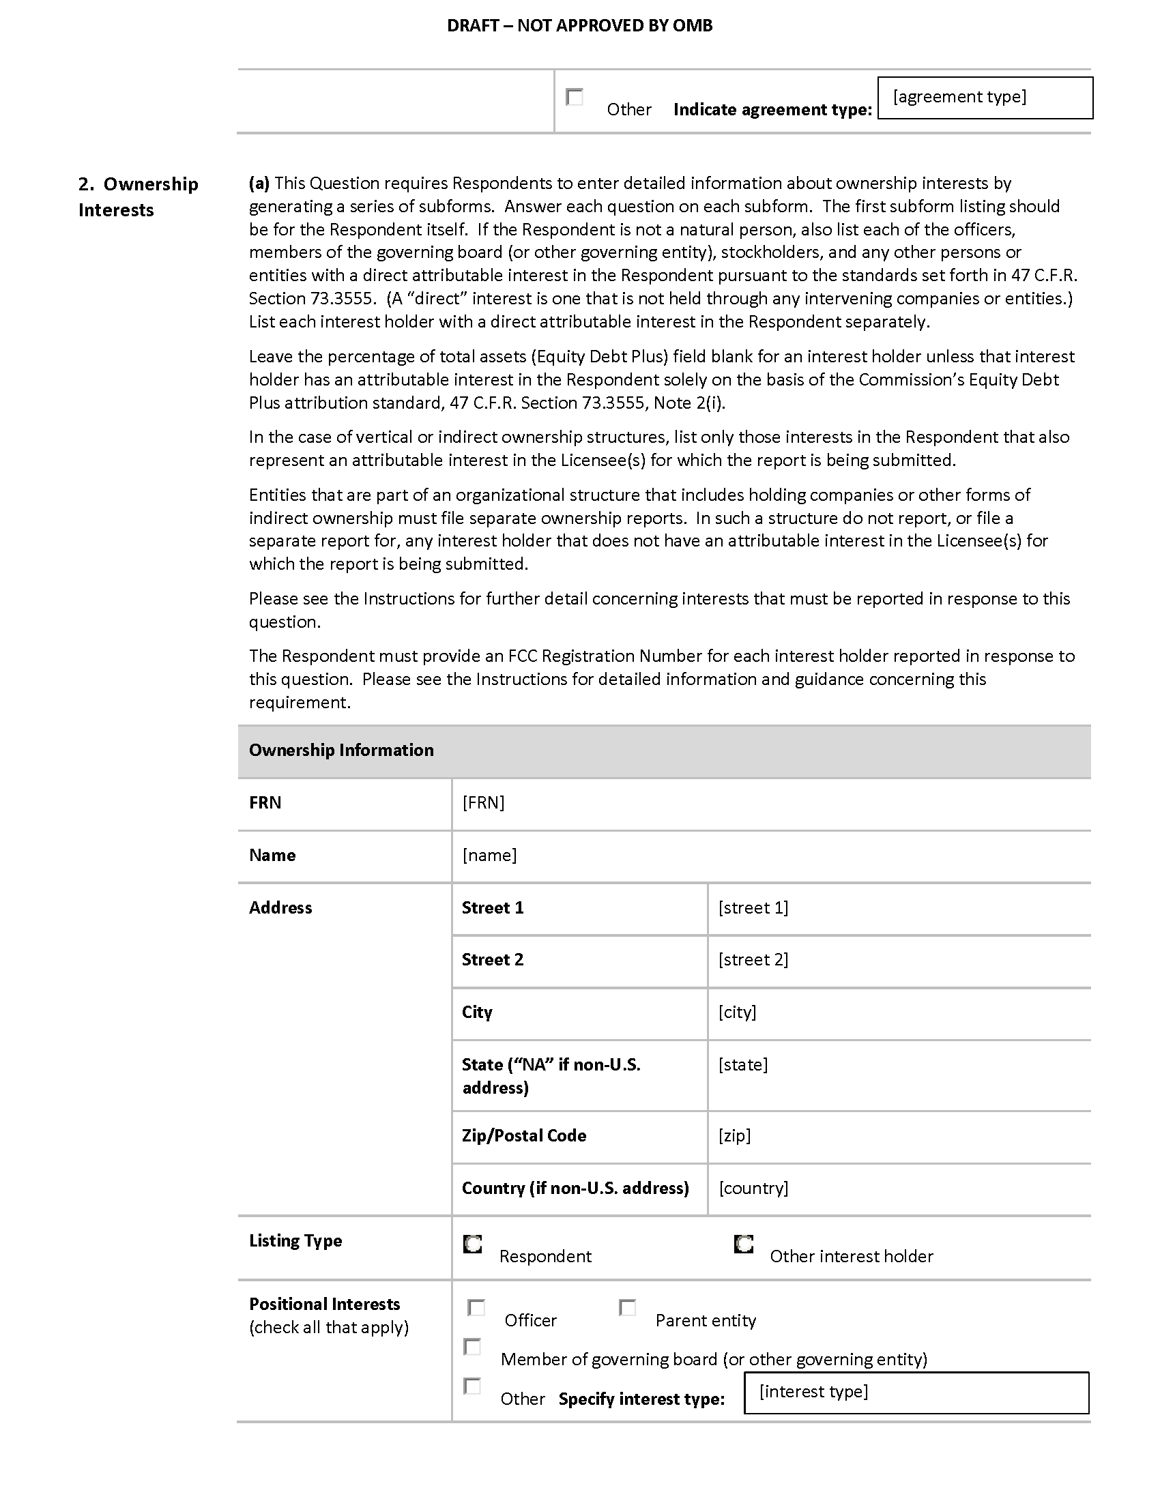
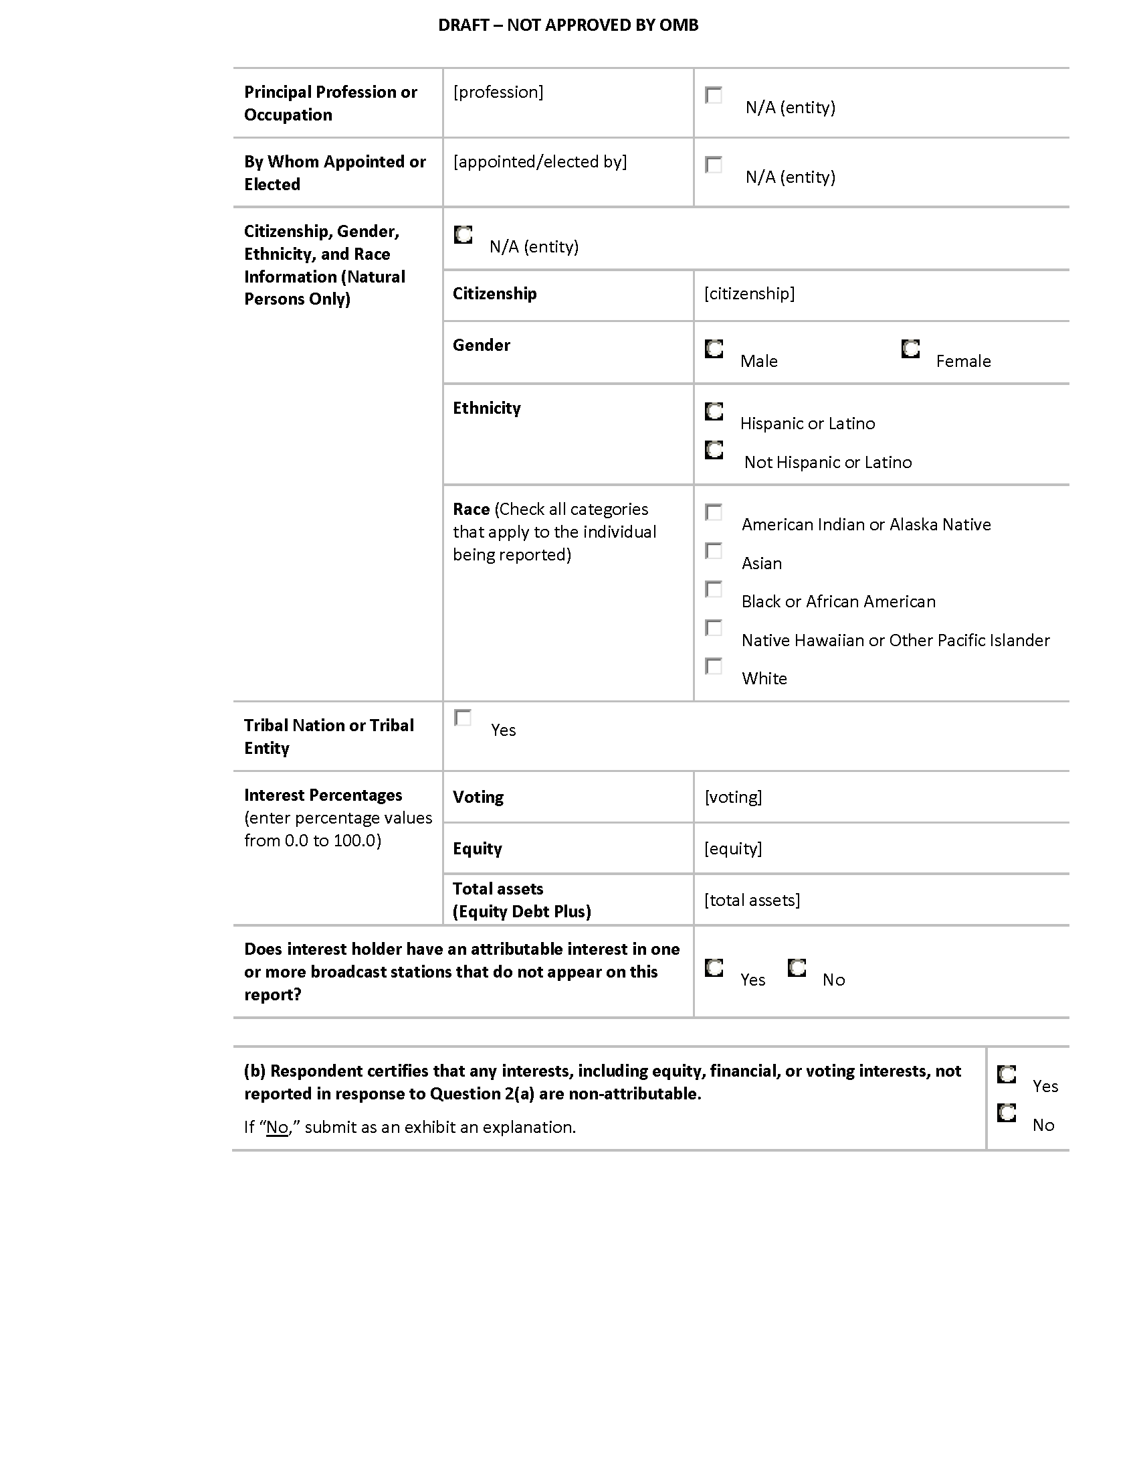
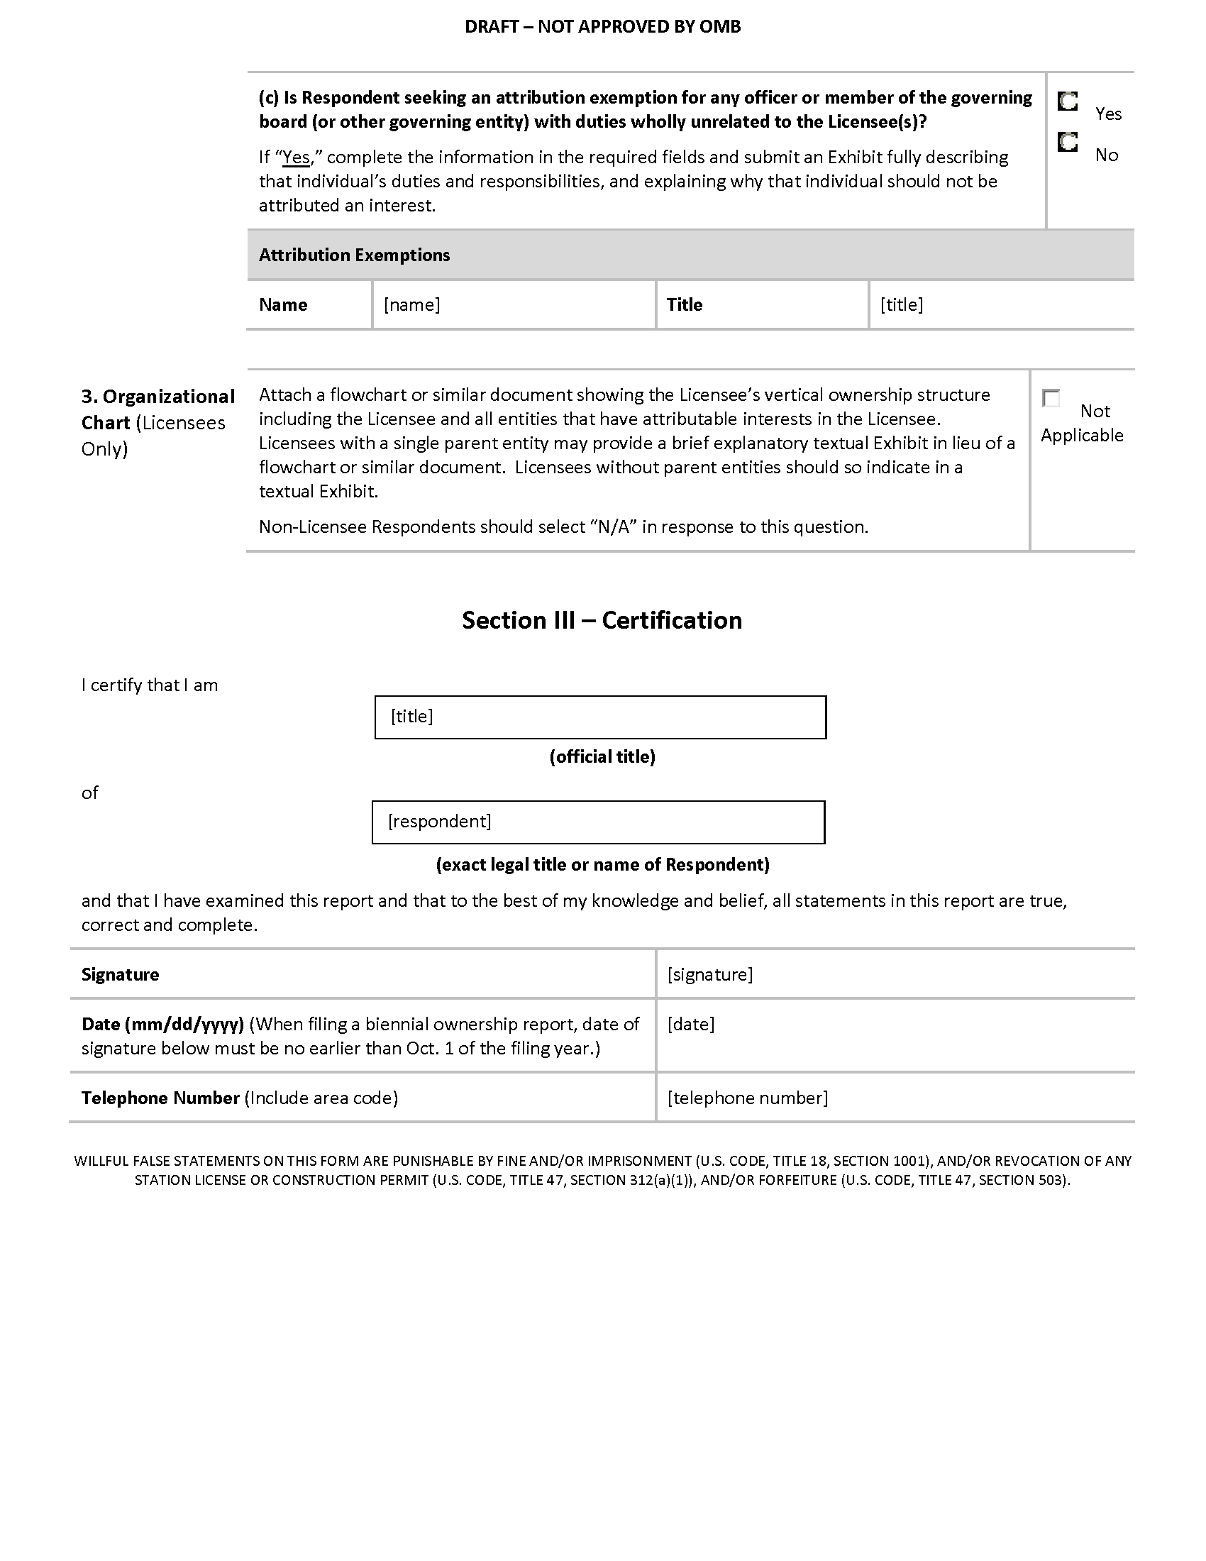

STATEMENT OF
COMMISSIONER AJIT PAI
APPROVING IN PART AND DISSENTING IN PART

Re: Promoting Diversification of Ownership in the Broadcasting Services, MB Docket No. 07-294; Review of Media Bureau Data Practices, MB Docket No. 10-103; Amendment of Part 1 of the Commission’s Rules, Concerning Practice and Procedure, Amendment of CORES Registration System, MD Docket No. 10-234

Today, we bring to a close a proceeding that has taken far too long and consumed far too many staff resources. For the better part of a decade, the Commission has been pirouetting on a pinhead—or, in agency-speak, trying to figure out what type of unique identifier those with attributable interests in broadcast stations should be required to obtain from the FCC for use in licensees’ biennial ownership report filings. Indeed, we have pondered which snowflake(s) to pluck from a blizzard of acronyms (CORES FRN, SUFRN, RUFRN, and more) for almost twice as long as it took the United States to defeat the Axis powers during World War II.

The ostensible purpose of this years-long exercise has been to provide the Commission with better data regarding minority and female ownership. And better data may well help us promote such ownership. But too much effort has been spent diving down rabbit holes that ultimately won’t help us accomplish much of anything. Meanwhile, we’ve ignored or even rejected measures that would boost minority and female broadcast ownership, such as an incubator program (which I’ve championed since joining the Commission over three-and-a-half years ago). We would have done well to spend more time taking concrete action and less time thinking about whether an attributable interest holder should be required to provide the FCC with a full Social Security number (SSN) or just its last four digits.

Turning to the specific decisions made by the Commission here, I believe that most of them are reasonable. In particular, I agree that attributable interest holders should not be required to submit full SSNs to the Commission. To anyone who believes that data stored in federal government IT systems is completely secure, I would respond with three letters: OPM. Consequently, such a mandate would have imposed greater risks of identity theft in the event of a security breach without any real countervailing benefits.

However, I cannot support the Commission’s imposition of a requirement that the officers and directors of noncommercial educational (NCE) broadcasters provide us with personal information, including the last four digits of an SSN, to obtain unique identifiers. For one, I fail to see how this will lead to any tangible benefit. After all, our multiple ownership rules do not apply to NCE stations. And “in contrast with the commercial broadcast industry, where individuals often have multiple commercial broadcast interests, the existence of such interests is in fact quite rare in the case of NCE board members and officers.” Therefore, unless we have reason to believe that many Americans are suddenly going to start volunteering to serve on the boards of multiple public broadcasting stations at once (and the record doesn’t suggest that), the case for requiring NCE board members and officers to obtain a reliable unique identifier from the Commission is incredibly thin.

For another, requiring attributable interest holders to submit their name, address, date of birth, and the last four digits of their SSN may reduce privacy concerns, but it doesn’t eliminate them. That’s because, as the record indicates, all of that information, taken together, can often allow someone to accurately predict an individual’s full SSN.

And so this aspect of the Commission’s decision brings to mind the old saying that no good deed goes unpunished. For those who are attributable interest holders in NCE stations are often volunteers. They don’t toil on station boards for the money; they do it to serve their community. And the record indicates that public broadcasters often have difficulty “find[ing] qualified, committed individuals to donate their time and attention to station governance.” This may explain why public broadcasters believe the regulation adopted by the Commission will “have a significant negative impact on their ability to recruit volunteers to serve on their licensee boards.” This isn’t idle speculation; it’s based on the reaction of volunteers to Commission’s actions in this proceeding to date.

To be sure, the Commission disagrees and “do[es] not believe the FRN requirement would serve as a serious disincentive to participation in NCE stations.” But it does not cite any evidence in support of this claim.

On this question, I would give more credence to those public broadcasters across the country who run the day-to-day operations of their stations than those of us here in Washington, DC. And I would have the FCC bestow upon those volunteering their time to NCE stations across our country not the burden of unnecessary regulations, but our gratitude.

For these reasons, I am voting to approve in part and dissent in part.

Statement of
Commissioner Michael O’Rielly
Approving in Part and Concurring in Part

Re: Promoting Diversification of Ownership in the Broadcasting Services, MB Docket No. 07-294; Review of Media Bureau Data Practices, MB Docket No. 10-103; Amendment of Part 1 of the Commission’s Rules, Concerning Practice and Procedure, Amendment of CORES Registration System, MD Docket No. 10-234

This Order includes some modifications to streamline the ownership reporting process for broadcasters, especially by reducing the number of filings required, and as I believe any efforts in this direction should be strongly encouraged, I generally approve.

I question whether the Commission’s limited resources are best spent collecting, crunching, and disseminating statistics about broadcast station owners, when the marketplace is extremely dynamic and fluid. To the extent it is to be done, it seems that the Restricted Use FRN may not be that harmful, as long as the data is sufficiently protected. I take no position on or responsibility for the Commission’s representations that it can do so going forward.

However, I have reservations about the value of imposing the reporting requirements for commercial entities onto noncommercial educational (“NCE”) broadcast stations. Many of these NCE licensees have such attenuated relationships with their reportable interest holders (for example, the individual members of a Board of Governors for an entire state university system may be considered to own a college radio station) that it strains the understanding of “ownership” beyond recognition within the context of attempts to promote ownership of TV and radio stations by small businesses, women, and minorities. The rationale for collecting (and taking responsibility for protecting) additional sensitive, personally identifiable information from these individual “owners” is equally as strained. In the end, I question whether the data collected will have any valuable impact on our decision making, given its uniqueness. Therefore, I concur in part.

On a larger perspective, my support and concurrence in this item should not be read as an endorsement of the use of certain practices in other contexts.

See, e.g., 1998 Biennial Regulatory Review – Streamlining of Mass Media Applications, Rules, and Processes, MM Docket No. 98-43, Report and Order, 13 FCC Rcd 23056, 23095, ¶ 96 (1998) (1998 Biennial Review Order), recon. granted in part and denied in part Memorandum Opinion and Order, 14 FCC Rcd 17525 (1999).
See, e.g., Statement of Policy on Minority Ownership of Broadcasting Facilities, Public Notice, 68 FCC 2d 979, 980-81 (1978).
See 1998 Biennial Review Order, 13 FCC Rcd at 23095-99, ¶¶ 96-105.
See Promoting Diversification of Ownership in the Broadcasting Services, MB Docket No. 07-294, Report and Order and Fourth Further Notice of Proposed Rulemaking, 24 FCC Rcd 5896, 5898, ¶ 3 (2009) (323 Order and Fourth Diversity Further Notice).
See Prometheus Radio Project v. FCC, 652 F.3d 431, 469, 471-72 (3d. Cir. 2011) (Prometheus II).
See Promoting Diversification of Ownership in the Broadcasting Services, MB Docket No. 07-294, Sixth Further Notice of Proposed Rulemaking, 28 FCC Rcd 461, 463, ¶ 4 (2013) (Sixth Diversity Further Notice) (citing 323 Order, 24 FCC Rcd at 5904, ¶ 13).
47 U.S.C. §§ 257, 309(j); see also 1998 Biennial Review Order, 13 FCC Rcd at 23095-98, ¶¶ 96-102.
Sixth Diversity Further Notice, 28 FCC Rcd at 463, ¶ 4; 323 Order, 24 FCC Rcd at 5902-04, ¶¶ 11-13; Promoting Diversification of Ownership in the Broadcasting Services, MB Docket No. 07-294, Memorandum Opinion & Order and Fifth Further Notice of Proposed Rulemaking, 24 FCC Rcd 13040, 13044, ¶ 8 (2009) (323 MO&O and Fifth Diversity Further Notice). In addition to the biennial filing of Form 323, licensees and permittees are required to file Form 323 (1) within 30 days of a grant of an application for original construction permit, (2) on the date the permittee applies for a station license, and (3) within 30 days of the consummation of authorized assignments or transfers of control of permits and licenses. 47 C.F.R. § 73.3615(b)-(c).
U.S. Gov’t Accountability Office, GAO-08-383, Media Ownership: Economic Factors Influence the Number of Media Outlets in Local Markets, While Ownership by Minorities and Women Appears Limited and is Difficult to Assess (2008) (GAO Report). GAO cited several shortcomings with the Commission’s data collection process: (1) exemptions from the biennial filing requirement for certain types of broadcast stations; (2) inadequate data quality procedures; and (3) problems with storage and retrieval. Id. at 5; see also 323 Order, 24 FCC Rcd at 5901, ¶ 10; Sixth Diversity Further Notice, 28 FCC Rcd at 463, ¶ 4.
See GAO Report at 5.
47 C.F.R. § 73.3615(a).
323 Order, 24 FCC Rcd at 5908-09, ¶ 22; Sixth Diversity Further Notice, 28 FCC Rcd at 463, ¶ 4.
47 C.F.R. § 73.3615(a); see also 323 Order, 24 FCC Rcd at 5904-05, ¶¶ 14-16; Sixth Diversity Further Notice, 28 FCC Rcd at 463-64, ¶ 4.
323 Order, 24 FCC Rcd at 5908, ¶ 21.
Id.
Id. The Bureau also revised the instructions and questions in Form 323 to (1) clarify the information sought in the form; (2) ensure that the data are collected in machine-readable formats that can be imported into programs used to prepare economic and policy studies; and (3) simplify completion of the form by giving respondents menu or checkbox options to enter data. 323 MO&O, 24 FCC Rcd at 13043, ¶ 8.
Fourth Diversity Further Notice, 24 FCC Rcd at 5910-11, ¶¶ 27-30.
Id. at 5910, ¶ 27.
Id. at 5910-11, ¶¶ 28-29.
Id. at 5911, ¶ 29. The Fourth Diversity Further Notice also sought comment on whether to require low power FM (LPFM) stations to file a Form 323-E to collect ownership data on the licensees or to continue to exempt LPFM licensees from the filing requirements. Id. at 5911, ¶ 30. The Commission will address issues in the Fourth Diversity Further Notice related to LPFM in a future order.
Promoting Diversification of Ownership in the Broadcasting Services, 74 Fed. Reg. 25,205 (May 27, 2009); see also Media Bureau Announces Comment and Reply Comment for the Fourth Diversity Further Notice of Proposed Rulemaking in the Diversification of Ownership Proceeding, MB Docket No. 07-294, Public Notice, 24 FCC Rcd 7295 (Med. Bur. 2009).
Public Information Collection Requirement Submitted to OMB for Review and Approval, Comments Requested, 74 Fed. Reg. 40,188 (Aug. 11, 2009).
Form 323 requires Respondents to list “each of the officers, directors, stockholders, non-insulated partners, members and other persons or entities with a direct attributable interest in the Respondent.” See FCC Form 323, Ownership Report for Commercial Broadcast Stations, Sections II-A & II-B, Item 3(a) (Mar. 2013), available at http://transition.fcc.gov/Forms/Form323/323.pdf; see also 323 MO&O, 24 FCC Rcd at 13043, ¶ 8 (noting that the Media Bureau is requiring a licensee “to report the FRNs of entities one step above and one step below it in the ownership chain” and to “identify the FRNs of its attributable officers, directors, and shareholders”).
Saga Communications, Inc. (Saga) Sept 10, 2009 OMB Comments at 4; 47 Named State Broadcasters Associations (State Associations) Sept. 10, 2009 OMB Comments at 7-10; see also Letter from Joseph DiScipio, Esq., et al., Counsel for Various Broadcaster Clients and Associations, to Marlene H. Dortch, Secretary, FCC (Nov. 6, 2009) (ex parte notification of meeting with Commission staff to discuss CORES FRN requirement); Fletcher, Heald & Hildreth, P.L.C., Petition for Reconsideration, MB Docket No. 07-294, at 17 (filed Nov. 30, 2009) (Fletcher Heald Petition for Reconsideration). Copies of comments filed with OMB are available on the OMB website at http://www.reginfo.gov/public/do/PRAViewDocument?ref_nbr=200908-3060-001 (visited July 9, 2015).
State Associations Sept. 10, 2009 OMB Comments at 9-12 (arguing, in part, that the FRN requirement will deter investment in broadcasting); National Association of Broadcasters (NAB) Sept. 10, 2009 OMB Comments at 7-11; ABC et al. Sept. 10, 2009 OMB Comments at 13 nn.30-31, 21 (expressing concern that some individuals with reportable interests may be unwilling to obtain FRNs, or provide their SSN to Form 323 filers so that they can obtain an FRN on behalf of these individuals).
The law firm of Fletcher, Heald & Hildreth, P.L.C., on behalf of itself and various state broadcaster association clients, filed the first Petition on December 23, 2009 (Doc. No. 09-1321), and the second Petition on May 28, 2010 (Doc. No. 10-1117). Emergency Petition for Writ of Mandamus Staying Administrative Proceedings, In re: Fletcher, Heald & Hildreth, P.L.C., et al., No. 09-1321 (D.C. Cir. Mar. 4, 2010) (per curium); Second Petition for Writ of Mandamus and/or Prohibition, In re: Fletcher, Heald & Hildreth, P.L.C., et al., No. 10-1117 (D.C. Cir. July 7, 2010) (per curium).
In re: Fletcher, Heald & Hildreth, P.L.C., et al., No. 09-1321 (D.C. Cir. Mar. 4, 2010) (per curium); In re: Fletcher, Heald & Hildreth, P.L.C., et al., No. 10-1117 (D.C. Cir. July 7, 2010) (per curium).
Letter from Walter Boswell, Acting Assoc. Managing Director, PERM, OMD, FCC, to Nicholas A. Fraser, OMB (Oct. 6, 2009) (Reply Letter).
Id. at 3-4.
Reply Letter at 2-3, 7; see ABC et al. Sept. 10, 2009 OMB Comments at 12-13; NAB Sept. 10, 2009 OMB Comments at 9; Wiley Rein LLP Sept. 10, 2009 OMB Comments at 10; State Associations Sept. 10, 2009 OMB Comments at 8; Saga Sept. 10, 2009 OMB Comments at 5; see also 5 U.S.C. § 522a (codification of the Privacy Act of 1974, as amended). The Commission issued a System of Records Notice (SORN) to cover the data contained in responses to Form 323 and that SORN became effective on December 21, 2009. Privacy Act System of Records, 74 Fed. Reg. 59,978 (Nov. 19, 2009) (system of records FCC/MB-1).
See Anthony T. Lepore, Esq., Aug. 21, 2009 OMB Comments at 1 (arguing that the new requirement will make the Commission’s databases “ripe for identity theft incursions”); The Law Office of Dan J. Alpert Sept. 10, 2009 OMB Comments at 5 (claiming that the CORES FRN registration process “will foster identity theft against unsuspecting users”); Saga Sept. 10, 2009 OMB Comments at 4-5 (noting regular security breaches of computer systems); State Associations Sept. 10, 2009 OMB Comments at 8-9 (citing to 2006 Congressional report about security breaches at other federal agencies where sensitive personal data was lost).
Reply Letter at 9.
Id.
Id. The 323 Order also directed staff to modify Form 323 to require those interest holders that would be attributable but for the single majority shareholder exemption and the exemption for interests held in eligible entities pursuant to the higher Equity/Debt Plus (EDP) thresholds adopted in the Diversity Order to be reported on the form. 323 Order, 24 FCC Rcd at 5906, ¶ 17. On October 15, 2009, the Commission addressed an NAB petition for reconsideration, in which NAB argued, inter alia, for reconsideration of elements of the 323 Order regarding the collection of information of certain nonattributable interest holders on Form 323. 323 MO&O, 24 FCC Rcd at 13045-47, ¶¶ 12-15; see NAB, Petition for Reconsideration, MB Docket No. 07-294 (filed June 26, 2009) (NAB Petition for Reconsideration). In an opposition to NAB’s petition for reconsideration, the Office of the United Church of Christ, Inc. (UCC), Benton Foundation, Common Cause, Media Alliance, and National Organization of Women Foundation (collectively, UCC et al.), supported the Commission’s decision to collect ownership information from certain nonattributable interest holders. See 323 MO&O, 24 FCC Rcd at 13046, ¶ 13 (citing UCC et al., Opposition to Petition for Reconsideration, MB Docket No. 07-294, at 6 (filed Aug. 11, 2009)). NAB disagreed on reply. 323 MO&O, 24 FCC Rcd at 13046, ¶ 14 (citing NAB, Reply to Opposition to Petition for Reconsideration, MB Docket No. 07-294, at 4-6 (Aug. 21, 2009)). Acknowledging that the Commission had not explicitly expressed its intention to require certain nonattributable interest holders to file information in its rulemaking notice, the Commission deleted the reporting requirements for the nonattributable interest holders and adopted the Fifth Diversity Further Notice. 323 MO&O, 24 FCC Rcd at 13046-47, ¶ 15. The Fifth Diversity Further Notice, released on October 16, 2009, proposed to collect ownership information from interest holders in a licensee that would be attributable but for the single majority shareholder exemption and those that would be attributable but for the higher EDP thresholds adopted in the Diversity Order. Fifth Diversity Further Notice, 24 FCC Rcd at 13047-50, ¶¶ 16-24. In the Sixth Diversity Further Notice the Commission sought comment, inter alia, on extending the CORES FRN requirement to those nonattributable interests described in the Fifth Diversity Further Notice in the event that the Commission requires that these interests be reported on Form 323. Sixth Diversity Further Notice, 28 FCC Rcd at 473, ¶ 20 (citing Fifth Diversity Further Notice, 24 FCC Rcd at 13047, ¶ 16). The Commission will address issues raised by and implicating proposals in the Fifth Diversity Further Notice in a future order.
See Promoting Diversification of Ownership in the Broadcasting Services, 74 Fed. Reg. 56,135 (Oct. 30, 2009); Promoting Diversification of Ownership in the Broadcasting Services, 74 Fed. Reg. 56,136 (Oct. 30, 2009) (Federal Register notices announcing OMB approval and effective date of revised Form 323). On October 16, 2009, the Commission sent a subsequent letter to OMB acknowledging the Commission’s action in the 323 MO&O to eliminate the reporting of certain nonattributable interest holders. Letter from Walter Boswell, Acting Assoc. Managing Director, PERM, OMD, FCC, to Nicholas A. Fraser, OMB (Oct. 16, 2009).
Media Bureau Extends the Biennial Filing Deadline for the Commercial Broadcast Ownership Report (Form 323), MB Docket No. 07-294, Public Notice, 24 FCC Rcd 14055 (Med. Bur. 2009) (announcing the Media Bureau’s extension of the Form 323 filing deadline until January 11, 2010, in order to allow for additional testing of the electronic version of the form); Promoting Diversification in the Broadcast Services, MB Docket No. 07-294, Order, 24 FCC Rcd 14628 (Med. Bur. 2009) (suspending the January 11, 2010, filing deadline to permit staff to investigate technical problems and announcing the new filing date will be at least 90 days from the date that the form is made available for biennial filings).
Media Bureau Announces Revised Form 323 will be Available Online on April 9, 2010, and Sets New Filing Deadline of July 8, 2010, MB Docket No. 07-294, Public Notice, 25 FCC Rcd 3595 (Med. Bur. 2010).
Media Bureau Announces Online Availability of Revised Biennial Form 323, an Instructional Workshop on the Revised Form, and the Possibility of Obtaining a Special Use FRN for the Form, MB Docket No. 07-294, Public Notice, 24 FCC Rcd 14329 (Med. Bur. 2009) (Dec. 4, 2009 PN). The information provided in the public notice has since been superseded. For example, as explained in the Media Bureau’s Frequently Asked Questions page for Form 323, filers are permitted to report an SUFRN on a non-biennial report submitted on Form 323. Federal Communications Commission, Form 323 Frequently Asked Questions, http://www.fcc.gov/guides/form-323-frequently-asked-questions (visited July 9, 2015) (Form 323 FAQ).
See Office of Management and Budget, FCC Form 323—OMB Control No. 3060-0010, Changes to Pop-up Box Text, Section II-A and Section II-B (2010 Pop-up Box Text), http://www.reginfo.gov/public/do/PRAViewDocument?ref_nbr=201006-3060-006 (select the hyperlink under “Supplementary Documents”) (visited July 9, 2015). On September 28, 2011, the Commission subsequently amended the pop-up box to inform filers that the guidance provided in the Dec. 4, 2009 PN has been superseded. Office of Management and Budget, FCC Form 323 – OMB Control No. 3060-0010, Changes to Pop-up Box Text, http://www.reginfo.gov/public/do/PRAViewDocument?ref_nbr=201109-3060-020 (select the bottom hyperlink under “Supplementary Documents”) (visited July 9, 2015).
See 2010 Pop-up Box Text at 1.
Form 323 FAQ (“If a Special Use FRN was previously reported for an individual and the Respondent is unable to report an FRN on the 2013 biennial ownership report, please use the same Special Use FRN that was previously reported for that individual. If an individual is reported on multiple reports, please coordinate with other Respondents to ensure that the same Special Use FRN for that individual is being reported consistently.”); see also Most Common Form 323 Filing Errors, FCC, https://www.fcc.gov/guides/most-common-form-323-filing-errors (visited July 9, 2015) (“If you obtained a Special Use FRN for any individual for the 2009 biennial filing, please use that same Special Use FRN again on the 2011 biennial filing. Please avoid obtaining a duplicate Special Use FRN for an individual reported on Form 323. To find previous Special Use FRNs, please refer to your 2009 biennial filing. Please be consistent and use the same Special Use FRN on all biennial filings for a single individual.”); 2010 Pop-up Box Text at 1 (“Respondents selecting [the Special Use FRN] option should first read the Commission’s [Form 323 FAQ] concerning the ‘Special Use FRN’ . . . .”); Dec. 4, 2009 PN, 24 FCC Rcd at 14330 (noting that the Form 323 FAQ provides instructions on how to obtain an SUFRN).
Koerner & Olender, P.C., Petition for Partial Reconsideration, MB Docket. No. 07-294 (filed Nov. 3, 2009) (Koerner & Olender Petition for Reconsideration); Fletcher Heald Petition for Reconsideration; see also UCC et al., Opposition to Petitions for Reconsideration, MB Docket No. 07-294 (filed Dec. 31, 2009) (opposing both petitions); Fletcher, Heald & Hildreth, P.L.C., Reply to Opposition to Petition for Reconsideration, MB Docket No. 07-294 (filed Jan. 13, 2010) (responding to opposition filed by UCC et al.); Hubbard Broadcasting, Inc., Reply Comments, MB Docket No. 07-294 (filed Jan. 11, 2010) (sharing petitioners’ concerns regarding the required submission of individuals’ full SSNs to the Commission). In the Sixth Diversity Further Notice, the Commission addressed petitioners’ concerns for adequate notice of the CORES FRN requirement for individuals and sought comment on Koerner & Olender’s request to “redefine or reinterpret” section 1.8002 of the Commission’s rules. See Sixth Diversity Further Notice, 28 FCC Rcd at 468-73, ¶¶ 11-19. This Report and Order resolves the remaining issues raised in these petitions for reconsideration.
See Pleading Cycle Established for Comments on Review of Media Bureau Data Practices, MB Docket No. 10-103, Public Notice, 25 FCC Rcd 8236, 8236 (Med. Bur. 2010) (Review of Media Bureau Data Practices).
See id. at 8236 nn.1, 2. The Bureau defined “‘data collection’ in the broadest manner possible, to include all information collections approved by the Office of Management and Budget under the Paperwork Reduction Act, including data that the Commission formally requires to be submitted and all information that must be retained by parties or disclosed to others.” Id. at 8236 n.1. Forms 323 and 323-E were included in the inventory of data collections linked in the item. See id. at 8236 nn.1, 2; Federal Communications Commission, Zero-Based Data Review, http://www.fcc.gov/data/data-review (link labeled “Spreadsheet of Data Under Review” under heading “Media Bureau”) (visited July 9, 2015).
Review of Media Bureau Data Practices, 25 FCC Rcd at 8236-38.
See Sixth Diversity Further Notice, 28 FCC Rcd at 474-75, ¶ 23; Minority Media and Telecommunications Council (MMTC) Comments, MB Docket No. 10-103, at 8-11 (Aug. 13, 2010) (MMTC Data Practices Comments); NAB Reply Comments, MB Docket No. 10-103, at 6-8 (Sept. 13, 2010) (NAB Data Practices Reply). The NAB and MMTC proposals are discussed in detail below. See infra Sections III.D, III.E.
Amendment of Part 1 of the Commission’s Rules, Concerning Practice and Procedure, Amendment of CORES Registration System, MD Docket No. 10-234, Notice of Proposed Rulemaking, 25 FCC Rcd 17407, 17411, ¶ 13 (2010) (CORES NPRM).
Id. at 17411-12, ¶¶ 13-15.
Id. at 17412, ¶ 15.
Id. at 17419-20, ¶¶ 38-39.
See generally Prometheus II, 652 F.3d 431.
See id. at 469-72.
Id. at 471-73. The Commission subsequently suspended the application of the eligible entity definition pending further Commission action. See Media Bureau Provides Notice of Suspension of Eligible Entity Rule Changes and Guidance on the Assignment of Broadcast Station Construction Permits to Eligible Entities, Public Notice, 26 FCC Rcd 10370 (Med. Bur. 2011).
Prometheus II, 652 F.3d at 471.
Id. at 469 (internal quotation omitted).
Id. at 471 n.42.
Id. at 471.
See 2010 Quadrennial Regulatory Review – Review of the Commission’s Broadcast Ownership Rules and Other Rules Adopted Pursuant to Section 202 of the Telecommunications Act of 1996, MB Docket No. 09-182, Report on Ownership of Commercial Broadcast Stations, 27 FCC Rcd 13814 (Med. Bur. 2012) (2012 323 Report). The 2012 323 Report is based on ownership information, as of November 1, 2009, and October 1, 2011, submitted by broadcasters in their biennial Form 323 filings. See 47 C.F.R. § 73.3615. The figures described are from tables contained in Appendix C of the report.
See 2014 Quadrennial Regulatory Review – Review of the Commission’s Broadcast Ownership Rules and Other Rules Adopted Pursuant to Section 202 of the Telecommunications Act of 1996, MB Docket No. 14-50, Report on Ownership of Commercial Broadcast Stations, 29 FCC Rcd 7835 (Med. Bur. 2014) (2014 323 Report).
The reports contain 100 pages of summary schedules and 30 spreadsheets of underlying data reflecting the Media Bureau’s analysis of the Form 323 data, which can be further studied and manipulated by researchers and interested parties. Future, similar reports are contemplated reflecting additional biennial reporting periods.
For example, the 2012 323 Report analyzed data for 1,348 full-power commercial television stations as of October 1, 2011. 2012 323 Report, 27 FCC Rcd at 13816-17, ¶¶ 5-7. Members of racial minorities held majority voting interests in 30 stations, or 2.2 percent. Female owners held majority voting interests in 91 stations, or 6.8 percent. The 2012 323 Report also analyzed data for 5,611 commercial FM stations as of October 1, 2011. Members of racial minorities held majority voting interests in 196 stations, or 3.5 percent, and female owners held majority voting interests in 323 stations, or 5.8 percent. Similarly, the 2012 323 Report analyzed data for 3,830 commercial AM stations as of October 1, 2011. Members of racial minorities held majority voting interests in 237 stations, or 6.2 percent, and female owners held majority voting interests in 300 stations, or 7.8 percent. The 2014 323 Report analyzed data for 1,386 full-power commercial television stations as of October 1, 2013. Members of racial minorities held majority voting interests in 41, or 3.0 percent, of those stations. 2014 323 Report, 29 FCC Rcd at 7838-7, ¶¶ 5, 7. Female owners held majority voting interests in 87 stations, or 6.3 percent. The 2014 323 Report also analyzed data for 5,714 commercial FM stations as of October 1, 2013. Members of racial minorities held majority voting interests in 169, or 3.0 percent, of these stations, and female owners held majority voting interests in 383 stations, or 6.7 percent. The 2014 323 Report also analyzed data for 3,737 commercial AM stations as of October 1, 2013. Members of racial minorities held majority voting interests in 225, or 6.0 percent, of these stations, and female owners held majority voting interests in 310 stations, or 8.3 percent.
2012 323 Report, 27 FCC Rcd 13814 at 13816, 13818, 13832-33, ¶ 5 n.8, ¶ 9 n.10, Appendix B (Explanatory note 2 for each broadcast service); 2014 323 Report, 29 FCC Rcd 7835, 7837, 7854-56, ¶5 n. 12, Appendix B (Explanatory note 2 for each broadcast service). See also the definitions of “insufficient data to identify” and “not filed” in Appendix A and the tables contained in Appendix C of the reports.
2012 323 Report, 27 FCC Rcd at 13816, 13818, ¶ 5 n.8, ¶ 9 n.10; 2014 323 Report, 29 FCC Rcd at 7837-38, ¶ 5 n.12. See 2012 323 Report, 27 FCC Rcd at 13832-33, Appendix B (explanatory note 2 for each broadcast service); 2014 323 Report, 29 FCC Rcd at 7854-56, Appendix B (explanatory note 2 for each broadcast service).
See 2012 323 Report, 27 FCC Rcd at 13832-33, Appendix B (explanatory note 2 for each broadcast service); 2014 323 Report, 29 FCC Rcd at 7854-56, Appendix B (explanatory note 2 for each broadcast service).
2012 323 Report, 27 FCC Rcd. at 13818, ¶ 9 n.10.
See Commission Seeks Comment on Broadcast Ownership Report, MB Docket No. 09-182, Public Notice, 27 FCC Rcd 15036 (Med. Bur. 2012) (2012 323 Report PN); 2014 Quadrennial Regulatory Review – Review of the Commission’s Broadcast Ownership Rules and Other Rules Adopted Pursuant to Section 202 of the Telecommunications Act of 1996, MB Docket No. 14-50, Order, 29 FCC Rcd 7911(Med. Bur. 2014) (2014 323 Report Order).
2012 323 Report PN at 15036.
Id. at 15037.
UCC et al. Dec. 26, 2012 Comments at 11-12 (UCC et al. 323 Report Comments); Free Press Jan. 4, 2013 Reply at 9 (Free Press 323 Report Reply).
UCC et al. 323 Report Comments at 13-14.
See generally 2014 323 Report Order.
See Promoting Diversification of Ownership in the Broadcasting Services, MB Docket No. 07-294, Second Further Notice of Proposed Rulemaking and Seventh Further Notice of Proposed Rulemaking, 30 FCC Rcd 1725, 1732-33, ¶ 11 (2015) (Seventh Diversity Further Notice) (citing National Hispanic Media Coalition Comments, MB Docket No. 14-50, at 16-17 (Aug. 6, 2014) (stating that the Commission’s efforts to improve the Form 323 data collection are laudable but that more work is needed); Free Press Comments, MB Docket No. 14-50, at 15-16 (Aug. 6, 2014) (urging the Commission “to organize Form 323 data so that it can be easily searched, aggregated, and cross-referenced”); UCC et al. Comments, MB Docket No. 14-50, at 19 (Aug. 6, 2014) (urging the Commission to promptly adopt the proposals in the Fourth, Fifth, and Sixth Diversity Further Notices); and Howard Media Group/Carolyn Byerly Comments, MB Docket No. 14-50, at 4-5 (Aug. 6, 2014) (stating that “the data provided in the 2014 323 Report is not organized in a user-friendly manner”)).
Sixth Diversity Further Notice, 28 FCC Rcd at 461, ¶ 1.
Id. at 461-62, ¶ 2.
Id. at 468, ¶ 12.
Id. at 468, ¶ 12, 470-71, ¶ 15. In discussing the considerations attendant to requiring that attributable interest holders submit an SSN to the Commission, the Sixth Diversity Further Notice noted that other governmental agencies require SSNs “to ensure program integrity and for statistical and research purposes.” Id. at 469-70, ¶ 14. The Commission invited comment on its tentative conclusion that the Privacy Act does not prohibit adoption of the CORES FRN proposal and asked commenters to discuss the degree of the risk to privacy the proposal poses in the event that commenters believe that the requirement presents such a risk. Id. at 472, ¶ 18. The Commission also noted that it has already adopted a Privacy Act SORN for CORES and with respect to the Form 323 requirement, which applies to any personally identifiable information required by Form 323 and CORES in connection with the CORES FRN registration process. Id.; see also Reply Letter at 7-8; Privacy Act System of Records, 74 Fed. Reg. 59,978 (Nov. 19, 2009) (system of records FCC/MB-1 for Form 323); Privacy Act System of Records, 71 Fed. Reg. 17,234 (Apr. 5, 2006) (system of records FCC/OMD-9 for CORES). These SORNS can be viewed at http://www.fcc.gov/encyclopedia/privacy-act-information#systems (visited May 21, 2015). The Sixth Diversity Further Notice also sought comment on whether the Commission should amend section 1.8002 of the Commission’s rules, which provides that persons “doing business” with the Commission must obtain a CORES FRN. 47 C.F.R. § 1.8002.
Sixth Diversity Further Notice, 28 FCC Rcd at 471-72, ¶ 17.
Id. at 473-74, ¶ 21.
Id. at 474, ¶ 22.
Id. at 474-75, ¶ 23.
Id.; see also MMTC Data Practices Comments at 8-11; NAB Data Practices Reply at 6-8.
Promoting Diversification of Ownership in the Broadcasting Services, 78 Fed. Reg. 2,925 (Jan. 15, 2013); see also Media Bureau Announces Comment and Reply Comment Deadlines for the Notice of Proposed Rulemakings Regarding the Collection of Broadcast Station Ownership Data, MB Docket No. 07-294, Public Notice, 28 FCC Rcd 218, 218 (Med. Bur. 2013).
Seventh Diversity Further Notice, 30 FCC Rcd at 1739, ¶ 23.
Id. at 1737-38, ¶¶ 18-19.
Id. at 1738, ¶ 20.
Id. at 1738, ¶ 19.
Id. at 1737, ¶ 18.
Id. at 1739, ¶ 23.
Id. at 1740-41, ¶ 26.
Id. at 1738, ¶ 20.
Id. at 1743, ¶ 30. The Commission also sought comment on its tentative conclusion that the Privacy Act does not bar the adoption of the RUFRN and its implementation on Form 323 and Form 323-E. Id. at 1743-44, ¶ 31. Moreover, the Commission noted that it has already adopted a Privacy Act SORN for CORES and with respect to the Form 323 requirement, and, if necessary, the SORN can be modified to address any changes required by the implementation of the RUFRN on Form 323 and Form 323-E. Id.
Id. at 1744, ¶ 32.
Id. at 1740-41, ¶ 26.
Id. at 1741, ¶ 27. See also Sixth Diversity Further Notice, 28 FCC Rcd at 474-75, ¶ 23.
See Seventh Diversity Further Notice, 30 FCC Rcd at 1742, ¶ 28.
Id.
Id.
Id. at 1744-45, ¶ 33. See also Sixth Diversity Further Notice, 28 FCC Rcd at 471-72, ¶ 17.
Seventh Diversity Further Notice, 30 FCC Rcd at 1744-45, ¶ 33.
Id.
Promoting Diversification of Ownership in the Broadcasting Services, 80 Fed. Reg. 10442 (Feb. 26, 2015); see also Media Bureau Announces that the Notice of Proposed Rulemaking Re: Creation of Restricted Use FRN for Broadcast Ownership Reports has been Published in the Federal Register, MB Docket No. 07-294, MD Docket No. 10-234, Public Notice 30 FCC Rcd 1968 (Med. Bur. 2015).
323 Order, 24 FCC Rcd at 5897, ¶ 2.
47 U.S.C. § 257(a); see also 1998 Biennial Review Order, 13 FCC Rcd at 23097-98, ¶ 102.
47 U.S.C. § 257(b).
1998 Biennial Review Order, 13 FCC Rcd at 23098, ¶ 102.
47 U.S.C. § 309(j)(3)(B).
Id. § 309(j)(4)(C).
Id. § 309(j)(4)(D).
1998 Biennial Review Order, 13 FCC Rcd at 23097, ¶ 101.
Id. at 23095, ¶ 96. In the 1998 Biennial Review Order, the Commission stated that it would take up at a later date whether to apply these requirements to Form 323-E, as well. Id. at 23098, ¶ 103. We now find that these requirements should be applied to Form 323-E, and our discussion on this matter can be found at paragraphs 45-51, infra.
1998 Biennial Review Order, 13 FCC Rcd at 23097-98, ¶¶ 101-02.
Seventh Diversity Further Notice, 30 FCC Rcd at 1740, ¶ 25.
Id.
Id.
The Media Bureau cannot confidently determine the number of individuals reporting SUFRNs. In the 2011 biennial ownership reports, the Bureau found that 3,326 unique SUFRNs were reported, and, because some were reported multiple times, SUFRNs were used in 8,719 instances. See Form 323 FAQ. Because it is possible for filers to improperly report SUFRNs for individuals — either reporting multiple SUFRNs for a single individual on multiple reports or using the same SUFRN for multiple individuals on multiple reports — despite instructions to the contrary, the Bureau concluded that the number of unique SUFRNs reported during the 2011 filing period cannot be relied on to accurately determine the number of individuals using SUFRNs. Id.
Sixth Diversity Further Notice, 28 FCC Rcd at 468-69, ¶ 13.
See, e.g., Alabama Educational Television Commission (AETC) et al. Mar. 1, 2013 Reply at 2, 6-7; National Public Radio (NPR) et al. Feb. 14, 2013 Comments at 8; State University of New York (SUNY) Feb. 14, 2013 Comments at 6-8; Capital of Texas Public Telecommunications Council et al. Feb. 12, 2013 Comments at 2-3; Syracuse University and University of Kansas (Syracuse/Kansas) Feb. 14, 2013 Comments at 4; Public Television and Radio Licensees Feb. 14, 2013 Comments at 4-5; Educational Media Foundation (EMF) Feb. 14, 2013 Comments at 3; University Station Alliance Feb. 14, 2013 Comments at 1-2; AETC et al. Feb. 14, 2013 Comments at 10; Public Radio Regional Organizations Mar. 1, 2013 Reply at 1-2.
Seventh Diversity Further Notice, 30 FCC Rcd at 1740-41, ¶ 26.
NAB April 13, 2015 Reply at 3; UCC et al. Mar. 30, 2015 Comments at 1-3; UCC et al. Apr. 13, 2015 Reply at 1.
UCC et al. Mar. 30, 2015 Comments at 2-4.
Id. at 2.
AETC et al. Mar. 30, 2015 Comments at 9. AETC et al. urge the Commission to retain the SUFRN for individual attributable interest holders that refuse to obtain a CORES FRN or RUFRN, without imposing substantiation requirements, and to specifically exclude “NCE and non-profit licensees” from the new RUFRN requirement. Id. at 10-13. We address these two requests below and address here the more general assertion.
See infra Section III.B.
See AETC et al. Mar. 30, 2015 Comments at 9-10.
Id. at 9.
Id. AETC et al. argue that users could accidentally enter information incorrectly, forget to enter a previously used SUFRN or FRN, or intentionally violate the Commission’s rules, and that errors could also stem from data entry problems on Form 323 itself, such as inadvertent or intentional mistyping of RUFRNs, SUFRNs, or FRNs. Id.
Id. at 9-10.
The same is true for the CORES FRN and underlying TIN.
In the Sixth Diversity Further Notice, the Commission sought comment on the Koerner & Olender Petition for Reconsideration, which requested that the Commission either reconsider its requirement that individuals holding attributable interests obtain a CORES FRN, which in turn would require such individuals to provide the Commission with their SSN, or “redefine or reinterpret” section 1.8002 of the Commission’s rules to clarify that individuals with reportable interests must obtain a CORES FRN. Sixth Diversity Further Notice, 28 FCC Rcd at 472-73, ¶ 19; see supra n.43; Koerner & Olender Petition for Reconsideration at 3, 5. We note that the petition’s concerns about the disclosure of individuals’ full SSNs are addressed by the RUFRN system we adopt today, which will allow individual attributable interest holders to obtain an RUFRN without disclosing their full SSNs to the Commission. See supra ¶ 33; Koerner & Olender Petition for Reconsideration at 3-4. Thus, we grant the petition to the extent Koerner & Olender sought reconsideration of the requirement for individuals holding attributable interests in licensees to provide their SSN to the Commission. Further, since we are not requiring such individuals to obtain a CORES FRN, which is the identifier addressed by section 1.8002, there is no need to modify section 1.8002 in connection with the adoption of the RUFRN requirement. We therefore deny the Koerner & Olender Petition for Reconsideration to the extent it requests that we amend section 1.8002. With this order, all the issues raised in the Fletcher Heald Petition for Reconsideration are resolved. The Fletcher Heald Petition for Reconsideration requested that the Commission provide additional opportunity for public comment on the CORES FRN requirement before requiring the reporting of CORES FRNs for individuals reported on Form 323 due to concerns about the disclosure of individuals’ full SSNs. Fletcher Heald Petition at 14-15, 18, 24. The Commission has issued two further notices of proposed rulemaking to consider these issues. See Seventh Diversity Further Notice, 30 FCC Rcd at 17138-39, ¶ 20 (proposing to adopt the RUFRN and seeking comment on that proposal); Sixth Diversity Further Notice, 28 FCC Rcd at 468-69, ¶ 13 (proposing to discontinue the use of SUFRNs on Form 323 and require the reporting of CORES FRNs for all individual attributable interest holders). Consistent with the discussion above, supra ¶¶ 33-34, we grant the Fletcher Heald Petition for Reconsideration to the extent it seeks reconsideration of the requirement that filers provide a traditional CORES FRN, requiring the submission of a full SSN/TIN, for every individual attributable interest holder reported on Form 323. See Fletcher Heald Petition for Reconsideration at 1-2, 14-25. Filers are permitted to provide RUFRNs, requiring submission of an alternate set of identifying information that does not include a full SSN, in lieu of CORES FRNs for individuals reported on Form 323. Supra ¶¶ 33-34. In addition, we will continue to allow the use of SUFRNs on Form 323 in the limited circumstances described below. Infra ¶ 57. To the extent that the Fletcher Heald Petition for Reconsideration seeks relief inconsistent with the actions taken in this Report and Order, we deny the Fletcher Heald Petition for Reconsideration. See Fletcher Heald Petition for Reconsideration at 15, 24-25 (requesting that the Commission formally announce that the revised version of Form 323, which was approved by OMB on October 19, 2009 and includes the CORES FRN requirement, will not be implemented until the Commission concludes, after further notice-and-comment proceedings, that such implementation is warranted).
See supra ¶ 32 & nn.125-128.
See supra ¶ 34. As described above, the raw Form 323 biennial ownership data is available to the public, and the Media Bureau has released reports reflecting its analysis of ownership data submitted for the 2009, 2011, and 2013 reporting rounds. See supra ¶¶ 15-16. Future, similar reports are contemplated reflecting additional biennial reporting periods.
As discussed elsewhere in this Report and Order, our examination of ownership reports from 2009, 2011, and 2013 revealed numerous data reporting errors, and we have no reason to believe that all of these errors were the result of filers attempting to deliberately mislead the Commission. See supra ¶ 15; infra ¶¶ 61, 63. The presence of a unique identifier improves the quality of our ownership data by permitting errors to be identified and remedied. For example, the presence of the same individual’s RUFRN on multiple reports, along with inconsistent gender and/or race information, may indicate one or more reporting errors that can then be cured. In light of the foregoing, we reject commenters’ arguments that the use of RUFRNs to identify individuals is inconsequential for the purpose of tracking ownership trends. See AETC et al. Mar. 30, 2015 Comments at 8-10.
The applicant also provides a password and a personal security question (to help in case the applicant later misplaces or forgets his or her password). See Federal Communications Commission, FRN Registration, https://apps.fcc.gov/coresWeb/regEntityType.do (select a registration type, then click “continue”) (visited July 9, 2015).
AETC et al. argue that the RUFRN requirement will be overly burdensome, particularly for “NCE and non-profit licensees.” AETC et al. Mar. 30, 2015 Comments at 3-5. Below, we address burden-related arguments specific to NCE stations. See infra ¶ 55.
Sixth Diversity Further Notice, 28 FCC Rcd at 472, ¶ 18.
Id. at 472, ¶ 18 n.75 (explaining that Form 323 does not collect TINs, and the use of CORES FRNs on Commission forms “comport[s] with a government-wide effort to safeguard personally identifiable information by reducing the unnecessary use of SSNs and exploring alternatives to serve as personal identifiers for Federal programs”); see also CORES NPRM, 25 FCC Rcd at 17410, ¶ 9 & n.18 (citing, e.g., Office of Mgmt. & Budget, Exec. Office of the President, OMB Memorandum M-07-16, Safeguarding Against and Responding to the Breach of Personally Identifiable Information (2007), available at http://www.whitehouse.gov/sites/default/files/omb/memoranda/fy2007/m07-16.pdf).
Public Broadcast Licensees Feb. 14, 2013 Comments at 4-6; SUNY Feb. 14, 2013 Comments at 4-5; AETC et al. Feb. 14, 2013 Comments at 7-9.
U.S. Gov’t Accountability Office, GAO-13-155, Federal Communications Commission Needs to Strengthen Controls over Enhanced Secured Network Project (2013) (Information Security GAO Report).
AETC et al. Feb. 14, 2013 Comments at 8; Public Broadcast Licensees Feb. 14, 2013 Comments at 5-6.
Seventh Diversity Further Notice, 30 FCC Rcd at 1742-43, ¶¶ 29-30.
Id. at 1743, ¶ 30.
See NAB Apr. 13, 2015 Reply at 3.
See id.
Association of Public Television Stations (APTS) et al. Mar. 30, 2015 Comments at 10; Public Broadcast Licensees Mar. 30, 2015 Comments at 4-5; Public Radio Regional Organizations Mar. 30, 2015 Comments at 10-11; Public Television and Radio Licensees Mar. 27, 2015 Comments at 9; University of Utah and the Utah State Board of Regents et al. Apr. 13, 2015 Reply at 8-9. Some commenters cite a study conducted by researchers at Carnegie Mellon University. See APTS et al. Mar. 30, 2015 Comments at 10; Public Radio Regional Organizations Mar. 30, 2015 Comments at 11; Public Television and Radio Licensees Mar. 27, 2015 Comments at 9; University of Utah and the Utah State Board of Regents et al. Apr. 13, 2015 Reply at 9. In that study, researchers were able 44 percent of the time to predict the first five digits of individual SSNs for persons born after 1989. See American Association for the Advancement of Science, Social Security Numbers are Easy to Guess, Science News, from the journal Science (July 6, 2009), http://news.sciensemag.org/2009/07/social-security-numbers-are-easy-guess. In addition, some commenters note that higher education institutions have recognized the need to protect the confidentiality of individuals’ birth dates and the last four digits of their SSNs. As an example, these commenters cite the California State University System’s Information Security Data Classification standards, which mandate the highest level of information security for an individual’s birth date combined with the last four digits of the SSN and state that unauthorized disclosure of that information could result in “severe damage to CSU, its students, employees or customers.” Public Radio Regional Organizations Mar. 30, 2015 Comments at 11 (citing The California State University, Integrated California State University Administrative Manual, § 8065.S02 Information Security Data Classification Standards, at 1 (2011), available at http://www.calstate.edu/icsuam/sections/8000/8065_FINAL_DRAFT_Data_Classification_CW_V4.pdf); Public Television and Radio Licensees Mar. 27, 2015 Comments at 9 (citing same).
AETC et al. Mar. 30, 2015 Comments at 6.
Id. at 6-7; APTS et al. Mar. 30, 2015 Comments at 10; Noncommercial Radio Licensees Mar. 30, 2015 Comments at 3-4; Public Radio Regional Organizations Mar. 30, 2015 Comments at 11-12; Public Television and Radio Licensees Mar. 27, 2015 Comments at 9-10; University of Utah and the Utah State Board of Regents et al. Apr. 13, 2015 Reply at 9. In the Seventh Diversity Further Notice, we proposed that, for the RUFRN, the individual’s name and RUFRN could be available publicly but the remaining identifying information would be held securely and confidentially within CORES. Seventh Diversity Further Notice, 30 FCC Rcd at 1738, n.105. As stated there, the Commission has taken steps and put in place procedures to assure the security of the Commission’s systems. Id. at 1743, ¶ 30. Moreover, we continue to strengthen the security of our systems, as discussed below. See infra ¶ 41.
AETC et al. Mar. 30, 2015 Comments at 7-8; APTS et al. Mar. 30, 2015 Comments at 9; Public Broadcast Licensees Mar. 30, 2015 Comments at 6; Public Radio Regional Organizations Mar. 30, 2015 Comments at 12; Public Television and Radio Licensees Mar. 27, 2015 Comments at 10; Taylor University Broadcasting, Inc. (TUBI) Mar. 27, 2015 Comments at 2.
AETC et al. Mar. 30, 2015 Comments at 7; APTS et al. Mar. 30, 2015 Comments at 9; Public Radio Regional Organizations Mar. 30, 2015 Comments at 12; Public Television and Radio Licensees Mar. 27, 2015 Comments at 10.
Public Radio Regional Organizations Mar. 30, 2015 Comments at 12; Public Television and Radio Licensees Mar. 27, 2015 Comments at 10; TUBI Mar. 27, 2015 Comments at 2.
AETC et al. Mar. 30, 2015 Comments at 7-8.
See id. at 7; APTS et al. Mar. 30, 2015 Comments at 9; Public Radio Regional Organizations Mar. 30, 2015 Comments at 12; Public Television and Radio Licensees Mar. 27, 2015 Comments at 10.
The Information Security GAO Report did not identify any security deficiencies in CORES. For the Commission’s statement regarding its response to the security breach and the deployment of the Enhanced Secured Network Project, see the Information Security GAO Report at 26-29.
AETC et al. Mar. 30, 2015 Comments at 7-8.
See supra ¶¶ 26-29 (citing 47 U.S.C. §§ 257, 309(j)).
See Sixth Diversity Further Notice, 28 FCC Rcd at 472, ¶ 18; Seventh Diversity Further Notice, 30 FCC Rcd at 1743, ¶ 30.
No commenters assert that the Privacy Act would bar the adoption of the RUFRN requirement for the reporting of attributable interest holders on ownership reports for either commercial stations or NCEs. We find that the RUFRN requirement described herein is consistent with the Privacy Act for Form 323 and Form 323-E. We direct the Media Bureau to prepare the necessary documents to comply with the Privacy Act.
See Fourth Diversity Further Notice, 24 FCC Rcd at 5910, ¶ 27, 5911, ¶ 29; Sixth Diversity Further Notice, 28 FCC Rcd at 473-74, ¶ 21; Seventh Further Diversity Notice, 30 FCC Rcd at 1742, ¶ 28. In limited circumstances there may be additional parties — other than officers or directors — that hold attributable interests in an NCE station. For example, some states allow non-profit organizations to issue voting stock or the equivalent thereto. See C-Span Radio Feb. 14, 2013 Comments at 3. Holders of five percent or more of the voting stock of such entities are attributable owners pursuant to section 73.3555, Note 2(a), and must be reported on Form 323-E in the same manner as officers and directors (including the provision of a CORES FRN and, in the case of individuals, race, gender, and ethnicity information). As noted below, our revisions to Form 323-E and its instructions confirm this point. See infra ¶ 47 & n.169, ¶ 50. Attached to this Report and Order is a draft of the revised version of Form 323-E that will be submitted for OMB approval. See infra Appendix E. The draft revised version of Form 323-E resembles in several ways the draft revised version of Form 323 that is attached to this Report and Order at Appendix D and, where applicable, includes counterparts to the modifications to Form 323 discussed herein. See infra Section III.D & Appendix E. Section and question references in this Report and Order refer to the current version of the form, which is implemented in the Commission’s Consolidated Database System (CDBS). Because the revised version of the form will be implemented in the Commission’s Licensing and Management System (LMS), it will be given a new number, and its format, structure, and question identification will differ from the CDBS version of the form. When discussing issues concerning Form 323-E, some commenters suggested that the Commission make changes to forms other than its broadcast ownership reports. See, e.g., National Federation of Community Broadcasters and Prometheus Radio Project (NFCB/Prometheus) June 26, 2009 Comments at 11-12; Native Public Media June 26, 2009 Comments at 7. We decline to do so at this time, as these proposals are outside the scope of this proceeding.
Supra ¶¶ 26-28; 1998 Biennial Review Order, 13 FCC Rcd at 23095-98, ¶¶ 96-102; see 47 U.S.C. §§ 257, 309(j).
See Fourth Diversity Further Notice, 24 FCC Rcd at 5910, ¶ 27.
Supra ¶¶ 26-28.
Fourth Diversity Further Notice, 24 FCC Rcd at 5910, ¶ 27. In light of this, commenters who assert that there is no policy justification for the Commission to collect ownership data from NCE stations are incorrect. See, e.g., Public Television and Radio Licensees June 26, 2009 Comments at 7; Capital of Texas Public Telecommunications Council et al. Feb. 12, 2013 Comments at 2-3; Syracuse/Kansas Feb. 14, 2013 Comments at 5-7; NPR et al. Feb. 14, 2013 Comments at 6; EMF Feb. 14, 2013 Comments at 2-3; University Station Alliance Feb 14, 2013 Comments at 2; C-Span Radio Feb. 14, 2013 Comments at 2-5; Public Television and Radio Licensees Feb. 14, 2013 Comments at 2-8; SUNY Feb. 14, 2013 Comments at 2-4; AETC et al. Feb. 14, 2013 Comments at 9-11. Similarly, we disagree with commenters who suggest that collection of ownership data from NCE licensees is unnecessary because, pursuant to section 73.3555(f) of the Commission’s rules, NCE stations are not subject to the Commission’s multiple ownership restrictions. See, e.g., Capital of Texas Public Telecommunications Council et al. Feb. 12, 2013 Comments at 3; Syracuse/Kansas Feb. 14, 2013 Comments at 5-8.
See Fourth Diversity Further Notice, 24 FCC Rcd at 5910, ¶ 27.
See, e.g., Carolyn M. Byerly and Reginald Miles (Byerly/Miles) June 23, 2009 Comments at 1-2; NFCB/Prometheus June 26, 2009 Comments at 2-4; Native Public Media June 26, 2009 Comments at 2-4, 6-7; UCC et al. June 26, 2009 Comments at 2-3; Free Press July 13, 2009 Reply at 2; Native Public Media July 13, 2009 Reply at 2; UCC et al. July 13, 2009 Reply at 2-4; NFCB/Prometheus July 30, 2009 Reply at 2-3.
Fourth Diversity Further Notice, 24 FCC Rcd at 5911, ¶ 29.
See, e.g., Byerly/Miles June 23, 2009 Comments at 2; EMF June 25, 2009 Comments at 2-3; Minnesota Public Radio June 29, 2009 Comments at 3; NFCB/Prometheus June 26, 2009 Comments at 5; Native Public Media June 26, 2009 Comments at 7; UCC et al. June 26, 2009 Comments at 3-4; Free Press July 13, 2009 Reply at 2-4; Native Public Media July 13, 2009 Reply at 4-5; UCC et al. July 13, 2009 Reply at 2-3; NFCB/Prometheus July 30, 2009 Reply at 2-3.
See, e.g., APTS et al. June 26, 2009 Comments at 3, 7-12; Public Television and Radio Licensees June 26, 2009 Comments at 7-8; APTS et al. July 13, 2009 Reply at 2-5; Letter from Julie M. Kearney, Director of Public Policy and Legislation, NPR, to Marlene H. Dortch, Secretary, FCC (Nov. 19, 2009) (letter filed on behalf of NPR, APTS, Station Resource Group, and Pacifica Foundation). Commenters also made similar arguments as they related to the proposals raised in the Sixth and Seventh Diversity Further Notices. See Letter from Rishi Hingoraney, Director of Public Policy and Legislation, NPR, to Marlene H. Dortch, Secretary, FCC (Jan. 30, 2013); Capital of Texas Public Telecommunications Council et al. Feb. 12, 2013 Comments at 2; Syracuse/Kansas Feb. 14, 2013 Comments at 5-8; NPR et al. Feb. 14, 2013 Comments at 2-7, Appendix A; Public Television and Radio Licensees Feb. 14, 2013 Comments at 3-4; EMF Feb. 14, 2013 Comments at 2-3; University Station Alliance Feb 14, 2013 Comments at 1-2; Regents of the University of California Feb. 14, 2013 Comments at 1-3; SUNY Feb. 14, 2013 Comments at 2-4; C-Span Radio Feb. 14, 2013 Comments at 2-5; Public Television and Radio Licensees Feb. 14, 2013 Comments at 2-4; AETC et al. Feb. 14, 2013 Comments at 9-11; AETC et al. Mar. 1, 2013 Reply at 2; Public Radio Regional Organizations Mar. 1, 2013 Reply at 1; AETC et al. Mar. 30, 2015 Comments at 11-12; APTS et al. Mar. 30, 2015 Comments at 4-8; Noncommercial Radio Licensees Mar. 30, 2015 Comments at 2; Public Radio Regional Organizations Mar. 30, 2015 Comments at 6-8; Public Television and Radio Licensees Mar. 27, 2015 Comments at 3-6; University Station Alliance Mar. 27, 2015 Comments at 2; University of Utah and the Utah State Board of Regents et al. Apr. 13, 2015 Reply at 3-4; Letter from Scott Blake Harris, Counsel to the University of Michigan, to Marlene H. Dortch, Secretary, FCC, MB Docket Nos. 10-103 and 07-294, MD Docket No. 10-234, at 1-2 (filed Nov. 5, 2015) (Univ. of Mich. Nov. 5, 2015 Ex Parte Letter); Letter from Gregory A. Lewis, Deputy General counsel, NPR, to Marlene H. Dortch, Secretary, FCC, MB Docket No. 07-294, MD Docket No. 10-234 (filed Nov. 6, 2015) (NPR Nov. 6, 2015 Ex Parte Letter); Letter from Scott Blake Harris, Counsel to the University of Michigan, to Marlene H. Dortch, Secretary, FCC, MB Docket Nos. 10-103 and 07-294, MD Docket No. 10-234, at 1-2 (filed Nov. 9, 2015) (Univ. of Mich. Nov. 9, 2015 Ex Parte Letter); Public Television and Radio Licensees Dec. 4, 2015 Ex Parte Comments at 1-2; Letter from Scott Blake Harris, Counsel to the University of Michigan, to Marlene H. Dortch, Secretary, FCC, MB Docket Nos. 10-103 and 07-294, MD Docket No. 10-234, at 1-2 (filed Dec. 7, 2015) (Univ. of Mich. Dec. 7, 2015 Ex Parte Letter).
See FCC Form 323-E, Ownership Report for Noncommercial Broadcast Stations (June 2002), available at http://transition.fcc.gov/Forms/Form323-E/323e.pdf; see also UCC et al. June 26, 2009 Comments at 3-4.
See 47 C.F.R. § 73.3555. NFCB/Prometheus ask what percentage voting interest standard is applicable to Form 323-E. See NFCB/Prometheus June 26, 2009 Comments at 12. Revised Form 323-E relies on the standards set forth in Section 73.3555.
Review of the Commission's Regulations Governing Attribution of Broadcast and Cable/MDS Interests, MM Docket No. 94-150, Report and Order, 14 FCC Rcd 12559, 12560, ¶ 1 (1999) (citing, inter alia, Attribution of Ownership Interests, 97 FCC 2d 997, 999, 1005 (1984) (1984 Attribution Order), on recon., 58 RR 2d 604 (1985), on further recon., 1 FCC Rcd 802 (1986)); cf. Review of the Commission’s Regulations Governing Attribution of Broadcast and Cable/MDS Interests, MM Docket No. 94-150, Memorandum Opinion and Order on Reconsideration, 16 FCC Rcd 1097, 1116, ¶ 43 (2000) (“[O]ur attribution rules are designed to identify not only interests that enable an entity to control a company, but also interests that give an entity the potential to exert significant influence on a company’s major decisions.”).
See 47 C.F.R. § 73.3555, Note 2(g). As discussed below, an officer or director may be granted an exemption from attribution only if his or her duties are wholly unrelated to the licensee. See infra ¶ 50.
See 47 C.F.R. § 73.3555, Note 2(f)(1). Such parties may be insulated from attribution, regardless of equity stake, if they certify that they will not be materially involved in any way in the licensee and the relevant organizational documents provide for such insulation. See id. § 73.3555, Notes 2(f)(2)-(3). It is not uncommon for limited liability companies or partnerships to assign little or no equity to the member(s) or partner(s) that hold the voting interest and assign all or most of the equity to members or limited partners that have no votes and/or are insulated pursuant to the relevant Commission criteria.
Id. § 73.3555, Note 2(d).
See id. § 73.3555, Notes 2(a), 2(b), 2(e), 2(i). Moreover, while an individual’s or entity’s equity stake can play a role in determining attribution under the EDP Rule, the equity is not an issue in and of itself; rather, the rationale is that the individual’s or entity’s combined equity and debt stake, plus additional factors specified in the rule, provide the requisite ability to influence the licensee. See id. § 73.3555, Note 2(i). Further, a party that is attributable under the EDP Rule may have no equity stake in the licensee whatsoever, but instead be attributable based on a significant debt-only interest (coupled with the other specified factors). See id.
See id. § 73.3555(f); see also Reexamination of the Comparative Standards for Noncommercial Educational Applicants, MM Docket No. 95-31, Report and Order, 15 FCC Rcd 7386, 7418-20, ¶¶ 75, 77, 79 (2000), clarified, Memorandum Opinion and Order, 16 FCC Rcd 5074 (2001) (2001 NCE Order), recon. denied, Memorandum Opinion and Second Order on Reconsideration, 17 FCC Rcd 13132 (2002) (2002 NCE Order) (subsequent history omitted) (applying the attribution standards in section 73.3555, including the EDP Rule, to the NCE point system process); 2001 NCE Order, 16 FCC Rcd at 5101-02, ¶¶ 80-81 (discussing applicability of the attribution standards in section 73.3555 to the NCE point system process); 2002 NCE Order, 17 FCC Rcd at 13139-40, ¶¶ 19-21 (discussing applicability of the attribution standards in Section 73.3555 to the NCE point system process). While the rule provides an example using the attribution standards to evaluate mutually exclusive NCE applications under the Commission’s point system, see 47 C.F.R. § 73.3555(f), we have made clear that the section 73.3555 attribution standards apply whenever attribution issues are relevant for NCE purposes. See 2002 NCE Order, 17 FCC Rcd at 13139-40, ¶¶ 19-21 (explaining that the attribution standards set forth in section 73.3555 apply in “any . . . circumstances in which attribution principles might apply to NCE organizations”); 2001 NCE Order, 16 FCC Rcd at 5101-02, ¶¶ 80-81 (noting that the reference to the NCE point system in section 73.3555 is merely an example, and “[w]henever attribution issues are relevant for NCE purposes, the standards in section 73.3555 will apply”).
In certain limited cases, a non-profit entity holds a commercial license. Several such licensees indicate that, because they are not commercial entities, much of Form 323 contains questions that are inapplicable to their structure, and these licensees ask to use Form 323-E instead. We will deem the filing of Form 323-E, in accordance with the standards set forth herein, compliant with the Commission’s biennial filing obligation where a non-profit entity holds a commercial license.
See supra ¶ 47.
See supra ¶ 47.
47 C.F.R. § 73.3555, Note 2(g).
See Syracuse/Kansas Feb. 14, 2013 Comments at 9-11.
See 47 C.F.R. § 73.3555(f), Note 2(g); see also 2001 NCE Order, 16 FCC Rcd at 5102, ¶¶ 82-83 (noting, in the context of the NCE point system, that attribution exemptions are available to NCE stations pursuant to the same standards and rationale that apply to their commercial counterparts).
See 47 C.F.R. § 73.3555(f), Note 2(g); see also Applications of Stockholders of CBS Inc. (Transferor) and Westinghouse Electric Corp. (Transferee), 11 FCC Rcd 3733, 3780, ¶ 110 (1995) (noting the standard for attribution exemption is “narrow” and not intended to permit disclaimer of positional interests “as a matter of course”); 1984 Attribution Order, 97 FCC 2d at 1025-26, ¶¶ 57-59 (noting that the narrow standard presupposes that any covered officer or director “will not exercise authority or influence in areas that will affect the licensee or licensees involved”).
Fourth Diversity Further Notice, 24 FCC Rcd at 5911, ¶ 29.
See, e.g., APTS et al. June 26, 2009 Comments at 13-14; Public Television and Radio Licensees June 26, 2009 Comments at 8-11. Similarly, several commenters argue that requiring filers to report CORES FRNs or RUFRNs for attributable interest holders on Form 323-E would be unduly burdensome and would discourage individuals from serving on the boards of NCE stations. As explained below, we also reject these arguments. See infra ¶ 55.
See, e.g., NFCB/Prometheus June 26, 2009 Comments at 2-6, 10; Native Public Media June 26, 2009 Comments at 3, 7; Byerly/Miles June 23, 2009 Comments at 2; UCC et al. June 26, 2009 Comments at 2-4; Native Public Media July 13, 2009 Reply at 2-5; Free Press July 13, 2009 Reply at 2-5.
See, e.g., Free Press July 13, 2009 Reply at 3.
GAO Report at 4.
See, e.g., APTS et al. June 26, 2009 Comments at 8; Public Television and Radio Licensees June 26, 2009 Comments at 10; Native Public Media July 13, 2009 Reply at 5. Of the approximately 4,500 NCE FM and television stations, CPB provides financial support to approximately 1,400 stations (FM and television). See Broadcast Station Totals as of June 30, 2015, Public Notice (MB, rel. July 8, 2015), available at http://transition.fcc.gov/Daily_Releases/Daily_Business/2015/db0708/DOC-334266A1.pdf; Corporation for Public Broadcasting, About CPB, http://www.cpb.org/aboutcpb/ (visited July 20, 2015). Stations that receive funding must submit an annual Station Activity Survey (SAS), which collects, among other data, general race/ethnicity information by gender of the stations’ board members (e.g., two African-American female board members and one Hispanic male board member). Corporation for Public Broadcasting, Station Activity Survey (SAS), http://www.cpb.org/stations/sas/ (download the television or radio Excel file; select the Governing Board tile of the spreadsheet) (visited July 20, 2015). CPB then issues an annual report that provides an overview of diversity in the public media industry, including programming and station employment and operation, though the report does not necessarily provide a breakdown of the demographic information collected with respect to the board members of individual stations. See, e.g., Corporation for Public Broadcasting, Public Media’s Services to Minority and Diverse Audiences (2011), available at http://www.cpb.org/aboutcpb/reports/diversity/11diversity.pdf.
Stations that receive CPB support already have procedures for the collection and reporting of similar demographic information on board members of these station licensees to a third party. We note, however, that for various reasons, the CPB data collection cannot be used as a substitute for the data collected on Form 323-E. For example, CPB does not collect information from all NCE stations; CPB data does not contain the same level of detail necessary to provide the snapshot of ownership data to effectively study and analyze ownership trends together with Form 323 data; there is no way to incorporate CPB’s data into LMS to create a searchable and aggregable database; and there is no public access to CPB’s underlying data to permit analysis and study.
Sixth Diversity Further Notice, 28 FCC Rcd at 473-74, ¶ 21.
Seventh Diversity Further Notice, 30 FCC Rcd at 1742, ¶ 28.
By this Report and Order, the Commission will require attributable entities to obtain and report a CORES FRN on Form 323-E, as proposed in the Sixth Diversity Further Notice. While this Report and Order discusses the availability of the RUFRN to attributable individuals, it does not preclude individuals from reporting a CORES FRN or SUFRN provided it is done so in accordance with the restrictions outlined herein.
See UCC et al. Mar. 30, 2015 Comments at 2-3.
See AETC et al. Mar. 30, 2015 Comments at 8; University of Utah and the Utah State Board of Regents et al. Apr. 13, 2015 Reply at 5-6; Public Broadcast Licensees Mar. 30, 2015 Comments at 6-7; TUBI Mar. 27, 2015 Comments at 2; Univ. of Mich. Nov. 5, 2015 Ex Parte Letter at 2; Univ. of Mich. Nov. 9, 2015 Ex Parte Letter at 2; Public Television and Radio Licensees Dec. 4, 2015 Ex Parte Comments at 2-3; Univ. of Mich. Dec. 7, 2015 Ex Parte Letter at 1-2.
See AETC et al. Mar. 30, 2015 Comments at 8.
University of Utah and the Utah State Board of Regents et al. Apr. 13, 2015 Reply at 6. The University of Utah and the Utah State Board of Regents et al. assert that, in the noncommercial context, the Commission has not identified a diversity problem that additional reporting requirements would help to solve. Noncommercial stations are already required to implement numerous diversity initiatives in order to receive funding from CPB, and unlike commercial stations, NCEs are also subject to political pressures to promote diversity, state the University of Utah and the Utah State Board of Regents et al. Diversity is also identified as an explicit goal in the governing documents of many NCE broadcast licensees, the commenters assert. Id. at 4-5. Further, the University of Utah and the Utah State Board of Regents et al. argue, even if the new reporting requirements enable the Commission to identify a diversity problem, it is unclear what remedial measures the Commission could take in the noncommercial context. Id. at 6. Any remedial measures would presumably rely on market-based incentives to lower the economic or regulatory cost of ownership, which would be irrelevant to NCEs given that board membership is not determined by the cost of investment in broadcast properties or prospective financial gain from broadcast station ownership, state the University of Utah and the Utah State Board of Regents et al. Id. at 6 (quoting Public Radio Regional Organizations Mar. 30, 2015 Comments at 7-8).
Public Broadcast Licensees Mar. 30, 2015 Comments at 7 & n.6. Similarly, Public Broadcast Licensees assert that the proposal to eliminate a filer’s obligation to disclose other attributable broadcast interests of attributable parties listed in the filing has “little or no relevance” to NCE stations, because unlike commercial stations, “where individuals often have multiple commercial broadcast interests, the existence of such interests is in fact quite rare in the case of NCE board members and officers.” Id. at 7, n.6.
See GAO Report at 4, 20, 22.
See supra ¶¶ 32-35 (addressing commenters’ assertions that use of RUFRNs will not provide superior data quality to SUFRNs).
See, e.g., AETC et a. Mar. 30, 2015 Comments at 13; APTS et al. Mar. 30, 2015 Comments at 8-9; Noncommercial Radio Licensees Mar. 30, 2015 Comments at 2-3; Public Broadcast Licensees Mar. 30, 2015 Comments at 4-6; Public Radio Regional Organization Mar. 30, 2015 Comments at 2, 8-10; TUBI Mar. 27, 2015 Comments at 2; University Station Alliance Mar. 27, 2015 Comments at 1-3; University of Utah and the Utah State Board of Regents Apr. 13, 2015 Reply at 6-9; Univ. of Mich. Nov. 5, 2015 Ex Parte Letter at 1-2; NPR Nov. 6, 2015 Ex Parte Letter; Univ. of Mich. Nov. 9, 2015 Ex Parte Letter at 1-2; Public Television and Radio Licensees Dec. 4, 2015 Ex Parte Comments at 2; Univ. of Mich. Dec. 7, 2015 Ex Parte Letter at 1-2.
See, e.g., AETC et al. Mar. 30, 2015 Comments at 3-4, 14; APTS et al. Mar. 30, 2015 Comments at 8-9; Noncommercial Radio Licensees Mar. 30, 2015 Comments at 2-3; Public Broadcast Licensees Mar. 30, 2015 Comments at 5; Public Radio Regional Organizations Mar. 30, 2015 Comments at 8-10, 12; Public Television and Radio Licensees Mar. 27, 2015 Comments at 7; TUBI Mar. 27, 2015 Comments at 2; University Station Alliance Mar. 27, 2015 Comments at 2; University of Utah and the Utah State Board of Regents Apr. 13, 2015 Reply at 6-9.
See supra ¶ 36.
See infra ¶ 57.
Seventh Diversity Further Notice, 30 FCC Rcd at 1745, ¶ 33.
Id.
UCC et al. Mar. 30, 2015 Comments at 1, 4; see also id. at 4-5 (stating that the Commission should also use its enforcement authority against parties that do not accurately disclose previously assigned SUFRNs). According to UCC et al., the Commission’s use of its enforcement authority should include license revocations. Id. at 4. In addition, UCC et al. claim that some broadcasters “simply do not file Form 323 at all, contrary to Bureau instructions,” and urge the Commission to “fix this problem.” Id. at 2.
AETC et al. Mar. 30, 2015 Comments at 11; Public Television and Radio Licensees Mar. 27, 2015 Comments at 11; see also Public Radio Regional Organizations Mar. 30, 2015 Comments at 12 (expressing concern about the use of the term “recalcitrant” to describe individuals who refuse to obtain an RUFRN or CORES FRN in accordance with the Commission’s rules). John Q states that the Commission should allow continued use of SUFRNs but limit each person to one SUFRN and store all SUFRNs within CORES. John Q Feb. 18, 2015 Comments at 1.
47 U.S.C. § 503(b). The commenters have offered no evidence in the record that the prospect of enforcement action for failing to comply with the RUFRN requirements adopted herein will have a chilling effect on participation in public broadcasting. Enforcement decisions will be made on a case-by-case basis based on the facts and circumstances of each unique case before the Commission.
This language is found on the electronic version of Forms 323 and 323-E, which are available on CDBS. As stated above, the revised versions of these forms will be implemented in LMS. See supra n.158.
When copying or importing data from a previously-submitted ownership report, filers must replace any SUFRNs that appeared on the prior report with RUFRNs or CORES FRNs before submitting the new report to the Commission, unless the reporting of one or more of those SUFRNs remains permissible under the narrow standard set forth in this Report and Order. See supra ¶ 57.
See UCC et al. Comments at 1 (urging the FCC to implement the RUFRN system prior to the 2015 Form 323 filing deadline).
The Commission directs the Media Bureau to revise Forms 323 and 323-E, as well as the pop-up boxes within CDBS, to reflect this policy change.
See supra ¶¶ 4, 6. Both GAO and the Third Circuit have highlighted the importance of comprehensive and reliable data. See supra ¶¶ 2, 4, 14.
Section and question references in this Report and Order refer to the current version of the form, which is implemented in CDBS. Because the revised version of the form will be implemented in LMS, it will be given a new number, and its format, structure, and question identification differs from the CDBS version of the form.
Several commenters suggest that we make additional, minor modifications to our ownership report forms and their instructions that we do not discuss in detail here. See, e.g., NAB Data Practices Reply at 6-8; Broadband Institute of California June 29, 2009 Comments at 11-14; NAB Feb. 14, 2013 Comments at 9-10; Minnesota Public Radio June 29, 2009 Comments at 4; NFCB/Prometheus June 26, 2009 Comments at 15; UCC et al. July 13, 2009 Reply at 2. We have incorporated certain of these changes into the revised ownership report forms to the extent we found them appropriate and useful. In addition to changes to the forms and instructions, we plan to implement improvements to CDBS, such as subform cloning features, auto-fill mechanisms, and data saving and validation routines, that will reduce data-entry burdens, simplify the form completion process, and prevent filers from submitting inconsistent data. See, e.g., Minnesota Public Radio June 29, 2009 Comments at 4; NFCB/Prometheus June 26, 2009 Comments at 14; NFCB/Prometheus July 30, 2009 Reply at 4.
See supra ¶¶ 5-6. Actions taken in this Report and Order to require, except in limited circumstances, individuals with an attributable interest in a broadcast station to obtain either a CORES FRN or an RUFRN and provide that FRN on Form 323 and Form 323-E filings will further improve the quality of our data. See supra Sections III.A-III.C.
The modified version of the form eliminates the “Two or More Races” category and allows filers to select as many categories as apply. Previously, the form provided five specific racial categories, plus a sixth category entitled “Two or More Races,” and allowed filers to choose only one category for each individual. While this change was made in response to a directive from OMB, see Revisions to the Standards for the Classification of Federal Data on Race and Ethnicity, 62 Fed. Reg. 58, 782 (Oct. 30, 1997), it improves our ownership data by requiring parties to submit more precise race information for multi-racial individuals.
See supra ¶ 15.
See supra ¶ 15; see also Free Press Dec. 21, 2012 Comments at 13-15 (Free Press 323 Report Comments); Free Press 323 Report Reply at 9-10.
See 2012 323 Report, 27 FCC Rcd at 13818, ¶ 9, n.10, Appendix B (explanatory note 2 in Appendix B for each broadcast service). Free Press submitted various “corrections” to the categorization of stations in the 2013 323 Report. See Free Press 323 Report Comments at 13-15; Free Press 323 Report Reply at 9-10. Many of these “corrections” involved updating the information provided with the 2012 323 Report to account for subsequent events, such as station assignments and transfers. See Free Press 323 Report Comments at 13-15. The data collection provides a same-date snapshot of broadcast ownership every two years and information after October 1, 2011, is not intended to be included. See, e.g., supra ¶ 15 & n.62.
See supra ¶ 7.
See supra ¶ 12.
See supra ¶ 16.
See supra ¶¶ 12, 17.
See, e.g., NAB Data Practices Reply at 6-9.
See supra ¶ 15.
We believe the measures discussed here reduce the number of required filings and burdens on filers and increase the data quality, integrity, and usability. We decline to adopt other suggestions from commenters as follows: (1) Overhaul the ownership reporting regime to require each licensee to disclose its entire ownership structure, including the race, gender, and ethnicity of all attributable interest holders, on a single filing. See Sixth Diversity Further Notice, 28 FCC Rcd at 474-75, ¶ 23; NAB Data Practices Reply at 6; MMTC Data Practices Comments at 8-11; Broadband Institute of California June 29, 2009 Comments at 11-14. The proposal lacks specificity and would not produce a data set that is comparable to data collected in 2009 and 2011. (2) Create cross-references between reports and allow parties to certify that no changes have occurred since the previous biennial filing date or submit abbreviated reports addressing only such changes, instead of filing complete reports on each biennial deadline. See Sixth Diversity Further Notice, 28 FCC Rcd at 474-75, ¶ 23; NAB Data Practices Reply at 6; Broadband Institute of California June 29, 2009 Comments at 11-14; UCC et al. June 26, 2009 Comments at 5. These changes are unnecessary, or of limited utility, because CDBS already allows users to create new ownership reports that contain the data from prior ownership filings quickly and easily. For example, while a filer cannot simply certify that there have been no changes since the last biennial report, that filer can, with little effort, use the “Validation and Resubmission of a previously filed Biennial Report (certifying no change from previous Report)” option within CDBS to copy and re-file a station’s previous biennial Form 323. CDBS also permits users to copy the prior biennial report and then make edits that reflect changes. (3) Permit parties to submit filings on paper or via alternative methods; allowing filers to enter ownership information into text boxes instead of requiring filers to provide data in a manner that allows it to be written into the appropriate database fields in the CDBS ownership data tables; and allowing parties to upload exhibits instead of entering ownership information directly into the electronic form. See Broadband Institute of California June 29, 2009 Comments at 11-14; Minnesota Public Radio June 29, 2009 Comments at 4; Native Public Media June 26, 2009 Comments at 6; Native Public Media July 13, 2009 Reply at 3; NFCB/Prometheus July 30, 2009 Reply at 4. These suggestions run counter to our intention to ensure, to the maximum extent possible, that ownership data is included in machine-readable data fields and can be electronically searched, aggregated, and cross referenced. See supra ¶¶ 5-6, 60.
47 C.F.R. § 73.3615(a).
NAB Feb. 14, 2013 Comments at 9.
See AETC et al. Feb. 14, 2013 Comments at 11-12 (supporting the extension of the filing window but urging the Commission to select a date other than December 1).
See Sixth Diversity Further Notice, 28 FCC Rcd at 474, ¶ 22.
AETC et al. Feb. 14, 2013 Comments at 11-12.
See, e.g., id.
See MMTC Data Practices Comments at 8-11; Sixth Diversity Further Notice, 28 FCC Rcd at 475, ¶ 23 & n.96.
Fourth Diversity Further Notice, 24 FCC Rcd at 5911, ¶ 29.
See 47 C.F.R. § 73.3615(d).
See id.
See id.
See, e.g., Public Television and Radio Licensees June 26, 2009 Comments at 12.
323 Order, 24 FCC Rcd at 5908-09, ¶ 22.
Id.
See, e.g., NFCB/Prometheus June 26, 2009 Comments at 9; UCC et al. June 26, 2009 Comments at 4; UCC et al. July 13, 2009 Reply at 4.
See APTS et al. June 26, 2009 Comments at 14; Native Public Media July 13, 2009 Reply at 5; NFCB/Prometheus July 30, 2009 Reply at 4-5.
The number of separate filings that a broadcaster must file under the current version of Form 323 depends on the characteristics of that licensee’s ownership structure, including the number of licensees and parent entities and the relationships that those entities have to each other.
NAB Data Practices Reply at 6.
See Sixth Diversity Further Notice, 28 FCC Rcd at 474-75, ¶ 23.
See NAB Feb. 14, 2013 Comments at 9-10; NAB Mar. 1, 2013 Reply at 1-2.
In some cases, an entity is both a licensee and the parent of one or more licensees. Such an entity must file two separate reports — one as a licensee and one as a parent company.
We make this change to allow a parent entity to file a consolidated ownership report even if an individual listed in response to Question 3(a) on the parent’s report does not have the same direct interests in all of the parent’s licensee subsidiaries. For example, an individual might hold officer positions in the parent and its radio licensee subsidiaries, but not in the parent’s television licensee subsidiaries. Because the responses to Question 3(a) on the report for each licensee include information concerning the relationship between each attributable party and that licensee, this modification will have no impact on the completeness of our ownership data.
This change will ensure that a parent entity can file a consolidated report in situations where it holds interests in some of its licensee subsidiaries directly and some indirectly and/or it holds its various subsidiary licensees through different intermediate entities. Cf. Sixth Diversity Further Notice, 28 FCC Rcd at 474-75, ¶ 23. We added this question to the revised version of Form 323 in an effort to improve the ability of researchers and others to cross reference ownership report data and construct complete ownership structures. See 323 Order, 24 FCC Rcd at 5908, ¶ 21. Experience has demonstrated, however, that information provided in response to Section II-A, Question 3(a) (non-biennial), and Section II-B, Question 3(a) (biennial), is sufficient for these purposes. This question does not appear on the non-biennial section of Form 323.
See NAB Data Practices Reply at 7. Our revised Form 323-E, like the current version of the form, requires disclosure of other broadcast interests, but does not require disclosure of other daily newspaper interests.
See id.
See Sixth Diversity Further Notice, 28 FCC Rcd at 474-75, ¶ 23.
See NAB Feb. 14, 2013 Comments at 9-10; NAB Mar. 1, 2013 Reply at 1-2.
Several commenters requested that the Commission add search capabilities of this type. See, e.g., Broadband Institute of California June 29, 2009 Comments at 6-8, 16-18; UCC et al. July 13, 2009 Reply at 2; NFCB/Prometheus July 30, 2009 Reply at 4.
As a result of these two factors, parties that use the additional FRN-based search capabilities we add to our electronic filing system, as well as parties that download our ownership data and work with it directly, can create lists of broadcast interests associated with particular entities and individuals easily and reliably, rendering the XML spreadsheets previously required for the broadcast portion of Question 3(c) unnecessary.
We note that, because reported newspaper interests generally are significantly fewer than the broadcast interests implicated in the first part of the question, eliminating the daily newspaper inquiry would be of limited value in reducing filing burdens.
See supra ¶¶ 7, 12.
See supra ¶¶ 5-6, 60.
Any FRN reported in response to Question 3(c) is already required in response to Question 3(a). Accordingly, this modification to Question 3(c) does not mandate the submission of any additional information or require any person or entity to obtain an RUFRN or CORES FRN that is not already required to do so.
As part of making these modifications, we will eliminate the relevant inconsistencies between the forms and the instructions noted by NAB in the Review of Media Bureau Data Practices proceeding. See NAB Data Practices Reply at 7-8; Sixth Diversity Further Notice, 28 FCC Rcd at 475, ¶ 23 & n.95.
Review of Media Bureau Data Practices, 25 FCC Rcd at 8236-38.
See Fourth Diversity Further Notice, 24 FCC Rcd at 5911, ¶ 29.
See, e.g., Native Public Media June 26, 2009 Comments at 5; NFCB/Prometheus June 26, 2009 Comments at 10-11.
See Policies to Promote Rural Radio Service and to Streamline Allotment and Assignment Procedures, MB Docket No. 09-52, Notice of Proposed Rule Making, 24 FCC Rcd 5239 (2009) (Rural Radio NPRM); Policies to Promote Rural Radio Service and to Streamline Allotment and Assignment Procedures, MB Docket No. 09-52, First Report and Order and Further Notice of Proposed Rule Making, 25 FCC Rcd 1583 (2010) (First Rural Radio Order); Policies to Promote Rural Radio Service and to Streamline Allotment and Assignment Procedures, MB Docket No. 09-52, Second Report and Order, First Order on Reconsideration, and Second Further Notice of Proposed Rule Making, 26 FCC Rcd 2556 (2011) (Second Rural Radio Order); Policies to Promote Rural Radio Service and to Streamline Allotment and Assignment Procedures, MB Docket No. 09-52, Third Report and Order, 26 FCC Rcd 17642 (2011). The Tribal Priority adopted in the Rural Radio proceeding benefits federally recognized American Indian Tribes and Alaska Native Villages, or Tribal consortia, and entities majority owned or controlled by such Tribes, proposing service to Tribal lands (or the equivalent thereto). See Rural Radio NPRM, 24 FCC Rcd at 5249, ¶ 22; First Rural Radio Order, 25 FCC Rcd at 1587-97, ¶¶ 4-27; Second Rural Radio Order, 26 FCC Rcd at 2558-63, ¶¶ 4-11; see also 47 C.F.R. §§ 73.7000, 73.7000(b); 73.3573(f)(6) & Note 5.
See, e.g., First Rural Radio Order, 25 FCC Rcd at 1586-97, ¶¶ 5-27 (providing Tribes and Tribal entities with a Section 307(b) priority when proposing FM allotments and when submitting AM and NCE FM filing window applications).
See supra ¶¶ 12, 62; see also generally Review of Media Bureau Data Practices, 25 FCC Rcd 8236.
For purposes of the Tribal Priority in the Rural Radio Proceeding, we defined a Tribe as any Indian or Alaska Native Tribe, band, nation, pueblo, village or community which is acknowledged by the Federal government to constitute a government-to-government relationship with the United States and eligible for the programs and services established by the United States for Indians. See Rural Radio NPRM, 24 FCC Rcd at 5248-49, ¶ 21 & n.29; Second Rural Radio Order, 26 FCC Rcd at 2557, ¶ 1 n.1; The Federally Recognized Indian Tribe List Act of 1994 (Indian Tribe Act), Pub. L. 103-454, 108 Stat. 4791 (1994) (the Secretary of the Interior is required to publish in the Federal Register an annual list of all Indian Tribes which the Secretary recognizes to be eligible for the special programs and services provided by the United States to Indians because of their status as Indians); Statement of Policy on Establishing a Government-to-Government Relationship with Indian Tribes, Policy Statement, 16 FCC Rcd 4078, 4080 (2000); see also 47 C.F.R. §§ 73.3573(f)(6) & Note 5, 73.7000. We use the same definition for purposes of implementing our Tribal Nation/entity designation. The criteria used by the Commission to award a Tribal Priority in the licensing context rely on this definition, but include additional factors as well. See supra n.265.
See supra ¶ 12.
See supra ¶ 16.
We also make modifications to the instructions for the form(s) consistent with these changes.
We did not receive positive or negative comments concerning the changes described below, except as indicated.
As part of this clarification, we will eliminate the relevant inconsistencies between the forms and the instructions noted by NAB in the Review of Media Bureau Data Practices proceeding. See NAB Data Practices Reply at 7-8; Sixth Diversity Further Notice, 28 FCC Rcd at 475, ¶ 23 & n.95.
47 C.F.R. § 73.3613. The relevant requirement applies to full-power television stations, AM radio stations, and FM radio stations. See id. The requirement does not apply to Class A television or LPTV stations. See id. §§ 73.6026, 74.789. Accordingly, licensee entities that only hold licenses for Class A television and/or LPTV stations should answer “N/A” to this question. We update Forms 323 and 323-E and the instructions for both forms to make this clear.
See id. § 73.3613.
For example, certain credit agreements may include one or more of the licensee’s parent entities as parties, but not the licensee. Similarly, network affiliations often include some, but not all, of the entities in a station’s ownership structure as parties.
Under the Commission’s rules, a full-power television station, Class A television station, AM radio station, or FM radio station must have an up-to-date list of all section 73.3613 documents, or copies of all such documents, in its public file at all times. See 47 C.F.R. §§ 73.3526(a)(2), 73.3526(e)(5), 73.3527(a)(2), 73.3527(e)(4). Accordingly, licensee entities are often in the best position to produce the information necessary to respond to this question. It is therefore sensible to require licensees’ filings to include a complete document list.
Moreover, to the extent that filers may have been providing different document lists on various reports for the same parent entity, this modification helps ensure that parent entities can file consolidated reports for all of their subsidiary licensees. See supra ¶¶ 68-69.
See supra ¶ 12.
As a result of this clarification, the section 73.3613 documents question mirrors Section II-B, Question 5, which directs parties to provide an ownership chart (or similar information) on the licensee’s ownership report and to check “N/A” on all parent filings. To further improve public review and use of our ownership data, the ownership report search results screen in LMS will indicate, for each report listed, whether that report was submitted for a licensee/permittee or a parent entity. This will help users quickly identify the filings that contain summary contracts and ownership structure information.
The parallel question on the revised version of Form 323-E includes different categories. Accordingly, the modification we make here applies only to Form 323.
The “other” option will remain on the form, along with the ability to upload an exhibit, for respondents that do not fit into one of the provided categories.
See supra ¶¶ 5-6, 60.
Neither the current nor revised version of Form 323-E contains this question.
Section II-B, Question 3(a) (biennial), requires information concerning both voting and equity rights in the respondent, while Section II-A, Question 3(a) (non-biennial), only requires information concerning voting rights in the respondent.
There are at least two reasons that the information provided in response to Question 3(a) is more useful than the information provided in response to Question 2. First, because Question 2 only applies to entities that issue stock (i.e., corporations), many filers (such as partnerships and limited liability companies) do not have to provide any information. Accordingly, there currently are large gaps in the Question 2 data collected by the Commission. Question 3(a), on the other hand, applies to all filers. Second, Question 2 does not solicit information concerning share equity values for the various classes of stock or the relative voting rights of different classes of voting stock. As a result, information provided in response to Question 2, unlike information from Question 3(a), generally is insufficient for understanding the voting or equity structures of the respondent.
2012 323 Report PN, 27 FCC Rcd at 15036-37 (noting, inter alia, the Commission’s desire “to improve its collection and analysis of broadcast ownership information” and make “improvements to the reliability and utility of the data reported in FCC Form 323”).
For example, faced with a situation in which parties A and B hold a 50 percent voting interest jointly, one filer might report both as having a 50 percent interest while another filer might report A and B as holding 25 percent of the voting interests each. Neither of these options accurately captures the voting rights at issue.
We do not believe that there are many jointly held voting interests in the NCE context. Accordingly, we do not make a similar modification to Form 323-E at this time.
See 2014 Quadrennial Regulatory Review – Review of the Commission’s Broadcast Ownership Rules and Other Rules Adopted Pursuant to Section 202 of the Telecommunications Act of 1996, MB Docket No. 14-50, Further Notice of Proposed Rulemaking and Report and Order, 29 FCC Rcd 4371 (2014).
One commenter proposes additional reporting requirements for parties that operate a station pursuant to a local marketing agreement (LMA). See Byerly/Miles June 23, 2009 Comments at 2. As an initial matter, we note that any party that has an attributable interest in a commercial broadcast station by virtue of an attributable LMA or JSA is already required to comply with Form 323 filing requirements for that station. This existing requirement captures any minority and female ownership interests in commercial broadcast stations that result from the operation of a station pursuant to an attributable agreement. We decline to extend the reporting requirement to nonattributable operating agreements because there is no information on the current record that reflects that a data collection focused on this category of nonattributable interest holders would meaningfully improve the data set.
As noted above, the Commission intends to move Forms 323 and 323-E from CDBS to LMS. Comments and arguments presented herein with respect to CDBS are equally applicable to our future LMS implementation of the forms and the associated public search capabilities.
Additional rejected proposals are addressed elsewhere in this Report and Order (see supra Section III.D) and that discussion is not repeated in this section.
See MMTC Data Practices Comments at 8-10.
The Public Access portion of CDBS allows users to search for assignment and transfer applications based on multiple criteria, including call sign, Facility ID Number, service, station location (city and state), application file number, and applications status. This electronic system also gives users access to the full content of each assignment and transfer application, including the portions that describe the parties to the application and the nature of the underlying transaction(s), and provides information about legal actions pertaining to those applications. We intend to implement these functions in LMS as well.
See, e.g., MMTC Data Practices Comments at 8-11; NFCB/Prometheus June 26, 2009 Comments at 8-14; UCC et al. June 26, 2009 Comments at 5; Native Public Media June 26, 2009 Comments at 7; Free Press July 13, 2009 Reply at 5.
See, e.g., NFCB/Prometheus June 26, 2009 Comments at 9-14; UCC et al. June 26, 2009 Comments at 5; Free Press July 13, 2009 Reply at 5.
CDBS pre-populates data in some other situations as well. For example, when a party launches a covering license application in CDBS, the system often pre-populates some information from the related permit application. Similarly, CDBS uses information in the Account Maintenance menu to prefill respondent, applicant, and contact representative information into applications. We intend to implement similar functions in LMS as well.
See, e.g., Broadband Institute of California June 29, 2009 Comments at 6-8, 15-19; UCC et al. July 13, 2009 Reply at 2; NFCB/Prometheus July 30, 2009 Reply at 4. Broadband Institute of California also requests that we allow users to search ownership reports by station call sign. The Public Access portion of CDBS already provides the ability to do so. It should be noted, however, that because station Facility ID Numbers, unlike station call signs, are permanent, Facility ID Number searches provide more reliable results than call sign searches.
UCC et. al argue that the form in which the Commission makes its broadcast ownership data available to the public renders the data incapable of being searched, aggregated, and cross referenced electronically. UCC et al. 323 Report Comments at 13-14. This is incorrect. The Commission has ensured that the data submitted on Form 323 are incorporated into a relational database, the most common database format, which is standard for large, complicated, interrelated datasets. It is available to the public. See Federal Communications Commission, CDBS Database Public Files, http://www.fcc.gov/mb/databases/cdbs (visited July 15, 2015) (CDBS Data Files); Federal Communications Commission, Readme File for 2009 CDBS Biennial Ownership Data, http://transition.fcc.gov/ftp/Bureaus/MB/Databases/cdbs/ bien09_read_me.html (visited July 15, 2015). Complete raw data from the Commission’s broadcast ownership filings, both current and historical, are available for download via a webpage on the Commission’s website, and it is updated on a daily basis to account for new and amended filings. CDBS Data Files. Users can access and manipulate the data in almost limitless ways. The Commission has also made explanatory documents publicly available and easy to find. These steps represent extensive progress towards the goal of making ownership data available to the public in a form that is capable of being electronically searched, aggregated, and cross referenced.
See, e.g., APTS et al. June 26, 2009 Comments at 3-4; EMF June 25, 2009 Comments at 3-5; Native Public Media June 26, 2009 Comments at 6-7; Public Television and Radio Licensees June 26, 2009 Comments at 11-12; NFCB/Prometheus June 26, 2009 Comments at 4, 6, 15-16; UCC et al. June 26, 2009 Comments at 5-6.
See 323 Order, 24 FCC Rcd at 5909-10, ¶¶ 25-26; Broadband Institute of California June 29, 2009 Comments at 11-14; UCC et al. July 13, 2009 Reply at 4; NFCB/Prometheus July 30, 2009 Reply at 4.
See 5 U.S.C. § 604.
This list contains the names of parties that filed comments or reply comments that are cited in this Report and Order, including the corresponding short names for their filings. All filings in this proceeding may be found in the Commission’s Electronic Comment Filing System (ECFS), available at http://apps.fcc.gov/ecfs/.
See 5 U.S.C. § 603. The RFA, see 5 U.S.C. § 601-612, has been amended by the Small Business Regulatory Enforcement Fairness Act of 1996, Pub. L. No. 104-121, Title II, 110 Stat. 857 (1996) (SBREFA).
Promoting Diversification of Ownership in the Broadcasting Services, MB Docket No. 07-294, Report and Order and Fourth Further Notice of Proposed Rulemaking, 24 FCC Rcd 5896 (2009) (323 Order and Fourth Diversity Further Notice); Promoting Diversification of Ownership in the Broadcasting Services, MB Docket No. 07-294, Sixth Further Notice of Proposed Rulemaking, 28 FCC Rcd 461 (2013) (Sixth Diversity Further Notice); Promoting Diversification of Ownership in the Broadcasting Services, MB Docket No. 07-294, Second Further Notice of Proposed Rulemaking and Seventh Further Notice of Proposed Rulemaking, 30 FCC Rcd 1725 (2014) (Seventh Diversity Further Notice).
See 5 U.S.C. § 604.
See, e.g., 1998 Biennial Regulatory Review – Streamlining of Mass Media Applications, Rules, and Processes, MM Docket No. 98-43, Report and Order, 13 FCC Rcd 23056, 23095, ¶ 96 (1998) (1998 Biennial Review Order).
See Report and Order ¶¶ 1-2.
See 1998 Biennial Review Order, 13 FCC Rcd at 23095-99, ¶¶ 96-105.
47 U.S.C. §§ 257, 309(j); see also 1998 Biennial Review Order, 13 FCC Rcd at 23095-98, ¶¶ 96-102.
See Report and Order ¶¶ 24, 56-58.
See Report and Order ¶¶ 25-42, 52-55.
See Report and Order ¶¶ 24, 43-51.
See Report and Order ¶¶ 24, 59-84.
See Report and Order ¶¶ 24, 85-88.
See Report and Order ¶ 25.
See Report and Order ¶ 10.
See Report and Order ¶ 29.
See Report and Order ¶ 25.
See Report and Order ¶ 33.
See Report and Order ¶ 29.
See Report and Order ¶ 33.
See Report and Order ¶ 34.
See Report and Order ¶ 34.
See Report and Order ¶ 36.
See Report and Order ¶¶ 37, 39-40.
See Report and Order ¶¶ 37, 41.
See Report and Order ¶ 38.
See Report and Order ¶ 43.
See Report and Order ¶ 44.
See Report and Order ¶ 46.
See Report and Order ¶ 46.
See Report and Order ¶ 46.
See Report and Order ¶ 47.
See Report and Order ¶ 48.
See Report and Order ¶ 49.
See Report and Order ¶ 50.
See Report and Order ¶ 51.
See Report and Order ¶ 52.
See Report and Order ¶¶ 53-54.
See Report and Order ¶ 55.
See Report and Order ¶ 57.
47 U.S.C. § 503(b). The commenters have offered no evidence in the record that the prospect of enforcement action for failing to comply with the RUFRN requirements adopted herein will have a chilling effect on participation in public broadcasting. Enforcement decisions will be made on a case-by-case basis based on the facts and circumstances of each unique case before the Commission.
See Report and Order ¶ 58.
See Report and Order ¶ 59.
See Report and Order ¶ 64.
See Report and Order ¶ 66.
See Report and Order ¶¶ 68-69.
See Report and Order ¶ 70.
See Report and Order ¶ 71.
See Report and Order ¶ 73.
See Report and Order ¶¶ 75-76.
See Report and Order ¶ 80.
See Report and Order ¶¶ 78-79.
See Report and Order ¶ 81.
See Report and Order ¶¶ 82-83 & n.289.
See Report and Order ¶ 84.
See Report and Order n.291.
See Report and Order ¶ 86. The Public Access portion of CDBS allows users to search for assignment applications based on multiple criteria, including call sign, Facility ID Number, service, station location (city and state), application file number, and applications status. This electronic system also gives users access to the full content of assignment and transfer applications and provides information concerning legal actions pertaining to those applications.
See Report and Order ¶ 87.
See Report and Order ¶ 88.
5 U.S.C. § 603(b)(3).
Id. § 601(6).
Id. § 601(3) incorporates by reference the definition of “small business concern” in 15 U.S.C. § 632. Pursuant to the RFA, the statutory definition of small business applies, “unless an agency, after consultation with the Office of Advocacy of the [SBA] and after opportunity for public comment, establishes one or more definitions of such term which are appropriate to the activities of the agency and publishes such definition(s) in the Federal Register.”
15 U.S.C. § 632.
U.S. Census Bureau, 2012 NAICS Definition, http://www.census.gov/cgi-bin/sssd/naics/naicsrch?code=515120&search=2012 (NAICS Search) (visited Dec. 29, 2014). Separate census categories pertain to businesses primarily engaged in producing programming. See Motion Picture and Video Production, NAICS code 512110; Motion Picture and Video Distribution, NAICS Code 512120; Teleproduction and Other Post-Production Services, NAICS Code 512191; and Other Motion Picture and Video Industries, NAICS Code 512199.
U.S. Census Bureau, American Fact Finder, http://factfinder.census.gov/faces/tableservices/jsf/pages/productview.xhtml?pid=ECN_2007_US_51SSSZ4&prodType=table (visited July 22, 2015).
See Broadcast Station Totals as of June 30, 2015, Public Notice (MB, rel. July 8, 2015) (Broadcast Station Totals), https://apps.fcc.gov/edocs_public/attachmatch/DOC-329966A1.pdf.
See id.
“[Businesses] are affiliates of each other when one [business] controls or has the power to control the other, or a third party or parties controls or has the power to control both.” 13 C.F.R. § 121.103(a)(1).
See 13 C.F.R. § 121.201, 2012 NAICS code 515112.
U.S. Census Bureau, 2012 NAICS Definitions, Radio Stations, available at https://www.census.gov/eos/www/naics/2012NAICS/2012_Definition_File.pdf (visited July 22, 2015).
U.S. Census Bureau, American Fact Finder, http://factfinder.census.gov/faces/tableservices/jsf/pages/productview.xhtml?pid=ECN_2007_US_51SSSZ4&prodType=table (visited July 22, 2015).
Broadcast Station Totals n.66.
“[Businesses] are affiliates of each other when one [business] controls or has the power to control the other, or a third party or parties controls or has the power to control both.” 13 C.F.R. § 121.103(a)(1).
See 13 C.F.R. § 121.201, 2012 NAICS Code 515120.
Broadcast Station Totals n.66.
5 U.S.C. § 603(c).
See Report and Order ¶ 57.
See 5 U.S.C. § 801(a)(1)(A).
See id. § 604(b).
After this system of records notice is revised, we expect that the title will be changed to FCC/MB-1, “Ownership Report for Commercial and Noncommercial Broadcast Stations.”
After this system of records notice is revised, we expect that the title will be changed to FCC/MB-1, “Ownership Report for Commercial and Noncommercial Broadcast Stations.”
Joint Comments of Public Broadcast Licensees at 7, n.6.
In contrast, commercial broadcasters have indicated they do not object to this reporting requirement, and ensuring that each attributable interest holder in a commercial broadcast station uses a unique identifier in biennial ownership report filings will make it easier for us to count accurately an individual’s multiple broadcast interests and thus assess industry trends that could have relevance in our examination of our multiple ownership rules.
See Order at para. 39 & note 144.
Joint Comments of Public Broadcast Licensees at 3.
Id. at 4. It is also worth mentioning that some individuals who hold attributable interests in NCE stations do so because of the government office in which they serve. Such public officials can be targeted by individuals dissatisfied with their decisions and thus face greater security threats.

