DISSENTING STATEMENT OF
COMMISSIONER MICHAEL O’RIELLY

Re: Rules and Regulations Implementing the Telephone Consumer Protection Act of 1991, CG Docket No. 02-278

When Congress enacted the Bipartisan Budget Act of 2015 (Budget Act), which included certain relief from the Telephone Consumer Protection Act (TCPA), the intent seemed clear. Faced with the alarming prospect that the FCC’s misguided interpretations of the TCPA, culminating in the order last June, might prevent the United States from collecting its debts, Congress stepped in to exempt calls regarding such debts from the TCPA’s prior express consent requirements. In other words, out of all of the legitimate entities that have valid reasons to autodial consumers, the federal government, along with companies servicing loans or collecting debts on behalf of the federal government, were moved to the front of the line and granted significant relief from the FCC’s wrongheaded rules. After all, the federal government has a significant interest both in helping borrowers avoid the potentially devastating financial consequences of defaulting on loans, as well as ensuring taxpayers recoup the $139.3 billion of delinquent debt owed to or guaranteed by the United States.

The U.S. Department of the Treasury rightfully has pressed for relief for nearly a decade. In 2007, its Financial Management Service (FMS) wrote that “[a] ruling by the FCC that would apply the restrictions on the use of autodialers to the efforts of private collection agencies collecting debts on behalf of the United States, or leaving the issue unresolved, could hinder FMS’ successful partnership with private debt collection agencies and negatively impact collections government-wide.” Again in 2010, FMS wrote to the FCC to reiterate that “autodialer restrictions should not apply to debt collectors.” At a minimum, the “use of autodialers should be permitted when collecting debts owed to the U.S., because additional protections are in place and the prohibition would decrease collections revenue.” Specifically, FMS noted:

- “[D]ebt collection is inherently different than telemarketing, as it is based on the collection of legitimate debts owed by individuals and other entities with a preexisting obligation to pay. Debt collectors are not using autodialers to cold call potential customers, but are instead using autodialers to contact individuals who have an existing relationship or indebtedness.

- [D]ebt collectors are already subject to numerous federal and state consumer protection laws, such as the Fair Debt Collection Practices Act (FDCPA) and the Fair Credit Reporting Act (FCRA), that prevent abusive use of all debt collection practices, including potential misuse of autodialers.

- [B]y reducing the potential for human error, autodialers assist with collectors’ compliance with consumer protection laws and sound debt collection practices.”

These concerns became even more imperative in the wake of the 2015 TCPA Omnibus Order, which placed even more restrictions on legitimate callers.

Against this backdrop, and without knowing how the FCC would ultimately decide pending petitions about whether federal agencies and their contractors were subject to the TCPA, Congress enacted the Budget Act exemption to ensure that, at a minimum, federal agencies and their contractors are protected when calling to collect debts owed to or guaranteed by the U.S. government. Just two months ago, however, a near unanimous Commission provided further clarification, determining that all federal agencies and their contractors performing any legitimate, government authorized functions are exempt from the TCPA. That’s because the Commission determined, consistent with Supreme Court precedent, that the federal government and its agents are not “persons” under the TCPA.

Having issued that broad and appropriate determination, this narrower item, required only to comply with the Budget Act, should have been simple and straightforward. It should have confirmed that federal agencies and their contractors are not subject to TCPA restrictions, regardless of whether they are calling to locate a debtor, service a debt, collect a debt, or for any other legitimate purpose, because they are not “persons” under the TCPA.

Therefore, it is beyond disappointing that the order decides that the federal government and its contractors will face more restrictions when making calls to collect debts than for any other type of call they make. That’s the exact opposite of what the Budget Act exemption was designed to accomplish. Clearly, no good law goes unabused in this Commission.

To reach this illogical outcome, the order pretends that section 227(b)(2)(H), which permits, but does not require, the FCC to adopt certain limits on debt collection calls, applies to non-persons. That’s absurd. Section 227(b)(2) directs the Commission “to prescribe regulations to implement the requirements of this subsection.” This subsection, of course, is section 227(b), and its requirements set forth in section 227(b)(1) make it “unlawful for any person within the United States” or “any person outside the United States if the recipient is within the United States” to make a call or send an unsolicited fax, subject to certain exceptions. It could not be clearer, therefore, that the subsection is confined to persons. Therefore, any rules adopted to implement the subsection, are also limited to regulating persons. If an entity is not a person, it is not subject to section 227(b), and it is certainly not subject to rules enacted to implement section 227(b).

Sensing the weakness of its argument, the Commission attempts the legal equivalent of a Hail Mary pass: hoping that a reviewing court will find its argument “at least rendered permissible”. It is not. Contrary to the revised order, section 227(b)(2)(H) is not another “requirement” of section 227(b). It states that the Commission “may restrict or limit the number and duration of calls . . . .” Not shall. Not must. May. That means it is not a requirement. Nor could it be. The “requirements” of section 227(b) are set forth in 227(b)(1). Section 227(b)(2), on the other hand, simply guides the Commission’s adoption of administrative rules implementing section 227(b)(1). Administrative rules, of course, are not statutory requirements.

Even if the Commission were able to overcome this significant threshold problem regarding the scope of its authority, which is impossible, the rules themselves are contrary to the law. The Budget Act exemption was designed to protect federal agencies and their contractors from liability when they make calls without consent of the called party. The revised order counters that there is “no support” for this statement as there is no legislative history. Wow. If only the Commission would read the text of the law itself, it would understand the purpose. Section 227(b)(1)(A) prohibits persons from using autodialers to “make any call (other than a call made for emergency purposes or made with the prior express consent of the called party)”. To state it another way, only emergency calls or calls made with prior express consent may be made using autodialers. The Budget Act exemption changes that by adding “unless such call is made solely to collect a debt owed to or guaranteed by the United States”. Accordingly, federal agencies and their contractors are no longer required to have prior express consent when they use autodialers to place calls solely to collect a debt. The fact that the Commission is authorized to place reasonable limits on the number and duration of calls does not change the fact that the exemption is from the prior express consent requirement.

After all, if callers already have consent to make calls—either from communicating with the borrower, or because the borrower has provided a number and therefore can be contacted for purposes related to the reason for which the number was provided—then there is no need for an exemption. Rather, the relief was intended to protect these specific callers when they do not have prior express consent. That is, when they misdial a number, when they call a number that, unbeknownst to them, has been reassigned, when they make calls in an attempt to track down the borrower’s current number, when the borrower provided the wrong number by mistake, and so forth. In doing so, Congress determined that the well documented benefits of making these calls outweighed any theoretical privacy concerns. Indeed, contrary to the revised order, the fact that Congress permitted the FCC to limit the number and duration of calls—but did not give the Commission authority to limit which numbers may be dialed—shows that Congress expected that, in the process of trying to reach the borrower, some number of calls would be made to people other than the borrower. While certain, reasonable limits on the number and duration of such calls may be permissible under the law, the order’s outright prohibition on misdialed calls and calls to entities other than the borrower, as well as the effective ban on calls to reassigned numbers do not “balance” the benefits and concerns as the revised order claims. They run counter to the law.

The order takes the position that these types of calls are not calls “made solely to collect a debt”. I disagree. To start, that phrase is not ambiguous as the Commission now claims. Therefore, it also should not receive deference for any of the limitations that flow from that decision, including the limitations on when calls may be made and who may be called.

Even if the phrase could somehow be construed by someone as ambiguous, the fact that a caller may have simply reached the wrong person—that is, made a mistake—does not change the fact that the call was placed with the sole purpose of trying to collect a debt. Consider this parallel: if I’m driving to a specific destination and I make a wrong turn along the way, that doesn’t change the fact that I am driving to that destination.

Including one free pass for reassigned numbers does nothing to remedy the problem. As many commenters and I have explained, one call frequently will be insufficient to determine that a number has been reassigned. In addition, given that over 100,000 numbers are recycled each day, I expect that a particularly high percentage of numbers will have changed hands between the time that student loan borrowers, for example, take out loans when they start school, when they graduate and actually begin to repay the loans, and when they finally pay them off. In addition, as one commenter points out, “[m]ortgage servicers are required to place calls to the last known phone number of record, even if the borrower is not the current subscriber.” This item makes compliance with those requirements illegal.

Moreover, nothing in the law limits the relief to calls made to the borrower. Perhaps that is because some agencies require contractors to call people other than the borrower. As the item itself notes, the Department of Education requires lenders to contact every “endorser, relative, reference, individual, and entity” identified in the delinquent borrower’s loan file as part of their due diligence efforts. Of course, the order falls back on the tired notion that lenders could manually dial these other people. But that is both unworkable, given the number of calls that must be made, and contrary to the intent of the law, which was to enable lenders to use modern dialing equipment as part of their efforts to collect debts on behalf of the federal government. Here again, the revised order finds “no support” for this statement and, here again, one need look no further than the statute itself. Section 227(b)(1)(A) sets forth a general prohibition on the use of autodialers, subject to certain exceptions. The Budget Act adds an exemption for calls made solely to collect a debt. Therefore, it is clear on its face that the exemption also enables this class of callers to use autodialers to make debt collection calls. If Congress intended that all of these calls be manually dialed, it would not have provided an exemption because manually dialed calls are not subject to the TCPA. I suppose the Commission’s next argument will be that section 227(b)(2)(H) gives it authority over manually dialed calls (i.e., non-autodialed calls). But that is no more plausible than asserting authority over non-persons. If a call or caller is outside the scope of the requirements set forth in section 227(b)(1), then the Commission has no authority to regulate them. Moreover, the fact that the law permits the Commission to adopt appropriate limits on the number and duration does not change the fact that the law authorizes the federal government and its contractors to use autodialers in the first instance.

Nor does the law limit calls made before delinquency is imminent. Indeed, any call to a borrower about the loan should be considered a call made solely to collect the debt. Yet, the order would bar “routine” communications, including calls to remind borrowers about scheduled upcoming payments. The Commission states that it will allow certain calls—ones that “often increase the probability that debts will be more readily collected and that a debtor will avoid delinquency”—but then it prohibits routine or other calls that meet this test. It also limits calls to only 30 days before a qualifying event.

The order further restricts the exemption to three call attempts per month. While the law gives the Commission the authority to limit the number of calls, this is far too narrow. The Commission is counting calls that never even go through. How is that supposed to help borrowers get the relief they might need or want? Multiple commenters noted that it can take dozens of call attempts just to reach a borrower, much less help them navigate their loan options. For example:

- The Bureau of the Fiscal Service (Fiscal) at the Treasury Department serviced certain student loan debt as part of a two-year pilot program, and it found that borrowers answered Fiscal’s calls less than 2 percent of the time. After one year, the Bureau had obtained live contact with just 33 percent of the borrowers.
- Another commenter noted that its takes “more than 15 call attempts to reach a right point of contact for approximately half of its delinquent federal student loan borrowers, and that for 25 percent of its delinquent federal student loan borrowers, it takes [the company] 40 or more call attempts.”

Counting call attempts as calls, therefore, will only hurt the people that the Budget Act exemption is trying to help.

Moreover, there is absolutely no justification for the number three other than the fact that some particular commenters liked it. These commenters, however, did not provide any explanation or data to support a three call limit. The Commission can’t make policies based on the number of likes it gets or emojis. It is required to have a rational basis for its decisions, and that is utterly lacking here.

The Commission’s laziness stands in sharp contrast to the comments of parties that could actually be impacted by the rules, who provided plenty of reasons and data for choosing a higher number. Chief amongst these is that fact that some are required by federal laws and rules to place more than three calls per month. Commenters summarized these requirements in the filings. I attach one such example to this statement so that it is very clear to the public and any reviewing court that the Commission’s decision is arbitrary and capricious.

Notably, several of these requirements take the form of a minimum number of required calls. In many cases, more calls are needed to actually reach borrowers and help them obtain relief. Here again, commenters stepped up and provided actual data to show how many calls it can take to assist a borrower. For example, one commenter noted that “20 percent of [its] federal student loan borrowers require more than 50 calls to reach a right point of contact. These borrowers would take well over a year to reach under the FCC’s proposal and, during that time, could easily reach default status without having a conversation about their repayment, forbearance, and forgiveness options.”

In addition, the Consumer Financial Protection Bureau (CFPB), who has informally consulted with the Commission on the Budget Act exemption, just last week proposed rules for the debt collection practices of consumer financial services providers that would be more flexible than the rules that the Commission is about to impose on the federal government and its contractors. The proposal would permit up to six total contact attempts per week. So even though CFPB knew that the Commission is about to adopt more stringent rules for federal agencies, it nonetheless proceeded to propose less restrictive rules for the private sector.

Incredibly, the FCC order before us points to all of the data submitted as a reason not to pick a different number or set of numbers. It says there’s no consensus in the record. Well, perhaps that’s because different agencies have different rules on the number of calls that must be placed. Given the work that commenters did to compile the various provisions, it would not take much for the Commission to review these filings and set different numbers where appropriate. Or it could choose the highest number required by the various federal laws to ensure that no particular type of caller will be left liable for complying with their agency’s rules. Instead, the order simply falls back on the number three.

Of course, if there are other laws that are stricter, in terms of the number of calls, time of day, or other restrictions, then the Commission is not fazed at all by the lack of uniformity. In those instances, the item requires that the most restrictive limit apply.

The Commission tries to salvage this mess with a waiver process. Incredibly, even though the Commission has a complete record for deciding appropriate limits now, it is putting the burden back on federal agencies to demonstrate, to a Bureau, that more relief would be appropriate. That is a cowardly attempt to avoid responsibility for implementing the law. In short, the FCC will consider providing relief, but only if: (1) someone else can provide the Commission with political cover to act; and (2) Commissioners are shielded from having to vote on it.

In post-adoption edits added to the item in a weak attempt to shore up the three-call-attempt limit and waiver process, the Commission asserts that section 227(b)(2)(H) was added to avoid “open[ing] the floodgates to unwanted robocalls.” However, the federal agency calling requirements summarized in the attached chart, and proposed by the CFPB, hardly constitute a flood. Even consumer advocacy groups have proposed limits that are higher than those adopted in this order.

The revised order also claims that given “Congress’s enduring goal of limiting the intrusiveness of robocalls, we believe prudence counsels in favor of adopting limits at the lower end of the range”. This claim is wrong on many levels. First, Congress’s primary goal in enacting the TCPA, as evident in both the law and supporting documentation, was to restrict telemarketing calls placed by equipment that would indiscriminately dial random numbers or blocks of numbers at a time. Calls by the federal government and its contractors to collect debt are nothing of the sort. The Commission itself has recognized that debt collection calls are informational calls. Moreover, nothing in the record suggests that the federal government or its contractors are calling random numbers or blocks of numbers. Indeed, the Treasury Department has said that it not the case, and it would be a nonsensical waste of time and resources. Second, three call attempts is the rock bottom of the range, as the attached chart makes clear. Third, setting the limit at three call attempts is far from prudent. As the U.S. Department of Education wrote: “[T]he FCC’s proposal to limit the number of covered calls to three per month per delinquency . . . would not afford borrowers with sufficient opportunity to be presented with options to establish more reasonable payment amounts and avoid default, especially given that the proposal limits the number of initiated calls, even if calls go unanswered.” The Department of Education further characterized the three-call-attempt limit as placing “severe limitations” on calls, with “significant downsides to borrowers in terms of the information they need to make sound decisions to manage their debt effectively.”

The revised order further states that “[n]othing in the Budget Act indicates that Congress intended to depart from that goal.” But that, again, ignores the fact that the Budget Act is proof in and of itself. If the Commission had taken a prudent course in interpreting the TCPA, then there would have been no need for a Budget Act exemption to the Commission’s rules. Instead, the Commission’s interpretations of the TCPA were so unworkable that the Administration and Congress took the momentous step of overruling the Commission to authorize this specific class of callers to use autodialers without prior express consent to collect debt. By adopting limitations that are the same as those that apply to other callers (or even more restrictive as compared to other federal agency or contractor calls or texts), the Commission brazenly ignores the rebuke and guts the exemption. Far from preventing “abuse and harassment”, the order would curtail expected and desired communications and chill speech.

In addition, the revised order attempts to justify its specious waiver process by acknowledging that it lacks expertise regarding other federal laws and rules. I agree that the FCC is not the expert agency, but that is why the law directs the Commission to consult with the Treasury Department. And it is why the Commission should have heeded the comments of the Department of Education, which is the expert agency with respect to its loans, stating that covered calls should not be limited to three per month. Instead, agencies will be subject to a waiver process, in which evidence presented by an expert agency “demonstrat[ing] . . . that a genuine conflict exists” will be merely “probative” of the need for a waiver. Moreover, agencies are on notice that the Bureau will also “consider any countervailing issues raised in the record” including whether the rules “necessarily require robocalls instead of, say, manual calls.” Additionally, the Commission makes no commitment that the Bureau will rule on any such requests in a timely fashion. In short, the waiver process is cold comfort to any agency that thought it would get a fair shake from this Commission. In reality, it is nothing more than a thinly veiled and wholly inadequate attempt to fend off additional complaints from the Administration and to survive judicial review.

Finally, I object to the conclusion that consumers can stop calls altogether. The order claims that “once a borrower has declared that he or she no longer wishes to receive these calls, there is no longer any reason for the calls to continue.” That’s flat out wrong. The reason the calls must continue is so that the federal government can collect its debts. That is the ultimate purpose of the Budget Act provision. While I am glad that the law also enables servicers to contact borrowers to offer relief before a loan ever becomes delinquent or enters default, should that occur, the government must be able to protect its financial interests, including by contacting debtors until the debt is paid or otherwise resolved to the government’s satisfaction.

In the end, the order simply ignores the costs to consumers and the economy when these calls are not made, as well as the benefits when they are. As one Treasury Department official highlighted,

Delinquencies are reported to the private credit bureaus and can inhibit a borrower’s access to future credit for buying a home, starting a business, or completing or furthering education. Borrowers may also have a portion of their wages taken directly from their paychecks. In other words, they may disengage from personal and professional development, and may drop into the ranks of those preyed upon by scams. Additionally, the fresh start afforded by bankruptcy is not available for student loan debt, unless student loan debtors mount a case that proves undue hardship. Given the weight of these and all the consequences I’ve discussed, as well as the importance of higher education in our nation’s prosperity, it is imperative that we structure an effective servicing and collection regime focused on helping borrowers avoid default and delinquency.

Moreover, as the Department of Education wrote:

The consequences of default on a federal student loan are indeed severe, and effective communication to borrowers by their loan servicers before default is critical to helping borrowers avoid those consequences. Defaulted borrowers are subject to offset of federal and state payments (including tax refunds and Social Security benefit payments) under the Treasury Offset Program, administrative wage garnishment, reporting of the default to credit reporting agencies, ineligibility for additional student loans, and potentially a civil judgment. Given these consequences, some of which are only available to collect on debts owed to the federal government, it seems appropriate to weigh the cost of a potentially unwanted phone call against garnishing the wages of a borrower who could have been enrolled in an income-driven repayment plan.

When callers do reach borrowers, however, borrowers get the information and relief that they need. As one commenter noted: “More than 90 percent of the time that we have a live conversation with a federal loan borrower, we are able to resolve a loan delinquency.”

Rather than facilitate these critical conversations, the order would chill them. Countless consumers will see their credit ruined for want of a phone call or text. Companies working for the federal government will face predatory lawsuits. And the federal government still won’t be able to collect its debts. That is contrary to the law and detrimental to all parties involved. I cannot support it.

Finally, I do respect that the Commission must issue an order to comply with the Budget Act. My vote to dissent is not a vote against complying with the law. Rather, given that the Chairman has secured the necessary votes to approve this item and move it forward, my particular vote line does not impact whether the agency is in compliance with the law.

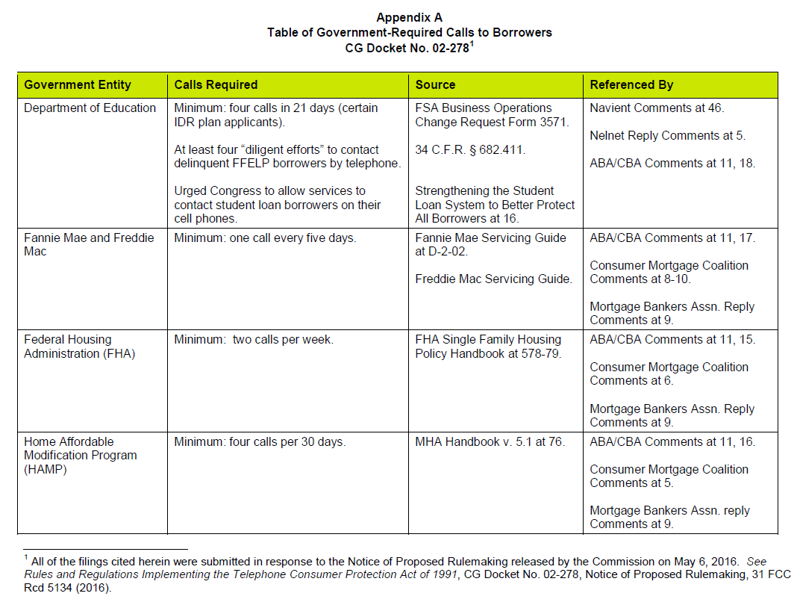

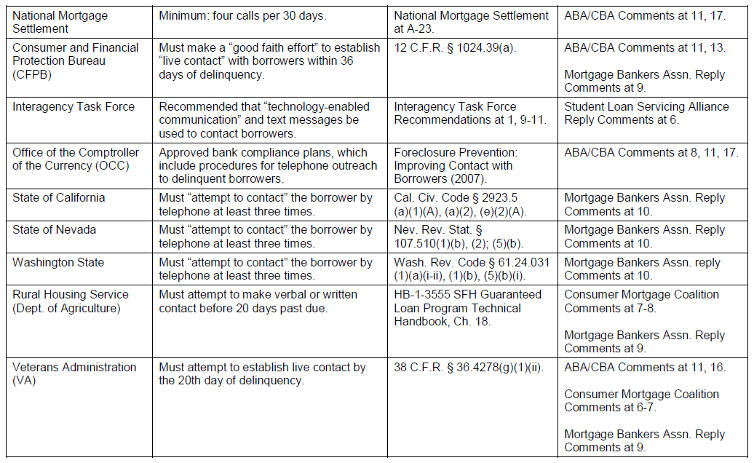

See Comments of the American Bankers Association and the Consumer Bankers Association, CC Docket No. 02-278, at 2 (filed June 6, 2016) (ABA/CBA Comments).
Letter from Rita Bratcher, Financial Management Service, U.S. Department of the Treasury, to Kevin Martin, FCC, CC Docket No. 02-278, at 2 (filed Jan. 26, 2007).
Letter from Scott Johnson, Financial Management Service, U.S. Department of the Treasury, to Marlene Dortch, FCC, CC Docket No. 02-278, at 2 (filed May 20, 2010).
Id.
Id.
See ABA/CBA Comments at 2 (“The Commission’s recent interpretations of the TCPA . . . fail to reflect technological change and consumer communication preferences, preventing consumers from receiving important communications from businesses and government entities on their mobile phones, communications that provide important information that consumers want and need to receive. This untenable situation prompted the Administration, beginning in 2013, to include in its budget proposals a request to exempt from the TCPA’s prior express consent requirement calls to mobile phones to collect on debts owed to or guaranteed by the United States. In 2015, Congress enacted a statutory provision codifying the exemption. Clearly, both the Administration and the Congress recognize that borrowers trying to manage their finances responsibly are best served if they communicate with their lender.”).
See Comments of ACA International, CC Docket No. 02-278, at 6 (filed June 6, 2016) (“Congress enacted the Budget Act exemption so that one category of debt collectors – those who collect debt owed to or guaranteed by the United States – would have a clear pathway to use modern calling technology to contact consumers on their mobile telephones in order to increase the recovery of government debt. Given this, the Commission must ensure that any final rules adopted reflect Congress’s clear intent to exempt government debt collectors from the TCPA’s prior express consent requirement.”).
See Comments of Navient Corporation, CC Docket No. 02-278, at viii (filed June 6, 2016) (Navient Comments) (“The FCC’s proposal effectively eliminates the exemption enacted by Congress and is contrary to Congress’ clear directive in passing the Bipartisan Budget Act (and contrary to the Administration’s longstanding efforts to include an exemption as part of the budget).”); see also id. at 18 (“Through its amendment, Congress unequivocally prioritized the collection of federal debt above other competing interests underlying the TCPA when it removed calls made solely to collect federal debts from the purview of the TCPA’s consent restrictions”); see also Reply Comments of the Mortgage Bankers Association, CC Docket No. 02-278, at 2 (filed June 16, 2016) (MBA Reply Comments) (observing that, in creating the exemption, “Congress highlighted the importance of collecting these debts owed to or guaranteed by the United States Government.”); see also Comments of Nelnet, Inc., CC Docket No. 02-278, at 2 (filed June 6, 2016) (Nelnet Comments) (Noting that the proposal “fails to effectuate the unequivocal policy objectives of the Budget Act amendments, which the White House has explained include “ensur[ing] that all debt owed to the United States is collected as quickly and efficiently as possible”) (citing Analytical Perspectives, Budget of the United States Government, Fiscal Year 2016, at 128, available at https://www.whitehouse.gov/sites/default/files/omb/budget/fy2016/assets/spec.pdf).
See, e.g., Rules and Regulations Implementing the Telephone Consumer Protection Act of 1991, Request of ACA International for Clarification and Declaratory Ruling, CG Docket No. 02-278, Declaratory Ruling, 23 FCC Rcd 559, 564, para. 9 (2007) (concluding that the provision of a cell phone number to a creditor, e.g., as a part of a credit application, reasonably evidences prior express consent by the cell phone subscriber to be contacted at that number regarding the debt).
See, e.g., Navient Comments at 3 (“We already have consent to autodial nine out of 10 of the federal student loan borrowers whose loans we service today, and they are far more likely to be current. But reaching the remaining 10 percent of borrowers has been challenging, and they are far more likely to default.”).
See also id. at 15 (“Ultimately, Congress prioritized collecting federal debts (and assisting these borrowers in avoiding delinquency and default) over other concerns that would otherwise suggest a need to obtain ‘consent’ from callers for exempted calls.”).
See id. (“Congress also afforded the FCC minimal discretion to adopt rules implementing this clear directive: the enabling legislation only permits the Commission to adopt regulations concerning the number and the duration of exempted calls, and only related to exempted calls to a telephone number assigned to a cellular telephone service.”); see id. at 35.
See id. at v (“If adopted, the proposals would undoubtedly turn the amendment on its head, essentially requiring callers to obtain ‘prior express consent’ to place calls that are exempt from the ‘prior express consent’ requirements (e.g., by limiting covered calls to only those to telephone numbers provided by the borrower).”).
See id. at 15 (“In relatively few words and using clear and concise language, Congress took decisive action to override prior Commission decisions that limited calls to collect federally owned or guaranteed debt.”); Comments of the National Council of Higher Education Resources (NCHER), CC Docket No. 02-278, at 3 (filed June 6, 2016) (NCHER Comments) (“NCHER believes that there is nothing in the Budget Act suggesting a narrow interpretation of what calls are covered. In fact, parsing the individual words of the statute ignores its plain reading that provides an exception for calls that are made for the purpose of collecting a debt and for no other purpose.”).
Separately, the order also refuses to address whether Fannie Mae and Freddie Mac loans are “owed to or guaranteed by” the federal government. The order claims that there are not enough facts in the record to decide the question. That ignores detailed filings on the issue. See, e.g., MBA Reply Comments at 3-8; ABA/CBA Comments at 3-6. Similarly, the order is silent as to whether Perkins Loans and HRSA Loans are covered by the exemption, despite filings in the record on the issue. See, e.g., Comments of the Coalition of Higher Education Assistance Organizations, CC Docket No. 02-278, at 2-3 (filed June 6, 2016). Failing to answer these and other questions will only create more uncertainty for both callers and borrowers.
Navient Comments at vii (“Borrower relationships can last 10 to 20 years or even longer, increasing the need to contact references and other non-borrowers, as well as the potential for the borrower’s number to change or be reassigned over time. Congress was aware of these situations and chose not to carve them out of the exemption.”); see id. at 42.
MBA Reply Comments at 13 (citing HAMP Handbook, 2.2.1 (01/06/16) (requiring a minimum of four telephone calls to the last known phone numbers of record, at different times of the day, within 30 day period)).
See Navient Comments at 35.
See id. at 36 (citing 34 C.F.R. § 682.411(h)).
See Nelnet Comments at 3 (“One clear purpose of the Budget Act amendments, then, is to facilitate the repayment of student loan and other debts owed to or guaranteed by the United States as a means of protecting federal assets. Toward that end, the Budget Act amendments are intended to and should authorize use of the full range of communication strategies that the federal government itself would undertake to service and collect its debts, including the use of automated and predictive dialing technology and artificial and prerecorded voice messages to contact borrowers through the communication channels that borrowers prefer (e.g., contact via cell phone calls and text messages).”).
Even though it is perfectly clear from the text of the law itself, I also note that the Administration was quite explicit that an intent of the Budget Act exemption was to authorize the use of autodialers. See, e.g., Nelnet Comments at 2 (citing Analytical Perspectives, Budget of the United States Government, Fiscal Year 2016, at 128, available at https://www.whitehouse.gov/sites/default/files/omb/budget/fy2016/assets/spec.pdf) (“The Budget proposes to clarify that the use of automatic dialing systems and prerecorded voice messages is allowed when contacting wireless phones in the collection of debt owed to or granted by the United States. In this time of fiscal constraint, the Administration believes that the Federal Government should ensure that all debt owed to the United States is collected as quickly and efficiently as possible and this provision could result in millions of defaulted debt being collected.”). In addition, a section-by-section summary posted by the House of Representatives states that “Subsection 301(a) amends the Communications Act of 1934 to authorize the use of automated telephone equipment to call cellular telephones for the purpose of collecting debts owed to the United States government.” See Bipartisan Budget Act of 2015 Section-by-Section Summary (last visited Aug. 9, 2016) (emphasis added), available at http://docs.house.gov/meetings/RU/RU00/CPRT-114-RU00-D001.pdf.
I continue to oppose the idea, set forth in the TCPA Omnibus Order, that even manually dialed calls may be treated as autodialed calls, unless placed from a rotary telephone, because the equipment could be modified into an autodialer.
I also want to make clear that, contrary to prior misguided Commission orders, predictive dialers are not autodialers. They do not meet the statutory definition because they do not “store or produce numbers to be called, using a random or sequential number generator”. 47 U.S.C. § 227(a)(1)(A) (emphasis added).
See Letter from Mark Brennan, Counsel to Navient, to Marlene Dortch, FCC, CC Docket No. 02-278, at 1-2 (filed July 8, 2016) (Navient July 8, 2016 Ex Parte) (citing BUREAU OF THE FISCAL SERVICE, U.S. DEPARTMENT OF THE TREASURY, REPORT ON INITIAL OBSERVATIONS FROM THE FISCAL-FEDERAL STUDENT AID PILOT FOR SERVICING DEFAULTED STUDENT LOAN DEBT (2016), at https://www.treasury.gov/connect/blog/Documents/student-loan-pilot-report-july-2016.pdf); see also Letter from Debra J. Chromy, Education Finance Council, to Marlene Dortch, FCC, CC Docket No. 02-278, at 3 (filed July 18, 2016) (citing the same pilot program and statistics and also noting that, “[p]rior to contacting borrowers, Fiscal attempted to update contact information with a commercially available database.”).
Navient Comments at 42-43.
See, e.g., NCHER Comments at 1-2 (“Live communication is key to borrowers understanding their rights, and a three call attempt per month restriction will largely nullify meaningful borrower contact. This arbitrary limit will be harmful to millions of federal student loan borrowers who want and need timely and accurate information to better manage their debt to avoid delinquency and default and to rehabilitate their defaulted loans.”); see also id. at 12 (“Unfortunately, far too many borrowers fail to have any meaningful contact with their student loan servicer, and the Commission’s proposed rule will not facilitate such contact, as was intended by the Congress when it passed the Bipartisan Budget Act of 2015.”); see also Nelnet Comments at 14 (“Borrowers are overwhelmingly relieved to understand their options and to resolve their account, but these solutions only work when servicers are able to reach the borrower.”).
See, e.g., MBA Reply Comments at 9-10; Letter from Eric Selk, HOPE NOW Alliance, to Marlene Dortch, FCC, CC Docket No. 02-278, at 2-3 (filed June 20, 2016).
See Letter from Mark Brennan, Counsel to Navient, to Marlene Dortch, FCC, CC Docket No. 02-278, at Appendix A (filed July 12, 2016).
Navient Comments at 43.
Consumer Financial Protection Bureau, Small Business Review Panel for Debt Collector and Debt Buyer Rulemaking; Outline of Proposals Under Consideration and Alternatives Considered (July 28, 2016), http://files.consumerfinance.gov/f/documents/20160727_cfpb_Outline_of_proposals.pdf.
Id.
Navient notes that, “in the context of the Fair Debt Collection Practices Act, NCLC urged the Consumer Financial Protection Bureau to limit calls from debt collectors to three per week.” Navient Comments at 44 (citing APRIL KUEHNHOFF AND MARGOT SAUNDERS, NATIONAL CONSUMER LAW CENTER, DEBT COLLECTION COMMUNICATIONS: PROTECTING CONSUMERS IN THE DIGITAL AGE 4 (June 2015), available at http://bit.ly/1LQxpDK.).
See also Navient Comments at 15.
See, e.g., Rules and Regulations Implementing the Telephone Consumer Protection Act of 1991, CG Docket No. 02-278, Report and Order, 27 FCC Rcd 1830, 1841, para. 28 (2012) (declining to require that prior express consent for non-telemarketing, informational calls, including debt collection calls, be provided in writing, as is the case for telemarketing calls).
See supra page 1 and note 3 (“Debt collectors are not using autodialers to cold call potential customers, but are instead using autodialers to contact individuals who have an existing relationship or indebtedness.”).
Letter from Ted Mitchell, United States Department of Education to Marlene Dortch, FCC, CC Docket No. 02-278, at 4 (filed July 11, 2016) (Department of Education Ex Parte).
Id.
See, e.g., Nelnet Comments at 2 (citing Analytical Perspectives, Budget of the United States Government, Fiscal Year 2016, at 128, available at https://www.whitehouse.gov/sites/default/files/omb/budget/fy2016/assets/spec.pdf) (“The Budget proposes to clarify that the use of automatic dialing systems and prerecorded voice messages is allowed when contacting wireless phones in the collection of debt owed to or granted by the United States. In this time of fiscal constraint, the Administration believes that the Federal Government should ensure that all debt owed to the United States is collected as quickly and efficiently as possible and this provision could result in millions of defaulted debt being collected. While protections against abuse and harassment are appropriate, changing technology should not absolve these citizens from paying back the debt they owe their fellow citizens.”).
Id.
See Navient Comments at 39-41 (raising First Amendment concerns about certain restrictions).
See, e.g., MBA Reply Comments at 13, 14 (“Creating a ‘stop calling’ right to receive covered calls frustrates the purpose of the Exemption and threatens to deprive consumers of important, beneficial calls. . . . Congress did not create a ‘stop calling’ right within the Exemption nor did it authorize the Commission to create such a right. In fact, creating a “stop calling” right would substantively repeal, not implement, the Budget Act Amendment.”).
Remarks of Deputy Secretary Raskin on Student Loans at the National Consumer Law Center's Annual Consumer Rights Litigation Conference (Nov. 6, 2014), https://www.treasury.gov/press-center/press-releases/Pages/JL2689.aspx. See also ABA/CBA Comments at 2 (“Communications between a borrower and lender may help the borrower prevent missed payments, minimize negative impacts to a borrower’s credit report, take advantage of loan modification or other workout programs, and avoid default. Successful loan workouts and other foreclosure alternatives also reduce credit risk and financial losses to the United States, helping taxpayers recoup the $139.3 billion of delinquent debt owed to or guaranteed by the United States. Using efficient dialing technology to communicate with borrowers enables more contacts and important conversations to occur with fewer personnel, reducing the cost of servicing and collections. This, in turn, promotes the affordability and availability of consumer credit.”); Reply Comments of Nelnet, Inc., CC Docket No. 02-278 (filed June 21, 2016) (summarizing comments filed by multiple parties showing the costs to consumers when calls are not made and the benefits when they are).
Navient Comments at 6; see also id. at 2 (“If we are able to speak to a borrower in real-time, we can counsel the borrower on the more than 16 repayment options—some of which involve monthly payments as low as $0 per month—or the 32 deferment, forbearance and forgiveness options available to the borrower.”); see also id. at 7-8 (“Conversely, 90 percent of borrowers who default on their federal student loans do not have a live telephone conversation with us, despite our efforts to reach them.”).

