Before the
Federal Communications Commission
Washington, D.C. 20554

In the Matter of  Amendment of the Commission’s Rules Regarding Implementation of the Final Acts of the World Radiocommunication Conference (Sharm el-Sheikh, 2019) (WRC-19), Other Allocation Issues, and Related Rule Updates  Amendment of the Commission’s Rules Regarding Implementation of the Final Acts of the World Radiocommunication Conference (Geneva, 2015) (WRC-15), Other Allocation Issues, and Related Rule Updates  Petition to Amend Parts 2 and 97 of the Commission’s Rules Regarding Implementation of the Final Acts of the World Radiocommunication Conference (Geneva, 2015) To Allocate the Band 5351.5-5366.5 kHz to the Amateur Radio Service | )  )  )  )  )  )  )  )  )  )  )  )  )  )  )  )  )  )  )  ) | ET Docket No. 23-121  ET Docket No. 23-120  RM-11785
Order and Notice of Proposed Rulemaking

Adopted: April 18, 2023 Released: April 21, 2023

Comment Date: [60 days after date of publication in the Federal Register]
Reply Comment Date: [90 days after date of publication in the Federal Register]
By the Commission:
Table of Contents
Heading Paragraph #
I. Introduction 1
II. Executive Summary 4
III. Background 5
IV. Order (WRC-19 ADMIN Order) 10
A. Reflecting WRC-19 Revisions in the International Table 11
B. Reflecting WRC-19 Revisions in the U.S. Table 12
C. Other Revisions to the Allocation Table 16
V. Notice of Proposed Rulemaking (WRC-15 Notice) 17
A. Satellite Issues 18
1. Protection of Search and Rescue Satellites Receiving in the 406-406.1 MHz Band 18
2. Space Research Service (space-to-space) in the 410-420 MHz Band 22
3. Global Flight Tracking for Civil Aviation (1087.7-1092.3 MHz) 23
4. Satellite Uplinks in the 7190-7250 MHz Band 25
5. Earth Exploration-Satellite Service (Active) in the 9.2-9.3 GHz and 9.9-10.4 GHz Bands 27
6. Revision of the 18.142-19.3 GHz, 28.5-29.1 GHz, and 29.25-29.5 GHz Bands 31
7. Deletion of the Radionavigation-Satellite Service from the 149.9-150.05 MHz and 399.9-400.05 MHz Bands 36
B. Terrestrial Issues 37
1. Amateur Service in the 5351.5-5366.5 kHz Band 37
2. Amateur Service in the 420-450 MHz Band 54
3. Maritime On-board Communication Stations (457/467 MHz) 55
4. Deletion of the Broadcasting Service from the 700 MHz Band 63
5. Deletion of Footnote NG155 64
C. Other Matters 65
VI. Procedural Matters 70
A. Order 70
B. NPRM 73
VII.Ordering Clauses 80
APPENDIX A – Final Rules
APPENDIX B – Proposed Rules
APPENDIX C – Initial Regulatory Flexibility Analysis

Introduction
- By this action, we take the necessary steps to implement certain decisions of the World Radiocommunication Conferences held in 2015 (WRC-15) and 2019 (WRC-19). This action consists of two components: 1) an Order that amends part 2 of the Commission’s rules to make non-substantive, editorial revisions to the Commission’s Table of Frequency Allocations (Allocation Table), primarily to reflect decisions from the Final Acts World Radiocommunication Conference 2019 (WRC-19 Final Acts); and 2) a Notice of Proposed Rulemaking that proposes to amend the Allocation Table and related service rules to implement certain radiofrequency allocation decisions from the Final Acts World Radiocommunication Conference 2015 (WRC-15 Final Acts).
- In the Order (WRC-19 Admin Order), we revise the Allocation Table by updating the International Table of Frequency Allocations (International Table) portion to reflect the International Telecommunication Union’s (ITU’s) Table of Frequency Allocations in its Radio Regulations (Edition of 2020) (Radio Regulations) and by making updates and corrections in the United States Table of Frequency Allocations (U.S. Table) portion. These ministerial actions do not modify or otherwise change the Commission’s rules with respect to any party’s underlying rights or responsibilities.
- In the Notice of Proposed Rulemaking (WRC-15 Notice), we propose to amend parts 2, 25, 74, 78, 90, 97, and 101 of the Commission’s rules to implement certain of the remaining allocation decisions from the WRC-15 Final Acts concerning portions of the radio spectrum between 5330.5 kHz and 29.5 GHz, make other allocation changes, and make related updates to our service rules in this frequency range. The WRC-15 Notice follows the WRC-15 Admin Order, which made non-substantive, editorial revisions to the Allocation Table and to other related rules. Many of these proposals are based on the National Telecommunications and Information Administration’s (NTIA’s) recommendations for national implementation of the WRC-15 Final Acts. Collectively, our proposals are designed to harmonize our spectrum allocations with and conform our rules to the WRC-15 Final Acts to the extent that doing so would better meet domestic requirements.

Executive Summary
- In the WRC-19 Order, we take non-substantive, editorial actions to update the Commission’s Allocation Table, including removing expired text and correcting errors. In the WRC-15 Notice, we propose to implement certain of the allocation decisions from the WRC-15 Final Acts, make other allocation changes, and make related updates to our service rules, including those for the amateur radio, cable television relay, fixed microwave, private land mobile, and satellite services, and for aural broadcast auxiliary and television broadcast auxiliary stations. Specifically, we seek comment on:
Satellite Issues
- Providing satellite-based search and rescue systems with protection from out-of-band emissions in the 406-406.1 MHz band by adding footnote US265 and revising section 90.265 to prohibit new fixed and mobile service assignments in the adjacent 100 kilohertz.
- Allocating the 410-420 MHz band to the space research service (space-to-space) on a secondary basis for non-Federal use, limited to communication links with an orbiting, manned space vehicle.
- Providing for Global Flight Tracking by allocating the 1087.7-1092.3 MHz sub-band to the aeronautical mobile-satellite (route) service (Earth-to-space) on a primary basis for Federal and non-Federal use, limited to space station reception of existing automatic dependent surveillance-broadcast (ADS-B) emissions from aircraft.
- Whether to allocate the 7190-7235 MHz band to the space research service (Earth-to-space) and the 7190-7250 MHz band to the Earth exploration-satellite service (Earth-to-space) on a secondary basis for non-Federal use.
- Whether to allocate the 9.2-9.3 GHz and 9.9-10.4 GHz bands to the Earth exploration-satellite service (active) on a primary basis for Federal use and on a secondary basis for non-Federal use and add several footnotes that will limit the impact of this new allocation on certain existing allocations.
- Revising footnote NG62 to permit grandfathered fixed stations in the 28.5-29.1 GHz and 29.25-29.5 GHz bands to operate on a secondary basis; update footnote US139 and the related service rules because incumbent fixed stations in the 18.3-19.3 GHz band no longer have primary status; and seek comment on whether the secondary non-Federal fixed-satellite service (space-to-Earth) allocation in the 18.142-18.3 GHz band should be raised to co-primary status with the fixed service.
- Deleting the primary radionavigation-satellite service allocation from the 149.9-150.05 MHz and 399.9-400.05 MHz bands.
Terrestrial Issues
- Allocating the 5351.5-5366.5 kHz (60 meter) band to the amateur service on a secondary basis, on whether four existing channels should continue to be made available for amateur use, and on appropriate limits for 60 meter band operations.
- Updating the coordination and contact information for amateur stations operating in previously defined areas of the 420-450 MHz (70 centimeter) band.
- Revising footnote US288 to authorize on-board communication stations to use three new 12.5 kilohertz channels/channel pairs nationwide, and five internationally-harmonized 6.25 kilohertz channels and channel pairs at coastal and certain inland ports; and revising footnote US287 to allocate several frequency bands between 457 MHz and 468 MHz totaling 231.25 kilohertz to the maritime mobile service, limited to on-board communication stations.
- Deleting the broadcasting service allocation from the 700 MHz band.
- Adding a new footnote US78 to the 960-1164 MHz band to recognize Federal use by military Identification Friend or Foe (IFF) systems on center frequencies 1030/1090 MHz.

Background
- The ITU convenes a World Radiocommunication Conference (WRC) typically every three to four years to address international spectrum use. Specifically, the ITU allocates frequency bands to various radio services generally on either a worldwide or Regional basis and enters these radio services in its Table of Frequency Allocations (which is reflected in section 2.106 of our rules as the International Table) as part of the Radio Regulations.
- The Commission conducted its primary preparations for WRC-15 via its 2015 World Radiocommunication Conference Advisory Committee (WAC), which held eight public meetings between August 9, 2012, and May 20, 2015, to evaluate and approve recommendations and preliminary views that were later submitted for Commission consideration. The ITU held a conference preparatory meeting (CPM) from March 23 through April 2, 2015, to prepare and approve a report on the technical, operational, and regulatory/procedural matters relevant to the WRC-15 agenda. In addition, the United States worked with other nations to craft common proposals for Region 2 (North and South America). By August 27, 2015, the United States had provided its contributions to the Inter-American Telecommunication Commission (CITEL), which then provided the Region 2 proposals to WRC-15.
- The ITU convened WRC-15 from November 2 to November 27, 2015, in Geneva, Switzerland, with 162 Member States, including the United States, participating. WRC-15 addressed more than 40 topics related to frequency allocation and frequency sharing for the efficient use of spectrum and orbital resources, and adopted allocation changes that affect both Federal and non-Federal entities. The ITU published the decisions made at WRC-15 as the WRC-15 Final Acts and subsequently revised the Radio Regulations to incorporate these decisions. On September 10, 2018, NTIA submitted its recommendations for national implementation of the WRC-15 Final Acts to the Commission.
- On December 23, 2019, the Chief, Office of Engineering and Technology and the Managing Director released the WRC-15 Admin Order, which reflected the WRC-15 changes to the International Table and made other non-substantive, editorial changes to the Commission’s rules, including revisions to the Federal Table that did not require notice and comment.
- The Commission has already considered certain of the WRC-15 allocation decisions in six different proceedings. Specifically, the Commission has revised its rules to provide for mobile broadband use in the 614-698 MHz and 3450-3700 MHz bands, vehicular and airport radar applications in the 76-81 GHz range, and earth stations in motion (ESIMs) in the 10.95-11.2, 11.45-12.2, 14-14.47, 19.7-20.2, and 29.5-30 GHz bands.

Order (WRC-19 ADMIN Order)
- In this Order, we make several non-substantive, editorial changes to the Commission’s Allocation Table. None of the rule changes discussed in this order are subject to the notice and comment requirements for rulemaking in the Administrative Procedure Act (APA). Section 553(b)(B) of the APA provides exceptions to the notice and comment requirements for rulemakings when, among other things, the agency finds good cause that the notice and comment requirements are “impracticable, unnecessary, or contrary to the public interest” with respect to the rules at issue. Specifically, in this Order, we make conforming changes to and correct minor errors in the Allocation Table, including removing expired text from domestic footnotes. All of these changes are summarized below. These changes have no substantive effect on industry or the general public. Accordingly, we find that it is “unnecessary,” within the meaning of section 553(b)(B) of the APA, to provide notice and an opportunity for public comment before adopting these rule revisions.

Reflecting WRC-19 Revisions in the International Table
- We update the International Table within section 2.106 of the Commission’s rules to reflect Article 5, section IV of the Radio Regulations (Edition of 2020), except as revised herein. The International Table is included within the Commission’s Allocation Table for informational purposes only. Consistent with past practice, we incorporate the following corrections and updates to the ITU’s Table of Frequency Allocations for display as the International Table in section 2.106 of the Commission’s rules: First, we update eight footnotes (5.328B, 5.341A, 5.341B, 5.341C, 5.351A, 5.384A, 5.388, 5.484B) by cross referencing four resolutions (Resolutions 155, 212, 223, 610) that were revised at WRC-19. Next, we: 1) revise two footnotes (5.169A, 5.169B) to make them consistent with the Federal Register’s style used in footnote 5.346 and update the cross reference to Resolution 99 in footnote 5.346 to match the version shown in footnotes 5.169A and 5.169B; and 2) correct footnotes 5.547 and 5.550E by adding the missing notation “Rev.” and by removing a dash that is inconsistent with 72 other instances of “non-geostationary-satellite systems” in Volume 1 of the Radio Regulations, respectively. Finally, we note that WRC-19 revised footnote 5.79 by permitting the use of the NAVDAT [navigational data] system to expand the potential uses of the band. Because this is not a non-substantive editorial change to the International Table that affects the U.S. Table, we maintain the status quo of the U.S. Table by replacing the existing reference to footnote 5.79 in the 415-472 kHz, 479-495 kHz, and 505-510 kHz bands within the U.S. Table with that of placeholder footnote US79A. Footnote US79A contains the pre-WRC-19 text of footnote 5.79, except that we list only the bands where footnote 5.79 currently applies (i.e., we exclude the 472-479 kHz band, which is no longer allocated to the maritime mobile service, and the 510-525 kHz band, to which we have never applied the provisions of footnote 5.79). We further note that revised footnote 5.79 applies to the maritime mobile service in the 415-495 kHz and 505-526.5 kHz bands in all ITU Regions; however, a reference to footnote 5.79 is not shown in the 510-525 kHz band within the Region 2 Table and there is no maritime mobile service entry or reference to footnote 5.79 in the 525-526.5 kHz sub-band within the Region 2 Table of the Radio Regulations. Therefore, we add this footnote 5.79 issue to note 1 of the Online Table.

Reflecting WRC-19 Revisions in the U.S. Table
- WRC-19 deleted one international footnote (5.396) that is referenced in the U.S. Table and revised a resolution that is referenced in two domestic footnotes (US444B, G132). We reviewed the relevant footnotes (5.396, US444B, G132) and find that implementing these changes in the Commission’s rules will have no substantive effect on non-Federal operations.
- Footnote 5.396 requires space stations in the broadcasting-satellite service (BSS) in the band 2310-2360 MHz operating in accordance with footnote 5.393 that may affect the services to which this band is allocated in other countries to be coordinated and notified in accordance with Resolution 33 (Rev.WRC-15), and further provides that complementary terrestrial broadcasting stations shall be subject to bilateral coordination with neighboring countries prior to their bringing into use. WRC-19 deleted Resolution 33 because the processing of filings under this Resolution was completed prior to WRC-07, and consequently deleted footnote 5.396 after moving its still-relevant text to footnote 5.393. We are updating footnote 5.393 in the International Footnotes to reflect the WRC-19 revisions. See Appendix A. In the United States, BSS operators provide satellite radio service to customers using the 2320-2345 MHz band and footnote 5.393 is not included in the 2310-2360 MHz band of the U.S. Table. We therefore find that removal of footnote 5.396 will have no substantive effect on non-Federal operations. We find that the reference to footnote 5.396 should be removed from the non-Federal Table, consistent with the WRC-19 implementation.
- Footnote US444B contains a cross reference to Resolution 418 (Rev.WRC-12). WRC-19 revised Resolution 418 by updating the guidance on the aeronautical mobile service use of the 5091-5150 MHz band by citing to Resolution 748 (Rev.WRC-19), by deleting the invitation that the ITU continue to study the conditions and arrangements for flight testing in this band, and by simplifying its text. Therefore, we find that changing the reference to WRC-19’s revision of Resolution 418 will not have any substantive effect on non-Federal operations.
- We update footnote G132, which applies to the 1215-1240 MHz band, to cross reference revised Resolution 608, replacing “(Rev.WRC-15)” with “(Rev.WRC-19).” Resolution 608 pertains to the protection of the radionavigation service in certain countries in Regions 1 and 3; because the United States is located in Region 2 , the revision of this resolution will not have any substantive effect on non-Federal operations.

Other Revisions to the Allocation Table
- In this section, we make the following additional editorial changes to section 2.106 of the Commission’s rules:
- Correct the Federal and non-Federal Tables by removing the reference to footnote 5.79A from the 435-472 kHz band because the footnote does not apply to that band.
- Revise footnotes US1, US82, US247, US281, US283, US296, US342, and G115 by changing the references to frequency units from “kHz” to “MHz” and revise footnote G32 from “MHz” to “GHz” in order to make the text of the footnotes consistent with the frequency units shown in the Allocation Table.
- Add a space between the third and fourth digits of frequency bands that contain five digits in 28 international footnotes.
- Simplify the display of facing pages in the Allocation Table.
- Remove the references to footnote US108 from the 3300-3500 and 3500-3550 MHz bands in the Federal Table and from the 3300-3450 and 3450-3600 MHz bands in the non-Federal Table and revise footnote G2 by deleting “(except as provided for in US108)” because footnote US108 no longer applies to the 3300-3550 MHz band. Also move the reference to footnote US431B from the bottom of the cell to the right of RADIOLOCATION in the 3300-3500 MHz band within the Federal Table because the footnote applies to only the radiolocation service.
- Place footnotes US431B and US433 in ascending numerical order in the 3450-3600 MHz band within the non-Federal Table. On page 39 of the Allocation Table, change the frequency range of the facing pages from “2483.5-3500” to “2483.5-3600” because 3450-3600 MHz is the last frequency band in the non-Federal Table in this set of facing pages.
- Simplify the non-Federal Table by combining the common radiocommunication service entries in the 3600-3650 MHz and 3650-3700 MHz bands to form the 3600-3700 MHz band, move the text of footnote NG185 to footnote NG169, and remove footnote NG185 from the list of non-Federal government (non-Federal) footnotes.
- Simplify the Federal Table by combining the common radiocommunication service entries in the 17.8-18.3 GHz and 18.3-18.6 GHz bands to form the 17.8-18.6 GHz band.
- Correct the placement of footnote NG65 in the 24.75-25.25 GHz and 47.2-48.2 GHz bands by moving the footnote reference from the right of the fixed-satellite service (Earth-to-space) entry to the bottom of the cell because this footnote refers to three allocated services.
- Correct footnotes 5.430A, 5.458, 5.509D, and 5.547 to reflect their text as shown in the Radio Regulations.
- Revise footnote US52 to account for now-expired text. Footnote US52 states that use of the frequencies 156.775 MHz and 156.825 MHz by the mobile-satellite service (Earth-to-space) is restricted to the reception of long-range Automatic Identification System (AIS) broadcast messages from ships. It also provided, in the text of the footnote, for port operations and ship navigation communications on these two frequencies (AIS 3 and AIS 4) until August 26, 2019. We revise footnote US52 paragraph (b) to remove the reference to August 26, 2019. Previous port operations and ship navigation communications on these two frequencies (AIS 3 and AIS 4) expired on August 26, 2019 and are no longer permitted.
- Revise footnotes US100, US312, and NG33 to remove footnote text that pertains to dates that have passed (i.e. expired text).

Notice of Proposed Rulemaking (WRC-15 Notice)
- In this Notice of Proposed Rulemaking (WRC-15 Notice), we propose to: 1) implement certain WRC-15 allocation decisions not previously addressed; 2) make other allocation changes that are not related to WRC-15 implementation; and 3) revise parts 2, 25, 74, 78, 90, 97, and 101 of the rules to reflect the allocation changes that we are proposing in this Notice. We first address satellite allocation issues in seven sections, and then we address terrestrial allocation issues in five sections.

Satellite Issues

Protection of Search and Rescue Satellites Receiving in the 406-406.1 MHz Band
- We propose to adopt new footnote US265 for the 403-410 MHz band to protect satellite-based search and rescue systems operating in the 406-406.1 MHz band from out-of-band emissions originating from operations in adjacent bands, as provided in Resolution 205 (Rev.WRC-19). Proposed US265 would prohibit new frequency assignments within the 405.9-406.0 MHz and 406.1-406.2 MHz bands under the mobile and fixed services allocations. For radiosonde applicants that seek to operate in this band, proposed US265 would require that the frequency drift characteristics of radiosondes be taken into account when selecting operating frequencies above 405 MHz to avoid transmitting in the 406-406.1 MHz band and that all practical steps be taken to avoid the operating frequency drifting close to 406 MHz. This proposed footnote seeks to address concerns that aggregate levels of electromagnetic interference, including interference from transmissions in adjacent frequency bands, may present a risk of satellite emergency transmissions being undetected, or delayed in reception, or lead to reduced accuracy of the calculated locations. We seek comment on this proposal.
- Currently, non-Federal use of the fixed and mobile services in the adjacent 403-406 MHz and 406.1-410 MHz bands is permitted pursuant to footnotes US13, US55, and US64. Footnote US64 states, inter alia, that the 403-406 MHz band is allocated to the mobile except aeronautical mobile service on a secondary basis and that non-Federal use is limited to medical device radiocommunication service (MedRadio) operations. MedRadio is an ultra-low power radio service that is associated with medical implant devices and medical body-worn devices. MedRadio stations are licensed-by-rule and operate in accordance with part 95, subpart I of the rules, so the Commission does not issue individual station licenses for MedRadio devices. Hence, we tentatively conclude that continued operations of MedRadio devices are consistent with proposed US265. We seek comment on this tentative conclusion.
- Footnote US13 and section 90.265 of the Commission’s rules make 48 channels available for transmitting hydrological and meteorological data (Hydro channels), including channels with center frequencies 406.125 MHz and 406.175 MHz. We propose to revise footnote US13 and section 90.265 to state that, after the effective date of final rules in this proceeding, no assignments for the frequencies 406.1250 MHz and 406.1750 MHz will be made, and that existing stations may continue to operate indefinitely on these frequencies as they are currently licensed. See Appendix B. By no longer issuing licenses for the frequencies 406.1250 MHz and 406.1750 MHz, we would ensure consistency with proposed new footnote US265 and protect satellite-based search and rescue systems operating in the adjacent 406-406.1 MHz band from out-of-band emissions originating on those frequencies. We seek comment on these proposals.
- Footnote US55 provides that the Commission may authorize public safety use of 40 Federal Interoperability Channels that are designated in section 4.3.16 of the NTIA Manual. However, because section 4.3.16 of the NTIA Manual does not include frequencies within the 406.1-406.2 MHz sub-band, it is not necessary to amend the language of this footnote. Finally, we propose to update footnote US117 to properly reflect that non-Federal use of the 406.1-410 MHz band is limited to the radio astronomy service and as provided by footnotes US13 and US55, as shown in Appendix B. We seek comment on these proposals, including any estimates of the costs and benefits of implementation.

Space Research Service (space-to-space) in the 410-420 MHz Band
- We propose to allocate the 410-420 MHz band to the space research service (space-to-space) on a secondary basis for non-Federal use, and to adopt footnote 5.268, which would limit use of this allocation to communication links with an orbiting, manned space vehicle and require compliance with a power flux-density limit at the Earth’s surface to protect existing and future licensees. The 410-420 MHz band is currently allocated to the fixed, mobile, and space research (space-to-space) services on a primary basis for Federal use; the 413-419 MHz segment is allocated to the mobile, except aeronautical mobile, service on a secondary basis, with non-Federal use limited to part 95 MedRadio operations. The National Aeronautics and Space Administration (NASA) operates systems in support of extra-vehicular activity communications for the manned space program and other space related efforts in this band. The systems are used for communications between crew members and for relaying telemetry data to the main spacecraft. Non-Federal use is limited to MedRadio operations, hydrological/meteorological data, and public safety. We expect that the additional non-Federal use would be similar to the current Federal uses and would occur because of increasing space exploration by private companies. We request comment on these proposals, including information on the costs and benefits.

Global Flight Tracking for Civil Aviation (1087.7-1092.3 MHz)
- We propose to allocate the 1087.7-1092.3 MHz band to the aeronautical mobile-satellite (route) service (Earth-to-space) on a primary basis, limited to space station reception of automatic dependent surveillance-broadcast (ADS-B) emissions from aircraft. If adopted, we would implement this proposed allocation by referencing footnote 5.328AA in the 960-1164 MHz band within the U.S. Table. The 960-1164 MHz band is currently allocated to the aeronautical mobile (route) and aeronautical radionavigation services on a primary basis for Federal and non-Federal use. Aircraft currently transmit ADS-B signals to report their position to ground-based receivers in a 4.6-megahertz wide band centered on 1090 MHz under the existing aeronautical mobile (route) service allocation. This proposed allocation would extend reception of ADS-B signals beyond terrestrial line-of-sight to facilitate reporting the position of aircraft located anywhere in the world. We tentatively conclude that providing for satellite reception of ADS-B signals would ensure the efficient management of air traffic in oceanic, polar, and remote airspace. Further, we tentatively conclude that this proposed allocation would support the Federal Aviation Administration’s rules regarding aircraft location information. We also propose to add new paragraph (a)(13) to section 25.202 of the Commission’s rules to permit the licensing of space stations that can receive ADS-B emissions from aircraft. We seek comment on these proposals.
- Further, as recommended by NTIA, we propose to add new footnote US78 to the 960-1164 MHz band to recognize Federal use by military Identification Friend or Foe (IFF) systems on center frequencies 1030/1090 MHz. We propose this use would be subject to the condition that harmful interference would not be caused to the aeronautical radionavigation service or the aeronautical mobile (R) service. Finally, we propose to revise footnote US224 to require that Federal systems utilizing spread spectrum techniques for terrestrial communication, navigation, and identification in the 960-1215 MHz band be authorized on the condition that harmful interference not be caused to the aeronautical mobile (R) and aeronautical radionavigation services in the 960-1164 MHz band, military IFF systems on center frequencies 1030/1090 MHz, aeronautical mobile-satellite (R) service (Earth-to-space) in the 1087.7-1092.3 MHz band, and the aeronautical radionavigation and radionavigation-satellite (space-to-Earth) (space-to-space) services in the 1164-1215 MHz band. We request comment on these proposals, including whether any modifications to the part 87 rules for aviation services would be necessary to implement our proposals.

Satellite Uplinks in the 7190-7250 MHz Band
- As recommended by NTIA, we seek comment on whether to provide additional spectrum on a secondary basis for non-Federal Earth-to-space operations in the Earth exploration-satellite service in the 7190-7250 MHz band and space research service in the 7190-7235 MHz band. In the U.S. Table, the 7190-7250 MHz band is allocated to the Earth exploration-satellite (Earth-to-space) and fixed services, both on a primary basis and exclusively for Federal use. The 7190-7235 MHz portion of the band is also allocated on a primary basis to the space research service (Earth-to-space) exclusively for Federal use.
- Consistent with NTIA’s recommendation, should we make these Federal uplink bands available for non-Federal use on a secondary basis for Earth-to-space operations in the Earth exploration-satellite and space research services, respectively, by adding footnotes US460 and US460A to the 7190-7235 MHz band and footnote US460A to the 7235-7250 MHz band? Footnote US460 would provide a secondary non-Federal allocation in the 7190-7235 MHz band for the space research service (Earth-to-space) and would prohibit emissions from such systems intended for deep space. Footnote US460A would allocate the 7190-7250 MHz band to the Earth exploration-satellite service (Earth-to-space) on a secondary basis for non-Federal use, limited to tracking, telemetry, and command (TT&C) for the operation of spacecraft. In both cases, should we explicitly require that authorizations be subject to a case-by-case electromagnetic compatibility (EMC) analysis and approval? Qualcomm urges the Commission to seek comment on whether such allocations would “remain in line with the Commission’s present spectrum priorities,” noting that the Chairwoman has identified the 7-15 GHz spectrum range, and some stakeholders, other administrations, and regional organizations are considering the 7190-7250 MHz band, for the next generation wireless technology. We request comment on these recommendations.

Earth Exploration-Satellite Service (Active) in the 9.2-9.3 GHz and 9.9-10.4 GHz Bands
- We seek comment on allocating the 9.2-9.3 GHz and 9.9-10.4 GHz bands to the Earth exploration-satellite service (active) on a primary basis for Federal use and on a secondary basis for non-Federal use, subject to four footnotes: 5.474A, 5.474B, 5.474C, and US474D. This would implement WRC-15’s expansion of the current worldwide Earth exploration-satellite service (active) allocation in the 9.3-9.9 GHz band by allocating 600 megahertz of additional spectrum in the adjacent bands to this service, which would support the growing demand for greater radar image resolution to satisfy global environmental monitoring requirements. Spaceborne radars operating in this band support a large number of scientific and geoinformation applications, such as disaster relief and humanitarian aid, land use, and large area coastal surveillance. We request comment on these potential allocations.
- In the U.S. Table, the 9.2-9.3 GHz band is allocated to the maritime radionavigation service on a primary basis and to the radiolocation service on a secondary basis for Federal and non-Federal use. The 9.9-10.5 GHz band is allocated to the radiolocation service on a primary basis for Federal use and on a secondary basis for non-Federal use. The 10-10.5 GHz and 10.45-10.5 GHz bands are allocated to the amateur and amateur-satellite services on a secondary basis, respectively. The 2023 World Radiocommunication Conference will consider whether to identify the 10-10.5 GHz for International Mobile Telecommunications (IMT) in ITU Region 2.
- The four footnotes we seek comment on adding to the 9.2-9.3 GHz and 9.9-10.4 GHz bands would limit their use to systems in the Earth exploration-satellite service (active) requiring a necessary bandwidth greater than 600 megahertz that cannot be fully accommodated within the 9.3-9.9 GHz band (5.474A); protect the radio astronomy service in the 10.6-10.7 GHz band from unwanted emissions (5.474B); protect the space research service (space-to-Earth) in the 8.4-8.5 GHz band from unwanted emissions (5.474C); and require that the Earth exploration-satellite service (active) not cause harmful interference to, or claim protection from, the maritime radionavigation service in the 9.2-9.3 GHz band and the radiolocation service in the 9.9-10.4 GHz band (US474D). Qualcomm urges the Commission to seek comment on whether the proposed allocations would “remain in line with the Commission’s present spectrum priorities,” noting that the Chairwoman has identified the 7-15 GHz spectrum range, and some stakeholders, other administrations, and regional organizations are considering the 9.2-9.3 GHz and 9.9-10.4 GHz bands, for the next generation wireless technology.
- We also propose to revise footnote US128 to support the Department of Defense’s development of pulsed emission systems in the 10-10.5 GHz band. Currently, US128 prohibits pulsed emissions in the 10-10.5 GHz band, except for weather radars on board meteorological satellites in the 10-10.025 GHz sub-band. NTIA states that the Department of Defense requires flexibility for development of pulsed systems in this band to meet future system needs. We seek comment on all of the proposals in this section. In addition we request comment on whether the 9.2-9.8 GHz and 9.9-10.4 GHz bands should be allocated to the Earth exploration-satellite service (active) on a primary basis for non-Federal use, so the status of those non-Federal allocations would mirror the status of the Federal Earth exploration-satellite service (active) allocations in those bands.

Revision of the 18.142-19.3 GHz, 28.5-29.1 GHz, and 29.25-29.5 GHz Bands
- In this section, we make proposals and seek comment on allocation and service rule changes that would clarify the status of grandfathered fixed stations in the 18.3-19.3 GHz band and permit a heavier use of the fixed-satellite service (FSS) in the 18.142-18.3 GHz, 28.5-29.1 GHz, and 29.25-29.5 GHz bands.
- First, we propose to amend footnote US139 by stating that, in the 18.3-19.3 GHz band, earth station licensees in the fixed-satellite service (space-to-Earth) may require that licensees of grandfathered stations in the fixed service cease operations, consistent with the provisions in section 101.95 of the Commission’s rules. We make this proposal because, in the 18.3-19.3 GHz band, there is no fixed service allocation and there are no longer any primary grandfathered fixed stations. Consequently, we also propose to revise sections 74.502(c), 74.602(g), 78.18(a)(4), and 101.147(r) of the rules in order to update the introductory text and the frequencies that are available to applicants of aural broadcast auxiliary stations, television broadcast auxiliary stations, cable television relay service, and fixed microwave services, respectively. These proposals are consistent with the Commission’s previous decision concerning the re-channelization of the 17.7-18.3 GHz and 19.3-19.7 GHz bands for fixed microwave services under part 101 of the rules. While most of the proposed changes remove channels that are no longer allocated to the fixed service, in one instance we propose to add replacement channels, i.e., we proposed replacing the 12 frequency pairs in section 74.502(c)(1)(i) of the rules with the 5 megahertz channels from section 101.147(r)(5) in Appendix B. We also propose to update sections 101.95(a) and 101.147(a) to remove expired text and to remove six sections concerning expired policies governing fixed service relocation from the 18.3-19.3 GHz band, i.e., sections 101.83 through 101.91 and 101.97. See Appendix B for the proposed revisions of sections 74.502(c), 74.602(g), 78.18(a)(4), 101.95(a), and 101.147(a) and (r). We request comment on these proposals.
- Second, we propose to revise footnote NG62 to permit the fixed stations authorized pursuant to the 10 listed call signs to continue to operate indefinitely on a secondary basis. The Commission adopted footnote NG62 when it deleted the primary fixed and mobile service allocations from the 28.5-29.1 GHz and 29.25-29.5 GHz bands. Footnote NG62 states that, in the 28.5-29.1 GHz and 29.25-29.5 GHz bands, stations in the fixed-satellite service shall not cause harmful interference to, or claim protection from, stations in the fixed service operating under 18 listed call signs; however, only 10 of these call signs are currently active. We note that WRC-19 and the Commission’s rules permit earth stations in motion (ESIMs) to operate in these frequency bands. The proposed secondary status of these fixed stations would recognize that ESIMs, which may operate anywhere without coordination with the fixed stations, may cause intermittent interference to these fixed stations. See Appendix B for the proposed text of revised footnote NG62. We request comment on these proposals.
- Third, we request comment on whether we should raise the non-Federal secondary fixed-satellite service (space-to-Earth) allocation in the 18.142-18.3 GHz band (158 megahertz) to primary status, i.e., co-equal with the non-Federal primary fixed service allocation in the band. If adopted, this upgrade of allocation status would provide receiving earth stations with interference protection from later-licensed fixed stations that are used for part 74 and part 101 Multichannel Video Programming Distributor (MVPD) and part 78 cable television relay service (CARS) operations that operate in accordance with the proposed rules in this section. We tentatively conclude this should result in significantly heavier earth station use of this band in the future, thereby enhancing spectrum efficiency. As background, we note that there are seven part 78 CARS licenses, which are located in three California counties and Maui Island, Hawaii; and 35 grandfathered fixed service licenses that authorize operations in the 18.142-18.3 GHz band. In contrast, as of August 26, 2022, there are 222 licenses for earth station reception in the 18.142-18.3 GHz band and there are 414 pending applications for earth stations that would receive in the band.
- Finally, we request comment on whether we should allow the continued operation of existing CARS licenses that authorize operation in the 18.3-18.304 GHz and 18.3-18.334 GHz bands in Puu Nianiau, Hawaii, and Placerville, California, respectively, and revise footnote US139 to codify that these fixed station operations may continue to operate indefinitely under the existing conditions.

Deletion of the Radionavigation-Satellite Service from the 149.9-150.05 MHz and 399.9-400.05 MHz Bands
- Consistent with the WRC-15 Final Acts, we propose to delete the radionavigation-satellite service allocation from the 149.9-150.05 MHz and 399.9-400.05 MHz bands. WRC-15 deleted this allocation because it had expired pursuant to footnote 5.224B. In the U.S. Table, the 149.9-150.05 MHz and 399.9-400.05 MHz bands are Federal/non-Federal shared bands that are allocated to the mobile-satellite service (Earth-to-space) and the radionavigation-satellite service on a primary basis. This proposal would make these two bands – totaling 300 kilohertz – exclusively allocated to the mobile-satellite service (Earth-to-space). We seek comment on this proposal.

Terrestrial Issues

Amateur Service in the 5351.5-5366.5 kHz Band
- We propose to allocate the 5351.5-5366.5 kHz band to the Amateur Radio Service on a secondary basis and seek comment on whether the amateur service should keep the existing channels they use in the 60 meter band. During WRC-15, the International Telecommunication Union allocated this band to the amateur service on a secondary basis in all ITU Regions. The ITU generally set the maximum radiated power at 15 watts (W) equivalent isotropically radiated power (EIRP), which is equivalent to 9.15 W effective radiated power (ERP).
- These frequencies are currently part of the 5275-5450 kHz band, which is allocated for Federal/non-Federal shared use, on a primary basis, to the fixed service and, on a secondary basis, to the mobile except aeronautical mobile service. Footnote US23 to the Allocation Table currently provides a secondary allocation to the amateur service on five discrete channels – each with a maximum bandwidth of 2.8 kilohertz and centered on the frequencies 5332, 5348, 5358.5, 5373, and 5405 kHz. However, pursuant to Commission rules, stations in the amateur service may transmit on these frequencies with a maximum radiated power of 100 W ERP – over ten times more powerful than WRC-15’s EIRP limit. NTIA recommends that we conform footnote US23 to the WRC-15 Final Acts by allocating the 5351.5-5366.5 kHz band to the amateur service on a secondary basis, removing the four existing amateur channels outside this proposed new amateur band, and restricting the maximum radiated power of amateur operations in the band to 15 W EIRP. Federal agencies use the larger 5275-5450 kHz band for services that include military, law enforcement, disaster relief, emergency, and contingency operations. Most non-Federal operations in the 60 meter band are part 90 industrial business pool land mobile operations.
- In 2017, ARRL, the National Association for Amateur Radio (ARRL), filed a petition for rulemaking asking the Commission to allocate the 5351.5-5366.5 kHz band to the amateur service on a secondary basis, as provided in the WRC-15 Final Acts, and also to retain the four amateur service channels that are outside this band (i.e., the frequencies 5332 kHz, 5348 kHz, 5373 kHz, and 5405 kHz) Further, ARRL supports using the same operating rules in terms of permitted emission types, power level, and access by class of amateur licensee for the new contiguous allocation that is currently applied to the existing five amateur channels. Essentially, ARRL supports extending the provisions of footnote US23 of the Allocation Table and section 97.303(h) of the Commission’s rules that apply to the existing five amateur channels, including the 100 watt ERP limit, to the new allocation. Therefore, ARRL disagrees with applying the 15 W EIRP limit suggested in the WRC-15 Final Acts. While most commenters support implementation of the ARRL Petition as filed, some commenters disagreed with various aspects of the ARRL Petition as addressed below. Some even argue that the entire 60 meter band should be opened for amateur use at higher power because they are not aware of any complaints of harmful interference. Finally, we note that Canada has essentially implemented the same rules as ARRL has requested.
- We propose to modify footnote US23 and part 97 of our rules to implement the new international allocation at 5351.5-5366.5 kHz, but also seek comment on whether we should maintain the existing four channels at 5332, 5348, 5373, and 5405 kHz that are outside of the new allocation. Under this proposal, amateurs would have access to a contiguous 15 kilohertz-wide band. Allowing amateurs to use these internationally-harmonized frequencies could facilitate amateur communications across international borders. We note however, there is significant opposition from the amateur community regarding the removal of the four discrete channels at 5332, 5348, 5373, and 5405 kHz from amateur use, as requested by NTIA. An argument could be made that amateur operations should remain on harmonized international frequencies because of the long-range propagation of these frequencies. Further, amateur licensees also have access to other high frequency (HF) bands at 3 and 7 MHz, so we believe there should be sufficient spectrum options for amateur operations without deviating from the internationally harmonized spectrum. However, some commenters contend that the amateur community has been using the four discrete channels at 5332, 5348, 5373, and 5405 kHz that fall outside of the proposed band for some time and argue that these channels are important in responding to disasters. We seek comment on this issue and what spectrum in the 60 meter band should be made available for amateur use.
- Alternatively, we seek comment on whether the four discrete channels at 5332, 5348, 5373, and 5405 kHz should be kept available for limited amateur use under certain conditions or only in response to disasters. For example, could the channels be authorized for amateur use during disasters as part of the Military Auxiliary Radio System (MARS) or SHAred RESources High Frequency Radio (SHARES) programs where participating amateur licensees can operate on Federal channels in coordination with the Department of Defense or Department of Homeland Security, respectively? Should we permit amateur stations participating in established emergency communications programs such as the Amateur Radio Emergency Service (ARES) or the Radio Amateur Civil Emergency Service (RACES) to use the additional channels or operate at higher power during emergencies and drills? Could the discrete channels be maintained under lower power or under other conditions that might reduce their potential to interfere with primary allocation services in the band? If so, we invite comment on whether the existing discrete channels should continue to be used for secondary amateur use and under what rules and conditions.
- While many amateur commenters argue they should be permitted access to more of the 60 meter band because they are not aware of any complaints of interference arising from their current operations, we note there are a variety of important non-Federal and Federal fixed and mobile except aeronautical mobile service operations in the band where even rare instances of interference could endanger public safety. Therefore, we tentatively find that the spectrum requirements for the amateur service in the 5005-5450 kHz band should be met by the WRC-15 amateur band and that only the four existing amateur channels at 5332, 5348, 5373, and 5405 kHz that are outside this band should be considered in this proceeding. Nevertheless, we seek comment on this idea. Commenters that support expanded access to the 60 meter band should provide information regarding how heavily the five amateur frequencies in the 5275-5450 kHz band are used and why additional amateur spectrum in this frequency range is needed if we adopt the proposed allocation.
- Power. ARRL seeks a maximum radiated power limit of 100 W ERP for the new secondary amateur allocation and to maintain the existing maximum radiated power limit of 100 W ERP for the existing discrete channels at 5332, 5348, 5373, and 5405 kHz. ARRL argues that such an implementation would support amateurs engaged in emergency and disaster relief communications to more reliably, flexibly, and capably conduct those communications; that imposing a maximum radiated power limit of 15 W EIRP would render the band unsuitable for emergency and public service communications; that the lower power limit is insufficient to permit reliable communications on the paths that are most critical; and that this reduced radiated power limit is not necessary to protect primary services from interference.
- Harold Ross Lambert and Michael Goltz argue that the power limit should be increased to 500 W to deal with propagation challenges in disaster communications; and Milton K. Miller supports 500 W power with the use of more efficient antennas. Phillip Finkle urges for at least 200 W of power designated as output power instead of ERP because ERP is difficult to measure. Janis Carson initially expresses concern over allowing U.S. amateurs to operate at much higher powers than the international standard, suggesting a compromise power of 30 W because digital modes are very effective at lower power and world-wide communications can be achieved at lower power levels like 5 W. However, in later comments Ms. Carson supports the ARRL proposal to allow 100 W for “more reliable communications in an environment of high static crashes.” William Springer urges the adoption of the 15 W power limit in the WRC-15 Final Acts because he contends that newer digital modes are more efficient, and so weaker signals are not an impediment to achieving communication. Finally Hugh Bahar cautions that deviating from limits agreed to at the international level is unwise and could lead to other countries ignoring the standards and could be viewed as an act of bad faith.
- Several commenters also argue for more flexibility in the types of antennas permitted in the 60 meter band. Scott Wright and George Dominick contend that antennas with gain greater than 0 dBi should be allowed since they are essential for efficient communications during an emergency. In contrast, Mathew Pitts does not support increasing the permitted antenna gain and contends the power should range between 15 and 30 W.
- We seek comment on the appropriate power limit for the new internationally harmonized amateur allocation and for the discrete channels if they are maintained for amateur use. We tentatively conclude that limiting the radiated power of amateur stations to 15 W EIRP would reduce the potential of harmful interference to incumbent primary operations, while maintaining consistency with the power limits established internationally for amateur operations in this band. However, the majority of the amateur comments are opposed to lower power limits and neighboring countries in Region 2 permit power levels higher than 15 W EIRP. We agree with certain commenters that the long-range propagation capabilities of these frequencies is likely to allow efficient communications at low-power levels, but there may be instances where more power is needed to deal with propagation challenges.
- We acknowledge that valid arguments may exist for adopting power limits above 15 W up to 100 W. For example, footnote 5.133B of the Allocations Table, which addresses this international allocation, outlines a power limit of 20 W EIRP for Mexico and 25 W EIRP for all Latin American countries and for many Caribbean countries/territories. Further, a review of our licensing database indicates other licenses with higher allocation status operating at power levels ranging from 15 W up to as high as 5000 W. Accordingly, we seek to build a more comprehensive record on the appropriate power limit for 60-meter band amateur operations. Interested parties seeking a power limit above the proposed 15 W EIRP limit should explain how much power would be appropriate, and how higher power limits would affect other operations in the 60-meter band? For example, should we allow the higher power allowed in other countries in ITU Region 2, such as Mexico and most Caribbean countries? Should we allow higher power during times of emergency drills/response or as part of programs where Amateur licensees support Federal emergency response? Should higher power only be permitted during disasters or drills supporting disaster relief? If, going forward, the discrete channels are permitted to be used by amateur operators under certain parameters or during disasters, what power limits should apply and when? What other conditions or considerations should be applied to amateur use of the 60 meter band?
- Further, we seek comment on how the limit should be specified in the rules. Specifically, should the power limit be defined in terms of EIRP to be consistent with the WRC-15 recommendation, or through some other means, such as ERP or transmitter output power? While some commenters argue that radiated power limits are difficult to calculate for certain types of antennas, we find that amateur licensees are supposed to study the radio arts and should be capable of determining their operating power. We seek comment on the pros and cons of the various power limit alternatives and which method is best for the 60 meter band. If we adopt a radiated power limit, we do not propose to adopt antenna limitations because a radiated power limit would ensure that excess power is not used, and flexibility in antenna choices may lead to spectrum efficiencies because the signal will propagate in its intended direction. Nevertheless, we seek comment on whether, and, if so what, antenna limitations are appropriate for amateur operations in this band using these different power limit measurements and how the Commission’s decision could affect how these frequencies would be used by the amateur community.
- Channelization. ARRL and several commenters argue that the new allocation should not designate sub-bands for various modes of operation to enable maximum flexibility to avoid interference with other operations. Janis Carson contends channelization is wasteful because narrowband modes can operate at less than three kilohertz and flexibility is need to address prevailing circumstances. She adds that a maximum bandwidth of 500 Hertz should be allowed in the new contiguous allocation. Charles Powell supports the ARRL request and contends that amateur equipment is not designed to maintain a high level of frequency accuracy and that such a design change would make equipment prohibitively expensive. However, William Springer argues that the new allocation should be channelized into five 3 kilohertz channels to promote efficiency and avoid overlapping transmissions. Benjamin Russell also supports five discrete channels, but suggests creating ten overlapping channels for narrowband carrier wave (CW) use. Ronald F Henry contends that channelization would facilitate sharing with Federal users and, given there are several bands available for amateur use, the “60 Meter band must be set aside for emergency communications as the primary use and as such, channelization is desired to protect both the primary and secondary user.”
- We propose that the 5351.5-5366.5 kHz band should not be channelized or have sub-bands. Due to the wide variety of potential applications and the need to protect other communications, dividing the band into channels may lead to inefficient spectrum use. However, we agree with commenters who state that some wideband digital emissions could create spectrum sharing problems, and so we propose a maximum emission bandwidth of 2.8 kilohertz for amateur operations in this band. We seek comment on this proposal and whether there are other limits or technical rule changes necessary to ensure reliable and efficient use of this band.
- Station Class and Permitted Uses. ARRL and certain other commenters state that only amateurs with a General Class license or higher should be allowed to use the new allocation, because Technician Class license holders may not have the experience to operate consistent with the interference avoidance protocols needed for the band. William Springer opposes the allowance of CW transmissions in the band because he contends that they are outdated and inefficient, but supports the use of any commonly-available, unencrypted digital transmission mode limited by a maximum occupied bandwidth that fits within the channel. Scott Wright supports the allowance of CW, arguing that several CW emissions can fit within a small amount of bandwidth. Janis Carson and Hugh Bahar oppose the allowance of automatically controlled digital stations and wideband digital modes that could block the entire allocation and could cause interference without busy channel detection. In her reply comments, Ms. Carson adds that the new allocation should be used for narrowband digital or CW and that the discrete channels, along with the one 3 kHz channel contained within the new allocation, could remain for use of single-side band (SSB) voice or wider digital modes. Ms. Carson also suggests not allowing any automatic store and forward email systems in the 60 meter band, claiming that these systems have a high potential to cause interference due to the “hidden transmitter” effect, where the offshore initiating station cannot hear a primary user in the skip zone of the shore based relay station. Finally, W. Lee McVey contends that the 60 meter band rules should ensure that only publicly documented digital codes operate in the band to prohibit encrypted communications.
- Consistent with the current amateur class requirements for the 60 meter band, we propose to permit amateurs holding a General Class license or higher to use the 5351.5-5366.5 kHz band. We agree with commenters that the long-range propagation characteristics in the band combined with the need to protect important safety of life communications by Federal operations potentially requires a higher level of radio knowledge to ensure the spectrum is properly shared. We seek comment on this proposal. Further, if we maintain the four existing discrete channels at 5332, 5348, 5373, and 5405 kHz outside of the international allocation, we propose that those channels also be permitted for General Class licensees or higher. We seek comment on this proposal and other alternatives. For example, if we adopt the new allocation and keep the existing discrete channels, should different amateur classes be permitted on the new allocation versus the discrete channels? If we allow station classes below General Class licensees to access the 60 meter band, what conditions should be applied? For example, should certain classes be permitted to operate in certain modes (i.e., voice vs. digital) or at certain times (e.g., only in response to a disaster)? Given the limited spectral resource at issue, commenters supporting more flexible use should support their comments with suggested safeguards or ideas on how the spectrum can be efficiently used without interfering with primary allocation operations.
- At this time, we are not proposing to preclude CW or any other radio technique currently permitted in the 60 meter band because the record is inconclusive on whether certain modulation methods should be prohibited. However, we note that the amateur rules generally preclude encrypted operations, and so we seek comment on whether the 60 meter band rules need to be clearer on what types of digital operations are permitted. As discussed above, we propose to limit the emission bandwidth to 2.8 kilohertz, which may limit some techniques. We seek comment on these proposals and encourage the amateur community to attempt to reach consensus on what radio techniques should be permitted, given the limited amount of spectrum available, the need to use this spectrum efficiently, and the importance of ensuring that the primary users are protected from harmful interference.

Amateur Service in the 420-450 MHz Band
- Based on a request from NTIA, we propose to update the coordination and contact information in footnote US270 for the areas wherein the peak envelope power of an amateur station operating in the 420-450 MHz (70 cm) band is generally limited to 50 watts, and to revise the cross reference to this footnote in section 97.313(f) of the rules. See Appendix B for the proposed text of footnote US270 and section 97.313(f). We request comment on these proposals.

Maritime On-board Communication Stations (457/467 MHz)
- We propose to revise footnote US288 to make a limited number of narrowband channels from the international channel plan adopted at WRC-15 available for use by on-board communication stations. An on-board communication station is a low-powered mobile station in the maritime mobile service used for internal communications on board a ship, or between a ship and its lifeboats and life-rafts during lifeboat drills or operations, or for communication within a group of vessels being towed or pushed, as well as for line handling and mooring instructions. Our proposals are intended to benefit the maritime industry by making available a subset of the internationally-harmonized narrowband channels for on-board communication use while ships are in U.S. territorial waters. Our overarching goals in making these proposals are to minimize the potential for intermittent and harmful interference to stations in the land mobile and fixed services that operate on the same or adjacent frequencies to on-board communication stations and to promote more efficient and effective use of the available spectrum, while fully meeting the operational requirements of ship station licensees for on-board communication stations.
- Footnote US288 and section 80.373(g) of the rules make seven internationally-harmonized frequencies in the 457.5125-457.5875 MHz and 467.5125-467.5875 MHz bands (150 kilohertz) and five other frequencies available for use by on-board communication stations in U.S. territorial waters (275 kilohertz in total). Specifically, section 80.373(g)(1) states that the frequencies 457.525 MHz, 457.550 MHz, 457.575 MHz, and 457.600 MHz may be used by on-board repeater stations and by unpaired on-board mobile stations (i.e., single-frequency simplex operation) and that four frequencies in the 467.7375-467.8375 MHz band (i.e., 467.750, 467.775, 467.800, and 467.825 MHz) may be used by on-board mobile stations in two-frequency repeater systems. In addition, section 80.373(g)(2) states that, where needed, equipment designed for 12.5 kilohertz channel spacing using the additional frequencies 457.5375 MHz, 457.5625 MHz, 467.5375 MHz, and 467.5625 MHz (i.e., channels 12, 14, 22, and 24) may be introduced for on-board communications; however, no use of these channels is currently authorized.
- WRC-15 revised the international channel plan for on-board communication stations to provide for 6.25 kilohertz channels. This new channel plan, shown in Table 1 below, specifies 40 frequencies that support the use of equipment designed to operate on 25, 12.5, or 6.25 kilohertz channels. The shaded channels in Table 1 indicate the internationally-harmonized channels that are currently available for use under our rules.

Table 1: International vs. United States Channels for On-Board Communication Stations
International Footnote 5.287 and Recommendation ITU-R M.1174-4 |  |  |  |  |  |  |  |  |  |  |  | US1-US3 (25/25 kHz with the lower channel harmonized)
Lower Band Channels |  |  |  |  |  | Upper Band Channels
25 kHz |  | 12.5 kHz |  | 6.25 kHz |  | 25 kHz |  | 12.5 kHz |  | 6.25 kHz
Ch | MHz | Ch | MHz | Ch | MHz | Ch | MHz | Ch | MHz | Ch | MHz
1 | 457.525 | - | - | 102 | 457.515625 | 4 | 467.525 | - | - | 202 | 467.515625 | US1 consists of channel 1 and a channel centered on 467.750 MHz
 |  | 11 | 457.5250 | 111 | 457.521875 |  |  | 21 | 467.5250 | 211 | 467.521875
 |  |  |  | 112 | 457.528125 |  |  |  |  | 212 | 467.528125
 |  | 12 | 457.5375 | 121 | 457.534375 |  |  | 22 | 467.5375 | 221 | 467.534375
2 | 457.550 |  |  | 122 | 457.540625 | 5 | 467.550 |  |  | 222 | 467.540625 | US2 consists of channel 2 and a  channel centered on 467.775 MHz
 |  | 13 | 457.5500 | 131 | 457.546875 |  |  | 23 | 467.5500 | 231 | 467.546875
 |  |  |  | 132 | 457.553125 |  |  |  |  | 232 | 467.553125
 |  | 14 | 457.5625 | 141 | 457.559375 |  |  | 24 | 467.5625 | 241 | 467.559375
3 | 457.575 |  |  | 142 | 457.565625 | 6 | 467.575 |  |  | 242 | 467.565625 | US3 consists of channel 3 and a  channel centered  on 467.800 MHz
 |  | 15 | 457.5750 | 151 | 457.571875 |  |  | 25 | 467.5750 | 251 | 467.571875
 |  |  |  | 152 | 457.578125 |  |  |  |  | 252 | 467.578125
 |  | - | - | 161 | 457.584375 |  |  | - | - | 261 | 467.584375
- To permit the deployment of more spectrally efficient narrowband equipment, we propose to revise footnote US288 by authorizing on-board communication stations to use 12.5 and 6.25 kilohertz channels in the territorial waters of the United States as described in the following paragraphs.
- First, we propose to revise footnote US288 to authorize: 1) nationwide use of channels 11-15, which are internationally-harmonized 12.5 kilohertz channels, for on-board repeater stations and on-board mobile stations used for single-frequency simplex operation; 2) on-board mobile stations to operate nationwide on five non-harmonized frequencies that are 10.225 megahertz higher in frequency than the center frequency of their associated on-board repeater stations (frequencies shown in Table 2, below); and 3) on-board repeater stations to operate on channels 12 and 14 and associated on-board mobile stations operating on channels 22 and 24, respectively, in the Territorial Sea of the United States and at coastal ports and the inland ports of Baton Rouge, Houston, and Portland, and on the waterways and at other ports between these inland ports and the ocean. We request comment on these proposals.
Table 2: Center Frequencies for 12.5 Kilohertz On-board Paired Channels
Channel | On-board Repeater Station | On-board Mobile Station
US11 | Channel 11 – 457.5250 MHz | 467.7500 MHz
US12 | Channel 12 – 457.5375 MHz | 467.7625 MHz
US13 | Channel 13 – 457.5500 MHz | 467.7750 MHz
US14 | Channel 14 – 457.5625 MHz | 467.7875 MHz
US15 | Channel 15 – 457.5750 MHz | 467.8000 MHz
- Second, we propose to revise footnote US288 to authorize on-board repeater stations and on-board mobile stations used for single-frequency simplex operation to operate on the 6.25 kilohertz channels 102, 121, 122, 141, and 142 and for on-board mobile stations operating with a repeater station to operate on the 6.25 kilohertz channels 202, 221, 222, 241, and 242, respectively, in the Territorial Sea of the United States and at coastal ports and the inland ports of Baton Rouge, Houston, and Portland, and on the waterways and at other ports between these inland ports and the ocean. We request comment on this proposal, noting that eight of these channels overlap the 12.5 kilohertz channels that we are proposing in the previous paragraph (i.e., channels 12, 14, 22, and 24) and that channels 102 and 202 are between low-power part 90 channels. We request comment on these proposals, noting that the use of 6.25 kilohertz channels with center frequencies that are offset from the frequencies used by stations in the fixed and land mobile services by 6.25 kilohertz are expected to enhance spectrum sharing. We also solicit comment on whether we should authorize the use of channel pairs 121/221 on those waterways in the contiguous United States that the Department of Transportation has designated as part of America’s Marine Highway.
- We also propose to revise the text of footnote US288 to state that, in the territorial waters of the United States, footnote 5.287 applies, except that on-board communication stations must transmit only on the listed frequencies and must operate as specified herein. On-board repeater stations and mobile stations used for single-frequency simplex operation currently may transmit only in the band 457.5125-457.6125 MHz. We propose that the preferred frequencies for repeater systems would be 457.525 MHz (channel 1 or 11), 457.5375 MHz (channel 12), 457.550 MHz (channel 2 or 13), 457.5625 MHz (channel 14), 457.575 MHz (channel 3 or 15), and 457.600 MHz paired, respectively, with 467.750 MHz, 467.7625 MHz, 467.775 MHz, 467.7875 MHz, 467.800 MHz, and 467.825 MHz; and the preferred frequencies for single-frequency operations would be those designated as channels 1-3, 11-15, and 121. Finally, we propose that use of channels 122, 141, and 142 and channel pairs 12/22, 14/24, 102/202, 121/221, 122/222, 141/241, and 142/242 would be authorized at coastal ports and the inland ports of Houston, Baton Rouge, and Portland, and along the waterways and at other ports between these inland ports and the ocean; however, on-board communication stations would not be able to transmit on these channels while in port and not underway or preparing to get underway. See Appendix B for the proposed text of footnote US288. We seek comment on these proposals.
- Finally, we propose to revise footnote US287 by allocating the 457.5125-457.6125 MHz, 467.512375-467.518625 MHz, 467.55625-467.56875 MHz, 467.53125-467.54375 MHz, and 467.7375-467.8375 MHz bands (231.25 kilohertz) to the maritime mobile service on a primary basis, by limiting the use of these allocations to on-board communication stations, and by stating that, in these frequency bands, stations in the fixed and land mobile services may not claim protection from interference caused by on-board communication stations operating in accordance with US288 and that on-board communication stations may not claim protection from stations in the fixed and land mobile services. See Appendix B for the proposed text of footnote US287. Alternatively, we request comment on whether existing part 90 Private Land Mobile and part 95 Personal Radio Service licensees operating in the 456-470 MHz band should be afforded any protection from interference caused by on-board communication stations operating in accordance with US288. We observe that the 456-470 MHz band is allocated to the mobile service on a primary basis in all ITU Regions, and request comment on the public interest benefits of both our proposal and the alternative.

Deletion of the Broadcasting Service from the 700 MHz Band
- We propose to delete the broadcasting service allocation in the 698-758 MHz, 775-788 MHz, and 805-806 MHz bands from the non-Federal Table and to revise footnote NG159 by removing the reference to part 74, subpart G. Between 1998 and 2010, the Commission transitioned the 698-806 MHz (700 MHz) band from television broadcasting use (i.e., TV channels 52-69) to public safety and mobile broadband uses. Currently, the entire 700 MHz band is allocated to the fixed and mobile services on a primary basis, but the broadcasting service allocation still remains in the 698-758 MHz, 775-788 MHz, and 805-806 MHz portions on a primary basis, and licensees in those bands have the flexibility to provide broadcast services, if they choose. See Appendix B for the proposed text of footnote NG159. We request comment on our proposal. In the event that we delete the broadcast allocation as proposed, we seek comment on whether, and which, part 27 service rules should be modified to reflect the change (e.g., sections 27.3 (Other Applicable Rule Parts), 27.4 (Terms and Definitions), 27.10 (Regulatory Status), 27.13 (License Period), 27.50 (Power Limits and Duty Cycle), and 27.55 (Power Strength Limits)).

Deletion of Footnote NG155
- We propose to remove footnote NG155 from the rules because the frequencies and frequency bands to which it applies are not authorized in part 80 of the Commission’s rules. The ITU has identified the frequencies that can generally be used worldwide for intership communications. Thus, we tentatively conclude that there is no need to specify any other frequencies for intership use. We note that, in the Second Report and Order in PR Docket No. 92-257 that added footnote NG155 to section 2.106 of the Commission’s rules, the Commission declined to adopt the proposed rules for part 80 regarding maritime sharing of private land mobile radio frequencies for intership communications. We request comment on this proposal.

Other Matters
- As a result of discussions regarding the protection of near-Earth operations of deep space missions, WRC-15 added a provision in Article 4 of the Radio Regulations (No. 4.24) to describe the use of space research service (deep space) allocations. Similarly, we propose to add a new paragraph to section 2.102 of the Commission’s rules to clarify that: “Space research systems intended to operate in deep space may also use the space research service (deep space) allocations, with the same status as those allocations, when the spacecraft is near the Earth, such as during launch, early orbit, flying by the Earth and returning to the Earth.” We request comment on this proposal.
- We propose to amend section 2.1(c) of the rules to add or revise the definitions for the terms “meteorological aids land station,” “meteorological aids mobile station,” and “coordinated universal time” in accordance with the WRC-15 adopted definitions. We also propose to add a definition for the term “frequency band” based on that term’s ITU definition. The proposed language of these definitions appears in the Appendix. We seek comment on these definitions.
- We propose to amend section 2.105(d) of the rules by stating that the footnote references which appear in the United States Table below the allocated service or services apply to more than one of the allocated services, or to the whole of the allocation concerned, and that the footnote references which appear to the right of the name of a service are applicable only to that particular service. See Appendix B for the proposed text of section 2.105(d)(6)-(8), where the text in paragraph (d)(6) has been moved to paragraph (d)(8).
- In response to NTIA’s recommendation that we add a subset of the international footnotes that identify spectrum for International Mobile Telecommunications (IMT) to the non-Federal Table, we direct the Chief, Office of Engineering and Technology to maintain a “Mobile Broadband Spectrum in the United States” file on the “Radio Spectrum Allocation” webpage. We request comment on whether this file meets the public’s needs.
- Digital Equity and Inclusion. Finally, the Commission, as part of its continuing effort to advance digital equity for all, including people of color, persons with disabilities, persons who live in rural or Tribal areas, and others who are or have been historically underserved, marginalized, or adversely affected by persistent poverty or inequality, invites comment on any equity-related considerations and benefits (if any) that may be associated with the proposals and issues discussed herein. Specifically, we seek comment on how our proposals may promote or inhibit advances in diversity, equity, inclusion, and accessibility, as well as the scope of the Commission’s relevant legal authority.

Procedural Matters

Order
- Regulatory Flexibility Act. None of the rule changes discussed in the Order are subject to the notice and comment requirements for rulemaking in the Administrative Procedure Act (APA). Section 553(b)(B) of the APA provides exceptions to the notice and comment requirements for rulemakings when, among other things, the agency finds good cause that the notice and comment requirements are “impracticable, unnecessary, or contrary to the public interest” with respect to the rules at issue. The changes discussed in the Order have no substantive effect on industry or the general public. Accordingly, we find that it is “unnecessary,” within the meaning of section 553(b)(B) of the APA, to provide notice and an opportunity for public comment before adopting these rule revisions. Because the rule changes are being adopted without notice and comment, the Regulatory Flexibility Act, 5 U.S.C. §§ 601 et seq., does not apply.
- Paperwork Reduction Act. This Order does not contain new or modified information collections subject to the Paperwork Reduction Act of 1995 (PRA), Public Law 104-13 (44 U.S.C. §§ 3501-3520). In addition, it does not contain any new or modified information collection burden for small business concerns with fewer than 25 employees pursuant to the Small Business Paperwork Relief Act of 2002, Public Law 107-198, see 44 U.S.C. § 3506(c)(4).
- Congressional Review Act. The Commission has determined, and the Administrator of the Office of Information and Regulatory Affairs, Office of Management and Budget, concurs, that this rule is “non-major” under the Congressional Review Act, 5 U.S.C. § 804(2). The Commission will send a copy of this Order to Congress and the Government Accountability office, pursuant to 5 U.S.C. § 801(a)(1)(A).

NPRM
- Paperwork Reduction Analysis. This document does not contain proposed information collection requirements subject to the Paperwork Reduction Act of 1995, Public Law 104-13. In addition, therefore, it does not contain any proposed information collection burden for small business concerns with fewer than 25 employees, pursuant to the Small Business Paperwork Relief Act of 2002, Public Law 107-198, see 44 U.S.C. 3506(c)(4).
- Regulatory Flexibility Act. The Regulatory Flexibility Act of 1980, as amended (RFA), requires an agency to prepare a regulatory flexibility analysis for notice and comment rulemakings, unless the agency certifies that “the rule will not, if promulgated, have a significant economic impact on a substantial number of small entities.” Accordingly, , the Commission has prepared an Initial Regulatory Flexibility Analysis (IRFA) concerning the potential impact of the rule and policy changes contained in the WRC-15 Notice. The IRFA is set forth in Appendix C. Written public comments are requested on the IRFA. Comments must be filed in accordance with the same filing deadlines as comments filed in response to the WRC-15 Notice, and must have a separate and distinct heading designating them as responses to the IRFA. The Commission’s Consumer and Governmental Affairs Bureau, Reference Information Center, will send a copy of this WRC-15 Notice, including the IRFA, to the Chief Counsel for Advocacy of the Small Business Administration, in accordance with the Regulatory Flexibility Act.
- Filing Requirements. Pursuant to sections 1.415 and 1.419 of the Commission’s rules, 47 CFR §§ 1.415, 1.419, interested parties may file comments and reply comments on or before the dates indicated on the first page of this document.
- Electronic Filers: Comments may be filed electronically using the Internet by accessing the Commission’s Electronic Comment Filing System (ECFS): http://apps.fcc.gov/ecfs/.

- Paper Filers: Parties who choose to file by paper must file an original and one copy of each filing.

Filings can be sent by commercial overnight courier, or by first-class or overnight U.S. Postal Service mail. All filings must be addressed to the Commission’s Secretary, Office of the Secretary, Federal Communications Commission.
- Commercial overnight mail (other than U.S. Postal Service Express Mail and Priority Mail) must be sent to 9050 Junction Drive, Annapolis Junction, MD 20701.
- U.S. Postal Service first-class, Express, and Priority mail must be addressed to 45 L Street, NE, Washington DC 20554.
- Effective March 19, 2020, and until further notice, the Commission no longer accepts any hand or messenger delivered filings. This is a temporary measure taken to help protect the health and safety of individuals, and to mitigate the transmission of COVID-19.
- People with Disabilities: To request materials in accessible formats for people with disabilities (braille, large print, electronic files, audio format), send an e-mail to fcc504@fcc.gov or call the Consumer & Governmental Affairs Bureau at 202-418-0530 (voice), 202-418-0432 (tty).

- The proceeding that this Notice initiates shall be treated as a “permit-but-disclose” proceeding in accordance with the Commission’s ex parte rules. Persons making ex parte presentations must file a copy of any written presentation or a memorandum summarizing any oral presentation within two business days after the presentation (unless a different deadline applicable to the Sunshine period applies). Persons making oral ex parte presentations are reminded that memoranda summarizing the presentation must (1) list all persons attending or otherwise participating in the meeting at which the ex parte presentation was made, and (2) summarize all data presented and arguments made during the presentation. If the presentation consisted in whole or in part of the presentation of data or arguments already reflected in the presenter’s written comments, memoranda or other filings in the proceeding, the presenter may provide citations to such data or arguments in his or her prior comments, memoranda, or other filings (specifying the relevant page and/or paragraph numbers where such data or arguments can be found) in lieu of summarizing them in the memorandum. Documents shown or given to Commission staff during ex parte meetings are deemed to be written ex parte presentations and must be filed consistent with rule 1.1206(b). In proceedings governed by rule 1.49(f) or for which the Commission has made available a method of electronic filing, written ex parte presentations and memoranda summarizing oral ex parte presentations, and all attachments thereto, must be filed through the electronic comment filing system available for that proceeding, and must be filed in their native format (e.g., .doc, .xml, .ppt, searchable .pdf). Participants in this proceeding should familiarize themselves with the Commission’s ex parte rules.
- Availability of Documents. Comments, reply comments, and ex parte submissions will be publicly available online via ECFS.
- When the FCC Headquarters reopens to the public, these documents will also be available for public inspection during regular business hours in the FCC Reference Center, Federal Communications Commission, 45 L Street N.E., Washington, DC 20554.
- Additional Information. For additional information on this proceeding, contact Patrick Forster, Office of Engineering and Technology, Patrick.Forster@fcc.gov, (202) 418-7061.

Ordering Clauses
- IT IS ORDERED that, pursuant to sections 1, 4(i), 4(j), 7, 301, 303(c), 303(f), and 303(r) of the Communications Act of 1934, as amended, 47 U.S.C. §§ 151, 154(i), 154(j), 157, 301, 303(c), 303(f), and 303(r), this Order and Notice of Proposed Rulemaking IS ADOPTED.
- IT IS FURTHER ORDERED pursuant to section 1.407 of the Commission's rules, 47 CFR § 1.407, that the petition for rulemaking filed by the American Radio Relay League, Incorporated, Amendment of Parts 2 and 97 of the Commission’s Rules Regarding Implementation of the Final Acts of the World Radiocommunication Conference (Geneva, 2015) to Allocate the Band 5351.5-5366.5 kHz to the Amateur Radio Service, RM-11785, IS GRANTED IN PART.
- IT IS FURTHER ORDERED that the amendments of part 2 of the Commission’s rules, as set forth in Appendix A, ARE ADOPTED, effective thirty (30) days after publication in the Federal Register.
- IT IS FURTHER ORDERED that the Commission’s Consumer and Governmental Affairs Bureau, Reference Information Center, SHALL SEND a copy of this Order and Notice of Proposed Rulemaking, including the Initial Regulatory Flexibility Analysis, to the Chief Counsel for Advocacy of the Small Business Administration.
- IT IS FURTHER ORDERED that the Commission SHALL SEND a copy of this Order in a report to be sent to Congress and the Government Accountability Office pursuant to the Congressional Review Act, see 5 U.S.C. § 801(a)(1)(A).
FEDERAL COMMUNICATIONS COMMISSION

Marlene H. Dortch
Secretary
APPENDIX A

Final Rules

The Federal Communications Commission amends 47 CFR part 2 as follows:

PART 2 – FREQUENCY ALLOCATIONS AND RADIO TREATY MATTERS; GENERAL RULES AND REGULATIONS

1. The authority citation for part 2 continues to read as follows:
Authority: 47 U.S.C. 154, 302a, 303, and 336, unless otherwise noted.
2. Amend § 2.106 as follows:
a. Revise pages 3, 4, 19 through 28, 30, 33, 34, 38 through 42, 50, 52 through 56, 58 through 60, 62, 66, and 68 in paragraph (a);
b. Revise paragraphs (b)(67) introductory text, (b)(67)(ii), and (b)(70);
c. Remove and reserve paragraph (b)(71);
d. Revise paragraphs (b)(77) and (79);
e. Add paragraph (b)(82)(i) and reserved paragraph (b)(82)(ii);
f. Revise paragraphs (b)(87), (107), (109) through (112), (114), (117), (118), (123), and (128), (b)(132) introductory text, (b)(132)(ii), (b)(133)(i) and (ii), (b)(134), (b)(141)(ii), (b)(145) introductory text, (b)(145)(ii), (b)(146) and (147), (b)(149) through (155), (b)(156) introductory text, (b)(156)(i), (b)(157) through (159), (b)(161)(i) and (ii), (b)(162)(i), and (b)(163) through (165);
g. Add paragraph (b)(166);
h. Revise paragraphs (b)(169), (171), (194), (201), and (202);
i. Add paragraph (b)(203);
j. Revise paragraphs (b)(204) and (b)(208)(i) and (ii);
k. Add paragraph (b)(209)(i) and reserved (b)(209)(ii);
l. Revise paragraphs (b)(211), (212), and (214);
m. Add paragraph (b)(218)(i) and reserved (b)(218)(ii);
n. Revise paragraphs (219) and (221);
o. Redesignate paragraphs (b)(228)(i) through (vii) as paragraphs (b)(228)(iii) through (ix) and add new paragraphs (b)(228)(i) and (ii);
p. Revise paragraphs (b)(242) and (252);
r. Add paragraphs (b)(260) and (b)(264)(i) and (ii);
s. Revise paragraphs (b)(265), (275), (277), and (278), (b)(279) introductory text, (b)(279)(i), (b)(280), (b)(286)(ii), (b)(287), (288), and (295), (b)(296) introductory text, (b)(296)(i), (b)(297), (b)(308) introductory text, and (b)(308)(i);
t. Remove and reserve paragraph (b)(311);
u. Revise paragraphs (b)(312) introductory text, (b)(312)(i), (b)(313) and (316), (b)(317)(i), (b)(323), (b)(325)(i), (b)(328)(ii) and (iii), (b)(329) and (331), (b)(338)(i), (b)(341)(i) through (iii), (b)(345), (346), (349), and (350), (b)(351)(i), (b)(352), (359), (368), and (372);
t. Add paragraph (b)(373);
u. Revise paragraphs (b)(382), (b)(384)(i), (b)(388) introductory text, (b)(388)(ii), (b)(389)(i) and (iv), and (b)(393);
v. Remove and reserve paragraph (b)(396);
w. Revise paragraphs (b)(401), (418), and (428), (b)(429) introductory text, (b)(429)(i) through (iv) and (vi), (b)(430) introductory text, (b)(430)(i), (b)(431) introductory text, (b)(432), (b)(433)(i), (b)(434), (b)(441)(i) and (ii), (b)(444)(ii), and (b)(446)(i) and (iii);
x. Add paragraph (b)(446)(iv);
y. Revise paragraphs (b)(447) introductory text, (b)(447)(vi), (b)(448), (b)(450)(i), (b)(453), (455), (458), and (468), (b)(473) introductory text, (b)(474)(iv), (b)(477), (b)(478) introductory text, (b)(479) through (481) and (483), (b)(484)(ii), (b)(495) and (505), (b)(508) introductory text, (b)(509)(iii), and (b)(516)(ii);
z. Add paragraph (b)(517)(i) and reserved paragraph (b)(517)(ii);
aa. Revise paragraph (b)(530)(ii);
bb. Redesignate paragraph (b)(532)(ii) as paragraph (b)(532)(iv) and add new paragraph (b)(532)(ii) and paragraph (b)(532)(iii);
cc. Add paragraph (b)(534);
dd. Revise paragraphs (b)(536)(i) and (ii), (b)(537)(i), (b)(543)(i), and (b)(546) and (547);
ee. Add paragraphs (b)(550)(ii) through (v);
ff. Revise paragraph (b)(552)(i).
gg. Add paragraphs (b)(553)(i) and (ii), and (b)(555)(ii);
hh. Revise paragraph (b)(559)(i);
ii. Add paragraph (b)(559)(ii);
jj. Revise paragraph (b)(562)(ii);
kk. Remove and reserve paragraphs (b)(562)(vi) and (vii);
ll. Add paragraph (b)(564);
mm. Revise paragraph (c)(1)
nn. Redesignate Note 2 to paragraph (c)(22)(ii)(B) as Note 4 to § 2.106(c)(22)(ii)(B);
oo. Revise paragraph (c)(52);
pp. Add paragraph (c)(79)(iii);
qq. Revise paragraph (c)(82);
rr. Redesignate Note 3 to table 4 to paragraph (c)(83) as Note 5 to table 4 to § 2.106(c)(83);
ss. Redesignate Note 4 to paragraph (c)(88)(ii) as Note 6 to § 2.106(c)(88)(ii);
tt. Redesignate Note 5 to paragraph (c)(91)(ii)(B) as Note 7 to § 2.106(c)(91)(ii)(B);
uu. Redesignate Note 6 to paragraph (c)(91)(ii)(C) as Note 8 to § 2.106(c)(91)(ii)(C);
vv. Redesignate Note 7 to paragraph (c)(97) as Note 9 to § 2.106(c)(97);
ww. Revise paragraph (c)(100);
xx. Redesignate Note 8 to paragraph (c)(136)(ii) as Note 10 to § 2.106(c)(136)(ii);
yy. Redesignate Note 9 to paragraph (c)(161)(ii) as Note 11 to § 2.106(c)(161)(ii);
zz. Revise paragraphs (c)(247), (281), (283), (296), (312), and (342), and (c)(444)(ii);
aaa. Redesignate Note 10 to paragraph (c)(565) as Note 12 to § 2.106(c)(565);
bbb. Revise paragraph (d)(33);
ccc. Redesignate Note 11 to paragraph (d)(53) as Note 13 to paragraph (d)(53);
ddd. Revise paragraph (d)(169);
eee. Remove and reserve paragraph (d)(185); and
fff. Revise paragraphs (e)(2), (32), (115), and (132).
The revisions and additions read as follows:

§ 2.106 Table of Frequency Allocations.

(a) * * *

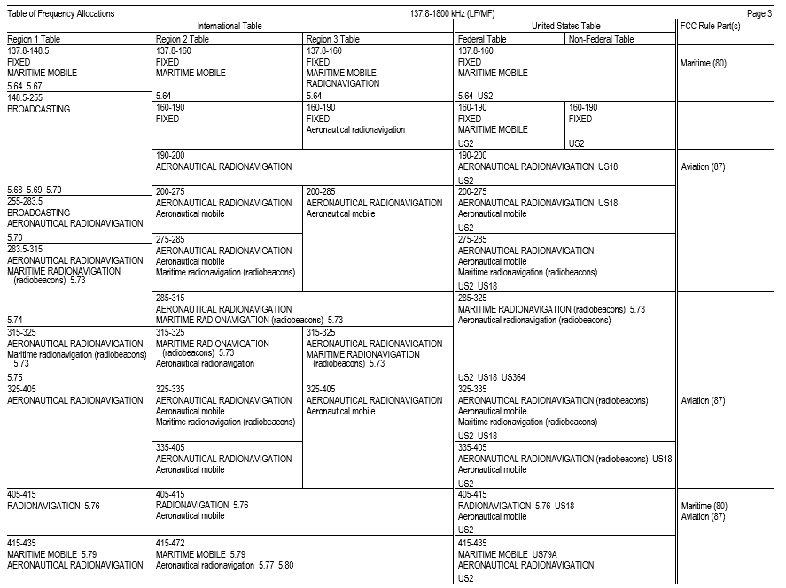

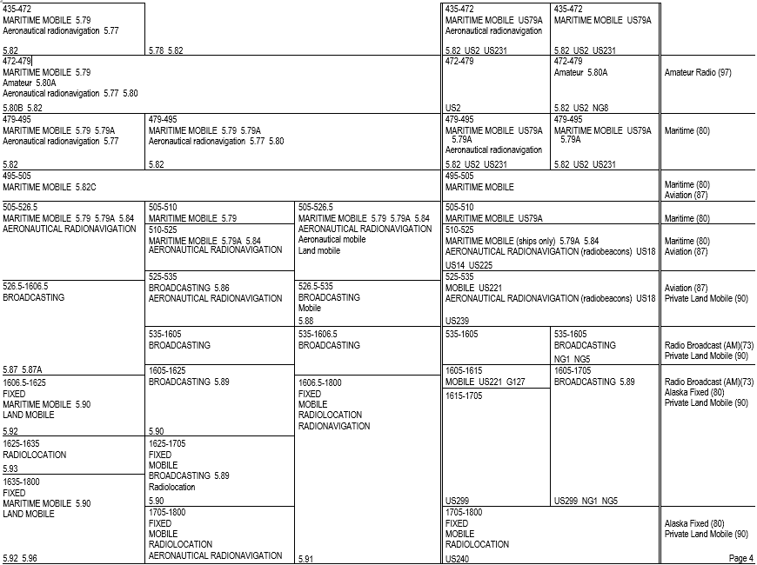
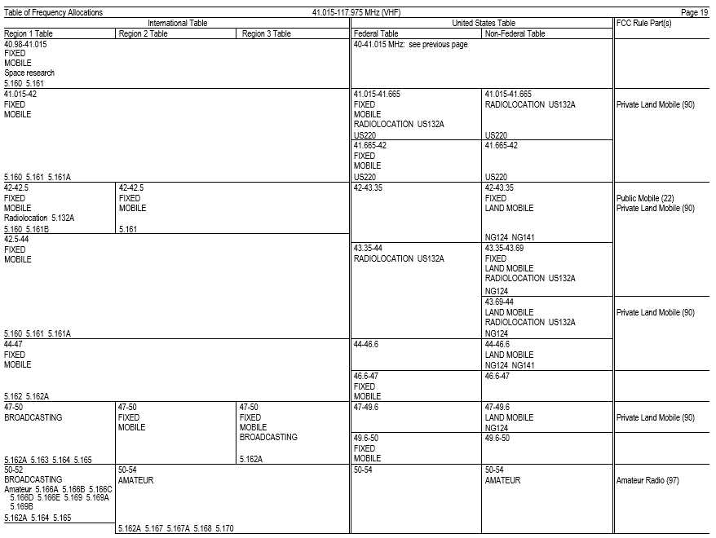
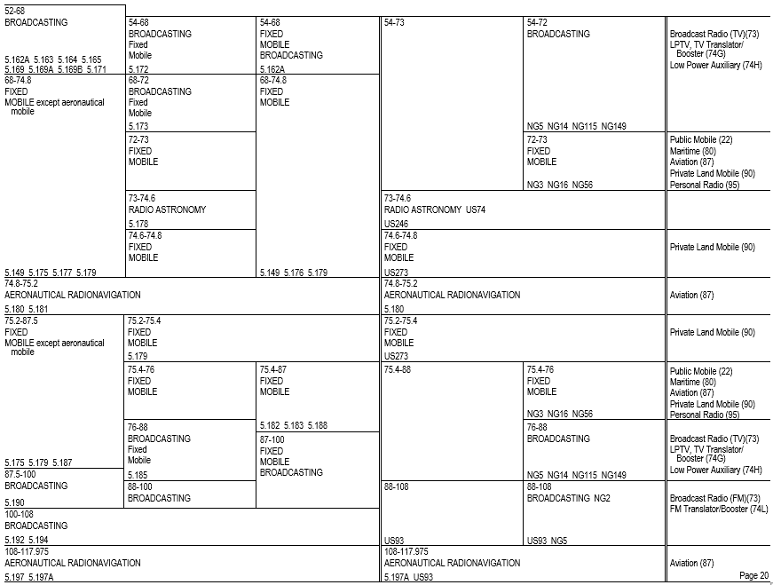
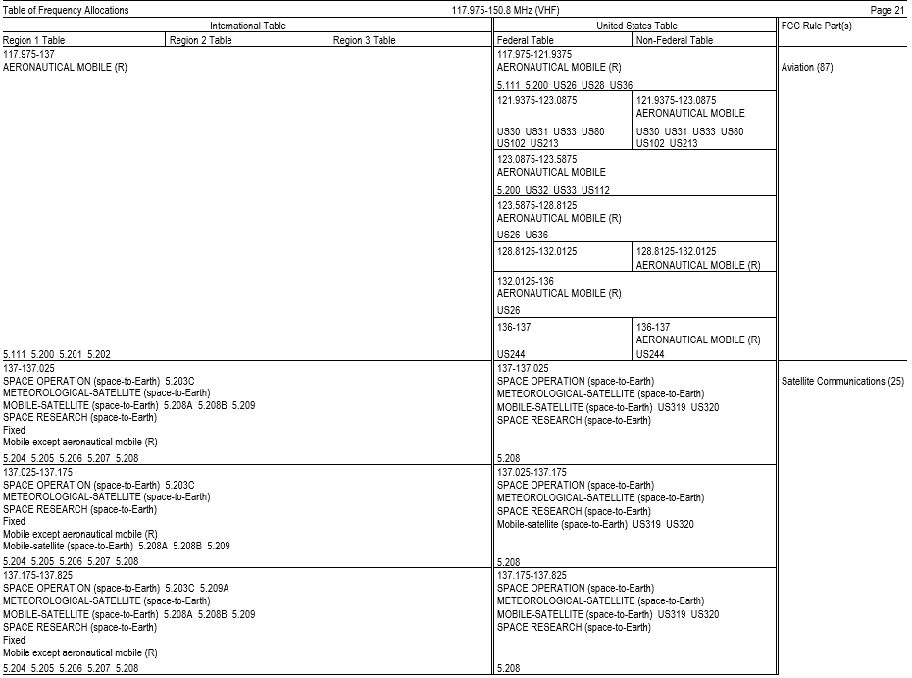
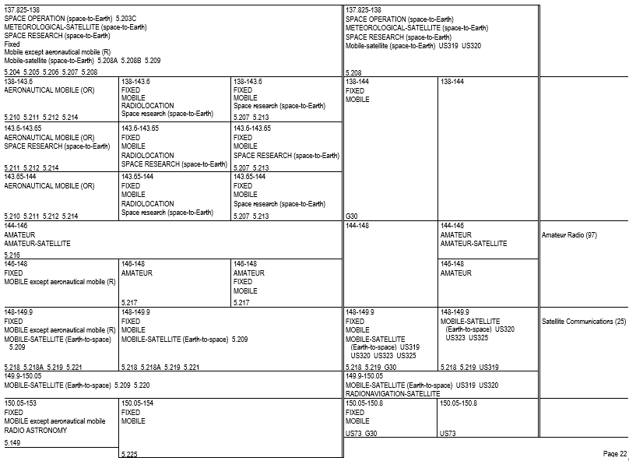
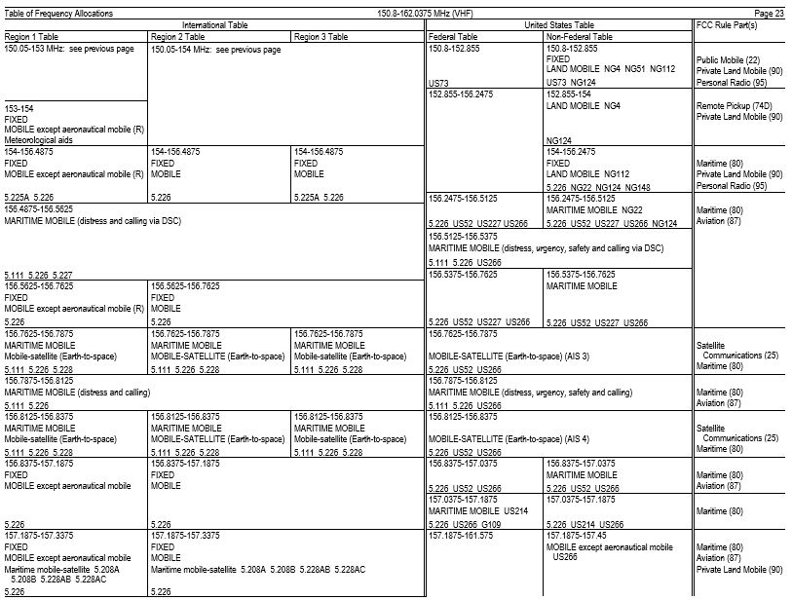

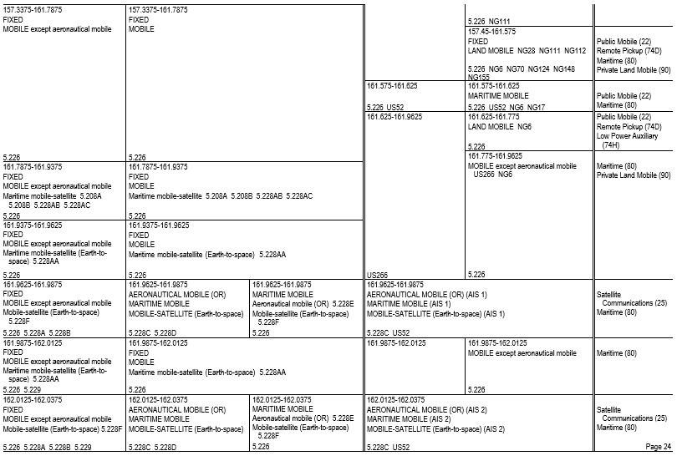
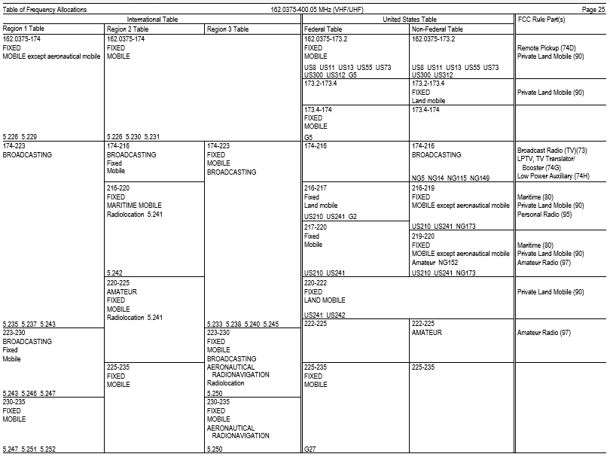

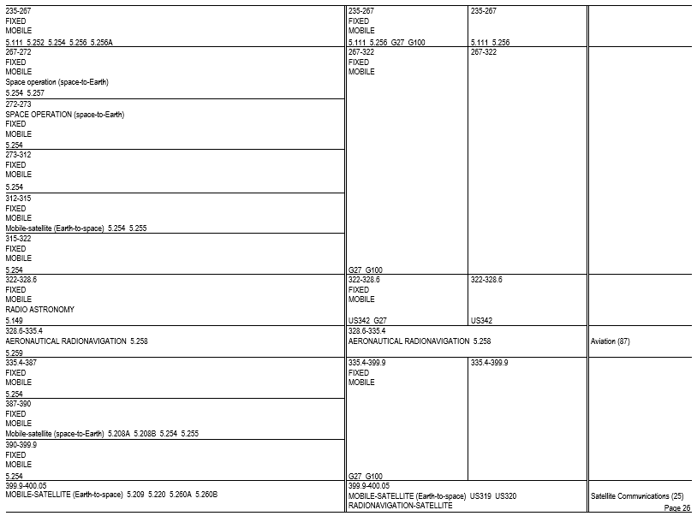

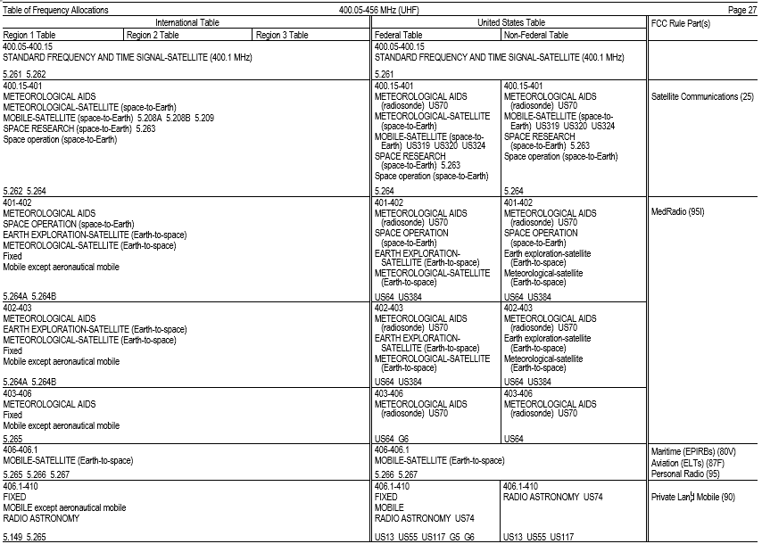
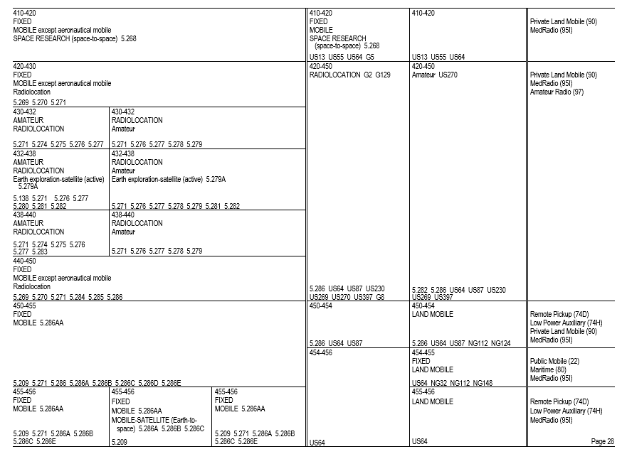

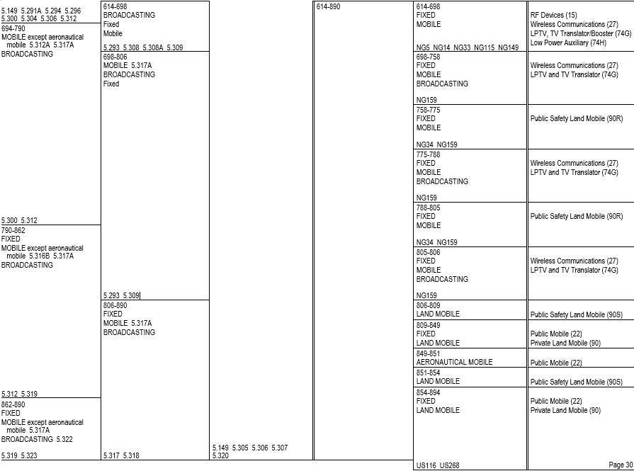

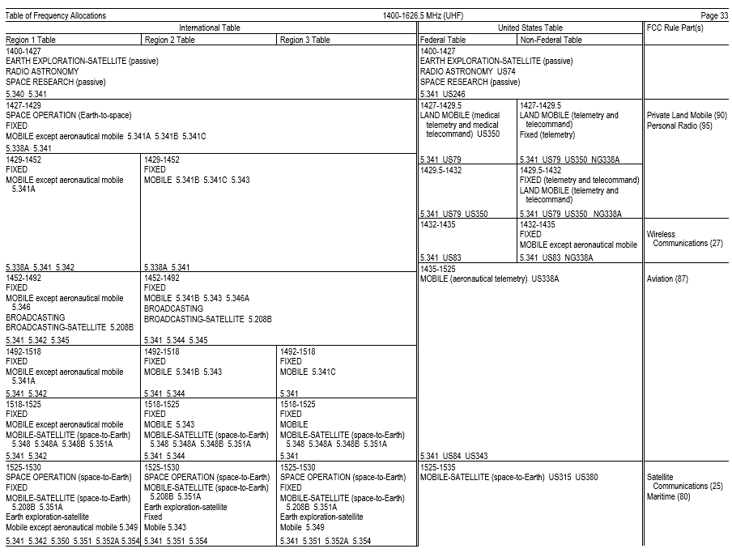

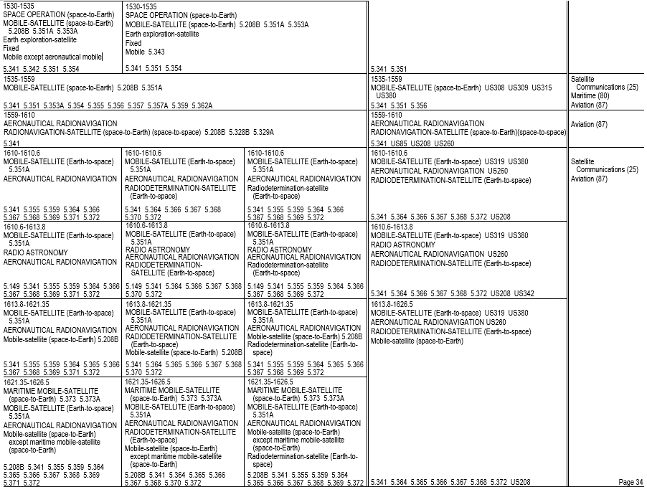

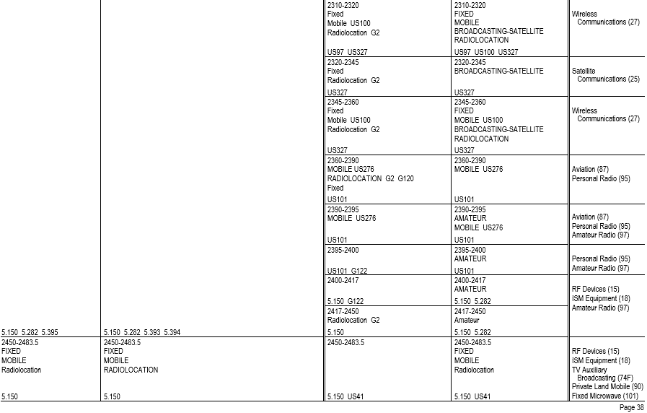
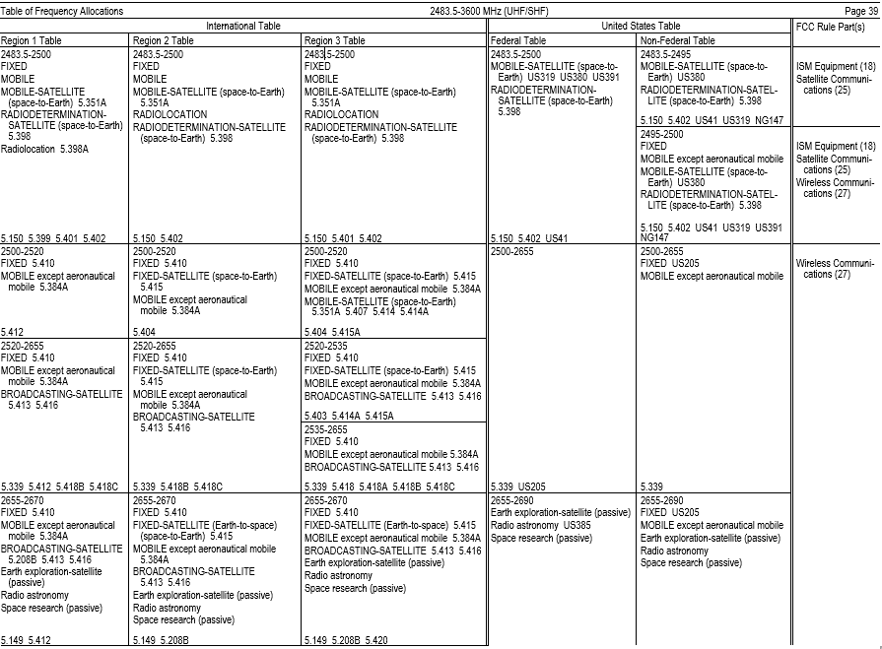

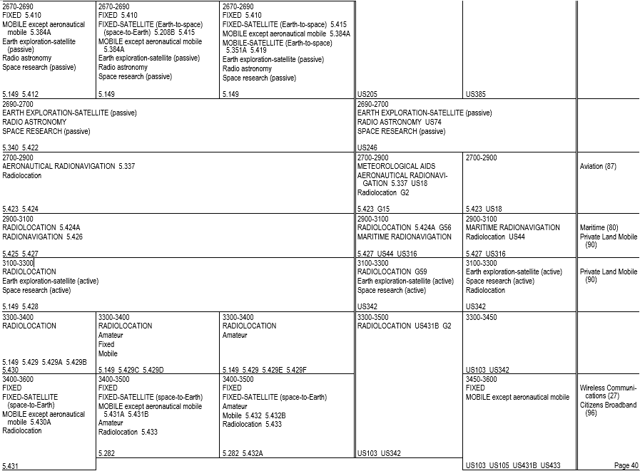

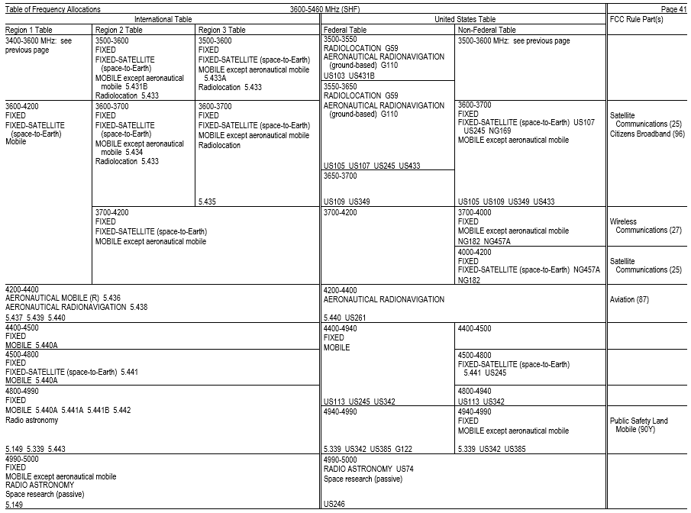

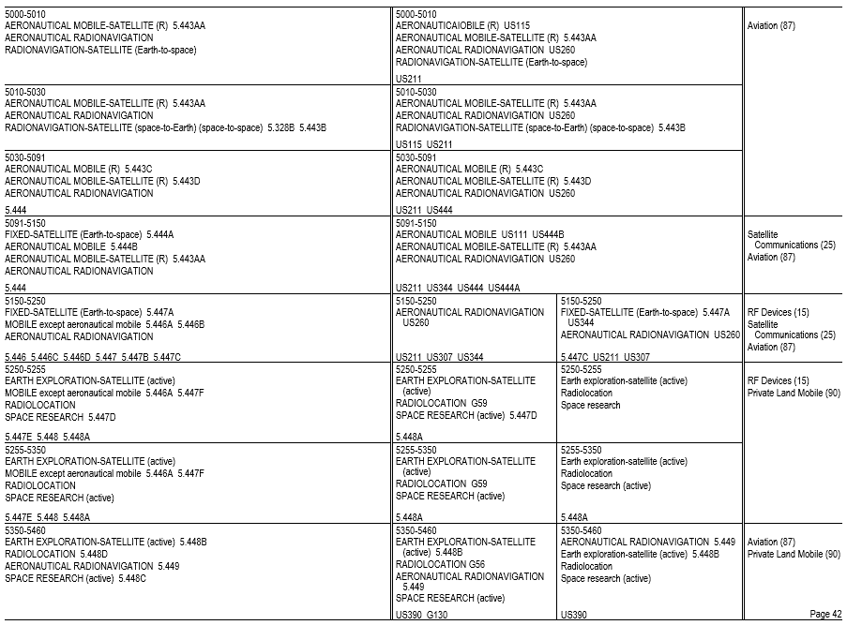

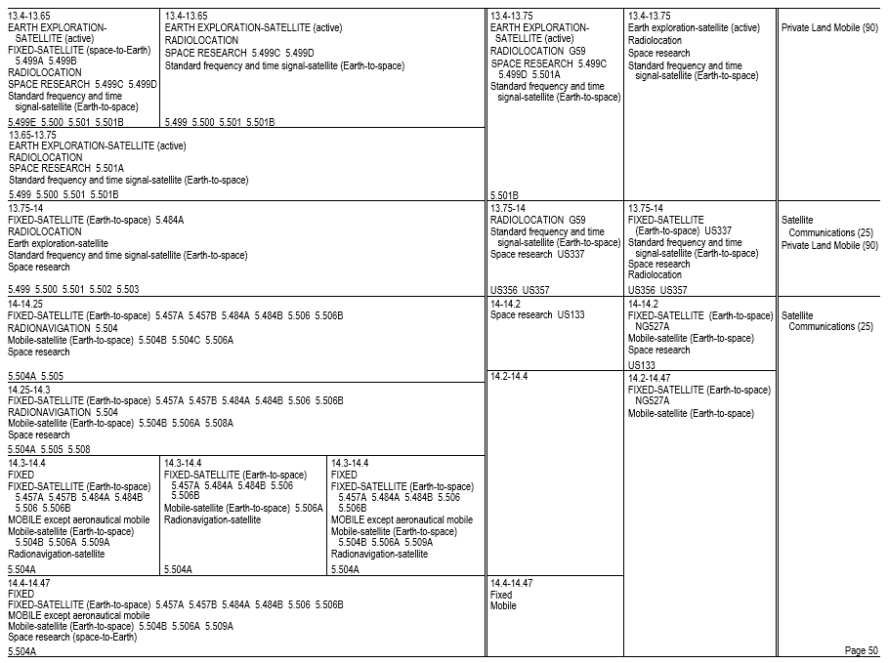
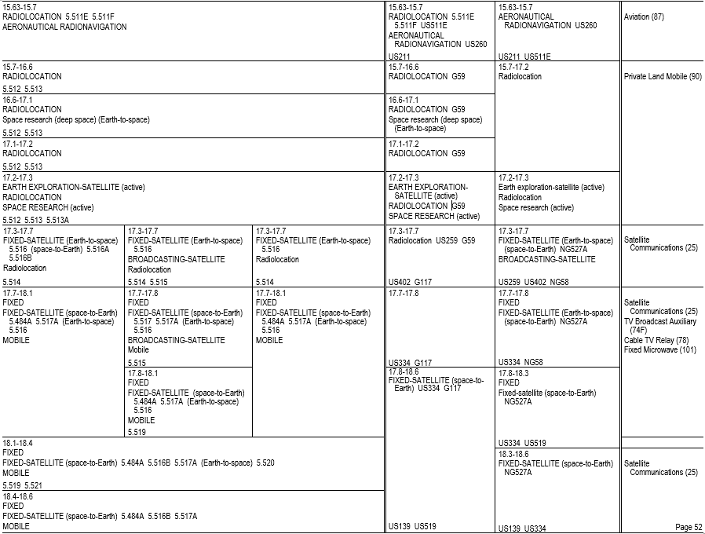

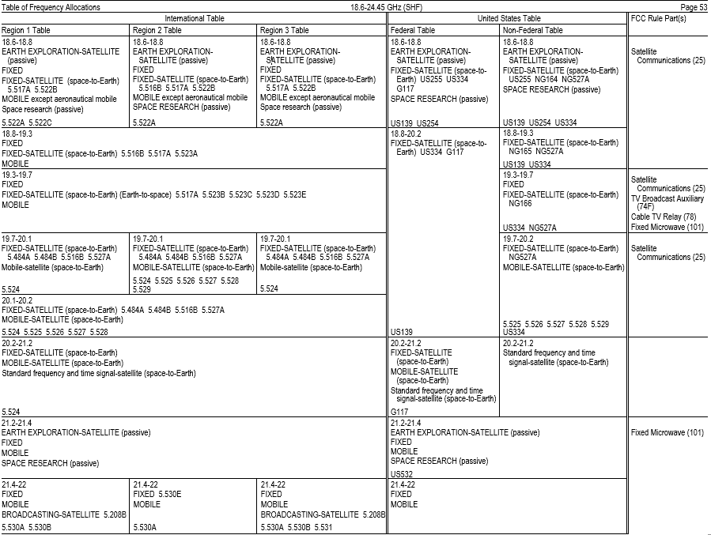

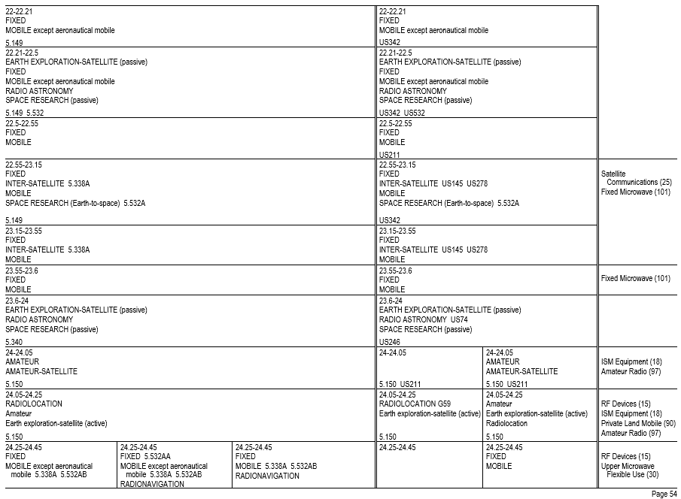
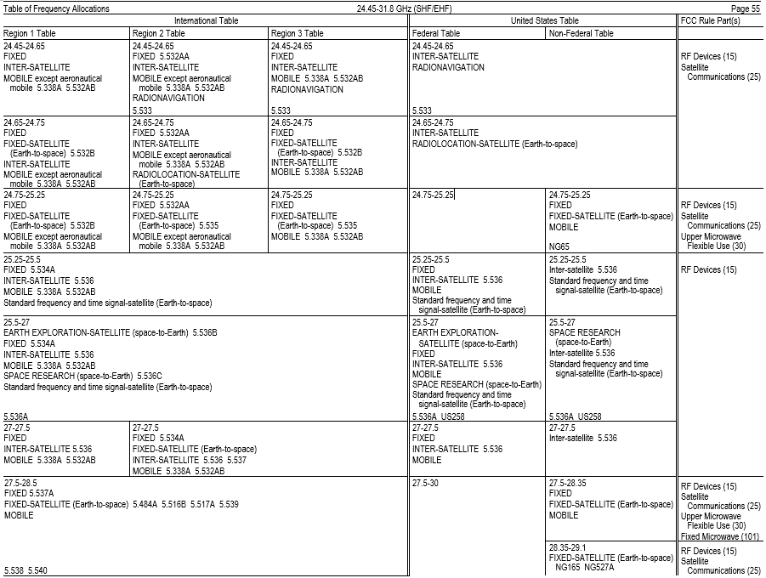

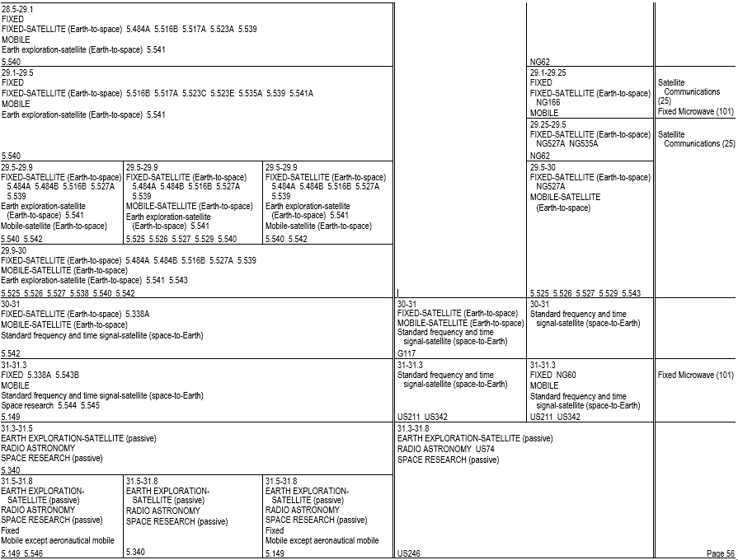

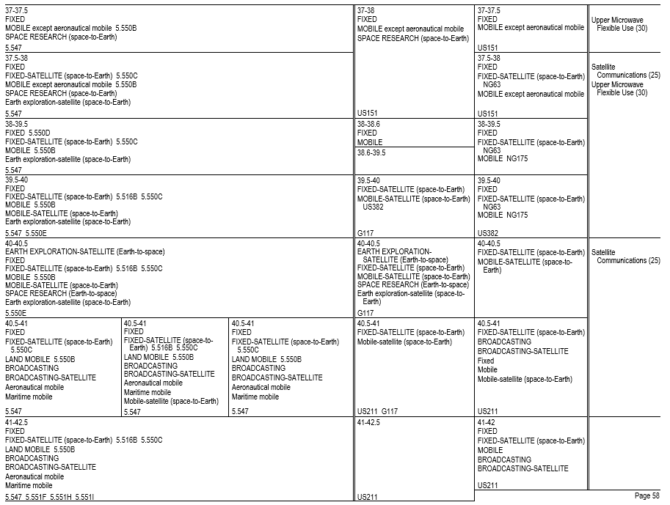

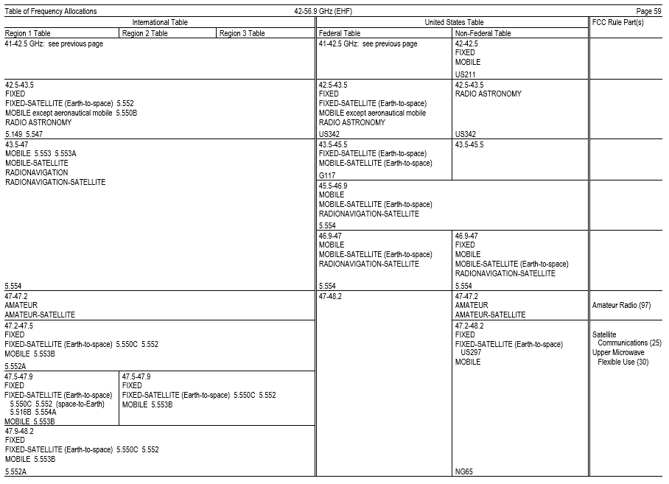

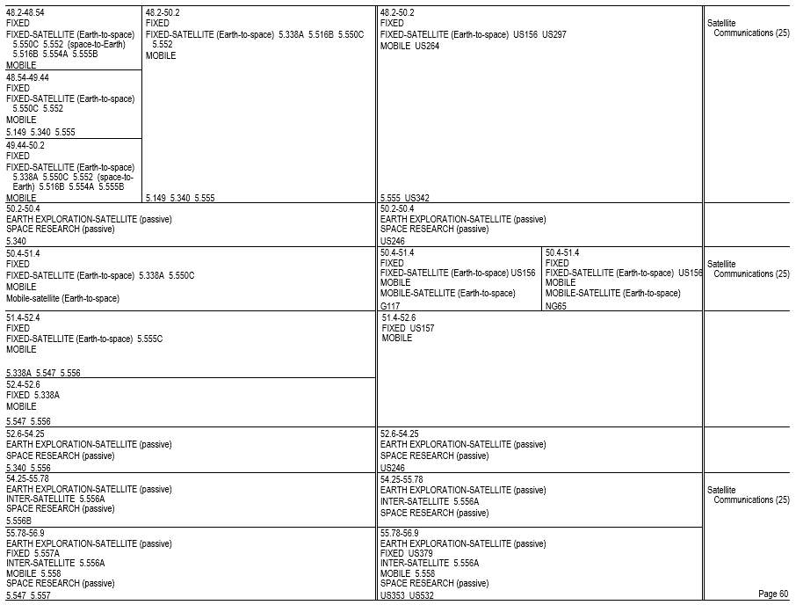

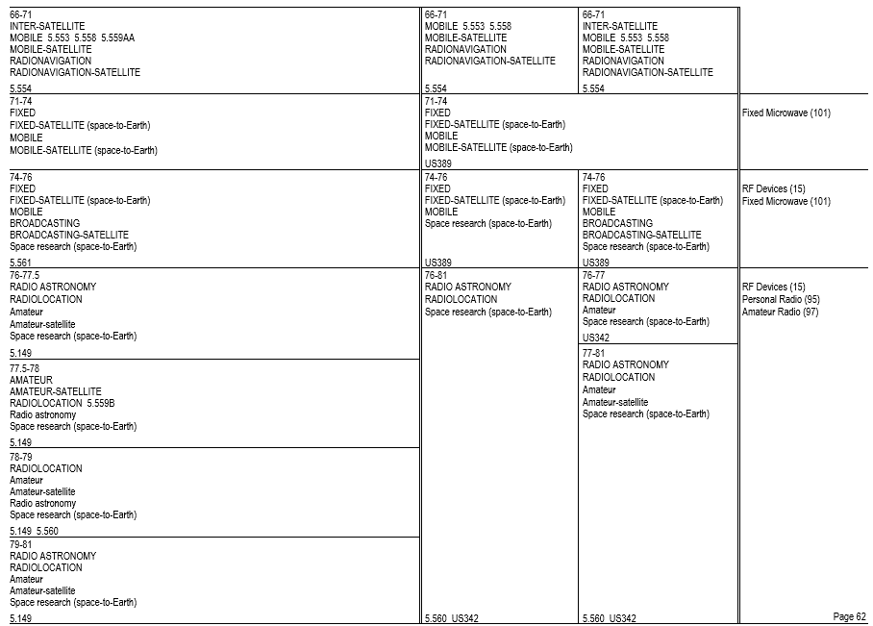

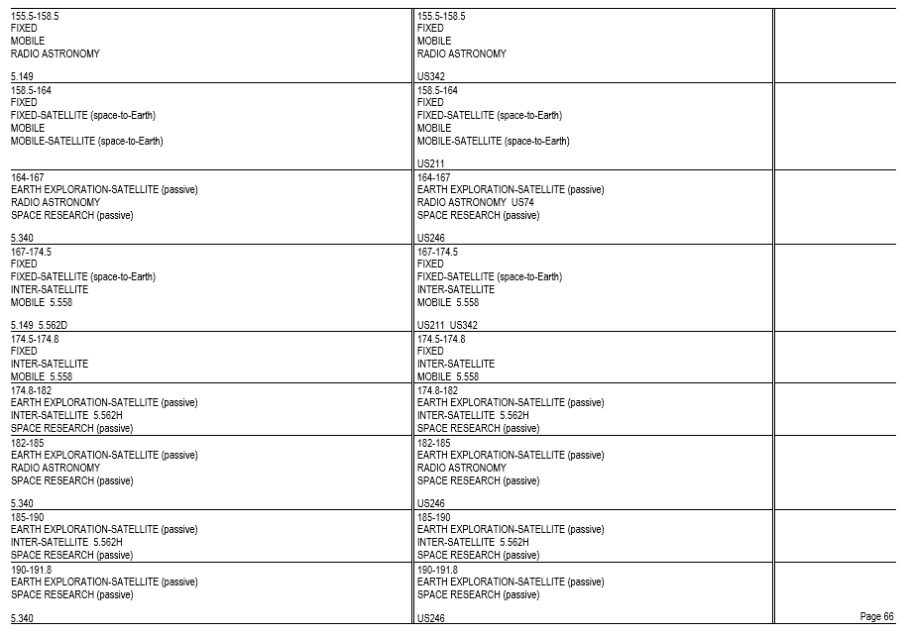
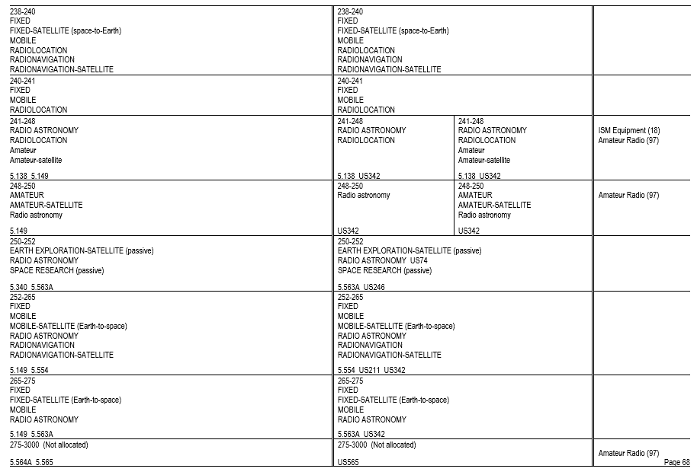
* * * * *
(b) * * *
(67) 5.67 Additional allocation: in Kyrgyzstan and Turkmenistan, the frequency band 130-148.5 kHz is also allocated to the radionavigation service on a secondary basis. Within and between these countries this service shall have an equal right to operate.
* * * * *
(ii) 5.67B The use of the frequency band 135.7-137.8 kHz in Algeria, Egypt, Iraq, Lebanon, Syrian Arab Republic, Sudan, South Sudan and Tunisia is limited to the fixed and maritime mobile services. The amateur service shall not be used in the previously-mentioned countries in the frequency band 135.7-137.8 kHz, and this should be taken into account by the countries authorizing such use.
* * * * *
(70) 5.70 Alternative allocation: in Angola, Botswana, Burundi, the Central African Rep., Congo (Rep. of the), Eswatini, Ethiopia, Kenya, Lesotho, Madagascar, Malawi, Mozambique, Namibia, Nigeria, Oman, the Dem. Rep. of the Congo, South Africa, Tanzania, Chad, Zambia and Zimbabwe, the frequency band 200-283.5 kHz is allocated to the aeronautical radionavigation service on a primary basis.
* * * * *
(77) 5.77 Different category of service: in Australia, China, the French overseas communities of Region 3, Korea (Rep. of), India, Iran (Islamic Republic of), Japan, Pakistan, Papua New Guinea, the Dem. People’s Rep. of Korea and Sri Lanka, the allocation of the frequency band 415-495 kHz to the aeronautical radionavigation service is on a primary basis. In Armenia, Azerbaijan, Belarus, the Russian Federation, Kazakhstan, Latvia, Uzbekistan and Kyrgyzstan, the allocation of the frequency band 435-495 kHz to the aeronautical radionavigation service is on a primary basis. Administrations in all the aforementioned countries shall take all practical steps necessary to ensure that aeronautical radionavigation stations in the frequency band 435-495 kHz do not cause interference to reception by coast stations of transmissions from ship stations on frequencies designated for ship stations on a worldwide basis.
* * * * *
(79) 5.79 In the maritime mobile service, the frequency bands 415-495 kHz and 505-526.5 kHz are limited to radiotelegraphy and may also be used for the NAVDAT system in accordance with the most recent version of Recommendation ITU-R M.2010, subject to agreement between interested and affected administrations. NAVDAT transmitting stations are limited to coast stations.
* * * * *
(82) * * *
(i) 5.82C The frequency band 495-505 kHz is used for the international NAVDAT system as described in the most recent version of Recommendation ITU-R M.2010. NAVDAT transmitting stations are limited to coast stations.
(ii) [Reserved]
* * * * *
(87) 5.87 Additional allocation: in Angola, Botswana, Eswatini, Lesotho, Malawi, Mozambique, Namibia and Niger, the frequency band 526.5-535 kHz is also allocated to the mobile service on a secondary basis.
* * * * *
(107) 5.107 Additional allocation: in Saudi Arabia, Eritrea, Eswatini, Ethiopia, Iraq, Libya and Somalia, the frequency band 2160-2170 kHz is also allocated to the fixed and mobile, except aeronautical mobile (R), services on a primary basis. The mean power of stations in these services shall not exceed 50 W.
* * * * *
(109) 5.109 The frequencies 2187.5 kHz, 4207.5 kHz, 6312 kHz, 8414.5 kHz, 12 577 kHz and 16 804.5 kHz are international distress frequencies for digital selective calling. The conditions for the use of these frequencies are prescribed in Article 31.
(110) 5.110 The frequencies 2174.5 kHz, 4177.5 kHz, 6268 kHz, 8376.5 kHz, 12 520 kHz and 16 695 kHz are international distress frequencies for narrow-band direct-printing telegraphy. The conditions for the use of these frequencies are prescribed in Article 31.
(111) 5.111 The carrier frequencies 2182 kHz, 3023 kHz, 5680 kHz, 8364 kHz and the frequencies 121.5 MHz, 156.525 MHz, 156.8 MHz and 243 MHz may also be used, in accordance with the procedures in force for terrestrial radiocommunication services, for search and rescue operations concerning manned space vehicles. The conditions for the use of the frequencies are prescribed in Article 31. The same applies to the frequencies 10 003 kHz, 14 993 kHz and 19 993 kHz, but in each of these cases emissions must be confined in a band of ± 3 kHz about the frequency.
(112) 5.112 Alternative allocation: in Sri Lanka, the frequency band 2194-2300 kHz is allocated to the fixed and mobile, except aeronautical mobile, services on a primary basis.
* * * * *
(114) 5.114 Alternative allocation: in Iraq, the frequency band 2502-2625 kHz is allocated to the fixed and mobile, except aeronautical mobile, services on a primary basis.
* * * * *
(117) 5.117 Alternative allocation: in Côte d'Ivoire, Egypt, Liberia, Sri Lanka and Togo, the frequency band 3155-3200 kHz is allocated to the fixed and mobile, except aeronautical mobile, services on a primary basis.
(118) 5.118 Additional allocation: in the United States, Mexico and Peru, the frequency band 3230-3400 kHz is also allocated to the radiolocation service on a secondary basis.
* * * * *
(123) 5.123 Additional allocation: in Botswana, Eswatini, Lesotho, Malawi, Mozambique, Namibia, South Africa, Zambia and Zimbabwe, the frequency band 3900-3950 kHz is also allocated to the broadcasting service on a primary basis, subject to agreement obtained under No. 9.21.
* * * * *
(128) 5.128 Frequencies in the frequency bands 4063-4123 kHz and 4130-4438 kHz may be used exceptionally by stations in the fixed service, communicating only within the boundary of the country in which they are located, with a mean power not exceeding 50 W, on condition that harmful interference is not caused to the maritime mobile service. In addition, in Afghanistan, Argentina, Armenia, Belarus, Botswana, Burkina Faso, the Central African Rep., China, the Russian Federation, Georgia, India, Kazakhstan, Mali, Niger, Pakistan, Kyrgyzstan, Tajikistan, Chad, Turkmenistan and Ukraine, in the frequency bands 4063-4123 kHz, 4130-4133 kHz and 4408-4438 kHz, stations in the fixed service, with a mean power not exceeding 1 kW, can be operated on condition that they are situated at least 600 km from the coast and that harmful interference is not caused to the maritime mobile service.
* * * * *
(132) 5.132 The frequencies 4210 kHz, 6314 kHz, 8416.5 kHz, 12579 kHz, 16 806.5 kHz, 19 680.5 kHz, 22 376 kHz and 26 100.5 kHz are the international frequencies for the transmission of maritime safety information (MSI) (see Appendix 17).
* * * * *
(ii) 5.132B Alternative allocation: in Armenia, Belarus, Moldova and Kyrgyzstan, the frequency band 4438-4488 kHz is allocated to the fixed and mobile, except aeronautical mobile (R), services on a primary basis.
(133) * * *
(i) 5.133A Alternative allocation: in Armenia, Belarus, Moldova and Kyrgyzstan, the frequency bands 5250-5275 kHz and 26 200-26 350 kHz are allocated to the fixed and mobile, except aeronautical mobile, services on a primary basis.
(ii) 5.133B Stations in the amateur service using the frequency band 5351.5-5366.5 kHz shall not exceed a maximum radiated power of 15 W (e.i.r.p.). However, in Region 2 in Mexico, stations in the amateur service using the frequency band 5351.5-5366.5 kHz shall not exceed a maximum radiated power of 20 W (e.i.r.p.). In the following Region 2 countries: Antigua and Barbuda, Argentina, Bahamas, Barbados, Belize, Bolivia, Brazil, Chile, Colombia, Costa Rica, Cuba, Dominican Republic, Dominica, El Salvador, Ecuador, Grenada, Guatemala, Guyana, Haiti, Honduras, Jamaica, Nicaragua, Panama, Paraguay, Peru, Saint Lucia, Saint Kitts and Nevis, Saint Vincent and the Grenadines, Suriname, Trinidad and Tobago, Uruguay, Venezuela, as well as the overseas countries and territories within the Kingdom of the Netherlands in Region 2, stations in the amateur service using the frequency band 5351.5-5366.5 kHz shall not exceed a maximum radiated power of 25 W (e.i.r.p.).
(134) 5.134 The use of the frequency bands 5900-5950 kHz, 7300-7350 kHz, 9400-9500 kHz, 11 600-11 650 kHz, 12 050-12 100 kHz, 13 570-13 600 kHz, 13 800-13 870 kHz, 15 600-15 800 kHz, 17 480-17 550 kHz and 18 900-19 020 kHz by the broadcasting service is subject to the application of the procedure of Article 12. Administrations are encouraged to use these frequency bands to facilitate the introduction of digitally modulated emissions in accordance with the provisions of Resolution 517 (Rev.WRC-19).
* * * * *
(141) * * *
(ii) 5.141B Additional allocation: in Algeria, Saudi Arabia, Australia, Bahrain, Botswana, Brunei Darussalam, China, Comoros, Korea (Rep. of), Diego Garcia, Djibouti, Egypt, United Arab Emirates, Eritrea, Guinea, Indonesia, Iran (Islamic Republic of), Japan, Jordan, Kuwait, Libya, Mali, Morocco, Mauritania, Niger, New Zealand, Oman, Papua New Guinea, Qatar, the Syrian Arab Republic, the Dem. People’s Rep. of Korea, Singapore, Sudan, South Sudan, Tunisia, Viet Nam and Yemen, the frequency band 7100-7200 kHz is also allocated to the fixed and the mobile, except aeronautical mobile (R), services on a primary basis.
* * * * *
(145) 5.145 The conditions for the use of the carrier frequencies 8291 kHz, 12 290 kHz and 16 420 kHz are prescribed in Articles 31 and 52.
* * * * *
(ii) 5.145B Alternative allocation: in Armenia, Belarus, Moldova and Kyrgyzstan, the frequency bands 9305-9355 kHz and 16 100-16 200 kHz are allocated to the fixed service on a primary basis.
(146) 5.146 Additional allocation: frequencies in the bands 9400-9500 kHz, 11 600-11 650 kHz, 12 050-12 100 kHz, 15 600-15 800 kHz, 17 480-17 550 kHz and 18 900-19 020 kHz may be used by stations in the fixed service, communicating only within the boundary of the country in which they are located, on condition that harmful interference is not caused to the broadcasting service. When using frequencies in the fixed service, administrations are urged to use the minimum power required and to take account of the seasonal use of frequencies by the broadcasting service published in accordance with the Radio Regulations.
(147) 5.147 On condition that harmful interference is not caused to the broadcasting service, frequencies in the bands 9775-9900 kHz, 11 650-11 700 kHz and 11 975-12 050 kHz may be used by stations in the fixed service communicating only within the boundary of the country in which they are located, each station using a total radiated power not exceeding 24 dBW.
* * * * *
(149) 5.149 In making assignments to stations of other services to which the bands listed in table 1 to paragraph (b)(149) of this section are allocated, administrations are urged to take all practicable steps to protect the radio astronomy service from harmful interference. Emissions from spaceborne or airborne stations can be particularly serious sources of interference to the radio astronomy service (see Nos. 4.5 and 4.6 and Article 29).
Table 1 to Paragraph (b)(149) Introductory Text
13 360-13 410 kHz,  25 550-25 670 kHz,  37.5-38.25 MHz,  73-74.6 MHz in Regions 1 and 3,  150.05-153 MHz in Region 1,  322-328.6 MHz,  406.1-410 MHz,  608-614 MHz in Regions 1 and 3,  1330-1400 MHz,  1610.6-1613.8 MHz,  1660-1670 MHz,  1718.8-1722.2 MHz,  2655-2690 MHz,  3260-3267 MHz,  3332-3339 MHz,  3345.8-3352.5 MHz,  4825-4835 MHz,  4950-4990 MHz,  4990-5000 MHz,  6650-6675.2 MHz,  10.6-10.68 GHz,  14.47-14.5 GHz,  22.01-22.21 GHz,  22.21-22.5 GHz,  22.81-22.86 GHz, | 23.07-23.12 GHz,  31.2-31.3 GHz,  31.5-31.8 GHz in Regions 1 and 3,  36.43-36.5 GHz,  42.5-43.5 GHz,  48.94-49.04 GHz,  76-86 GHz,  92-94 GHz,  94.1-100 GHz,  102-109.5 GHz,  111.8-114.25 GHz,  128.33-128.59 GHz,  129.23-129.49 GHz,  130-134 GHz,  136-148.5 GHz,  151.5-158.5 GHz,  168.59-168.93 GHz,  171.11-171.45 GHz,  172.31-172.65 GHz,  173.52-173.85 GHz,  195.75-196.15 GHz,  209-226 GHz,  241-250 GHz,  252-275 GHz
(i) 5.149A Alternative allocation: in Armenia, Belarus, Moldova and Kyrgyzstan, the frequency band 13 450-13 550 kHz is allocated to the fixed service on a primary basis and to the mobile, except aeronautical mobile (R), service on a secondary basis.
(ii) [Reserved]
(150) 5.150 The following bands: 13 553-13 567 kHz (centre frequency 13 560 kHz), 26 957-27 283 kHz (centre frequency 27 120 kHz), 40.66-40.70 MHz (centre frequency 40.68 MHz), 902-928 MHz in Region 2 (centre frequency 915 MHz), 2400-2500 MHz (centre frequency 2450 MHz), 5725-5875 MHz (centre frequency 5800 MHz), and 24-24.25 GHz (centre frequency 24.125 GHz) are also designated for industrial, scientific and medical (ISM) applications. Radiocommunication services operating within these bands must accept harmful interference which may be caused by these applications. ISM equipment operating in these bands is subject to the provisions of No. 15.13.
(151) 5.151 Additional allocation: frequencies in the bands 13 570-13 600 kHz and 13 800-13 870 kHz may be used by stations in the fixed service and in the mobile except aeronautical mobile (R) service, communicating only within the boundary of the country in which they are located, on the condition that harmful interference is not caused to the broadcasting service. When using frequencies in these services, administrations are urged to use the minimum power required and to take account of the seasonal use of frequencies by the broadcasting service published in accordance with the Radio Regulations.
(152) 5.152 Additional allocation: in Armenia, Azerbaijan, China, Côte d’Ivoire, the Russian Federation, Georgia, Iran (Islamic Republic of), Kazakhstan, Uzbekistan, Kyrgyzstan, Tajikistan, Turkmenistan and Ukraine, the band 14 250-14 350 kHz is also allocated to the fixed service on a primary basis. Stations of the fixed service shall not use a radiated power exceeding 24 dBW.
(153) 5.153 In Region 3, the stations of those services to which the band 15 995-16 005 kHz is allocated may transmit standard frequency and time signals.
(154) 5.154 Additional allocation: in Armenia, Azerbaijan, the Russian Federation, Georgia, Kazakhstan, Kyrgyzstan, Tajikistan, Turkmenistan and Ukraine, the band 18 068-18 168 kHz is also allocated to the fixed service on a primary basis for use within their boundaries, with a peak envelope power not exceeding 1 kW.
(155) 5.155 Additional allocation: in Armenia, Azerbaijan, Belarus, the Russian Federation, Georgia, Kazakhstan, Moldova, Mongolia, Uzbekistan, Kyrgyzstan, Slovakia, Tajikistan, Turkmenistan and Ikraine, the band 21 850-21 870 kHz is also allocated to the aeronautical mobile (R) service on a primary basis.
(i) 5.155A In Armenia, Azerbaijan, Belarus, the Russian Federation, Georgia, Kazakhstan, Moldova, Mongolia, Uzbekistan, Kyrgyzstan, Slovakia, Tajikistan, Turkmenistan and Ukraine, the use of the band 21 850-21 870 kHz by the fixed service is limited to provision of services related to aircraft flight safety.
(ii) 5.155B The band 21 870-21 924 kHz is used by the fixed service for provision of services related to aircraft flight safety.
(156) 5.156 Additional allocation: in Nigeria, the band 22 720-23 200 kHz is also allocated to the meteorological aids service (radiosondes) on a primary basis.
(i) 5.156A The use of the band 23 200-23 350 kHz by the fixed service is limited to provision of services related to aircraft flight safety.
* * * * *
(157) 5.157 The use of the band 23 350-24 000 kHz by the maritime mobile service is limited to inter-ship radiotelegraphy.
(158) 5.158 Alternative allocation: in Armenia, Belarus, Moldova and Kyrgyzstan, the frequency band 24 450-24 600 kHz is allocated to the fixed and land mobile services on a primary basis.
(159) 5.159 Alternative allocation: in Armenia, Belarus, Moldova and Kyrgyzstan, the frequency band 39-39.5 MHz is allocated to the fixed and mobile services on a primary basis.
* * * * *
(161) * * *
(i) 5.161A Additional allocation: in Korea (Rep. of), the United States and Mexico, the frequency bands 41.015-41.665 MHz and 43.35-44 MHz are also allocated to the radiolocation service on a primary basis. Stations in the radiolocation service shall not cause harmful interference to, or claim protection from, stations operating in the fixed or mobile services. Applications of the radiolocation service are limited to oceanographic radars operating in accordance with Resolution 612 (Rev.WRC-12).
(ii) 5.161B Alternative allocation: in Albania, Germany, Armenia, Austria, Belarus, Belgium, Bosnia and Herzegovina, Cyprus, Vatican, Croatia, Denmark, Spain, Estonia, Finland, France, Greece, Hungary, Ireland, Iceland, Italy, Latvia, Liechtenstein, Lithuania, Luxembourg, North Macedonia, Malta, Moldova, Monaco, Montenegro, Norway, Uzbekistan, Netherlands, Portugal, Kyrgyzstan, Slovakia, Czech Rep., Romania, United Kingdom, San Marino, Slovenia, Sweden, Switzerland, Turkey and Ukraine, the frequency band 42-42.5 MHz is allocated to the fixed and mobile services on a primary basis.
(162) * * *
(i) 5.162A Additional allocation: in Germany, Austria, Belgium, Bosnia and Herzegovina, China, Vatican, Denmark, Spain, Estonia, the Russian Federation, Finland, France, Ireland, Iceland, Italy, Latvia, Liechtenstein, Lithuania, Luxembourg, North Macedonia, Monaco, Montenegro, Norway, the Netherlands, Poland, Portugal, the Czech Rep., the United Kingdom, Serbia, Slovenia, Sweden and Switzerland the frequency band 46-68 MHz is also allocated to the radiolocation service on a secondary basis. This use is limited to the operation of wind profiler radars in accordance with Resolution 217 (WRC-97).
* * * * *
(163) 5.163 Additional allocation: in Armenia, Belarus, the Russian Federation, Georgia, Kazakhstan, Latvia, Moldova, Uzbekistan, Kyrgyzstan, Tajikistan, Turkmenistan and Ukraine, the frequency bands 47-48.5 MHz and 56.5-58 MHz are also allocated to the fixed and land mobile services on a secondary basis.
(164) 5.164 Additional allocation: in Albania, ’lgeria, Germany, Austria, Belgium, Bosnia and Herzegovina, Botswana, Bulgaria, Côte d'Ivoire, Croatia, Denmark, Spain, Estonia, Eswatini, Finland, France, Gabon, Greece, Hungary, Ireland, Israel, Italy, Jordan, Lebanon, Libya, Liechtenstein, Lithuania, Luxembourg, Madagascar, Mali, Malta, Morocco, Mauritania, Monaco, Montenegro, Nigeria, Norway, the Netherlands, Poland, Syrian Arab Republic, Slovakia, Czech Rep., Romania, the United Kingdom, Serbia, Slovenia, Sweden, Switzerland, Chad, Togo, Tunisia and Turkey, the frequency band 47-68 MHz, in South Africa the frequency band 47-50 MHz, and in Latvia the frequency bands 48.5-56.5 MHz and 58-68 MHz, are also allocated to the land mobile service on a primary basis. However, stations of the land mobile service in the countries mentioned in connection with each frequency band referred to in this footnote shall not cause harmful interference to, or claim protection from, existing or planned broadcasting stations of countries other than those mentioned in connection with the frequency band.
(165) 5.165 Additional allocation: in Angola, Cameroon, Congo (Rep. of the), Egypt, Madagascar, Mozambique, Niger, Somalia, Sudan, South Sudan, Tanzania and Chad, the frequency band 47-68 MHz is also allocated to the fixed and mobile, except aeronautical mobile, services on a primary basis.
(166)(i) 5.166A Different category of service: in Austria, Cyprus, the Vatican, Croatia, Denmark, Spain, Finland, Hungary, Latvia, the Netherlands, the Czech Republic, the United Kingdom, Slovakia and Slovenia, the frequency band 50.0-50.5 MHz is allocated to the amateur service on a primary basis. Stations in the amateur service in these countries shall not cause harmful interference to, or claim protection from, stations of the broadcasting, fixed and mobile services operating in accordance with the Radio Regulations in the frequency band 50.0-50.5 MHz in the countries not listed in this provision. For a station of these services, the protection criteria in paragraph (b)(169)(ii) of this section shall also apply. In Region 1, with the exception of those countries listed in paragraph (b)(169) of this section, wind profiler radars operating in the radiolocation service under paragraph (b)(162)(i) of this section are authorized to operate on the basis of equality with stations in the amateur service in the frequency band 50.0-50.5 MHz.
(ii) 5.166B In Region 1, stations in the amateur service operating on a secondary basis shall not cause harmful interference to, or claim protection from, stations of the broadcasting service. The field strength generated by an amateur station in Region 1 in the frequency band 50-52 MHz shall not exceed a calculated value of +6 dB(μV/m) at a height of 10 m above ground for more than 10% of time along the border of a country with operational analogue broadcasting stations in Region 1 and of neighbouring countries with broadcasting stations in Region 3 listed in paragraphs (b)(167) and (b)(168) of this section.
(iii) 5.166C In Region 1, stations in the amateur service in the frequency band 50-52 MHz, with the exception of those countries listed in paragraph (b)(169) of this section, shall not cause harmful interference to, or claim protection from, wind profiler radars operating in the radiolocation service under paragraph (b)(162)(i) of this section.
(iv) 5.166D Different category of service: in Lebanon, the frequency band 50-52 MHz is allocated to the amateur service on a primary basis. Stations in the amateur service in Lebanon shall not cause harmful interference to, or claim protection from, stations of the broadcasting, fixed and mobile services operating in accordance with the Radio Regulations in the frequency band 50-52 MHz in the countries not listed in this provision.
(v) 5.166E In the Russian Federation, only the frequency band 50.080-50.280 MHz is allocated to the amateur service on a secondary basis. The protection criteria for the other services in the countries not listed in this provision are specified in paragraphs (b)(166)(ii) and (b)(169)(ii) of this section.
* * * * *
(169) 5.169 Alternative allocation: in Botswana, Eswatini, Lesotho, Malawi, Namibia, Rwanda, South Africa, Zambia and Zimbabwe, the frequency band 50-54 MHz is allocated to the amateur service on a primary basis. In Senegal, the frequency band 50-51 MHz is allocated to the amateur service on a primary basis.
(i) 5.169A Alternative allocation: in the following countries in Region 1: Angola, Saudi Arabia, Bahrain, Burkina Faso, Burundi, the United Arab Emirates, Gambia, Jordan, Kenya, Kuwait, Mauritius, Mozambique, Oman, Uganda, Qatar, South Sudan and Tanzania, the frequency band 50-54 MHz is allocated to the amateur service on a primary basis. In Guinea-Bissau, the frequency band 50.0-50.5 MHz is allocated to the amateur service on a primary basis. In Djibouti, the frequency band 50-52 MHz is allocated to the amateur service on a primary basis. With the exception of those countries listed in this paragraph (b)(169), stations in the amateur service operating in Region 1 under this footnote, in all or part of the frequency band 50-54 MHz, shall not cause harmful interference to, or claim protection from, stations of other services operating in accordance with the Radio Regulations in Algeria, Egypt, Iran (Islamic Republic of), Iraq, Israel, Libya, Palestine, the Syrian Arab Republic, the Dem. People’s Republic of Korea, Sudan and Tunisia. The field strength generated by an amateur station in the frequency band 50-54 MHz shall not exceed a value of +6 dB(μV/m) at a height of 10 m above ground for more than 10% of time along the borders of listed countries requiring protection.
Note 1 to § 2.106(b)(169)(i): Pursuant to Resolution 99 (Rev. Dubai, 2018) and taking into account the Israeli-Palestinian Interim Agreement of 28 September 1995.
(ii) 5.169B Except countries listed under this paragraph (b)(169), stations in the amateur service used in Region 1, in all or part of the 50-54 MHz frequency band, shall not cause harmful interference to, or claim protection from, stations of other services used in accordance with the Radio Regulations in Algeria, Armenia, Azerbaijan, Belarus, Egypt, Russian Federation, Iran (Islamic Republic of), Iraq, Kazakhstan, Kyrgyzstan, Libya, Uzbekistan, Palestine, the Syrian Arab Republic, Sudan, Tunisia and Ukraine. The field strength generated by an amateur station in the frequency band 50-54 MHz shall not exceed a value of +6 dB(μV/m) at a height of 10 m above ground for more than 10% of time along the borders of the countries listed in this provision.
Note 2 to § 2.106(b)(169)(ii): Pursuant to Resolution 99 (Rev. Dubai, 2018) and taking into account the Israeli-Palestinian Interim Agreement of 28 September 1995.
* * * * *
(171) 5.171 Additional allocation: in Botswana, Eswatini, Lesotho, Malawi, Mali, Namibia, Dem. Rep. of the Congo, Rwanda, South Africa, Zambia and Zimbabwe, the frequency band 54-68 MHz is also allocated to the fixed and mobile, except aeronautical mobile, services on a primary basis.
* * * * *
(194) 5.194 Additional allocation: in Kyrgyzstan, Somalia and Turkmenistan, the frequency band 104-108 MHz is also allocated to the mobile, except aeronautical mobile (R), service on a secondary basis.
* * * * *
(201) 5.201 Additional allocation: in Armenia, Azerbaijan, Belarus, Bulgaria, Estonia, the Russian Federation, Georgia, Hungary, Iran (Islamic Republic of), Iraq (Republic of), Japan, Kazakhstan, Mali, Mongolia, Mozambique, Uzbekistan, Papua New Guinea, Poland, Kyrgyzstan, Romania, Senegal, Tajikistan, Turkmenistan and Ukraine, the frequency band 132-136 MHz is also allocated to the aeronautical mobile (OR) service on a primary basis. In assigning frequencies to stations of the aeronautical mobile (OR) service, the administration shall take account of the frequencies assigned to stations in the aeronautical mobile (R) service.
(202) 5.202 Additional allocation: in Saudi Arabia, Armenia, Azerbaijan, Bahrain, Belarus, Bulgaria, the United Arab Emirates, the Russian Federation, Georgia, Iran (Islamic Republic of), Jordan, Mali, Oman, Uzbekistan, Poland, the Syrian Arab Republic, Kyrgyzstan, Romania, Senegal, Tajikistan, Turkmenistan and Ukraine, the frequency band 136-137 MHz is also allocated to the aeronautical mobile (OR) service on a primary basis. In assigning frequencies to stations of the aeronautical mobile (OR) service, the administration shall take account of the frequencies assigned to stations in the aeronautical mobile (R) service.
(203) 5.203C The use of the space operation service (space-to-Earth) with non-geostationary satellite short-duration mission systems in the frequency band 137-138 MHz is subject to Resolution 660 (WRC-19). Resolution 32 (WRC-19) applies. These systems shall not cause harmful interference to, or claim protection from, the existing services to which the frequency band is allocated on a primary basis.
(204) 5.204 Different category of service: in Afghanistan, Saudi Arabia, Bahrain, Bangladesh, Brunei Darussalam, China, Cuba, the United Arab Emirates, India, Indonesia, Iran (Islamic Republic of), Iraq, Kuwait, Montenegro, Oman, Pakistan, the Philippines, Qatar, Singapore, Thailand and Yemen, the frequency band 137-138 MHz is allocated to the fixed and mobile, except aeronautical mobile (R), services on a primary basis (see No. 5.33).
* * * * *
(208) * * *
(i) 5.208A In making assignments to space stations in the mobile-satellite service in the frequency bands 137-138 MHz, 387-390 MHz and 400.15-401 MHz and in the maritime mobile-satellite service (space-to-Earth) in the frequency bands 157.1875-157.3375 MHz and 161.7875-161.9375 MHz, administrations shall take all practicable steps to protect the radio astronomy service in the frequency bands 150.05-153 MHz, 322-328.6 MHz, 406.1-410 MHz and 608-614 MHz from harmful interference from unwanted emissions as shown in the most recent version of Recommendation ITU-R RA.769.
(ii) 5.208B In the frequency bands 137-138 MHz, 157.1875-157.3375 MHz, 161.7875-161.9375 MHz, 387-390 MHz, 400.15-401 MHz, 1452-1492 MHz, 1525-1610 MHz, 1613.8-1626.5 MHz, 2655-2690 MHz, 21.4-22 GHz, Resolution 739 (Rev.WRC-19) applies.
(209) * * *
(i) 5.209A The use of the frequency band 137.175-137.825 MHz by non-geostationary-satellite systems in the space operation service identified as short-duration mission in accordance with Appendix 4 is not subject to No. 9.11A.
(ii) [Reserved]
* * * * *
(211) 5.211 Additional allocation: in Germany, Saudi Arabia, Austria, Bahrain, Belgium, Denmark, the United Arab Emirates, Spain, Finland, Greece, Guinea, Ireland, Israel, Kenya, Kuwait, Lebanon, Liechtenstein, Luxembourg, North Macedonia, Mali, Malta, Montenegro, Norway, the Netherlands, Qatar, Slovakia, the United Kingdom, Serbia, Slovenia, Somalia, Sweden, Switzerland, Tanzania, Tunisia and Turkey, the frequency band 138-144 MHz is also allocated to the maritime mobile and land mobile services on a primary basis.
(212) 5.212 Alternative allocation: in Angola, Botswana, Cameroon, the Central African Rep., Congo (Rep. of the), Eswatini, Gabon, Gambia, Ghana, Guinea, Iraq, Jordan, Lesotho, Liberia, Libya, Malawi, Mozambique, Namibia, Niger, Oman, Uganda, Syrian Arab Republic, the Dem. Rep. of the Congo, Rwanda, Sierra Leone, South Africa, Chad, Togo, Zambia and Zimbabwe, the frequency band 138-144 MHz is allocated to the fixed and mobile services on a primary basis.
* * * * *
(214) 5.214 Additional allocation: in Eritrea, Ethiopia, Kenya, North Macedonia, Montenegro, Serbia, Somalia, Sudan, South Sudan and Tanzania, the frequency band 138-144 MHz is also allocated to the fixed service on a primary basis.
* * * * *
(218) * * *
(i) 5.218A The frequency band 148-149.9 MHz in the space operation service (Earth-to-space) may be used by non-geostationary-satellite systems with short-duration missions. Non-geostationary-satellite systems in the space operation service used for a short-duration mission in accordance with Resolution 32 (WRC-19) of the Radio Regulations are not subject to agreement under No. 9.21. At the stage of coordination, the provisions of Nos. 9.17 and 9.18 also apply. In the frequency band 148-149.9 MHz, non-geostationary-satellite systems with short-duration missions shall not cause unacceptable interference to, or claim protection from, existing primary services within this frequency band, or impose additional constraints on the space operation and mobile-satellite services. In addition, earth stations in non-geostationary-satellite systems in the space operation service with short-duration missions in the frequency band 148-149.9 MHz shall ensure that the power flux-density does not exceed −149 dB(W/(m² · 4 kHz)) for more than 1% of time at the border of the territory of the following countries: Armenia, Azerbaijan, Belarus, China, Korea (Rep. of), Cuba, Russian Federation, India, Iran (Islamic Republic of), Japan, Kazakhstan, Malaysia, Uzbekistan, Kyrgyzstan, Thailand and Viet Nam. In case this power flux-density limit is exceeded, agreement under No. 9.21 is required to be obtained from countries mentioned in this footnote.
(ii) [Reserved]
(219) 5.219 The use of the frequency band 148-149.9 MHz by the mobile-satellite service is subject to coordination under No. 9.11A. The mobile-satellite service shall not constrain the development and use of the fixed, mobile and space operation services in the frequency band 148-149.9 MHz. The use of the frequency band 148-149.9 MHz by non-geostationary-satellite systems in the space operation service identified as short-duration mission is not subject to No. 9.11A.
* * * * *
(221) 5.221 Stations of the mobile-satellite service in the frequency band 148-149.9 MHz shall not cause harmful interference to, or claim protection from, stations of the fixed or mobile services operating in accordance with the Table of Frequency Allocations in the following countries: Albania, Algeria, Germany, Saudi Arabia, Australia, Austria, Bahrain, Bangladesh, Barbados, Belarus, Belgium, Benin, Bosnia and Herzegovina, Botswana, Brunei Darussalam, Bulgaria, Cameroon, China, Cyprus, Congo (Rep. of the), Korea (Rep. of), Côte d'Ivoire, Croatia, Cuba, Denmark, Djibouti, Egypt, the United Arab Emirates, Eritrea, Spain, Estonia, Eswatini, Ethiopia, the Russian Federation, Finland, France, Gabon, Georgia, Ghana, Greece, Guinea, Guinea Bissau, Hungary, India, Iran (Islamic Republic of), Ireland, Iceland, Israel, Italy, Jamaica, Japan, Jordan, Kazakhstan, Kenya, Kuwait, Lesotho, Latvia, Lebanon, Libya, Liechtenstein, Lithuania, Luxembourg, North Macedonia, Malaysia, Mali, Malta, Mauritania, Moldova, Mongolia, Montenegro, Mozambique, Namibia, Norway, New Zealand, Oman, Uganda, Uzbekistan, Pakistan, Panama, Papua New Guinea, Paraguay, the Netherlands, the Philippines, Poland, Portugal, Qatar, the Syrian Arab Republic, Kyrgyzstan, Dem. People’s Rep. of Korea, Slovakia, Romania, the United Kingdom, Senegal, Serbia, Sierra Leone, Singapore, Slovenia, Sudan, Sri Lanka, South Africa, Sweden, Switzerland, Tanzania, Chad, Togo, Tonga, Trinidad and Tobago, Tunisia, Turkey, Ukraine, Viet Nam, Yemen, Zambia and Zimbabwe.
* * * * *
(228) * * *
(i) 5.228AB The use of the frequency bands 157.1875-157.3375 MHz and 161.7875-161.9375 MHz by the maritime mobile-satellite service (Earth-to-space) is limited to non-geostationary-satellite systems operating in accordance with Appendix 18.
(ii) 5.228AC The use of the frequency bands 157.1875-157.3375 MHz and 161.7875-161.9375 MHz by the maritime mobile-satellite service (space-to-Earth) is limited to non-geostationary-satellite systems operating in accordance with Appendix 18. Such use is subject to agreement obtained under No. 9.21 with respect to the terrestrial services in Azerbaijan, Belarus, China, Korea (Rep. of), Cuba, the Russian Federation, the Syrian Arab Republic, the Dem. People’s Rep. of Korea, South Africa and Viet Nam.
* * * * *
(242) 5.242 Additional allocation: in Canada and Mexico, the frequency band 216-220 MHz is also allocated to the land mobile service on a primary basis.
* * * * *
(252) 5.252 Alternative allocation: in Botswana, Eswatini, Lesotho, Malawi, Mozambique, Namibia, South Africa, Zambia and Zimbabwe, the frequency bands 230-238 MHz and 246-254 MHz are allocated to the broadcasting service on a primary basis, subject to agreement obtained under No. 9.21.
* * * * *
(260)(i) 5.260A In the frequency band 399.9-400.05 MHz, the maximum e.i.r.p. of any emission of earth stations in the mobile-satellite service shall not exceed 5 dBW in any 4 kHz band and the maximum e.i.r.p. of each earth station in the mobile-satellite service shall not exceed 5 dBW in the whole 399.9-400.05 MHz frequency band. Until 22 November 2022, this limit shall not apply to satellite systems for which complete notification information has been received by the Radiocommunication Bureau by 22 November 2019 and that have been brought into use by that date. After 22 November 2022, these limits shall apply to all systems within the mobile-satellite service operating in this frequency band. In the frequency band 399.99-400.02 MHz, the e.i.r.p. limits as specified in this paragraph (b)(260)(i) shall apply after 22 November 2022 to all systems within the mobile-satellite service. Administrations are requested that their mobile-satellite service satellite links in the 399.99-400.02 MHz frequency band comply with the e.i.r.p. limits as specified in this paragraph (b)(260)(i), after 22 November 2019.
(ii) 5.260B In the frequency band 400.02-400.05 MHz, the provisions of paragraph (b)(169)(i) of this section are not applicable for telecommand uplinks within the mobile-satellite service.
(264) * * *
(i) 5.264A In the frequency band 401-403 MHz, the maximum e.i.r.p. of any emission of each earth station in the meteorological-satellite service and the Earth exploration-satellite service shall not exceed 22 dBW in any 4 kHz band for geostationary-satellite systems and non-geostationary-satellite systems with an orbit of apogee equal or greater than 35 786 km. The maximum e.i.r.p. of any emission of each earth station in the meteorological-satellite service and the Earth exploration-satellite service shall not exceed 7 dBW in any 4 kHz band for non-geostationary-satellite systems with an orbit of apogee lower than 35 786 km. The maximum e.i.r.p. of each earth station in the meteorological-satellite service and the Earth exploration-satellite service shall not exceed 22 dBW for geostationary-satellite systems and non-geostationary-satellite systems with an orbit of apogee equal or greater than 35 786 km in the whole 401-403 MHz frequency band. The maximum e.i.r.p. of each earth station in the meteorological-satellite service and the Earth exploration-satellite service shall not exceed 7 dBW for non-geostationary-satellite systems with an orbit of apogee lower than 35 786 km in the whole 401-403 MHz frequency band. Until 22 November 2029, these limits shall not apply to satellite systems for which complete notification information has been received by the Radiocommunication Bureau by 22 November 2019 and that have been brought into use by that date. After 22 November 2029, these limits shall apply to all systems within the meteorological-satellite service and the Earth exploration-satellite service operating in this frequency band.
(ii) 5.264B Non-geostationary-satellite systems in the meteorological-satellite service and the Earth exploration-satellite service for which complete notification information has been received by the Radiocommunication Bureau before 28 April 2007 are exempt from provisions of paragraph (b)(264)(i) of this section and may continue to operate in the frequency band 401.898-402.522 MHz on a primary basis without exceeding a maximum e.i.r.p. level of 12 dBW.
(265) 5.265 In the frequency band 403-410 MHz, Resolution 205 (Rev.WRC-19) applies.
* * * * *
(275) 5.275 Additional allocation: in Croatia, Estonia, Finland, Libya, North Macedonia, Montenegro and Serbia, the frequency bands 430-432 MHz and 438-440 MHz are also allocated to the fixed and mobile, except aeronautical mobile, services on a primary basis.
* * * * *
(277) 5.277 Additional allocation: in Angola, Armenia, Azerbaijan, Belarus, Cameroon, Congo (Rep. of the), Djibouti, the Russian Federation, Georgia, Hungary, Israel, Kazakhstan, Mali, Uzbekistan, Poland, the Dem. Rep. of the Congo, Kyrgyzstan, Slovakia, Romania, Rwanda, Tajikistan, Chad, Turkmenistan and Ukraine, the frequency band 430-440 MHz is also allocated to the fixed service on a primary basis.
(278) 5.278 Different category of service: in Argentina, Brazil, Colombia, Costa Rica, Cuba, Guyana, Honduras, Panama, Paraguay, Uruguay and Venezuela, the allocation of the frequency band 430-440 MHz to the amateur service is on a primary basis (see No. 5.33).
(279) 5.279 Additional allocation: in Mexico, the frequency bands 430-435 MHz and 438-440 MHz are also allocated on a primary basis to the mobile, except aeronautical mobile, service, and on a secondary basis to the fixed service, subject to agreement obtained under No. 9.21.
(i) 5.279A The use of the frequency band 432-438 MHz by sensors in the Earth exploration-satellite service (active) shall be in accordance with Recommendation ITU-R RS.1260-2. Additionally, the Earth exploration-satellite service (active) in the frequency band 432-438 MHz shall not cause harmful interference to the aeronautical radionavigation service in China. The provisions of this footnote in no way diminish the obligation of the Earth exploration-satellite service (active) to operate as a secondary service in accordance with Nos. 5.29 and 5.30.
* * * * *
(280) 5.280 In Germany, Austria, Bosnia and Herzegovina, Croatia, Liechtenstein, North Macedonia, Montenegro, Portugal, Serbia, Slovenia and Switzerland, the frequency band 433.05-434.79 MHz (centre frequency 433.92 MHz) is designated for industrial, scientific and medical (ISM) applications. Radiocommunication services of these countries operating within this frequency band must accept harmful interference which may be caused by these applications. ISM equipment operating in this frequency band is subject to the provisions of No. 15.13.
* * * * *
(286) * * *
(ii) 5.286AA The frequency band 450-470 MHz is identified for use by administrations wishing to implement International Mobile Telecommunications (IMT) – see Resolution 224 (Rev.WRC-19). This identification does not preclude the use of this frequency band by any application of the services to which it is allocated and does not establish priority in the Radio Regulations.
* * * * *
(287) 5.287 Use of the frequency bands 457.5125-457.5875 MHz and 467.5125-467.5875 MHz by the maritime mobile service is limited to on-board communication stations. The characteristics of the equipment and the channelling arrangement shall be in accordance with Recommendation ITU-R M.1174-4. The use of these frequency bands in territorial waters is subject to the national regulations of the administration concerned.
(288) 5.288 In the territorial waters of the United States and the Philippines, the preferred frequencies for use by on-board communication stations shall be 457.525 MHz, 457.550 MHz, 457.575 MHz and 457.600 MHz paired, respectively, with 467.750 MHz, 467.775 MHz, 467.800 MHz and 467.825 MHz. The characteristics of the equipment used shall conform to those specified in Recommendation ITU-R M.1174-4.
* * * * *
(295) 5.295 In the Bahamas, Barbados, Canada, the United States and Mexico, the frequency band 470-608 MHz, or portions thereof, is identified for International Mobile Telecommunications (IMT) – see Resolution 224 (Rev.WRC-19). This identification does not preclude the use of these frequency bands by any application of the services to which they are allocated and does not establish priority in the Radio Regulations. Mobile service stations of the IMT system within the frequency band are subject to agreement obtained under No. 9.21 and shall not cause harmful interference to, or claim protection from, the broadcasting service of neighbouring countries. Nos. 5.43 and 5.43A apply.
(296) 5.296 Additional allocation: in Albania, Germany, Angola, Saudi Arabia, Austria, Bahrain, Belgium, Benin, Bosnia and Herzegovina, Botswana, Bulgaria, Burkina Faso, Burundi, Cameroon, Vatican, Congo (Rep. of the), Côte d’Ivoire, Croatia, Denmark, Djibouti, Egypt, United Arab Emirates, Spain, Estonia, Eswatini, Finland, France, Gabon, Georgia, Ghana, Hungary, Iraq, Ireland, Iceland, Israel, Italy, Jordan, Kenya, Kuwait, Lesotho, Latvia, Lebanon, Libya, Liechtenstein, Lithuania, Luxembourg, North Macedonia, Malawi, Mali, Malta, Morocco, Mauritius, Mauritania, Moldova, Monaco, Mozambique, Namibia, Niger, Nigeria, Norway, Oman, Uganda, the Netherlands, Poland, Portugal, Qatar, the Syrian Arab Republic, Slovakia, the Czech Republic, Romania, the United Kingdom, Rwanda, San Marino, Serbia, Sudan, South Africa, Sweden, Switzerland, Tanzania, Chad, Togo, Tunisia, Turkey, Ukraine, Zambia and Zimbabwe, the frequency band 470-694 MHz is also allocated on a secondary basis to the land mobile service, intended for applications ancillary to broadcasting and programme-making. Stations of the land mobile service in the countries listed in this footnote shall not cause harmful interference to existing or planned stations operating in accordance with the Table in countries other than those listed in this footnote.
(i) 5.296A In Micronesia, the Solomon Islands, Tuvalu and Vanuatu, the frequency band 470-698 MHz, or portions thereof, and in Bangladesh, Maldives and New Zealand, the frequency band 610-698 MHz, or portions thereof, are identified for use by these administrations wishing to implement International Mobile Telecommunications (IMT) – see Resolution 224 (Rev.WRC-19). This identification does not preclude the use of these frequency bands by any application of the services to which they are allocated and does not establish priority in the Radio Regulations. The mobile allocation in this frequency band shall not be used for IMT systems unless subject to agreement obtained under No. 9.21 and shall not cause harmful interference to, or claim protection from, the broadcasting service of neighbouring countries. Nos. 5.43 and 5.43A apply.
* * * * *
(297) 5.297 Additional allocation: in Canada, Costa Rica, Cuba, El Salvador, the United States, Guatemala, Guyana and Jamaica, the frequency band 512-608 MHz is also allocated to the fixed and mobile services on a primary basis, subject to agreement obtained under No. 9.21. In the Bahamas, Barbados and Mexico, the frequency band 512-608 MHz is also allocated to the mobile service on a primary basis, subject to agreement obtained under No. 9.21. In Mexico, the frequency band 512-608 MHz is also allocated on a secondary basis to the fixed service (see No. 5.32).
* * * * *
(308) 5.308 Additional allocation: in Belize, Colombia and Guatemala, the frequency band 614-698 MHz is also allocated to the mobile service on a primary basis. Stations of the mobile service within the frequency band are subject to agreement obtained under No. 9.21.
(i) 5.308A In the Bahamas, Barbados, Belize, Canada, Colombia, the United States, Guatemala and Mexico, the frequency band 614-698 MHz, or portions thereof, is identified for International Mobile Telecommunications (IMT) – see Resolution 224 (Rev.WRC-19). This identification does not preclude the use of these frequency bands by any application of the services to which they are allocated and does not establish priority in the Radio Regulations. Mobile service stations of the IMT system within the frequency band are subject to agreement obtained under No. 9.21 and shall not cause harmful interference to, or claim protection from, the broadcasting service of neighbouring countries. Nos. 5.43 and 5.43A apply.
* * * * *
(312) 5.312 Additional allocation: in Armenia, Azerbaijan, Belarus, the Russian Federation, Georgia, Kazakhstan, Uzbekistan, Kyrgyzstan, Tajikistan, Turkmenistan and Ukraine, the frequency band 645-862 MHz, and in Bulgaria the frequency bands 646-686 MHz, 726-753 MHz, 778-811 MHz and 822-852 MHz, are also allocated to the aeronautical radionavigation service on a primary basis.
(i) 5.312A In Region 1, the use of the frequency band 694-790 MHz by the mobile, except aeronautical mobile, service is subject to the provisions of Resolution 760 (Rev.WRC-19). See also Resolution 224 (Rev.WRC-19).
* * * * *
(313) 5.313A The frequency band, or portions of the frequency band 698-790 MHz, in Australia, Bangladesh, Brunei Darussalam, Cambodia, China, Korea (Rep. of), Fiji, India, Indonesia, Japan, Kiribati, Lao P.D.R., Malaysia, Myanmar (Union of), New Zealand, Pakistan, Papua New Guinea, the Philippines, the Dem. People’s Rep. of Korea, Solomon Islands, Samoa, Singapore, Thailand, Tonga, Tuvalu, Vanuatu and Viet Nam, are identified for use by these administrations wishing to implement International Mobile Telecommunications (IMT). This identification does not preclude the use of these frequency bands by any application of the services to which they are allocated and does not establish priority in the Radio Regulations.
* * * * *
(316) 5.316B In Region 1, the allocation to the mobile, except aeronautical mobile, service in the frequency band 790-862 MHz is subject to agreement obtained under No. 9.21 with respect to the aeronautical radionavigation service in countries mentioned in No. 5.312. For countries party to the GE06 Agreement, the use of stations of the mobile service is also subject to the successful application of the procedures of that Agreement. Resolutions 224 (Rev.WRC-19) and 749 (Rev.WRC-19) shall apply, as appropriate.
(317) * * *
(i) 5.317A The parts of the frequency band 698-960 MHz in Region 2 and the frequency bands 694-790 MHz in Region 1 and 790-960 MHz in Regions 1 and 3 which are allocated to the mobile service on a primary basis are identified for use by administrations wishing to implement International Mobile Telecommunications (IMT) – see Resolutions 224 (Rev.WRC-19), 760 (Rev.WRC-19) and 749 (Rev.WRC-19), where applicable. This identification does not preclude the use of these frequency bands by any application of the services to which they are allocated and does not establish priority in the Radio Regulations.
* * * * *
(323) 5.323 Additional allocation: in Armenia, Azerbaijan, Belarus, the Russian Federation, Kazakhstan, Uzbekistan, Kyrgyzstan, Tajikistan, Turkmenistan and Ukraine, the frequency band 862-960 MHz, in Bulgaria the frequency bands 862-880 MHz and 915-925 MHz, and in Romania the frequency bands 862-880 MHz and 915-925 MHz, are also allocated to the aeronautical radionavigation service on a primary basis. Such use is subject to agreement obtained under No. 9.21 with administrations concerned and limited to ground-based radiobeacons in operation on 27 October 1997 until the end of their lifetime.
* * * * *
(325) * * *
(i) 5.325A Different category of service: in Argentina, Brazil, Costa Rica, Cuba, Dominican Republic, El Salvador, Ecuador, the French overseas departments and communities in Region 2, Guatemala, Paraguay, Uruguay and Venezuela, the frequency band 902-928 MHz is allocated to the land mobile service on a primary basis. In Mexico, the frequency band 902-928 MHz is allocated to the mobile, except aeronautical mobile, service on a primary basis. In Colombia, the frequency band 902-905 MHz is allocated to the land mobile service on a primary basis.
* * * * *
(328) * * *
(ii) 5.328AA The frequency band 1087.7-1092.3 MHz is also allocated to the aeronautical mobile-satellite (R) service (Earth-to-space) on a primary basis, limited to the space station reception of Automatic Dependent Surveillance-Broadcast (ADS-B) emissions from aircraft transmitters that operate in accordance with recognized international aeronautical standards. Stations operating in the aeronautical mobile-satellite (R) service shall not claim protection from stations operating in the aeronautical radionavigation service. Resolution 425 (Rev.WRC-19) shall apply.
(iii) 5.328B The use of the bands 1164-1300 MHz, 1559-1610 MHz and 5010-5030 MHz by systems and networks in the radionavigation-satellite service for which complete coordination or notification information, as appropriate, is received by the Radiocommunication Bureau after 1 January 2005 is subject to the application of the provisions of Nos. 9.12, 9.12A and 9.13. Resolution 610 (Rev.WRC-19) shall also apply; however, in the case of radionavigation-satellite service (space-to-space) networks and systems, Resolution 610 (Rev.WRC-19) shall only apply to transmitting space stations. In accordance with No. 5.329A, for systems and networks in the radionavigation-satellite service (space-to-space) in the bands 1215-1300 MHz and 1559-1610 MHz, the provisions of Nos. 9.7, 9.12, 9.12A and 9.13 shall only apply with respect to other systems and networks in the radionavigation-satellite service (space-to-space).
(329) 5.329 Use of the radionavigation-satellite service in the frequency band 1215-1300 MHz shall be subject to the condition that no harmful interference is caused to, and no protection is claimed from, the radionavigation service authorized under paragraph (b)(331) of this section. Furthermore, the use of the radionavigation-satellite service in the frequency band 1215-1300 MHz shall be subject to the condition that no harmful interference is caused to the radiolocation service. No. 5.43 shall not apply in respect of the radiolocation service. Resolution 608 (Rev.WRC-19) shall apply.
* * * * *
(331) 5.331 Additional allocation: in Algeria, Germany, Saudi Arabia, Australia, Austria, Bahrain, Belarus, Belgium, Benin, Bosnia and Herzegovina, Brazil, Burkina Faso, Burundi, Cameroon, China, Korea (Rep. of), Croatia, Denmark, Egypt, the United Arab Emirates, Estonia, the Russian Federation, Finland, France, Ghana, Greece, Guinea, Equatorial Guinea, Hungary, India, Indonesia, Iran (Islamic Republic of), Iraq, Ireland, Israel, Jordan, Kenya, Kuwait, Lesotho, Latvia, Lebanon, Liechtenstein, Lithuania, Luxembourg, North Macedonia, Madagascar, Mali, Mauritania, Montenegro, Nigeria, Norway, Oman, Pakistan, the Kingdom of the Netherlands, Poland, Portugal, Qatar, the Syrian Arab Republic, Dem. People’s Rep. of Korea, Slovakia, the United Kingdom, Serbia, Slovenia, Somalia, Sudan, South Sudan, Sri Lanka, South Africa, Sweden, Switzerland, Thailand, Togo, Turkey, Venezuela and Viet Nam, the frequency band 1215-1300 MHz is also allocated to the radionavigation service on a primary basis. In Canada and the United States, the frequency band 1240-1300 MHz is also allocated to the radionavigation service, and use of the radionavigation service shall be limited to the aeronautical radionavigation service.
* * * * *
(338) * * *
(i) 5.338A In the frequency bands 1350-1400 MHz, 1427-1452 MHz, 22.55-23.55 GHz, 24.25-27.5 GHz, 30-31.3 GHz, 49.7-50.2 GHz, 50.4-50.9 GHz, 51.4-52.4 GHz, 52.4-52.6 GHz, 81-86 GHz and 92-94 GHz, Resolution 750 (Rev.WRC-19) applies.
* * * * *
(341) * * *
(i) 5.341A In Region 1, the frequency bands 1427-1452 MHz and 1492-1518 MHz are identified for use by administrations wishing to implement International Mobile Telecommunications (IMT) in accordance with Resolution 223 (Rev.WRC-19). This identification does not preclude the use of these frequency bands by any other application of the services to which it is allocated and does not establish priority in the Radio Regulations. The use of IMT stations is subject to agreement obtained under No. 9.21 with respect to the aeronautical mobile service used for aeronautical telemetry in accordance with paragraph (b)(342) of this section.
(ii) 5.341B In Region 2, the frequency band 1427-1518 MHz is identified for use by administrations wishing to implement International Mobile Telecommunications (IMT) in accordance with Resolution 223 (Rev.WRC-19). This identification does not preclude the use of this frequency band by any application of the services to which they are allocated and does not establish priority in the Radio Regulations.
(iii) 5.341C The frequency bands 1427-1452 MHz and 1492-1518 MHz are identified for use by administrations in Region 3 wishing to implement International Mobile Telecommunications (IMT) in accordance with Resolution 223 (Rev.WRC-19). The use of these frequency bands by the referenced administrations for the implementation of IMT in the frequency bands 1429-1452 MHz and 1492-1518 MHz is subject to agreement obtained under No. 9.21 from countries using stations of the aeronautical mobile service. This identification does not preclude the use of these frequency bands by any application of the services to which it is allocated and does not establish priority in the Radio Regulations.
* * * * *
(345) 5.345 Use of the frequency band 1452-1492 MHz by the broadcasting-satellite service, and by the broadcasting service, is limited to digital audio broadcasting and is subject to the provisions of Resolution 528 (Rev.WRC-19).
(346) 5.346 In Algeria, Angola, Saudi Arabia, Bahrain, Benin, Botswana, Burkina Faso, Burundi, Cameroon, Central African Republic, Congo (Rep. of the), Côte d'Ivoire, Djibouti, Egypt, United Arab Emirates, Eswatini, Gabon, Gambia, Ghana, Guinea, Iraq, Jordan, Kenya, Kuwait, Lesotho, Lebanon, Liberia, Madagascar, Malawi, Mali, Morocco, Mauritius, Mauritania, Mozambique, Namibia, Niger, Nigeria, Oman, Uganda, Palestine, Qatar, Dem. Rep. of the Congo, Rwanda, Senegal, Seychelles, Sudan, South Sudan, South Africa, Tanzania, Chad, Togo, Tunisia, Zambia, and Zimbabwe, the frequency band 1452-1492 MHz is identified for use by administrations listed in this paragraph (b)(346) wishing to implement International Mobile Telecommunications (IMT) in accordance with Resolution 223 (Rev.WRC-19). This identification does not preclude the use of this frequency band by any other application of the services to which it is allocated and does not establish priority in the Radio Regulations. The use of this frequency band for the implementation of IMT is subject to agreement obtained under No. 9.21 with respect to the aeronautical mobile service used for aeronautical telemetry in accordance with paragraph (b)(342) of this section. See also Resolution 761 (Rev.WRC-19).
Note 3 to § 2.16(b)(346) introductory text: The use by Palestine of the allocation to the mobile service in the frequency band 1452-1492 MHz identified for IMT is noted, pursuant to Resolution 99 (Rev. Dubai, 2018) and taking into account the Israeli-Palestinian Interim Agreement of 28 September 1995.
(i) 5.346A The frequency band 1452-1492 MHz is identified for use by administrations in Region 3 wishing to implement International Mobile Telecommunications (IMT) in accordance with Resolution 223 (Rev.WRC-19) and Resolution 761 (Rev.WRC-19). The use of this frequency band by the above administrations for the implementation of IMT is subject to agreement obtained under No. 9.21 from countries using stations of the aeronautical mobile service. This identification does not preclude the use of this frequency band by any application of the services to which it is allocated and does not establish priority in the Radio Regulations.
(ii) [Reserved]
* * * * *
(349) 5.349 Different category of service: in Saudi Arabia, Azerbaijan, Bahrain, Cameroon, Egypt, Iran (Islamic Republic of), Iraq, Israel, Kazakhstan, Kuwait, Lebanon, North Macedonia, Morocco, Qatar, Syrian Arab Republic, Kyrgyzstan, Turkmenistan and Yemen, the allocation of the frequency band 1525-1530 MHz to the mobile, except aeronautical mobile, service is on a primary basis (see No. 5.33).
(350) 5.350 Additional allocation: in Kyrgyzstan and Turkmenistan, the frequency band 1525-1530 MHz is also allocated to the aeronautical mobile service on a primary basis.
(351) * * *
(i) 5.351A For the use of the bands 1518-1544 MHz, 1545-1559 MHz, 1610-1645.5 MHz, 1646.5-1660.5 MHz, 1668-1675 MHz, 1980-2010 MHz, 2170-2200 MHz, 2483.5-2520 MHz and 2670-2690 MHz by the mobile-satellite service, see Resolutions 212 (Rev.WRC-19) and 225 (Rev.WRC-12).
* * * * *
(352) 5.352A In the frequency band 1525-1530 MHz, stations in the mobile-satellite service, except stations in the maritime mobile-satellite service, shall not cause harmful interference to, or claim protection from, stations of the fixed service in Algeria, Saudi Arabia, Egypt, Guinea, India, Israel, Italy, Jordan, Kuwait, Mali, Morocco, Mauritania, Nigeria, Oman, Pakistan, the Philippines, Qatar, Syrian Arab Republic, Viet Nam and Yemen notified prior to 1 April 1998.
* * * * *
(359) 5.359 Additional allocation: in Germany, Saudi Arabia, Armenia, Azerbaijan, Belarus, Cameroon, the Russian Federation, Georgia, Guinea, Guinea-Bissau, Jordan, Kazakhstan, Kuwait, Lithuania, Mauritania, Uganda, Uzbekistan, Pakistan, Poland, the Syrian Arab Republic, Kyrgyzstan, the Dem. People’s Rep. of Korea, Romania, Tajikistan, Tunisia, Turkmenistan and Ukraine, the frequency bands 1550-1559 MHz, 1610-1645.5 MHz and 1646.5-1660 MHz are also allocated to the fixed service on a primary basis. Administrations are urged to make all practicable efforts to avoid the implementation of new fixed-service stations in these frequency bands.
* * * * *
(368) 5.368 The provisions of No. 4.10 do not apply with respect to the radiodetermination-satellite and mobile-satellite services in the frequency band 1610-1626.5 MHz. However, No. 4.10 applies in the frequency band 1610-1626.5 MHz with respect to the aeronautical radionavigation-satellite service when operating in accordance with paragraph (b)(366) of this section, the aeronautical mobile satellite (R) service when operating in accordance with paragraph (b)(367) of this section, and in the frequency band 1621.35-1626.5 MHz with respect to the maritime mobile-satellite service when used for GMDSS.
* * * * *
(372) 5.372 Harmful interference shall not be caused to stations of the radio astronomy service using the frequency band 1610.6-1613.8 MHz by stations of the radiodetermination-satellite and mobile-satellite services (No. 29.13 applies). The equivalent power flux-density (epfd) produced in the frequency band 1610.6-1613.8 MHz by all space stations of a non-geostationary-satellite system in the mobile-satellite service (space-to-Earth) operating in frequency band 1613.8-1626.5 MHz shall be in compliance with the protection criteria provided in Recommendations ITU-R RA.769-2 and ITU-R RA.1513-2, using the methodology given in Recommendation ITU-R M.1583-1, and the radio astronomy antenna pattern described in Recommendation ITU-R RA.1631-0.
(373) 5.373 Maritime mobile earth stations receiving in the frequency band 1621.35-1626.5 MHz shall not impose additional constraints on earth stations operating in the maritime mobile-satellite service or maritime earth stations of the radiodetermination-satellite service operating in accordance with the Radio Regulations in the frequency band 1610-1621.35 MHz or on earth stations operating in the maritime mobile-satellite service operating in accordance with the Radio Regulations in the frequency band 1626.5-1660.5 MHz, unless otherwise agreed between the notifying administrations.
(i) 5.373A Maritime mobile earth stations receiving in the frequency band 1621.35-1626.5 MHz shall not impose constraints on the assignments of earth stations of the mobile-satellite service (Earth-to-space) and the radiodetermination-satellite service (Earth-to-space) in the frequency band 1621.35-1626.5 MHz in networks for which complete coordination information has been received by the Radiocommunication Bureau before 28 October 2019.
(ii) [Reserved]
* * * * *
(382) 5.382 Different category of service: in Saudi Arabia, Armenia, Azerbaijan, Bahrain, Belarus, Congo (Rep. of the), Egypt, the United Arab Emirates, Eritrea, Ethiopia, the Russian Federation, Guinea, Iraq, Israel, Jordan, Kazakhstan, Kuwait, Lebanon, North Macedonia, Mauritania, Moldova, Mongolia, Oman, Uzbekistan, Poland, Qatar, the Syrian Arab Republic, Kyrgyzstan, Somalia, Tajikistan, Turkmenistan, Ukraine and Yemen, the allocation of the frequency band 1690-1700 MHz to the fixed and mobile, except aeronautical mobile, services is on a primary basis (see No. 5.33), and in the Dem. People’s Rep. of Korea, the allocation of the frequency band 1690-1700 MHz to the fixed service is on a primary basis (see No. 5.33) and to the mobile, except aeronautical mobile, service on a secondary basis.
* * * * *
(384) * * *
(i) 5.384A The frequency bands 1710-1885 MHz, 2300-2400 MHz and 2500-2690 MHz, or portions thereof, are identified for use by administrations wishing to implement International Mobile Telecommunications (IMT) in accordance with Resolution 223 (Rev.WRC-19). This identification does not preclude the use of these frequency bands by any application of the services to which they are allocated and does not establish priority in the Radio Regulations.
* * * * *
(388) 5.388 The frequency bands 1885-2025 MHz and 2110-2200 MHz are intended for use, on a worldwide basis, by administrations wishing to implement International Mobile Telecommunications (IMT). Such use does not preclude the use of these frequency bands by other services to which they are allocated. The frequency bands should be made available for IMT in accordance with Resolution 212 (Rev.WRC-19) (see also Resolution 223 (Rev.WRC-19)).
* * * * *
(ii) 5.388B In Algeria, Saudi Arabia, Bahrain, Benin, Burkina Faso, Cameroon, Comoros, Côte d’Ivoire, China, Cuba, Djibouti, Egypt, United Arab Emirates, Eritrea, Ethiopia, Gabon, Ghana, India, Iran (Islamic Republic of), Israel, Jordan, Kenya, Kuwait, Lebanon, Libya, Mali, Morocco, Mauritania, Nigeria, Oman, Uganda, Pakistan, Qatar, the Syrian Arab Republic, Senegal, Singapore, Sudan, South Sudan, Tanzania, Chad, Togo, Tunisia, Yemen, Zambia and Zimbabwe, for the purpose of protecting fixed and mobile services, including IMT mobile stations, in their territories from co-channel interference, a high altitude platform station (HAPS) operating as an IMT base station in neighbouring countries, in the frequency bands referred to in paragraph (b)(388)(i) of this section, shall not exceed a co-channel power flux-density of −127 dB(W/(m² · MHz)) at the Earth’s surface outside a country’s borders unless explicit agreement of the affected administration is provided at the time of the notification of HAPS.
(389) * * *
(i) 5.389B The use of the frequency band 1980-1990 MHz by the mobile-satellite service shall not cause harmful interference to or constrain the development of the fixed and mobile services in Argentina, Brazil, Canada, Chile, Ecuador, the United States, Honduras, Jamaica, Mexico, Paraguay, Peru, Suriname, Trinidad and Tobago, Uruguay and Venezuela.
* * * * *
(iv) 5.389F In Algeria, Cape Verde, Egypt, Iran (Islamic Republic of), Mali, Syrian Arab Republic and Tunisia, the use of the frequency bands 1980-2010 MHz and 2170-2200 MHz by the mobile-satellite service shall neither cause harmful interference to the fixed and mobile services, nor hamper the development of those services prior to 1 January 2005, nor shall the former service request protection from the latter services.
* * * * *
(393) 5.393 Additional allocation: in Canada, the United States and India, the frequency band 2310-2360 MHz is also allocated to the broadcasting-satellite service (sound) and complementary terrestrial sound broadcasting service on a primary basis. Such use is limited to digital audio broadcasting and is subject to the provisions of Resolution 528 (Rev.WRC-19), with the exception of resolves 3 in regard to the limitation on broadcasting-satellite systems in the upper 25 MHz. Complementary terrestrial sound broadcasting stations shall be subject to bilateral coordination with neighbouring countries prior to their bringing into use.
* * * * *
(401) 5.401 In Angola, Australia, Bangladesh, China, Eritrea, Eswatini, Ethiopia, India, Lebanon, Liberia, Libya, Madagascar, Mali, Pakistan, Papua New Guinea, Syrian Arab Republic, Dem. Rep. of the Congo, Sudan, Togo and Zambia, the frequency band 2483.5-2500 MHz was already allocated on a primary basis to the radiodetermination-satellite service before WRC-12, subject to agreement obtained under No. 9.21 from countries not listed in this provision. Systems in the radiodetermination-satellite service for which complete coordination information has been received by the Radiocommunication Bureau before 18 February 2012 will retain their regulatory status, as of the date of receipt of the coordination request information.
* * * * *
(418) 5.418 Additional allocation: in India, the frequency band 2535-2655 MHz is also allocated to the broadcasting-satellite service (sound) and complementary terrestrial broadcasting service on a primary basis. Such use is limited to digital audio broadcasting and is subject to the provisions of Resolution 528 (Rev.WRC-19). The provisions of paragraph (b)(416) of this section and Table 21-4 of Article 21 do not apply to this additional allocation. Use of non-geostationary-satellite systems in the broadcasting-satellite service (sound) is subject to Resolution 539 (Rev.WRC-19). Geostationary broadcasting-satellite service (sound) systems for which complete Appendix 4 coordination information has been received after 1 June 2005 are limited to systems intended for national coverage. The power flux-density at the Earth’s surface produced by emissions from a geostationary broadcasting-satellite service (sound) space station operating in the frequency band 2630-2655 MHz, and for which complete Appendix 4 coordination information has been received after 1 June 2005, shall not exceed the following limits, for all conditions and for all methods of modulation: −130 dB(W/(m² · MHz)) for 0° ≤ θ ≤ 5°, −130 + 0.4 (θ - 5) dB(W/(m² · MHz)) for 5° < θ ≤ 25°, −122 dB(W/(m² · MHz)) for 25° < θ ≤ 90°, where θ is the angle of arrival of the incident wave above the horizontal plane, in degrees. These limits may be exceeded on the territory of any country whose administration has so agreed. As an exception to the limits provided in this paragraph (b)(418), the pfd value of −122 dB(W/(m² · MHz)) shall be used as a threshold for coordination under No. 9.11 in an area of 1500 km around the territory of the administration notifying the broadcasting-satellite service (sound) system. In addition, an administration listed in this provision shall not have simultaneously two overlapping frequency assignments, one under this provision and the other under paragraph (b)(416) of this section for systems for which complete Appendix 4 coordination information has been received after 1 June 2005.
* * * * *
(428) 5.428 Additional allocation: in Kyrgyzstan and Turkmenistan, the frequency band 3100-3300 MHz is also allocated to the radionavigation service on a primary basis.
(429) 5.429 Additional allocation: in Saudi Arabia, Bahrain, Bangladesh, Benin, Brunei Darussalam, Cambodia, Cameroon, China, Congo (Rep. of the), Korea (Rep. of), Côte d'Ivoire, Egypt, the United Arab Emirates, India, Indonesia, Iran (Islamic Republic of), Iraq, Japan, Jordan, Kenya, Kuwait, Lebanon, Libya, Malaysia, New Zealand, Oman, Uganda, Pakistan, Qatar, the Syrian Arab Republic, the Dem. Rep. of the Congo, the Dem. People’s Rep. of Korea, Sudan and Yemen, the frequency band 3300-3400 MHz is also allocated to the fixed and mobile services on a primary basis. New Zealand and the countries bordering the Mediterranean shall not claim protection for their fixed and mobile services from the radiolocation service.
(i) 5.429A Additional allocation: in Angola, Benin, Botswana, Burkina Faso, Burundi, Djibouti, Eswatini, Ghana, Guinea, Guinea-Bissau, Lesotho, Liberia, Malawi, Mauritania, Mozambique, Namibia, Niger, Nigeria, Rwanda, Sudan, South Sudan, South Africa, Tanzania, Chad, Togo, Zambia and Zimbabwe, the frequency band 3300-3400 MHz is allocated to the mobile, except aeronautical mobile, service on a primary basis. Stations in the mobile service operating in the frequency band 3300-3400 MHz shall not cause harmful interference to, or claim protection from, stations operating in the radiolocation service.
(ii) 5.429B In the following countries of Region 1 south of 30° parallel north: Angola, Benin, Botswana, Burkina Faso, Burundi, Cameroon, Congo (Rep. of the), Côte d’Ivoire, Egypt, Eswatini, Ghana, Guinea, Guinea-Bissau, Kenya, Lesotho, Liberia, Malawi, Mauritania, Mozambique, Namibia, Niger, Nigeria, Uganda, the Dem. Rep. of the Congo, Rwanda, Sudan, South Sudan, South Africa, Tanzania, Chad, Togo, Zambia and Zimbabwe, the frequency band 3300-3400 MHz is identified for the implementation of International Mobile Telecommunications (IMT). The use of this frequency band shall be in accordance with Resolution 223 (Rev.WRC-19). The use of the frequency band 3300-3400 MHz by IMT stations in the mobile service shall not cause harmful interference to, or claim protection from, systems in the radiolocation service, and administrations wishing to implement IMT shall obtain the agreement of neighbouring countries to protect operations within the radiolocation service. This identification does not preclude the use of this frequency band by any application of the services to which it is allocated and does not establish priority in the Radio Regulations.
(iii) 5.429C Different category of service: in Argentina, Belize, Brazil, Chile, Colombia, Costa Rica, the Dominican Republic, El Salvador, Ecuador, Guatemala, Mexico, Paraguay and Uruguay, the frequency band 3300-3400 MHz is allocated to the mobile, except aeronautical mobile, service on a primary basis. In Argentina, Brazil, the Dominican Republic, Guatemala, Mexico, Paraguay and Uruguay, the frequency band 3300-3400 MHz is also allocated to the fixed service on a primary basis. Stations in the fixed and mobile services operating in the frequency band 3300-3400 MHz shall not cause harmful interference to, or claim protection from, stations operating in the radiolocation service.
(iv) 5.429D In the following countries in Region 2: Argentina, Belize, Brazil, Chile, Colombia, Costa Rica, the Dominican Republic, El Salvador, Ecuador, Guatemala, Mexico, Paraguay and Uruguay, the use of the frequency band 3300-3400 MHz is identified for the implementation of International Mobile Telecommunications (IMT). Such use shall be in accordance with Resolution 223 (Rev.WRC-19). This use in Argentina, Paraguay and Uruguay is subject to the application of No. 9.21. The use of the frequency band 3300-3400 MHz by IMT stations in the mobile service shall not cause harmful interference to, or claim protection from, systems in the radiolocation service, and administrations wishing to implement IMT shall obtain the agreement of neighbouring countries to protect operations within the radiolocation service. This identification does not preclude the use of this frequency band by any application of the services to which it is allocated and does not establish priority in the Radio Regulations.
* * * * *
(vi) 5.429F In the following countries in Region 3: Cambodia, India, Indonesia, Lao P.D.R., Pakistan, the Philippines and Viet Nam, the use of the frequency band 3300-3400 MHz is identified for the implementation of International Mobile Telecommunications (IMT). Such use shall be in accordance with Resolution 223 (Rev.WRC-19). The use of the frequency band 3300-3400 MHz by IMT stations in the mobile service shall not cause harmful interference to, or claim protection from, systems in the radiolocation service. Before an administration brings into use a base or mobile station of an IMT system in this frequency band, it shall seek agreement under No. 9.21 with neighbouring countries to protect the radiolocation service. This identification does not preclude the use of this frequency band by any application of the services to which it is allocated and does not establish priority in the Radio Regulations.
(430) 5.430 Additional allocation: in Kyrgyzstan and Turkmenistan, the frequency band 3300-3400 MHz is also allocated to the radionavigation service on a primary basis.
(i) 5.430A The allocation of the frequency band 3400-3600 MHz to the mobile, except aeronautical mobile, service is subject to agreement obtained under No. 9.21. This frequency band is identified for International Mobile Telecommunications (IMT). This identification does not preclude the use of this frequency band by any application of the services to which it is allocated and does not establish priority in the Radio Regulations. The provisions of Nos. 9.17 and 9.18 shall also apply in the coordination phase. Before an administration brings into use a (base or mobile) station of the mobile service in this frequency band, it shall ensure that the power flux-density (pfd) produced at 3 m above ground does not exceed −154.5 dB(W/(m²  4 kHz)) for more than 20% of time at the border of the territory of any other administration. This limit may be exceeded on the territory of any country whose administration has so agreed. In order to ensure that the pfd limit at the border of the territory of any other administration is met, the calculations and verification shall be made, taking into account all relevant information, with the mutual agreement of both administrations (the administration responsible for the terrestrial station and the administration responsible for the earth station) and with the assistance of the Bureau if so requested. In case of disagreement, calculation and verification of the pfd shall be made by the Bureau, taking into account the information referred to above. Stations of the mobile service in the frequency band 3400-3600 MHz shall not claim more protection from space stations than that provided in Table 21-4 of the Radio Regulations (Edition of 2004).
* * * * *
(431) 5.431 Additional allocation: in Germany, the frequency band 3400-3475 MHz is also allocated to the amateur service on a secondary basis.
* * * * *
(432) 5.432 Different category of service: in Korea (Rep. of), Japan, Pakistan and the Dem. People’s Rep. of Korea, the allocation of the frequency band 3400-3500 MHz to the mobile, except aeronautical mobile, service is on a primary basis (see No. 5.33).
(i) 5.432A In Korea (Rep. of), Japan, Pakistan and the Dem. People’s Rep. of Korea, the frequency band 3400-3500 MHz is identified for International Mobile Telecommunications (IMT). This identification does not preclude the use of this frequency band by any application of the services to which it is allocated and does not establish priority in the Radio Regulations. At the stage of coordination the provisions of Nos. 9.17 and 9.18 also apply. Before an administration brings into use a (base or mobile) station of the mobile service in this frequency band it shall ensure that the power flux-density (pfd) produced at 3 m above ground does not exceed −154.5 dB(W/(m²  4 kHz)) for more than 20% of time at the border of the territory of any other administration. This limit may be exceeded on the territory of any country whose administration has so agreed. In order to ensure that the pfd limit at the border of the territory of any other administration is met, the calculations and verification shall be made, taking into account all relevant information, with the mutual agreement of both administrations (the administration responsible for the terrestrial station and the administration responsible for the earth station), with the assistance of the Bureau if so requested. In case of disagreement, the calculation and verification of the pfd shall be made by the Bureau, taking into account the information referred to in this paragraph (i). Stations of the mobile service in the frequency band 3400-3500 MHz shall not claim more protection from space stations than that provided in Table 21-4 of the Radio Regulations (Edition of 2004).
(ii) 5.432B Different category of service: in Australia, Bangladesh, Brunei Darussalam, China, French overseas communities of Region 3, India, Indonesia, Iran (Islamic Republic of), Malaysia, New Zealand, the Philippines, Singapore and Thailand, the frequency band 3400-3500 MHz is allocated to the mobile, except aeronautical mobile, service on a primary basis, subject to agreement obtained under No. 9.21 with other administrations and is identified for International Mobile Telecommunications (IMT). This identification does not preclude the use of this frequency band by any application of the services to which it is allocated and does not establish priority in the Radio Regulations. At the stage of coordination the provisions of Nos. 9.17 and 9.18 also apply. Before an administration brings into use a (base or mobile) station of the mobile service in this frequency band it shall ensure that the power flux-density (pfd) produced at 3 m above ground does not exceed −154.5 dB(W/(m²  4 kHz)) for more than 20% of time at the border of the territory of any other administration. This limit may be exceeded on the territory of any country whose administration has so agreed. In order to ensure that the pfd limit at the border of the territory of any other administration is met, the calculations and verification shall be made, taking into account all relevant information, with the mutual agreement of both administrations (the administration responsible for the terrestrial station and the administration responsible for the earth station), with the assistance of the Bureau if so requested. In case of disagreement, the calculation and verification of the pfd shall be made by the Bureau, taking into account the information referred to in this paragraph (ii). Stations of the mobile service in the frequency band 3400-3500 MHz shall not claim more protection from space stations than that provided in Table 21-4 of the Radio Regulations (Edition of 2004).
(433) * * *
(i) 5.433A In Australia, Bangladesh, Brunei Darussalam, China, French overseas communities of Region 3, Korea (Rep. of), India, Indonesia, Iran (Islamic Republic of), Japan, New Zealand, Pakistan, the Philippines and the Dem. People’s Rep. of Korea, the frequency band 3500-3600 MHz is identified for International Mobile Telecommunications (IMT). This identification does not preclude the use of this frequency band by any application of the services to which it is allocated and does not establish priority in the Radio Regulations. At the stage of coordination the provisions of Nos. 9.17 and 9.18 also apply. Before an administration brings into use a (base or mobile) station of the mobile service in this frequency band it shall ensure that the power flux-density (pfd) produced at 3 m above ground does not exceed −154.5 dB (W/(m²  4 kHz)) for more than 20% of time at the border of the territory of any other administration. This limit may be exceeded on the territory of any country whose administration has so agreed. In order to ensure that the pfd limit at the border of the territory of any other administration is met, the calculations and verification shall be made, taking into account all relevant information, with the mutual agreement of both administrations (the administration responsible for the terrestrial station and the administration responsible for the earth station), with the assistance of the Bureau if so requested. In case of disagreement, the calculation and verification of the pfd shall be made by the Bureau, taking into account the information referred to in this paragraph (i). Stations of the mobile service in the frequency band 3500-3600 MHz shall not claim more protection from space stations than that provided in Table 21-4 of the Radio Regulations (Edition of 2004).
* * * * *
(434) 5.434 In Canada, Chile, Colombia, Costa Rica, El Salvador, the United States and Paraguay, the frequency band 3600-3700 MHz, or portions thereof, is identified for use by these administrations wishing to implement International Mobile Telecommunications (IMT). This identification does not preclude the use of this frequency band by any application of the services to which it is allocated and does not establish priority in the Radio Regulations. At the stage of coordination the provisions of Nos. 9.17 and 9.18 also apply. Before an administration brings into use a base or mobile station of an IMT system, it shall seek agreement under No. 9.21 with other administrations and ensure that the power flux-density (pfd) produced at 3 m above ground does not exceed −154.5 dB(W/(m²  4 kHz)) for more than 20% of time at the border of the territory of any other administration. This limit may be exceeded on the territory of any country whose administration has so agreed. In order to ensure that the pfd limit at the border of the territory of any other administration is met, the calculations and verification shall be made, taking into account all relevant information, with the mutual agreement of both administrations (the administration responsible for the terrestrial station and the administration responsible for the earth station), with the assistance of the Bureau if so requested. In case of disagreement, the calculation and verification of the pfd shall be made by the Bureau, taking into account the information referred to in this paragraph (434). Stations of the mobile service, including IMT systems, in the frequency band 3600-3700 MHz shall not claim more protection from space stations than that provided in Table 21-4 of the Radio Regulations (Edition of 2004).
* * * * *
(441) * * *
(i) 5.441A In Brazil, Paraguay and Uruguay, the frequency band 4800-4900 MHz, or portions thereof, is identified for the implementation of International Mobile Telecommunications (IMT). This identification does not preclude the use of this frequency band by any application of the services to which it is allocated and does not establish priority in the Radio Regulations. The use of this frequency band for the implementation of IMT is subject to agreement obtained with neighbouring countries, and IMT stations shall not claim protection from stations of other applications of the mobile service. Such use shall be in accordance with Resolution 223 (Rev.WRC-19).
(ii) 5.441B In Angola, Armenia, Azerbaijan, Benin, Botswana, Brazil, Burkina Faso, Burundi, Cambodia, Cameroon, China, Côte d’Ivoire, Djibouti, Eswatini, Russian Federation, Gambia, Guinea, Iran (Islamic Republic of), Kazakhstan, Kenya, Lao P.D.R., Lesotho, Liberia, Malawi, Mauritius, Mongolia, Mozambique, Nigeria, Uganda, Uzbekistan, the Dem. Rep. of the Congo, Kyrgyzstan, the Dem. People's Rep. of Korea, Sudan, South Africa, Tanzania, Togo, Viet Nam, Zambia and Zimbabwe, the frequency band 4800-4990 MHz, or portions thereof, is identified for use by administrations wishing to implement International Mobile Telecommunications (IMT). This identification does not preclude the use of this frequency band by any application of the services to which it is allocated and does not establish priority in the Radio Regulations. The use of IMT stations is subject to agreement obtained under No. 9.21 with concerned administrations, and IMT stations shall not claim protection from stations of other applications of the mobile service. In addition, before an administration brings into use an IMT station in the mobile service, it shall ensure that the power flux-density (pfd) produced by this station does not exceed −155 dB(W/(m² · 1 MHz)) produced up to 19 km above sea level at 20 km from the coast, defined as the low-water mark, as officially recognized by the coastal State. This pfd criterion is subject to review at WRC-23. Resolution 223 (Rev.WRC-19) applies. This identification shall be effective after WRC-19.
* * * * *
(444) * * *
(ii) 5.444B The use of the frequency band 5091-5150 MHz by the aeronautical mobile service is limited to: systems operating in the aeronautical mobile (R) service and in accordance with international aeronautical standards, limited to surface applications at airports. Such use shall be in accordance with Resolution 748 (Rev.WRC-19); aeronautical telemetry transmissions from aircraft stations (see No. 1.83) in accordance with Resolution 418 (Rev.WRC-19).
* * * * *
(446) * * *
(i) 5.446A The use of the frequency bands 5150-5350 MHz and 5470-5725 MHz by the stations in the mobile, except aeronautical mobile, service shall be in accordance with Resolution 229 (Rev.WRC-19).
* * * * *
(iii) 5.446C Additional allocation: in Region 1 (except in Algeria, Saudi Arabia, Bahrain, Egypt, United Arab Emirates, Iraq, Jordan, Kuwait, Lebanon, Morocco, Oman, Qatar, Syrian Arab Republic, Sudan, South Sudan and Tunisia), the frequency band 5150-5250 MHz is also allocated to the aeronautical mobile service on a primary basis, limited to aeronautical telemetry transmissions from aircraft stations (see No. 1.83), in accordance with Resolution 418 (Rev.WRC-19). These stations shall not claim protection from other stations operating in accordance with Article 5. No. 5.43A does not apply.
(iv) 5.446D Additional allocation: in Brazil, the band 5150-5250 MHz is also allocated to the aeronautical mobile service on a primary basis, limited to aeronautical telemetry transmissions from aircraft stations (see No. 1.83), in accordance with Resolution 418 (Rev.WRC-19).
(447) 5.447 Additional allocation: in Côte d'Ivoire, Egypt, Lebanon, the Syrian Arab Republic and Tunisia, the frequency band 5150-5250 MHz is also allocated to the mobile service, on a primary basis, subject to agreement obtained under No. 9.21. In this case, the provisions of Resolution 229 (Rev.WRC-19) do not apply.
* * * * *
(vi) 5.447F In the frequency band 5250-5350 MHz, stations in the mobile service shall not claim protection from the radiolocation service, the Earth exploration-satellite service (active) and the space research service (active). The radiolocation service, the Earth exploration-satellite service (active) and the space research service (active) shall not impose more stringent conditions upon the mobile service than those stipulated in Resolution 229 (Rev.WRC-19).
(448) 5.448 Additional allocation: in Kyrgyzstan, Romania and Turkmenistan, the frequency band 5250-5350 MHz is also allocated to the radionavigation service on a primary basis.
* * * * *
(450) * * *
(i) 5.450A In the frequency band 5470-5725 MHz, stations in the mobile service shall not claim protection from radiodetermination services. The radiodetermination services shall not impose more stringent conditions upon the mobile service than those stipulated in Resolution 229 (Rev.WRC-19).
* * * * *
(453) 5.453 Additional allocation: in Saudi Arabia, Bahrain, Bangladesh, Brunei Darussalam, Cameroon, China, Congo (Rep. of the), Korea (Rep. of), Côte d’Ivoire, Djibouti, Egypt, the United Arab Emirates, Eswatini, Gabon, Guinea, Equatorial Guinea, India, Indonesia, Iran (Islamic Republic of), Iraq, Japan, Jordan, Kenya, Kuwait, Lebanon, Libya, Madagascar, Malaysia, Niger, Nigeria, Oman, Uganda, Pakistan, the Philippines, Qatar, the Syrian Arab Republic, the Dem. People’s Rep. of Korea, Singapore, Sri Lanka, Tanzania, Chad, Thailand, Togo, Viet Nam and Yemen, the frequency band 5650-5850 MHz is also allocated to the fixed and mobile services on a primary basis. In this case, the provisions of Resolution 229 (Rev.WRC-19) do not apply. In addition, in Afghanistan, Angola, Benin, Bhutan, Botswana, Burkina Faso, Burundi, Dem. Rep. of the Congo, Fiji, Ghana, Kiribati, Lesotho, Malawi, Maldives, Mauritius, Micronesia, Mongolia, Mozambique, Myanmar, Namibia, Nauru, New Zealand, Papua New Guinea, Rwanda, Solomon Islands, South Sudan, South Africa, Tonga, Vanuatu, Zambia and Zimbabwe, the frequency band 5725-5850 MHz is allocated to the fixed service on a primary basis, and stations operating in the fixed service shall not cause harmful interference to and shall not claim protection from other primary services in the frequency band.
* * * * *
(455) 5.455 Additional allocation: in Armenia, Azerbaijan, Belarus, Cuba, the Russian Federation, Georgia, Hungary, Kazakhstan, Moldova, Uzbekistan, Kyrgyzstan, Romania, Tajikistan, Turkmenistan and Ukraine, the frequency band 5670-5850 MHz is also allocated to the fixed service on a primary basis.
* * * * *
(458) 5.458 In the band 6425-7075 MHz, passive microwave sensor measurements are carried out over the oceans. In the band 7075-7250 MHz, passive microwave sensor measurements are carried out. Administrations should bear in mind the needs of the Earth exploration-satellite (passive) and space research (passive) services in their future planning of the bands 6425-7075 MHz and 7075-7250 MHz.
* * * * *
(468) 5.468 Additional allocation: in Saudi Arabia, Bahrain, Bangladesh, Brunei Darussalam, Burundi, Cameroon, China, Congo (Rep. of the), Djibouti, Egypt, the United Arab Emirates, Eswatini, Gabon, Guyana, Indonesia, Iran (Islamic Republic of), Iraq, Jamaica, Jordan, Kenya, Kuwait, Lebanon, Libya, Malaysia, Mali, Morocco, Mauritania, Nepal, Nigeria, Oman, Uganda, Pakistan, Qatar, Syrian Arab Republic, the Dem. People’s Rep. of Korea, Senegal, Singapore, Somalia, Sudan, Chad, Togo, Tunisia and Yemen, the frequency band 8500-8750 MHz is also allocated to the fixed and mobile services on a primary basis.
* * * * *
(473) 5.473 Additional allocation: in Armenia, Austria, Azerbaijan, Belarus, Cuba, the Russian Federation, Georgia, Hungary, Uzbekistan, Poland, Kyrgyzstan, Romania, Tajikistan, Turkmenistan and Ukraine, the frequency bands 8850-9000 MHz and 9200-9300 MHz are also allocated to the radionavigation service on a primary basis.
* * * * *
(474) * * *
(iv) 5.474D Stations in the Earth exploration-satellite service (active) shall not cause harmful interference to, or claim protection from, stations of the maritime radionavigation and radiolocation services in the frequency band 9200-9300 MHz, the radionavigation and radiolocation services in the frequency band 9900-10 000 MHz and the radiolocation service in the frequency band 10.0-10.4 GHz.
* * * * *
(477) 5.477 Different category of service: in Algeria, Saudi Arabia, Bahrain, Bangladesh, Brunei Darussalam, Cameroon, Djibouti, Egypt, the United Arab Emirates, Eritrea, Ethiopia, Guyana, India, Indonesia, Iran (Islamic Republic of), Iraq, Jamaica, Japan, Jordan, Kuwait, Lebanon, Liberia, Malaysia, Nigeria, Oman, Uganda, Pakistan, Qatar, Syrian Arab Republic, the Dem. People’s Rep. of Korea, Singapore, Somalia, Sudan, South Sudan, Trinidad and Tobago, and Yemen, the allocation of the frequency band 9800-10 000 MHz to the fixed service is on a primary basis (see No. 5.33).
(478) 5.478 Additional allocation: in Azerbaijan, Kyrgyzstan, Romania, Turkmenistan and Ukraine, the frequency band 9800-10 000 MHz is also allocated to the radionavigation service on a primary basis.
* * * * *
(479) 5.479 The band 9975-10 025 MHz is also allocated to the meteorological-satellite service on a secondary basis for use by weather radars.
(480) 5.480 Additional allocation: in Argentina, Brazil, Chile, Cuba, El Salvador, Ecuador, Guatemala, Honduras, Paraguay, the overseas countries and territories within the Kingdom of the Netherlands in Region 2, Peru and Uruguay, the frequency band 10-10.45 GHz is also allocated to the fixed and mobile services on a primary basis. In Colombia, Costa Rica, Mexico and Venezuela, the frequency band 10-10.45 GHz is also allocated to the fixed service on a primary basis.
(481) 5.481 Additional allocation: in Algeria, Germany, Angola, Brazil, China, Côte d'Ivoire, Egypt, El Salvador, Ecuador, Spain, Guatemala, Hungary, Japan, Kenya, Morocco, Nigeria, Oman, Uzbekistan, Pakistan, Paraguay, Peru, the Dem. People’s Rep. of Korea, Romania, Tunisia and Uruguay, the frequency band 10.45-10.5 GHz is also allocated to the fixed and mobile services on a primary basis. In Costa Rica, the frequency band 10.45-10.5 GHz is also allocated to the fixed service on a primary basis.
* * * * *
(483) 5.483 Additional allocation: in Saudi Arabia, Armenia, Azerbaijan, Bahrain, Belarus, China, Colombia, Korea (Rep. of), Egypt, the United Arab Emirates, Georgia, Iran (Islamic Republic of), Iraq, Israel, Jordan, Kazakhstan, Kuwait, Lebanon, Mongolia, Qatar, Kyrgyzstan, the Dem. People’s Rep. of Korea, Tajikistan, Turkmenistan and Yemen, the frequency band 10.68-10.7 GHz is also allocated to the fixed and mobile, except aeronautical mobile, services on a primary basis. Such use is limited to equipment in operation by 1 January 1985.
(484) * * *
(ii) 5.484B Resolution 155 (Rev.WRC-19) shall apply.
* * * * *
(495) 5.495 Additional allocation: in Greece, Monaco, Montenegro, Uganda and Tunisia, the frequency band 12.5-12.75 GHz is also allocated to the fixed and mobile, except aeronautical mobile, services on a secondary basis.
* * * * *
(505) 5.505 Additional allocation: in Algeria, Saudi Arabia, Bahrain, Botswana, Brunei Darussalam, Cameroon, China, Congo (Rep. of the), Korea (Rep. of), Djibouti, Egypt, the United Arab Emirates, Eswatini, Gabon, Guinea, India, Indonesia, Iran (Islamic Republic of), Iraq, Israel, Japan, Jordan, Kuwait, Lebanon, Malaysia, Mali, Morocco, Mauritania, Oman, the Philippines, Qatar, the Syrian Arab Republic, the Dem. People’s Rep. of Korea, Singapore, Somalia, Sudan, South Sudan, Chad, Viet Nam and Yemen, the frequency band 14-14.3 GHz is also allocated to the fixed service on a primary basis.
* * * * *
(508) 5.508 Additional allocation: in Germany, France, Italy, Libya, North Macedonia and the United Kingdom, the frequency band 14.25-14.3 GHz is also allocated to the fixed service on a primary basis.
* * * * *
(509) * * *
(iii) 5.509D Before an administration brings into use an earth station in the fixed-satellite service (Earth-to-space) not for feeder links for the broadcasting-satellite service in the frequency bands 14.5-14.75 GHz (in countries listed in Resolution 163 (WRC-15)) and 14.5-14.8 GHz (in countries listed in Resolution 164 (WRC-15)), it shall ensure that the power flux-density produced by this earth station does not exceed −151.5 dB(W/(m² · 4 kHz)) produced at all altitudes from 0 m to 19 000 m above sea level at 22 km seaward from all coasts, defined as the low-water mark, as officially recognized by each coastal State.
* * * * *
(516) * * *
(ii) 5.516B The following bands are identified for use by high-density applications in the fixed-satellite service: 17.3-17.7 GHz (space-to-Earth) in Region 1, 18.3-19.3 GHz (space-to-Earth) in Region 2, 19.7-20.2 GHz (space-to-Earth) in all Regions, 39.5-40 GHz (space-to-Earth) in Region 1, 40-40.5 GHz (space-to-Earth) in all Regions,40.5-42 GHz (space-to-Earth) in Region 2, 47.5-47.9 GHz (space-to-Earth) in Region 1, 48.2-48.54 GHz (space-to-Earth) in Region 1, 49.44-50.2 GHz (space-to-Earth) in Region 1, and 27.5-27.82 GHz (Earth-to-space) in Region 1, 28.35-28.45 GHz (Earth-to-space) in Region 2, 28.45-28.94 GHz (Earth-to-space) in all Regions, 28.94-29.1 GHz (Earth-to-space) in Regions 2 and 3,
29.25-29.46 GHz (Earth-to-space) in Region 2, 29.46-30 GHz (Earth-to-space) in all Regions, 48.2-50.2 GHz (Earth-to-space) in Region 2. This identification does not preclude the use of these frequency bands by other fixed-satellite service applications or by other services to which these frequency bands are allocated on a co-primary basis and does not establish priority in these Radio Regulations among users of the frequency bands. Administrations should take this into account when considering regulatory provisions in relation to these frequency bands. See Resolution 143 (Rev.WRC-19).
* * * * *
(517) * * *
(i) 5.517A The operation of earth stations in motion communicating with geostationary fixed-satellite service space stations within the frequency bands 17.7-19.7 GHz (space-to-Earth) and 27.5-29.5 GHz (Earth-to-space) shall be subject to the application of Resolution 169 (WRC-19).
(ii) [Reserved]
* * * * *
(530) * * *
(ii) 5.530E The allocation to the fixed service in the frequency band 21.4-22 GHz is identified for use in Region 2 by high-altitude platform stations (HAPS). This identification does not preclude the use of this frequency band by other fixed-service applications or by other services to which it is allocated on a co-primary basis, and does not establish priority in the Radio Regulations. Such use of the fixed-service allocation by HAPS is limited to the HAPS-to-ground direction, and shall be in accordance with the provisions of Resolution 165 (WRC-19).
* * * * *
(532) * * *
(ii) 5.532AA The allocation to the fixed service in the frequency band 24.25-25.25 GHz is identified for use in Region 2 by high-altitude platform stations (HAPS). This identification does not preclude the use of this frequency band by other fixed-service applications or by other services to which this frequency band is allocated on a co-primary basis, and does not establish priority in the Radio Regulations. Such use of the fixed-service allocation by HAPS is limited to the HAPS-to-ground direction and shall be in accordance with the provisions of Resolution 166 (WRC-19).
(iii) 5.532AB The frequency band 24.25-27.5 GHz is identified for use by administrations wishing to implement the terrestrial component of International Mobile Telecommunications (IMT). This identification does not preclude the use of this frequency band by any application of the services to which it is allocated and does not establish priority in the Radio Regulations. Resolution 242 (WRC-19) applies.
* * * * *
(534) 5.534A The allocation to the fixed service in the frequency band 25.25-27.5 GHz is identified in Region 2 for use by high-altitude platform stations (HAPS) in accordance with the provisions of Resolution 166 (WRC-19). Such use of the fixed-service allocation by HAPS shall be limited to the ground-to-HAPS direction in the frequency band 25.25-27.0 GHz and to the HAPS-to-ground direction in the frequency band 27.0-27.5 GHz. Furthermore, the use of the frequency band 25.5-27.0 GHz by HAPS shall be limited to gateway links. This identification does not preclude the use of this frequency band by other fixed-service applications or by other services to which this band is allocated on a co-primary basis, and does not establish priority in the Radio Regulations.
* * * * *
(536) * * *
(i) 5.536A Administrations operating earth stations in the Earth exploration-satellite service or the space research service shall not claim protection from stations in the fixed and mobile services operated by other administrations. In addition, earth stations in the Earth exploration-satellite service or in the space research service should be operated taking into account the most recent version of Recommendation ITU-R SA.1862. Resolution 242 (WRC-19) applies.
(ii) 5.536B In Algeria, Saudi Arabia, Austria, Bahrain, Belgium, Brazil, China, Korea (Rep. of), Denmark, Egypt, United Arab Emirates, Estonia, Finland, Hungary, India, Iran (Islamic Republic of), Iraq, Ireland, Israel, Italy, Jordan, Kenya, Kuwait, Lebanon, Libya, Lithuania, Moldova, Norway, Oman, Uganda, Pakistan, the Philippines, Poland, Portugal, Qatar, the Syrian Arab Republic, Dem. People’s Rep. of Korea, Slovakia, the Czech Rep., Romania, the United Kingdom, Singapore, Slovenia, Sudan, Sweden, Tanzania, Turkey, Viet Nam and Zimbabwe, earth stations operating in the Earth exploration-satellite service in the frequency band 25.5-27 GHz shall not claim protection from, or constrain the use and deployment of, stations of the fixed and mobile services. Resolution 242 (WRC-19) applies.
* * * * *
(537) * * *
(i) 5.537A In Bhutan, Cameroon, China, Korea (Rep. of), the Russian Federation, India, Indonesia, Iran (Islamic Republic of), Iraq, Japan, Kazakhstan, Malaysia, Maldives, Mongolia, Myanmar, Uzbekistan, Pakistan, the Philippines, Kyrgyzstan, the Dem. People’s Rep. of Korea, Sudan, Sri Lanka, Thailand and Viet Nam, the allocation to the fixed service in the frequency band 27.9-28.2 GHz may also be used by high altitude platform stations (HAPS) within the territory of these countries. Such use of 300 MHz of the fixed-service allocation by HAPS in the above countries is further limited to operation in the HAPS-to-ground direction and shall not cause harmful interference to, nor claim protection from, other types of fixed-service systems or other co-primary services. Furthermore, the development of these other services shall not be constrained by HAPS. See Resolution 145 (Rev.WRC-19).
* * * * *
(543) * * *
(i) 5.543B The allocation to the fixed service in the frequency band 31-31.3 GHz is identified for worldwide use by high-altitude platform stations (HAPS). This identification does not preclude the use of this frequency band by other fixed-service applications or by other services to which this frequency band is allocated on a co-primary basis, and does not establish priority in the Radio Regulations. Such use of the fixed-service allocation by HAPS shall be in accordance with the provisions of Resolution 167 (WRC-19).
* * * * *
(546) 5.546 Different category of service: in Saudi Arabia, Armenia, Azerbaijan, Bahrain, Belarus, Egypt, the United Arab Emirates, Spain, Estonia, the Russian Federation, Georgia, Hungary, Iran (Islamic Republic of), Israel, Jordan, Lebanon, Moldova, Mongolia, Oman, Uzbekistan, Poland, the Syrian Arab Republic, Kyrgyzstan, Romania, the United Kingdom, South Africa, Tajikistan, Turkmenistan and Turkey, the allocation of the frequency band 31.5-31.8 GHz to the fixed and mobile, except aeronautical mobile, services is on a primary basis (see No. 5.33).
(547) 5.547 The bands 31.8-33.4 GHz, 37-40 GHz, 40.5-43.5 GHz, 51.4-52.6 GHz, 55.78-59 GHz and 64-66 GHz are available for high-density applications in the fixed service (see Resolution 75 (Rev.WRC-12)). Administrations should take this into account when considering regulatory provisions in relation to these bands. Because of the potential deployment of high-density applications in the fixed-satellite service in the bands 39.5-40 GHz and 40.5-42 GHz (see para. (b)(516)(ii) of this section), administrations should further take into account potential constraints to high-density applications in the fixed service, as appropriate.
* * * * *
(550) * * *
(ii) 5.550B The frequency band 37-43.5 GHz, or portions thereof, is identified for use by administrations wishing to implement the terrestrial component of International Mobile Telecommunications (IMT). This identification does not preclude the use of this frequency band by any application of the services to which it is allocated and does not establish priority in the Radio Regulations. Because of the potential deployment of FSS earth stations within the frequency range 37.5-42.5 GHz and high-density applications in the fixed-satellite service in the frequency bands 39.5-40 GHz in Region 1, 40-40.5 GHz in all Regions and 40.5-42 GHz in Region 2 (see paragraph (b)(516)(ii) of this section), administrations should further take into account potential constraints to IMT in these frequency bands, as appropriate. Resolution 243 (WRC-19) applies.
(iii) 5.550C The use of the frequency bands 37.5-39.5 GHz (space-to-Earth), 39.5-42.5 GHz (space-to-Earth), 47.2-50.2 GHz (Earth-to-space) and 50.4-51.4 GHz (Earth-to-space) by a non-geostationary-satellite system in the fixed-satellite service is subject to the application of the provisions of No. 9.12 for coordination with other non-geostationary-satellite systems in the fixed-satellite service but not with non-geostationary-satellite systems in other services. Resolution 770 (WRC-19) shall also apply, and No. 22.2 shall continue to apply.
(iv) 5.550D The allocation to the fixed service in the frequency band 38-39.5 GHz is identified for worldwide use by administrations wishing to implement high-altitude platform stations (HAPS). In the HAPS-to-ground direction, the HAPS ground station shall not claim protection from stations in the fixed, mobile and fixed-satellite services; and No. 5.43A does not apply. This identification does not preclude the use of this frequency band by other fixed-service applications or by other services to which this frequency band is allocated on a co-primary basis and does not establish priority in the Radio Regulations. Furthermore, the development of the fixed-satellite, fixed and mobile services shall not be unduly constrained by HAPS. Such use of the fixed-service allocation by HAPS shall be in accordance with the provisions of Resolution 168 (WRC-19).
(v) 5.550E The use of the frequency bands 39.5-40 GHz and 40-40.5 GHz by non-geostationary-satellite systems in the mobile-satellite service (space-to-Earth) and by non-geostationary-satellite systems in the fixed-satellite service (space-to-Earth) is subject to the application of the provisions of No. 9.12 for coordination with other non-geostationary-satellite systems in the fixed-satellite and mobile-satellite services but not with non-geostationary-satellite systems in other services. No. 22.2 shall continue to apply for non-geostationary-satellite systems.
* * * * *
(552) * * *
(i) 5.552A The allocation to the fixed service in the frequency bands 47.2-47.5 GHz and 47.9-48.2 GHz is identified for use by high-altitude platform stations (HAPS). This identification does not preclude the use of this frequency band by any application of the services to which it is allocated on a co-primary basis, and does not establish priority in the Radio Regulations. Such use of the fixed-service allocation in the frequency bands 47.2-47.5 GHz and 47.9-48.2 GHz by HAPS shall be in accordance with the provisions of Resolution 122 (Rev.WRC-19).
* * * * *
(553) * * *
(i) 5.553A In Algeria, Angola, Bahrain, Belarus, Benin, Botswana, Brazil, Burkina Faso, Cabo Verde, Korea (Rep. of), Côte d’Ivoire, Croatia, United Arab Emirates, Estonia, Eswatini, Gabon, Gambia, Ghana, Greece, Guinea, Guinea-Bissau, Hungary, Iran (Islamic Republic of), Iraq, Jordan, Kuwait, Lesotho, Latvia, Liberia, Lithuania, Madagascar, Malawi, Mali, Morocco, Mauritius, Mauritania, Mozambique, Namibia, Niger, Nigeria, Oman, Qatar, Senegal, Seychelles, Sierra Leone, Slovenia, Sudan, South Africa, Sweden, Tanzania, Togo, Tunisia, Zambia and Zimbabwe, the frequency band 45.5-47 GHz is identified for use by administrations wishing to implement the terrestrial component of International Mobile Telecommunications (IMT), taking into account paragraph (b)(553) of this section. With respect to the aeronautical mobile service and radionavigation service, the use of this frequency band for the implementation of IMT is subject to agreement obtained under No. 9.21 with concerned administrations and shall not cause harmful interference to, or claim protection from these services. This identification does not preclude the use of this frequency band by any application of the services to which it is allocated and does not establish priority in the Radio Regulations. Resolution 244 (WRC-19) applies.
(ii) 5.553B In Region 2 and Algeria, Angola, Saudi Arabia, Australia, Bahrain, Benin, Botswana, Burkina Faso, Burundi, Cameroon, Central African Rep., Comoros, Congo (Rep. of the), Korea (Rep. of), Côte d’Ivoire, Djibouti, Egypt, United Arab Emirates, Eswatini, Ethiopia, Gabon, Gambia, Ghana, Guinea, Guinea-Bissau, Equatorial Guinea, India, Iran (Islamic Republic of), Iraq, Japan, Jordan, Kenya, Kuwait, Lesotho, Liberia, Libya, Lithuania, Madagascar, Malaysia, Malawi, Mali, Morocco, Mauritius, Mauritania, Mozambique, Namibia, Niger, Nigeria, Oman, Uganda, Qatar, the Syrian Arab Republic, the Dem. Rep. of the Congo, Rwanda, Sao Tome and Principe, Senegal, Seychelles, Sierra Leone, Singapore, Slovenia, Somalia, Sudan, South Sudan, South Africa, Sweden, Tanzania, Chad, Togo, Tunisia, Zambia and Zimbabwe, the frequency band 47.2-48.2 GHz is identified for use by administrations wishing to implement International Mobile Telecommunications (IMT). This identification does not preclude the use of this frequency band by any application of the services to which it is allocated, and does not establish any priority in the Radio Regulations. Resolution 243 (WRC-19) applies.
* * * * *
(555) * * *
(ii) 5.555C The use of the frequency band 51.4-52.4 GHz by the fixed-satellite service (Earth-to-space) is limited to geostationary-satellite networks. The earth stations shall be limited to gateway earth stations with a minimum antenna diameter of 2.4 metres.
* * * * *
(559) * * *
(i) 5.559AA The frequency band 66-71 GHz is identified for use by administrations wishing to implement the terrestrial component of International Mobile Telecommunications (IMT). This identification does not preclude the use of this frequency band by any application of the services to which this frequency band is allocated and does not establish priority in the Radio Regulations. Resolution 241 (WRC-19) applies.
(ii) 5.559B The use of the frequency band 77.5-78 GHz by the radiolocation service shall be limited to short-range radar for ground-based applications, including automotive radars. The technical characteristics of these radars are provided in the most recent version of Recommendation ITU-R M.2057. The provisions of No. 4.10 do not apply.
* * * * *
(562) * * *
(ii) 5.562B In the frequency bands 105-109.5 GHz, 111.8-114.25 GHz and 217-226 GHz, the use of this allocation is limited to space-based radio astronomy only.
* * * * *
(564) 5.564A For the operation of fixed and land mobile service applications in frequency bands in the range 275-450 GHz: The frequency bands 275-296 GHz, 306-313 GHz, 318-333 GHz and 356-450 GHz are identified for use by administrations for the implementation of land mobile and fixed service applications, where no specific conditions are necessary to protect Earth exploration-satellite service (passive) applications. The frequency bands 296-306 GHz, 313-318 GHz and 333-356 GHz may only be used by fixed and land mobile service applications when specific conditions to ensure the protection of Earth exploration-satellite service (passive) applications are determined in accordance with Resolution 731 (Rev.WRC-19). In those portions of the frequency range 275-450 GHz where radio astronomy applications are used, specific conditions (e.g. minimum separation distances and/or avoidance angles) may be necessary to ensure protection of radio astronomy sites from land mobile and/or fixed service applications, on a case-by-case basis in accordance with Resolution 731 (Rev.WRC-19). The use of the above-mentioned frequency bands by land mobile and fixed service applications does not preclude use by, and does not establish priority over, any other applications of radio services in the range of 275-450 GHz.
* * * * *
(c) * * *
(1) US1 The bands 2501-2502 kHz, 5003-5005 kHz, 10.003-10.005 MHz, 15.005-15.01 MHz, 19.99-19.995 MHz, 20.005-20.01 MHz, and 25.005-25.01 MHz are also allocated to the space research service on a secondary basis for Federal use. In the event of interference to the reception of the standard frequency and time broadcasts, these space research transmissions are subject to immediate temporary or permanent shutdown.
* * * * *
(52) US52 In the VHF maritime mobile band (156-162 MHz), the following provisions apply:
(i) Except as provided for below, the use of the bands 161.9625-161.9875 MHz (AIS 1 with center frequency 161.975 MHz) and 162.0125-162.0375 MHz (AIS 2 with center frequency 162.025 MHz) by the maritime mobile and mobile-satellite (Earth-to-space) services is restricted to Automatic Identification Systems (AIS). The use of these bands by the aeronautical mobile (OR) service is restricted to AIS emissions from search and rescue aircraft operations. Frequencies in the AIS 1 band may continue to be used by non-Federal base, fixed, and land mobile stations until March 2, 2024.
(ii) The use of the bands 156.7625-156.7875 MHz (AIS 3 with center frequency 156.775 MHz) and 156.8125-156.8375 MHz (AIS 4 with center frequency 156.825 MHz) by the mobile-satellite service (Earth-to-space) is restricted to the reception of long-range AIS broadcast messages from ships (Message 27; see most recent version of Recommendation ITU-R M.1371).
(iii) The frequency 156.3 MHz may also be used by aircraft stations for the purpose of search and rescue operations and other safety-related communication.
(iv) Federal stations in the maritime mobile service may also be authorized as follows:
(A) Vessel traffic services under the control of the U.S. Coast Guard on a simplex basis by coast and ship stations on the frequencies 156.25, 156.55, 156.6 and 156.7 MHz;
(B) Inter-ship use of the frequency 156.3 MHz on a simplex basis;
(C) Navigational bridge-to-bridge and navigational communications on a simplex basis by coast and ship stations on the frequencies 156.375 and 156.65 MHz;
(D) Port operations use on a simplex basis by coast and ship stations on the frequencies 156.6 and 156.7 MHz;
(E) Environmental communications on the frequency 156.75 MHz in accordance with the national plan; and
(F) Duplex port operations use of the frequencies 157 MHz for ship stations and 161.6 MHz for coast stations.
* * * * *
(79) * * *
(iii) US79A The use of the bands 415-472 kHz, 479-495 kHz, and 505-510 kHz by the maritime mobile service is limited to radiotelegraphy.
* * * * *
(82) US82 In the bands 4146-4152 kHz, 6224-6233 kHz, 8294-8300 kHz, 12.353-12.368 MHz, 16.528-16.549 MHz, 18.825-18.846 MHz, 22.159-22.18 MHz, and 25.1-25.121 MHz, the assignable frequencies may be authorized on a shared non-priority basis to Federal and non-Federal ship and coast stations (SSB telephony, with peak envelope power not to exceed 1 kW).
* * * * *
(100) US100 The bands 2310-2320 and 2345-2360 MHz are available for Federal aeronautical telemetering and associated telecommand operations for flight testing of manned or unmanned aircraft, missiles, or major components thereof, on a secondary basis to the Wireless Communications Service (WCS). The frequencies 2312.5 MHz and 2352.5 MHz are shared on a co-equal basis by Federal stations for telemetering and associated telecommand operations of expendable and reusable launch vehicles, irrespective of whether such operations involve flight testing. Other Federal mobile telemetering uses may be provided in the bands 2310-2320 and 2345-2360 MHz on a non-interference basis to all other uses authorized pursuant to this paragraph (c)(100).
* * * * *
(247) US247 The band 10.1-10.15 MHz is allocated to the fixed service on a primary basis outside the United States and its insular areas. Transmissions from stations in the amateur service must not cause harmful interference to this fixed service use and stations in the amateur service must make all necessary adjustments (including termination of transmission) if harmful interference is caused.
* * * * *
(281) US281 In the band 25.07-25.21 MHz, non-Federal stations in the Industrial/Business Pool must not cause harmful interference to, and must accept interference from, stations in the maritime mobile service operating in accordance with the Table of Frequency Allocations.
* * * * *
(283) US283 In the bands 2850-3025 kHz, 3400-3500 kHz, 4650-4700 kHz, 5450-5680 kHz, 6525-6685 kHz, 10.005-10.1 MHz, 11.275-11.4 MHz, 13.26-13.36 MHz, and 17.9-17.97 MHz, frequencies may be authorized for non-Federal flight test purposes on the condition that harmful interference will not be caused to services operating in accordance with the Table of Frequency Allocations.
* * * * *
(296) US296 In the bands designated for ship wide-band telegraphy, facsimile and special transmission systems, the following assignable frequencies are available to non-Federal stations on a shared basis with Federal stations: 2070.5 kHz, 2072.5 kHz, 2074.5 kHz, 2076.5 kHz, 4154 kHz, 4170 kHz, 6235 kHz, 6259 kHz, 8302 kHz, 8338 kHz, 12.37 MHz, 12.418 MHz, 16.551 MHz, 16.615 MHz, 18.848 MHz, 18.868 MHz, 22.182 MHz, 22.238 MHz, 25.123 MHz, and 25.159 MHz.
* * * * *
(312) US312 The frequency 173.075 MHz may also be authorized on a primary basis to non-Federal stations in the Public Safety Radio Pool, limited to police licensees and an authorized bandwidth not to exceed 12.5 kHz, for stolen vehicle recovery systems.
* * * * *
(342) US342 In making assignments to stations of other services to which the bands in table 17 to paragraph (c)(342) of this section are allocated (*indicates radio astronomy use for spectral line observations), all practicable steps must be taken to protect the radio astronomy service from harmful interference. Emissions from spaceborne or airborne stations can be particularly serious sources of interference to the radio astronomy service (see ITU Radio Regulations at Nos. 4.5 and 4.6 and Article 29).
Table 17 to paragraph (c)(342)
13.36-13.41 MHz | 42.77-42.87 GHz*
25.55-25.67 MHz | 43.07-43.17 GHz*
37.5-38.25 MHz | 43.37-43.47 GHz*
322-328.6 MHz* | 48.94-49.04 GHz*
1330-1400 MHz* | 76-86 GHz
1610.6-1613.8 MHz* | 92-94 GHz
1660-1660.5 MHz* | 94.1-100 GHz
1668.4-1670 MHz* | 102-109.5 GHz
3260-3267 MHz* | 111.8-114.25 GHz
3332-3339 MHz* | 128.33-128.59 GHz*
3345.8-3352.5 MHz* | 129.23-129.49 GHz*
4825-4835 MHz* | 130-134 GHz
4950-4990 MHz | 136-148.5 GHz
6650-6675.2 MHz* | 151.5-158.5 GHz
14.47-14.5 GHz* | 168.59-168.93 GHz*
22.01-22.21 GHz* | 171.11-171.45 GHz*
22.21-22.5 GHz | 172.31-172.65 GHz*
22.81-22.86 GHz* | 173.52-173.85 GHz*
23.07-23.12 GHz* | 195.75-196.15 GHz*
31.2-31.3 GHz | 209-226 GHz
36.43-36.5 GHz* | 241-250 GHz
42.5-43.5 GHz | 252-275 GHz
* * * * *
(444) * * *
(ii) US444B In the band 5091-5150 MHz, the following provisions apply to the aeronautical mobile service:
(A) Use is restricted to:
(1) Systems operating in the aeronautical mobile (R) service (AM(R)S) in accordance with international aeronautical standards, limited to surface applications at airports, and in accordance with Resolution 748 (Rev.WRC-12) (i.e., AeroMACS); and
(2) Aeronautical telemetry transmissions from aircraft stations (AMT) in accordance with Resolution 418 (Rev.WRC-19).
(B) Consistent with Radio Regulation No. 4.10, airport surface wireless systems operating in the AM(R)S have priority over AMT systems in the band.
(C) Operators of AM(R)S and AMT systems at the following airports are urged to cooperate with each other in the exchange of information about planned deployments of their respective systems so that the prospects for compatible sharing of the band are enhanced:
(1) Boeing Field/King County Intl Airport, Seattle, WA;
(2) Lambert-St. Louis Intl Airport, St. Louis, MO;
(3) Charleston AFB/Intl Airport, Charleston, SC;
(4) Wichita Dwight D. Eisenhower National Airport, Wichita, KS;
(5) Roswell Intl Air Center Airport, Roswell, NM; and
(6) William P. Gwinn Airport, Jupiter, FL. Other airports may be addressed on a case-by-case basis.
(D) Aeronautical fixed communications that are an integral part of the AeroMACS system authorized in paragraph (c)(444)(ii)(A)(1) of this section are also authorized on a primary basis.
* * * * *
(d) * * *
(33) NG33 In the band 614-698 MHz, the following provisions apply. In the sub-bands 617-652 MHz and 663-698 MHz, low power television and TV translator stations may operate on a secondary basis to stations in the fixed and mobile services until required to terminate their operations in accordance with § 73.3700(g)(4) of this chapter, and white space devices may also operate in these sub-bands, except in those areas where their use is prohibited in accordance with §§ 15.707(a)(5) and 15.713(b)(2)(iv) of this chapter. In addition, white space devices may operate in the sub-band 657-663 MHz in accordance with § 15.707(a)(2) of this chapter, low power auxiliary stations may operate in the sub-band 653-657 MHz, and unlicensed wireless microphones may operate in the sub-bands 614-616 MHz and 657-663 MHz.
* * * * *

(169) NG169 In the band 3650-3700 MHz, use of the non-Federal fixed-satellite service (space-to-Earth) is limited to international inter-continental systems and, after December 1, 2000, primary operations are limited to grandfathered earth stations. All other earth station operations in the band 3650-3700 MHz are authorized on a secondary basis. Grandfathered earth stations are those authorized prior to December 1, 2000, or granted as a result of an application filed prior to December 1, 2000, and constructed within 12 months of initial authorization. License applications for primary operations for new earth stations, major amendments to pending earth station applications, or applications for major modifications to earth station facilities filed on or after December 18, 1998, and prior to December 1, 2000, will not be accepted unless the proposed facilities are within 16.1 kilometers (10 miles) of an authorized primary earth station operating in the band 3650-3700 MHz. License applications for primary operations by new earth stations, major amendments to pending earth station applications, and applications for major modifications to earth station facilities, filed after December 1, 2000, will not be accepted, except for changes in polarization, antenna orientation or ownership of a grandfathered earth station.
* * * * *
(e) * * *
(2) G2 In the bands 216.965-216.995 MHz, 420-450 MHz (except as provided for in G129), 890-902 MHz, 928-942 MHz, 1300-1390 MHz, 2310-2390 MHz, 2417-2450 MHz, 2700-2900 MHz, 3300-3500 MHz, 5650-5925 MHz, and 9000-9200 MHz, use of the Federal radiolocation service is restricted to the military services.
* * * * *
(32) G32 Except for weather radars on meteorological satellites in the band 9.975-10.025 GHz and for Federal survey operations (see paragraph (c)(108) of this section), Federal radiolocation in the band 10-10.5 GHz is limited to the military services.
* * * * *
(115) G115 In the band 13.36-13.41 MHz, the fixed service is allocated on a primary basis outside the conterminous United States. Within the conterminous United States, assignments in the fixed service are permitted, and will be protected for national defense purposes or, if they are to be used only in an emergency jeopardizing life, public safety, or important property under conditions calling for immediate communication where other means of communication do not exist.
* * * * *
(132) G132 Use of the radionavigation-satellite service in the band 1215-1240 MHz shall be subject to the condition that no harmful interference is caused to, and no protection is claimed from, the radionavigation service authorized under paragraph (b)(331) of this section. Furthermore, the use of the radionavigation-satellite service in the band 1215-1240 MHz shall be subject to the condition that no harmful interference is caused to the radiolocation service. ITU Radio Regulation No. 5.43 shall not apply in respect of the radiolocation service. ITU Resolution 608 (Rev.WRC-19) shall apply.
* * * * *

APPENDIX B

Proposed Rules

The Federal Communications Commission proposes to amend 47 CFR parts 2, 25, 74, 78, 90, 97, and 101 as follows:

PART 2—FREQUENCY ALLOCATIONS AND RADIO TREATY MATTERS; GENERAL RULES AND REGULATIONS

1. The authority citation for part 2 continues to read as follows:

Authority: 47 U.S.C. 154, 302a, 303, and 336, unless otherwise noted.

2. Amend section 2.1(c) by:

i. Revising the definition for “Coordinated Universal Time (UTC)” and

ii. Adding definitions for “Frequency band (Band),” “Meteorological aids land station,” and “Meteorological aids mobile station” in alphabetical order.

The revisions and additions read as follows:

§ 2.1 Terms and definitions.

* * * * *

(c) * * *

Coordinated Universal Time (UTC). Time scale, based on the second (SI), as described in Resolution 655 (WRC-15). (RR)

* * * * *

Frequency band (Band). A contiguous set of frequencies lying between two specified limiting frequencies. A frequency band is characterized by two values which define its position in the frequency spectrum, for example, its lower and upper limiting frequencies.

* * * * *

Meteorological aids land station. A station in the meteorological aids service not intended to be used while in motion. (RR)

Meteorological aids mobile station. A station in the meteorological aids service intended to be used while in motion or during halts at unspecified points. (RR)

* * * * *

3. Amend section 2.102 by adding paragraph (i) to read as follows:

§ 2.102 Assignment of frequencies.

* * * * *

(i) Space research systems intended to operate in deep space may also use the space research service (deep space) allocations, with the same status as those allocations, when the spacecraft is near the Earth, such as during launch, early orbit, flying by the Earth and returning to the Earth.

4. Amend section 2.105 by revising paragraph (d)(6) and adding paragraphs (d)(7) and (8) to read as follows:

§ 2.105 United States Table of Frequency Allocations.

* * * * *

(d) * * *

(6) The footnote references which appear in the United States Table below the allocated service or services apply to more than one of the allocated services, or to the whole of the allocation concerned.

(7) The footnote references which appear to the right of the name of a service are applicable only to that particular service.

(8) The coordinates of latitude and longitude that are listed in United States, Federal, and non-Federal footnotes are referenced to the North American Datum of 1983 (NAD 83).

5. Amend section 2.106 by:

a. Revising paragraph (a) Allocation Table pages 22, 24, 26 through 30, 32, 45, 47, and 48.

b. Revising paragraphs (c)(13) and (23);

c. Adding paragraph (c)(78);

d. Revising paragraphs (c)(117), (128), (139), and (224);

e. Adding paragraph (c)(265);

f. Revising paragraphs (c)(270), (287), and (288);

g. Adding paragraphs (c)(460), (460)(i), and (474);

h. Revising paragraph (d)(62);

i. Removing and reserving paragraph (d)(155); and

j. Revising paragraph (d)(159).

The revisions and additions read as follows:

§ 2.106 Table of Frequency Allocations.

* * * * *

137.825-138  SPACE OPERATION (space-to-Earth)  METEOROLOGICAL-SATELLITE (space-to-Earth)  SPACE RESEARCH (space-to-Earth)  Fixed  Mobile-satellite (space-to-Earth) 5.208A 5.208B 5.209  Mobile except aeronautical mobile (R)  5.204 5.205 5.206 5.207 5.208 |  |  | 137.825-138  SPACE OPERATION (space-to-Earth)  METEOROLOGICAL-SATELLITE (space-to-Earth)  SPACE RESEARCH (space-to-Earth)  Mobile-satellite (space-to-Earth) US319 US320  5.208
138-143.6  AERONAUTICAL MOBILE (OR)  5.210 5.211 5.212 5.214 | 138-143.6  FIXED  MOBILE  RADIOLOCATION  Space research (space-to-Earth) | 138-143.6  FIXED  MOBILE  Space research (space-to-Earth)  5.207 5.213 | 138-144  FIXED  MOBILE | 138-144
143.6-143.65  AERONAUTICAL MOBILE (OR)  SPACE RESEARCH (space-to-Earth)  5.211 5.212 5.214 | 143.6-143.65  FIXED  MOBILE  RADIOLOCATION  SPACE RESEARCH (space-to-Earth) | 143.6-143.65  FIXED  MOBILE  SPACE RESEARCH (space-to-Earth)  5.207 5.213
143.65-144  AERONAUTICAL MOBILE (OR)  5.210 5.211 5.212 5.214 | 143.65-144  FIXED  MOBILE  RADIOLOCATION  Space research (space-to-Earth) | 143.65-144  FIXED  MOBILE  Space research (space-to-Earth)  5.207 5.213 | G30
144-146  AMATEUR  AMATEUR-SATELLITE  5.216 |  |  | 144-148 | 144-146  AMATEUR  AMATEUR-SATELLITE | Amateur Radio (97)
146-148  FIXED  MOBILE except aeronautical mobile (R) | 146-148  AMATEUR  5.217 | 146-148  AMATEUR  FIXED  MOBILE  5.217 |  | 146-148  AMATEUR
148-149.9  FIXED  MOBILE except aeronautical mobile (R)  MOBILE-SATELLITE (Earth-to-space)  5.209  5.218 5.219 5.221 | 148-149.9  FIXED  MOBILE  MOBILE-SATELLITE (Earth-to-space) 5.209  5.218 5.219 5.221 |  | 148-149.9  FIXED  MOBILE  MOBILE-SATELLITE  (Earth-to-space) US319  US320 US323 US325  5.218 5.219 G30 | 148-149.9  MOBILE-SATELLITE  (Earth-to-space) US320  US323 US325  5.218 5.219 US319 | Satellite Communications (25)
149.9-150.05  MOBILE-SATELLITE (Earth-to-space) 5.209 5.220 |  |  | 149.9-150.05  MOBILE-SATELLITE (Earth-to-space) US319 US320
150.05-153  FIXED  MOBILE except aeronautical mobile  RADIO ASTRONOMY | 150.05-154  FIXED  MOBILE  5.225 |  | 150.05-150.8  FIXED  MOBILE  US73 G30 | 150.05-150.8  US73
5.149 |  |  | Page 22

5.226 | 5.226 |  |  |  |  | 157.45-161.575  FIXED  LAND MOBILE NG28 NG111 NG112  5.226 NG6 NG70 NG124 NG148 |  | Public Mobile (22)  Remote Pickup (74D)  Maritime (80)  Private Land Mobile (90)
 |  |  |  | 161.575-161.625  5.226 US52 |  | 161.575-161.625  MARITIME MOBILE  5.226 US52 NG6 NG17 |  | Public Mobile (22)  Maritime (80)
 |  |  |  | 161.625-161.9625 |  | 161.625-161.775  LAND MOBILE NG6  5.226 |  | Public Mobile (22)  Remote Pickup (74D)  Low Power Auxiliary (74H)
 |  |  |  | US266 |  | 161.775-161.9625  MOBILE except aeronautical mobile  US266 NG6  5.226 |  | Maritime (80)  Private Land Mobile (90)
161.9375-161.9625  FIXED  MOBILE except aeronautical mobile  Maritime mobile-satellite (Earth-to-  space) 5.228AA  5.226 | 161.9375-161.9625  FIXED  MOBILE  Maritime mobile-satellite (Earth-to-space) 5.228AA  5.226
161.9625-161.9875  FIXED  MOBILE except aeronautical mobile  Mobile-satellite (Earth-to-space)  5.228F  5.226 5.228A 5.228B | 161.9625-161.9875  AERONAUTICAL MOBILE (OR)  MARITIME MOBILE  MOBILE-SATELLITE (Earth-to-space)  5.228C 5.228D | 161.9625-161.9875  MARITIME MOBILE  Aeronautical mobile (OR) 5.228E  Mobile-satellite (Earth-to-space)  5.228F  5.226 |  | 161.9625-161.9875  AERONAUTICAL MOBILE (OR) (AIS 1)  MARITIME MOBILE (AIS 1)  MOBILE-SATELLITE (Earth-to-space) (AIS 1)  5.228C US52 |  |  |  | Satellite  Communications (25)  Maritime (80)
161.9875-162.0125  FIXED  MOBILE except aeronautical mobile  Maritime mobile-satellite (Earth-to-  space) 5.228AA  5.226 5.229 | 161.9875-162.0125  FIXED  MOBILE  Maritime mobile-satellite (Earth-to-space) 5.228AA  5.226 |  |  | 161.9875-162.0125 |  | 161.9875-162.0125  MOBILE except aeronautical mobile  5.226 |  | Maritime (80)
162.0125-162.0375  FIXED  MOBILE except aeronautical mobile  Mobile-satellite (Earth-to-space) 5.228F  5.226 5.228A 5.228B 5.229 | 162.0125-162.0375  AERONAUTICAL MOBILE (OR)  MARITIME MOBILE  MOBILE-SATELLITE (Earth-to-space)  5.228C 5.228D | 162.0125-162.0375  MARITIME MOBILE  Aeronautical mobile (OR) 5.228E  Mobile-satellite (Earth-to-space)  5.228F  5.226 |  | 162.0125-162.0375  AERONAUTICAL MOBILE (OR) (AIS 2)  MARITIME MOBILE (AIS 2)  MOBILE-SATELLITE (Earth-to-space) (AIS 2)  5.228C US52 |  |  |  | Satellite  Communications (25)  Maritime (80)
162.0375-174  FIXED  MOBILE except aeronautical mobile | 162.0375-174  FIXED  MOBILE |  |  | 162.0375-173.2  FIXED  MOBILE  US8 US11 US13 US55  US73 US300 US312 G5 |  | 162.0375-173.2  US8 US11 US13 US55 US73 US300  US312 |  | Remote Pickup (74D)  Private Land Mobile (90)
5.226 5.229 | 5.226 5.230 5.231 |  |  | 173.2-173.4 |  | 173.2-173.4  FIXED  Land mobile |  | Private Land Mobile (90)
 |  |  |  | 173.4-174  FIXED  MOBILE  G5 |  | 173.4-174 |  | Page 24
272-273
SPACE OPERATION (space-to-Earth)
FIXED
MOBILE

5.254
273-312
FIXED
MOBILE

5.254
312-315
FIXED
MOBILE
Mobile-satellite (Earth-to-space) 5.254 5.255
315-322  FIXED  MOBILE  5.254 |  |  | G27 G100
322-328.6  FIXED  MOBILE  RADIO ASTRONOMY  5.149 |  |  | 322-328.6  FIXED  MOBILE  US342 G27 |  | 322-328.6  US342
328.6-335.4  AERONAUTICAL RADIONAVIGATION 5.258  5.259 |  |  | 328.6-335.4  AERONAUTICAL RADIONAVIGATION 5.258 |  |  |  | Aviation (87)
335.4-387  FIXED  MOBILE  5.254 |  |  | 335.4-399.9  FIXED  MOBILE |  | 335.4-399.9
387-390
FIXED
MOBILE
Mobile-satellite (space-to-Earth) 5.208A 5.208B 5.254 5.255
390-399.9  FIXED  MOBILE  5.254 |  |  | G27 G100
399.9-400.05  MOBILE-SATELLITE (Earth-to-space) 5.209 5.220 |  |  | 399.9-400.05  MOBILE-SATELLITE (Earth-to-space) US319 US320 |  |  |  | Satellite Communications (25)
400.05-400.15  STANDARD FREQUENCY AND TIME SIGNAL-SATELLITE (400.1 MHz)  5.261 5.262 |  |  | 400.05-400.15  STANDARD FREQUENCY AND TIME SIGNAL-SATELLITE (400.1 MHz)  5.261 |  |  |  | Page 26

Table of Frequency Allocations 400.15-456 MHz (UHF) |  |  |  |  | Page 27
International Table |  |  | United States Table |  | FCC Rule Part(s)
Region 1 Table | Region 2 Table | Region 3 Table | Federal Table | Non-Federal Table
400.15-401  METEOROLOGICAL AIDS  METEOROLOGICAL-SATELLITE (space-to-Earth)  MOBILE-SATELLITE (space-to-Earth) 5.208A 5.208B 5.209  SPACE RESEARCH (space-to-Earth) 5.263  Space operation (space-to-Earth) |  |  | 400.15-401  METEOROLOGICAL AIDS  (radiosonde) US70  METEOROLOGICAL-SATELLITE  (space-to-Earth)  MOBILE-SATELLITE (space-to-  Earth) US319 US320 US324  SPACE RESEARCH  (space-to-Earth) 5.263  Space operation (space-to-Earth) | 400.15-401  METEOROLOGICAL AIDS  (radiosonde) US70  MOBILE-SATELLITE (space-to-  Earth) US319 US320 US324  SPACE RESEARCH  (space-to-Earth) 5.263  Space operation (space-to-Earth) | Satellite Communications (25)
5.262 5.264
 |  |  | 5.264 | 5.264
401-402  METEOROLOGICAL AIDS  SPACE OPERATION (space-to-Earth)  EARTH EXPLORATION-SATELLITE (Earth-to-space)  METEOROLOGICAL-SATELLITE (Earth-to-space)  Fixed  Mobile except aeronautical mobile |  |  | 401-402  METEOROLOGICAL AIDS  (radiosonde) US70  SPACE OPERATION  (space-to-Earth)  EARTH EXPLORATION-  SATELLITE (Earth-to-space)  METEOROLOGICAL-SATELLITE  (Earth-to-space)  US64 US384 | 401-402  METEOROLOGICAL AIDS  (radiosonde) US70  SPACE OPERATION  (space-to-Earth)  Earth exploration-satellite  (Earth-to-space)  Meteorological-satellite  (Earth-to-space)  US64 US384 | MedRadio (95I)
402-403  METEOROLOGICAL AIDS  EARTH EXPLORATION-SATELLITE (Earth-to-space)  METEOROLOGICAL-SATELLITE (Earth-to-space)  Fixed  Mobile except aeronautical mobile |  |  | 402-403  METEOROLOGICAL AIDS  (radiosonde) US70  EARTH EXPLORATION-  SATELLITE (Earth-to-space)  METEOROLOGICAL-SATELLITE  (Earth-to-space)  US64 US384 | 402-403  METEOROLOGICAL AIDS  (radiosonde) US70  Earth exploration-satellite  (Earth-to-space)  Meteorological-satellite  (Earth-to-space)  US64 US384
403-406  METEOROLOGICAL AIDS  Fixed  Mobile except aeronautical mobile  5.265 |  |  | 403-406  METEOROLOGICAL AIDS  (radiosonde) US70  US64 US265 G6 | 403-406  METEOROLOGICAL AIDS  (radiosonde) US70  US64 US265
406-406.1  MOBILE-SATELLITE (Earth-to-space)  5.265 5.266 5.267 |  |  | 406-406.1  MOBILE-SATELLITE (Earth-to-space)  5.266 5.267 US265 |  | Maritime (EPIRBs) (80V)  Aviation (ELTs) (87F)  Personal Radio (95)
406.1-410  FIXED  MOBILE except aeronautical mobile  RADIO ASTRONOMY  5.149 5.265 |  |  | 406.1-410  FIXED  MOBILE  RADIO ASTRONOMY US74  US13 US55 US117 US265 G5 G6 | 406.1-410  RADIO ASTRONOMY US74  US13 US55 US117 US265 | Private Land Mobile (90)
410-420  FIXED  MOBILE except aeronautical mobile  SPACE RESEARCH (space-to-space) 5.268 |  |  | 410-420  FIXED  MOBILE  SPACE RESEARCH  (space-to-space) 5.268  US13 US55 US64 G5 | 410-420  Space research (space-to-space) 5.268  US13 US55 US64 | Private Land Mobile (90)  MedRadio (95I)

420-430  FIXED  MOBILE except aeronautical mobile  Radiolocation  5.269 5.270 5.271 |  |  | 420-450  RADIOLOCATION G2 G129 | 420-450  Amateur US270 | Private Land Mobile (90)  MedRadio (95I)  Amateur Radio (97)
430-432  AMATEUR  RADIOLOCATION  5.271 5.274 5.275 5.276 5.277 | 430-432  RADIOLOCATION  Amateur  5.271 5.276 5.277 5.278 5.279
432-438  AMATEUR  RADIOLOCATION  Earth exploration-satellite (active)  5.279A  5.138 5.271 5.276 5.277 5.280  5.281 5.282 | 432-438  RADIOLOCATION  Amateur  Earth exploration-satellite (active) 5.279A  5.271 5.276 5.277 5.278 5.279 5.281 5.282
438-440  AMATEUR  RADIOLOCATION  5.271 5.274 5.275 5.276  5.277 5.283 | 438-440  RADIOLOCATION  Amateur  5.271 5.276 5.277 5.278 5.279
440-450  FIXED  MOBILE except aeronautical mobile  Radiolocation  5.269 5.270 5.271 5.284 5.285 5.286 |  |  | 5.286 US64 US87 US230  US269 US270 US397 G8 | 5.282 5.286 US64 US87 US230  US269 US397
450-455  FIXED  MOBILE 5.286AA |  |  | 450-454  5.286 US64 US87 | 450-454  LAND MOBILE  5.286 US64 US87 NG112 NG124 | Remote Pickup (74D)  Low Power Auxiliary (74H)  Private Land Mobile (90)  MedRadio (95I)
5.209 5.271 5.286 5.286A 5.286B 5.286C 5.286D 5.286E |  |  | 454-456 | 454-455  FIXED  LAND MOBILE  US64 NG32 NG112 NG148 | Public Mobile (22)  Maritime (80)  MedRadio (95I)
455-456  FIXED  MOBILE 5.286AA  5.209 5.271 5.286A 5.286B  5.286C 5.286E | 455-456  FIXED  MOBILE 5.286AA  MOBILE-SATELLITE (Earth-to-  space) 5.286A 5.286B 5.286C  5.209 | 455-456  FIXED  MOBILE 5.286AA  5.209 5.271 5.286A 5.286B  5.286C 5.286E | US64 | 455-456  LAND MOBILE  US64 | Remote Pickup (74D)  Low Power Auxiliary (74H)  MedRadio (95I)
 |  |  |  |  | Page 28

Table of Frequency Allocations 456-894 MHz (UHF) |  |  |  |  | Page 29
International Table |  |  | United States Table |  | FCC Rule Part(s)
Region 1 Table | Region 2 Table | Region 3 Table | Federal Table | Non-Federal Table
456-459  FIXED  MOBILE 5.286AA  5.271 5.287 5.288 |  |  | 456-459  US64 US287 US288 | 456-460  FIXED  LAND MOBILE | Public Mobile (22)  Maritime (80)  Private Land Mobile (90)  MedRadio (95I)
459-460  FIXED  MOBILE 5.286AA  5.209 5.271 5.286A 5.286B  5.286C 5.286E | 459-460  FIXED  MOBILE 5.286AA  MOBILE-SATELLITE (Earth-to-  space) 5.286A 5.286B 5.286C  5.209 | 459-460  FIXED  MOBILE 5.286AA  5.209 5.271 5.286A 5.286B  5.286C 5.286E | 459-460 | US64 US287 US288 NG32 NG112  NG124 NG148
460-470  FIXED  MOBILE 5.286AA  Meteorological-satellite (space-to-Earth) |  |  | 460-470  Meteorological-satellite  (space-to-Earth) | 460-462.5375  FIXED  LAND MOBILE  US209 US289 NG124 | Private Land Mobile (90)
 |  |  |  | 462.5375-462.7375  LAND MOBILE  US289 | Personal Radio (95)
 |  |  |  | 462.7375-467.5375  FIXED  LAND MOBILE  US73 US209 US287 US288 US289  NG124 | Maritime (80)  Private Land Mobile (90)
 |  |  |  | 467.5375-467.7375  LAND MOBILE  US287 US288 US289 | Maritime (80)  Personal Radio (95)
5.287 5.288 5.289 5.290 |  |  | US73 US209 US287 US288  US289 | 467.7375-470  FIXED  LAND MOBILE  US73 US287 US288 US289 NG124 | Maritime (80)  Private Land Mobile (90)
470-694  BROADCASTING | 470-512  BROADCASTING  Fixed  Mobile  5.292 5.293 5.295 | 470-585  FIXED  MOBILE 5.296A  BROADCASTING | 470-608 | 470-512  FIXED  LAND MOBILE  BROADCASTING  NG5 NG14 NG66 NG115 NG149 | Public Mobile (22)  Broadcast Radio (TV)(73)  LPTV, TV Translator/Booster (74G)  Low Power Auxiliary (74H)  Private Land Mobile (90)
 | 512-608  BROADCASTING  5.295 5.297 | 5.291 5.298 |  | 512-608  BROADCASTING  NG5 NG14 NG115 NG149 | Broadcast Radio (TV)(73)  LPTV, TV Translator/Booster (74G)  Low Power Auxiliary (74H)
585-610
FIXED
MOBILE 5.296A
BROADCASTING
RADIONAVIGATION

5.149 5.305 5.306 5.307
 | 608-614  RADIO ASTRONOMY  Mobile-satellite except aeronautical  mobile-satellite (Earth-to-space) |  | 608-614  LAND MOBILE (medical telemetry and medical telecommand)  RADIO ASTRONOMY US74  US246 |  | Personal Radio (95)
610-890
FIXED
MOBILE 5.296A 5.313A 5.317A
BROADCASTING

5.149 5.291A 5.294 5.296  5.300 5.304 5.306 5.312 |  | 614-698  BROADCASTING  Fixed  Mobile  5.293 5.308 5.308A 5.309 |  |  | 614-890 | 614-698  FIXED  MOBILE  NG5 NG14 NG33 NG115 NG149 |  | RF Devices (15)  Wireless Communications (27)  LPTV, TV Translator/Booster (74G)  Low Power Auxiliary (74H)
694-790
MOBILE except aeronautical
mobile 5.312A 5.317A
BROADCASTING
 |  | 698-806  MOBILE 5.317A  BROADCASTING  Fixed |  |  |  | 698-758  FIXED  MOBILE  NG159 |  | Wireless Communications (27)  LPTV and TV Translator (74G)
 |  |  |  |  |  | 758-775  FIXED  MOBILE  NG34 NG159 |  | Public Safety Land Mobile (90R)
 |  |  |  |  |  | 775-788  FIXED  MOBILE  NG159 |  | Wireless Communications (27)  LPTV and TV Translator (74G)
 |  | 5.293 5.309
5.300 5.312 |  |  |  |  |  | 788-805  FIXED  MOBILE  NG34 NG159 |  | Public Safety Land Mobile (90R)
790-862
FIXED
MOBILE except aeronautical
mobile 5.316B 5.317A
BROADCASTING
 |  |  |  |  |  | 805-806  FIXED  MOBILE  NG159 |  | Wireless Communications (27)  LPTV and TV Translator (74G)
 |  | 806-890  FIXED  MOBILE 5.317A  BROADCASTING |  |  |  | 806-809  LAND MOBILE |  | Public Safety Land Mobile (90S)
 |  |  |  |  |  | 809-849  FIXED  LAND MOBILE |  | Public Mobile (22)  Private Land Mobile (90)
5.312 5.319
 |  |  |  |  |  | 849-851  AERONAUTICAL MOBILE |  | Public Mobile (22)
 |  |  |  |  |  | 851-854  LAND MOBILE |  | Public Safety Land Mobile (90S)
 |  |  |  |  |  | 854-894  FIXED  LAND MOBILE |  | Public Mobile (22)  Private Land Mobile (90)
862-890  FIXED  MOBILE except aeronautical  mobile 5.317A  BROADCASTING 5.322  5.319 5.323 |  | 5.317 5.318 | 5.149 5.305 5.306 5.307  5.320
 |  |  |  |  |  | US116 US268 |  | Page 30
5.323 | 5.325 |  | 5.327 | US116 US268 G2 |  |  | 939.5-940  FIXED  LAND MOBILE  US116 US268 |  | Private Land Mobile (90)
 |  |  |  |  |  |  | 940-941  FIXED  MOBILE  US116 US268 |  | Personal Communications (24)
 |  |  |  | 941-944  FIXED  US84 US268 US301 G2 |  |  | 941-944  FIXED  US84 US268 US301 NG30 NG35 |  | Public Mobile (22)  Aural Broadcast Auxiliary (74E)  Low Power Auxiliary (74H)  Fixed Microwave (101)
942-960  FIXED  MOBILE except aeronautical  mobile 5.317A  BROADCASTING 5.322  5.323 | 942-960  FIXED  MOBILE 5.317A |  | 942-960  FIXED  MOBILE 5.317A  BROADCASTING  5.320
 |  |  |  | 944-960 |  |  | 944-960  FIXED  NG35
960-1164  AERONAUTICAL MOBILE (R) 5.327A  AERONAUTICAL RADIONAVIGATION 5.328  5.328AA |  |  |  | 960-1164  AERONAUTICAL MOBILE (R) 5.327A  AERONAUTICAL RADIONAVIGATION 5.328  5.328AA US78 US224 |  |  |  |  | Aviation (87)
1164-1215  AERONAUTICAL RADIONAVIGATION 5.328  RADIONAVIGATION-SATELLITE (space-to-Earth) (space-to-space) 5.328B  5.328A |  |  |  | 1164-1215  AERONAUTICAL RADIONAVIGATION 5.328  RADIONAVIGATION-SATELLITE (space-to-Earth) (space-to-space)  5.328A US224
1215-1240  EARTH EXPLORATION-SATELLITE (active)  RADIOLOCATION  RADIONAVIGATION-SATELLITE (space-to-Earth) (space-to-space) 5.328B 5.329 5.329A  SPACE RESEARCH (active)  5.330 5.331 5.332 |  |  |  | 1215-1240  EARTH EXPLORATION-SATELLITE (active)  RADIOLOCATION G56  RADIONAVIGATION-SATELLITE  (space-to-Earth) (space-to-space) G132  SPACE RESEARCH (active)  5.332 |  |  | 1215-1240  Earth exploration-satellite (active)  Space research (active)
1240-1300  EARTH EXPLORATION-SATELLITE (active)  RADIOLOCATION  RADIONAVIGATION-SATELLITE (space-to-Earth) (space-to-space) 5.328B 5.329 5.329A  SPACE RESEARCH (active)  Amateur  5.282 5.330 5.331 5.332 5.335 5.335A |  |  |  | 1240-1300  EARTH EXPLORATION-SATELLITE (active)  RADIOLOCATION G56  SPACE RESEARCH (active)  AERONAUTICAL RADIONAVIGATION  5.332 5.335 |  |  | 1240-1300  AERONAUTICAL RADIONAVIGATION  Amateur  Earth exploration-satellite (active)  Space research (active)  5.282 |  | Amateur Radio (97)
1300-1350  RADIOLOCATION  AERONAUTICAL RADIONAVIGATION 5.337  RADIONAVIGATION-SATELLITE (Earth-to-space)  5.149 5.337A |  |  |  | 1300-1350  AERONAUTICAL RADIONAVIGATION  5.337  Radiolocation G2  US342 |  |  | 1300-1350  AERONAUTICAL  RADIONAVIGATION 5.337  US342 |  | Aviation (87)
1350-1400  FIXED  MOBILE  RADIOLOCATION  5.149 5.338 5.338A 5.339 | 1350-1400  RADIOLOCATION 5.338A  5.149 5.334 5.339 |  |  | 1350-1390  FIXED  MOBILE  RADIOLOCATION G2  5.334 5.339 US342 US385 G27 G114 |  |  | 1350-1390  5.334 5.339 US342 US385
 |  |  |  | 1390-1395  5.339 US79 US342 US385 |  |  | 1390-1395  FIXED  MOBILE except aeronautical mobile  5.339 US79 US342 US385 NG338A |  | Wireless Communications (27)
 |  |  |  | 1395-1400  LAND MOBILE (medical telemetry and medical telecommand)  5.339 US79 US342 US385 |  |  |  |  | Personal Radio (95)  Page 32

Table of Frequency Allocations 7145-8650 MHz (SHF) |  |  |  |  | Page 45
International Table |  |  | United States Table |  | FCC Rule Part(s)
Region 1 Table | Region 2 Table | Region 3 Table | Federal Table | Non-Federal Table
7145-7190  FIXED  MOBILE  SPACE RESEARCH (deep space) (Earth-to-space)  5.458 5.459 |  |  | 7145-7190  FIXED  SPACE RESEARCH (deep space)(Earth-to-space) US262  5.458 G116 | 7145-7190  5.458 US262 | RF Devices (15)
7190-7235  EARTH EXPLORATION-SATELLITE (Earth-to-space) 5.460A 5.460B  FIXED  MOBILE  SPACE RESEARCH (Earth-to-space) 5.460  5.458 5.459 |  |  | 7190-7235  EARTH EXPLORATION-SATELLITE (Earth-to-space) 5.460A  5.460B  FIXED  SPACE RESEARCH (Earth-to-space) 5.460  5.458 US460 US460A G134 | 7190-7235  5.458 US460 US460A
7235-7250  EARTH EXPLORATION-SATELLITE (Earth-to-space) 5.460A  FIXED  MOBILE  5.458 |  |  | 7235-7250  EARTH EXPLORATION-SATELLITE (Earth-to-space) 5.460A  FIXED  5.458 US460A | 7235-7250  5.458 US460A
7250-7300  FIXED  FIXED-SATELLITE (space-to-Earth)  MOBILE  5.461 |  |  | 7250-7300  FIXED-SATELLITE (space-to-Earth)  MOBILE-SATELLITE (space-to-Earth)  Fixed  G117 | 7250-8025
7300-7375  FIXED  FIXED-SATELLITE (space-to-Earth)  MOBILE except aeronautical mobile  5.461 |  |  | 7300-7375  FIXED  FIXED-SATELLITE (space-to-Earth)  Mobile-satellite (space-to-Earth)  G117
7375-7450  FIXED  FIXED-SATELLITE (space-to-Earth)  MOBILE except aeronautical mobile  MARITIME MOBILE-SATELLITE (space-to-Earth) 5.461AA 5.461AB |  |  | 7375-7450  FIXED  FIXED-SATELLITE (space-to-Earth)  MOBILE except aeronautical mobile  MARITIME MOBILE-SATELLITE (space-to-Earth) 5.461AA  5.461AB  Mobile-satellite except maritime mobile-satellite (space-to-Earth)  G117
7450-7550  FIXED  FIXED-SATELLITE (space-to-Earth)  METEOROLOGICAL-SATELLITE (space-to-Earth)  MOBILE except aeronautical mobile  MARITIME MOBILE-SATELLITE (space-to-Earth) 5.461AA 5.461AB  5.461A |  |  | 7450-7550  FIXED  FIXED-SATELLITE (space-to-Earth)  METEOROLOGICAL-SATELLITE (space-to-Earth)  MARITIME MOBILE-SATELLITE (space-to-Earth) 5.461AA  5.461AB  Mobile-satellite except maritime mobile-satellite (space-to-Earth)  G104 G117

Table of Frequency Allocations 8.65-11.7 GHz (SHF) |  |  |  |  | Page 47
International Table |  |  | United States Table |  | FCC Rule Part(s)
Region 1 Table | Region 2 Table | Region 3 Table | Federal Table | Non-Federal Table
8.65-8.75  RADIOLOCATION  5.468 5.469 |  |  | 8.65-9  RADIOLOCATION G59 | 8.65-9  Radiolocation | Aviation (87)  Private Land Mobile (90)
8.75-8.85
RADIOLOCATION
AERONAUTICAL RADIONAVIGATION 5.470
5.471
8.85-9  RADIOLOCATION  MARITIME RADIONAVIGATION 5.472  5.473 |  |  | US53 | US53
9-9.2  AERONAUTICAL RADIONAVIGATION 5.337  RADIOLOCATION  5.471 5.473A |  |  | 9-9.2  AERONAUTICAL  RADIONAVIGATION 5.337  RADIOLOCATION G2  5.473A G19 | 9-9.2  AERONAUTICAL  RADIONAVIGATION 5.337  Radiolocation
9.2-9.3  EARTH EXPLORATION-SATELLITE (active) 5.474A 5.474B 5.474C  RADIOLOCATION  MARITIME RADIONAVIGATION 5.472  5.473 5.474 5.474D |  |  | 9.2-9.3  EARTH EXPLORATION-SATELLITE (active) 5.474A 5.474B 5.474C  MARITIME RADIONAVIGATION  5.472  Radiolocation US110 G59  5.474 US474D | 9.2-9.3  MARITIME RADIONAVIGATION  5.472  Earth exploration-satellite  (active) 5.474A 5.474B 5.474C  Radiolocation US110  5.474 US474D | Maritime (80)  Private Land Mobile (90)
9.3-9.5  EARTH EXPLORATION-SATELLITE (active)  RADIOLOCATION  RADIONAVIGATION 5.475  SPACE RESEARCH (active)  5.427 5.474 5.475A 5.475B 5.476A |  |  | 9.3-9.5  EARTH EXPLORATION-  SATELLITE (active)  RADIOLOCATION G56  RADIONAVIGATION US475  SPACE RESEARCH (active)  Meteorological aids  5.427 5.474 5.475A 5.475B US67 US71 US476A | 9.3-9.5  RADIONAVIGATION US475  Meteorological aids  Earth exploration-satellite (active)  Radiolocation  Space research (active)  5.427 5.474 US67 US71 US476A | Maritime (80)  Aviation (87)  Private Land Mobile (90)
9.5-9.8  EARTH EXPLORATION-SATELLITE (active)  RADIOLOCATION  RADIONAVIGATION  SPACE RESEARCH (active)  5.476A |  |  | 9.5-9.8  EARTH EXPLORATION-  SATELLITE (active)  RADIOLOCATION  SPACE RESEARCH (active) | 9.5-9.9  Earth exploration-satellite (active)  Radiolocation  Space research (active) | Private Land Mobile (90)
9.8-9.9  RADIOLOCATION  Earth exploration-satellite (active)  Fixed  Space research (active)  5.477 5.478 5.478A 5.478B |  |  | 9.8-9.9  RADIOLOCATION  Earth exploration-satellite (active)  Space research (active)
9.9-10  EARTH EXPLORATION-SATELLITE (active) 5.474A 5.474B 5.474C  RADIOLOCATION  Fixed  5.474D 5.477 5.478 5.479 |  |  | 9.9-10  EARTH EXPLORATION-  SATELLITE (active) 5.474A 5.474B 5.474C  RADIOLOCATION  5.479 US474D | 9.9-10  Earth exploration-satellite (active)  5.474A 5.474B 5.474C  Radiolocation  5.479 US474D
10-10.4  EARTH EXPLORATION-SATELLITE  (active) 5.474A 5.474B 5.474C  FIXED  MOBILE  RADIOLOCATION  Amateur  5.474D 5.479 | 10-10.4  EARTH EXPLORATION-SATELLITE  (active) 5.474A 5.474B 5.474C  RADIOLOCATION  Amateur  5.474D 5.479 5.480 | 10-10.4  EARTH EXPLORATION-SATELLITE  (active) 5.474A 5.474B 5.474C  FIXED  MOBILE  RADIOLOCATION  Amateur  5.474D 5.479 | 10-10.5  EARTH EXPLORATION-  SATELLITE (active) 5.474A 5.474B 5.474C  RADIOLOCATION US108 G32 | 10-10.45  Amateur  Earth exploration-satellite (active)  5.474A 5.474B 5.474C  Radiolocation US108  5.479 US128 474D NG50 | Private Land Mobile (90)  Amateur Radio (97)
10.4-10.45  FIXED  MOBILE  RADIOLOCATION  Amateur | 10.4-10.45  RADIOLOCATION  Amateur  5.480 | 10.4-10.45  FIXED  MOBILE  RADIOLOCATION  Amateur
10.45-10.5  RADIOLOCATION  Amateur  Amateur-satellite  5.481 |  |  | 5.479 US128 US474D | 10.45-10.5  Amateur  Amateur-satellite  Radiolocation US108  US128 NG50
10.5-10.55  FIXED  MOBILE  Radiolocation | 10.5-10.55  FIXED  MOBILE  RADIOLOCATION |  | 10.5-10.55  RADIOLOCATION US59 |  | Private Land Mobile (90)
10.55-10.6  FIXED  MOBILE except aeronautical mobile  Radiolocation |  |  | 10.55-10.6 | 10.55-10.6  FIXED | Fixed Microwave (101)
10.6-10.68  EARTH EXPLORATION-SATELLITE (passive)  FIXED  MOBILE except aeronautical mobile  RADIO ASTRONOMY  SPACE RESEARCH (passive)  Radiolocation  5.149 5.482 5.482A |  |  | 10.6-10.68  EARTH EXPLORATION-  SATELLITE (passive)  SPACE RESEARCH (passive)  US130 US131 US482 | 10.6-10.68  EARTH EXPLORATION-  SATELLITE (passive)  FIXED US482  SPACE RESEARCH (passive)  US130 US131
10.68-10.7  EARTH EXPLORATION-SATELLITE (passive)  RADIO ASTRONOMY  SPACE RESEARCH (passive)  5.340 5.483 |  |  | 10.68-10.7  EARTH EXPLORATION-SATELLITE (passive)  RADIO ASTRONOMY US74  SPACE RESEARCH (passive)  US131 US246
10.7-10.95  FIXED  FIXED-SATELLITE (space-to-Earth)  5.441 (Earth-to-space) 5.484  MOBILE except aeronautical mobile | 10.7-10.95  FIXED  FIXED-SATELLITE (space-to-Earth) 5.441  MOBILE except aeronautical mobile |  | 10.7-11.7  US131 US211 | 10.7-11.7  FIXED  FIXED-SATELLITE (space-to-Earth)  5.441 US131 US211 NG52  NG527A | Satellite  Communications (25)  Fixed Microwave (101)  Page 48
10.95-11.2  FIXED  FIXED-SATELLITE (space-to-Earth)  5.484A 5.484B (Earth-to-space)  5.484  MOBILE except aeronautical mobile | 10.95-11.2  FIXED  FIXED-SATELLITE (space-to-Earth) 5.484A 5.484B  MOBILE except aeronautical mobile

* * * * *

United States (US) Footnotes

(c) * * *

(13)(i) US13 The following center frequencies, each with a channel bandwidth not greater than 12.5 kHz, are available for assignment to non-Federal fixed stations for the specific purpose of transmitting hydrological and meteorological data in cooperation with Federal agencies, subject to the condition that harmful interference will not be caused to Federal stations:
Table 2 to paragraph (c)(13)(i):
Hydro Channels (MHz)
169.4250  169.4375  169.4500  169.4625  169.4750  169.4875  169.5000  169.5125  169.5250  ………... | 170.2250  170.2375  170.2500  170.2625  170.2750  170.2875  170.3000  170.3125  170.3250  ………... | 171.0250  171.0375  171.0500  171.0625  171.0750  171.0875  171.1000  171.1125  171.1250  171.8250 | 171.8375  171.8500  171.8625  171.8750  171.8875  171.9000  171.9125  171.9250  406.1250  406.1750 | 412.6625  412.6750  412.6875  412.7125  412.7250  412.7375  412.7625  412.7750  415.1250  415.1750

(ii) After [INSERT DATE 30 DAYS AFTER DATE OF FEDERAL REGISTER PUBLICATION OF FINAL RULES], no assignments on the frequencies 406.125 MHz and 406.175 MHz will be made, but stations with existing assignments may continue to operate on these frequencies.

* * * * *

(23) US23 The band 5351.5-5366.5 kHz (60 m band) is allocated to the amateur service on a secondary basis. Amateur service use of the 60 m band frequencies must meet the requirements in Part 97 of these rules. Amateur operators using the data and RTTY emissions must exercise care to limit the length of transmissions so as to avoid causing harmful interference to Federal stations.

* * * * *

(78) US78 Military systems used for Identification, Friend or Foe (IFF) operations are authorized to operate in the band 960-1164 MHz on center frequencies 1030 MHz for interrogators and 1090 MHz for transponders on the condition that harmful interference will not be caused to the aeronautical radionavigation service (ARNS) or the aeronautical mobile (R) service (AM(R)S).

* * * * *

(117) US117 In the band 406.1-410 MHz, the following provisions shall apply:
(i) Stations in the fixed and mobile services are limited to a transmitter output power of 125 watts, and new authorizations for stations, other than mobile stations, are subject to prior coordination by the applicant in the following areas:
(A) Within Puerto Rico and the U.S. Virgin Islands, contact Spectrum Manager, Arecibo Observatory, HC3 Box 53995, Arecibo, PR 00612. Phone: 787-878-2612, Fax: 787-878-1861, E-mail: prcz@naic.edu.
(B) Within 350 km of the Very Large Array (34° 04' 44" N, 107° 37' 06" W), contact Spectrum Manager, National Radio Astronomy Observatory, P.O. Box O, 1003 Lopezville Road, Socorro, NM 87801. Phone: 505-835-7000, Fax: 505-835-7027, E-mail: nrao-rfi@nrao.edu.
(C) Within 10 km of the Table Mountain Observatory (40° 08' 02" N, 105° 14' 40" W) and for operations only within the sub-band 407-409 MHz, contact Radio Frequency Manager, Department of Commerce, 325 Broadway, Boulder, CO 80305. Phone: 303-497-4619, Fax: 303-497-6982, E-mail: frequencymanager@its.bldrdoc.gov.
(ii) Non-Federal use is limited to the radio astronomy service and as provided by footnotes US13 and US55.

* * * * *

(128) US128 In the band 10-10.5 GHz, pulsed emissions are prohibited, except for the military services and for weather radars on board meteorological satellites in the sub-band 10-10.025 GHz. The amateur service, the amateur satellite service, and the non-Federal radiolocation service, which shall not cause harmful interference to the Federal radiolocation service, are the only non-Federal services permitted in this band. The non-Federal radiolocation service is limited to survey operations as specified in footnote US108.

* * * * *

(139) US139 In the band 18.3-19.3 GHz, earth station licensees in the fixed-satellite service (space-to-Earth) may require that licensees of grandfathered stations in the fixed service cease operations in accordance with the provisions in section 101.95 of this chapter.

* * * * *

(224) US224 Federal systems utilizing spread spectrum techniques for terrestrial communication, navigation and identification may be authorized to operate in the band 960-1215 MHz on the condition that harmful interference will not be caused to the aeronautical mobile (R) and aeronautical radionavigation services in the band 960-1164 MHz, military Identification Friend or Foe (IFF) systems on center frequencies 1030/1090 MHz, aeronautical mobile-satellite (R) service (Earth-to-space) in the band 1087.7-1092.3 MHz, and the aeronautical radionavigation and radionavigation-satellite (space-to-Earth) (space-to-space) services in the band 1164-1215 MHz. These systems will be handled on a case-by-case basis. Such systems are subject to a review at the national level for operational requirements and electromagnetic compatibility prior to development, procurement or modification.

* * * * *

(265) US265 In accordance with Resolution 205 (Rev.WRC-19), the following provisions apply in the band 403-410 MHz:
(i) New frequency assignments to stations in the fixed and mobile services will not be made within the bands 405.9-406.0 MHz and 406.1-406.2 MHz.
(ii) The frequency drift characteristics of radiosondes must be taken into account when selecting their operating frequencies above 405 MHz to avoid transmitting in the band 406-406.1 MHz and all practical steps must be taken to avoid frequency drifting close to 406 MHz.

* * * * *

(270) US270 In the band 420-450 MHz, the following provisions shall apply to the amateur service:
(i) The peak envelope power of an amateur station shall not exceed 50 watts in the following areas, unless expressly authorized by the FCC after mutual agreement, on a case-by-case basis, between the Regional Director of the applicable field office and the military area frequency coordinator at the applicable military base as listed in table 1 to paragraph (c)(270)(i).
Table 1 to paragraph (c)(270)(i)
Location | Geographic limitation | Coordination contact information
Arizona | None (statewide) | DoD AFC AZ, (520) 538-6423  DoD AFC AZ – DSN – 879-6423
New Mexico | None (statewide) | DoD AFC WSMR – DSN – 258-5417  DoD AFC WSMR, (575) 678-5417,  usarmy.wsmr.imcomcentral.list.dodafc@mail.mil
Texas | West of longitude 104° W
California | South of latitude 37° 10’ N | DoD Western AFC, (760) 939-6832  DoD Western – DSN – 437-6832
Nevada | South of latitude 37° 10’ N | Nevada AFC – DSN – 875-0607  Nevada AFC, (702) 679-0607, dodafc@nellis.af.mil  usaf.nellis.99-abw.mbx.dod-afcorg@mail.smil.mil
Point Mugu, CA | Within 322 km of 34° 09’ N, 119° 11’ W | NMCSO SW DSN 312-735-9889  NMCSO SW at (619)545-9978,  Nctssdsdni_nmcso_southwest@navy.mil
Florida | None (statewide) | DoD Eastern – DSN – 467-8436  DoD Eastern AFC, (321) 853-8426,  45sw.dodeafc@us.af.mil
Patrick AFB, FL | Within 322 km of 28° 21’ N, 080° 43’ W
Eglin AFB, FL | Within 322 km of 30° 30’ N, 086° 30’ W | DoD Gulf – DSN – 875-5648  DoD Gulf AFC, (850) 883-5982
Beale AFB, CA | Within 240 km of 39° 08’ N, 121° 26’ W | HQ SpOC Spectrum Management Office, (719) 554-6400,  SpOC.SMO@us.af.mil  HQ SpOC DSN – 692-6400
Goodfellow  AFB, TX | Within 200 km of 31° 25’ N, 100° 24’ W
Warner Robins  AFB, GA | Within 200 km of 32° 38’ N, 083° 35’ W
Clear AFS, AK | Within 160 km of 64° 17’ N, 149° 10’ W
Concrete, ND | Within 160 km of 48° 43’ N, 097° 54’ W
Otis AFB, MA | Within 160 km of 41° 45’ N, 070° 32’ W

(ii) In the sub-band 420-430 MHz, the amateur service is not allocated north of Line A (def. § 2.1).

* * * * *

(287) US287 The bands 457.5125-457.6125 MHz, 467.53125-467.54375 MHz, 467.512375-467.518625 MHz, 467.55625-467.56875 MHz, and 467.7375-467.8375 MHz are also allocated to the maritime mobile service on a co-equal, primary basis with the non-Federal fixed and land mobile services. Use of these frequency bands by the maritime mobile service is limited to on-board communication stations. In these frequency bands, stations in the fixed and land mobile services may not claim protection from interference caused by on-board communication stations operating in accordance with US288 and on-board communication stations may not claim protection from stations in the fixed and land mobile services.

(288) US288 In the territorial waters of the United States, footnote 5.287 applies, except that on-board communication stations must transmit only on the listed frequencies and must operate as specified herein. On-board repeater stations and mobile stations used for single-frequency simplex operation may transmit only in the band 457.5125-457.6125 MHz. The preferred frequencies for repeater systems are 457.525 MHz (channel 1 or 11), 457.5375 MHz (channel 12), 457.550 MHz (channel 2 or 13), 457.5625 MHz (channel 14), 457.575 MHz (channel 3 or 15), and 457.600 MHz paired, respectively, with 467.750 MHz, 467.7625 MHz, 467.775 MHz, 467.7875 MHz, 467.800 MHz, and 467.825 MHz; and the preferred frequencies for single-frequency operations are channels 1-3, 11-15, and 121. Use of channels 122, 141, and 142 and channel pairs 12/22, 14/24, 102/202, 121/221, 122/222, 141/241, and 142/242 is also authorized at coastal ports and the inland ports of Houston, Baton Rouge, and Portland, and along the waterways and at other ports between these inland ports and the ocean; however, on-board communication stations must not transmit on these channels while in port and not underway or preparing to get underway.

* * * * *

(460) US460 The band 7190-7235 MHz is also allocated to the space research service (Earth-to-space) on a secondary basis for non-Federal use. No emissions from space research service (Earth-to-space) systems intended for deep space may be effected in this frequency band. Authorizations are subject to a case-by-case electromagnetic compatibility analysis and approval.

(i) US460A The band 7190-7250 MHz is also allocated to the Earth exploration-satellite service (Earth-to-space) on a secondary basis for non-Federal use, limited to tracking, telemetry and command for the operation of spacecraft. Authorizations are subject to a case-by-case electromagnetic compatibility analysis and approval.

(ii) [Reserved]

* * * * *

(474) US474D Stations in the Earth exploration-satellite service (active) must not cause harmful interference to, or claim protection from, stations of the maritime radionavigation service in the band 9.2-9.3 GHz and the radiolocation service in the band 9.9-10.4 GHz.

* * * * *
Non-Federal Government (NG) Footnotes

(d) * * *

(62) NG62 In the bands 28.5-29.1 GHz and 29.25-29.5 GHz, stations in the fixed service operating under the following call signs may operate indefinitely on a secondary basis: KIL20, KME49, KQG58, KQH74, KSA96, KSE73, KZS88, WML443, WMP367, and WSL69.

* * * * *

(159) NG159 In the band 698-806 MHz, stations authorized under 47 CFR part 74, subpart F may continue to operate indefinitely on a secondary basis to all other stations operating in that band.

* * * * *

PART 25—SATELLITE COMMUNICATIONS

6. The authority citation for part 25 continues to read as follows:

Authority: 47 U.S.C. 154, 301, 302, 303, 307, 309, 310, 319, 332, 605, and 721, unless otherwise noted.

7. Amend section 25.202 by adding paragraph (a)(13) to read as follows:

§ 25.202 Frequencies, frequency tolerance, and emission limits.

(a) * * *

* * * * *

(13) The 1087.7-1092.3 MHz band (center frequency 1090 MHz) is available for use by the aeronautical mobile-satellite (R) service (Earth-to-space) for the reception of Automatic Dependent Surveillance-Broadcast (ADS-B) emissions from aircraft.

* * * * *

PART 74—EXPERIMENTAL RADIO, AUXILIARY, SPECIAL BROADCAST AND OTHER PROGRAM DISTRIBUTIONAL SERVICES

8. The authority citation for part 74 continues to read as follows:

Authority: 47 U.S.C. 154, 302a, 303, 307, 309, 310, 325, 336 and 554.

9. Amend section 74.502 by revising paragraphs (c) introductory text and (c)(1)(i) to read as follows:

§ 74.502 Frequency assignment.

* * * * *

(c) The following frequencies are available for assignment to aural broadcast STL and intercity relay stations. Licensees in the fixed-satellite service may require that licensees of grandfathered stations operating in the bands 18,760-18,820 MHz and 19,100-19,160 MHz cease operations in accordance with the provisions in section 101.95 of this chapter.

(1)(i) 5 MHz maximum authorized bandwidth channels:

Transmit (receive) (MHz) | Receive (transmit) (MHz)
1560 Megahertz Separation
17702.5 | n/a
17707.5 | n/a
17712.5 | n/a
17717.5 | n/a
17722.5 | n/a
17727.5 | n/a
17732.5 | n/a
17737.5 | n/a
18062.5 | 19622.5
18067.5 | 19627.5
18072.5 | 19632.5
18077.5 | 19637.5
18082.5 | 19642.5
18087.5 | 19647.5
18092.5 | 19652.5
18097.5 | 19657.5
18102.5 | 19662.5
18107.5 | 19667.5
18112.5 | 19672.5
18117.5 | 19677.5
18122.5 | 19682.5
18127.5 | 19687.5
18132.5 | 19692.5
18137.5 | 19697.5

* * * * *
10. Amend section 74.602 by:
a. Revising paragraph (g) introductory text
b. Removing and reserving paragraph (g)(2); and
c. Revising paragraphs (g)(3) through (6).
The revisions read as follows:

§ 74.602 Frequency assignment.

* * * * *

(g) The following frequencies are available for assignment to television STL, television relay stations and television translator relay stations. Licensees may use either a two-way link or one or both frequencies of a frequency pair for a one-way link and shall coordinate proposed operations pursuant to procedures required in § 101.103(d) of this chapter. Licensees in the fixed-satellite service may require that licensees of grandfathered stations operating in the 18.3-18.58 GHz and 19.26-19.3 GHz bands cease operations in accordance with the provisions in § 101.95 of this chapter.
(1) * * *
(2) [Reserved]
(3) 10 MHz maximum authorized bandwidth channels:
Transmit (receive) (MHz) | Receive (transmit) (MHz)
1560 MHz Separation
17705.0 | n/a
17715.0 | n/a
17725.0 | n/a
17735.0 | n/a
17745.0 | 19305.0
17755.0 | 19315.0
17765.0 | 19325.0
17775.0 | 19335.0
17785.0 | 19345.0
17795.0 | 19355.0
17805.0 | 19365.0
17815.0 | 19375.0
17825.0 | 19385.0
17835.0 | 19395.0
17845.0 | 19405.0
17855.0 | 19415.0
17865.0 | 19425.0
17875.0 | 19435.0
17885.0 | 19445.0
17895.0 | 19455.0
17905.0 | 19465.0
17915.0 | 19475.0
17925.0 | 19485.0
17935.0 | 19495.0
17945.0 | 19505.0
17955.0 | 19515.0
17965.0 | 19525.0
17975.0 | 19535.0
17985.0 | 19545.0
17995.0 | 19555.0
18005.0 | 19565.0
18015.0 | 19575.0
18025.0 | 19585.0
18035.0 | 19595.0
18045.0 | 19605.0
18055.0 | 19615.0
18065.0 | 19625.0
18075.0 | 19635.0
18085.0 | 19645.0
18095.0 | 19655.0
18105.0 | 19665.0
18115.0 | 19675.0
18125.0 | 19685.0
18135.0 | 19695.0
(4) 20 MHz maximum authorized bandwidth channels:
Transmit (receive) (MHz) | Receive (transmit) (MHz)
1560 MHz Separation
17710.0 | n/a
17730.0 | n/a
17750.0 | 19310.0
17770.0 | 19330.0
17790.0 | 19350.0
17810.0 | 19370.0
17830.0 | 19390.0
17850.0 | 19410.0
17870.0 | 19430.0
17890.0 | 19450.0
17910.0 | 19470.0
17930.0 | 19490.0
17950.0 | 19510.0
17970.0 | 19530.0
17990.0 | 19550.0
18010.0 | 19570.0
18030.0 | 19590.0
18050.0 | 19610.0
18070.0 | 19630.0
18090.0 | 19650.0
18110.0 | 19670.0
18130.0 | 19690.0
(5) 40 MHz maximum authorized bandwidth channels:
Transmit (receive) (MHz) | Receive (transmit) (MHz)
1560 MHz Separation
17720.0 | n/a
17760.0 | 19320.0
17800.0 | 19360.0
17840.0 | 19400.0
17880.0 | 19440.0
17920.0 | 19480.0
17960.0 | 19520.0
18000.0 | 19560.0
18040.0 | 19600.0
18080.0 | 19640.0
18120.0 | 19680.0
(6) 80 MHz maximum authorized bandwidth channels:
Transmit (receive) (MHz) | Receive (transmit) (MHz)
1560 MHz Separation
17740.0 | n/a
17820.0 | 19380.0
17900.0 | 19460.0
17980.0 | 19540.0
18060.0 | 19620.0

* * * * *

PART 78—CABLE TELEVISION RELAY SERVICE

11. The authority citation for part 78 continues to read as follows:

Authority: 47 U.S.C. 152, 153, 154, 301, 303, 307, 308, 309.

12. Amend section 78.18 by:

a. Revising paragraph (a)(4) introductory text:

b. Removing and reserving paragraph (a)(4)(ii); and

c. Revising paragraphs (a)(4)(iii) through (vi).

The revisions read as follows:

§78.18 Frequency assignments.

(a) * * *

(4) The Cable Television Relay Service is also assigned the following frequencies in the 17,700-18,300 MHz and 19,300-19,700 MHz bands. These frequencies are co-equally shared with stations in other services under parts 25, 74, and 101 of this chapter. Licensees in the fixed-satellite service may require that licensees of grandfathered stations operating in the 18.3-18.58 GHz and 19.26-19.3 GHz bands cease operations in accordance with the provisions in § 101.95 of this chapter.

* * * * *
(iii) 10 MHz maximum authorized bandwidth channels:
Transmit (receive) (MHz) | Receive (transmit) (MHz)
1560 MHz Separation
17705.0 | n/a
17715.0 | n/a
17725.0 | n/a
17735.0 | n/a
17745.0 | 19305.0
17755.0 | 19315.0
17765.0 | 19325.0
17775.0 | 19335.0
17785.0 | 19345.0
17795.0 | 19355.0
17805.0 | 19365.0
17815.0 | 19375.0
17825.0 | 19385.0
17835.0 | 19395.0
17845.0 | 19405.0
17855.0 | 19415.0
17865.0 | 19425.0
17875.0 | 19435.0
17885.0 | 19445.0
17895.0 | 19455.0
17905.0 | 19465.0
17915.0 | 19475.0
17925.0 | 19485.0
17935.0 | 19495.0
17945.0 | 19505.0
17955.0 | 19515.0
17965.0 | 19525.0
17975.0 | 19535.0
17985.0 | 19545.0
17995.0 | 19555.0
18005.0 | 19565.0
18015.0 | 19575.0
18025.0 | 19585.0
18035.0 | 19595.0
18045.0 | 19605.0
18055.0 | 19615.0
18065.0 | 19625.0
18075.0 | 19635.0
18085.0 | 19645.0
18095.0 | 19655.0
18105.0 | 19665.0
18115.0 | 19675.0
18125.0 | 19685.0
18135.0 | 19695.0
(iv) 20 MHz maximum authorized bandwidth channels:
Transmit (receive) (MHz) | Receive (transmit) (MHz)
1560 MHz Separation
17710.0 | n/a
17730.0 | n/a
17750.0 | 19310.0
17770.0 | 19330.0
17790.0 | 19350.0
17810.0 | 19370.0
17830.0 | 19390.0
17850.0 | 19410.0
17870.0 | 19430.0
17890.0 | 19450.0
17910.0 | 19470.0
17930.0 | 19490.0
17950.0 | 19510.0
17970.0 | 19530.0
17990.0 | 19550.0
18010.0 | 19570.0
18030.0 | 19590.0
18050.0 | 19610.0
18070.0 | 19630.0
18090.0 | 19650.0
18110.0 | 19670.0
18130.0 | 19690.0
(v) 40 MHz maximum authorized bandwidth channels:
Transmit (receive) (MHz) | Receive (transmit) (MHz)
1560 MHz Separation
17720.0 | n/a
17760.0 | 19320.0
17800.0 | 19360.0
17840.0 | 19400.0
17880.0 | 19440.0
17920.0 | 19480.0
17960.0 | 19520.0
18000.0 | 19560.0
18040.0 | 19600.0
18080.0 | 19640.0
18120.0 | 19680.0
(vi) 80 MHz maximum authorized bandwidth channels:
Transmit (receive) (MHz) | Receive (transmit) (MHz)
1560 MHz Separation
17740.0 | n/a
17820.0 | 19380.0
17900.0 | 19460.0
17980.0 | 19540.0
18060.0 | 19620.0

* * * * *

PART 90—PRIVATE LAND MOBILE RADIO SERVICES

13. The authority citation for part 90 continues to read as follows:

Authority: 47 U.S.C. 154(i), 161, 303(g), 303(r), 332(c)(7), 1401-1473.

* * * * *

14. Amend section 90.265 by revising paragraph (a)(8) to read as follows:

§ 90.265 Assignment and use of frequencies in the bands allocated for Federal use.

(a) * * *

(8) After [INSERT DATE 30 DAYS AFTER DATE OF FEDERAL REGISTER PUBLICATION OF FINAL RULES], no assignments for the frequencies 406.1250 MHz and 406.1750 MHz will be made, but stations with existing assignments may continue to operate on these frequencies.

* * * * *

PART 97—AMATEUR RADIO SERVICE

15. The authority citation for part 97 continues to read as follows:

Authority: 47 U.S.C. 151-155, 301-609, unless otherwise noted.

16. Amend section 97.301 by revising the entry for the “60 m” wavelength band in the table in paragraphs (b) through (d) to read as follows:

§ 97.301 Authorized frequency bands.

* * * * *

(b) * * *

Wavelength band | ITU Region 1 | ITU Region 2 | ITU Region 3 | Sharing requirements see § 97.303 (Paragraph)
* * * * * * *
HF | MHz | MHz | MHz
* * * * * * *
60 m | 5.3515-5.3665 | 5.3515-5.3665 | 5.3515-5.3665 | (h)
* * * * * * *

(c) * * *

Wavelength band | ITU Region 1 | ITU Region 2 | ITU Region 3 | Sharing requirements see § 97.303 (Paragraph)
* * * * * * *
HF | MHz | MHz | MHz
* * * * * * *
60 m | 5.3515-5.3665 | 5.3515-5.3665 | 5.3515-5.3665 | (h)
* * * * * * *

(d) * * *

Wavelength band | ITU Region 1 | ITU Region 2 | ITU Region 3 | Sharing requirements see § 97.303 (Paragraph)
* * * * * * *
HF | MHz | MHz | MHz
* * * * * * *
60 m | 5.3515-5.3665 | 5.3515-5.3665 | 5.3515-5.3665 | (h)
* * * * * * *

17. Amend section 97.303 by revising paragraph (h) to read as follows:

§ 97.303 Frequency sharing requirements.

* * * * *

(h) Amateur stations transmitting on frequencies in the 60 m band must not cause harmful interference to, and must accept interference from, stations authorized by:
(1) The United States (NTIA and FCC) and other nations in the fixed service; and
(2) Other nations in the mobile except aeronautical mobile service.

* * * * *

18. Amend section 97.305 by revising the entry for the “60 m” wavelength band in the table in paragraph (c) to read as follows:

§ 97.305 Authorized emission types.

* * * * *

(c) * * *

Wavelength band | Frequencies | Emission types authorized | Standards see § 97.307(f), paragraph:
* * * * * * *
HF:
* * * * * * *
60 m | 5.3515-5.3665 MHz | Phone, RTTY, data | (14)
* * * * * * *

19. Amend section 97.307 by revising paragraph (f)(14) to read as follows:

§ 97.307 Emission standards.

* * * * *

(f) * * *

(14) In the 60 m band: (i) A station may transmit only phone, RTTY, data, and CW emissions. RTTY or data emissions shall meet the digital code specifications listed in § 97.309. Emissions shall not exceed a bandwidth of 2.8 kilohertz.

(ii) The control operator of a station transmitting data or RTTY emissions must exercise care to limit the length of transmissions so as to avoid causing harmful interference to United States Government stations.

20. Amend section 97.313 by revising paragraphs (f) and (i) to read as follows:

§ 97.313 Transmitter power standards.

* * * * *

(f) No station may transmit with a transmitter power exceeding 50 W PEP on the UHF 70 cm band from an area specified in paragraph (i) of footnote US270 in § 2.106 of this chapter, unless expressly authorized by the FCC after mutual agreement, on a case-by-case basis, between the Regional Director of the applicable field facility and the military area frequency coordinator at the applicable military base. An Earth station or telecommand station, however, may transmit on the 435-438 MHz segment with a maximum of 611 W effective radiated power (1 kW equivalent isotropically radiated power) without the authorization otherwise required. The transmitting antenna elevation angle between the lower half-power (−3 dB relative to the peak or antenna bore sight) point and the horizon must always be greater than 10°.

* * * * *

(i) No station may transmit on frequencies in the 60 m band with a radiated power exceeding 15 W (insert value at order stage). For the purpose of computing EIRP, the transmitter PEP will be multiplied by the antenna gain relative to an isotropic antenna. An isotropic antenna will be presumed to have a gain of 1 (0 dBi). Licensees must maintain in their station records either the antenna manufacturer's data on the antenna gain or calculations of the antenna gain.

* * * * *

PART 101—FIXED MICROWAVE SERVICES

21. The authority citation for part 101 continues to read as follows:

Authority: 47 U.S.C. 154, 303.

22. Remove and reserve § 101.83.

§ 101.83 [Removed and Reserved]

23. Remove and reserve § 101.85.

§ 101.85 [Removed and Reserved]

24. Remove and reserve § 101.89.

§ 101.89 [Removed and Reserved]

25. Remove and reserve § 101.91.

§ 101.91 [Removed and Reserved]

26. Amend § 101.95 by revising the section heading and paragraph (a) to read as follows:

§ 101.95 Provisions for grandfathered licensees in the 18.30-19.30 GHz band.

(a) The transition period for the 18.30-19.30 GHz band has concluded and thus FSS licensees are not required to pay relocation costs. FSS licensees may require the incumbent to cease operations, provided that the FSS licensee intends to turn on a system within interference range of the incumbent, as determined by TIA Bulletin 10-F or any standard successor. FSS licensee notification to the affected FS licensee must be in writing and must provide the incumbent with no less than six months to vacate the spectrum. After the six-month notice period has expired, the FS licensee must turn its license back into the Commission, unless the parties have entered into an agreement which allows the FS licensee to continue to operate on a mutually agreed upon basis.

* * * * *

27. Remove and reserve § 101.97.

§ 101.97 [Removed and Reserved]

28. Amend § 101.147 by:
a. In paragraph (a):
i. Revising the list of frequency bands; and
ii. Removing note 30;
b. Revising paragraph (r) introductory text;
c. Removing and reserving paragraph (r)(4); and
d. Revising paragraphs (r)(7), (8), (10), (12), and (13).
The revisions read as follows:

§ 101.147 Frequency assignments.

(a) * * *
928.0–929.0 MHz (28)
932.0–932.5 MHz (27)
932.5–935 MHz (17)
941.0–941.5 MHz (27)
941.5–944 MHz (17) (18)
952.0–960.0 MHz (28)
1,850–1,990 MHz (20) (22)
2,110–2,130 MHz) (1) (3) (7) (20) (23)
2,130–2,150 MHz (20) (22)
2,160–2,180 MHz (1) (2) (20) (23)
2,180–2,200 MHz (20) (22)
2,450–2,500 MHz (12)
2,650–2,690 MHz
3,700–4,200 MHz (8) (14) (25)
5,925–6,425 MHz (6) (14) (25)
6,425–6,525 MHz (24)
6,525–6.875 MHz (14) (33)
6,875–7,125 MHz (10), (34)
10,550–10,680 MHz (19)
10,700–11,700 MHz (8) (9) (19) (25)
11,700–12,200 MHz (24)
12,200–12,700 MHz (31)
12,700–13,200 (22), (34)
13,200–13,250 MHz (4) (24) (25)
14,200-14,400 MHz (24)
17,700-18,300 MHz (5) (10) (15)
19,300-19,700 MHz (5) (10) (15)
21,200–22,000 MHz (4) (11) (12) (13) (24) (25) (26)
22,000–23,600 MHz (4) (11) (12) (24) (25) (26)
24,250–25,250 MHz
29,100–29,250 MHz (5), (16)
31,000–31,300 MHz (16)
42,000–42,500 MHz
71,000–76,000 MHz (5) (17)
81,000–86,000 MHz (5) (17)
92,000–94,000 MHz (17)
94,100–95,000 MHz (17)
* * * * *

(r) In the bands 17,700 to 19,700 and 24,250 to 25,250 MHz: Operation of stations using frequencies in these bands is permitted to the extent specified in this paragraph (r). Licensees, except 24 GHz band licensees, may use either a two-way link or one frequency of a frequency pair for a one-way link and must coordinate proposed operations pursuant to the procedures required in § 101.103. The use of the band 18.3-19.3 GHz is limited to grandfathered stations. Licensees in the fixed-satellite service may require that licensees of grandfathered stations operating in the bands 18.3-19.3 GHz cease operations in accordance with the provisions in section 101.95. (Note that stations authorized as of September 9, 1983, to use frequencies in the band 17.7-19.7 GHz may, upon proper application, continue to be authorized for such operations, consistent with the above conditions related to the 18.3-19.3 GHz band.) Applicants for one-way spectrum from 17.7-18.3 GHz for multichannel video programming distribution are governed by paragraph (r)(6) of this section. Licensees are also allowed to use one-way (unpaired) channels in the 17.7-17.74 GHz sub-band to pair with other channels in the FS portions of the 18 GHz band where, for example, the return pair is already in use and therefore blocked or in TDD systems. Stations used for MVPD operations in the 17.7-17.8 GHz band must coordinate with the Federal Government before operating in the zones specified in § 1.924(e) of this chapter.
* * * * *
(7) 10 Megahertz maximum authorized bandwidth channels:
Transmit (receive) (MHz) | Receive (transmit) (MHz)
1560 Megahertz Separation
17705.0 | N/A
17715.0 | N/A
17725.0 | N/A
17735.0 | N/A
17745.0 | 19305.0
17755.0 | 19315.0
17765.0 | 19325.0
17775.0 | 19335.0
17785.0 | 19345.0
17795.0 | 19355.0
17805.0 | 19365.0
17815.0 | 19375.0
17825.0 | 19385.0
17835.0 | 19395.0
17845.0 | 19405.0
17855.0 | 19415.0
17865.0 | 19425.0
17875.0 | 19435.0
17885.0 | 19445.0
17895.0 | 19455.0
17905.0 | 19465.0
17915.0 | 19475.0
17925.0 | 19485.0
17935.0 | 19495.0
17945.0 | 19505.0
17955.0 | 19515.0
17965.0 | 19525.0
17975.0 | 19535.0
17985.0 | 19545.0
17995.0 | 19555.0
18005.0 | 19565.0
18015.0 | 19575.0
18025.0 | 19585.0
18035.0 | 19595.0
18045.0 | 19605.0
18055.0 | 19615.0
18065.0 | 19625.0
18075.0 | 19635.0
18085.0 | 19645.0
18095.0 | 19655.0
18105.0 | 19665.0
18115.0 | 19675.0
18125.0 | 19685.0
18135.0 | 19695.0
(8) 20 Megahertz maximum authorized bandwidth channels:
Transmit (receive) (MHz) | Receive (transmit) (MHz)
1560 Megahertz Separation
17710.0 | N/A
17730.0 | N/A
17750.0 | 19310.0
17770.0 | 19330.0
17790.0 | 19350.0
17810.0 | 19370.0
17830.0 | 19390.0
17850.0 | 19410.0
17870.0 | 19430.0
17890.0 | 19450.0
17910.0 | 19470.0
17930.0 | 19490.0
17950.0 | 19510.0
17970.0 | 19530.0
17990.0 | 19550.0
18010.0 | 19570.0
18030.0 | 19590.0
18050.0 | 19610.0
18070.0 | 19630.0
18090.0 | 19650.0
18110.0 | 19670.0
18130.0 | 19690.0
* * * * *
(10) 40 Megahertz maximum authorized bandwidth channels:
Transmit (receive) (MHz) | Receive (transmit) (MHz)
1560 Megahertz Separation
17720.0 | N/A
17760.0 | 19320.0
17800.0 | 19360.0
17840.0 | 19400.0
17880.0 | 19440.0
17920.0 | 19480.0
17960.0 | 19520.0
18000.0 | 19560.0
18040.0 | 19600.0
18080.0 | 19640.0
18120.0 | 19680.0
* * * * *
(12) 80 Megahertz maximum authorized bandwidth channels:
Transmit (receive) (MHz) | Receive (transmit) (MHz)
1560 Megahertz Separation
17740.0 | N/A
17820.0 | 19380.0
17900.0 | 19460.0
17980.0 | 19540.0
18060.0 | 19620.0
(13) The following frequencies on channels 35-39 are available for point-to-multipoint systems and are available by geographic area licensing in the 24 GHz Service to be used as the licensee desires. The 24 GHz spectrum can be aggregated or disaggregated and does not have to be used in the transmit/receive manner shown except to comply with international agreements along the U.S. borders. Channels 35 through 39 are licensed in the 24 GHz Service by Economic Areas for any digital fixed service. Channels may be used at either nodal or subscriber station locations for transmit or receive but must be coordinated with adjacent channel and adjacent area users in accordance with the provisions of § 101.509. Stations also must comply with international coordination agreements.
Channel No. | Nodal station  frequency band  (MHz) limits | User station  frequency band  (MHz) limits
35 | 24,250-24,290 | 25,050-25,090
36 | 24,290-24,330 | 25,090-25,130
37 | 24,330-24,370 | 25,130-25,170
38 | 24,370-24,410 | 25,170-25,210
39 | 24,410-24,450 | 25,210-25,250

* * * * *

APPENDIX C

Initial Regulatory Flexibility Analysis

- As required by the Regulatory Flexibility Act of 1980, as amended (RFA), the Commission has prepared this Initial Regulatory Flexibility Analysis (IRFA) of the possible significant economic impact on a substantial number of small entities by the policies and rules proposed in the WRC-15 Notice of Proposed Rulemaking (WRC-15 Notice). Written public comments are requested on this IRFA. Comments must be identified as responses to the IRFA and must be filed by the deadlines for comments provided in the WRC-15 Notice. The Commission will send a copy of the WRC-15 Notice, including this IRFA, to the Chief Counsel for Advocacy of the Small Business Administration (SBA). In addition, the WRC-15 Notice and IRFA (or summaries thereof) will be published in the Federal Register.

Need for, and Objectives of, the Proposed Rules
- In the WRC-15 Notice, the Commission proposes to amend parts 2, 25, 74, 78, 90, 97, and 101 of its rules to implement certain frequency allocation decisions from the World Radiocommunication Conference (Geneva, 2015) (WRC-15) in the Commission’s Table of Frequency Allocations, to make other allocation changes, and to make certain updates to its service rules for service providers and other entities, including those for the amateur radio, aviation, cable television relay, fixed microwave, private land mobile, and satellite services, and for aural broadcast auxiliary and television broadcast auxiliary stations. These proposals are designed to conform the Commission’s rules to the WRC-15 Final Acts and seek to harmonize U.S. frequency allocations with the decisions made at WRC-15 to the extent this would better meet domestic requirements.

Legal Basis
- The proposed action is authorized pursuant to sections 1, 4(i), 4(j), 7, 301, 303(c), 303(f), and 303(r) of the Communications Act of 1934, as amended, 47 U.S.C. §§ 151, 154(i), 154(j), 157, 301, 303(c), 303(f), and 303 (r).

Description and Estimate of the Number of Small Entities to Which the Proposed Rules Would Apply
- The RFA directs agencies to provide a description of and, where feasible, an estimate of the number of small entities that may be affected by the proposed rules, if adopted. The RFA generally defines the term “small entity” as having the same meaning as the terms “small business,” “small organization,” and “small governmental jurisdiction." In addition, the term “small business” has the same meaning as the term “small business concern” under the Small Business Act. A small business concern is one which: (1) is independently owned and operated; (2) is not dominant in its field of operation; and (3) satisfies any additional criteria established by the SBA.
- Small Businesses, Small Organizations, and Small Governmental Jurisdictions. Our actions, over time, may affect small entities that are not easily categorized at present. We therefore describe, at the outset, three broad groups of small entities that could be directly affected herein. First, while there are industry specific size standards for small businesses that are used in the regulatory flexibility analysis, from the Small Business Administration’s (SBA) Office of Advocacy, in general a small business is an independent business having fewer than 500 employees. These types of small businesses represent 99.9% of all businesses in the United States which translates to 32.5 million businesses.
- Next, the type of small entity described as a “small organization” is generally “any not-for-profit enterprise which is independently owned and operated and is not dominant in its field.” The Internal Revenue Service (IRS) uses a revenue benchmark of $50,000 or less to delineate its annual electronic filing requirements for small exempt organizations. Nationwide, for tax year 2020, there were approximately 447,689 small exempt organizations in the U.S. reporting revenues of $50,000 or less according to the registration and tax data for exempt organizations available from the IRS.
- Finally, the small entity described as a “small governmental jurisdiction” is defined generally as “governments of cities, counties, towns, townships, villages, school districts, or special districts, with a population of less than fifty thousand.” U.S. Census Bureau data from the 2017 Census of Governments indicate there were 90,075 local governmental jurisdictions consisting of general purpose governments and special purpose governments in the United States. Of this number, there were 36,931 general purpose governments (county, municipal, and town or township) with populations of less than 50,000 and 12,040 special purpose governments—independent school districts with enrollment populations of less than 50,000. Accordingly, based on the 2017 U.S. Census of Governments data, we estimate that at least 48,971 entities fall into the category of “small governmental jurisdictions.”
- Amateur Radio Service. Amateur service is a radiocommunication service intended for self-training, intercommunication and technical investigations carried out by amateurs, that is, duly authorized persons interested in radio technique solely with a personal aim and without pecuniary interest. Amateur radio service encompasses amateur service, amateur-satellite service and radio amateur civil emergency service. Licenses are generally held by individuals but can also be held by clubs, associations and other non-profit entities. Radio Stations is the closest industry with a SBA small business size standard applicable to this service. The SBA small business size standard for this industry classifies a small entity as one that has $41.5 million or less in annual receipts. U.S. Census Bureau data for 2017 show that 2,963 firms operated in this industry during that year. Of this number, 1,879 firms operated with revenue of less than $25 million per year. Therefore, based on the SBA’s size standard the majority of firms are small entities. Additionally, according to Commission data as of December 2021, there were approximately 841,734 active licenses for this service. While the majority of these licenses are held by individuals, the Commission estimates that the licenses in this service held by clubs, associations and other non-profit entities are small entities under the SBA small business size standard.
- Radio Frequency Equipment Manufacturers (RF Manufacturers). There are several analogous industries with an SBA small business size standard that are applicable to RF Manufacturers. These industries are Fixed Microwave Services, Other Communications Equipment Manufacturing, Radio and Television Broadcasting and Wireless Communications Equipment Manufacturing. A description of these industries and the SBA small business size standards are detailed below.
- Fixed Microwave Services. Fixed microwave services include common carrier, private-operational fixed, and broadcast auxiliary radio services. They also include the Upper Microwave Flexible Use Service (UMFUS), Millimeter Wave Service (70/80/90 GHz), Local Multipoint Distribution Service (LMDS), the Digital Electronic Message Service (DEMS), 24 GHz Service, Multiple Address Systems (MAS), and Multichannel Video Distribution and Data Service (MVDDS), where in some bands licensees can choose between common carrier and non-common carrier status. Wireless Telecommunications Carriers (except Satellite) is the closest industry with an SBA small business size standard applicable to these services. The SBA small size standard for this industry classifies a business as small if it has 1,500 or fewer employees. U.S. Census Bureau data for 2017 show that there were 2,893 firms that operated in this industry for the entire year. Of this number, 2,837 firms employed fewer than 250 employees. Thus, under the SBA size standard, the Commission estimates that a majority of fixed microwave service licensees can be considered small.
- The Commission’s small business size standards with respect to fixed microwave services involve eligibility for bidding credits and installment payments in the auction of licenses for the various frequency bands included in fixed microwave services. When bidding credits are adopted for the auction of licenses in fixed microwave services frequency bands, such credits may be available to several types of small businesses based average gross revenues (small, very small and entrepreneur) pursuant to the competitive bidding rules adopted in conjunction with the requirements for the auction and/or as identified in Part 101 of the Commission’s rules for the specific fixed microwave services frequency bands.
- In frequency bands where licenses were subject to auction, the Commission notes that as a general matter, the number of winning bidders that qualify as small businesses at the close of an auction does not necessarily represent the number of small businesses currently in service. Further, the Commission does not generally track subsequent business size unless, in the context of assignments or transfers, unjust enrichment issues are implicated. Additionally, since the Commission does not collect data on the number of employees for licensees providing these services, at this time we are not able to estimate the number of licensees with active licenses that would qualify as small under the SBA’s small business size standard.
- Other Communications Equipment Manufacturing. This industry comprises establishments primarily engaged in manufacturing communications equipment (except telephone apparatus, and radio and television broadcast, and wireless communications equipment). Examples of such manufacturing include fire detection and alarm systems manufacturing, Intercom systems and equipment manufacturing, and signals (e.g., highway, pedestrian, railway, traffic) manufacturing. The SBA small business size standard for this industry classifies firms having 750 or fewer employees as small. For this industry, U.S. Census Bureau data for 2017 shows that 321 firms operated for the entire year. Of that number, 310 firms operated with fewer than 250 employees. Based on this data, we conclude that the majority of Other Communications Equipment Manufacturers are small.
- Radio and Television Broadcasting and Wireless Communications Equipment Manufacturing. This industry comprises establishments primarily engaged in manufacturing radio and television broadcast and wireless communications equipment. Examples of products made by these establishments are: transmitting and receiving antennas, cable television equipment, GPS equipment, pagers, cellular phones, mobile communications equipment, and radio and television studio and broadcasting equipment. The SBA small business size standard for this industry classifies firms having 1,250 employees or less as small. U.S. Census Bureau data for 2017 show that there were 656 firms in this industry that operated for the entire year. Of this number, 624 had fewer than 250 employees. Based on this data, we conclude that a majority of manufacturers in this industry are small.
- Wireless Telecommunications Carriers (except Satellite). This industry comprises establishments engaged in operating and maintaining switching and transmission facilities to provide communications via the airwaves. Establishments in this industry have spectrum licenses and provide services using that spectrum, such as cellular services, paging services, wireless Internet access, and wireless video services. The SBA size standard for this industry classifies a business as small if it has 1,500 or fewer employees. U.S. Census Bureau data for 2017 show that there were 2,893 firms in this industry that operated for the entire year. Of that number, 2,837 firms employed fewer than 250 employees. Additionally, based on Commission data in the 2021 Universal Service Monitoring Report, as of December 31, 2020, there were 797 providers that reported they were engaged in the provision of wireless services. Of these providers, the Commission estimates that 715 providers have 1,500 or fewer employees. Consequently, using the SBA’s small business size standard, most of these providers can be considered small entities.

Description of Projected Reporting, Recordkeeping, and Other Compliance Requirements for Small Entities
- The WRC-15 Notice proposes and seeks comment regarding the implementation of WRC-15 allocation decisions and other allocation changes. Further, the WRC-15 Notice proposes to revise footnote US288 by authorizing use of new 12.5 kilohertz and 6.25 kilohertz channels by on-board communication stations operating on spectrum near 457 MHz and 467 MHz in the 450 470 MHz band in the territorial waters of the United States.
- The WRC-15 Notice does not propose to establish any new reporting or recordkeeping requirements for small entities, nor does it specifically propose any additional operational or implementation costs. At this time however, the Commission is not in a position to determine whether, if adopted, our proposals and the matters upon which we seek comment will require small entities to hire professionals to comply, and cannot quantify the cost of compliance with the potential rule changes discussed herein.
- We anticipate the information we receive in comments including, where requested, cost and benefit analyses, will help the Commission identify and evaluate relevant compliance matters for small entities, including compliance costs and other burdens that may result from the proposals and inquiries we make in the WRC-15 Notice.

Steps Taken to Minimize Significant Economic Impact on Small Entities, and Significant Alternatives Considered
- The RFA requires an agency to describe any significant, specifically small business, alternatives that it has considered in reaching its proposed approach, which may include the following four alternatives (among others): “(1) the establishment of differing compliance or reporting requirements or timetables that take into account the resources available to small entities; (2) the clarification, consolidation, or simplification of compliance and reporting requirements under the rule for such small entities; (3) the use of performance rather than design standards; and (4) an exemption from coverage of the rule, or any part thereof, for such small entities.”
- The WRC-15 Notice proposal to revise footnote US288 by authorizing operation on new narrower-bandwidth channels for on-board communication stations using spectrum near 457 MHz and 467 MHz in the 450-470 MHz band has the potential to cause harmful interference to existing operations of stations in the fixed and land mobile services, which could require some small entities to relocate to other channels to avoid such interference. This potential for interference and the need for relocation to other channels has been minimized by proposing to: 1) allow use of the existing channels for many of the proposed narrower-bandwidth channels; 2) limit the use of channels 122, 141, and 142 and channel pairs 12/22, 14/24, 102/202, 121/221, 122/222, 141/241, and 142/242 by on-board communication stations to coastal ports and the inland ports of Houston, Baton Rouge, and Portland, and along the waterways and at other ports between these inland ports and the ocean; and 3) require that on-board communication stations do not transmit on these channels while in port and not underway or preparing to get underway.
- The measures proposed above to minimize the potential for harmful interference to land mobile radio stations operated by small and other entities may be sufficient to avoid causing any harmful interference to such existing stations and thereby avoid imposing a significant economic burden on small entities by requiring relocation to other channels. In addition, the power authorized for on-board communication stations is sufficiently low enough for us to tentatively find that implementation of these narrowbanding proposals would not have a significant economic impact on a substantial number of small entities in the 450-470 MHz band. However, we anticipate considering additional measures (e.g., a constant power spectral density consistent with that used in the existing 25 kilohertz channels) to protect land mobile operations from harmful interference in the follow-on service rules proceeding for these on-board communication operations.
- The regulatory burdens we have proposed are necessary to implement certain of the frequency allocation decisions from the 2015 World Radiocommunication Conference in the Commission’s Table of Frequency Allocations, to make other frequency allocation decisions, and make certain updates to the Commission’s service rules. These proposals are designed to conform the Commission’s rules to the WRC-15 Final Acts and seek to harmonize U.S. frequency allocations with the decisions made at WRC-15 to the extent that doing so would better meet domestic requirements.
- To assist in the Commission’s evaluation of the economic impact on small entities, as a result of proposed rules in the WRC-15 Notice and to better explore options and alternatives, the Commission seeks public comment as to whether the proposed rules pose any significant economic impacts to small entities and whether any of the costs associated with the WRC-15 Notice requirements can be alleviated for small entities. The Commission expects to more fully consider the economic impact and alternatives for small entities following the review of comments filed in response to the WRC-15 Notice.

Federal Rules that May Duplicate, Overlap, or Conflict with the Proposed Rules
- None.

See International Telecommunication Union (ITU), Final Acts WRC-15 (2016) (WRC-15 Final Acts), http://handle.itu.int/11.1002/pub/80d4e1c0-en; ITU Final Acts WRC-19 (2020) (WRC-19 Final Acts), http://handle.itu.int/11.1002/pub/813b5921-en; and 47 CFR § 2.106.
47 CFR § 2.106. See ITU Radio Regulations, http://handle.itu.int/11.1002/pub/814b0c44-en. All citations to the ITU Radio Regulations in this document refer to the Edition of 2020 unless otherwise stated. Id., Vol. 1, at III. The United States Table of Frequency Allocations (U.S. Table) is subdivided into the Federal Table of Frequency Allocations (Federal Table, column 4 of § 2.106) and the non-Federal Table of Frequency Allocations (non-Federal Table, column 5 of § 2.106). The Federal Table is administered by the National Telecommunications and Information Administration (NTIA) and the non-Federal Table is administered by the Commission. 47 CFR § 2.105(a). The International Table and Federal Table are included in the Allocation Table for informational purposes only. 47 CFR §§ 2.104(a), 2.105(d)(3).
Amendment of Parts 1, 2, 15, 27, and 95 of the Commission’s Rules to Make Non-Substantive Editorial Revisions to the Table of Frequency Allocations and to Various Other Rules, Order, 34 FCC Rcd 12830 (2020) (WRC-15 Admin Order).
All references to Title 47 of the Code of Federal Regulations (CFR) refer to the annual edition, which was revised as of October 1, 2021. 47 CFR § 2.106.
Infra note 15. The Federal Communications Commission (FCC), an independent agency, administers non-Federal radio spectrum, and NTIA, an agency of the U.S. Department of Commerce, administers Federal radio spectrum. NTIA sets forth regulations for Federal use of the radio spectrum within its Manual of Regulations and Procedures for Federal Radio Frequency Management (NTIA Manual). 47 CFR §§ 2.1(c), 2.105(a).
When we refer to the ITU in this document, we are generally referring to ITU Radiocommunication Sector (ITU-R). The work of ITU-R is organized and coordinated by the Director of the Radiocommunication Bureau (referred to as the “Bureau” in the ITU Radio Regulations, including the International Table). Under its constitution, the ITU is charged with allocating bands of the radiofrequency (RF) spectrum, allotting radio frequencies, and registering RF assignments in order to avoid harmful interference between radio stations of different countries. The ITU constitution also provides that world radiocommunication conferences “shall normally be convened every three to four years” to consider specific radiocommunication matters. See Constitution and Convention of the International Telecommunication Union adopted by the 2018 Plenipotentiary Conference (published in Basic Texts, 2019), http://handle.itu.int/11.1004/020.1000/5, at 5, 21, 90. See also the ITU Radiocommunication Sector’s homepage, http://www.itu.int/en/ITU-R (last visited Feb. 28, 2022).
The ITU may also include allocation use conditions, which are specified in international footnotes to the Allocation Table.
The WAC was chartered under the Federal Advisory Committee Act (FACA) to provide the Commission with advice, technical support, and recommended proposals for WRC-15. The Commission published the committee’s recommendations for public comment. After consideration by the U.S. Government, many of the recommendations became a part of the U.S. views and draft proposals. For the Commission’s WRC-15 homepage, see https://www.fcc.gov/wrc-15 (last visited Feb. 28, 2022).
See ITU Radiocommunication Sector “CPM Report on technical, operational and regulatory/procedural matters to be considered by the World Radiocommunication Conference 2015” (CPM Report to WRC-15), https://www.itu.int/pub/R-ACT-CPM-2015.
See “U.S. WRC-15 Contributions to CITEL PCC.II” (updated on 8/7/2015), https://www.fcc.gov/general/us-contributions-sent-citel-pccii.
See CITEL’s WRC-15 Inter-American Proposals (IAPs) at https://www.fcc.gov/general/citel-inter-american-proposals-iap.
See ITU Press Release captioned “World Radiocommunication Conference allocates spectrum for future innovation,” Nov. 27, 2015, http://www.itu.int/net/pressoffice/press_releases/2015/56.aspx#.WjL1sfCnHcs. For the ITU’s WRC-15 homepage, see https://www.itu.int/en/ITU-R/conferences/wrc/2015/Pages/default.aspx (last visited Feb. 28, 2022).
“Results and implications of World Radiocommunication Conference, 2015,” https://www.itu.int/en/ITU-R/seminars/rrs/2017-Africa/Documents/Plenary/03_%20WRC-15%20Outcomes.pdf (last visited Feb. 28, 2022).
ITU Radio Regulations (Edition of 2016), Vol. 1, Article 5 (titled “Frequency allocations”), at 37, section IV (titled “Table of Frequency Allocations”) at 43, https://www.itu.int/pub/R-REG-RR-2016.
Letter from Peter A. Tenhula, Acting Associate Administrator, Office of Spectrum Management, NTIA, to Julius P. Knapp, Chief, FCC Office of Engineering and Technology, dated Sept. 10, 2018 (NTIA WRC-15 Implementation Recommendations).
Supra notes 3 and 5. WRC-15 Admin Order, paras. 9-14 (Revisions to the Federal Table).
Amendment of the Commission's Rules With Regard to the 3650-3700 MHz Government Transfer Band, ET Docket No. 98-237, First Report and Order and Second Notice of Proposed Rule Making, 15 FCC Rcd 20488 (2000) para. 1 (FCC 00-363); Expanding the Economic and Innovation Opportunities of Spectrum Through Incentive Auctions, GN Docket No. 12-268, Report and Order, 29 FCC Rcd 6567, 6705-07 paras. 317-321 (2014); Order, 32 FCC Rcd 6916, 6917-19 paras. 4-5 (2017); Amendment of the Commission’s Rules with Regard to Commercial Operations in the 3550-3650 MHz Band, GN Docket No. 12-354, Report and Order and Second Further Notice of Proposed Rulemaking, 30 FCC Rcd 3959, 3970-74 paras. 30-43 (2015); Facilitating Shared Use in the 3100-3550 MHz Band, WTB Docket No. 19-348, Second Report and Order, Order on Reconsideration, and Order of Proposed Modification, 36 FCC Rcd 5987-88, 5995-97 paras. 1, 17-19 (2021); Amendment of Parts 1, 2, 15, 90 and 95 of the Commission’s Rules to Permit Radar Services in the 76-81 GHz Band, ET Docket No. 15-26, Report and Order, 32 FCC Rcd 8822, 8827-29 paras. 10-12 (2017); and Amendment of Parts 2 and 25 of the Commission’s Rules to Facilitate the Use of Earth Stations in Motion Communicating with Geostationary Orbit Space Stations in Frequency Bands Allocated to the Fixed Satellite Service, IB Docket No. 17-95, Report and Order and Further Notice of Proposed Rulemaking, 33 FCC Rcd 9327, 9337-38, 9340, 9349, 9354 paras. 32-33, 44, 66, 89 (2018).
47 CFR part 27, subpart N, 600 MHz Band, §§ 27.1300-27.1321, subpart Q, 3.45 GHz Service (3450-3550 MHz), §§ 27.1600-27.1607; 47 CFR part 90, subpart Z, Wireless Broadband Services in the 3650-3700 MHz Band, §§ 90.1301-90.1338; 47 CFR part 96, subpart A, Citizens Broadband Radio Service (3550-3700 MHz), § 96.11. WRC-15 identified the 614-698 MHz, 3.3-3.6 GHz, and 3.6-3.7 GHz bands for International Mobile Telecommunications (IMT), which is generally known as mobile broadband in the United States, through its adoption of footnotes 5.308A, 5.431B, and 5.434, respectively. 47 CFR § 2.106 footnotes 5.308A, 5.431B, and 5.434.
47 CFR part 95, subpart M, The 76-81 GHz Band Radar Service, §§ 95.3301-95.3385.
47 CFR §§ 25.115, 25.202, 25.209, 25.228. The frequency bands listed that pertain to ESIMs contain a reference to footnote 5.484B, which states that “Resolution 155 (WRC-15) shall apply.” This resolution states, inter alia, that ESIMs on board unmanned aircraft in Region 2 may communicate with geostationary satellites in the fixed-satellite service (GSO FSS) in the 10.95-11.2, 11.45-12.2, 14-14.47, 19.7-20.2, and 29.5-30 GHz bands for the control and non-payload communications (CNPC) of unmanned aircraft systems (UAS) and that CNPC links relate to the safe operation of UAS. Footnote 5.527A states that the operation of ESIMs is subject to Resolution 156, which pertains to ESIMs communicating with GSO FSS satellites in the 19.7-20.2 and 29.5-30 GHz bands for non-safety-of-life applications. In footnote NG527A and its part 25 rules, the Commission did not limit ESIMs to safety-of-life applications in any frequency band, made additional frequency bands available to ESIMs operating with GSO FSS satellites, and made most of the same frequency bands available to ESIMs operating with non-geostationary FSS satellites. 47 CFR § 2.106 footnotes 5.484B, 5.527A, NG527A.
The Commission’s rules provide the International Table for informational purposes only. 47 CFR § 2.104(a). To ensure that we timely and efficiently reflect WRC decisions affecting the International Table, we typically first issue an order, as appropriate, to reflect such updates and to address administrative changes within the U.S. Allocation Table. Substantive changes to the U.S. Table require additional review and coordination between NTIA and FCC and are therefore addressed through a subsequent notice and comment rulemaking proceeding. We develop proposals in that subsequent proceeding to harmonize our spectrum allocations with and conform our rules to the International Table to the extent that doing so would better meet domestic allocation requirements.
See 5 U.S.C. § 553 (herein referred to as the “APA”), and in particular, 5 U.S.C. § 553(b)(B) (allowing for implementation without notice and comment or publication in the Federal Register if good cause exists).
Specifically, we reflect WRC-19’s allocation actions by revising the International Table (by updating the radio service entries and the references to international footnotes in the Region 1, Region 2, and Region 3 Tables) and the list of International Footnotes (by adding 35 international footnotes, revising 127 existing international footnotes, and removing seven international footnotes). The International Table within section 2.106 of the rules is included for informational purposes only, and thus, the changes that we make are non-substantive, editorial actions. 47 CFR § 2.104(a). Any minor, editorial differences between the ITU Radio Regulations and the International Table in section 2.106 of the Commission’s rules that are discussed in this Order will also be listed in the FCC Online Table of Frequency Allocations, http://www.fcc.gov/oet/spectrum/table/fcctable.pdf. We note that Title 47 of the Code of Federal Regulations (CFR) contains the official version of the Table of Frequency Allocations and the FCC Online Table of Frequency Allocations is provided for convenience only. The official version of Title 47 CFR is available at https://www.ecfr.gov/current/title-47.
47 CFR § 2.104(a).
See, e.g., Amendment of Parts 1, 2, 15, 25, 73, and 90 of the Commission’s Rules to Make Non-Substantive Editorial Revisions to the Table of Frequency Allocations and to Various Other Rules, Order, 25 FCC Rcd 9712, 9721, para. 17 (OET and OMD 2010) (stating that “we will not replicate typographical or other errors (in the version of the International Table displayed in section 2.106) that hold the potential to cause reader confusion or convey misleading information.”).
We are in the process of revising the Allocation Table to comport with Federal Register codification formatting requirements. See Amendment of the Commission’s Rules to Make Non-Substantive Editorial Revisions to Part 2, ET Docket No. 23-108, Order (2023). To conform to the rules and policies of the Office of the Federal Register, we will no longer use the ITU’s notational system, which signifies which world radiocommunication conference adopted or revised an international footnote, in the Commission’s list of international footnotes. Nor will we append the notation “(FCC)” to signify that we are revising (simplifying) the text of an international footnote in section 2.106. We will continue to maintain a list of discrepancies in note 1 of the FCC Online Table. We are maintaining previous cross reference updates for six resolutions (Resolutions 75, 222, 225, 413, 517, 716) in six footnotes (5.197A, 5.351A, 5.353A, 5.389A, 5.389C, 5.547) that WRC-19 did not update. We note that while footnote 5.357A contains the correct cross reference to Resolution 222, i.e., “(Rev.WRC-12),” the Radio Regulations still include a note by the Secretariat stating that this resolution was revised by WRC-07 and WRC-12. ITU Radio Regulations, Vol. 1, Article 5, footnote 5.357A, Note by the Secretariat, at 104.
ITU Radio Regulations, Vol. 1, Article 5, at 48.
Commission staff will revise note 1 of the FCC Online Table to read as follows: The International Table (columns 1-3 of § 2.106) reflects Article 5, section IV of the ITU Radio Regulations (Edition of 2020), except for certain style/notational/accounting differences (e.g., suppressed footnotes, footnote numbers that are not used, bolded text, a historical note, and a space between the third and fourth digits are not shown), minor corrections (i.e., the deletion of an unneeded note by the Secretariat and an unneeded dash in footnotes 5.357A and 5.550E, respectively), and the note and revisions listed below: Band; Table Remarks 510-525 kHz; Region 2 Footnote 5.79 is missing in the bands 510-525 kHz and 525-526.5 kHz and “MARITIME MOBILE” is not shown in the band 525-526.5 kHz. 525-526.5 kHz; Region 2 International Footnote Action 5.169A, 5.169B, 5.346 Deleted the first star, replaced the second star with “Note:” and updated Resolution 99 from “(Rev. Busan, 2014)” to “(Rev. Dubai, 2018)” in 5.346. 5.197A, 5.328B, 5.341A, 5.341B, 5.341C, 5.351A, 5.353A, 5.384A, 5.388, 5.389A, 5.389C, 5.484B, 5.547 The cross-references to ITU Resolutions 75, 155, 212, 222, 223, 225, 413, 608, 610, and 716 have been updated to reflect the versions shown in Volume 3 of the ITU Radio Regulations (Edition of 2020).
See CPM Report to WRC-15, supra note 9, Annex 6/4-1, page 838. WRC-19 edited footnote 5.393 by including the last sentence in deleted footnote 5.396 (“Complementary terrestrial broadcasting stations shall be subject to bilateral coordination with [neighboring] countries prior to their bringing into use.”). See ITU Radio Regulations, Vo1. 1, Article 5, footnote 5.393, at 115.
In pertinent part, footnote US444B states that, in the 5091-5150 MHz band, use of the primary aeronautical mobile service allocation by aeronautical telemetry transmissions from aircraft stations (AMT) must be in accordance with Resolution 418 (Rev.WRC-12). 47 CFR § 2.106 footnote US444B.
47 CFR § 2.106 footnote G132.
In each of these footnotes, we also move the decimal point three spaces to the left and delete unneeded zeros. In footnote US342, we also correct a typographical error by changing from “23.07-23.12 GHz” to “23.07-23.12 GHz.”
Specifically, we make this display change by revising footnotes 5.109, 5.110, 5.111, 5.132, 5.133A, 5.134, 5.145, 5.145B, 5.146, 5.147, 5.149, 5.149A, 5.150, 5.151, 5.152, 5.153, 5.154, 5.155, 5.155A, 5.155B, 5.156, 5.156A, 5.157, 5.158, 5.474D, 5.477, 5.478, and 5.479. This display change is based on the format used in the Radio Regulations. ITU Radio Regulations, Vol. 1, Article 5, at 35-186.
The heading on the top page of Allocation Table also applies to the bottom page, i.e., every two pages in the Allocation Table are facing pages. We simplify the display of facing pages in the Allocation Table by ending page 19 on the frequency 52 MHz in the Region 1 Table and on the frequency 54 MHz in all other tables (instead of permitting the entries for the 50-54 MHz band in the combined table for Regions 2 and 3 and the non-Federal Table, and the 50-73 MHz band in the Federal Table, to span pages 19 and 20).
Footnote US108 was recently revised to remove the text that applied to the 3300-3550 MHz band. Facilitating Shared Use in the 3100-3550 MHz Band, WT Docket No. 19-348, Second Report and Order, Order on Reconsideration, and Order of Proposed Modification, 36 FCC Rcd 5987, 6057, 6060 (2021); 47 CFR § 2.106 footnote US108.
For consistency in the Allocation Table, we employ the following rules for footnote placement in both the International and U.S. Tables: The footnote references that appear below the allocated service or services apply to more than one of the allocated services, or to the whole of the allocation concerned. The footnote references that appear to the right of the name of a service are applicable only to that particular service. 47 CFR § 2.104(h)(5)-(6).
ITU Radio Regulations, Vol. 1, Article 5, at 122, 132, 150, and 164. Specifically, we correct footnotes: 1) 5.430A by deleting the last sentence (i.e., “This allocation is effective from 17 November 2010.”); 2) 5.458 by changing from “6425-7025 MHz” to “6425-7075 MHz” in the last sentence; 3) 5.509D by changing from “19000” to “19 000” in the last sentence; and 4) 5.547 by changing from “Resolution 75 (WRC-12)” to “Resolution 75 (Rev.WRC-12).”
47 CFR § 2.106 footnote US52 paragraph (b).
Recommendation ITU-R M.1371-5 (02-2014) designates channels 75 and 76, otherwise known as AIS 3 and AIS 4, for Long Range Detection of AIS, Earth-to-space. Recommendation ITU-R M.1371-5 (02-2014), 49, § 4.1.1, 65-67, § 3, Annex 4. This change was made due to excessive channel loading on AIS 1 and AIS 2 that made ship detection by satellite extremely difficult and could result in a potential safety hazard.
47 CFR § 2.106 footnote US100. Specifically, we update footnote US100 by removing the expired text in paragraph (b) providing that the 2345-2360 MHz band would be available for non-Federal aeronautical telemetering and associated telecommand operations for flight testing of aircraft and missiles until January 1, 2020.
47 CFR § 2.106 footnote US312. Specifically, we update footnote US312 by limiting the use of the frequency 173.075 MHz by all stolen vehicle recovery systems to an authorized bandwidth not to exceed 12.5 kilohertz and striking language regarding operations on 20 kilohertz that expired on May 27, 2019.
47 CFR § 2.106 footnote NG33. Specifically, we update footnote NG33 by removing the expired text in paragraph (a), i.e., the transition period for full-power and Class A television (TV) station and fixed TV broadcast auxiliary station operations in the 614-698 MHz band has concluded and the band is now used predominately for mobile broadband services. We also correct a typographical error, i.e., white space devices may operate in the 657-663 MHz band in accordance with section 15.707(a)(2), instead of paragraph (a)(4), and we simplify the text of the footnote. 47 CFR § 15.707(a)(2).
The proposals that are not related to WRC-15 implementation are: 1) restricting the use of the mobile-satellite service (Earth-to-space) in the frequency bands designated for use by the Automatic Identification System (AIS 1-4) to non-Federal space station reception of AIS messages; 2) deleting the broadcasting service allocation from the 700 MHz band; 3) updating the rules to recognize that the transition period for the reallocation of the 18.3-19.3 GHz band from the fixed service to the fixed-satellite service (space-to-Earth) has concluded; and 4) removing eight inactive call signs from footnote NG62.
Our rules authorize Emergency Position-Indicating Radio Beacon, Emergency Locator Transmitter, and Personal Locator Beacon transmissions to Federal government satellites that carry Search and Rescue Satellite (SARSAT) receivers. The National Oceanic and Atmospheric Administration (NOAA) operates polar orbiting and geostationary satellites that carry payloads providing distress alert and location information to appropriate public safety rescue authorities for maritime, aviation, and land users in distress. 47 CFR §§ 80.209(a)(7), 80.905(a)(3)(vi), (a)(4)(vi), 80.1077, 80.1129(c), 87.139(h), 87.147(e), 87.173(b), 87.187(m), 87.195(a), 87.199, 95.2963, and 95.2971. NTIA WRC-15 Implementation Recommendations, Attachment 1 – Annex 9.1.1, 83-86.
In the companion WRC-19 Order, footnote 5.265 is revised to cross reference Resolution 205 (Rev.WRC-19), i.e., WRC-19 added noting d), which states “that Report ITU-R SM.1051 provides a methodology to monitor the electromagnetic environment in the adjacent frequency bands 405.9-406 MHz and 406.1-406.2 MHz).” ITU Radio Regulations, Vol. 3, p. 225, Resolution 205 (Rev.WRC-19), noting d). Footnote 5.267 states that any emission capable of causing harmful interference to the authorized uses of the 406-406.1 MHz band is prohibited. 47 CFR § 2.106 footnote 5.267.
Assignment (of a radio frequency or radio frequency channel) is defined as an authorization given by an administration for a radio station to use a radio frequency or radio frequency channel under specified conditions. 47 CFR § 2.1(c). In general, the assignment of frequencies and frequency bands must be in accordance with the Allocation Table. 47 CFR § 2.102(a). The radio frequency devices authorized pursuant to 47 CFR part 15 are not based on allocated radio services. 47 CFR § 2.105(e) note 1. The term, short-range radiocommunication devices, is intended to cover radio transmitters that have low capability of causing interference to other radio equipment. In general, such devices are permitted to operate on a non-interference, no protection from interference basis. Simple licensing requirements may be applied, e.g. general licenses or general frequency assignments or even license exemption. See Recommendation ITU-R SM.1538-1, Annex 1, p. 2 at 2 (Definition of short-range radiocommunication devices). Medical Device Radio Communications (MedRadio) devices, similar to part 15 devices, are short-range devices.
In Resolution 205, WRC-15 (and later WRC-19) resolved to “to request administrations not to make new frequency assignments within the frequency bands 405.9-406.0 MHz and 406.1-406.2 MHz under the mobile and fixed services.” Id. at resolves 1.
The 403-406 MHz band is a Federal/non-Federal shared band that is allocated to the meteorological aids service (radiosonde) on a primary basis. The Commission licenses radiosondes under its part 5 experimental radio service; however, there are currently no active licenses for non-Federal radiosonde use of the 403-406 MHz band. 47 CFR part 5.
47 CFR § 2.106 footnotes US13, US55, and US64.
47 CFR § 2.106, US64(a).
See 47 CFR §§ 95.2505 (MedRadio is defined as an ultra-low power radio service), 95.2567 (radiated power limited to a maximum of 25 microwatts M-EIRP, 95.2503 [MedRadio equivalent isotropically radiated power]). “Licensed-by-rule” means that an authorized user can access the entire available spectrum without an individual station license document and is instead authorized to operate as long as the operations are in accordance with the applicable service rules. See 47 U.S.C. § 307(e). Thus, while all spectrum use is shared among users who meet the eligibility and technical qualifications and no one has exclusive rights to any portion of the spectrum, those users are collectively afforded interference protection vis-à-vis other services, based on the allocation status under which they operate.
47 CFR §§ 2.106 footnote US13, 90.265(a), (a)(8).
As of April 18, 2023, 63 licenses in the Commission’s Universal Licensing System authorized operation in the 406.125-406.175 MHz band. This Notice does not modify those licenses.
See National Telecommunications and Information Administration’s Manual of Regulations and Procedures for Federal Radio Frequency Management (NTIA Manual), 2021 Edition, section 4.3.16, at pages 4-280 and 4-281.
This proposed revision of US117 was overlooked when the Commission originally adopted US55.
Footnote 5.268 limits the power flux-density (PFD) at the surface of the Earth to maximum specified values (–153 to –148 dBW/m² in a 4 kilohertz bandwidth) depending on the angle of arrival and prohibits stations in the space research service from claiming protection from, or constraining the use and development of, stations of the fixed and mobile services. 47 CFR § 2.106 footnote 5.268.
47 CFR § 2.106, US64(b); see supra note 50.
NTIA’s “Federal Government Spectrum Use Reports 225 MHz – 7.125 GHz,” 410-420 MHz, at 13 no. 4c. (last visited Feb. 28, 2022).
47 CFR § 2.106 footnotes US13, US55, US64(b).
NTIA recommends we adopt this proposal. NTIA WRC-15 Implementation Recommendations, Attachment 1 – Annex 1.13, 66.
Footnote 5.328AA states that: 1) stations must operate in accordance with recognized international aeronautical standards; 2) stations in the aeronautical mobile-satellite (route) service operating in the band shall not claim protection from stations operating in the aeronautical radionavigation service; and 3) Resolution 425 (WRC-15) shall apply). 47 CFR § 2.106 footnote 5.328AA. In the companion WRC-19 Order, we update footnote 5.328AA by cross referencing the current version of Resolution 425, i.e., “(Rev.WRC-19)” instead of the superseded version, i.e., “(Rev.WRC-15).” See also NTIA WRC-15 Implementation Recommendations, Attachment 1 – Annex GFT/IFF, 104, and Attachment 2 – US128, 107; and ITU Radio Regulations, Resolution 425 (WRC-15), at 281-282.
47 CFR § 2.106. Under footnote 5.327A, use of the aeronautical mobile (route) service allocation is limited to systems that operate in accordance with recognized international aeronautical standards and in accordance with Resolution 417 (Rev.WRC-15). Under footnote 5.328, use of the 960-1215 MHz band by the aeronautical radionavigation service is reserved on a worldwide basis for the operation and development of airborne electronic aids to air navigation and any directly associated ground-based facilities. Under footnote US224, Federal systems utilizing spread spectrum techniques for terrestrial communication, navigation, and identification may be authorized to operate in the 960-1215 MHz band on the condition that harmful interference will not be caused to the aeronautical radionavigation service. Id. footnotes 5.327A, 5.328, US224.
47 CFR § 2.106.
Supra note 61, Resolution 425 (WRC-15) at considering g). On June 6, 2019, we proposed in WT Docket No. 19-140 to establish rules specifically for airborne ADS-B transmissions on 1090 MHz. Amendment of the Commission’s Rules to Promote Aviation Safety, WT Docket No. 19-140, Notice of Proposed Rulemaking, 34 FCC Rcd 4984, 4991-93, paras. 22-24 (2019) (Aviation Safety NPRM).
See generally, CITEL Proposals to WRC-15, agenda item GFT(PP-14), Addendum 25 to Document 7-E, dated August 21, 2015 (Doc. 4000-GFT.doc), p. 5 (Reasons for proposed footnote).
Aviation Safety NPRM, 34 FCC Rcd 4991-92, para. 22.
See Appx. B.
Specifically, NTIA recommends a footnote (which we propose as US78) stating that military systems used for Identification Friend or Foe (IFF) operations are authorized to operate on the center frequencies 1030 MHz for interrogators and 1090 MHz for transponders on the condition that harmful interference would not be caused to the aeronautical radionavigation service or the aeronautical mobile (route) service. Supra note 61.
NTIA WRC-15 Implementation Recommendations, Attachment 1 – Annex 1.11, 56-60.
As requested by NTIA, in the WRC-15 Admin Order, we added a primary allocation for the Federal Earth exploration-satellite service (EESS) (Earth-to-space) in the 7190-7250 MHz band and two international footnotes (5.460A, 5.460B) that limit the use of this EESS uplink allocation. Footnote 5.460A limits the EESS uplink allocation to tracking, telemetry, and command for the operation of spacecraft, and, e.g., specifies that space stations operating under this allocation in the 7190-7250 MHz band may not claim protection from stations in the fixed and mobile services. Footnote 5.460B states that EESS geostationary satellites receiving in the 7190-7235 MHz band may not claim protection from existing and future stations of the space research service. We also replaced footnote G133 with the essentially identical international footnote 5.460. WRC-15 Admin Order, supra note 3, para. 10. 47 CFR § 2.106 footnotes 5.458 (passive measurements), 5.460A, 5.460B, G134 (up to five earth stations in the meteorological-satellite service (Earth-to-space) may be authorized).
The restrictions in footnotes US460 and US460A are based on footnotes 5.460 and 5.460A.
Appx. B, footnotes US460 and US460A (proposed text).
Letter from Aspasia A. Paroutsas, Vice President, Federal Regulatory Affairs, Qualcomm, to Marlene Dortch, Secretary, FCC, ET Docket Nos. 23-121 and 23-120, RM-11785, at 2 (filed April 12, 2023) (Qualcomm Ex Parte).
Footnote US474D is based on the text in international footnote 5.474D, except that we do not include the radiolocation service in the 9.2-9.3 GHz band because this allocation has secondary status in both the Federal and non-Federal Tables, and we do not include the radionavigation service in the 9.9-10 GHz band because that allocation only applies in the countries listed in footnote 5.478. Appx. B (US474D); 47 CFR § 2.106 footnotes 5.474A, 5.474B, 5.474C, 5.474D; and NTIA WRC-15 Implementation Recommendations, Attachment 1 – Annex 1.12, 61-63.
WRC-15 added a primary Earth exploration-satellite service (active) allocation in the 9.2-9.3 GHz, 9.9-10.0 GHz, and 10-10.4 GHz bands for all Regions in the ITU Allocation Table, adjacent to the existing Earth exploration-satellite service (active) allocations at 9.3-9.8 GHz (primary) and 9.8-9.9 GHz (secondary). See WRC-15 Final Acts at 37 and 39.
“For such applications, there is a growing demand for increasing radar image resolution. Therefore, it is necessary to increase the bandwidth by another 600 MHz for a total of 1200 MHz contiguous bandwidth.” CITEL Proposals to WRC-15, agenda item 1.12, Addendum 12 to Document 7-E, dated August 21, 2015 (Doc-4000-1_12.doc) and CPM Report to WRC-15, agenda item 11.2, Chapter 2, p. 21-22, Background.
These allocations are subject to four footnotes. 47 CFR § 2.106 footnotes 5.472, 5.474, US110, G59.
The 9.975-10.025 GHz band is also allocated to the meteorological-satellite service on a secondary basis for use by weather radars. 47 CFR § 2.106 footnote 5.479.
Five footnotes apply to the 10-10.5 GHz band. 47 CFR § 2.106 footnotes 5.479, US108, US128, G32, NG50.
47 CFR § 2.106 footnotes 5.474A, 5.474B, 5.474C, and 5.474D and Appx. B (US474D). See also Recommendation ITU-R RS.2065-0 (12/2014) and Recommendation ITU-R RS.2066-0 (12/2014).
Qualcomm Ex Parte at 2.
47 CFR § 2.106 footnote US128 (the amateur, the amateur-satellite, and the non-Federal radiolocation services, which shall not cause harmful interference to the Federal radiolocation service, are the only non-Federal services permitted in the 10-10.5 GHz band, and the non-Federal radiolocation service is limited to survey operations as specified in footnote US108).
NTIA WRC-15 Implementation Recommendations, Attachment 2 – US128, at 106; e-mail from Charles Cooper, Associate Administrator, Office of Spectrum Management, NTIA, to Ronald Repasi, Acting Chief, FCC Office of Engineering and Technology, August 8, 2021, attachment at 1.
On August 26, 2022, Commission staff conducted an advanced license search of the Universal Licensing System (ULS) and found 344 active licenses that authorize operations in the 18.3-19.3 GHz band: 182 microwave public safety pool (radio service code MW), 81 microwave industrial/business pool (MG), 66 common carrier fixed point-to-point microwave (CF), eight TV intercity relay (TI), six local television transmission (CT), and one TV studio transmitter link (TS) licenses.
Specifically, section 101.85 states that fixed service operations in the 18.3-18.58 GHz and 18.58-19.3 GHz bands that remain co-primary under the provisions of sections 74.502(c), 74.602(g), 78.18(a)(4), and 101.147(r) will continue to be co-primary with the fixed-satellite service (FSS) until dates that have long since passed, i.e., these transition periods have concluded. In addition, section 101.95(a), which concerns the sunset provisions for the 18.3-19.3 GHz band, includes the following: Once the relocation rules sunset, an FSS licensee may require the incumbent to cease operations, provided that the FSS licensee intends to turn on a system within interference range of the incumbent, as determined by TIA Bulletin 10-F or any standard successor. FSS licensee notification to the affected FS [fixed service] licensee must be in writing and must provide the incumbent with no less than six months to vacate the spectrum. After the six-month notice period has expired, the FS licensee must turn its license back into the Commission, unless the parties have entered into an agreement that allows the FS licensee to continue to operate on a mutually agreed upon basis. 47 CFR §§ 101.85(b)(1)-(2), 101.95(a).
In 2006, the Commission adopted a revised band plan for the paired and unpaired spectrum used by the fixed service from 17.7-18.3 GHz and 19.3-19.7 GHz, consisting of a variety of channel bandwidths, primarily narrower bandwidths, and a block of unpaired spectrum from 17.7-17.74 GHz and also designated a contiguous 600 megahertz block of one-way spectrum from 17.7-18.3 GHz for use by Multichannel Video Programming Distributors (MVPDs). Rechannelization of the 17.7-19.7 GHz Frequency Band for Fixed Microwave Services under Part 101 of the Commission’s Rules, WT Docket No. 04-143, Report and Order, 21 FCC Rcd 10900 (2006), (FCC 06-141).
On Feb. 28, 2022, Commission staff conducted a Site Based Search of the Universal Licensing System (ULS) and found that ten licenses authorize common carrier fixed point-to-point microwave (radio service code CF) operations in the 28.5-29.1 GHz and 29.25-29.5 GHz bands. Specifically, one license authorizes operational fixed use (station class FXO) in the 28.5-29.5 GHz band in Honolulu, Hawaii (call sign WML443) and nine licenses authorize temporary fixed operations (station class FX5) in the 29.1-29.5 GHz band in a total of 15 states (call signs KIL20, KME49, KQG58, KQH74, KSA96, KSE73, KZS88, WMP367, and WSL69).
47 CFR § 25.202(a)(10)(i)-(ii); Appx. A, footnote 5.517A.
On March 1, 2022, Commission staff conducted a General Menu (GENMEN) license search (by site/frequency) and found the following under the heading “FCC Media Bureau Cable Operations and Licensing System Database” in the 18.142-18.3 GHz band: 1) the 17,982-18,300 MHz band is licensed in Vacaville, Solano County, California (call sign WLY-820); 2) the 18,138-18,294 MHz band is licensed in Blue Ridge and Porterville, Tulare County, California (call signs WGV-505 and WHZ-511); 3) the 18,148-18,304 MHz band is licensed in Puu Nianiau, Maui County, Hawaii (call sign WBM-742); and 4) the 18,154-18,226 MHz band is licensed in Georgetown and Auburn Lake and the 18,250-18,334 MHz band is licensed in Placerville, El Dorado County, California (call signs WLY-796, WLY-797, and WGK-480). On Feb. 28, 2022, Commission staff conducted a Site License Search of the Universal Licensing System (ULS) and found 35 active licenses that authorize grandfathered operations (i.e., operations not in accordance with the current part 101 channel plan) in the 18.142-18.3 GHz band. The 35 grandfathered fixed service licenses consist of 25 temporary fixed station (station class FX5) licenses [18 common carrier point-to-point microwave (radio service code CF) licenses, which authorize nationwide (one license), continental (three), multistate (seven), and statewide (eight) use, and six local television transmission (CT) licenses, which authorize nationwide use] and 10 operational fixed station (station class FXO) licenses (eight microwave industrial/business pool (MG) licenses and two microwave public safety pool (MW) licenses, all of which authorize local area use). We note that grandfathered licensees are required to disclose locations and technical parameters of their links during the coordination process.
While conducting the GENMEN license search on March 3, 2021, Commission staff noted that there were 119 currently licensed and pending International Bureau Filing System (IBFS) files; however, as of August 26, 2022, there are 636 currently licensed and pending IBFS files. Id.
NTIA WRC-15 Implementation Recommendations, Attachment 1 – Annexes 9.2b and 9.2c, 88-89.
Footnote 5.224B was adopted at the 1997 World Radiocommunication Conference. The WRC-15 Admin Order removed footnote 5.224B from the Commission’s rules. WRC-15 Admin Order, supra note 3, Appx. at 13 (amendatory instruction 9.b).
Amateur radio service licensees often refer to frequency bands by the wavelength of the signal. The bands at issue here are often collectively referred to as the 60 meter band.
WRC-15 adopted footnote 5.133B, which is shown in Appendix A and that we summarize as follows: Stations in the amateur service using the 5351.5-5366.5 kHz band must not exceed a maximum EIRP of 15 watts, except that in 33 of the 35 ITU Member States in Region 2 a higher maximum EIRP is permitted, i.e., 20 W in Mexico and 25 W in all other ITU Member States in Region 2 – except for the United States and Canada. However, Canada subsequently decided to permit stations in the amateur service using the WRC-15 band to operate with a maximum ERP of 100 W; see note 102, below.
While footnote US23 of the Allocations Table does not have an explicit bandwidth limit, it limits use of these frequencies to specified emission types and designators, which in effect limit the bandwidth to a maximum of 2.8 kilohertz, i.e. phone (2K80J3E), data (2K80J2D), RTTY [narrow-band direct-printing telegraphy emissions having specified designators] (60H0J2B), and CW [International Morse code telegraphy emissions having specified designators] (150HA1A). 47 CFR §§ 2.101, 2.102, 2.106 footnote US23, 97.3(c)(1), (c)(7).
Footnote US23 of the Allocations Table and section 97.313(i) of the Commission’s rules state that amateur service use of these frequencies is restricted to a maximum ERP of 100 watts “PEP” and that no station may transmit with an ERP exceeding 100 watts “PEP,” respectively. These requirements are inconsistent with the definitions in part 97 of the Commission’s rules, i.e., PEP is the average power supplied to the antenna transmission line by a transmitter during one RF cycle at the crest of the modulation envelope taken under normal operating conditions and ERP is the product of the power supplied to the antenna and its gain relative to a half-wave dipole in a given direction. 47 CFR § 97.3(b)(2)-(3), (9). Our review finds that these rules were intended to limit the radiated power to 100 watts ERP based on the 2006 agreement between NTIA and ARRL and, to minimize confusion we refer to this limit in our discussion. Petition for Rule Making of ARRL, RM-11353, at Exhibit A (filed Oct. 10, 2006); 47 CFR § 97.313(k), (l).
NTIA WRC-15 Implementation Recommendations, Attachment 1 – Annex 1.4, 29 (emphasis in original).
As of March 2022, there are 36 Federal assignments in the 5351.5-5366.5 kHz band.
As of April 17, 2023, there are 44 non-Federal licenses that authorize operations in the 5351.5-5366.5 kHz segment and 44 non-Federal licenses that authorize operations in the 5275-5450 kHz band. Licenses that authorize operations in the 5351.5-5366.5 kHz segment authorize disaster or long distance communications pursuant to footnote US22 on specific frequencies in the 5005-5450 kHz band. 47 CFR §§ 2.106 footnote US22, 90.264, 90.266.
Petition for Rule Making, ARRL, RM-11785 (filed Jan. 12, 2017) (ARRL Petition); Comments of ARRL, RM-11785 (filed March 29, 2017). The Commission issued a public notice announcing receipt of this petition on February 16, 2017. See Public Notice Consumer & Governmental Affairs Bureau Information Center Petition For Rulemakings Filed, Report No. 3071 (rel. Feb. 16, 2017). As of Feb. 28, 2022, there were 119 filings in RM-11785, most of which support the ARRL petition.
ARRL Petition at 18.
Id. at 19.
See, e.g., Daniel P Schaff Comments at 1; Michael Goltz Comments at 1; Danny Douglas Comments at 1.
See Decision on Proposed Revisions to the Canadian Table of Frequency Allocations, SMSE-07-18, April 2018, pages 1-2.
Specifically, we propose to make the following amendments to part 97 of the rules: 1) replace the five center frequencies with the 5351.5-5366.5 kHz band in sections 97.301(b)-(d) and 97.305(c); 2) simplify the frequency sharing requirements in section 97.303(h) by stating that amateur stations transmitting in the band must not cause harmful interference to, and must accept interference from, stations authorized by the United States and other nations in the fixed service; and other nations in the mobile except aeronautical mobile service; and 3) revise the emission standard in section 97.307(f)(14) by removing unneeded text, including the unneeded upper sideband and Morse telegraphy restrictions (as requested by ARRL in its petition). Appx. B.
See, e.g., Steve Schroder Comments at 1; Ronald F. Henry Comments at 1; James J. Martin Comments at 1.
See, e.g., Roland Wayne Woodhams Comments at 1; Troy M King Comments at 1; Hugh Bahar Comments at 1; ARRL Comments at 9.
RACES is a radio service using amateur stations for civil defense communications during periods of local, regional, or national civil emergencies. 47 CFR § 97.3(a)(38). ARES is an ARRL program for radio amateurs who participate in emergency communications. See http://www.arrl.org/ares (last visited Feb. 28, 2022).
ARRL Petition at 3, 19-21.
Harold Ross Lambert Comments at 1; Michael Goltz Comments at 1.
Milton K. Miller Comments at 1.
Phillip Finkle Comments at 1.
Janis Carson March 13, 2017 Comments at 1.
Janis Carson December 2, 2019 Comment at 1.
William Springer Comments at 1, William K. Mabry Comments at 1.
Hugh Bahar Comments at 1.
The rules do not limit antenna gain and thus it is unclear why commenters have made this assertion. These comments appear to relate to section 97.313(i) of the rules, which states that: 1) for the purpose of computing ERP, the transmitter PEP will be multiplied by the antenna gain relative to a half-wave dipole antenna; 2) a half-wave dipole antenna will be presumed to have a gain of 1 (0 dBd); and 3) licensees using other antennas must maintain in their station records either the antenna manufacturer's data on the antenna gain or calculations of the antenna gain. 47 CFR § 97.313(i).
Scott Wright Comments at 1, George Dominick Comments at 1.
Mathew Pitts Comments at 1.
See, e.g., Blair Balden Comments at 1; Bruce Pitman Comments at 1; Harold Ross Lambert Comments at 1; Roland Wayne Woodhams Comments at 1.
See 47 C.F.R § 2.106 footnote 5.133B.
See e.g., Louis Lee Grande Barrett Comments at 1 (arguing “[n]o one can easily determine their wire antenna gain (or other) without intensive mathematical analysis and a knowledge of logarithms to determine ERP. Please conform to a Power Output as on other bands and disregard the antenna gain/ERP ratings.”)
ARRL Petition at 18. See also e.g., Phillip Finkle Comments at 1, Scott Wright Comments at 1.
Janis Carson March 13, 2017 Comments at 2.
Id. at 3.
Charles Powell Comments at 1.
William Springer Comments at 1. Other commenters supporting channelization of the band include: John Rohow Comment at 1; Ronald F. Henry Comment at 1.
Benjamin Russell Comments at 1. CW (the abbreviation coming from the fact that it uses a Carrier Wave, or a Continuous Wave that is interrupted) is defined as international Morse code telegraphy emissions having designators with A, C, H, J or R as the first symbol; 1 as the second symbol; A or B as the third symbol; and emissions J2A and J2B. 47 CFR § 97.3(c)(1).
Ronald F. Henry Comment at 1.
ARRL Petition at 21; Janis Carson March 13, 2017 Comments at 1; Hugh Bahar Comments at 1.
William Springer Comments at 1.
Scott Wright Comments at 1.
Janis Carson March 13, 2017 Comments at 2, Hugh Bahar Comments at 1.
Janis Carson Reply Comment at 2.
Janis Carson December 2, 2019 Comment.
W. Lee McVey August 30, 2021 ex parte at 1-2.
See 47 C.F.R. § 97.301.
See, e.g., Hugh Bahar Comments at 1; ARRL Comments at 9; Janis Carson Comments at 1.
See generally 47 C.F.R. § 97.309 (outlining various requirements for RTTY and data emissions including the requirement that digital codes must not be transmitted for the purpose of obscuring the meaning of any communication).
See e-mail from Charles Cooper, Associate Administrator, Office of Spectrum Management, NTIA, to Ronald Repasi, Acting Chief, FCC Office of Engineering and Technology, August 8, 2021, attachment at 1-2.
47 CFR §§ 2.1(c), 80.5.
WRC-15 revised footnote 5.287 to require that the characteristics of on-board communications stations conform to Recommendation ITU-R M.1174-3. Subsequently, Recommendation ITU-R M.1174-3 was revised to correct the frequency deviation for 6.25 kilohertz channels, and consequently, Recommendation ITU-R M.1174-4 is now in force. For the purposes of this section, internationally-harmonized channel means that the center frequency is specified in Recommendation ITU-R M.1174-4 and that this frequency is available, or is proposed to be made available, for licensed use in part 80 of our rules. Recommendation ITU-R 1174-4 includes the following: “Provision is made for 25 kHz or 12.5 kHz channel spacing for analogue and digital technologies. In addition, 6.25 kHz channel spacing may also be used for digital technology.” In this section, we refer to the 25, 12.5, and 6.25 kilohertz-spaced channels in the 457.5125-457.6125 MHz, 467.5125-467.5875 MHz, and 467.7375-467.8375 MHz bands as “25 kilohertz channels,” “12.5 kilohertz channels,” and “6.25 kilohertz channels,” respectively. With respect to the United States, “territorial sea means the waters, 12 nautical miles wide, adjacent to the coast of the United States and seaward of the territorial sea baseline” for “[i]nterpreting international law” and the other purposes specified in 33 CFR section 2.22(a), internal waters means the waters shoreward of the territorial sea baseline, and territorial waters of the United States means the territorial sea and the internal waters of the United States. Normally, the territorial sea baseline is the mean low water line along the coast of the United States. See 33 CFR subpart B at §§ 2.20, 2.22(a), 2.24(a), 2.26, and 2.36; Recommendation ITU-R M.1174-4 (10-2019), Technical characteristics of equipment used for on-board vessel communications in the bands between 450 and 470 MHz.
The 456-460 MHz and 462.7375-462.5375 MHz bands are allocated to the fixed and land mobile services on a primary basis for non-Federal use and the bands are available for licensing to applicants in the Industrial/Business Radio Pool pursuant to our part 90 rules for Private Land Mobile Radio Services. The 467.5375-467.7375 MHz band is allocated to the land mobile service on a primary basis for non-Federal use and this band is licensed by rule pursuant to our part 95 rules for Personal Radio Services. This band is shared between the Family Radio Service (part 95 subpart B) and the General Mobile Radio Service (part 95 subpart E). A ship station license permits operation of all maritime services transmitting equipment on board a vessel. In contrast, a ship station that is licensed by rule is limited to certain part 80 VHF frequencies. In particular, ship stations that are licensed by rule do “not travel to foreign ports” and are not eligible for on-board communication stations. 47 CFR §§ 80.13, part 90 subpart C, part 95 subparts B and E.
The seven internationally-harmonized frequencies are 457.525 MHz (channel 1 or 11), 457.5375 MHz (channel 12), 457.550 MHz (channel 2 or 13), 457.5625 MHz (channel 14), 457.575 MHz (channel 3 or 15), 467.5375 MHz (channel 22), and 467.5625 MHz (channel 24), which are specified in Recommendation ITU-R M.1174-4. The five frequencies that are not internationally harmonized are 457.600 MHz, 467.750 MHz, 467.775 MHz, 467.800 MHz, and 467.825 MHz. Channels 1-3 and the five non-harmonized frequencies are 25 kilohertz channels and channels 11-15, 22, and 24 are 12.5 kilohertz channels. Footnote US288 does not currently prohibit on-board communications stations on foreign-flagged vessels from operating on other internationally-harmonized channels in U.S. territorial waters that are not licensed for such use by the Commission, and thus stations in the fixed and land mobile services may experience intermittent interference from on-board communication stations that operate in up to 275 kilohertz of spectrum (457.5125-457.6125 MHz, 467.5125-467.5875 MHz, and 467.7375-467.8375 MHz) under the current rules.
An on-board repeater is a radio station that receives and automatically retransmits signals between on-board communication stations. On-board frequencies are assignable only to ship stations. When an on-board repeater is used, paired frequencies must be used. On-board repeater frequencies must be used for single-frequency simplex operations. 47 CFR §§ 80.5, 80.1177.
Simplex operation is the operating method in which transmission is made possible alternatively in each direction of a telecommunication channel, for example, by means of manual control. Duplex operation is the operating method in which transmission is possible simultaneously in both directions of a telecommunication channel. In general, duplex operation requires two frequencies and simplex operation may use either one or two. 47 CFR § 2.1(c).
47 CFR § 80.373(g)(2).
The 12.5 kilohertz channels are internationally-harmonized channels centered on the frequencies 457.5375 MHz, 457.5625 MHz, 467.5375 MHz, and 467.5625 MHz (designated as channels 12, 14, 22, and 24, respectively). As of April 17, 2023, no equipment for use in the 12.5 kilohertz channels had been certified. 47 CFR §§ 2.106 footnote US288, 80.203(a), 80.373(g)(2).
See also WRC-15 Admin Order, supra note 3, para. 8, Appx. at 25 (U.S. Table); 47 CFR § 2.106 footnotes 5.287, 5.288.
Because the frequencies 457.525, 457.550, and 457.575 MHz are designated as channels 1-3 in Recommendation ITU-R M.1174-4 (when using equipment designed to operate in 25 kHz spaced channels), we are referring to these channel pairs as channels US1-US3 in this proceeding.
Three of the center frequency pairs proposed for 12.5 kilohertz channels are the same as those currently used by 25 kilohertz channels (i.e., channels US1-US3) and the other two proposed center frequencies in the 457 MHz band are the existing 12.5 kilohertz channels (i.e., channels 12 and 14) and they (like channels US1-US3) are paired with center frequencies in the 467 MHz band that are offset from the internationally-harmonized frequencies by 225 kilohertz.
Channel 24 is co-channel with the Family Radio Service (FRS) and General Mobile Radio Service (GMRS) interstitial channel centered on 467.5625 MHz (± 6.25 kilohertz; FRS channel 8) and channel 24 overlaps the GMRS main channels centered on 467.5500 MHz and 467.5750 MHz (± 10 kilohertz) by 3.75 kilohertz, which is the same overlap as the FRS/GMRS interstitial channel. Channel 22 also overlaps the GMRS main channel centered on 467.5500 MHz by 3.75 kilohertz. Because the effective radiated power (ERP) of these FRS and GMRS units must not exceed 0.5 watt, the increase in interference potential to these GRMS main channels would be caused solely by on-board mobile stations transmitting at 2 watts ERP. 47 CFR §§ 95.563, 95.567, 95.1763, 95.1767(c).
Our proposal would make two new frequencies (467.7625 and 467.7875 MHz) available for use by on-board communication stations and would authorize the use of eight existing frequencies with twice the power spectral density (PSD) in their narrower authorized bandwidth, which increases the potential for harmful interference to nearby stations of the fixed and land mobile services that also operate on these frequencies. PSD is defined as the “power of an emission in the frequency domain, such as in terms of ERP or EIRP, stated per unit bandwidth, e.g., watts/MHz.” 47 CFR § 22.99. Currently, the part 80 rules limit the ERP of on-board communication stations in the 456-468 MHz band to 2 watts in a 25 kilohertz channel (80 mW/kHz). If we authorize the same ERP in 6.25 kilohertz, then the PSD would double (160 mW/kHz), thereby increasing the potential for harmful interference over the signal’s bandwidth because the signal’s power is concentrated over a narrower bandwidth. We intend to address the PSD issue in any subsequent service rules proceeding.
For purposes of this proceeding, we are referring to the associated channel pairs as channels US11-US15.
The eight 6.25 kilohertz channels are internationally-harmonized channels that are centered on the frequencies 457.534375 MHz, 457.540625 MHz, 457.559375 MHz, 457.565625 MHz, 467.534375 MHz, 467.540625 MHz, 467.559375 MHz, and 467.565625 MHz, which are designated as channels 121, 122, 141, 142, 221, 222, 241, and 242, respectively. Channels 222, 241, and 242 also overlap the GMRS main channels centered on 467.5500 MHz and 467.5750 by 3.75 kilohertz.
Channels 102 and 202 are between frequencies in the Group A low power pool (i.e., 457.5125, 457.51875, 467.5125, and 467.51875 MHz), which are limited to a maximum ERP of 2 or 6 watts. 47 CFR § 90.267(b)(2)(i), (b)(4), (c)(2)(i), (c)(3).
We also note that the power spectral density of these channels would be four times greater than that of 25 kilohertz channels (320 mW/6.25 kHz). See supra note 151.
See https://www.maritime.dot.gov/grants/marine-highways/marine-highway and, in particular, https://cms.marad.dot.gov/sites/marad.dot.gov/files/2021-05/Route%20Designation%20one-pagers%20May%202021.pdf (last visited , 2022).
Reallocation of Television Channels 60-69, the 746-806 MHz Band, 12 FCC Rcd 22953 (1998); Reallocation and Service Rules for the 698-746 MHz Spectrum Band (Television Channels 52-59), 17 FCC Rcd 1022 (2002); Service Rules for the 698-746, 747-762 and 777-792 MHz Bands, 22 FCC Rcd 5289 (2007); Amendment of Parts 1, 2, 25, 73, 74, 90, and 97 of the Commission’s Rules to Make Non-Substantive Editorial Revisions to the Table of Frequency Allocations and to Various Service Rules, 23 FCC Rcd 3775, 3785 para. 27 (2008); and Revisions to Rules Authorizing the Operation of Low Power Auxiliary Stations in the 698-806 MHz Band, 25 FCC Rcd 643 (2010). Specifically, the 698-758, 775-788, and 805-806 MHz bands are licensed for commercial mobile broadband use and as reflected in footnote NG34, the 758-775 and 788-805 MHz bands are designated for public safety use.
While full-power television stations have vacated this spectrum, part 27 geographic area licenses may provide broadcast services, although none currently list it as a radio service type on their licenses. There are also television broadcast auxiliary stations remaining in the band. Footnote NG159 allows these stations to operate indefinitely on a secondary basis to all other stations operating in that band. Television broadcast auxiliary stations may be authorized pursuant to part 74, subpart F of the rules. On April 17, 2023, Commission staff conducted a Site Based Search of the Universal Licensing System (ULS) and found that 14 licenses authorize various types of television broadcast auxiliary stations to operate in the 698-806 MHz band (i.e., one TV relay, two TV translator relay, and 11 TV studio-transmitter link stations) and that there are no active licenses that authorize operations pursuant to part 74, subpart G in the band. WRC-15 Admin Order, supra note 3, para. 15; 47 CFR § 2.106 footnote NG159.
See, e.g., 47 CFR §§ 27.3, 27.4, 27.10, 27.13, 27.50, 27.55.
Footnote NG155 states that: “The bands 159.500-159.675 MHz and 161.375-161.550 MHz are allocated to the maritime service as described in 47 CFR part 80. Additionally, the frequencies 159.550, 159.575, and 159.600 MHz are available for low-power intership communications.” 47 CFR § 2.106 footnote NG155.
ITU Radio Regulations, Vol. 2, Appendix 18 (Rev.WRC-19) at 299.
See Amendment of the Commission’s Rules Concerning Maritime Communications, PR Docket No. 92-257, Second Report and Order and Second Further Notice of Proposed Rulemaking, 12 FCC Rcd 16949, 16894-16896, paras. 70-73
Specifically, in examining the wording of footnotes 5.460 and 5.465, parties concluded that there may be an interpretation of these footnotes that is physically impossible to comply with and could lead to constraints on the use of frequencies that are not compatible with the design of a spacecraft meant for deep space operations. CITEL Proposals to WRC-15, agenda item 9.2 (9.2.2), Addendum 2 to Document 7(Add.23)(Add.2)-E, dated August 21, 2015 (Doc. 4000-9_2_2.doc).
ITU Radio Regulations, Vol. 1, Article 4 (Assignment and use of frequencies), No. 4.24.
This clarification pertains to the following frequency bands: Table 3: Frequency Bands Allocated to the Space Research Service (Deep Space) in the U.S. Table Band Directional Indicator Remarks 2110-2120 MHz Earth-to-space Primary allocation per footnote US252 2290-2300 MHz Space-to-Earth Primary Federal and non-Federal allocations 7145-7190 MHz Earth-to-space Primary Federal & secondary non-Federal use, Goldstone only per US262 8400-8450 MHz Space-to-Earth Primary Federal and secondary non-Federal allocations 12.75-13.25 GHz Space-to-Earth Secondary international allocation; use limited to Goldstone per US251 16.6-17.1 GHz Earth-to-space Secondary Federal allocation 31.8-32.3 GHz Space-to-Earth Primary allocation, limited to Goldstone, per footnote US262 34.2-34.7 GHz Earth-to-space Primary Federal & secondary non-Federal use, Goldstone only per US262
NTIA WRC-15 Implementation Recommendations, Attachment 1 – Annexes 1.14 and 9.2.1, 70, 101. We note that NTIA revised its existing term “meteorological aids base station” to “meteorological aids base/land station” in order to avoid confusion. Because we do not have such an existing term in our rules, it is unnecessary to propose NTIA’s term. The definition for “frequency band” is taken from the ITU’s online database of Terms and Definitions, https://www.itu.int/pub/R-TER-DB (last visited Feb. 28, 2022).
The FCC Online Allocation Table and Allocation History File are currently available on the “Radio Spectrum Allocation” webpage, i.e., https://www.fcc.gov/engineering-technology/policy-and-rules-division/general/radio-spectrum-allocation. NTIA recommends that we add references to footnotes 5.295, 5.308A, 5.431B, and 5.434 to the 470-608 MHz, 614-698 MHz, 3550-3600 MHz, and 3600-3700 MHz bands, respectively. NTIA WRC-15 Implementation Recommendations, Attachment 1 – Annex 1.1 and 1.2, at 4, 11.
Section 1 of the Communications Act of 1934 as amended provides that the FCC “regulat[es] interstate and foreign commerce in communication by wire and radio so as to make [such service] available, so far as possible, to all the people of the United States, without discrimination on the basis of race, color, religion, national origin, or sex.” 47 U.S.C. § 151.
The term “equity” is used here consistent with Executive Order 13985 as the consistent and systematic fair, just, and impartial treatment of all individuals, including individuals who belong to underserved communities that have been denied such treatment, such as Black, Latino, and Indigenous and Native American persons, Asian Americans and Pacific Islanders and other persons of color; members of religious minorities; lesbian, gay, bisexual, transgender, and queer (LGBTQ+) persons; persons with disabilities; persons who live in rural areas; and persons otherwise adversely affected by persistent poverty or inequality. See Exec. Order No. 13985, 86 Fed. Reg. 7009, Executive Order on Advancing Racial Equity and Support for Underserved Communities Through the Federal Government (January 20, 2021).
See 5 U.S.C. § 553 (herein referred to as the “APA”), and in particular, 5 U.S.C. § 553(b)(B) (allowing for implementation without notice and comment or publication in the Federal Register if good cause exists).
See 5 U.S.C. §§ 601(2) (definition of “rule”), 604(a) (requiring a final regulatory flexibility analysis when an agency promulgates a final rule “after being required … to publish a general notice of proposed rulemaking”).
5 U.S.C. §§ 601–612. The RFA has been amended by the Small Business Regulatory Enforcement Fairness Act of 1996 (SBREFA), Pub. L. No. 104-121, Title II, 110 Stat. 857 (1996).
5 U.S.C. § 605(b).
5 U.S.C. § 603.
5 U.S.C. § 603(a).
See Electronic Filing of Documents in Rulemaking Proceedings, 63 FR 24121 (1998).
See FCC Announces Closure of FCC Headquarters Open Window and Change in Hand-Delivery Policy, Public Notice, DA 20-304 (Mar. 19, 2020). https://www.fcc.gov/document/fcc-closes-headquarters-open-window-and-changes-hand-delivery-policy.
47 CFR §§ 1.1200 et seq.
Documents will generally be available electronically in ASCII, Microsoft Word, and/or Adobe Acrobat.
See 5 U.S.C. § 603. The RFA, 5 U.S.C. §§ 601–612, has been amended by the Small Business Regulatory Enforcement Fairness Act of 1996 (SBREFA), Pub. L. No. 104-121, Title II, 110 Stat. 857 (1996).
See 5 U.S.C. § 603(a).
See id.
5 U.S.C. § 603(b)(3).
5 U.S.C. § 601(6).
5 U.S.C. § 601(3) (incorporating by reference the definition of “small business concern” in the Small Business Act, 15 U.S.C. § 632). Pursuant to 5 U.S.C. § 601(3),, the statutory definition of a small business applies “unless an agency, after consultation with the Office of Advocacy of the Small Business Administration and after opportunity for public comment, establishes one or more definitions of such term that are appropriate to the activities of the agency and publishes such definition(s) in the Federal Register.”
15 U.S.C. § 632.
See 5 U.S.C. § 601(3)-(6).
See SBA, Office of Advocacy, Frequently Asked Questions, “What is a small business,” https://cdn.advocacy.sba.gov/wp-content/uploads/2021/11/03093005/Small-Business-FAQ-2021.pdf. (Nov 2021).
Id.
5 U.S.C. § 601(4).
The IRS benchmark is similar to the population of less than 50,000 benchmark in 5 U.S.C § 601(5) that is used to define a small governmental jurisdiction. Therefore, the IRS benchmark has been used to estimate the number of small organizations in this small entity description. See Annual Electronic Filing Requirement for Small Exempt Organizations — Form 990-N (e-Postcard), "Who must file," https://www.irs.gov/charities-non-profits/annual-electronic-filing-requirement-for-small-exempt-organizations-form-990-n-e-postcard. We note that the IRS data does not provide information on whether a small exempt organization is independently owned and operated or dominant in its field.
See Exempt Organizations Business Master File Extract (EO BMF), “CSV Files by Region,” https://www.irs.gov/charities-non-profits/exempt-organizations-business-master-file-extract-eo-bmf. The IRS Exempt Organization Business Master File (EO BMF) Extract provides information on all registered tax-exempt/non-profit organizations. The data utilized for purposes of this description was extracted from the IRS EO BMF data for businesses for the tax year 2020 with revenue less than or equal to $50,000 for Region 1-Northeast Area (58,577), Region 2-Mid-Atlantic and Great Lakes Areas (175,272), and Region 3-Gulf Coast and Pacific Coast Areas (213,840) that includes the continental U.S., Alaska, and Hawaii. This data does not include information for Puerto Rico.
See 5 U.S.C. § 601(5).
See 13 U.S.C. § 161. The Census of Governments survey is conducted every five (5) years compiling data for years ending with “2” and “7”. See also Census of Governments, https://www.census.gov/programs-surveys/cog/about.html.
See U.S. Census Bureau, 2017 Census of Governments – Organization Table 2. Local Governments by Type and State: 2017 [CG1700ORG02], https://www.census.gov/data/tables/2017/econ/gus/2017-governments.html. Local governmental jurisdictions are made up of general purpose governments (county, municipal and town or township) and special purpose governments (special districts and independent school districts). See also tbl.2. CG1700ORG02 Table Notes_Local Governments by Type and State_2017.
See id. at tbl.5. County Governments by Population-Size Group and State: 2017 [CG1700ORG05], https://www.census.gov/data/tables/2017/econ/gus/2017-governments.html. There were 2,105 county governments with populations less than 50,000. This category does not include subcounty (municipal and township) governments.
See id. at tbl.6. Subcounty General-Purpose Governments by Population-Size Group and State: 2017 [CG1700ORG06], https://www.census.gov/data/tables/2017/econ/gus/2017-governments.html. There were 18,729 municipal and 16,097 town and township governments with populations less than 50,000.
See id. at tbl.10. Elementary and Secondary School Systems by Enrollment-Size Group and State: 2017 [CG1700ORG10], https://www.census.gov/data/tables/2017/econ/gus/2017-governments.html. There were 12,040 independent school districts with enrollment populations less than 50,000. See also tbl.4. Special-Purpose Local Governments by State Census Years 1942 to 2017 [CG1700ORG04], CG1700ORG04 Table Notes_Special Purpose Local Governments by State_Census Years 1942 to 2017.
While the special purpose governments category also includes local special district governments, the 2017 Census of Governments data does not provide data aggregated based on population size for the special purpose governments category. Therefore, only data from independent school districts is included in the special purpose governments category.
This total is derived from the sum of the number of general purpose governments (county, municipal and town or township) with populations of less than 50,000 (36,931) and the number of special purpose governments - independent school districts with enrollment populations of less than 50,000 (12,040), from the 2017 Census of Governments - Organizations tbls.5, 6 & 10.
See 47 CFR § 97.3(a)(4).
See id. § 97.3(a)(2).
See U.S. Census Bureau, 2017 NAICS Definition, “515112 Radio Stations,” https://www.census.gov/naics/?input=515112&year=2017&details=515112.
See 13 CFR § 121.201, NAICS Code 515112 (as of 10/1/22 NAICS Code 516110).
See U.S. Census Bureau, 2017 Economic Census of the United States, Selected Sectors: Sales, Value of Shipments, or Revenue Size of Firms for the U.S.: 2017, Table ID: EC1700SIZEREVFIRM, NAICS Code 515112, https://data.census.gov/cedsci/table?y=2017&n=515112&tid=ECNSIZE2017.EC1700SIZEREVFIRM&hidePreview=false. We note that the US Census Bureau withheld publication of the number of firms that operated for the entire year.
Id. The available U.S. Census Bureau data does not provide a more precise estimate of the number of firms that meet the SBA size standard. We note that the U.S. Census Bureau withheld publication of the number of firms that operated with sales/value of shipments/revenue in the individual categories for less than $100,000, and $100,000 to $249,999 to avoid disclosing data for individual companies (see Cell Notes for the sales/value of shipments/revenue in these categories). Therefore, the number of firms with annual receipts that meet the SBA size standard would be higher that noted herein. We also note that according to the U.S. Census Bureau glossary, the terms receipts and revenues are used interchangeably, see https://www.census.gov/glossary/#term_ReceiptsRevenueServices.
Based on a FCC Universal Licensing System search on December 9, 2021, https://wireless2.fcc.gov/UlsApp/UlsSearch/searchAdvanced.jsp. Search parameters: Service Group = All, “Match only the following radio service(s)”, Radio Service = HV, HA; Authorization Type = All; Status = Active.
See 47 CFR Part 101, Subparts C and I.
See id. Subparts C and H.
Auxiliary Microwave Service is governed by Part 74 of Title 47 of the Commission’s Rules. See 47 CFR Part 74. Available to licensees of broadcast stations and to broadcast and cable network entities, broadcast auxiliary microwave stations are used for relaying broadcast television signals from the studio to the transmitter, or between two points such as a main studio and an auxiliary studio. The service also includes mobile TV pickups, which relay signals from a remote location back to the studio.
See 47 CFR Part 30.
See 47 CFR Part 101, Subpart Q.
See id. Subpart L.
See id. Subpart G.
See id.
See id. Subpart O.
See id. Subpart P.
See 47 CFR §§ 101.533, 101.1017.
See U.S. Census Bureau, 2017 NAICS Definition, “517312 Wireless Telecommunications Carriers (except Satellite),” https://www.census.gov/naics/?input=517312&year=2017&details=517312.
See 13 CFR § 121.201, NAICS Code 517312 (as of 10/1/22, NAICS Code 517112).
See U.S. Census Bureau, 2017 Economic Census of the United States, Employment Size of Firms for the U.S.: 2017, Table ID: EC1700SIZEEMPFIRM, NAICS Code 517312, https://data.census.gov/cedsci/table?y=2017&n=517312&tid=ECNSIZE2017.EC1700SIZEEMPFIRM&hidePreview=false.
Id. The available U.S. Census Bureau data does not provide a more precise estimate of the number of firms that meet the SBA size standard.
See 47 CFR §§ 101.538(a)(1)-(3), 101.1112(b)-(d), 101.1319(a)(1)-(2), and 101.1429(a)(1)-(3).
See U.S. Census Bureau, 2017 NAICS Definitions, “334290 Other Communications Equipment Manufacturing,” https://www.census.gov/naics/?input=334290&year=2017&details=334290.
Id.
See 13 CFR 121.201, NAICS Code 334290.
See U.S. Census Bureau, 2017 Economic Census of the United States, Selected Sectors: Employment Size of Firms for the U.S.: 2017, Table ID: EC1700SIZEEMPFIRM, NAICS Code 334290, https://data.census.gov/cedsci/table?y=2017&n=334290&tid=ECNSIZE2017.EC1700SIZEEMPFIRM&hidePreview=false.
Id. The available U.S. Census Bureau data does not provide a more precise estimate of the number of firms that meet the SBA size standard.
See U.S. Census Bureau, 2017 NAICS Definition, “334220 Radio and Television Broadcasting and Wireless Communications Equipment Manufacturing,” https://www.census.gov/naics/?input=334220&year=2017&details=334220.
Id.
See 13 CFR § 121.201, NAICS Code 334220.
See U.S. Census Bureau, 2017 Economic Census of the United States, Employment Size of Firms for the U.S.: 2017, Table ID: EC1700SIZEEMPFIRM, NAICS Code 334220, https://data.census.gov/cedsci/table?y=2017&n=334220&tid=ECNSIZE2017.EC1700SIZEEMPFIRM&hidePreview=false.
Id. The available U.S. Census Bureau data does not provide a more precise estimate of the number of firms that meet the SBA size standard.
See U.S. Census Bureau, 2017 NAICS Definition, “517312 Wireless Telecommunications Carriers (except Satellite),” https://www.census.gov/naics/?input=517312&year=2017&details=517312.
Id.
See 13 CFR § 121.201, NAICS Code 517312 (as of 10/1/22, NAICS Code 517112).
See U.S. Census Bureau, 2017 Economic Census of the United States, Employment Size of Firms for the U.S.: 2017, Table ID: EC1700SIZEEMPFIRM, NAICS Code 517312, https://data.census.gov/cedsci/table?y=2017&n=517312&tid=ECNSIZE2017.EC1700SIZEEMPFIRM&hidePreview=false.
Id. The available U.S. Census Bureau data does not provide a more precise estimate of the number of firms that meet the SBA size standard.
Federal-State Joint Board on Universal Service, Universal Service Monitoring Report at 26, Table 1.12 (2021), https://docs.fcc.gov/public/attachments/DOC-379181A1.pdf.
Id.
See 5 U.S.C. § 603(c)(1)–(4).

