Dissenting Statement of
Commissioner brendan carr

Re: Safeguarding and Securing the Open Internet, WC Docket No. 23-320, Notice of Proposed Rulemaking (October 19, 2023).

Six years ago, Americans lived through one of the greatest hoaxes in regulatory history. They were told that the FCC’s 2017 decision to overturn the Obama Administration’s failed, two-year experiment with government control of the Internet—known as Title II—would quite literally break the Internet. It was a viral disinformation campaign replete with requisite doses of Orwellian wordplay. Lots of discussion about “net neutrality” and virtually none about the actual issue before the FCC: Title II and the agency’s application of sweeping, 1930s-era utility regulations to the Internet. Rather than shedding light on this debate, far too many people in DC simply fanned the false flames of fear. While some have tried to memory hole this entire episode, it is important to remember what we were told about Title II.
Senator Bernie Sanders stated that “This is the end of the Internet as know it” and “If this passes, the internet and its free exchange of information as we have come to know it will cease to exist.”

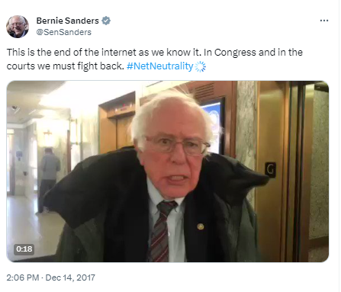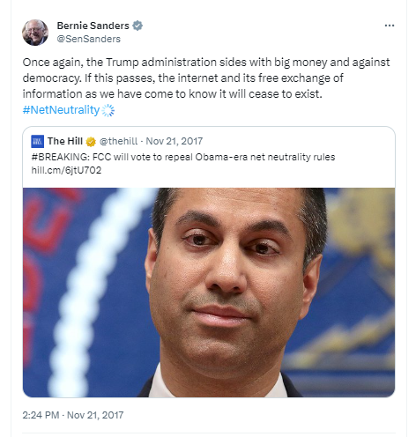

Senator Ed Markey stated that “If the @FCC kills #NetNeutrality, the internet will never be the same” and that “If we don’t #SaveNetNeutrality @AjitPaiFCC will turn the Internet into a digital oligarchy.”

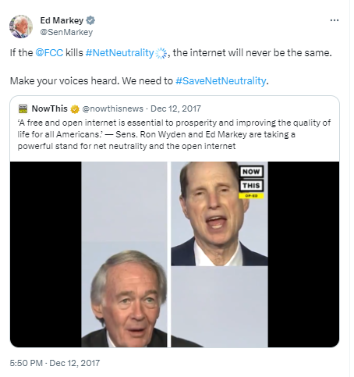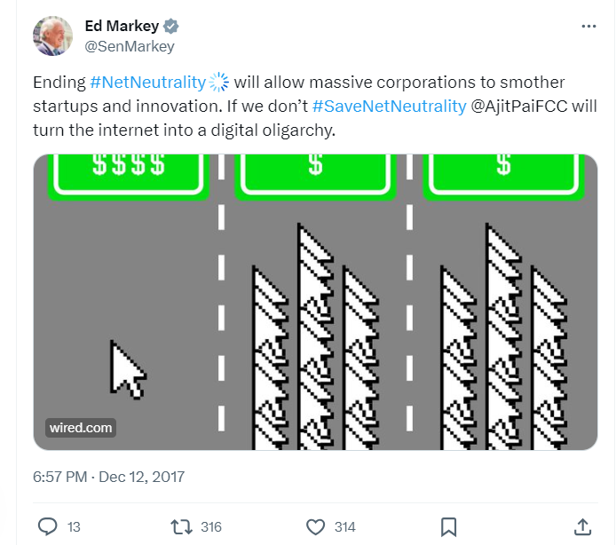
Senator John Tester wrote that “Ending #NetNeutrality ends the Internet as we know it.”

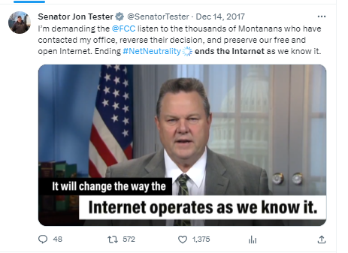

Senate Democrats asserted that “If we don’t save net neutrality, you’ll get the internet one word at a time.”

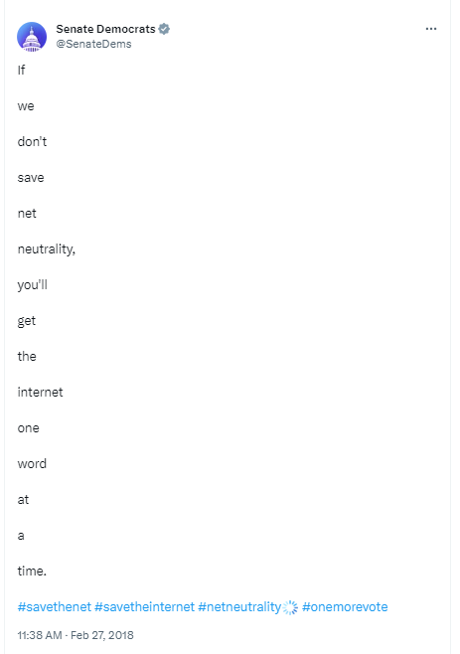

The media parroted these false claims. The New York Times ran an article headlined “The Internet Is Dying. Repealing Net Neutrality Hastens That Death.” The article went on to state that “a vote . . . by the Federal Communications Commission to undo net neutrality would be the final pillow in its face.”
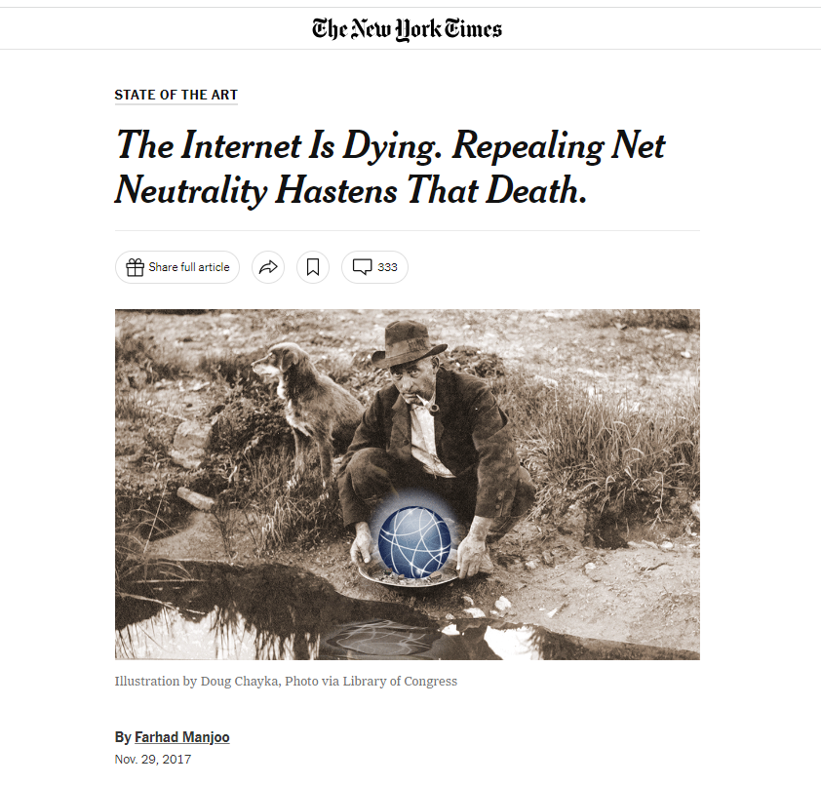

GQ—not one to let a cultural moment pass by apparently—published, in its news section, an article titled “How the FCC’s Killing of Net Neutrality Will Ruin the Internet Forever.”

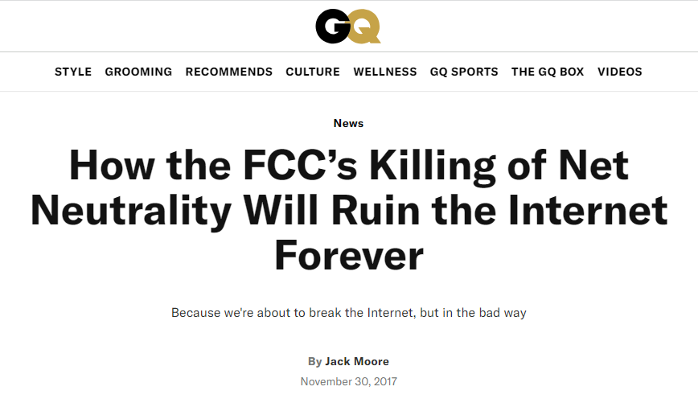

Not to be outdone, CNN ran a bolded, banner headline across the top of its main page proclaiming the “End of the internet as we know it.”

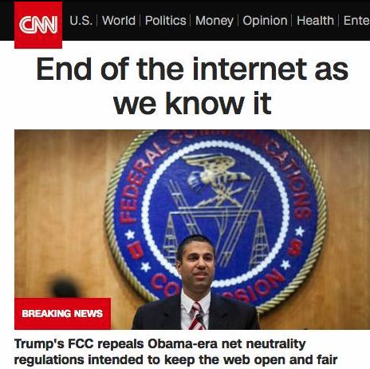

The false claims only accelerated from there. The co-founder of a progressive organization said this of the Republicans involved in the net neutrality repeal: “They hate Americans, freedom, the flag, and the 1stAm.”

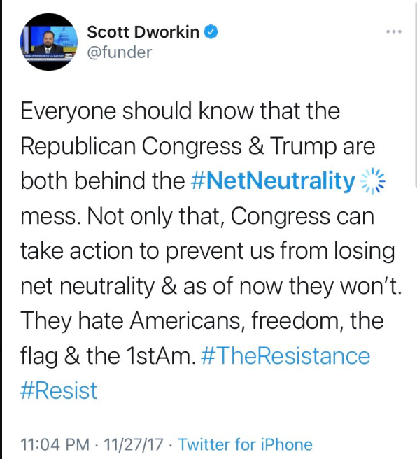

Not surprisingly, people believed the Apocalyptic rhetoric that the so-called “experts” on this issue were feeding them. One person was sentenced to prison for threatening to murder the family of then FCC Chairman Ajit Pai over Title II. Another was indicted for calling in a bomb threat to the FCC’s headquarters, which resulted in us having to evacuate the Commission meeting room during our vote on repealing Title II.

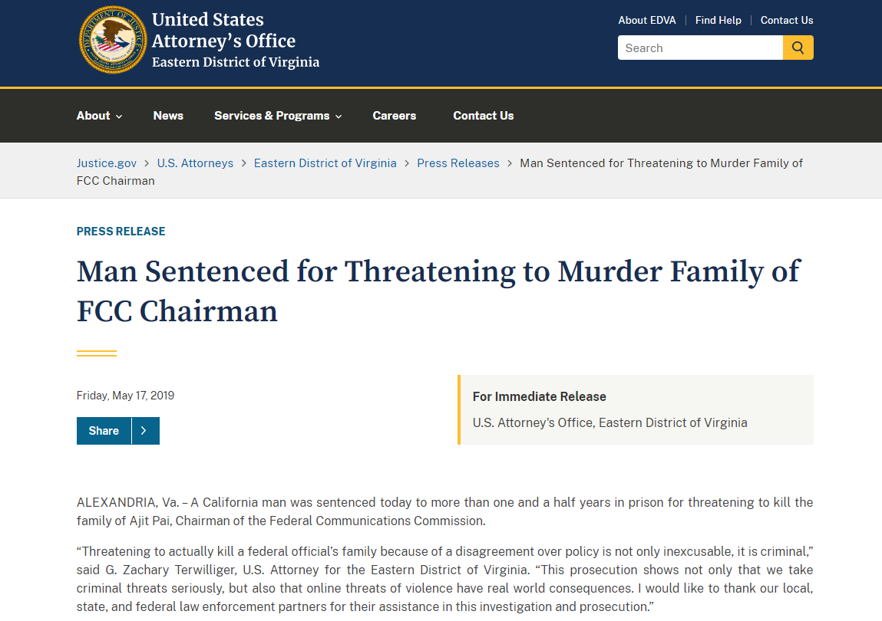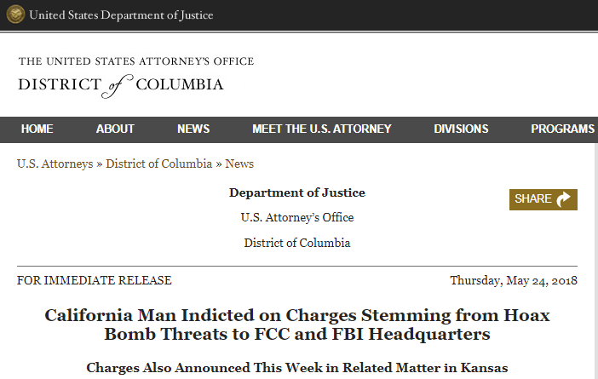

Now, moving on from those clearly deranged individuals, let’s turn back to some of the very specific harms that Title II’s proponents predicted. They said that the prices for broadband would spike, that you would be charged for each website you wanted to visit, and that the Internet itself would slow down.
Did any one of those predictions come to pass? Of course not. Since the FCC’s 2017 decision to return the Internet to the same successful and bipartisan regulatory framework under which it thrived for decades, broadband speeds in the U.S. have increased, prices are down, competition has intensified, and record-breaking new broadband builds have brought millions of Americans across the digital divide.
Here are just some of the facts:
- Internet Speeds are up:
- Average fixed download speeds in the U.S. have increased over 3.5-fold or nearly 260% since 2017, as shown by Ookla data.
- Average mobile download speeds have increased over 6-fold or 456% since 2017, as shown by Ookla data.
- The U.S. now has one of the highest average fixed broadband download speeds in the world, as shown by Ookla data.
- Competition has increased:
- The percentage of Americans with access to two or more high-speed, fixed ISPs has increased by about 30% since 2017—up from 229 million in 2017 to approximately 295 million in 2022, according to FCC measures.
- New forms of intermodal competition have also emerged and increased since 2017.
- The new generation of low-earth orbit satellites is one example. Starlink, which launched its first satellite in 2019, now offers high-speed broadband throughout the entire United States.
- New fixed wireless services represent additional competition as well. The number of Americans that can now choose fixed, high-speed or 5G for home broadband as an alternative to fiber or other wired connections has grown exponentially from effectively zero in 2017. 5G fixed wireless providers now cover more than 94 million homes and businesses. Indeed, fixed wireless services accounted for 90% of net broadband additions in 2022.
- The Digital Divide is narrowing:
- Telecom crews recently set records for new high-speed fiber builds—with builders adding over 400,000 route miles in 2022 alone—which represents more than a 50% increase over 2016 numbers and enough new fiber to wrap around the Earth over 16 times.
- In 2017, there were about 100,000 outdoor small cell nodes and that number has now increased over 4-fold to 452,000 by year end 2022.
- Prices are down:
- In real terms, prices for Internet services are down and, on a price per megabyte basis, they have fallen substantially since 2017.
In other words, utility-style regulation of the Internet was never about improving your online experience—that was just the sheep’s clothing. It was always about government control. But don’t take my word for it.
Last month, when reports emerged that the FCC would soon head down the path of applying vast and expansive utility-style controls to the Internet, two of President Obama’s former Solicitors General, Donald B. Verrilli, Jr. and Ian Heath Gershengorn, published their views. The two Obama Administration alums described Title II this way: “classifying broadband internet access service as Title II telecommunications service would ‘bring about an enormous and transformative expansion in [the agency’s] regulatory authority . . . over the national economy.’” Continuing, the former Solicitors General stated that regulating the Internet as a Title II utility service “would vastly expand the Commission’s authority and would transform the way a federal agency regulates a vitally important element of our economy and the personal and social lives of hundreds of millions of Americans.”
They’re telling the truth. The FCC should follow that example and level with the American people. Years into this discussion, the public deserves an honest debate about the future of Internet regulation—not just the repeated and talismanic invocation of the phrase “net neutrality.” We should be talking about whether it makes sense for this agency to apply 1930s-era government controls to the modern Internet. We should be talking about whether Washington should reserve to itself the freewheeling power to micromanage how networks function through an undefined general conduct standard.
After all, you might expect some degree of regulatory humility after the 2017 predictions failed to materialize and it became clear to everyone (other than partisan activists) that Title II is a solution that won’t work to a problem that does not exist. But you will find none of that in today’s Notice. Instead, the proponents of Title II are moving full steam ahead. Gone are the old justifications—replaced with new ones. The goalposts have moved, but the goal remains the same: increasing government control of the Internet.
The new justifications for Title II that have been conjured up this time around are just as farfetched as the ones activists made up in 2017. They do not withstand even casual scrutiny.
We’re now told that Title II is necessary for national security. But the Notice identifies no gap in national security that Title II would fill. Indeed, Congress has already empowered Executive Branch agencies with national security expertise, including the DOJ, DHS, and Treasury, with the lead when it comes to security issues in the communications sector. It would be incredible, if it were true, that the FCC has known about a national security threat for years now and simply stood by the wayside, did not seek to eliminate it through existing authorities or new ones, and waited to raise it until now—in fact, that is not credible. The Administration has the power it needs to deal with any bad actors, without Title II.
We’re now told that Title II is necessary for law enforcement, too. But the FCC applied the Communications Assistance for Law Enforcement Act or CALEA to broadband providers long ago, without Title II regulation.
We’re now told that Title II is necessary for outage reports as well, which advance public safety. Except, the FCC already requires outage reports from services that are not subject to Title II, like VoIP.
We’re now told that Title II is necessary because COVID-19 demonstrated the importance of connectivity. But this takes the lessons learned from the pandemic and turns them on their heads. COVID-19 exposed the error of applying Title II-like utility regulations to the Internet as the European Union has long done. As I detailed in a separate statement, when online traffic spiked during COVID-19, EU officials asked Netflix and other streamers to ration their service to keep the continent’s slow, fragile networks from breaking. The U.S. had no need to ration service—our network speeds exceeded theirs by 83%. This is because our Title I regulatory approach encouraged investment and buildout. America’s networks are not only faster than those in Europe, they are more competitive, cover a much higher percentage of households, and benefit from levels of per household investment that are 3 times higher than in Europe. So, no, now is not the time to make America’s broadband networks look more like Europe’s.
We’re now told that Title II is necessary to stop ISPs from engaging in blocking, throttling, or anti-consumer prioritization. Wrong again. We have a free and open Internet today without Title II. ISPs aren’t engaging in that conduct for reasons that have nothing to do with Title II. The DC Circuit made this clear when it reviewed the FCC’s 2015 Title II rules. There, now Chief Judge Srinivasan and Judge Tatel joined in a statement expressly noting that—even with the FCC’s Title II decision in place—ISPs are free to engage in “blocking websites,” the “throttling of certain applications chosen by the ISP,” and even the “filtering of content into fast (and slow) lanes based on the ISP’s commercial interests,” provided they disclose those practices. In other words, Title II does not even accomplish the purported goal that its advocates claim they seek.
But enough about what Title II fails to do. Let’s talk about what utility-style rules do achieve.
For one, Title II includes rate regulation, as today’s Notice expressly proposes. There is no more surefire way of killing off investment and innovation than putting price controls squarely on the table. Adjudicating broadband rates under a “just and reasonable” standard should be a nonstarter.
For another, Title II would strip the nation’s lead consumer protection agency—the Federal Trade Commission—of 100% of its authority over broadband. That includes exempting ISPs from the FTC’s privacy rules. What’s more, federal law now prohibits the FCC from reimposing its old broadband privacy rules on ISPs.
For still another, Title II will hit Americans in their pocketbook. In fact, prices for utility-regulated services like electricity, water, and gas have been increasing over two times faster than the prices for Internet services. Monopoly regulation invariably leads to monopoly prices.
For yet another, Title II targets free data plans and pro-consumer zero rating offerings. So if you like your plan, you may not be able to keep your plan.
Title II will also slow down America’s rural ISPs. Small and rural providers are already facing significant headwinds due to inflation and the Administration’s failure to streamline the permitting process. The last thing that these broadband builders need right now is a regulatory onslaught from Washington. Yet that is precisely what Title II utility-style regulation entails. As the FCC determined in 2017, the agency’s 2015 experiment with Title II regulation negatively impacted small ISPs that serve rural communities. Indeed, those small ISPs reduced broadband infrastructure investment due to the FCC’s 2015 Title II decision.
It should be clear by now that the FCC’s efforts to revive utility-style regulation of the Internet is not good policy—that is why its proponents keep layering on new shades of lipstick. But if that’s not enough to convince you, it’s also bad on the law.
Here, I once again agree with President Obama’s lawyers. In the submission that the two respected Solicitors General released last month, they addressed head on the question of the FCC’s legal authority in light of the sea change in administrative law that has taken place since the FCC’s 2015 Title II decision. In their words, an FCC decision applying Title II to the Internet today “would be struck down by the Supreme Court” under the major questions doctrine, as West Virginia v. EPA makes clear. Indeed, as the two appellate lawyers succinctly put it, the legal question “is an easy one:”
A Commission decision reclassifying broadband as a Title II telecommunications service will not survive a Supreme Court encounter with the major questions doctrine. It would be folly for the Commission and Congress to assume otherwise.
While some argue that the Supreme Court’s Brand X opinion supports an FCC decision to classify broadband as a Title II service, the former Obama Solicitors General put that claim to rest too. As they explain, the Supreme Court’s finding of statutory ambiguity in Brand X precludes the FCC from applying Title II today because the Supreme Court requires more than mere ambiguity before a court can rule in favor of an agency that is seeking to expand its authority on a major question like this one.
* * *
Finally, I think it is important to take a step back. The hockey star Wayne Gretzky famously described his play by stating: “I skate to where the puck is going, not where it has been.” In my view, every government official should strive to meet the Gretzky test. One of the things we must do is focus on emerging trends and challenges. We should lay the foundation for new innovations and new forms of competition. We should tackle the issues consumers care about now and into the future.
We should not spend our time staring into the regulatory rear-view mirror or relitigating disputes that have long since passed from relevancy. Yet that is precisely what the agency does today with Title II. I would encourage my colleagues to change course and focus the FCC’s work on the numerous, important subjects that Congress has authorized the Commission to address—from rural broadband to spectrum to universal service reform. Heading down the path to Title II will not only push vital FCC matters onto the back burner, it will knock many of them off the stove altogether.
So how did we get here? I don’t mean how did we get here in the sense that President Biden signed an executive order in 2021 calling on the FCC to take this step. I don’t mean how did we get here in the sense that President Obama published a YouTube video in 2014 to pressure (successfully, I might add) the then FCC Chair into embracing Title II. I mean it in a more fundamental way: how did we really get here?
The answer to that question goes back almost 20 years—all the way back to 2005. That is when a handful of then-emerging Silicon Valley upstarts, including Google, first asked DC to heavily regulate their ISP competitors. The tech companies wanted to create a moat around their business models to foreclose any competition for decades to come and to divert attention away from their abusive conduct. So Big Tech’s allies came up with a catchy branding for their regulatory rent seeking: “net neutrality.”
But what has happened in the many years since Google first launched this effort? Well, predictably, it is the tech companies—not ISPs—that have emerged as dominant gatekeepers that are abusing market power. Big Tech is the one blocking the sharing of disfavored news stories, not ISPs. Big Tech is the one threatening to freeze payment accounts and fine users for the content of their speech, not ISPs. And Big Tech is the one censoring lawful videos and documentaries, not ISPs.
Indeed, the Biden Administration is currently suing Google and others because the Administration believes that they have amassed too much power and must be reined in. Yet the FCC is proposing to extend new protections to those very same corporations through Title II—just what Google first asked for all those years ago. Talk about backwards looking.
In closing, I am well aware that neither my position nor reason will prevail today. Reinstating Title II is now an article of faith for many in Washington (and a handy fundraising tool to boot). But make no mistake: any FCC decision to impose Title II on the Internet will be overturned by the courts, by Congress, or by a future FCC.
I dissent.

Press Release, FCC Commissioner Brendan Carr, Following Europe’s Approach to Internet Regulation—With Its Sweeping Government Controls—Would Be a Serious Mistake, as COVID-19 Showed (Oct. 4, 2023), https://docs.fcc.gov/public/attachments/DOC-397479A1.pdf.
Donald B. Verrilli, Jr. and Ian Heath Gershengorn, Title II “Net Neutrality” Broadband Rules Would Breach Major Questions Doctrine at 12 (Sept. 20, 2023) (quoting Utility Air Regulatory Group v. EPA, 573 U.S. 302, 324 (2014)), https://aboutblaw.com/bazq; see also Press Release, FCC Commissioner Brendan Carr, Carr Agrees With President Obama’s Lawyers On Internet Regulation (Sept. 26, 2023), https://docs.fcc.gov/public/attachments/DOC-397209A1.pdf.

